PRUB: A Privacy Protection Friend
Recommendation System based on User Behavior
Wei Jiang, Ruijin Wang*, Zhiyuan Xu, Yaodong Huang, Shuo Chang, Zhiguang Qin
Universiry of Electronic Science and Technology of China, Chengdu 611731, China

Abstract
Fast developing social network is a double-edged sword. It remains a serious problem to provide users with excellent mobile social network services as well as protecting privacy data. Most popular social applications utilize behavior of users to build connection with people having similar behavior, thus improving user experience. However, many users do not want to share their certain behavioral information to the recommendation system. In this paper we aim to design a secure friend recommendation system based on the user behavior, called PRUB. The system proposed aims at achieving fine grained recommendation to friends who share some same characteristics without exposing the actual user behavior. We utilized the anonymous data from a Chinese ISP, which records the user browsing behavior, for 3 months, to test our system. The experiment result shows that our system can achieve a remarkable recommendation goal, and at the same time, protect the privacy of the user behavior information.

Keywords: Mobile Social Network，Privacy Protection，Friend Recommendation System, User Behavior

1. Introduction
We are now embracing the era of mobile social network. It connects the people with similar characteristics through mobile devices, such as smartphone. User on the mobile social networks can share their states conveniently. Mobile based social network is an open platform: it is established on the basis of actual social relationship, and developed by further expanding the social circle. Aiming at recommending new links for each user, almost all the mobile social networking services provide a service to recommend friends. Considering the fact that the size of the network grows exponentially, many service providers and researchers are trying to import distributed management to implement recommendation system as a way to relieve the pressure of services on centralized management system [1], and improving user experience at the same time.
The recommendation system can achieve a promising result using the information of user behavior [2] However, some of the information contain personal privacy data, and users are unwilling to share their certain behavioral information to the others. They prefer to exchange their information with people who share the same common interests, instead to all the strangers. Especially in the distributed systems, because there are no regulators in the interactive process, the privacy security will be a problem. Thus, “how to realize high quality recommendation as well as protecting the privacy of user behavior information of user” is becoming a research hotspot [3,4,5].
To solve these problems, we designed a secure friend recommendation system based on the user behavior, called PRUB. This system aims at achieving fine grained recommendation to friends who share common characteristics without exposing the actual user behavior. PRUB provides modified matching protocol and authorization protocol to ensure the security of user behavior information in hybrid management which combines the centralized and distributed management.
PRUB works mainly in two steps: First, realize coarse friend recommendation. Authentication server classifies users using KNN classification algorithm based on the information of user behavior, such as browsing records, and returns friend recommendation result such as who share the same interests with users. Second, realize the fine grained friend recommendation. Each user uses coarse grained friend recommendation on similarity calculation using matching protocol. If the similarity degree greater than the user defined threshold, PRUB adds the friend to the fine grained recommendation list.

This paper makes the following contributions：
- We present hybrid management architecture according to the characters of mobile social networks, relieving the pressure from the server and improving the user experience.
- We propose privacy supported matching protocol. Utilizing the behavior of users, it can realize personalized instead of blindly recommend result. At the same time, the protocol ensure the personal privacy security, users can protect their own sensitive information and avoid exposing them to all the strangers.
- We define a security model, and theoretically analyze the security of our protocol. We prove our protocol can defend against attack in the position of initiator and matching target respectively.
To evaluate our system PRUB, we utilize the anonymous data from a Chinese ISP, which records the user browsing behavior for 3 months. The experiment result shows that our system can achieve a fine grained recommendation, and protect the privacy of the user behavior information at the same time.
The rest of the paper is organized as follows: Section II discusses related works. Section III provides the system overview of PRUB. The secure matching protocol is discussed in Section IV. Section V analyzes the security of the system. The experiment result is presented in Section VI. We conclude our work in Section VII.

2. Related Works
Corresponding to the structure of mobile social network, there are three application patterns of friend recommendation: centralized management, distributed management and hybrid management.
Centralized management: In this pattern, all the user information is stored in the central server. As a trusted third party, central server manages the whole system and handles all the processes. Users only need to access to server using mobile client and they can acquire the expected service. Central server will complete the characters matching and return recommended friend list to users [6]. Throughout the process, there is no interaction between the users. In the centralized management, central server holds all the information about user characteristics. It can effectively protect the user privacy through enhancing the server security. However, server cannot be accessed at any time; it depends on the network conditions. Thus, user experience decreases under serious network condition. What's more, not all the user are willing to deliver their behavior information to server providers, especially some personal privacy information. Some server providers may utilize the information for illegal activities[7].
Distributed management: In distributed social networks, data are stored and handled at the local clients, and users can directly interact with each other. Clients broadcast their own information, and receive information of others at the same time, then match characteristics to discover target users. In this pattern, the whole recommendation process can be realized among clients without any server participation [8]. This pattern certainly relieves the pressure of server. However, clients may unintentionally publish some unnecessary information, even user privacy [9]. In the distributed system, interaction process lacks of control and fails to ensure the security of recommendation process. Many researchers presented secure matching protocols to avoid the shortage, such as [10], it utilizes Shamir secret dividing to complete matching.
Hybrid management: In order to integrate the advantages of centralized and distributed management, some researchers presented hybrid management [11]. In this pattern, users could interact directly, but during the process of matching, appropriate server control is required, such as storing temporary data and arbitration. It can reduce the server stress and provide security mechanism as well. The problem for researchers is how to minimize the information provided by users, how to realize secure matching with server involvement as little as possible and how to realize arbitration using minimal user information as well as ensure accuracy [12].
Our recommendation system PRUB is built based on hybrid management. Matching protocols is the core of hybrid management, users can find some friends who share with common interests, such as common browsing habits, and also protect their private information. The process of matching can be regarded as PSI (private set intersection problem) or PCSI (private cardinality of set intersection problem) [13]. Currently, the popular resolution algorithm can be categorized into three types.
Matching protocol based on commutative encryption function: Agrawal [14] presented a commutative encryption protocol to solve PSI/PCSI problem. It used a pair of encryption function and, and 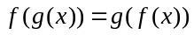, the property of each function is that the encrypted result is independent from calculation order, such as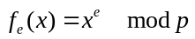, where is safe prime. This protocol is secure under the hypothesis of DDH (Decisional Diffie-Hellman hypothesis), and only one of participator know the intersection, the other cannot acquire anything. However, this protocol cannot defend against malicious attacks.
Marco et al. [15] presented a social platform VENETA based on the algorithm of Agrawal. They rely on a construction based on commutative encryption. Compared to Agrawal, they assume that the attack cannot cause any serious damage. A victim only reveals a contact he was willing to share, without getting this information in return. VENETA enables two users calculating the intersection of their characters in a certain range. If it successfully matches between two users, VENETA will recommend this stranger to the user.
Xie et al. [16] presented a matching protocol in mobile social networks. The protocol adds signature verification to property elements, this paper shows that Agrawal et al. prove that given the Decisional Diffie-Hellman hypothesis(DDH), <Xi, f_{e}(X_{i}), Y_{j}, f_{e}(Y_{j})> for fixed values of i and j, with f_{e}(x)=x^{e}, is indistinguishable from< Xi, f_{e}(X_{i}), Y_{j}, Z>, when e is not given. They prove that these certificates are sent across an encrypted channel, so a passive eavesdropper cannot learn Alice’s or Bob’s interests. Thus attackers cannot reorder property freely and thus avoiding counterfeit and scanning attacks.
In [17], it constructs a new efficient solution to Yao’s millionaires’ problem based on symmetric cryptography, and the privacy-preserving property of the solution is demonstrated by a well-accepted simulation paradigm. It propose a new security paradigm that quantitatively captures the security levels of different solutions. The paper propose an ideal model with a trusted third party, Alice and Bob have x and y, they want privately to compute functionality f(x,y)=(f₁(x,y),f₂(x,y)) with the help of a trusted third party. At the end of the protocol, Alice (Bob) obtains f₁(x,y),f₂(x,y) without leaking x(y). The ideal model provides the best possible security of secure multiparty computations, and its security level is the highest level than that any secure multi-party computation solution can achieve. And they use this followings to judge such as Protocol π₁ is more sucure than Protocol π₂.
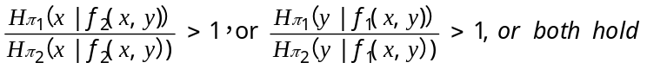
They concluded that the new solution was as secure as both the ideal secure multi-party computation solution and Yao’s solution. In this paper, it enables XOR operating in commutative encryption function, but it greatly increases the calculation costs and decreases the security of the system.
Matching protocol based on linear polynomial: Paper [13] presented FNP protocol, which transforms properties into linear polynomial, and uses the character of homomorphy to handle the encrypted coefficients. In exchange process, one side is client and the other is server. For each input property of client, it only knows whether the property belongs to server and cannot acquire any other information. Meanwhile, the server cannot get any other input information from the client.
Kissner[18] used polynomial to represent multiple collections. Taking advantage of polynomial and addition homomorphy function, it realizes the secure operation of intersection, union and complementation. This protocol can be applied to against semi-honest attacks and these techniques can be applied to a wide range of practical problems. This paper has an important feature of privacy-preserving multiset operations which can be composed, and enable a wide range of applications. They use the following grammar to compute the output of any function over the multi sets.
Υ::=s|Rd_{d}(Υ)| Υ∩Υ|s∪Υ|Υ∪s. They construct an algorithms for computing the polynomial representation of operations on sets, including union, intersection, and element reduction. They extend these techniques including intersection, element reduction with a trusted third party to encrypted polynomials, allowing secure implementation of our techniques without a trusted third party. Dachman-Soled et al. [19] presented a PSI protocol which can be applied for defending against malicious users. They also use polynomial coefficient to represent properties, and use Shamir Secret Share to dividing coefficient for realizing higher security.
Lu et al. \cite{20} puts forward Secure Handshake with symptom-matching, and deploys the matching protocol into disease monitoring. Their system enables patients who have the same symptoms communicating and sharing information. The core of their algorithm is the feature of bilinear matching function. In this system model, they consider a typical mHealthcare social network (MHSN), which consists of trusted authority(TA) at eHealth center and a large number of mobile patients. As the patient health condition is very sensitive to the patients,therefore, it is essential that the privacy of PHI should be controlled by the patient in a MHSN environment, so they develop a secure same-symptom-based handshake(SSH) scheme. It consists of these algorithms: system setup, patient joining, and patient’s same-symptom-based handshaking (PatientsSSH). The paper show the employed identity-based encryption.
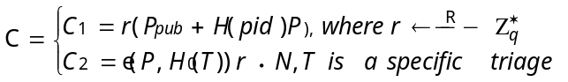
The identity-based encryption (IBE) should be semantic security (indistinguishable) under selective-PID-Symptoms and chosen-plaintext attacks. In this paper, Let IBE be and secure encryption scheme with security parameter l, and they define the advantage probability of A to be an INDsPS-CPA adversary against IBE. It is very important in the random oracle model.
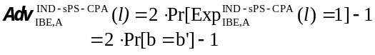
In this paper, SSH is of vital important to the success of MHSN, But this algorithm can be only applied to matching single property, and difficultly extended into multi-properties.
Matching protocol based on pseudo random number: This protocol is firstly presented in paper [21] Hazay and Lindell designed a PSI protocol, in order to defend against different attacks and ensure the operating efficiency at the same time. The pseudo random number is used for encryption. In this paper, the protocols for secure computing the set intersection functionality are based in secure pseudorandom function evaluations, in contrast to previous protocols. This paper proposed a Secure Pattern Matching; they used F_{PM} to address the question of how to securely compute the above basic pattern matching functionality.
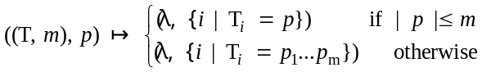
They present this protocol for securely computing F_{PM} in the presence of malicious adversaries with one-sided simulatability. And they utilize specific properties of the Naor-Reingold pseudorandom function and the protocol π_{PRF} for computing the Naor-Reingold funciotn. They use the following instead of orrupted party P₁ computes and sends the set.
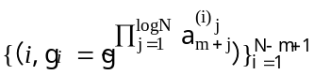
So the Naor-Reingold pseudorandom function will achieve high efficiency.
Yang and Zhang et al. [22] designed a distributed mobile social network, E-SmallTalker. It utilizes Bloom Filter as the store structure of properties, and calculates the intersection through several rounds of iterative with pseudo random function. E-SmallTalker can reduce storage space effectively and avoid interactive users acquire more information besides the common properties. It requires no data services like Internet access, and exchanges user information between two phones and performs matching locally. Yang and Zhang et al. bulid on Bluetooth Service Discovery Protocol(SDP) to search for nearby E-SmallTalker users. And the iterative Bloom filter (IBF) they proposed is to encode user information, data is encoded in a bit string to address SDP attributes’ size limit. This system architecture includes four software componets: Context data store, Context encoding and matching, Context exchange, User interface (UI). They devise multi-round protocol to achieve the desired false-positive rate f with a minimum total amount of transmission given the constraints imposed by the implementation of Bluetooth SDP, and the quantitative measurement of the false-positive rate is defined by the following formula: f=(1-(1-1/m)^{kn})^{k}≈(1-e^{-kn/m})^{k}. So this paper’s approach was efficient in computation and communication.
3.PRUB System Overview
The PRUB system is based on users browsing behavior to recommend related friends with similar behavior and activities. The system adopts hybrid management architecture mentioned above. The system is consist of several users, several smartphones, one Verification Server (VS) and several Anchor Severs (AS). The basic structure is shown in Figure 1.
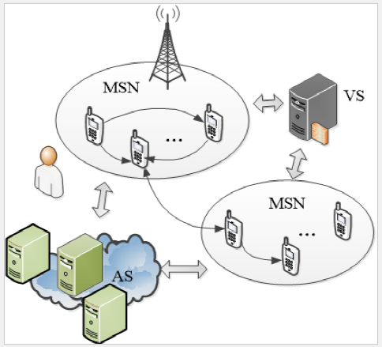
Figure 1 PRUB System Structure
3.1 Users
Every user who wants to use our system to find friends with similar behavior should have a smartphone and install our application. The application will collect users browsing histories and classify them into several catalogues. The value of each catalogue is defined as properties of the user. The users should sign up an account to use the service.
To test the security of our system, we define some kinds of abnormal users. The first kind of abnormal users will not try to break protocols of the network. They want to obtain some privacy of other users by analyzing the information they obtain from the recommendation result. The way they are trying to do is defined as passive attack. These users are called Semi-honest User. Another kind of users who are trying to do attack actively is called Malicious User. They do not obey the protocols to get more information of other users and even try to break down the whole system. Some methods of the attacking are sending fake messages or terminating an agreement before it finishes.
3.2 Smartphones
The smartphones which have installed our application are also part of the system. The application saves the personal information of the user, including its ID, properties, private key and public key etc. The smartphone should have some computability in order to compute some secure information. The smartphones of the users form Mobile Social Networks (MSNs).
3.3 Verification Server (VS)
The user should have registered on the verification server before it obtains the recommendation data. The application will send the encrypted user's personal information to the VS to get the ID and a pair of RSA keys. When verifying the user's ID and properties, the application will send the username and the public key to VS, VS generates a random number and then sends the random number to user's application. The application will utilize the properties, and send the ID to the VS. The VS uses its private key to get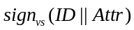, and sends it back to user's application. The VS can bind the user with its properties and signature certification, in order to avoid abnormal users to change their properties to obtain others private information.
3.4 Anchor Sever (AS)
The anchor servers are used to connect several MSNs. The user can register on several different MSNs, and the AS transmits information to the users from different MSNs.
4. Secure Matching Protocol
One-way authentication protocol: In the beginning of establishing interaction communication channel between VS and user, VS utilizes one-way authentication protocol to authenticate the identity of user. The protocol is described in the TABLE 1
After the interaction about setting identity and random identification, the protocol can realize the identification between dual direction key and one-way entity though verifying hash value. It achieves forward secrecy and non-repudiation, and can defend the attack from man-in-the-middle, including replay attack, reflection attack, prophesy attack and interleaving attack. Mutual authentication protocol: This protocol is used to mutual authentication between pairing of interaction when initially establishing channel. The protocol is described in the TABLE 2. Where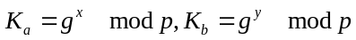,, and 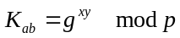.
Our mutual authentication protocol is developed on the base of STS workstation protocol. After adding identify and using random number a timestamp, the identification is completed. This protocol also can be used to defend man-in-the-middle attack.
Matching protocol: In order to achieve fine grained friend recommendation, the user calculates the similarity of common properties with coarse grained recommendation. The mutual protocol must be done before matching. The protocol is presented as following TABLE 3.
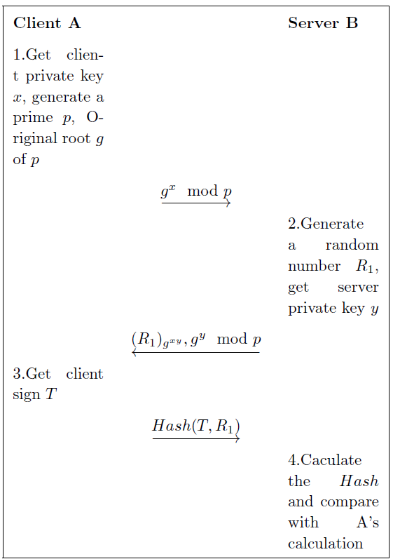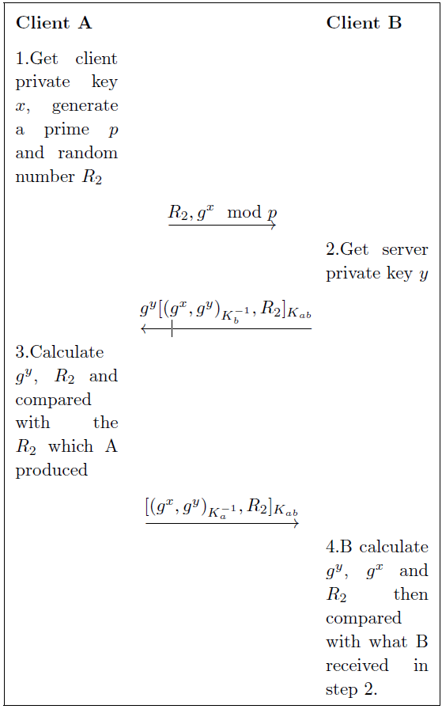
Table 1 One-way Authentication Protocol Table 2 Mutual Authentication Protocol
Where denotes all the user that are recommended to A.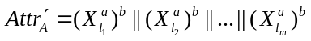 and 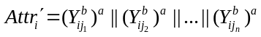.
The core of matching protocol is the principle of commutative encryption of messages. Pairing of interaction acquire the amount of common properties though two encrypted comparisons of each property.
Meanwhile, adding confusing operation to ensure the equity and security. In the last step, comparing common properties of both side, if they are not the same, then turning into arbitration.
Common property exchange protocol: This protocol is used for pairing of users to exchange the detail of common properties. The mutual protocol must be done before exchanging properties. TABLE 4 shows this protocol.
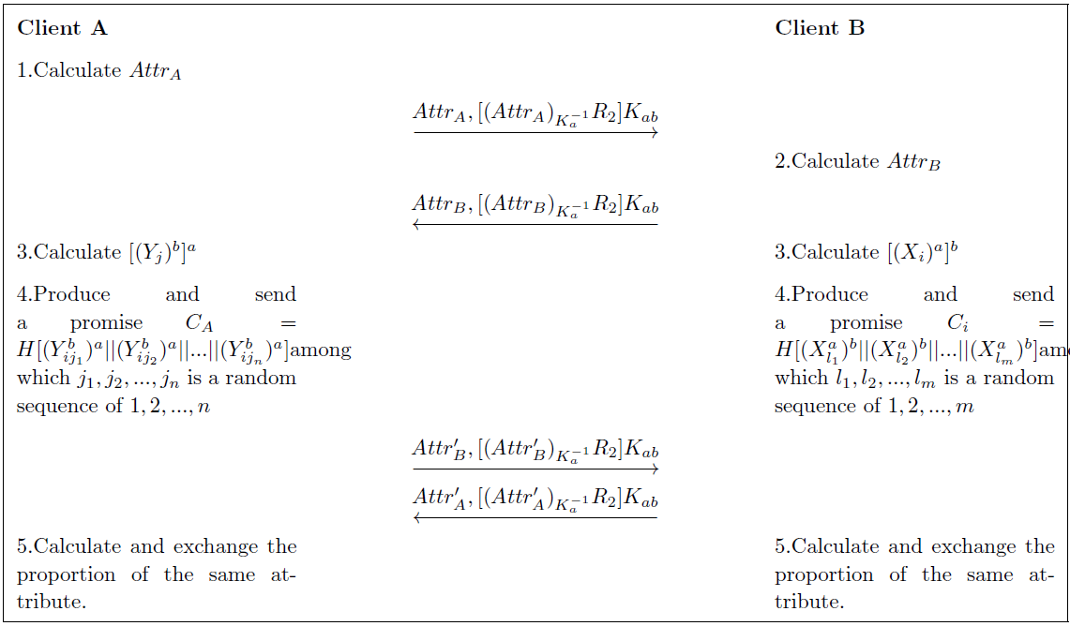
Table 3 Matching Protocol

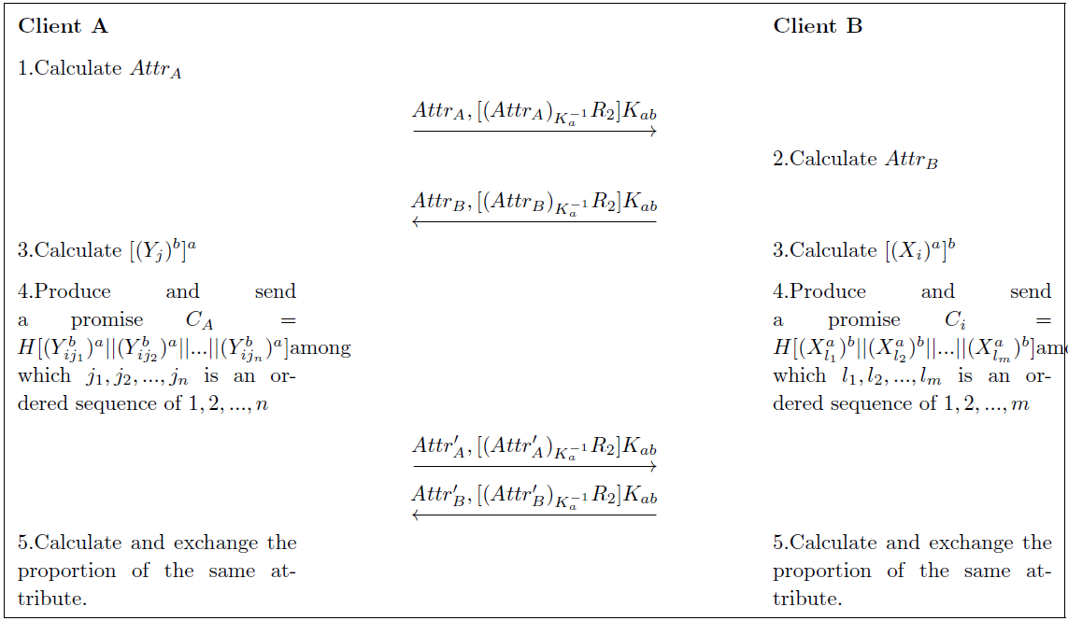
Table 4 Attribute Exchange Protocol

The core of protocol is also commutative encryption, but not includes confusing operation. Pairing of interaction can get the detail of properties by the number. Similarly, comparing common properties of both side in the last step and decide whether doing arbitration.

5 Security Principles
In this section we evaluate the security of the proposed scheme under the security protocols we proposed in Section IV. Our protocols are designed based on the Dolev-Yao security model [23].
5.1 Definitions
Define 1 (Ignorable function): Function 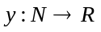is an ignorable function, when polynomial, 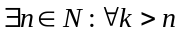,
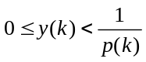
Define 2 (Probabilistic polynomial (PP): A language is in PP if and only if there exists a probabilistic Turing machine, such that:
runs for polynomial time on all inputs;
For all in outputs with probability strictly greater than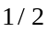;
For all not in , M outputs with probability less than or equal to .
Define 3 (Computationally Indistinguishable): Probability Collectives 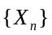 and 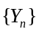are computationally indistinguishable if Probabilistic polynomial Turing machine, a large enough integer, and any polynomial:
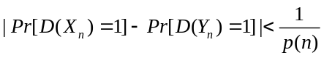
For 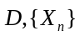 and are the same. cannot get any information of $ from and vice versa.
Define 4 (Decisional Diffie-Hellman (DDH) hypothesis): is a prime number, 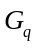 is a cycle group ordered, is a generator of . 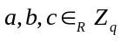. The distributions of 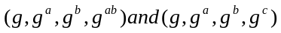 are computationally indistinguishable.
5.2 Security analysis
The system security faces a number of threats, such as man-in-the-middle attack, passive wiretapping, property modification and malicious match by abnormal users. We analyze four threats on our system.

5.2.1 Man-in-the-middle attack
User should register on the VS first. VS matches the properties, and sends back the coarse recommendation result. The system implements the one-way authentication protocol to defend against man-in-the-middle attack. The process is shown in Figure 2.

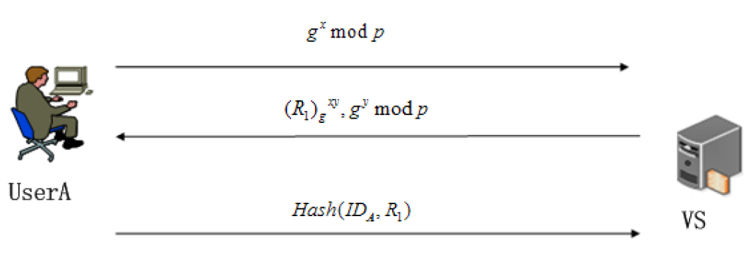
Figure 2 One-way authentication protocol

The fine-grained friend recommendation in our system is based on matching protocol based on commutative encryption function. In order to defend against the man-in-the-middle attack, we implement mutual authentication protocol when the communication channel establishes. The process is shown in Figure 3.
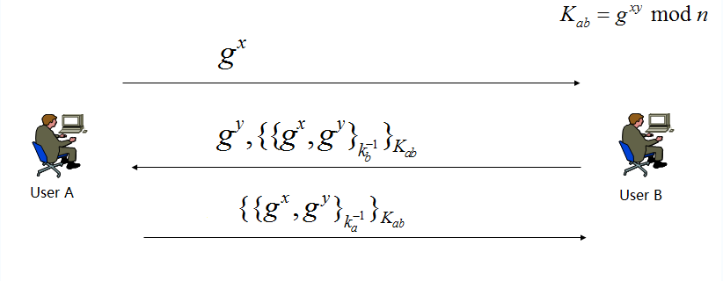
Figure 3 Mutual authentication protocol

One-way authentication protocol achieves the bidirectional key and unidirectional entity confirmation. Mutual authentication protocol achieves the bidirectional key and bidirectional entity confirmation. They complete forward secrecy and non-repudiation, which can defend against basic man-in-the-middle attack including replay attack, reflection attack and interleaving attack etc.

5.2.2 Passive wiretapping
Passive wiretapping is that attackers are trying to obtain users information through the communication channel. The register process, when VS is matching the properties and sending back the coarse recommendation result, is threatened by passive wiretapping.
To avoid passive wiretapping, the system uses encrypted properties. Key agreement in the authentication protocols will encrypt the value of the properties, which will efficiently defend against passive wiretapping.
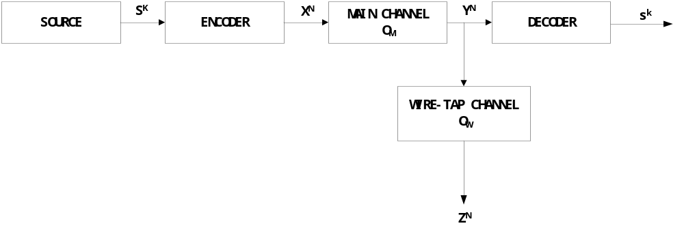
Figure 4 Communication channel general model
Communication channel’s general model shows that the source is discrete and memoryless with entropy H_{s}.The “main channel” and the”wire-tap channel” are discrete memoryless channels with transition probabilities Q_{M}(⋅|⋅) and Q_{w}(⋅|⋅). The source and the transition probabilitiesQ_{M} and Q_{w} are given and fixed.The encoder,as in the above example, is a channel with the K vector S^{K} as input and the N vector X^{N} as output. The vector X^{N} is in turn the input to the main channel. The main channel output and the wire-tap channel input is Y^{N}. The wire-tap channel out put is Z^{N}. The decoder associates a K vector 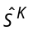 with Y^{N},and the error probablity P_{e} =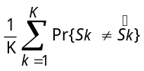,The source emits a data sequence S₁,S₂,…,which consists of independent copies of the binary random varianle S, where Pr{S=0}=Pr{S=1}=1/2.The encoder examines the first K source bits S^{k}=(S₁,…,S_{k}) and encodes S^{k} into a binary N vector X^{N}=(X₁,..,X_{N}).X^{N} in turn is transmitted perfectly to the decoder via the noiseless channel and is transformed into a binary data stream 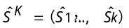 for delivery to the destination. The wire-tapper oberserves the encoded vector X^{N},through a binary symmetric channel with crossover probability 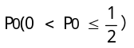.The corresponding output at the wire-tap is Z^{N}=(Z₁,…,Z_{N}), so that for x,z=0,1, and take the equivocation 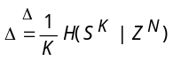, and the transmission rate is KH_{S}/N source bits per channel input symbol.
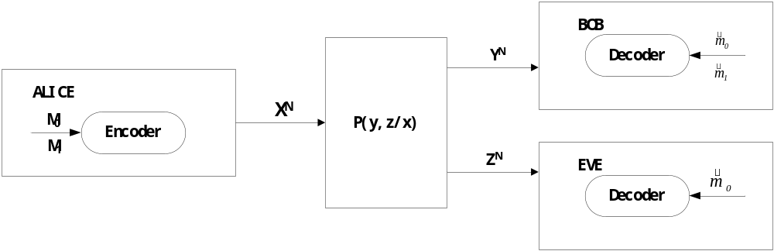
Figure 5 Secret information of brod
Alice and Bob communicate with each other. The Transmission probability is P_{YZ/X}(y,z/x). Supposing the channel is no memory,so the length of sequence n‘stransmisiion probability is
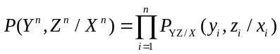 Alice send a common message M₀ to Bob and Eve, and send a private massage to Bob. The codeword A(2^{nR0},2^{nR1},n) is definde by these :
1.M₀={1,2,…, 2^{nR0}} and M₁={1,2,…, 2^{nR1}}.
2. An encode function:
3.Two decode functions:
Attackers get the signal M₁’s Uncertainty: 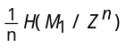, so if making sure the security, it need a codeword (2^{nR0},2^{nR1},n), for any ε>0, the set of rate (R₀,R₁,R_{e}) should satisfy by:
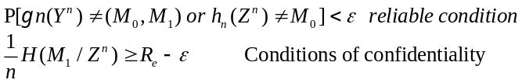

5.2.3 Property modification by abnormal users
Some malicious users are not following the protocols. They send fake message stream to get more details and more private information than the normal users. To defend against this kind of attack, the matching protocol confused the property information sequence, thus the information will not be leaked by property modification.
Using users behavior analysis to find malicious users. Behavior analysis is a technique that can show whether and how strongly one user is similar with other users. In our method we are using two types of behavior analysis to find malicious users 1) Behavior analysis of single user with other products and 2) Behavior analysis of multiple user IDs with commonly rated products. To analyze behavior of users A and B, we have used cosine similarity method. If A and B are the rating values of common user IDs rated to common products, the cosine similarity, θ is defined as
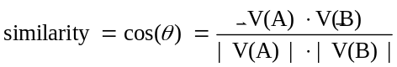
The resulting similarity ranges from 0 usually indicating independence and 1 meaning exactly the same, and in between values indicating intermediate similarity or dissimilarity
Malicious users and attacks have been mostly considered from a system perspective for particular protocols or algorithms. We use a game theoretic model for explaining abnormal users. The network is modeled as an undirected graph G = (V, L), where each node in V corresponds to one user. An edge (i, j) ∈ L means that there is a communication link between the users corresponding to nodes i and j. The set of neighbors of user i, denoted N_{i}, is the set of users j such that there exists an edge (i, j):N_{i}= {j ∈ V |(i, j) ∈ L}. The neighbors of user i are also called adjacent nodes to i. Since the graph is undirected, the neighbor relationship is symmetric: j ∈ N_{i} ⇔ i ∈ Nj. The assumption for an undirected graph can be dropped, in order to model asymmetric links, but we believe the extension to be straightforward. We denote the set of Bad users by V_{B}, and the set of Good users by V_{G}. It holds that V_{B} ∩ V_{G} = ∅ and V_{B} ∪ V_{G} = V . We will be using the term type of a user for the property of being Good or Bad
Bad
 |  | C | D
Good | C | N-E,E-N | -E,E
 | D | 0,0 | 0,0

Good
 |  | C | D
Good | C | N-E,E-N | -E,0
 | D | 0,-E | 0,0
Figure 6 The two games that can take place on a link: Good versus Bad and Good versusGood.

Users have a choice between two actions: C (for Cooperate), and D (for Defect). When all users choose their actions, each user receives a payoff that depends on three things: his own action, his neighbors’ actions, and his own type (but not his neighbors’ types). The payoff is decomposed as a sum of payoffs, one for each link. Each term of the sum depends on the user’s own action, and the action and type of his neighbor along that link. Observe that the user is playing the same action against all neighbors. The payoff of user i is denoted by Ri(ai|ti), when i’s action is a_{i} and i’s type is t_{i}. We extend and slightly abuse this notation to denote by R_{i}(a_{i}a_{j}|t_{i}) the payoff for i when j is a neighbor of i and j’s action is aj. So, the decomposition of i’s payoff can be written as:
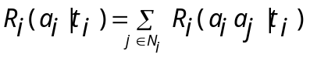
Users have incentives and disincentives to cooperate, both of which we model in a game theoretic fashion, with appropriate payoffs (N and E).

5.2.4 Malicious match by abnormal users
During the matching process based on commutative encryption function, the attackers can modify its properties to scan the recommended friend's common browsing behaviors. Because the matching protocol is based on the similarity of the user's properties, i.e. browsing behavior, the abnormal users can change their properties to get detailed private information of one recommend friend.
To avoid such attack, the system designed the arbitration protocol to detect the abnormal users.
The arbitration protocol is as follows:
- In one-way authentication protocol, users will have a key agreement with the VS and gets a key 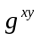. The VS gets 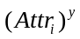 from the key.
- Both the semi-honest user and the recommend friends send their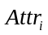, the VS calculates using its private key.
3) Calculate the hash of by the key from server and clients. Then the abnormal user can be found.
Then we analysis the security of the matching protocol based on commutative encryption function.
Let Alice be the protocol initiator, Bob be the person to be recommend.
Theory 1 (Correctness). When Alice and Bob have the same properties, the system will recommend Bob to Alice.
Proof. Let Alice has the property set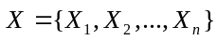 which indicates browsing behaviors and secrete parameter. Let Bob have the property set 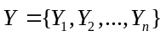 and secrete parameter. An arbitrary element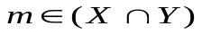.
Alice and Bob calculate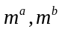, respectively and send it to each other. Then calculate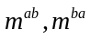. Because the properties sequence is confused, we can only get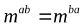, according to the DDH hypothesis, is not clear.
In the second phase Alice sends 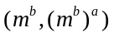 to Bob, Bob sends 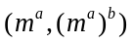to Alice. If, then we can get from 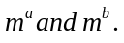 Thus if Alice and Bob have the same properties, the system believes that Bob and Alice have the similar browsing behaviors, and recommends Bob to Alice. Thus we can see the matching protocol based on commutative encryption function is correct.
Theory 2 Matching protocol based on commutative encryption function can defend from passive attack.
Proof. Semi-honest users want to get sensitive private information of others, such as private key and properties, by analyzing the information they get from the system.
Assume Alice is a semi-honest user. She wants to get Bob's private key and properties. During the process, Alice can get Bob's information of
. According to the DDH hypothesis, get 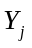 from 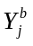 is hard. So she cannot get $b$ from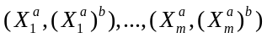. For the same reason, assume Bob is a semi-honest user. He cannot get anyand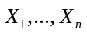 of Alice. Thus in the first phase, both users can only get the size of the common property set. Then in the second phase, they can only know the common property set without other information. The matching protocol based on commutative encryption function is efficient on defending from passive attack.
To prove that the matching protocol based on commutative encryption function can defend from active attack, we proposed 3 different situations. We analysis the attack from both the initiator and recommended friends to prove that the matching protocol we proposed can protect the privacy of the user.
Scenario 1: It can occur in the first phase of the protocol. The initiator counterfeits its properties or sending fake message at the last step, which will get false ratio of the inter-section. When someone found the mistake, the protocol can be terminated immediately, and find out who is the malicious user from the arbitration protocol. Even if the malicious user is not clear, the common set will be incorrect in phase two. Then the VS can still find out the malicious user through the arbitration protocol.
Scenario 2: It can occur in the second phase of the protocol. We assume that Alice is the malicious user and Bob is a normal user. At first Bob sends Alice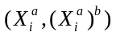. By receiving, Alice gets the intersection. Alice counterfeits 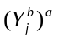 (e.g. replace some part of by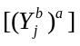, where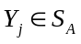). Bob gets the intersection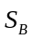. Because is a subset of, Alice can get more information than Bob. This kind of attack cannot be detected. In order to avoid the properties modification from the user, we add promise form Alice to Bob
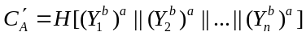.
Using the promise, we can ensure that Alice sends proper information after receiving Bob’s. If Bob receives different information from Alice, Bob can terminate the process and report to the VS.
Scenario 3: It can occur in the second phase of the protocol. We assume that Alice is the malicious user and Bob is a normal user. Alice modifies its properties (e.g. using 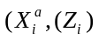 to replace, where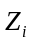 is a random number. Before Bob sends, Alice should send the promise of to Bob. Obviously, Bob will think that the protocol is processed normally and compute the information from Alice. If there is no supervision, Alice can get detailed properties of Bob. However, when they commute property set, Bob can find the difference. Then he can report to the VS
We compare our work with some other protocols, which shows in TABLE 5.

Table 5 Abilities on defending against attacks
Protocols | Passive Attack | Scenario 1 | Scenario 2 | Scenario 3
PRUB | √ | √ | √ | √
Xie’s[14] | √ | × | √ | √
Agrawal’s[16] | √ | × | × | ×

Agrawal’s protocol can only defend against the attack from semi-honest users. Xie improves Agrawal’s work; the protocol can defend against some attack from malicious users. PRUB improve these protocols by adding promise information and VS validation, which enhance the security of the protocol.
6. Experiment
In this section, we present the performance evaluation of PRUB. We first show how the user uses the system. After that, we evaluate the recommendation performance using the anonymous data from a Chinese ISP.
6.1 Using process
User first register on the VS and the VS requires some data from user. Picture 7 shows the register interface of the user.
The users are then asked about what kind of information they are willing to share with and the threshold on how many kinds of information should be the same as the friends. If the user chooses not to share one catalog of the browsing information, the system will not utilize the catalog to do recommendation.
After that, the server returns the coarse recommendation result to the client application. Then the client application scans the recommended friends using the matching protocol we proposed. If a friend shares more common interests, which meet the threshold, the application will add the person to the friend list. Picture 8 shows the friend list.
The user then can choose a friend in the list to exchange the common interests. If the protocol fails, either one can ask for an arbitration to find out who is the abnormal user. If it succeeds, the system will give a result on which interests are the same. The result is shown in Picture 9
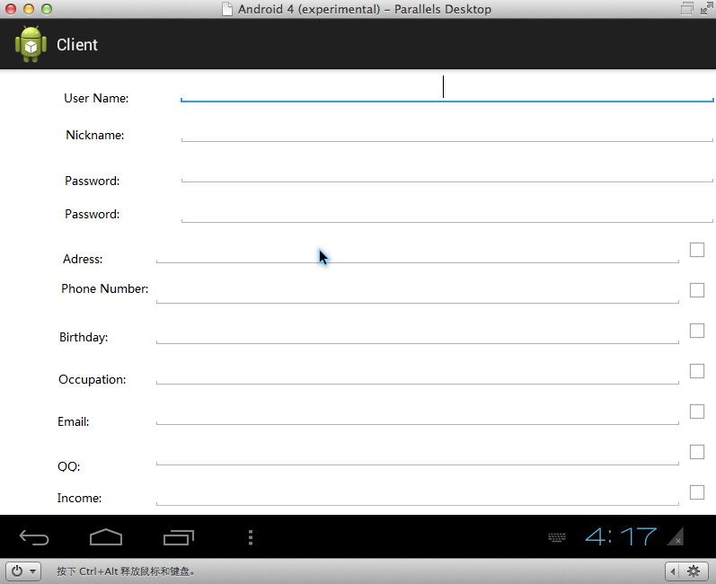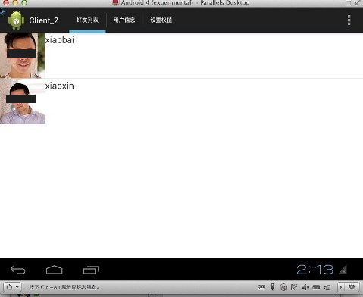
Figure 7 Registration Interface Figure 8 Recommendation list

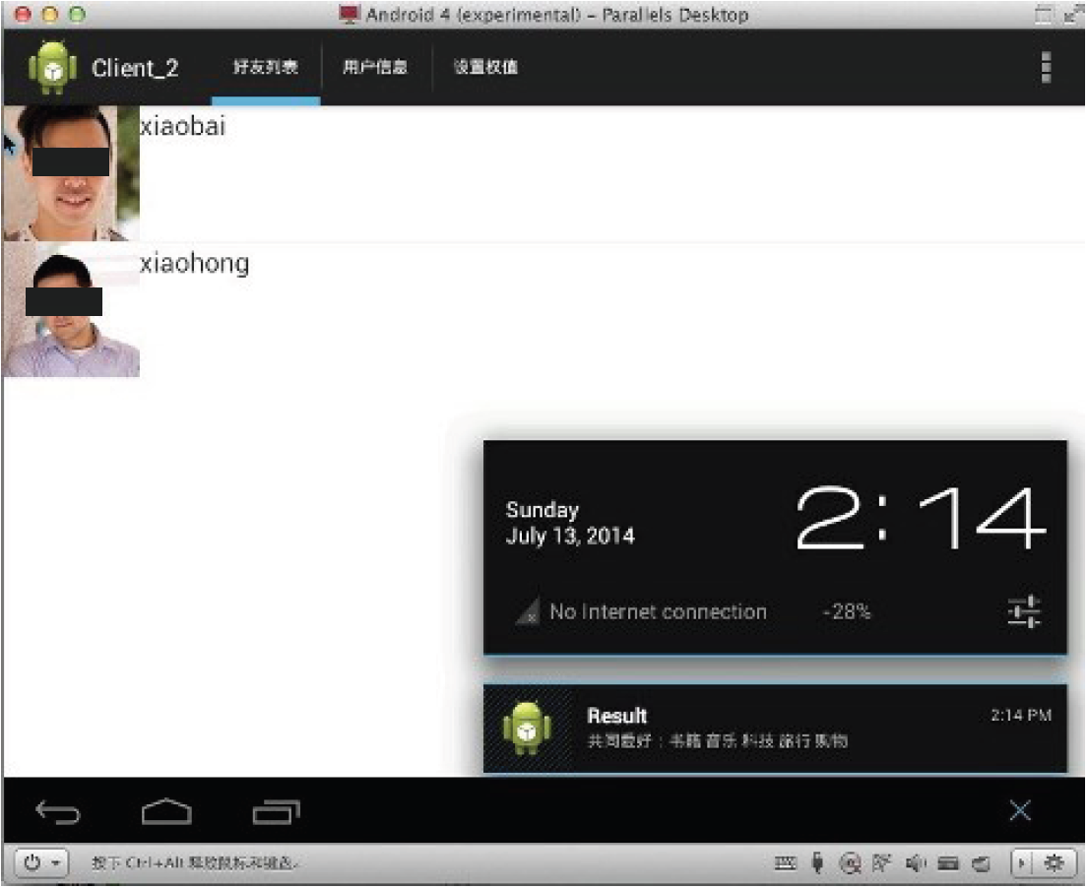
Figure 9 Recommendation result. Users can check what kinds interests they share in common.

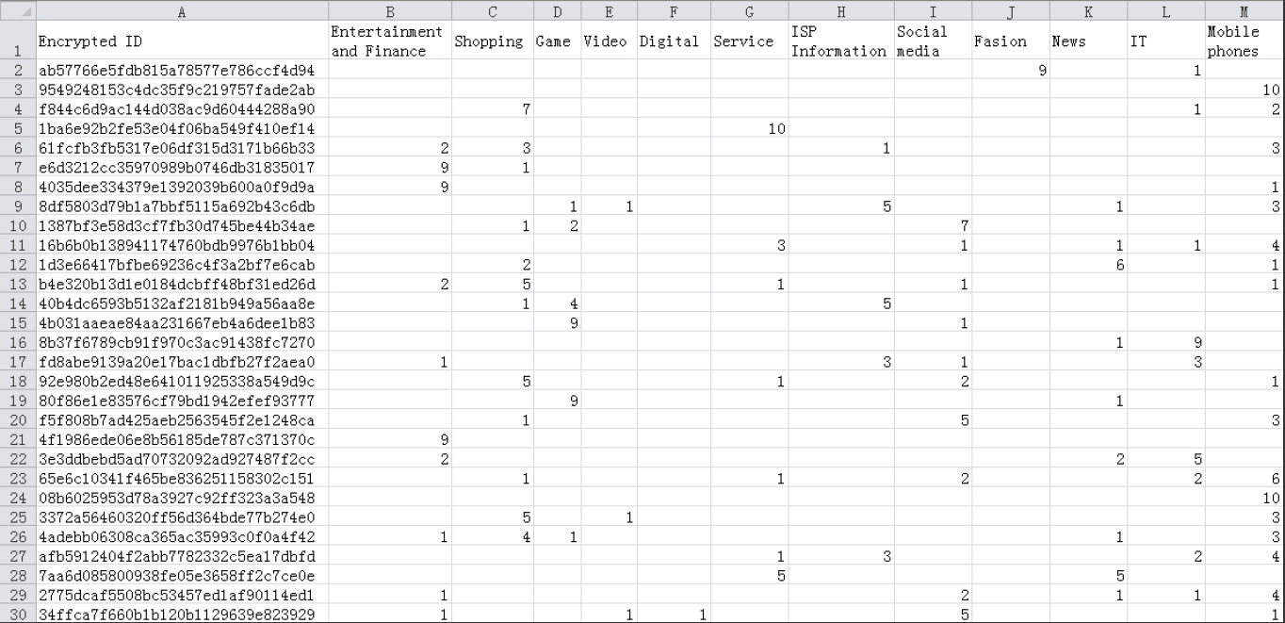
Figure10 30 user data from a Chinese ISP

6.2 Recommendation performance
We now evaluate recommendation performance using the anonymous data from a Chinese ISP. The data record 20000 users about their browsing histories for 3 months (October 2013 to December 2013). The users are told that their information would be recorded. Then the browsing behavior is classified into 12 catalogs. We then compute the ratio of the browsing histories and marked 1 to 10 of each catalogs to indicate the interest of the user. This data is used in the system as properties of the user. A data example of 30 users is shown in Picture 10.
Since the data is only the browning behavior. The friend relationship is not established. According to the Pew Research on Teens, Social Media, and Privacy [25] teen Facebook users have an average (mean number) of 425.4 friends. We assume that every person have about 500 friends and apply k-mean to form the possible friend relationship of the users from the browsing data we get from a Chinese ISP. Let 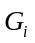 denotes the set of possible friends for each user.
Then we apply our recommendation scheme to the ISP data of the user browsing behavior. We then randomly select user to query the system and obtain its friend recommendation results. Let 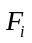 denotes the set of recommended friends. The following measurement metrics are used for performance evaluation.
Recommendation precision: the average of the ratio of the number of recommended friends in the set of possible friends of the query user over the total number of recommended friends.
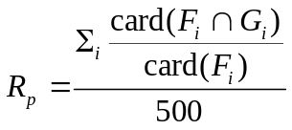
Where 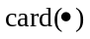 denotes the number of elements in a set. The dominator is 500 because 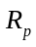 is the average of 500 users in one experiment.
Recommendation recall: the average ratio of the number of recommended friends in the set of possible friends of the query user over the number of the set of possible friends of the query user.

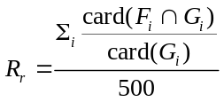
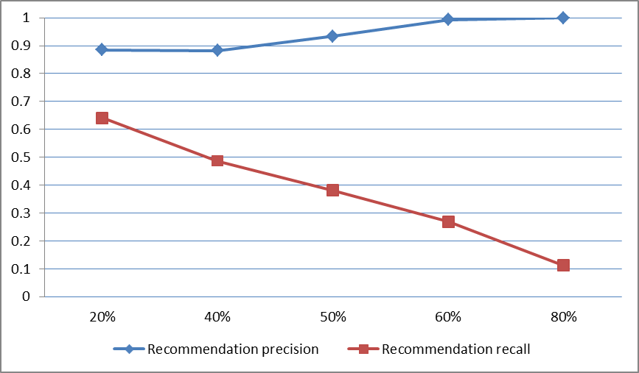
Figure 11 the recommendation precision and recommendation recall of 500 users. The X-coordinate indicates the threshold of matching.
Using different thresholds, we calculated the average recommendation precision and recommendation recall of the random selected 500 users. Picture11 presents the result.
With a higher threshold, the recommendation recall is comparatively low. Since the friends sharing much more same interests are not easy to find. However, the precision is increasing alongside with the threshold. The more browsing behavior similarities are, the more precise the recommendation result will be.
The experiment shows that our system can achieve relatively high recommendation precision and recommendation recall, the recommendation system receives a remarkable recommendation satisfaction.
7. Conclusion
While enjoying the benefits brought by friend recommendation system on mobile social network, users and researchers begin to notice the personal privacy protection in the social networks. In centralized management architectures, all security is ensured by the central server, but in distributed or hybrid architectures, users can directly exchange information with little or even without the involvement of server. The security of network has to be guaranteed by other protocols. In this paper, we presented a secure friend recommendation system PRUB based on user behavior which deploys hybrid management architecture, as a way of reducing the pressure on servers. PRUB can achieve fine grained recommendation to friends who share the same characteristics without exposing the actual user behavior. In PRUB, the modified matching and authorization protocol can provide guarantee of privacy security. PRUB first uses KNN classification algorithm to do coarse friend recommendation and then uses matching protocol to realize find-grained recommendation. To evaluate the security and performance of PRUB, we theoretically prove that our protocol can defend against attack in the aspect of initiator and matching target respectively, and we utilize the anonymous data for a realistic deployment. The experiment result shows that PRUB not only realize the fine grained friend recommendation, but also protect the privacy information of users.
Acknowledgements
This work is supported by Fundamental Research Funds for the Central Universities (No. ZYGX2014J051，ZYGX2014J066),Science and Postdoctoral fund in China（2015M572464）and Technology projects in Sichuan Province (2015JY0178) and The Project-sponsored by OATF, UESTC.
References
1 H. Shen, Z. Li, G. Liu, and J. Li, Sos: A distributed mobile Q&A system based on social networks, 2014.
2 J. Liu, P. Dolan, and E. R. Pedersen, Personalized news recommendation based on click behavior, in Proceedings of the 15th international conference on Intelligent user interfaces. ACM, 2010, pp. 31-40.
3 A. C. Squicciarini, F. Paci, and S. Sundareswaran, Prima: a comprehensive approach to privacy protection in social
network sites, annals of telecommunications-annales des telecommunications, vol. 69, no. 1-2, pp. 21-36, 2014.
4 T. R. Hoens, M. Blanton, A. Steele, and N. V. Chawla, Reliable medical recommendation systems with patient privacy,ACM Transactions on Intelligent Systems and Technology (TIST), vol. 4, no. 4, p. 67, 2013.
5 L. Fang, H. Kim, K. LeFevre, and A. Tami, A privacy recommendation wizard for users of social networking sites, in Proceedings of the 17th ACM conference on Computer and communications security. ACM, 2010, pp. 630-632.
6 M. Moricz, Y. Dosbayev, and M. Berlyant, Pymk: friend recommendation at myspace, in Proceedings of the 2010 ACM SIGMOD International Conference on Management of data. ACM, 2010, pp. 999-1002.
7 B. K. Samanthula and W. Jiang, Structural and message based private friend recommendation, in Proceedings of the 2012 International Conference on Advances in Social Networks Analysis and Mining (ASONAM 2012). IEEE Computer Society, 2012, pp. 684-690.
8 L. M. Aiello and G. Ruﬀo, Lotusnet: tunable privacy for distributed online social network services, Computer Com-munications, vol. 35, no. 1, pp. 75-88, 2012.
9 M. Li, S. Yu, N. Cao, and W. Lou, Privacy-preserving distributed profile matching in proximity-based mobile social networks, Wireless Communications, IEEE Transactions on, vol. 12, no. 5, pp. 2024-2033, 2013.
10 M. Li, N. Cao, S. Yu, and W. Lou, Findu: Privacy-preserving personal profile matching in mobile social networks, in INFOCOM, 2011 Proceedings IEEE. IEEE, 2011, pp. 2435-2443.
11 S. Alsaleh, R. Nayak, Y. Xu, and L. Chen, Improving matching process in social network using implicit and explicit user information, in Web Technologies and Applications. Springer, 2011, pp. 313-320.
12 R. Zhang, Y. Zhang, J. Sun, and G. Yan, Fine-grained private matching for proximity-based mobile social networking, in INFOCOM, 2012 Proceedings IEEE. IEEE, 2012, pp. 1969-1977.
13 M. J. Freedman, K. Nissim, and B. Pinkas, Eﬃcient private matching and set intersection, in Advances in Cryptology-EUROCRYPT 2004. Springer Berlin Heidelberg, 2004, pp. 1-19.
14 R. Agrawal, A. Evfimievski, and R. Srikant, Information sharing across private databases, in Proceedings of the 2003 ACM SIGMOD international conference on Management of data. ACM, 2003, pp. 86-97.
15 M. Von Arb, M. Bader, M. Kuhn, and R. Wattenhofer, Veneta: Serverless friend-of-friend detection in mobile social networking, in Networking and Communications, 2008. WIMOB08. IEEE International Conference on Wireless and Mobile Computing,. IEEE, 2008, pp. 184- 189.
16 Q. Xie and U. Hengartner, Privacy-preserving matchmaking for mobile social networking secure against malicious users, in Privacy, Security and Trust (PST), 2011 Ninth Annual International Conference on. IEEE, 2011, pp. 252-259.
17 L. Shundong, W. Daoshun, D. Yiqi, and L. Ping, Symmetric cryptographic solution to yaos millionaires problem and an evaluation of secure multiparty computations, Information Sciences, vol. 178, no. 1, pp. 244-255, 2008.
18 L. Kissner and D. Song, Privacy-preserving set operations, in Advances in CryptologyCCRYPTO 2005. Springer, 2005,pp. 241-257.
19 D. Dachman-Soled, T. Malkin, M. Raykova, and M. Yung, Eﬃcient robust private set intersection, International Journal of Applied Cryptography, vol. 2, no. 4, pp. 289-303, 2012.
20 R. Lu, X. Lin, X. Liang, and X. S. Shen, Secure handshake with symptoms-matching: The essential to the success of mhealthcare social network, in Proceedings of the Fifth International Conference on Body Area Networks. ACM,2010, pp. 8-15.
21 C. Hazay and Y. Lindell, Eﬃcient protocols for set intersection and pattern matching with security against malicious and covert adversaries, in Theory of Cryptography. Springer, 2008, pp. 155-175.
22 Z. Yang, B. Zhang, J. Dai, A. C. Champion, D. Xuan, and D. Li, E-smalltalker: A distributed mobile system for social networking in physical proximity, in Distributed Computing Systems (ICDCS), 2010 IEEE 30th International Conference on. IEEE, 2010, pp. 468-477.
23 D. Dolev and A. C. Yao, On the security of public key protocols, Information Theory, IEEE Transactions on, vol. 29,no. 2, pp. 198-208, 1983.
24 D. Boneh, The decision diﬃe-hellman problem, in Algorithmic number theory. Springer, 1998, pp. 48-63.
25 M. Madden, A. Lenhart, S. Cortesi, U. Gasser, M. Duggan, A. Smith, and M. Beaton, Teens, social media, and privacy, part 2: Information sharing, friending, and privacy settings on social media,http://www.pewinternet.org/2013/05/21/part-2-informationsharing-friending-and-privacy-settings-on-social-media/,2013.

