Loss of flagellar regulator FlhC changes the transcriptional response of plant-associated Acidovorax delafieldii strains to extracts from Rhizophagus irregularis-colonized Lotus japonicus roots

Roberto Siani ^{1-2*}, Yang Si ³⁻⁴, Stephanie Katherine Thaqi ¹⁻², Georg Stabl ³⁻⁴, Caroline Gutjahr ³⁻⁴, Michael Schloter ¹⁻²

1. Research Unit for Comparative Microbiome Analysis, Helmholtz Munich, Germany
2. Chair of Environmental Microbiology, TUM School of Life Sciences, Technical University Munich, Germany
3. Plant Genetics, TUM School of Life Sciences, Technical University Munich, Germany
4. Department of Root Biology and Symbiosis, Max Planck Institute of Molecular Plant Physiology, Potsdam-Golm, Germany
* Corresponding author: roberto.siani@helmholtz-munich.de

Abstract
Plants harbour diverse bacteria, with effects ranging from harmful to beneficial. Flagella aid bacterial colonization of plant tissues, but their filament protein can trigger plant immune responses. Due to selective pressure, adaptations emerge that allow some flagellated bacteria to evade detection, while others lose the capacity to synthesize the flagella altogether. Here, we investigated the role of FlhC, a regulator needed to initiate flagellar assembly, in mediating the global transcriptional response to plant metabolites. We studied two closely related Acidovorax delafieldii strains, originally isolated from Lotus japonicus roots and differing by the presence of flhC and 4 hypothetical coding sequences. In planta bioassays showed that flhC+ strains are less able to colonize L. japonicus roots, and are associated with a reduction in root length. To examine the phenotypic difference between the two strains in interaction with the plant in a reductionist system, we analysed their transcriptional response to extracts of L. japonicus roots and roots colonized by the arbuscular mycorrhiza fungus Rhizophagus irregularis. Our results showed significant transcriptional differences between flhC+ and flhC- strains, as well as in their response to R. irregularis. To understand whether changes can be attributed to the presence of flhC, we generated a deletion mutant (flhC-) from the flhC+ strain, as well as a complemented line (flhC+). We corroborated the changes in the expression of genes linked to plant-microbe interaction (notably, response to abiotic stress, quorum sensing and biofilm formation, plant-derived substrate usage), highlighting the role of flhC in organizing the response to environmental signals. Higher modularity and lower efficiency of the transcriptional networks of flhC- strains suggest that the loss of this regulatory element might also enhance bacterial adaptability. Our findings illuminate how small evolutionary changes of plant-associated bacteria affect the intricate regulatory mechanisms underlying plant-microbiome interactions.

Introduction
Associated bacteria can exert a great influence on their host plants, as is the case for phytopathogenic bacteria. Other bacteria are, instead, remarkably beneficial for plants, by helping them to tolerate abiotic stresses¹, as well as offering protection from pathogens and pests². The majority of plant-associated bacteria, however, lies somewhere in between those extremes. Plants are thought to selectively recruit³ and assemble their microbiome⁴. As part of these processes, the immune system of the plant recognizes certain molecular patterns, associated with microbes (MAMPs), to discriminate between beneficial and potentially deleterious ones.
The genus Acidovorax exemplifies the diversity of plant-associated phenotypes, including notorious pathogens, such as A. avenae and A. citrulli, as well as commensal and beneficial strains, e.g. A. delafieldii and A. radicis. Whilst several virulence traits of phytopathogenic Acidovorax have been identified⁵, flagella can be found on beneficial and commensal species alike.
The bacterial flagella, and in particular the flagellin protein, is an extremely immunogenic MAMP⁶. Thus, pathogenic bacteria that heavily rely on the flagella for infection engage in the arms race to preserve the trait⁷. Other plant-associated bacteria, that benefit less from motility, might eventually lose the flagella altogether. Flagellar assembly is orchestrated by genes organized in hierarchical classes, with regulators at each level initiating the transcription of genes from the following class. In most members of the phylum Pseudomonadota, the class I genes consists of the master regulators flhC and flhD. The product of these genes, the hetero-hexamer FlhD₂C₂ (for simplicity, hereafter FlhDC), binds to the promoters of class II genes to initiate the assembly⁸. Thus, the most parsimonious adaptation to modulate assembly are mutations at flhDC⁹. Given the advantage of co-regulating motility with a variety of other processes, it is not a surprise that in many species FlhDC has been implicated in the regulation of traits such as virulence, metabolism and growth¹⁰,¹¹. Assuming evolutionary incentives to the loss of flhDC, how and to what extent is the plant-associated bacterial phenotype reshaped by this adaptation? We envisioned that loss of the master regulators could affect the broader phenotype, due to direct regulatory changes as well as indirect effects on allocation of resources¹².
To investigate the phenotypic impact of the impairment of FlhDC, we studied two clonal A. delafieldii strains. These strains, LR124 and LR140, belong to a collection originally isolated from healthy Lotus japonicus ecotype Gifu plants¹³, and are distinguished by the absence from LR124 of flhC. L. japonicus is a model legume frequently used as a platform to study plant-microbe interactions, due to the ability to form symbiosis with both arbuscular mycorrhizal fungi (AMF), such as Rhizophagus irregularis, and nitrogen-fixing bacteria. Thus, endophytic bacteria associated with L. japonicus are exposed to complex molecular patterns generated by co-occurring symbioses. We explored whether flhC loss would alter perception and response to these environmental signals as well.
We studied the transcriptional response of flhC+ and flhC- A. delafieldii, together with a newly generated mutants pair, to root metabolites from axenic and R. irregularis-colonized L. japonicus. By analysing the differential response to the root extracts, we were able to identify the role of flhC in perception of and response to L. japonicus and the molecular patterns generated by R. irregularis infection. In particular, we focused on changes in expression of pathways considered important to plant-microbiome interactions and plant-growth promotion. Furthermore, we analysed the transcriptional network, expecting to see extensive structural changes as a result of direct and indirect effects of the absence of flhC. Deregulation has been found to pre-date specialization and other extreme lifestyle transitions^{14,15,16}. Therefore, loss of regulatory elements could have the beneficial secondary effect of promoting the evolvability of the bacteria during adaptation.

Results

flhC negatively impact root length and bacterial colonization
Our choice of Acidovorax delafieldii LR140 (flhC+) as a model was motived by a previous study⁵, where the strain was found to negatively impact growth of Lotus japonicus upon inoculation. The closely related A. delafieldii LR124 (flhC-) had exerted a positive effect instead. Members of the genus Acidovorax are regularly found as member of plants’ microbiome, and both strains were originally isolated from healthy L. japonicus plants¹³.
First, we established an in-frame deletion (LR140^{ΔflhC}) and reconstitute (LR140ΔflhC;flhC) LR140 mutants. We confirmed that both L124 and LR140^{ΔflhC} were non-motile in soft agar (Fig. 1a and b).
Additionally, we investigated the effects of the strain on the host-of-isolation, L. japonicus root and shoot length, as well as evaluating their capacity to colonize their plant. To do so, we inoculated L. japonicus plantlets with each of the strain separately and placed them in sterile plates. After 2 weeks of growth, we measured root and shoot length and counted colony forming units (CFU) from each plate after serial dilution of, weight adjusted, crushed roots.
Overall, LR124 and LR140ΔflhC were better root colonizers, as shown by the number of recovered CFU (Fig. 1c), with LR140 performing the worst. We modelled the effects of the inoculation on root and shoot length. Beside being less able to colonize the plant, LR140 and LR140ΔflhC;flhC had detrimental effect on the length of the roots (p = 0.004 and p = 0.0001). LR124 and LR140ΔflhC had only minor effects on plant growth parameters, when compared to the control. However, LR140ΔflhC inoculation resulted in significantly longer shoots (p = 0.03) than control plants.
Taken together, we have shown that all A. delafieldii strains are able to colonize L. japonicus roots, irrespective of flhC status. However, the level of colonization is lower for flhC+ strains, and their presence negatively affect the length of the roots, possibly as a result of the stimulation of the immune response.
Interestingly, flhC- strains exhibited higher variability both in terms of number of CFU recovered and effects on the plant. We postulate this to be linked to the absence of flhC, as the removal of a regulatory element could influence the stability of the phenotype.
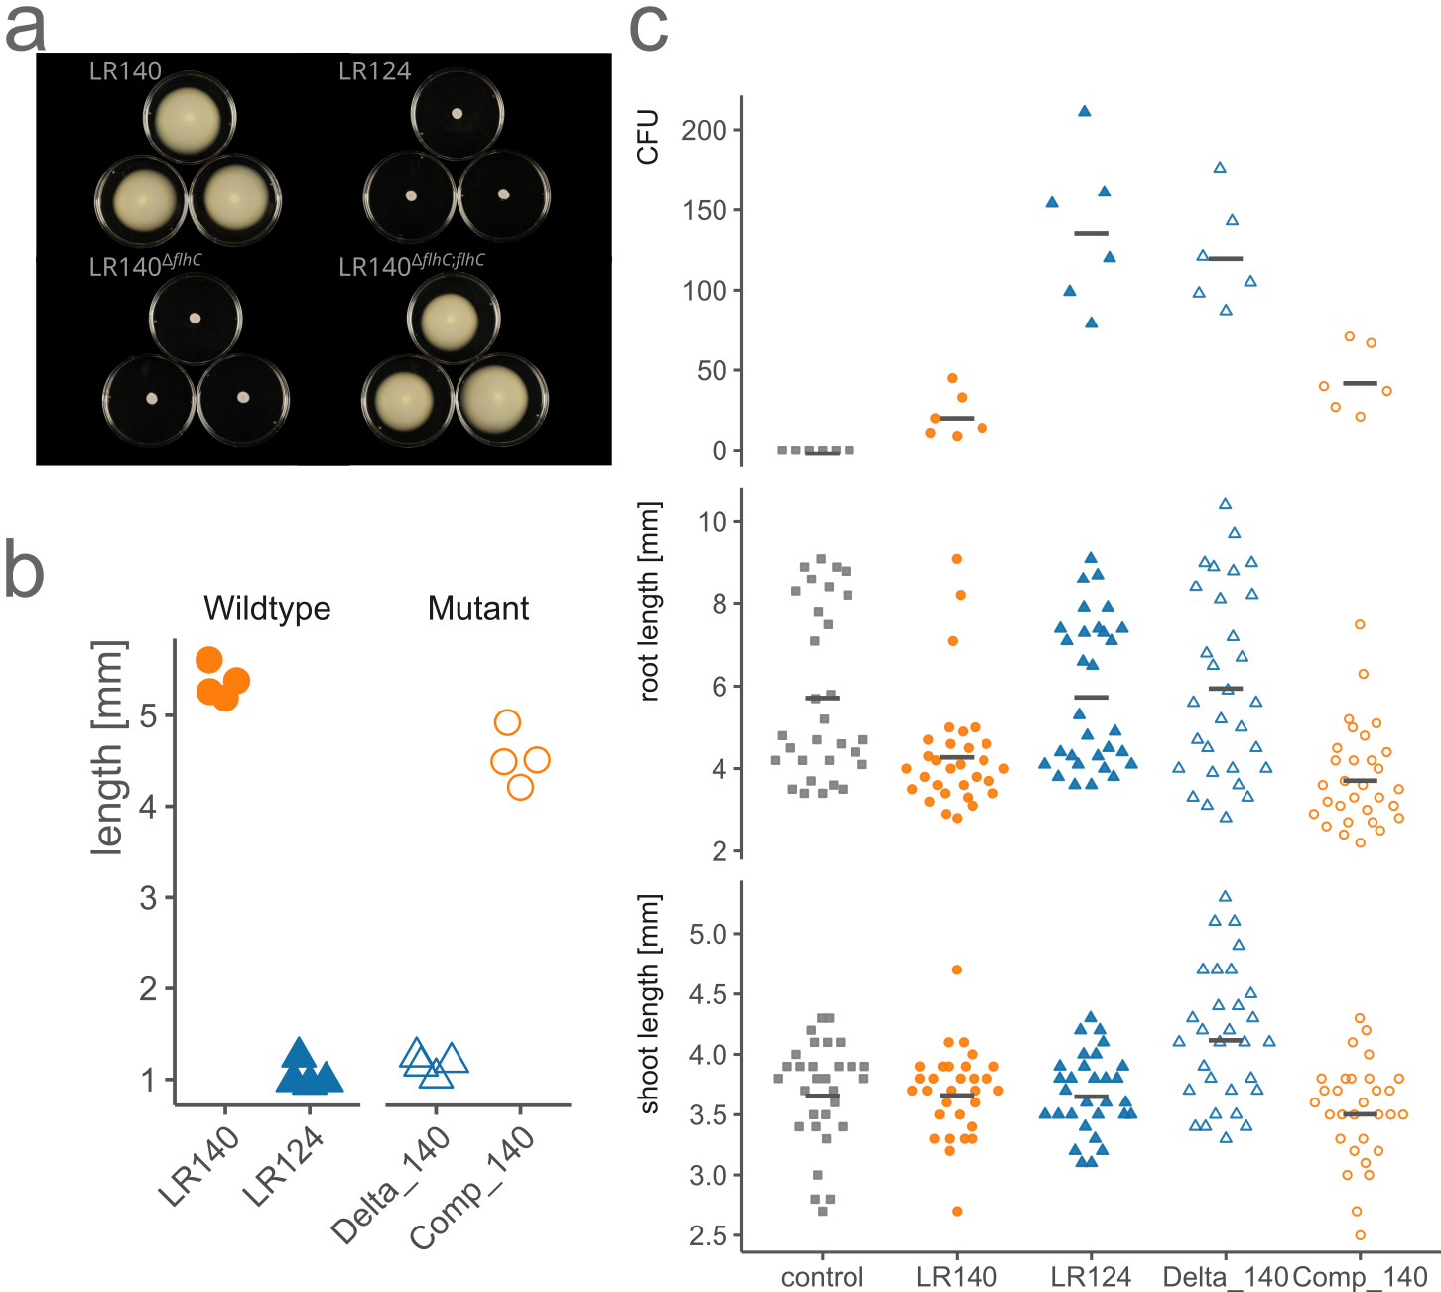Figure 1

Flagellar status produces distinct transcriptional response
To better understand the differences in growth observed in the inoculated L. japonicus, we studied the transcriptome of the strains. We designed an in vitro experiment to quantify the effects of flhC loss on traits important for microbe-host and microbe-microbe interactions (Fig. 1a). Additionally, we were interested in understanding how these effects would be modulated by the presence of a third interaction partner, R. irregularis. We expected the response to the plant metabolites, and to the AMF-altered metabolome¹⁷, to be different due to the regulatory role of flhC. We prepared two different root extracts, either from uncolonized L. japonicus (Lj media) or L. japonicus colonized by R. irregularis (Lj+Ri media). After 24 hours of growing in minimal media supplemented with these extracts, we sequenced the strains’ transcriptome.
We used singular value decompositions (SVD) to embed the samples transcriptional profiles in a low dimensional space and permutational multivariate analysis of variance (PERMANOVA) to assess the size and significance of between and within group variation. Firstly, the analysis was performed on the wildtype strains only (Fig. 2b). The SVD separate LR124 and LR140 samples on the first dimension, incorporating 13% of the total variance (PERMANOVA R2 = 0.125). We also observed a less distinct separation due to the media type (R2 = 0.094). When incorporating also the mutant strains in the decomposition, we detected 4 distinct clusters (Fig. 2c), with significant differences due to media type represented on the first dimension (12% of total variance, R2 = 0.076), and due to flhC presence on the second dimension (7% of total variance, R2 = 0.69). The mutants LR140^{ΔflhC} and LR140^{ΔflhC;flhC} clusters are also separated from their wildtype counterparts (R2 = 0.095), likely due to residual differences in the genotype. Interestingly, both LR124 and LR140^{ΔflhC} had higher expression levels of flhD compared to the flhC+ strains (Fig. 2d). LR140^{ΔflhC;flhC} had higher expression levels of both flhC and flhD compared to the wildtype LR140. The differences between these last two were most pronounced in the Lj+Ri media, where a clear separation is visible. However, the size of this difference might be confounded by other factors, such as biases in sequencing intensity among samples, which is also captured in the ordination.
Taken together, we have shown that deletion of flhC in LR140 reproduces the transcriptional patterns of LR124. By reintroducing flhC in LR140^{ΔflhC}, we reconstituted the paternal transcriptional patterns. Furthermore, the differences we observed between media types (Lj vs Lj+Ri) in both flhC+ and flhC- strains indicates that the changes induced by mycorrhization in L. japonicus metabolome are sufficient to evoke a response in A. delafieldii. In flhC- strains, flhD expression levels did not change with media type. However, in both flhC+ strains, expression of flhDC was, on average higher in the Lj+Ri media, suggesting that flhC, and not flhD, could play a role in regulating the response to environmental changes.
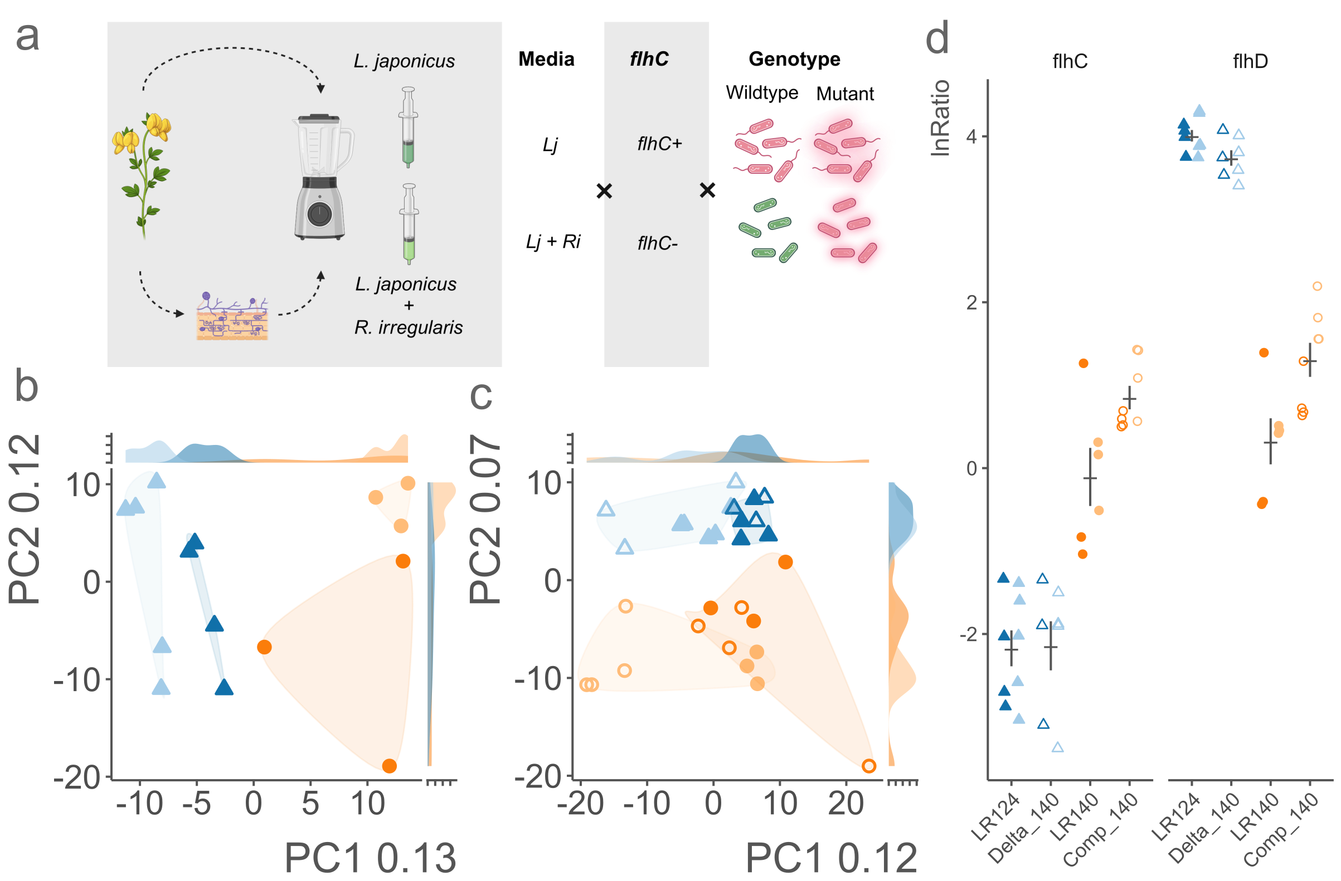Figure 2
Loss of flhC leads to smaller, less connected and inefficient regulatory networks
We have shown that the transcriptional profiles of flhC+ and flhC- strains are consistently distinct (Fig. 2b and 2c), which suggest underlying differences in their regulatory networks. Could alterations within the local flagellar assembly regulatory network have propagated to create a broad disruption of the global network? Whilst many regulatory pathways would be directly altered by the absence of FlhDC, we expected others to be indirectly affected, by changes in transcriptional and metabolic stoichiometry¹⁸.
As a test, we compared gene-association networks of flhC+ and flhC- strains. We included in the analysis the most consistently detected genes (1065 for flhC+ and 1068 for flhC- strains) and considered only correlations above .75 (absolute) as evidence of an association. Then, we compared graph properties of the recovered networks (Fig. 3).
Our approach recovered strong associations across a large share of the tested genes, 841 for the flhC+ strains and 819 for the flhC-. However, we observed that genes in the flhC- network had, on average, less than half of the connections than those in the flhC+ network (degree). This contributed to differences in the total number of genes (order) and connections (size) in the network. Additionally, flhC- network displayed higher modularity, with more granular clustering than in the flhC+ network, and lower efficiency in information exchange. Pathway and genes that are either co-regulated or present a degree of coordination under flhC+ appear to be more loosely connected in flhC-. The disruption of the transcriptional network explains how the broader phenotype is affected by flhC absence.
To study whether these differences could potentially impact the strains' behaviour in the plant microbiome, we consulted PLABase, a curated ontology of genes related to plant growth promotion. PLABase is organized in 6 hierarchical levels (PGP1 to PGP6) and covers direct bacterial effects on the plant as well as indirect effects, that is, traits that can influence bacterial fitness or interactions in the plant microbiome. Here, we refer to these terms collectively as plant microbiome related traits (PMRs).
In the flhC+ network, flhDC belong to a cluster of 121 genes. We conducted a term over-representation test at level 2 to 4 of the PLABase ontology¹⁹. The flhDC cluster was enriched in terms related to flagellum control (flhDC, flgM, fliST), temperature tolerance and stress signaling (clpSP, groESL, grpE, htpGX, hslU, ctpA, hslU, uvrB and gene coding for a periplasmic serine endoprotease DegP-like protein, a thiol:disulfide interchange protein and an aldeide dehydrogenase), metabolism of plant derived lipid and volatile (pcaF and genes coding for Acetyl-CoA acetyltransferase, Acyl-Coa binding protein, Acyl-CoA dehydrogenase), bacterial antitoxin system (ftsZ, smbP, and a putative small secreted protein). Beside flhD, we observed a strong association between flhC and 7 genes: clsP (ATP-dependent Clp protease adapter), groES (co-chaperonin), groL (chaperonine), narJ (nitrate reductase), smpB (Ssr-A-binding protein), sodA (superoxide dismutase) and a gene coding for a dioxygenase superfamily protein. In conjunction with flhD, other strongly associated genes included dnaK (molecular chaperon DnaK), narZ (subunit alpha a nitrate reductase), and genes coding for 3-hydroxyacyl-CoA dehydrogenase, the endopeptidase La and a nitrate/nitrite transporter. These findings corroborate a link between flagellar motility and nitrogen utilization, which has been proposed in the plant-pathogen Acidovorax citrulli²⁰.
Taken together, we conclude that extensive changes can stem from the loss of a single regulatory element. Given the close relatedness of LR124 and LR140, we assume that loss of flhC must have been a recent event. It would be interesting to observe to what extent the disrupted network would adapt over time, and if some of the unregulated elements would be eventually brought back in, through novel adaptations, as was observed in other studies²¹.
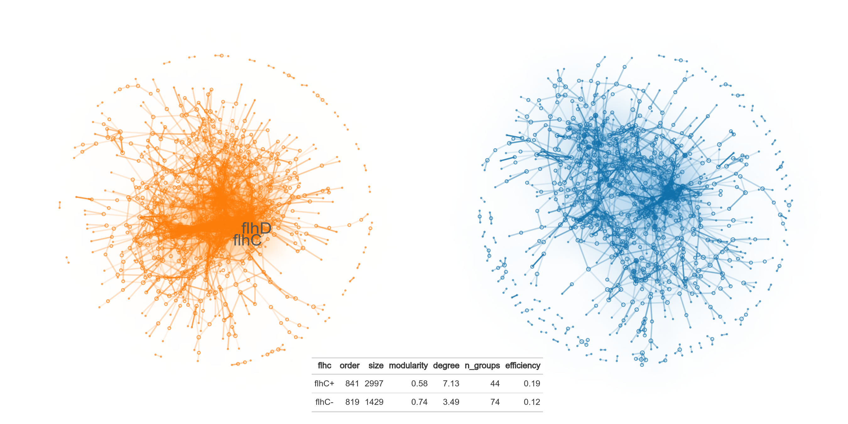Figure 3

Absence of flhC is associated with expression of stress related genes
To look in more detail at which processes and pathway were directly or indirectly under FlhC regulation, we compared differences between flhC+ and flhC- strains at the gene and pathway level. Here, we refer to the global effects of flhC absence as effects on expression, the global effects of media as response, and the interaction between response and flhC absence as effects on regulation (Fig. 4a). The PLABase ontology was again used to understand the potential role significant differences could have in reshaping the bacterial behaviour in the plant microbiome.
About 7% (124 of 1605) of the genes were significantly differentially expressed (q < 0.05), across both media types, by the flhC- cohort compared to the flhC+ (Fig. 4b, Supplementary Table 1). Compared to flhC+, flhC- showed relatively lower expression levels of competitive exclusion and colonization genes, with higher levels for genes involved in remediation, and fertilization (Fig. 4c, Supplementary Table 2).
Of the 124 differentially expressed genes, 29 were relatively more expressed by flhC- strains. These genes were putatively involved in plant-derived substrate usage and root colonization, resistance to abiotic stress and xenobiotics degradation, bacterial fitness, phosphate and potassium solubilization. Interestingly, 12 of these genes were upregulated by flhC+ strains in response to Lj+Ri metabolites, whilst 11 were exclusively associated with the absence of flhC (cysD, ftsA, gspE, hisD, ilvE, nadE, nuoF, ugpA and genes coding for a putative permase, a GGDEF domain-containing protein and a protein of the acyltransferase family).
The remainder of the differentially expressed genes (95) were relatively more expressed by flhC+ strains. Beside genes participating in the flagellar assembly and chemotaxis, we observed higher expression of genes involved in plant-derived substrate usage, resistance to abiotic stress, biofilm formation and quorum sensing response, secretion and surface attachment, cell envelope remodelling. Also in these case, only a fraction of these genes (29) was uniquely associated with higher expression in flhC+, including ftsQ. FlhD has been previously shown to modulate cell division rates, with FlhD mutants showing higher division rates and smaller cell size²². Furthermore, in Escherichia coli and other species, both cell division and motility are known to be inversely regulated by quorum sensing²³. Our results confirm that co-regulation of these processes must exist also in Acidovorax, even though it remains to be clarified why the expression of ftsQ and ftsA appear to be anti-proportional.
To further characterize the effects of flhC absence on the plant-microbiome interaction phenotype, we modelled the collective behaviour of genes involved in PMR pathways (PGP5, see Fig. 4d, Supplementary Table 3). Absence of flhC was associated with the expression of phosphate and potassium solubilization by succinic acid biosynthesis, iron transport and resistance, and transport of plant derived glycerol-3-phosphate. More pathways were repressed, including general secretion, c-di-GMP signalling, autoinducer perception, alanine and fumarate metabolism, hemophores production and vitamin B6 production, resistance to salinity, regulation of nitrogen acquisition and phosphate solubilization, as well as the carbohydrate starvation response.
Taken together, we have demonstrated the involvement of flhDC in a variety of processes which could potentially results in very different interaction at the plant-microbiome intersection. However, given the elevated expression levels of flhD observed in flhC- strains, it is difficult to ascertain whether all effects are due to the absence of FlhC or the accumulation of free FlhD.
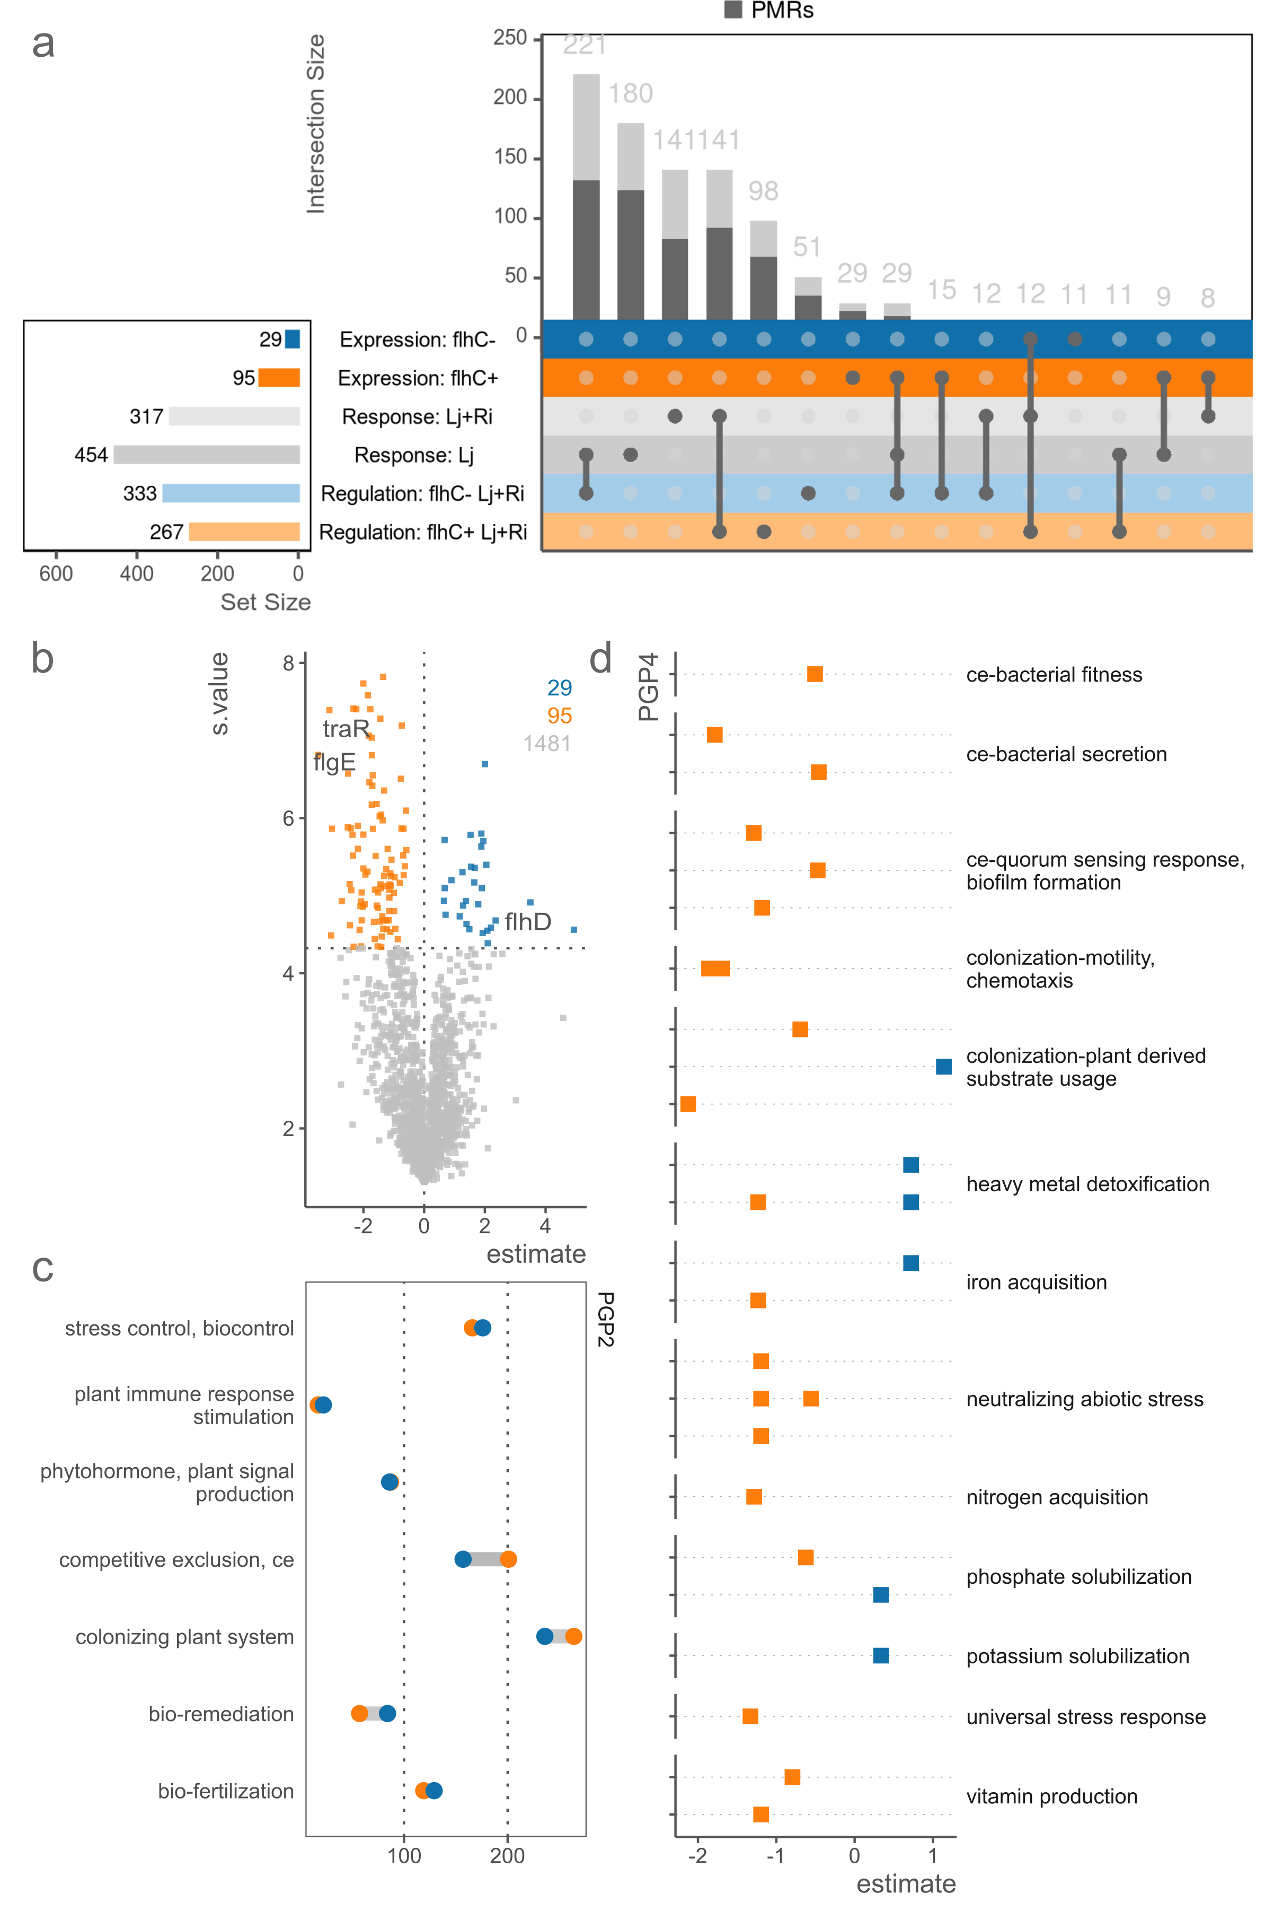Figure 4
Acidovorax adapts substrate preferences following R. irregularis-induced changes in the root metabolome
Our Lj+Ri media was prepared from roots colonized by R. irregularis. From this, we can assume that the final media mimicked the mycorrhizal metabolome, containing both plant and fungal metabolites. Given the extent to which plant expression is modulated by mycorrhization, L. japonicus metabolome is itself expected to change following colonization. Therefore, we looked at how Acidovorax species, irrespective of flhC presence, changed their own expression profiles when challenged with the Lj+Ri media. We have already shown how small, synergistic, effects on L. japonicus can occur with co-inoculation. Thus, we expected to see differences in the usage of PMR traits.
We found significant changes in the expression levels of around 48% of the genes (771 of 1601), of which 454 down-regulated and 317 up-regulated in the Lj+Ri media (Fig. 5a, Supplementary Table 1). Up-regulated genes belonged to the PMR broader categories (Fig. 5b, Supplementary Table 2) of stress control (resistance to abiotic stress), colonization (plant-derived substrate usage, motility and chemotaxis), competitive exclusion (quorum sensing response and biofilm formation) and fertilization (potassium and phosphate solubilization). At a higher resolution (Fig. 5c and Supplementary Table 3), we observed higher relative expression of ubiquinone/coenzime Q synthesis, sulfate and thisulfate transport, thioredoxins and proteases synthesis and a higher activation of the chemotaxis two component system, degradation of dimethyl sulfide, metabolism of malate and plant derived glicines, resistance to copper and beta-lactamases. Among the down-regulated processes, most were related to the metabolism of plant derived substrates and abiotic stress tolerance. Interestingly, Lj+Ri was also associated with lower expression of 7 pathways related to biofilm formation and auto-inducer perception and down-regulation of general secretion.
Overall, these extensive differences highlight the metabolic flexibility of Acidovorax and the complex interplay between co-occurring species in the microbiome. The root extracts can only provide a static picture of the root and mycorrhiza metabolome. However, we observed significant differences in Acidovorax transcriptional response, suggesting that the alterations to the metabolome are themselves significant, and that plant-associated microbes are finely attuned to respond to these changes.

Absence of flhC- modulates response to R. irregularis-induced metabolome
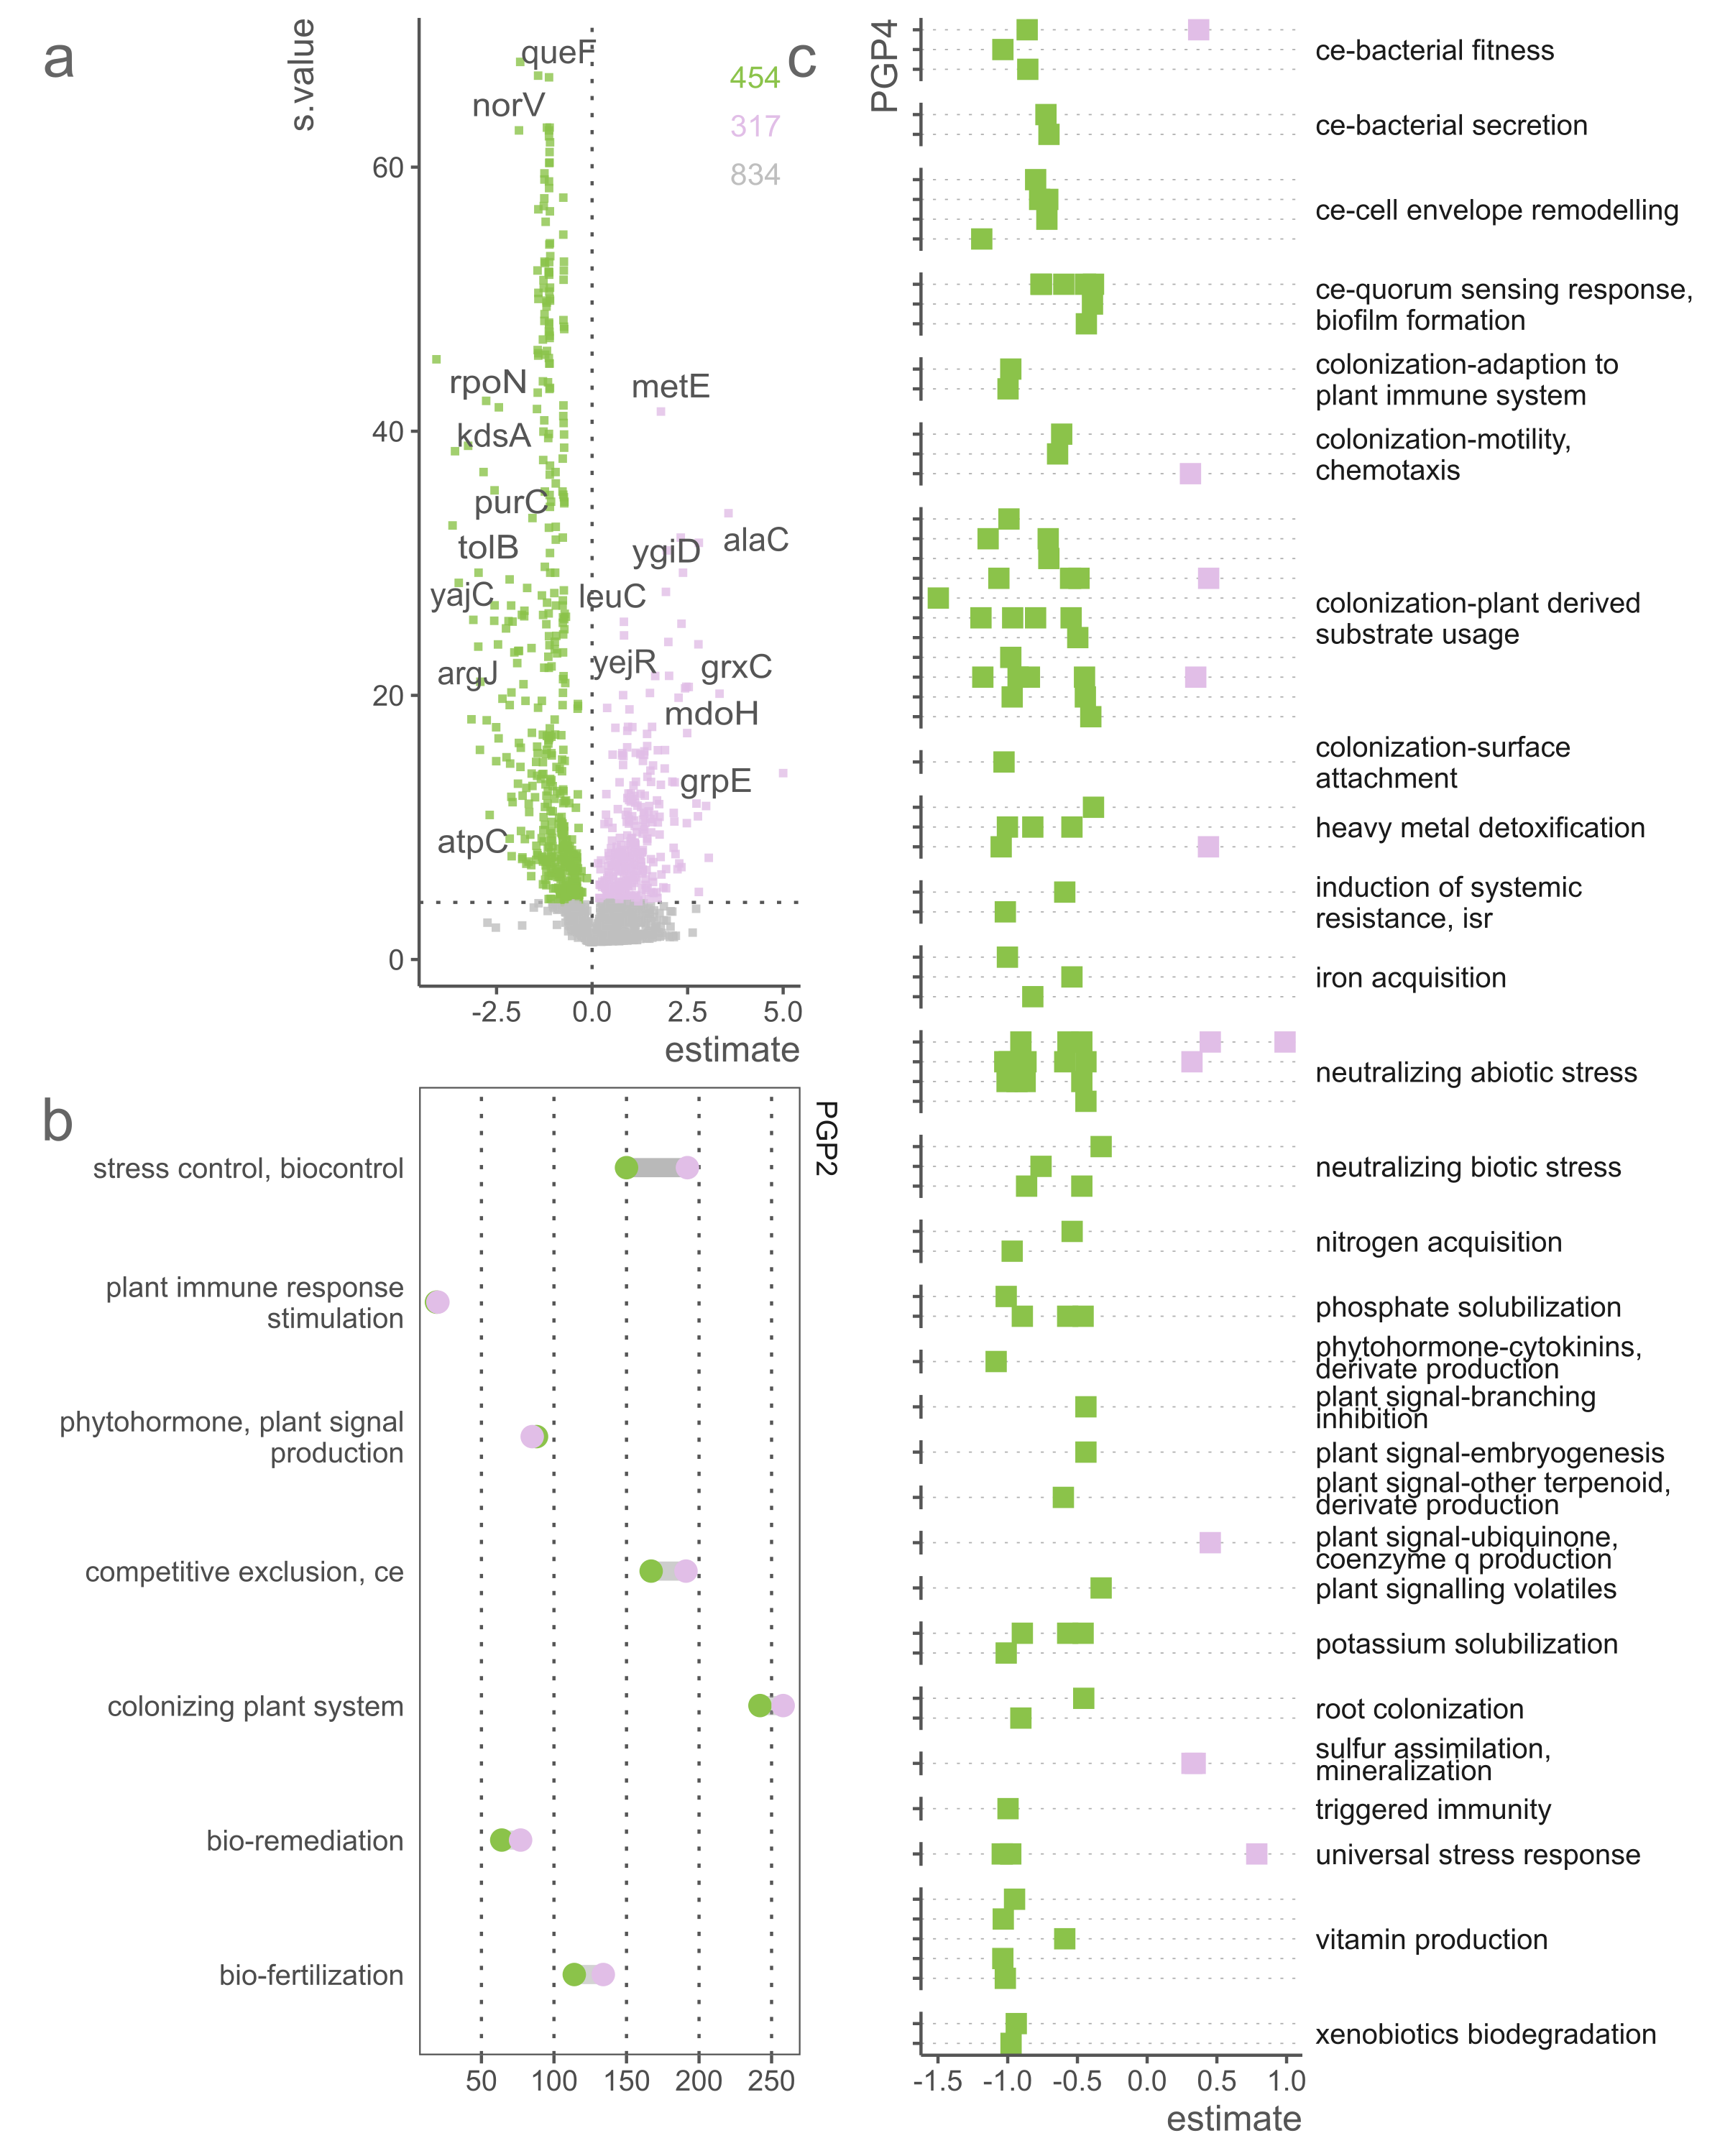Figure 5
Finally, we dissected how the absence of flhC- affects the response to R. irregularis induced changes in the root metabolome. We have already shown how the gene association network of flhC- strains appear more sparse and modular, which would translate in a less concerted response to environmental changes.
Here, we report significant regulatory differences in 37% (600 of 1605) of the genes, with up-regulation of 333 and down-regulation of 267 (Fig. 6a, Supplementary Table 2). The largest differences were found in the number of differentially regulated genes assigned to the stress control and colonization of plant systems categories (Fig. 6b, Supplementary Table 2). More in detail, we observed down-regulation of PMRs including dimethyl sulfide degradation, synthesis of succinic acid, metabolism of gylcine-betaine, resistance to salinity, oxidative and temperature stress and glycine degradation (Fig. 6c, Supplementary Table 3). Up-regulated PMRs also involved stress response processes, and utilization of plant derived substrates (formate, C4-dicarboxyrate, pyrimidine fumarate). Furthermore, biosynthesis of xanthine, cobalamin, niacin and rioflavin were also positively regulated, as well as synthesis of surface attachment proteins. Finally, we observed an up-regulation of the nuo (type I NADH-quinone oxidoreductase), ndh (NADH dehydrogenase and type II NADH-quinone oxidoreductase), cco (cytochrome-c oxidase) operons. In E. coli, FlhDC is known to repress aerobic respiration and positively regulate anaerobic respiration¹¹. Thus, absence of FlhDC in flhC- strains is associated with up-regulation of aerobic respiration under Lj+Ri conditions.
Taken together, we have shown that a large share of genes are differentially regulated across environmental changes due to the absence of flhC, affecting broader processes such as respiration and stress response. As previously, we can not exclude a possible relationship with increased levels of free FlhD rather than with the absence of FlhC or via indirect effects due to alteration to the global regulatory network.

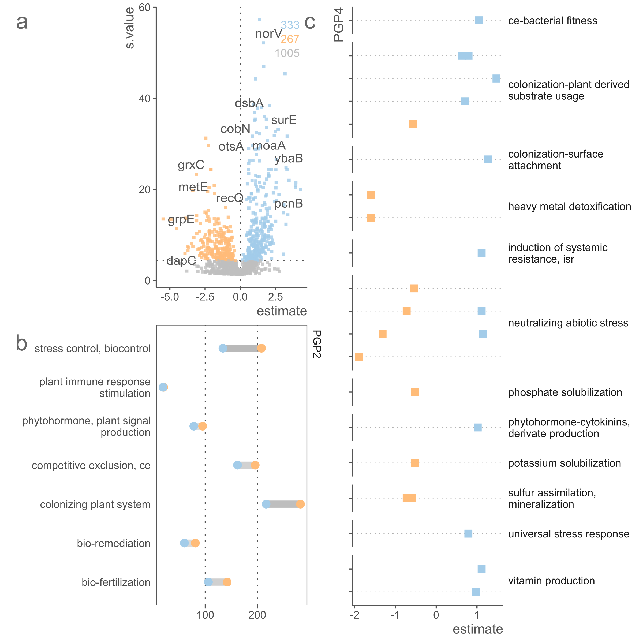Figure 6
Discussion
Plant associated bacteria interact with their host and co-occurring microbes in a complex system. We tested the relevance of one transcriptional regulator, FlhC, at the interface between strains of A. delafieldii, a common plant-associated bacteria, their host L. japonicus, and, indirectly, the AMF R. irregularis. The strain selected for this study, LR124 and LR140, share most of their genome, except for flhC and 4 other predicted coding sequences: lysR and 3 hypothetical protein of unknown function. Given that the additional lysR in LR124 is located among two predicted lysR (one a predicted pseudo-gene), which are found in LR140, we assumed the extra copy to be the result of a duplication event. We established a deletion and complementation mutant to robustly connect our observations with the absence/presence of flhC.
Firstly, we tested our strains' ability to colonize and interact with L. japonicus. Whilst LR124 and LR140 were originally isolated from healthy plants of the same species¹³, we wanted to ascertain the contribution of flhC to their fitness in planta. Based on the number of CFU recovered after 2 weeks from inoculation, we concluded that flhC negatively impact colonization. The flhC+ strains, LR140 and LR140^{ΔflhC;flhC} were both recovered in lower numbers and caused a reduction in the root length of the plants they colonized. As root length did not appear to be correlated with the number of CFU recovered (for all strains), we interpreted the effect to be dose independent. L. japonicus, like other plants, is able to recognize the main structural component of the flagella, the flagellin protein, and its epitope region flg22, via dedicated the dedicated receptor flagellin-sensing 2 (LjFls2), which is strongly expressed in the roots²⁴. Upon recognition, different mechanism of immune response are activated²⁵. Thus, we explain the reduction in root length and in flhC+ strains colonization ability as a consequence of L. japonicus immune response to the strains. The flhC- strains were, on the other hand, undeterred, and their colonization was associated with moderately longer roots, even though the effect was non-significant.
Next, we designed an in vitro experiment to understand Acidovorax response to Lotus roots molecular patterns in reductionist conditions. We exposed the strains to two different media, one obtained from axenic L. japonicus and one from L. japonicus colonized by R. irregularis, a common AMF symbiont. This treatment was designed to test Acidovorax response to a common co-occuring member of L. japonicus microbiome and to dissect the role of flhC in regulating the response.
We identified distinct transcriptional profiles of flhC+ and flhC- strains and in response to the Lj+Ri media. This distinction was visible for mutant and wildtype strains (see Fig. 1c), even though we observed residual differences within the pairs. In particular, LR140^{ΔflhC;flhC} showed relatively higher expression of flhDC compared to LR140. We also identified an approximately 2-fold higher expression of flhD in both flhC- strains, compared to flhC+. Several regulators of flhDC have been so far identified, integrating signals from temperature, osmolarity, nutritional state and catabolite repression, quorum sensing and more^{26–29}. In particular, negative feedback loops are essential to the tuning of FlhDC activity to meet motility demands³⁰. We postulated that in the absence of FlhDC downstream products, these negative feedback loops remain inactivated, leading to the increased expression of flhD, as well as likely accumulation of free FlhD in the intracellular milieu. Whilst FlhD has been thought to have regulatory activity of its own¹¹, possibly in combination with other protein (FlhC being the DNA-binding element of the complex), more recent studies have put the observation into question^{31,32}. In this regard, our study lacks the power to discern between the effects due to flhC deletion and possible effects due to flhD over-expression.
Having shown the global effects on transcriptional profiles, we hypothesised that the observed differences could be connected to changes in the underlying networks. Thus, we recovered transcriptional gene-association networks from flhC+ and flhC- strains. We did not discern between media type for this analysis, as we expected the proportionality between gene pairs to be respected across conditions. Surprisingly, our results showed extensive degeneration of the gene-association network in flhC- strains, with about half the number of association per gene with respect to gene in the flhC+ strains network. As a result, flhC- showed a lower information transfer efficiency and increased modularity. As previously noted, we refrain to interpret all changes in expression as directly produced by flhC. Rather, we explain most of the changes as a result of indirect interactions (e.g. several non-flagellar genes are indirectly regulated by FlhDC through FliA³²) and intracellular stoichiometry¹⁸. Furthermore, as shown by the increased number of recovered CFU in our in planta bioassays, we argue that higher modularity in the network could in fact benefit flhC- strains. Evolvability is constrained by pleiotropy³³, and modular organization is central to the adaptability of regulatory networks^{34,35}. In the flhC+ gene-association network, flhDC is embedded in a large cluster of genes involved in temperature tolerance, lipid and volatile metabolism, toxin-antitoxin system, stress signalling, nitrogen acquisition, regulation of biofilm formation, beside assembly and control of flagella. The equivalent genes in the flhC- network (except for those with no strong association recovered) are part of 25 different clusters.
Next, we investigated how the transcriptional differences caused by the absence of flhC could modulate plant-bacteria interactivity. Our results showed differential expression and regulation of a large share of genes involved in a variety of PMR pathways. Notably, we linked the absence of flhC- with repression of regulatory elements of the nitrogen cycle, carbohydrate starvation response, cyclic di-GMP (c-di-GMP) signalling and general secretion, and promotion of iron acquisition, potassium and phosphate solubilization by succinic acid biosynthesis, surface adehsion and vitamin biosynthesis. In particular, c-di-GMP is now recognized to play a crucial role in host-microbe interactions³⁶. Our results suggest a previously underestimated involvement of FlhDC in substrate preferences and stress response, in the context of plant-association.
Our experiment also allowed us to study the response of Acidovorax delafieldii to R. irregularis derived changes in the composition of the root metabolome. Even though we did not characterize the chemical composition of these complex media, the root metabolome is known to undergo an extensive transformation with AMF colonization³⁷. In response to Lj+Ri, we identified higher expression levels for beta-lactamase and oxidative stress resistance genes, two component systems related to chemotaxis, sulfur assimilation, glycin and malate metabolism. Furthermore, we observed a down-regulation of several pathways involved in stress response, solubilization and utilization of plant derived substrates, as well as a repression of the type II secretion system. These patterns of differential expression could indicate a higher availability of nutrient and minerals in the Lj+Ri media. Type II secretion systems (T2SS) are used by plant-associated bacteria to secrete hydrolytic enzymes³⁸. Recent studies have shown that the plant immune system ability to repress T2SS activity is crucial in preventing opportunistic infection and dysbiosis in the leaf microbiome^{39,40}. Further studies could disentangle whether the reduction in T2SS activity is explained by nutrient availability or AMF-derived signals plays a role in repressing T2SS activity in the root microbiome.
To conclude, our transcriptional analysis of Acidovorax strains confirmed the deep integration of FlhDC in the global regulatory network. Our results lead us to draw connections between flagellar regulation and multiple aspects of plant-microbe interactions, highlighting the complex interplay of the regulation of motility with bacterial stress response and substrate preferences. However, the relative contribution of FlhC, FlhD and indirect effects to our observations remains an open question. Finally, regulatory elements are pivotal to navigate novel environments but can hamper the capacity to adapt, when pleitropy prevents modules to evolve independently. Disruption of such networks can lead to progressive adaptation of the genome and reshape host-microbe interactions¹⁴,¹⁵,¹⁶.

Material and Methods

Strains selection and genome annotation
Two strains, denoted LR124 and LR140, belonging to the species Acidovorax delafieldii, were selected from a collection of 52 endophytic and commensal Acidovorax, isolated from healthy Lotus japonicus roots. The isolation and successive sequencing procedure is detailed elsewhere¹³. Characteristics of the collection are thoroughly discussed in an earlier study⁵. LR124 and LR140 share a similar genome size of 5.02 mb, with an average nucleotide identity of 99.968, as calculated by fastANI v1.3⁴¹. The genome assemblies are publicly available under the accession number PRJEB37696 at the European Nucleotide Archive. The genomes were re-annotated for this study using Bakta v1.8.1⁴², InterProScan v5.64-96⁴³ with Pfam 36.0⁴⁴ and PLaBAse v1.02⁴⁵ for plant microbiome related traits (PMRs). Reciprocal best-hits among the genomes were calculated using mmseqs2 easy-rbh v13.45111⁴⁶. Annotations and reciprocal best-hits equivalences are available in the Supplementary Data.

Construction of flhC in-frame deletion and complementation
Acidovorax LR140 was used as the parental strain for generating the in-frame deletion of flhC following a previously described method⁴⁷. Briefly, the flanking fragments of gene flhC were cloned into a suicide vector pK19mobsacB by Golden Gate cloning. The primers used to generate upstream and downstream regions are listed in ST2. The constructed plasmid pK19-Δ flhC was introduced into Escherichia coli ST18 to serve as the donor in the biparental conjugation, with strain Acidovorax LR140 as the recipient. For biparental conjugation, the donor and recipient cells were combined at 1:3 based on optical density values. The mixed cell solution was loaded on a 50% TSB plate. After incubation at 30 ℃ for 24 h, the conjugation colonies were selected on TSB plates supplemented with kanamycin. Double-crossover events were selected on 50% TSB-sucrose (10% sucrose) plates after the first “cross-in” homologous recombination. Positive colonies were selected and streaked on 50% TSB plates and 50% TSB plates containing kanamycin for 3 days. The colonies that only grew on 50% TSB plates were further confirmed by sequencing. For complementation analysis, the coding region of flhC and its promoter was amplified and cloned into the plasmid pUC57 by Golden Gate cloning using the primers listed in Table 2. The resulting recombination plasmid was conjugated into its corresponding deletion mutant strain by biparental conjugation.

Swimming motility assay
Acidovorax strains LR140, LR140^{ΔflhC}, LR140^{ΔflhC;flhC}, and LR124 were grown in Tryptic Soy Broth (TSB) medium, and their OD⁶⁰⁰ was adjusted to 2.0. Ten microliters of each bacterial suspension were placed in the centre of a soft TSB plate (0.3% agar) for 72 h at 21°C. The diameter of the colony on each plate was then measured.

In planta bioassays
L. japonicus seeds were manually scarified with sand paper and surface sterilized with 11% NaClO, then incubated for 2 hours in sterile water. Imbibed seeds were germinated on B5 medium (3.3 g/L Gamborg B5 Salt, 20 g/L Sucrose, 10 g/L Bacto Agar), at 24°C for 3 days in the dark. Acidovorax strains were grown in 50% TSB media at 21 °C overnight to exponential phase. Germinated L. japonicus seedlings were inoculated with bacterial suspension at a final OD⁶⁰⁰ of 0.01 for 1 h. Inoculated seedlings were transferred onto new square plates containing B5 medium. Plates were partially covered with black paper to keep the roots in the dark, and placed at 24°C with a 16 h light/8 h dark cycle for 2 weeks. After 2 weeks of growth, plants root and shoot length were measured. Results were analysed using linear mixed-effects models as implemented by the package nlme v3.1-164⁴⁸.

Quantification of bacteria
For colony-forming unit counting, roots were harvested, weighted and crushed in 1 mL sterile water. Serial dilution of crushed roots were prepared in sterile water. Then 100 µL of each sample were spread onto 50% TSB plates. Single colonies were counted after 3 days.

Cultivation of L. japonicus with R. irregularis
L. japonicus seeds were prepared by sandpaper scarification and surface sterilization using a 10% DanKlorix Original (CP GABA GmbH, Germany) and 0.1% Sodium Dodecyl sulfate solution. The seeds were germinated on 0.8% water-agar plate, kept for 3 days at 22C in the dark and then, 4 days at 22C in the light, with an intensity of 210 uM/m2s (growth cabinet PK520-LED; Polyklima GmbH, Germany). Plantlets were transferred to 7 x 7 x 8 cm Göttinger Pots (Hermann Meyer KG, Germany), filled with washed and autoclave sterilized quartz-sand (Casafino Quarzsand, fire-dried, 0,7 – 1,2 mm, BayWa AG, Germany) at a density of 5 plants per pot, with 5 pots per condition (n = 25). The pots were equipped with a bottom layer of synthetic cotton to prevent sand loss through the holes.
Half of the pots (15 pots) were inoculated with 500 spores of the arbuscular mychorrhizal fungus (AMF) Rhizophagus irregularis (R. irregularis spores C-grade, Agronutrition SAS, France). All plants were grown at 60% air-humidity and a light intensity of 150 um/m2s, using a 16 h light to 8 h dark photoperiod and a temperature cycle of 24/22C. Plants were watered 3 times a week, twice with sterile water and once with 1/2 Hoagland solution. Harvesting was conducted after 8 weeks. AMF root colonization rate, root and shoot length, fresh weight and dry weight after freeze drying were measured.

Spiked media preparation
Adapting from Nour and colleagues⁴⁹, a crude extract was prepared from control (Lj) and R. irregularis colonized L. japonicus (Lj+Ri). Ten grams of freeze-dried root biomass from colonized and control plants were separately homogenized with a tabletop blender in 300 ml of distilled water. Each homogenate was progressively filtered through miracloth (insert brand), watman (insert brand) and 22 um sterile syringe filter (insert brand) to remove plant debris and contamination. The filtered homogenate was diluted at 1:3 in M9 minimal media (Merck KGaA, Darmstadt, Germany), prepared according to supplier specification.

Cultivation conditions
Fresh colonies of LR124, LR140, LR140^{ΔflhC} and LR140^{ΔflhC;flhC} were picked from R2A plates and used to inoculate 4 ml of Lj media, which was placed in a shaking incubator at 30 ℃ and 124 rpm. Measures of optical density were automatically collected over a period of 48 hours to determine the ideal harvesting time point. After 24 hours, 10 ul of inocula were plated to verify the pureness of both cultures and diluted them to an optical density of 0.4. Then, 100 ul of the inocula were transferred to falcon tubes containing 10 ml aliquots of Lj and Lj+Ri media, which were placed in a shaking incubator at 30 °C and 124 rpm for 24 hours. The cultures were centrifuged at 3750 g for 5 minutes to harvest the cells. The supernatant was completely removed, and the cell pellet was immediately frozen in liquid nitrogen and stored at -80 °C for RNA extraction.

RNA extraction and purification
Total RNA was extracted using the PureLinkTM RNA Mini Kit (Invitrogen™). The manufacturer's instructions were slightly modified. For cell lysis, after a lysozyme digestion for 5 min, the lysate was homogenized in bead tubes using the Precellys24 Instrument (Bertin Technologies) at maximum speed for > 45 seconds. Additionally, no digestion on the column was performed. After the extraction, genomic DNA was digested and then purified using the RNA Clean & Concentrator-5 Kit (ZYMO-Research). 16S rRNA PCR was performed to check for gDNA contamination. Quantity was determined using the Quant-itTM RiboGreen RNA Assay-Kit (Thermo Fisher Scientific Inc.). The quality of the RNA was checked on the Fragment analyzer automated CE system (Agilent Technologies, Inc.) using the 471 RNA standard kit and Ribosomal integrity number (RIN) values were recorded for each sample. Five biological replicates were performed for transcriptome analysis.

Illumina transcriptome library preparation and sequencing
150 ng, except for one sample with 65 ng, quantified total RNA input, was used to synthesize the first-strand complementary DNA (cDNA) using the SuperScript™ IV VILO™ Mastermix with ezDNase™-Enzym (Invitrogen™). Sequencing libraries were generated using the NEBNext Ultra II FS DNA Library Prep Kit for Illumina (New England BioLabs Inc.), according to the manufacturer's instructions. Briefly, cDNA was enzymatically fragmented for 15 min at 37 °C. Afterwards, adapter oligonucleotides were ligated with the NEBNext Ultra II Multiplex Oligos for Illumina (New England BioLabs Inc.) and purified using MagSi-NGSPrep Plus beads (Magtivio BV). DNA fragments with ligated adaptors were selectively enriched by 10 cycles of polymerase chain reaction (PCR) using the NEBNext® Multiplex Oligos for Illumina (New England BioLabs Inc.). The products were purified twice (MagSi-NGSPrep Plus beads) and were validated for length and adapter dimer removal using a Fragment analyzer automated CE system (Agilent Technologies, Inc.) with the 473 standard sensitivity kit. Sequencing read depth was targeted up to 400M total paired-end reads/sample. Sample libraries were sequenced on Illumina NextSeq 550 using the NextSeq High Output Kit v2.5 (Illumina) (2x 150 bp, paired-end).

Sequencing reads library processing
The RNA sequencing resulted in a library of 1.11x10⁹ reads. Sequencing reads were quality trimmed using fastp v0.23.4⁵⁰.(Supplementary Table X, see Supplementary Data for multiqc v1.23⁵¹ report). Reads were pseudo-aligned to the predicted coding-sequences of the respective parental strain using kallisto v.50.1⁵², with 99 bootstrap samples. Kmer sizes from 17 to 31 were tested and a final size of 31 was selected based on average percentage of pseudoaligned and unique reads in subjects and negative sequencing controls. A median of 5.5x10⁶ reads were pseudoaligned per sample (61.75%, negative controls excluded). In R, kallisto count estimates and inferential replicates were imported using tximport v1.32.0⁵³ and summarized at gene level. Reads assigned to ribosomal and transfer RNA, elongation and initiation factors were filtered out. Samples with low number of genes detected (12) and genes with low coverage (1016) were filtered out. In total, 30 samples (n = 3-5 per group, 14 flhC+ samples and 16 flhC- samples), 9.67x10⁵ reads (a median of 2.12x10⁴ per sample), and 1605 genes were retained. Sparsity of the count matrix was controlled at 0.112. To address sequencing intensity inequality and compositionality of sequencing data⁵⁴, a centred log-ratio (CLR) transformation was applied. As the log is only defined for positive numbers, a small pseudo-count was added to zero counts. The pseudo-count was calculated per-sample as the product of the numerical constant e⁻¹ and the bottom detection limit. The average and variance of the CLR transformed counts across all inferential replicates were used as measure of gene relative expression and technical variability.

Transcriptome analysis
A singular value decomposition (SVD) was performed to embed the samples in a low-dimensional representation. Permutational Multivariate Analysis of Variance (PERMANOVA) was used to assess contributions of the covariates on the distances among samples in the low-dimensional space. A gene-association matrix was separately calculated for flhC+ and flhC- groups using the package propr v5.0.2⁵⁵. The analysis was performed on equal number of samples per group (n = 14) and including only genes which received equal or more than the per-sample median number of reads in at least half of the samples. Partial correlation coefficients with basis shrinkage were computed, and false discovery rates were calculated using 99 permutations. A cutoff on the estimates was imposed at .75 to preserve only robust associations. The resulting graphs were analysed using the packages tidygraph v1.3.1⁵⁶ and ggraph v2.1.1⁵⁷. Graph size, order, modularity and efficiency were calculated, as well as degree centrality of the nodes and clustering by greedy optimization. The package culsterProfiler v4.12.0⁵⁸ was used to test enrichment of PMR terms in the flhDC cluster. A linear mixed-effects model, from the package nlme v3.1-164, was fit to each gene, to assess the effects of flhC status on expression, the response to the media and the interaction of flhC status and media (formula = ~ flhC * media). The strain identity was used as a random effect covariate to control between-strains residual differences. A combination of variance functions was included as a parameter of the model to account for technical variability from the pseudo-alignment process and heteroscedasticity of residuals. Local false discovery rates were controlled at an alpha of 0.05 using the package qvalue v2.36.0⁵⁹. Pathway analysis was performed using nlme generalized least squares method at the 5th level of the PLABase ontology on the estimates from the linear mixed-effects model. The square of estimated standard deviation for each gene was included as a fixed variance parameter. Changes in the transcriptional balance between type II and type VI secretion system were tested by fitting the previously described linear model on the log-ratio of amalgams of all genes belonging to each system.

Data availability
Upload RNAseq reads, minimal reproducible dataset

Code availability
Deposited here https://github.com/rsiani/flagellar_motility_symbiosis

Bibliography

1. Rolfe, S. A., Griffiths, J. & Ton, J. Crying out for help with root exudates: adaptive mechanisms by which stressed plants assemble health-promoting soil microbiomes. Curr. Opin. Microbiol. 49, (2019).
2. Microbial antibiotics take the lead in the fight against plant pathogens. Microb. Biotechnol. doi:10.1111/1751-7915.14185.
3. Sasse, J., Martinoia, E. & Northen, T. Feed Your Friends: Do Plant Exudates Shape the Root Microbiome? Trends Plant Sci. (2018) doi:10.1016/j.tplants.2017.09.003.
4. Trivedi, P., Leach, J. E., Tringe, S. G., Sa, T. & Singh, B. K. Plant–microbiome interactions: from community assembly to plant health. Nat. Rev. Microbiol. 18, 1–15 (2020).
5. Siani, R., Stabl, G., Gutjahr, C., Schloter, M. & Radl, V. Acidovorax pan-genome reveals specific functional traits for plant beneficial and pathogenic plant-associations. Microb. Genomics 7, 000666–000666 (2021).
6. Gómez-Gómez, L. & Boller, T. Flagellin perception: a paradigm for innate immunity. Trends Plant Sci. 7, 251–256 (2002).
7. Stringlis, I. A. & Pieterse, C. M. J. Evolutionary “hide and seek” between bacterial flagellin and the plant immune system. Cell Host Microbe 29, 548–550 (2021).
8. Liu, X. & Matsumura, P. The FlhD/FlhC complex, a transcriptional activator of the Escherichia coli flagellar class II operons. J. Bacteriol. 176, 7345–7351 (1994).
9. Parker, D. J., Demetci, P. & Li, G.-W. Rapid Accumulation of Motility-Activating Mutations in Resting Liquid Culture of Escherichia coli. J. Bacteriol. 201, 10.1128/jb.00259-19 (2019).
10. Sule, P., Horne, S. M., Logue, C. M. & Prüß, B. M. Regulation of Cell Division, Biofilm Formation, and Virulence by FlhC in Escherichia coli O157:H7 Grown on Meat. Appl. Environ. Microbiol. 77, 3653–3662 (2011).
11. Prüβ, B. M. et al. FlhD/FlhC Is a Regulator of Anaerobic Respiration and the Entner-Doudoroff Pathway through Induction of the Methyl-Accepting Chemotaxis Protein Aer. J. Bacteriol. 185, 534–543 (2003).
12. Schavemaker, P. E. & Lynch, M. Flagellar energy costs across the tree of life. eLife 11, e77266 (2022).
13. Wippel, K. et al. Host preference and invasiveness of commensal bacteria in the Lotus and Arabidopsis root microbiota. Nat. Microbiol. doi:10.1038/s41564-021-00941-9.
14. Merhej, V., Royer-Carenzi, M., Pontarotti, P. & Raoult, D. Massive comparative genomic analysis reveals convergent evolution of specialized bacteria. Biol. Direct 4, 13–13 (2009).
15. Marchetti, M. et al. Experimental Evolution of a Plant Pathogen into a Legume Symbiont. PLOS Biol. 8, e1000280 (2010).
16. Damkiær, S., Yang, L., Molin, S. & Jelsbak, L. Evolutionary remodeling of global regulatory networks during long-term bacterial adaptation to human hosts. Proc. Natl. Acad. Sci. 110, 7766–7771 (2013).
17. Ranner, J. L. et al. Primary and Secondary Metabolites in Lotus japonicus. J. Agric. Food Chem. 71, 11277–11303 (2023).
18. On the Dependency of Cellular Protein Levels on mRNA Abundance: Cell. https://www.cell.com/cell/fulltext/S0092-8674(16)30270-7?_returnURL=https%3A%2F%2Flinkinghub.elsevier.com%2Fretrieve%2Fpii%2FS0092867416302707%3Fshowall%3Dtrue.
19. Patz, S. et al. PLaBAse: A comprehensive web resource for analyzing the plant growth-promoting potential of plant-associated bacteria. 2021.12.13.472471 Preprint at https://doi.org/10.1101/2021.12.13.472471 (2021).
20. Liu, D. et al. ntrC Contributes to Nitrogen Utilization, Stress Tolerance, and Virulence in Acidovorax citrulli. Microorganisms 11, 767 (2023).
21. Taylor, T. B. et al. Evolutionary resurrection of flagellar motility via rewiring of the nitrogen regulation system. Science 347, 1014–1017 (2015).
22. Prüss, B. M. & Matsumura, P. A regulator of the flagellar regulon of Escherichia coli, flhD, also affects cell division. J. Bacteriol. 178, 668–674 (1996).
23. Sperandio, V., Torres, A. G., Girón, J. A. & Kaper, J. B. Quorum Sensing Is a Global Regulatory Mechanism in Enterohemorrhagic Escherichia coli O157:H7. J. Bacteriol. 183, 5187–5197 (2001).
24. Mun, T., Bachmann, A., Gupta, V., Stougaard, J. & Andersen, S. U. Lotus Base: An integrated information portal for the model legume Lotus japonicus. Sci. Rep. 6, 39447 (2016).
25. Murakami, T. et al. Distribution of flagellin CD2-1, flg22, and flgII-28 recognition systems in plant species and regulation of plant immune responses through these recognition systems. Biosci. Biotechnol. Biochem. 86, 490–501 (2022).
26. Lehnen, D. et al. LrhA as a new transcriptional key regulator of flagella, motility and chemotaxis genes in Escherichia coli. Mol. Microbiol. 45, 521–532 (2002).
27. Schumacher, K., Braun, D., Kleigrewe, K. & Jung, K. Motility-activating mutations upstream of flhDC reduce acid shock survival of Escherichia coli. Microbiol. Spectr. 12, e00544-24 (2024).
28. Clarke, M. B. & Sperandio, V. Transcriptional regulation of flhDC by QseBC and σ 28 (FliA) in enterohaemorrhagic Escherichia coli. Mol. Microbiol. 57, 1734–1749 (2005).
29. Shi, W., Zhou, Y., Wild, J., Adler, J. & Gross, C. A. DnaK, DnaJ, and GrpE are required for flagellum synthesis in Escherichia coli. J. Bacteriol. 174, 6256–6263 (1992).
30. Aldridge, C. et al. The interaction dynamics of a negative feedback loop regulates flagellar number in Salmonella enterica serovar Typhimurium. Mol. Microbiol. 78, 1416–1430 (2010).
31. Siegele, D. A., Bain, S. & Mao, W. Mutations in the flhD gene of Escherichia coli K-12 do not cause the reported effect on cell division. FEMS Microbiol. Lett. 309, 94–99 (2010).
32. Fitzgerald, D. M., Bonocora, R. P. & Wade, J. T. Comprehensive Mapping of the Escherichia coli Flagellar Regulatory Network. PLOS Genet. 10, e1004649 (2014).
33. Wagner, G. P. & Altenberg, L. PERSPECTIVE: COMPLEX ADAPTATIONS AND THE EVOLUTION OF EVOLVABILITY. Evolution 50, 967–976 (1996).
34. Melo, D., Porto, A., Cheverud, J. M. & Marroig, G. Modularity: Genes, Development, and Evolution. Annu. Rev. Ecol. Evol. Syst. 47, 463–486 (2016).
35. Verd, B., Monk, N. A. & Jaeger, J. Modularity, criticality, and evolvability of a developmental gene regulatory network. eLife 8, e42832 (2019).
36. Bacterial c-di-GMP has a key role in establishing host–microbe symbiosis. Nat. Microbiol. doi:10.1038/s41564-023-01468-x.
37. Kaur, S. & Suseela, V. Unraveling Arbuscular Mycorrhiza-Induced Changes in Plant Primary and Secondary Metabolome. Metabolites 10, 335 (2020).
38. Lomovatskaya, L. A. & Romanenko, A. S. Secretion Systems of Bacterial Phytopathogens and Mutualists (Review). Appl. Biochem. Microbiol. 56, 115–129 (2020).
39. Entila, F., Han, X., Mine, A., Schulze-Lefert, P. & Tsuda, K. Commensal lifestyle regulated by a negative feedback loop between Arabidopsis ROS and the bacterial T2SS. Nat. Commun. 15, 456 (2024).
40. Pfeilmeier, S. et al. Leaf microbiome dysbiosis triggered by T2SS-dependent enzyme secretion from opportunistic Xanthomonas pathogens. Nat. Microbiol. 9, 136–149 (2024).
41. Jain, C., Rodriguez-R, L. M., Phillippy, A. M., Konstantinidis, K. T. & Aluru, S. High throughput ANI analysis of 90K prokaryotic genomes reveals clear species boundaries. Nat. Commun. 9, 5114 (2018).
42. Schwengers, O. et al. Bakta: rapid and standardized annotation of bacterial genomes via alignment-free sequence identification. Microb. Genomics 7, 000685–000685 (2021).
43. Jones, P. et al. InterProScan 5: genome-scale protein function classification. Bioinformatics 30, 1236–1240 (2014).
44. Blum, M. et al. The InterPro protein families and domains database: 20 years on. Nucleic Acids Res. 49, D344–D354 (2021).
45. PLaBAse: A comprehensive web resource for analyzing the plant growth-promoting potential of plant-associated bacteria | bioRxiv. https://www.biorxiv.org/content/10.1101/2021.12.13.472471v1.
46. Steinegger, M. & Söding, J. MMseqs2 enables sensitive protein sequence searching for the analysis of massive data sets. Nat. Biotechnol. 35, 1026–1028 (2017).
47. Sant’Anna, F. H., Andrade, D. S., Trentini, D. B., Weber, S. S. & Schrank, I. S. Tools for genetic manipulation of the plant growth-promoting bacterium Azospirillum amazonense. BMC Microbiol. 11, 1–11 (2011).
48. Pinheiro, J. C. & Bates, D. M. Mixed-Effects Models in S and S-PLUS. (Springer, New York, 2000). doi:10.1007/b98882.
49. Nour, E. H. et al. The crude plant juices of desert plants as appropriate culture media for the cultivation of rhizospheric microorganisms. J. Adv. Res. 3, 35–43 (2012).
50. Chen, S., Zhou, Y., Chen, Y. & Gu, J. fastp: an ultra-fast all-in-one FASTQ preprocessor. Bioinformatics 34, i884–i890 (2018).
51. Ewels, P., Magnusson, M., Lundin, S. & Käller, M. MultiQC: summarize analysis results for multiple tools and samples in a single report. Bioinformatics 32, 3047–3048 (2016).
52. Bray, N. L., Pimentel, H., Melsted, P. & Pachter, L. Near-optimal probabilistic RNA-seq quantification. Nat. Biotechnol. 34, 525–527 (2016).
53. Soneson, C., Love, M. I. & Robinson, M. D. Differential analyses for RNA-seq: transcript-level estimates improve gene-level inferences. F1000Research 4, 1521 (2016).
54. Quinn, T. P., Erb, I., Richardson, M. F. & Crowley, T. M. Understanding sequencing data as compositions: an outlook and review. Bioinformatics 34, 2870–2878 (2018).
55. Quinn, T. P., Richardson, M. F., Lovell, D. & Crowley, T. M. Propr: An R-package for Identifying Proportionally Abundant Features Using Compositional Data Analysis. Sci. Rep. 7, 1–9 (2017).
56. Pedersen, T. L. Tidygraph: A Tidy API for Graph Manipulation. (2023).
57. Pedersen, T. L. Ggraph: An Implementation of Grammar of Graphics for Graphs and Networks. (2023).
58. Yu, G., Wang, L.-G., Han, Y. & He, Q.-Y. clusterProfiler: an R package for comparing biological themes among gene clusters. OMICS J. Integr. Biol. 16, 284–287 (2012).
59. Storey, J. D., Bass, A. J., Dabney, A. & Robinson, D. Qvalue: Q-Value Estimation for False Discovery Rate Control. (2024). doi:10.18129/B9.bioc.qvalue.

Figure captions

Figure 1: flhC- strains are non-motile, have higher in planta fitness and maintain root development. a) Motility assay in 3% soft agar media, showing the loss of motility due to lack of flhC (strains LR124 and LR140ΔflhC;flhC). b) Diameter of halo in the swimming assay. flhC+ strains are shown as orange circles (widltype as full circle, mutants as empty circles) and flhC- strains as blue triangles. c) Number of recovered CFU from crashed roots, root and shoot length (mm) for control plants and strains. Shape and color of the points as in 1b.
Figure 2: flhC and media type create distinct transcriptional profiles. a) Depiction of the experiment design. Axenic and R. irregularis-colonized L. japonicus roots were homogenized into a root extract (sterilization was conducted by progressive filtering to .22 µm). LR140, LR124, LR140^{ΔflhC} and LR140ΔflhC;flhC were cultivated in minimal media M9 supplemented with the root extract (Lj or Lj+Ri) for 24h prior to cell harvesting and RNA extraction. b) Singular value decomposition of the transformed count data. Here, only wildtype strains are included. flhC+ samples are shown as orange circles, flhC- samples are shown as blue circles. Darker and lighter shades are used to denote samples cultivated in Lj or Lj+Ri media. c) Singular value decomposition of the transformed count data with both wildtype and mutant strains. Point color and shape is consistent with 2b. Empty circles and triangles are used to denote samples of mutant strains. d) Centered log-ratio transformed values showing expression levels of the genes flhC and flhD in the four strains across the two media conditions. Point color, shape and filling is consistent with 2c.
Figure 3: flhC- shows a more modular network, with less association per genes and lower size and efficiency. a) Transcriptional network based on partial correlation coefficients with basis shrinkage. Graph properties are listed in the table. flhC+ network is shown in orange, flhC- in blue. Shading of the links represents the strength of the correlation (only correlations above .75 or below .75 are included). Size of the nodes represent the number of connection per node, with bigger nodes having more connections.
Figure 4: Stress response, substrate preferences, biofilm formation and secretion are modulated by flhC. a) Upset plot showing the number and intersection of differentially expressed genes across all experimental conditions. We refer to expression as differences between flhC+ and flhC- strains across both media type, response as differences between Lj and Lj+Ri media for all strains and regulation as the differences between flhC+ and flhC- strains in the response to change in media type. Bars on the upper side of the plot represent size of the intersection, with shaded area showing the proportion of PMRs in the intersection. b) Differentially expressed genes between flhC+ (orange) and flhC- (blue). Significance threshold was set to control local false discovery rates below 0.05. c) Number of genes assigned to the broad PGP2 level of the PLABase ontology, showing general trends in the expression of PMRs. d) Pathway analysis showing the estimated coefficients for each significantly (lFDR controlled at 0.05) differentially expressed PMR pathway. Each PMR pathway is assigned to a broader category of the ontology, shown on the right side of the plot.
Figure 5: Lj+Ri mediates plant-derived substrate usage, stress response, type II secretion systems and chemotaxis. a) Differentially expressed genes between Lj (green) and Lj+Ri (purple). Significance threshold was set to control local false discovery rates below 0.05. b) Number of genes assigned to the broad PGP2 level of the PLABase ontology, showing general trends in the expression of PMRs. c) Pathway analysis showing the estimated coefficients for each significantly (lFDR controlled at 0.05) differentially expressed PMR pathway. Each PMR pathway is assigned to a broader category of the ontology, shown on the right side of the plot.
Figure 6: flhC modulates the response to Lj+Ri, regulating surface attachment and nutrient utilization. a) Differentially regulated genes between flhC+ (light orange) and flhC- (light blue). Significance threshold was set to control local false discovery rates below 0.05. b) Number of genes assigned to the broad PGP2 level of the PLABase ontology, showing general trends in the expression of PMRs. c) Pathway analysis showing the estimated coefficients for each significantly (lFDR controlled at 0.05) differentially expressed PMR pathway. Each PMR pathway is assigned to a broader category of the ontology, shown on the right side of the plot.

