### S4 Figure. Ecuadorian Health Services Network from the Perspective of an End-Stage CKD Patient.

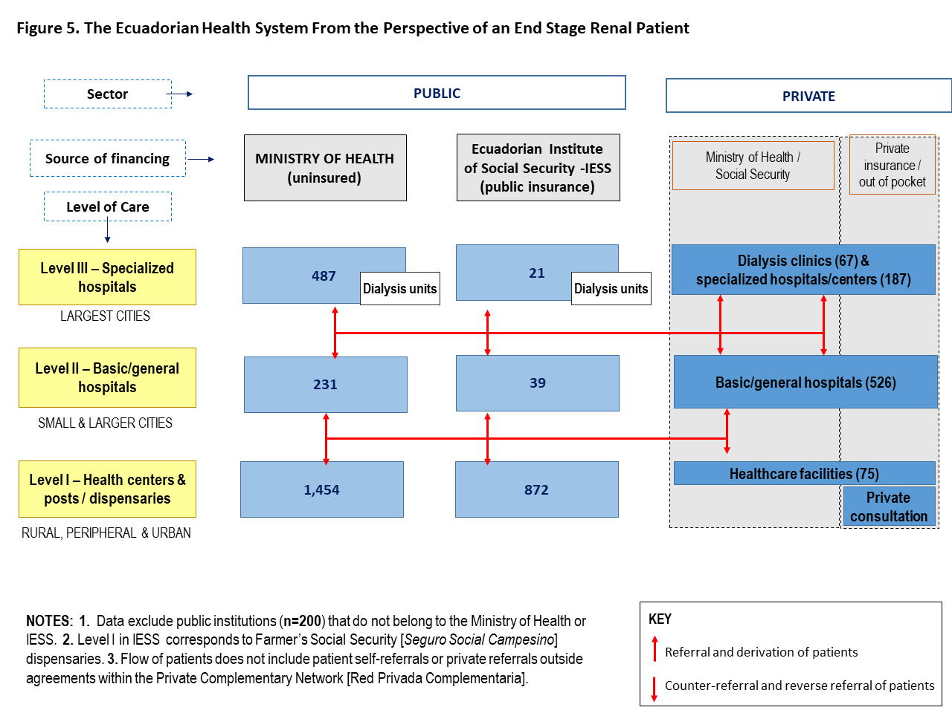

|  |
| --- |
| SOURCES: Statistical Registry of Health Resources and Activities (39); Government of Ecuador Official Register Nº 428, Supplement, January 30, 2015; Ministry of Health Technical Guidelines 2014 [*Norma técnica Subsistema de referencia, derivación, contrareferencia, referencia inversa y transferencia del Sistema Nacional de Salud*]; Licensed kidney health specialized centers 2019 [*Centros especializados en salud renal con licencias emitidas*]; Interviews. |