**Browser Screenshots**

***Adding an employee:***

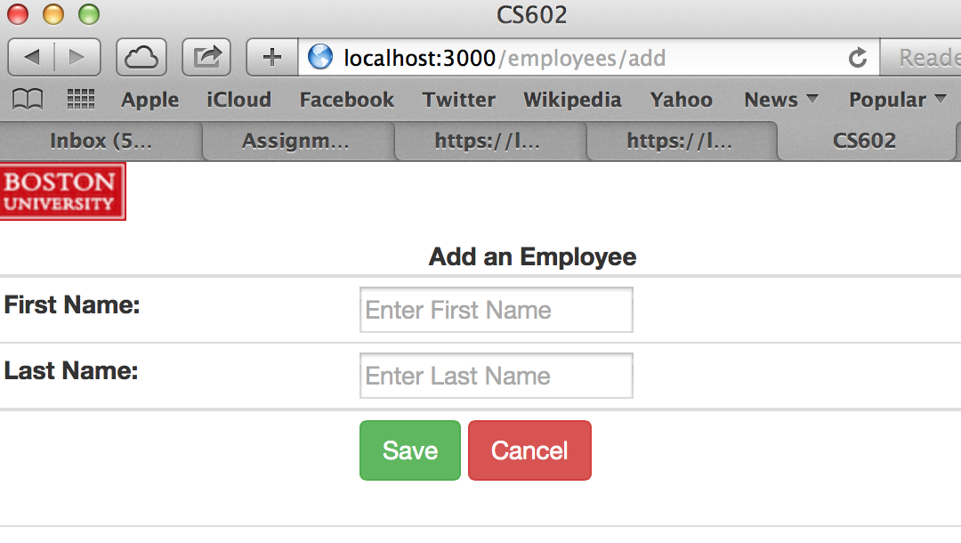

***Deleting an existing employee (for this screenshot, the first employee John Smith had just been deleted. After successful delete, it redirects to the employee list):***

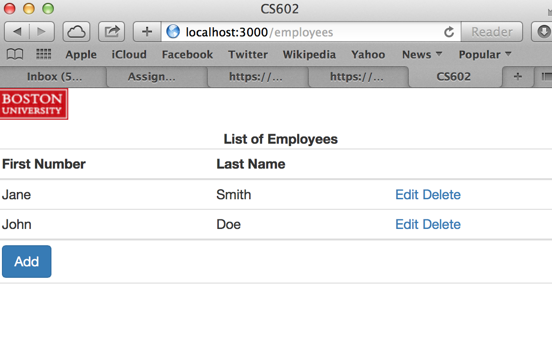

***Displaying all employees (this was taken prior to the first employee John Smith being deleted, after the client mongoose.js file created and saved three employees to the database):***

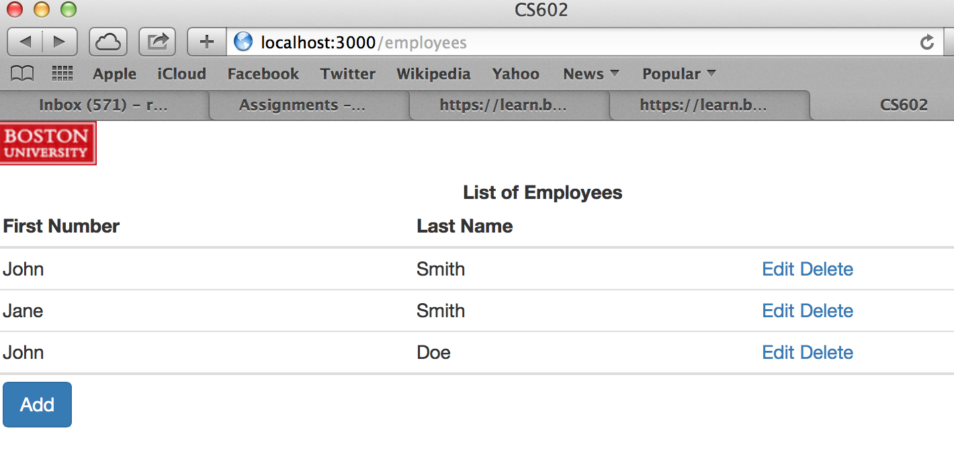

***Editing an employee (this was taken before John Smith was deleted):***

