Robert Judka

Professor Sasaki

Lab 5 – Pointers and Structures

February 17, 2016

1.

int b[4] = {2, 4, 2, 8};

int \*p, \*q, \*r;

p = &b[0];

q = &b[1];

r = &b[2];

2.

a) compile-time: “comparison between pointer and integer [enabled by default]”, “comparisons

like ‘X<=Y<=Z<=’ do not have their mathematical meaning [-Wparentheses]”

run-time: evaluates to TRUE

b) compile-time: no errors

run-time: evaluates to TRUE

c) compile-time: no errors

run-time: evaluates to FALSE

d) compile-time: no errors

run-time: evaluates to TRUE

e) compile-time: no errors

run-time: evaluates to TRUE

f) compile-time: “invalid operands to binary + (have ‘int \*’ and ‘int \*’)”

run-time: DOES NOT COMPILE

3.

a)

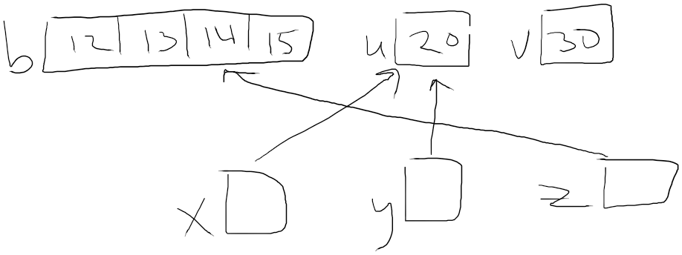

b) 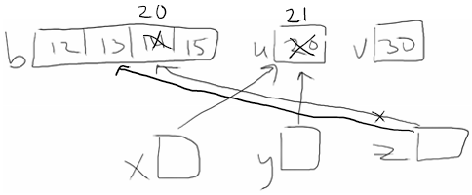

4.

