James Guerrera-Sapone - A20365203

Robert Judka - A20348051

**Finding Memory Leaks with *gdb* and *Valgrind***

1. **malloc() but forget to free()**

Running the program prints a message indicating the memory address of the allocated memory. Since it is never freed there is a memory leak, which means that the space is never deallocated. This can be found in *gdb* by using breakpoints and checking stack frames. Checking the local variables after the program has returned reveals that the variable’s memory address is still valid. Using *Valgrind* it is immediately apparent that there is a problem with the program. It easily finds that 450 bytes were lost due to a memory leak and it can point out the allocation that caused the problem.

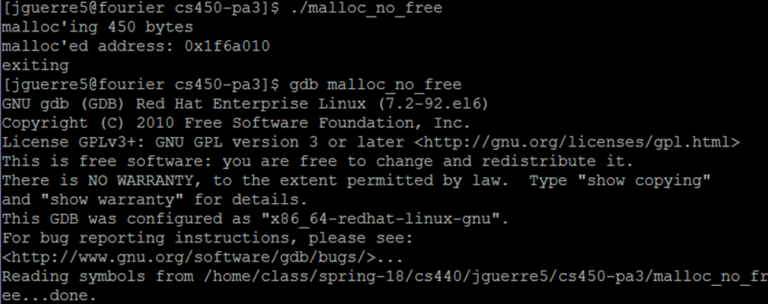

Running the program, displaying newly allocated memory address then exiting.



Starting program in *gdb*.

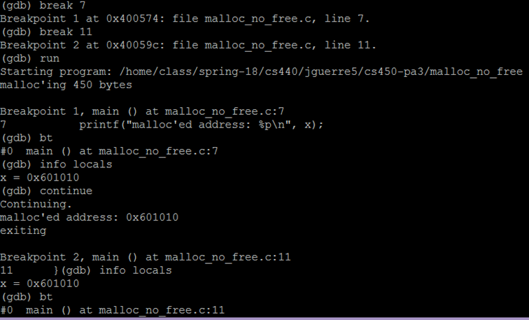

Setting breakpoints in *gdb* based on line number then running the program through *gdb*. The local variables are checked using “*info locals”* at each break point.

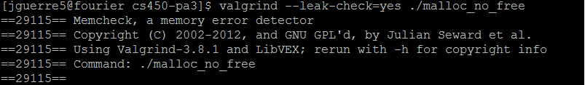

Running *Valgrind* on the program to check for memory leaks.

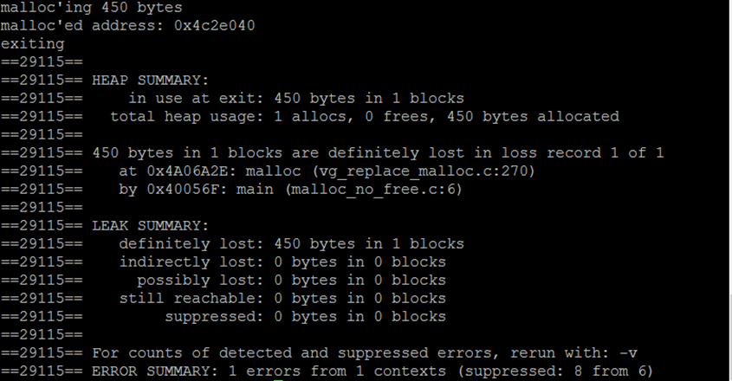

*Valgrind* showing the memory leak in the program.

1. **malloc() array, free() array, and printf() element of array**

The program runs and returns the same value that it did before the data was freed. *Valgrind* acknowledges that the data was freed and that there are no memory leaks. However, *Valgrind* complains that there was an invalid read at the line where the data is printed after it is freed. The message states that the data being accessed is within a block of data that was freed in a prior line of code. *Valgrind* says that there is 1 error from 1 context referring to the invalid read.

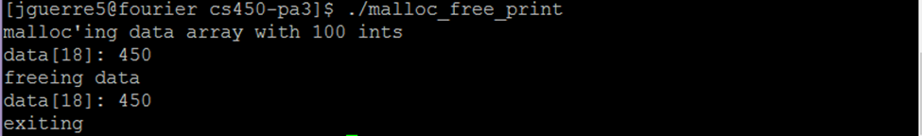

Running the program, displaying the value before and after freeing the array.

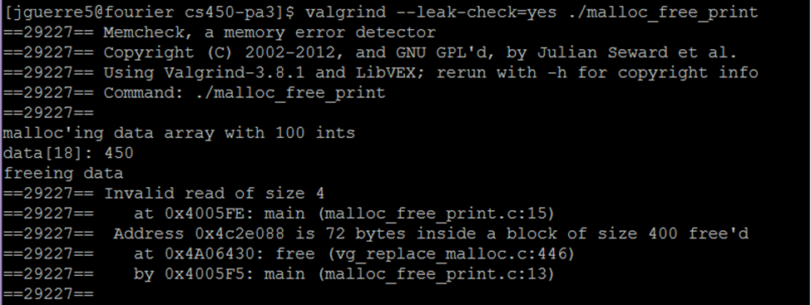

Running *Valgrind* on the program. *Valgrind* detects an invalid read caused by freeing the array.

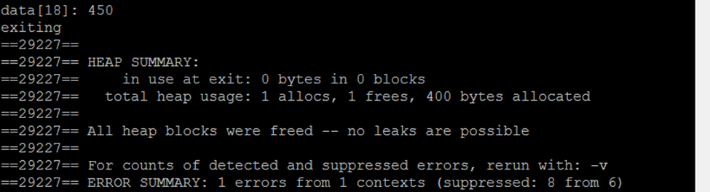

The rest of *Valgrind’s* output where it reports one error in 1 context.