Expense management System like splitwise

25/03/2022

PROJECT DETAIL DOCUMENT

## Team Members

|  | *Devesh Modi (201901173)*  *Khalsa Ravindersigh (201901179)*  *Hastin Dave (201901225)*  *Srushti Menpara (201901307)*  *Devyanish Koul (201901444)*  *Dhaval Vaidya (201901462)* |
| --- | --- |

## Reporting TA

|  | *Pinank Gajera* |
| --- | --- |

## 

## Date

|  | *25 / 03 / 2022*  *Friday* |
| --- | --- |

## 

## Version number

|  | *1.0* |
| --- | --- |

## 

## Start – End Date

|  | *Start Date: 15 / 03 / 2022*  *End Date: 15 / 05 / 2022* |
| --- | --- |

## Objectives of The Project

| * *To design and implement a web based or android based software system for the users to track their expenses so that they are neither bothered about managing individual or group expenses nor splitting the shared bill at the time of spending when they are having fun.* * *To help the user to calculate how much they owe or are owed.* * *Suggest the user a simpler way to combine and settle payments.* * *This project also aims to help users in managing recurring expenses like paying maid, electricity or water bills, rent etc.* |
| --- |

## Functionalities

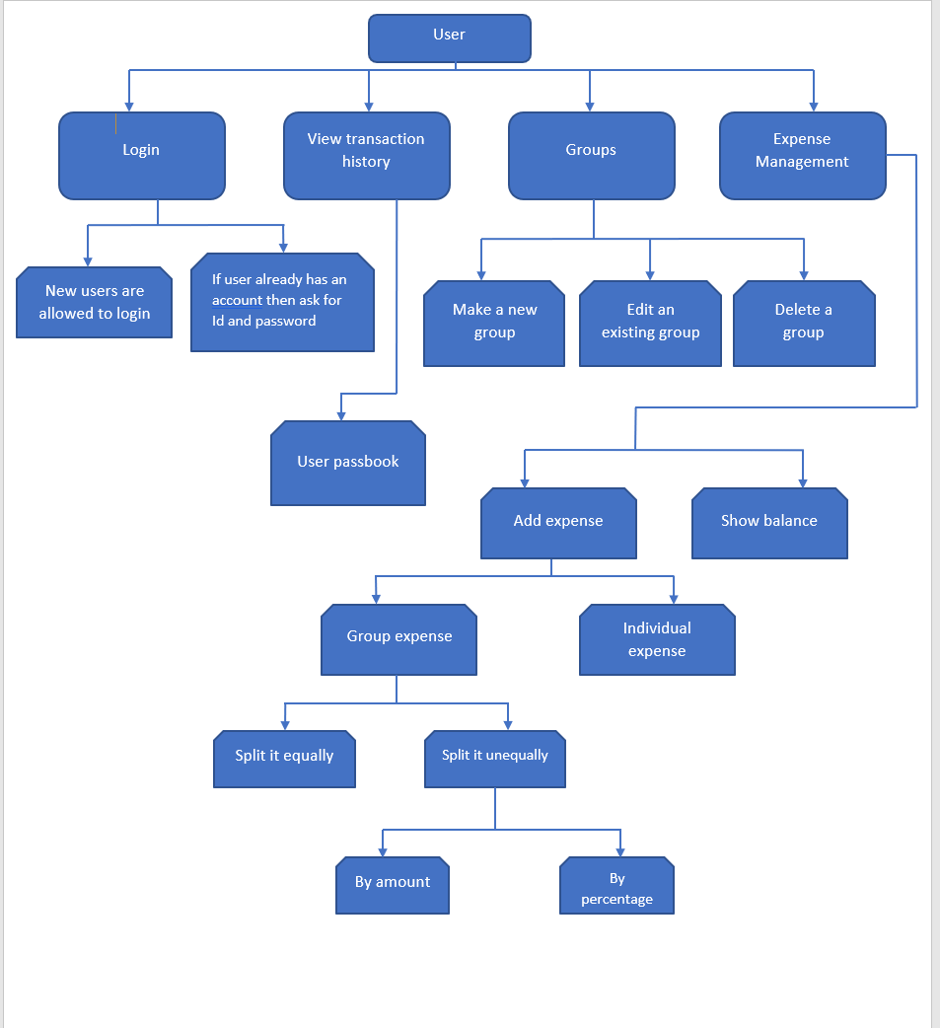

| * *User should be able to set/ reset the currency he wishes to use.* * *User should be able to add or delete expense.* * *User can pay for others and the amount should be splitted among the friends.* * *Splitting can be equally or unequally like based on percentage or custom.* * *User should be able to see his past activities.* * *User should be able to see his balance.* * *Expense details include name, date, added by, image, location, category.* * *The user should be able to create groups like one for house sharing, one for weekend, one for a friends trip etc and add contacts to it .* * *The user should be able subscribe to or unsubscribe to recurring payments.* * *The user should be able to export the split policy for one group to other groups.* * *System should be integrated with payment gateways.* * *When an expense is added for any member then that member should be notified about it. The member adding the expense should be able to send a personalized message along with the request.* |
| --- |

## Project Deliverables

| ***Milestones***   * ***15th March to 31st March****: List all types of users who possibly would be using our software. Find the new features that are why users will use our software and not other ones which are already existing in the market.* * ***1st April to 10h April****: Decide and design different interfaces for users and come up with some new features.* * ***11th April to 15th April:*** *Work on authentication of users for signing up our software while working on Design.* * ***15th April to 30th April:*** *Implementation of the features.* * ***01st May to 10th May:*** *Testing and feedback* |
| --- |

## Estimated Total Time

| ***Time (unit: hours)*** | ***Activity*** |
| --- | --- |
| *10* | *Requirement Analysis* |
| *8* | *Design* |
| *10* | *Configuring backend logic* |
| *15* | *Learning the technology* |
| *15* | *Coding* |
| *10* | *UI/UX designing* |
| *8* | *Testing* |
| *4* | *Deployment* |
| *80* | ***Total*** |

## H/W Requirements

| * *Front end server* * *Business logic server* * *Database server* * *Internet connectivity* * *8 GB RAM for development and evaluation* |
| --- |

## S/W Requirements

| * *Domain name for the website or for Google play store in case of android application.* * *Azure portal and cloud CLI* * *JDBC to connect database* * *Java JDK (Java Development Kit)* * *IDE (eg. VS code)* * *Payment processing API* |
| --- |

## Technology/Architecture Plan

| * *Front end*   + *HTML*   + *CSS*   + *Javascript* * *Back end*   + *Java*   + *Django*   + *REST API* * *Database*   + *Firebase* * *Tool*   + *Git* |
| --- |

## Standards to be followed throughout project

*We are going to follow the following standard:*

| ***Activity*** | ***Description*** | ***Deadline*** |
| --- | --- | --- |
| *Planning* | *We are going to plan the whole workflow of the project* | *31 March 2022* |
| *Design* | *We will decide the design the solution that we are going to implement in the project* | *10 April 2022* |
| *Code* | *We are planning to implement the design into a web based or android based application* | *20 April 2022* |
| *Review* | *After completion, we will review the entire project properly and add some new features if necessary.* | *30 April 2022* |
| *Deploy* | *We will deploy the project using cloud services.* | *10 May 2022* |
| *Management* | *We plan to use Git as version control tool.* | *Throughout the project* |
| *Storage* | *We plan to use Github for backup and repository* | *Throughout the project* |
| *Proper indentation* | *Certain standard spacing convention will be followed eg. each block should be indented with a single tab of size 4 spaces etc.* | *Throughout the coding phase* |