**Python Elasticsearch Solution**

# Install elasicsearch and validate the elasticsearch service

helm repo add elastic <https://helm.elastic.co>

helm install elasticsearch elastic/elasticsearch -f ./values.yaml

kubectl get pods -l app=elasticsearch-master -w

helm test elasticsearch

kubectl port-forward svc/elasticsearch-master 9200

curl -XGET <http://localhost:9200/>

**values.yml**

---

# Permit co-located instances for solitary minikube virtual machines.

antiAffinity: "soft"

# Shrink default JVM heap.

esJavaOpts: "-Xmx128m -Xms128m"

# Allocate smaller chunks of memory per pod.

resources:

requests:

cpu: "100m"

memory: "512M"

limits:

cpu: "1000m"

memory: "512M"

# Request smaller persistent volumes.

volumeClaimTemplate:

accessModes: [ "ReadWriteOnce" ]

storageClassName: "standard"

resources:

requests:

storage: 100M

# Load data

curl -H 'Content-Type: application/json' -XPOST "http://localhost:9200/cities/_bulk" --data-binary @worldcities_100records.json

# Copy Python Programs

**es_health_local.py**

from elasticsearch import Elasticsearch

es = Elasticsearch([{'host': 'localhost', 'port': 9200}])

def connect_elasticsearch(_es):

if _es.ping():

print('Elasticsearch is UP!')

else:

print('Elasticsearch is DOWN!')

return _es

if __name__ == '__main__':

status=connect_elasticsearch(es)

**es_insert_local.py**

from operator import index

from random import random

from elasticsearch import Elasticsearch

es = Elasticsearch([{'host': 'localhost', 'port': 9200}])

index="cities"

city = input("Enter the city: ")

country = input("Enter the country: ")

population = input("Enter the population: ")

id=city+country

doc = {

'city': city,

'country': country,

'population': population,

}

def insert_elasticsearch(_es,_index,_id,_doc):

ret = _es.index(index=index, id=_id, body=_doc)

return ret

if __name__ == '__main__':

response=insert_elasticsearch(es,index,id,doc)

print(response)

**es_update_local.py**

from elasticsearch import Elasticsearch

es = Elasticsearch([{'host': 'localhost', 'port': 9200}])

index_name='cities'

def print_total_cities(_es,_index_name):

print("Total Cities:")

print(_es.count(index=_index_name))

def get_input_city_population():

_city = input("Enter the city to get the population: ")

_new_population = input("Enter the updated population: ")

return _city, _new_population

def get_elasticsearch_id(_es,_index_name,_matchdoc):

citysearch = _es.search(index=_index_name, body=_matchdoc)

current_population_id = citysearch["hits"]["hits"][0]["_id"]

print(current_population_id)

return current_population_id

def update_elasticsearch(_es,_index_name,_current_population_id,_updatedoc):

doctype = "_doc"

ret = _es.update(index=_index_name, doc_type=doctype, id=_current_population_id, body=_updatedoc)

print ('Updated Record:', ret)

return ret

if __name__ == '__main__':

print_total_cities(es,index_name)

city, new_population = get_input_city_population()

matchdoc = {'query': {'bool': {'must': [{'match': {'city': city}}]}}}

body = {'query': {'bool': {'must': [{'match': {'city': city}}]}}}

updatedoc = {

'doc' : {

'population': new_population

}

}

current_population_id = get_elasticsearch_id(es,index_name,matchdoc)

response = update_elasticsearch(es,index_name,current_population_id,updatedoc)

print(response)

**es_search_local.py**

from elasticsearch import Elasticsearch

es = Elasticsearch([{'host': 'localhost', 'port': 9200}])

index_name='cities'

print("Total Cities:")

print(es.count(index=index_name))

city = input("Enter the city to get the population: ")

doc = {'query': {'bool': {'must': [{'match': {'city': city}}]}}}

def search_elasticsearch(_es,_index_name,_doc):

citysearch = _es.search(index=_index_name, body=_doc)

population = citysearch["hits"]["hits"][0]["_source"]["population"]

return population

if __name__ == '__main__':

response=search_elasticsearch(es,index_name,doc)

print("Population is:", response)

# Run Python programs to interact with elasticsearch

## Health Check



**sathiskumarraju@Sathiss-MacBook-Air es_local %** python3 es_health_local.py

/opt/homebrew/lib/python3.9/site-packages/elasticsearch/connection/base.py:208: ElasticsearchWarning: Elasticsearch built-in security features are not enabled. Without authentication, your cluster could be accessible to anyone. See https://www.elastic.co/guide/en/elasticsearch/reference/7.17/security-minimal-setup.html to enable security.

warnings.warn(message, category=ElasticsearchWarning)

Elasticsearch is UP!

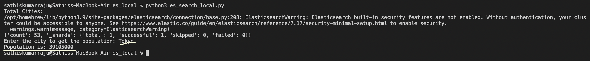

## 2. Search city

**sathiskumarraju@Sathiss-MacBook-Air es_local %** python3 es_search_local.py

Total Cities:

/opt/homebrew/lib/python3.9/site-packages/elasticsearch/connection/base.py:208: ElasticsearchWarning: Elasticsearch built-in security features are not enabled. Without authentication, your cluster could be accessible to anyone. See https://www.elastic.co/guide/en/elasticsearch/reference/7.17/security-minimal-setup.html to enable security.

warnings.warn(message, category=ElasticsearchWarning)

{'count': 53, '_shards': {'total': 1, 'successful': 1, 'skipped': 0, 'failed': 0}}

Enter the city to get the population: Tokyo

Population is: 39105000

## 3. Insert new City, Country and its population

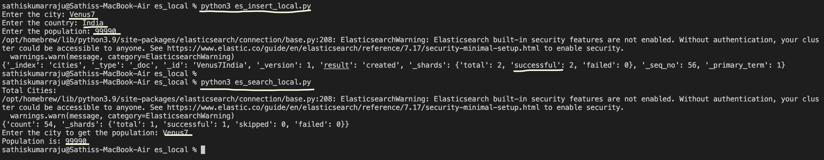

**sathiskumarraju@Sathiss-MacBook-Air es_local %** python3 es_insert_local.py

Enter the city: Venus7

Enter the country: India

Enter the population: 99990

/opt/homebrew/lib/python3.9/site-packages/elasticsearch/connection/base.py:208: ElasticsearchWarning: Elasticsearch built-in security features are not enabled. Without authentication, your cluster could be accessible to anyone. See https://www.elastic.co/guide/en/elasticsearch/reference/7.17/security-minimal-setup.html to enable security.

warnings.warn(message, category=ElasticsearchWarning)

{'_index': 'cities', '_type': '_doc', '_id': 'Venus7India', '_version': 1, 'result': 'created', '_shards': {'total': 2, 'successful': 2, 'failed': 0}, '_seq_no': 56, '_primary_term': 1}

**sathiskumarraju@Sathiss-MacBook-Air es_local %** python3 es_search_local.py

Total Cities:

/opt/homebrew/lib/python3.9/site-packages/elasticsearch/connection/base.py:208: ElasticsearchWarning: Elasticsearch built-in security features are not enabled. Without authentication, your cluster could be accessible to anyone. See https://www.elastic.co/guide/en/elasticsearch/reference/7.17/security-minimal-setup.html to enable security.

warnings.warn(message, category=ElasticsearchWarning)

{'count': 54, '_shards': {'total': 1, 'successful': 1, 'skipped': 0, 'failed': 0}}

Enter the city to get the population: Venus7

Population is: 99990

## 4. Update Population count of a City

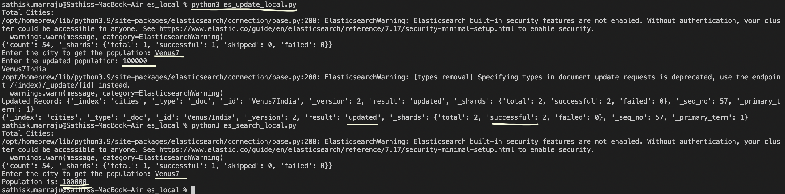

**sathiskumarraju@Sathiss-MacBook-Air es_local %** python3 es_update_local.py

Total Cities:

/opt/homebrew/lib/python3.9/site-packages/elasticsearch/connection/base.py:208: ElasticsearchWarning: Elasticsearch built-in security features are not enabled. Without authentication, your cluster could be accessible to anyone. See https://www.elastic.co/guide/en/elasticsearch/reference/7.17/security-minimal-setup.html to enable security.

warnings.warn(message, category=ElasticsearchWarning)

{'count': 54, '_shards': {'total': 1, 'successful': 1, 'skipped': 0, 'failed': 0}}

Enter the city to get the population: Venus7

Enter the updated population: 100000

Venus7India

/opt/homebrew/lib/python3.9/site-packages/elasticsearch/connection/base.py:208: ElasticsearchWarning: [types removal] Specifying types in document update requests is deprecated, use the endpoint /{index}/_update/{id} instead.

warnings.warn(message, category=ElasticsearchWarning)

Updated Record: {'_index': 'cities', '_type': '_doc', '_id': 'Venus7India', '_version': 2, 'result': 'updated', '_shards': {'total': 2, 'successful': 2, 'failed': 0}, '_seq_no': 57, '_primary_term': 1}

{'_index': 'cities', '_type': '_doc', '_id': 'Venus7India', '_version': 2, 'result': 'updated', '_shards': {'total': 2, 'successful': 2, 'failed': 0}, '_seq_no': 57, '_primary_term': 1}

**sathiskumarraju@Sathiss-MacBook-Air es_local %** python3 es_search_local.py

Total Cities:

/opt/homebrew/lib/python3.9/site-packages/elasticsearch/connection/base.py:208: ElasticsearchWarning: Elasticsearch built-in security features are not enabled. Without authentication, your cluster could be accessible to anyone. See https://www.elastic.co/guide/en/elasticsearch/reference/7.17/security-minimal-setup.html to enable security.

warnings.warn(message, category=ElasticsearchWarning)

{'count': 54, '_shards': {'total': 1, 'successful': 1, 'skipped': 0, 'failed': 0}}

Enter the city to get the population: Venus7

Population is: 100000