**COIT20257: DISTRIBUTED SYSTEMS: PRINCIPLES AND DEVELOPMENT**

**Term 3, 2018**

**Assessment 2**

Lecturer: Ahmed, Mahbub

Tutor: Ahmed, Mahbub

Prepared by:

Student Name - Rohit Sudhakaran

Student Number - 12073824

**INTRODUCTION**

In Assignment 2 the PDFS application implements the user registration and login where the user can either register or login and the password is sent between the client and server are encrypted and decrypted using the RSA algorithm. The application uses thread per client architecture. In thread per client request for every client new thread is created until the connection closed for the client. The user can then choose the multiple options available for the different types of listings

**PDFS Architecture**

Client

Database

Client

Server

Client

Fig: PDFS Distributed Systems Architecture

The client connects with the server through socket (for this assignment connected to localhost) once the server accepts the connection through the port the client registration/login process starts where the password exchange between the client and server is encrypted and decrypted using the RSA algorithm. At the beginning the server sends the public key and the client encrypts using the private and sends to the server so that it is secure.

**USER INSTRUCTIONS**

The application is developed using netbeans and the database used is mysql. The database created is fooddetails. Upon running the application checks whether the database ‘fooddetails’ exists, if not a new database is created. Once the database is established the program checks whether table userdetails exist. The table user details consists of three columns UserID(The primary which is on autoincrement),User name and password.

The program consists of 5 classes

FoodItem.java – Source code for the FoodItem class

FoodServer.java – Source code for the FoodServer class

FoodClient.java – Source code for Client class

DataFile.java – Source code for DataFile class

DatabaseUtility.java

First the server is started, and the tables are loaded. When the client program is run it prompts the user if they are existing user or new user. If the user is new then option 1 is selected and user enters the name and password and then the client receives the UserID with which he can log in. If it is a registered user the client selects option 2 and user enters the userid and then the password. If the password matches the user is logged and choose the respective option for the listing required

**TEST PLAN**

The testing will be performed for the user registration/ login with 2 clients interacting with the server at the same time with thread per client.

In test case 1 we check the registration of the client 1.

In test case 2 we check whether the user can login using the given userID and password

In test case 3 we verify the result when the user enters the incorrect password

In test case 4 we verify whether user can select the lunch listing options once logged in

**TEST CASE - 1**

Step 1 – Start the server

Step 2 – Start the client 1

Step 3 – Select option 1 to register as a new client

Step 4 – Enter the Name,password

Step 5 – Receive the UserID

Step 6 – Select the respective option for the lunch listing required

Client 1 output

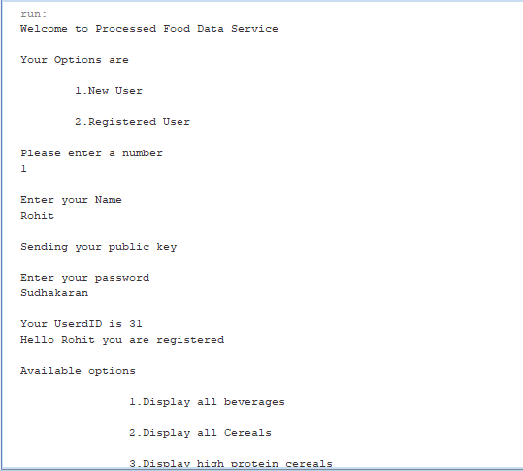

Fig 1.1

Server response

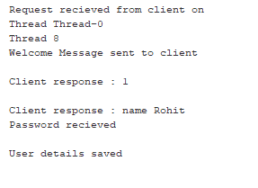

Fig 1.2

**TEST RESULT**

The client 1 is registered and the data is saved in the database. Once register the client is logged in and able to select the options available

Fig 1.1 shows the output of the client which shows that the user is registered. Fig 1.2 shows the server side output. The test result is as expected

**TEST CASE -2**

Step 1 – Start the server

Step 2 – Start the client 2

Step 3 – Select option 2 to register as a new client

Step 4 – Enter the UserID and password

Client 2 output

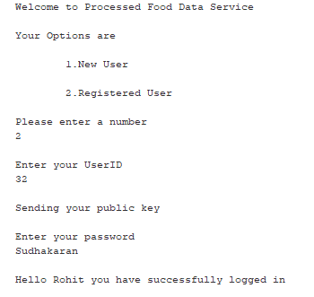

Fig 1.3

**TEST RESULT**

The client 2 can login upon entering the password

Figure 1.3 shows the output of the client 2

**TEST CASE 3**

Step 1 – Start the server

Step 2 – Start the client 3

Step 3 – Select option 2 to register as a new client

Step 4 – Enter the UserID and wrong password

Client 3 Output

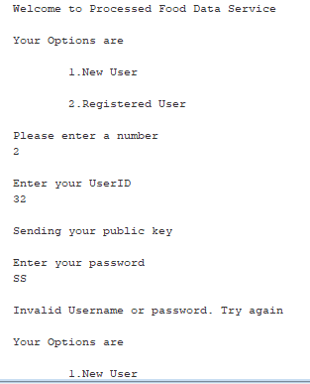

Fig 1.4

**TEST RESULT**

Upon entering the wrong password the client 3 is unable to login

Figure 1.4 shows the output where the user is unable to login and has to enter the right password or register as a new user

**TEST CASE 4**

Step 1 – Start the server

Step 2 – Start the client 4

Step 3 – Login

Step 4 – Enter option 4 to view

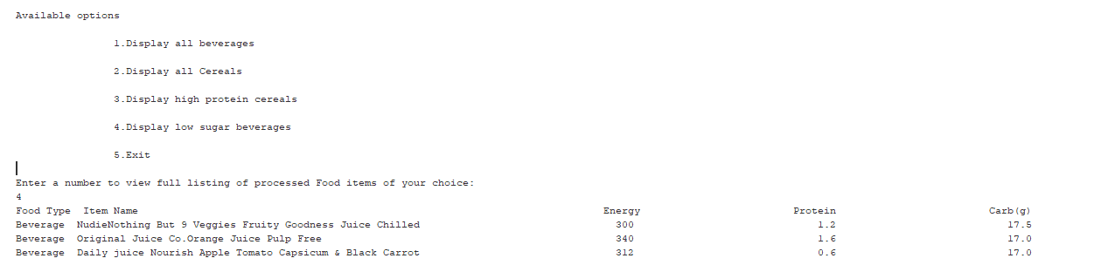

**Fig 1.5**

**TEST RESULT**

Once logged in the user enters option 4 and the list of top 3 low sugar beverages is displayed