**VISVESVARAYATECHNOLOGICAL UNIVERSITY**

**“JnanaSangama”, Belgaum -590014, Karnataka.**



**LAB REPORT**

**on**

INTERNET OF THINGS LAB

***Submitted by***

**ROHAN SATISH KUMAR (1BM21CS168)**

***in partial fulfillment for the award of the degree of***

**BACHELOR OF ENGINEERING**

***in***

**COMPUTER SCIENCE AND ENGINEERING**



**B.M.S. COLLEGE OF ENGINEERING**

**(Autonomous Institution under VTU)**

**BENGALURU-560019**

**Oct-2023 to Feb-2024**

**B. M. S. College of Engineering,**

**Bull Temple Road, Bangalore 560019**

(Affiliated To Visvesvaraya Technological University, Belgaum)

**Department of Computer Science and Engineering**



**CERTIFICATE**

This is to certify that the Lab work entitled “Internet of things lab” carried out by **ROHAN SATISH KUMAR (1BM21CS68),** who is a bonafide student of **B. M. S. College of Engineering.** It is in partial fulfillment for the award of **Bachelor of Engineering in Computer Science and Engineering** of the Visvesvaraya Technological University, Belgaum during the year 2023. The Lab report has been approved as it satisfies the academic requirements in respect of a **Internet of things lab (21CS5PCIOT)**work prescribed for the said degree.

**SANDHYA A KULKARNI Dr.Jyothi S Nayak**

Assistant Professor Professor and Head

Department of CSE Department of CSE

BMSCE, Bengaluru BMSCE, Bengaluru

`

**TABLE OF CONTENTS**

|  |  |  |  |
| --- | --- | --- | --- |
| **Sl no.** | **Date** | **Name of the Experiment** | **page no.** |
| 1 | 23/11/202  3 | LED Blinking | 3-4 |
| 2 | 23/11/202  3 | LED ON/OFF Using pushbutton | 5-6 |
| 3 | 23/11/202  3 | LED fading using potentiometer | 7-8 |
| 4 | 23/11/202  3 | LED fading without using potentiometer | 9-10 |
| 5 | 07/12/202  3 | Simulating a night light using LDR | 11-12 |
| 6 | 07/12/202  3 | Simulating a night light using PIR | 13-14 |
| 7 | 07/12/202  3 | Simulating ultrasound with Arduino UNO and ultrasonic sensor | 15-17 |
| 8 | 07/12/202  3 | Fire alarm Simulation | 18-20 |
| 9 | 07/12/202  3 | Automatic irrigation controller simulation | 21-23 |
| 10 | 21/12/202  3 | Read the code present on RFID tag | 24-25 |
| 11 | 21/12/202  3 | Access control through RFID | 26-29 |
| 12 | 21/12/202  3 | Temperature sensing | 30-32 |
| 13 | 28/12/202  3 | Call to a specific number using GSM module | 33-34 |
| 14 | 11/01/202  4 | Call a specific mobile number when flame sensor detects fire | 35-36 |
| 15 | 11/01/202  4 | Send SMS using Arduino and GSM module | 37-39 |
| 16 | 18/01/24 | Control LED in bluetooth master device using bluetooth client | 40-44 |

Program no: **01** Program Title: **LED BLINK** Date:23/11/2023

**Aim:** To control the LED using arduino ( to turn ON/OFF LED)

# Hardware/components Required

Arduino Uno board - 1 USB Cable - 1

LED - 1

Jumper wires

# Circuit Diagram / Pin connection

* LED's positive leg is connected to digital pin 13
* 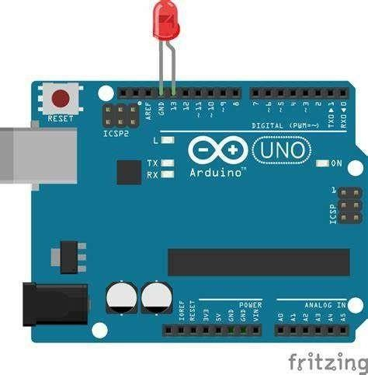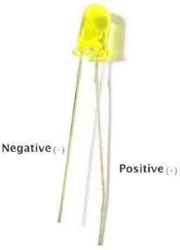LED's negative leg is connected to ground

# Code:

void setup()

{

// initialize digital pin 9 as an output. pinMode(13, OUTPUT);

}

// the loop function runs over and over again forever void loop()

{

digitalWrite(13, HIGH); delay(1000); digitalWrite(13, LOW); }

# Handwritten code pic:

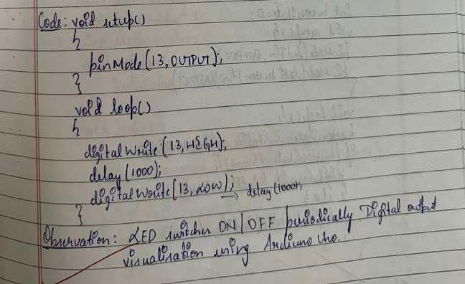

**Observation:** LED switches ON/OFF periodically. Digital output visualization using Arduino Uno.

Program no: **02** Program Title: **LED ON/OFF** Date:23/11/2023

**Aim:** To turn an LED ON /OFF using a Pushbutton.

# Hardware/components Required

Arduino Uno board - 1 USB Cable - 1

LED - 1

Pushbutton Jumper wires

# Circuit Diagram / Pin connection

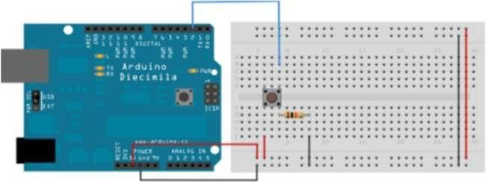

**Code:**

const int buttonPin=2; const int ledPin=13; int buttonState=0; void setup()

{.

pinMode(ledPin, OUTPUT); pinMode(buttonPin,OUTPUT);

}

void loop()

{

buttonState=digitalRead(buttonPin); if(buttonState==HIGH)

{ digitalWrite(ledPin,HIGH);

}

else{ digitalWrite(ledPin,LOW);

}

}

# Handwritten code pic:

**Observation:** LED turns ON when push button is pressed and turns OFF when it is released. Digital output visualization using Arduino Uno.

Program no: **03** Program Title: **LED FADING** Date:23/11/2023

**Aim:** To control the brightness of an LED using aPotentiometer.

# Hardware/components Required

Arduino Uno board - 1 USB Cable - 1

LED - 1

Potentiometer Jumper wires

# Circuit Diagram / Pin connection

LED positive to pin 9,LED negative to ground Potentiometer: VCC - 5V , A0 -A0 , GND-GND

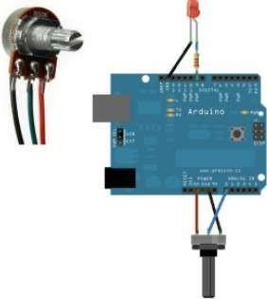

# Code:

const int analogPin=A0; const int analogOutPin=9; int sensorValue=0;

int outputValue=0; void setup()

{ Serial.begin(9600);

}

void loop()

{ sensorValue=analogRead(analogPin); outputValue=map(sensorValue,0,1023,0,255);

analogWrite(analogOutPin,outputValue); Serial.print(sensorValue); Serial.print(outputValue);

delay(2);

}

# Handwritten code pic:

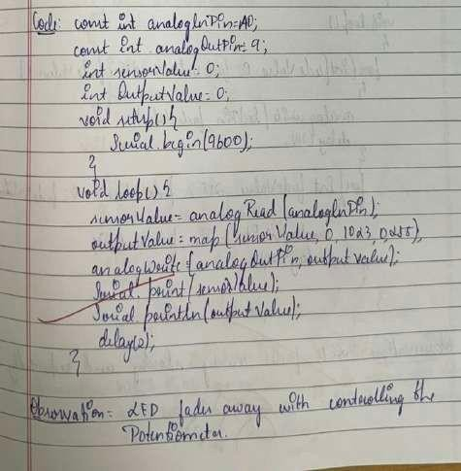

**Observation:**Based on the potentiometer shaft rotation output varies.LED glows if we rotate towards right and fades if we rotate towards left..

Program no: **04** Program Title: **LED FADING** Date:23/11/2023

**Aim:** To control the brightness of an LED without using aPotentiometer.

# Hardware/components Required

Arduino Uno board - 1 USB Cable - 1

LED - 1

Jumper wires

# Circuit Diagram / Pin connection

LED positive to pin 9 ,negative to ground

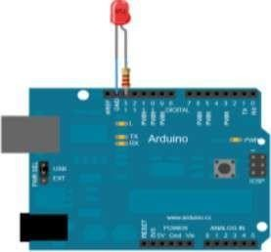

# Code:

int ledPin = 9; // LED connected to digital pin 9 void setup() {

}

void loop()

{

// fade in from min to max in increments of 5 points:

for (int fadeValue = 0 ; fadeValue <= 255; fadeValue += 5) {

// sets the value (range from 0 to 255): analogWrite(ledPin, fadeValue);

delay(30); // wait for 30 milliseconds to see the dimming effect

}

// fade out from max to min in increments of 5 points:

for (int fadeValue = 255 ; fadeValue >= 0; fadeValue -= 5) {

// sets the value (range from 0 to 255):

analogWrite(ledPin, fadeValue); delay(30); } }

# Handwritten code pic:

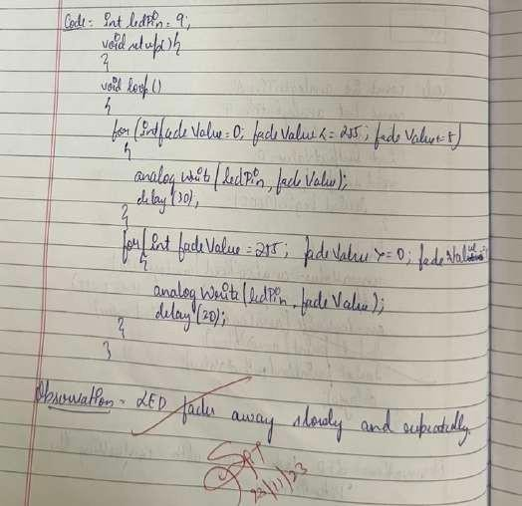

**Observation:**LED fades and glows periodically , output is visualized using arduino uno.

Program no: **05** Program Title: **Nightlight Simulation** Date:07/12/2023

**Aim:** Simulating a night light using LDR

# Hardware/components Required

Arduino Uno board - 1 USB Cable - 1

LED - 1 LDR-1

10K resistor-1 Jumper wires

# Circuit Diagram / Pin connection

1. Attach one leg of LDR to 5V and another leg to Arduino Analog pin A0
2. Attach one leg of 110K register with that leg of LDR connected to A0
3. Attach another leg of register to the ground
4. Connect the positive leg of LED to pin 11 and negative to GND

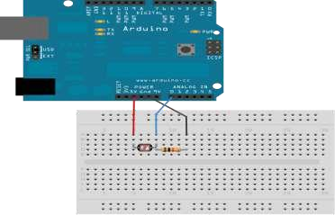

# Code:

int LDR = 0; //analog pin to which LDR is connected, here we set it to 0 so it means A0 int LDRValue = 0; //that’s a variable to store LDR values

int light_sensitivity = 500; //This is the approx value of light surrounding your LDR

void setup()

{

Serial.begin(9600); //start the serial monitor with 9600 buad pinMode(11, OUTPUT); //attach positive leg of LED to pin 11

}

void loop()

{

LDRValue = analogRead(LDR); //reads the ldr’s value through LDR Serial.println(LDRValue);

//prints the LDR values to serial monitor delay(50);

//This is the speed by which LDR sends value to arduino

if (LDRValue < light_sensitivity)

{

digitalWrite(11, HIGH);

}

else

{

digitalWrite(11, LOW);

}

delay(1000);

}

# Handwritten code pic:

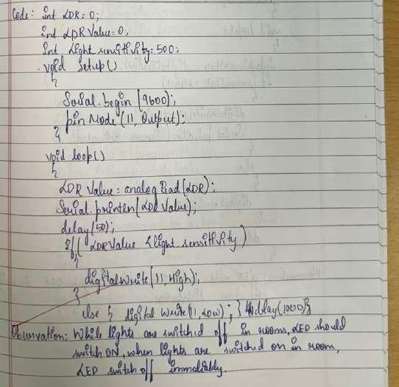

**Observation:**While lights are switched off in the room, LED should switch ON, when lights areswitched on in the room, LED should switch off immediately

Program no: **06** Program Title: **Nightlight Simulation** Date:07/12/2023

**Aim:** Simulating a night light using PIR

# Hardware/components Required

Arduino Uno board - 1 USB Cable - 1

LED - 1

PIR sensor-1 Jumper wires

# Circuit Diagram / Pin connection

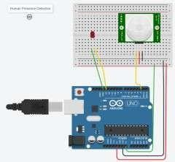

**Code:**

int sensorState = 0;

void setup()

{

pinMode(2, INPUT); pinMode(13, OUTPUT); Serial.begin(9600);

}

void loop()

// check if sensor pin is HIGH. if it is, set the // LED on.

if (sensorState == HIGH)

{ digitalWrite(13, HIGH); Serial.println("Sensor activated!");

} else {

digitalWrite(13, LOW);

}

delay(10);

}

# Handwritten code pic:

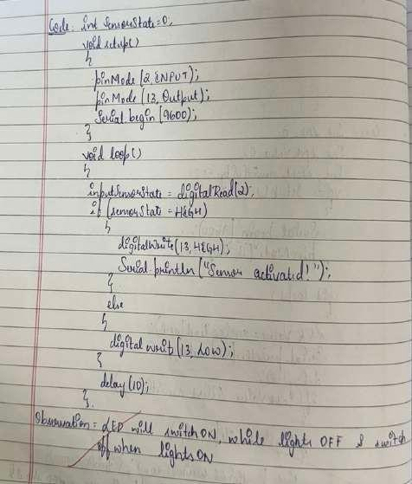

**Observation:**While lights are switched off in the room, LED should switch ON, when lights are switched on in the room, LED switches off.

Program no: **07** Program Title: **Ultrasound sensing** Date:07/12/2023

**Aim:** Simulating ultrasound with Arduino UNO and Ultrasonic sensor

# Hardware/components Required

Arduino Uno board - 1 USB Cable - 1 Ultrasonic sensor-1 Jumper wires

# Circuit Diagram / Pin connection

VCC-5V , GND-GND , pingpin-7 , echopin - 6

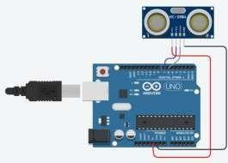

# Code:

const int pingPin = 7;

const int echoPin=6;// Trigger Pin of Ultrasonic Sensor const int echoPin = 6; // Echo Pin of Ultrasonic Sensor

void setup()

{

Serial.begin(9600); pinMode(pingPin, OUTPUT); pinMode(echoPin, INPUT);

}

void loop()

{

long duration, inches, cm; digitalWrite(pingPin, LOW); delayMicroseconds(2); digitalWrite(pingPin, HIGH); delayMicroseconds(10); digitalWrite(pingPin, LOW); duration = pulseIn(echoPin, HIGH);

inches = microsecondsToInches(duration); Serial.print(inches);

Serial.print("inches");

cm = microsecondsToCentimeters(duration); Serial.print(cm);

Serial.println("cm");

}

long microsecondsToInches(long microseconds)

{ return microseconds / 74 / 2;

}

long microsecondsToCentimeters(long microseconds)

{ return microseconds / 29 / 2;

}

# Handwritten code pic:

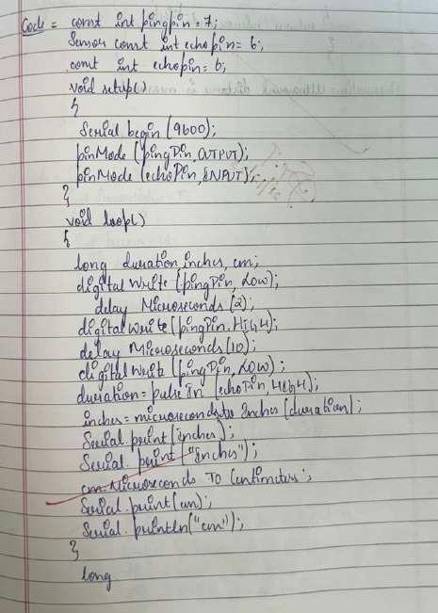 

**Observation:**Based on vibrations of sound,distance will be measured

Program no: **08** Program Title: **Fire Alert** Date:07/12/2023

**Aim:** Fire alarm simulation

**Hardware/components Required** Flame sensor (Analogue Output) Arduino

Bread board

LED

Buzzer Connecting wires

# Circuit Diagram / Pin connection

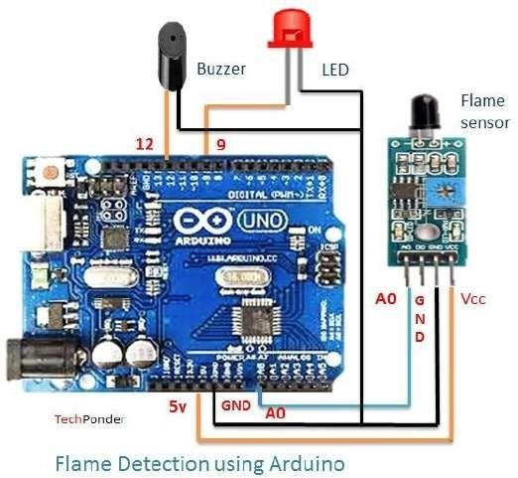

**Flame sensor interfacing to Arduino**

Flame sensor to Arduino vcc -> vcc

gnd -> gnd A0 -> A0

# Led interfacing to Arduino

**LED +ve** is connected to **9th pin** of Arduino **LED -ve** is connected to **gnd pin** of arduino **Buzzer interfacing to Arduino**

**Buzzer +ve** is connected to **12th pin** of Arduino **Buzzer -ve** is connected to **GND** pin of Arduino **Code:**

int sensorPin = A0; // select the input pin for the LDR

int sensorValue = 0; // variable to store the value coming from the sensor int led = 9; // Output pin for LED

int buzzer = 12; // Output pin for Buzzer void setup() {

// declare the ledPin and buzzer as an OUTPUT: pinMode(led, OUTPUT); pinMode(buzzer,OUTPUT); Serial.begin(9600);

}

void loop()

{

sensorValue = analogRead(sensorPin); Serial.println(sensorValue);

if (sensorValue < 100)

{

Serial.println("Fire Detected"); Serial.println("LED on"); digitalWrite(led,HIGH); digitalWrite(buzzer,HIGH); delay(1000);

}

digitalWrite(led,LOW); digitalWrite(buzzer,LOW);

delay(sensorValue);

}

# Handwritten code pic:

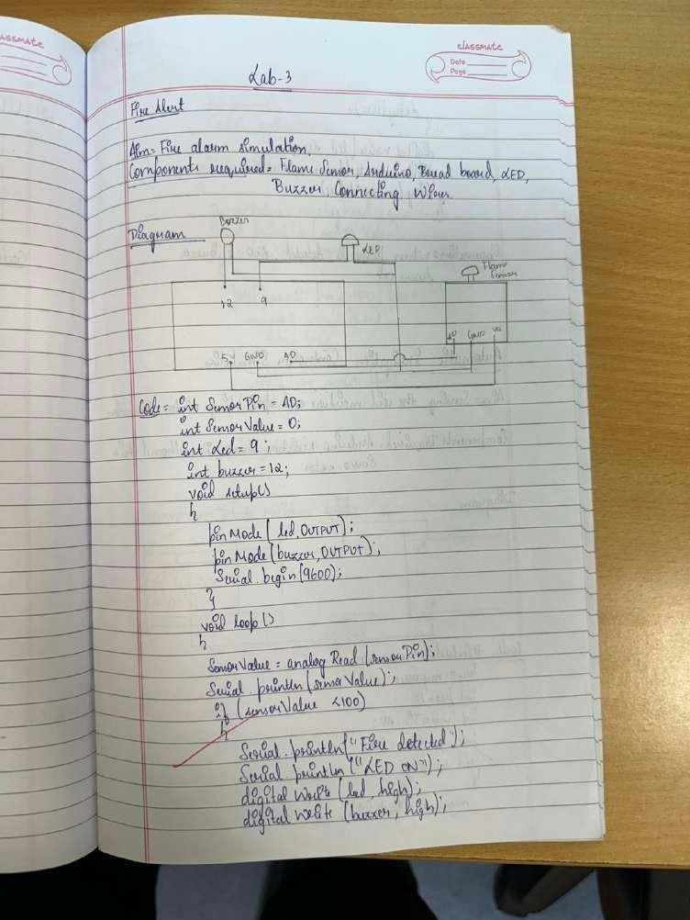

**Observation:**When flame is detected,LED and buzzer turns ON.

Program no: **09** Program Title: **Automatic Irrigation** Date:07/12/2023

**Aim:** Sensing the soil moisture and sprinkling the Water simulation

# Hardware Required

Arduino Moisture Sensor Breadboard

Min servo motor

# Circuit diagram

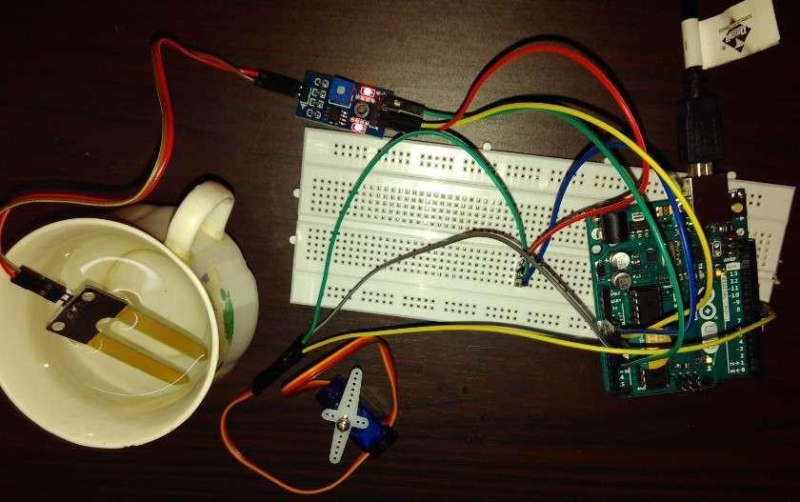

Moisture sensor VCC to Arduino 5V Moisture sensor GND to Arduino GND Moisture sensor A0 to Arduino A0

Servo motor VCC to Arduino 5V Servo motor GND to Arduino GND

Servo Motor Signal to Arduino digital pin 9

Code:

#include <Servo.h>

Servo myservo; // create servo object to control a servo

// twelve servo objects can be created on most boards int pos = 0; // variable to store the servo position

int sensorPin = A0; // select the input pin for the potentiometer

int sensorValue = 0; // variable to store the value coming from the sensor void setup() {

myservo.attach(9); // attaches the servo on pin 9 to the servo object Serial.begin(9600);

}

void loop() {

// read the value from the sensor: sensorValue = analogRead(sensorPin); Serial.println (sensorValue); if(sensorValue>500)

{

for (pos = 0; pos <= 180; pos += 1) { // goes from 0 degrees to 180 degrees

// in steps of 1 degree

myservo.write(pos); // tell servo to go to position in variable 'pos' delay(15); // waits 15ms for the servo to reach the position

}

for (pos = 180; pos >= 0; pos -= 1) { // goes from 180 degrees to 0 degrees myservo.write(pos); // tell servo to go to position in variable 'pos' delay(15); // waits 15ms for the servo to reach the position

}

}

delay (1000);

}

# Handwritten code pic:

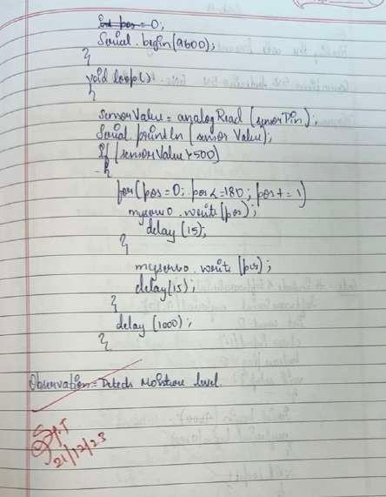

**Observation:**Soil moisture sensor continuously detects the soil moisture and servo motor would turn ON when there is a low moisture level.

Program no: **10** Program Title: **READING RFID TAG** Date:21/12/2023

**Aim:** To read the code present on RFID tag and print it in serial monitor.

# Hardware/components Required

Arduino Uno board - 1 USB Cable - 1

RFID tag Jumper wires

# Circuit Diagram / Pin connection

5V-Arduino 5V GND-Arduino GND Tx-pin 9

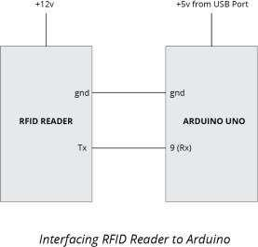

**Code:** #include<SoftwareSerial.h> SoftwareSerial mySerial(9, 10); int count = 0; // count = 0

char input[12];

boolean flag = 0; // flag =0void setup()

{

Serial.begin(9600); // begin serial port with baud rate 9600bps mySerial.begin(9600);

}

void loop()

{

if(mySerial.available())

{

count = 0;

while(mySerial.available() && count < 12) // Read 12 characters and store them in input array

{

input[count] =mySerial.read(); count++;

delay(5);

}

Serial.print(input); // Print RFID tag number

}

}

# Handwritten code pic:



**Observation:**The output consists of 12 character ASCII data, where first 10 bits will be the tag number and last 2 bits will be the XOR result of the tag number which can be used for error correction.

Program no: **11** Program Title: **ACCESS CONTROL via RFID TAG** Date:21/12/2023

**Aim:** To read the code present on RFID tag tapped. If the code matches with the previously known tag(configured in the code), it will grant access(here LED will glow), otherwise access will be denied.

# Hardware/components Required

Arduino Uno board - 1 USB Cable - 1

RFID tag Jumper wires

# Circuit Diagram / Pin connection

5V-Arduino 5V GND-Arduino GND Tx-pin 9



**Code:** #include<SoftwareSerial.h> SoftwareSerial mySerial(9, 10);

#define LEDPIN 12

char tag[] ="5300292DD087"; // Replace with your own Tag ID

char input[12]; // A variable to store the Tag ID being presented int count = 0; // A counter variable to navigate through the input[] character array

boolean flag = 0; // A variable to store the Tag match status void setup()

{

Serial.begin(9600); // Initialise Serial Communication with the Serial Monitor mySerial.begin(9600);

pinMode(LEDPIN,OUTPUT); //WRONG TAG INDICATOR

}

void loop()

{

Buffer.

if(mySerial.available())// Check if there is incoming data in the RFID Reader Serial

{

count = 0; // Reset the counter to zero

/* Keep reading Byte by Byte from the Buffer till the RFID Reader Buffer is

empty

or till 12 Bytes (the ID size of our Tag) is read */ while(mySerial.available() && count < 12)

{

input[count] = mySerial.read();

// Read 1 Byte of data and store it in the input[] variable Serial.write(input[count]);

count++; // increment counter delay(5);

}

value

/* When the counter reaches 12 (the size of the ID) we stop and compare each

of the input[] to the corresponding stored value */ if(count == 12) //

{

count =0; // reset counter varibale to 0 flag = 1;

/* Iterate through each value and compare till either the 12 values are all matching or till the first mistmatch occurs */

while(count<12 && flag !=0)

{

to 1 if(input[count]==tag[count])

flag = 1; // everytime the values match, we set the flag variable

else flag= 0;

/* if the ID values don't match, set flag variable to 0 and stop comparing by exiting the while loop */

count++; // increment i

}

}

if(flag == 1) // If flag variable is 1, then it means the tags match

{

Serial.println("Access Allowed!"); digitalWrite(LEDPIN,HIGH); delay (2000);

digitalWrite (LEDPIN,LOW);

}

else

{

Serial.println("Access Denied"); // Incorrect Tag MessagedigitalWrite(LEDPIN,LOW); delay(2000);

}

\/* Fill the input variable array with a fixed value 'F' to overwriteall values getting it empty for the next read cycle */ for(count=0; count<12; count++)

{

input[count]= 'F';

}

count = 0; // Reset counter variable

}

}

Handwritten code pic:

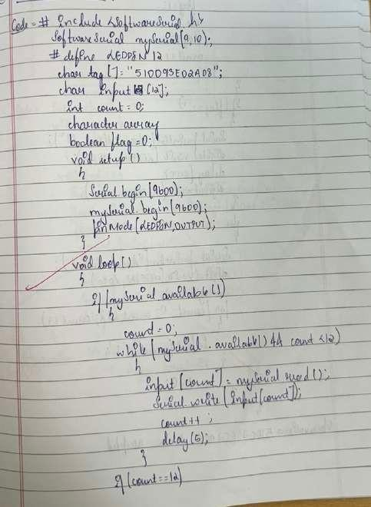

**Observation:**If the code matches with the previously known tag(configured in the code), it willgrant access(here LED will glow), otherwise access will be denied.

Program no: **12** Program Title: **TEMPERATURE SENSING** Date:21/12/2023

**Aim:** To monitor the temperature using LM35.

# Hardware/components Required

Arduino Uno board - 1 USB Cable - 1 Temperature sensor LM35 Jumper wires

# Circuit Diagram / Pin connection

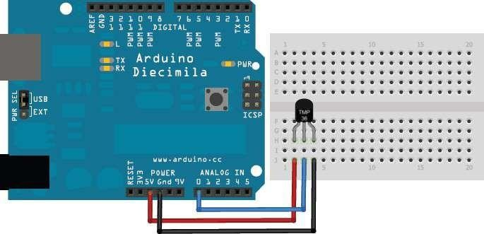

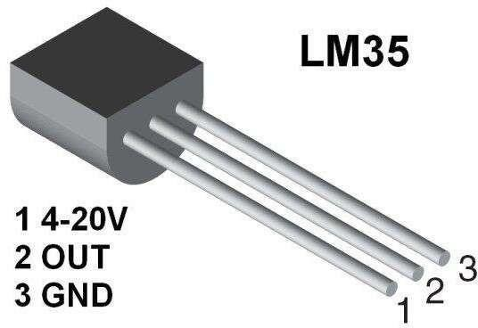

**Code:**

int sensorPin = 0; //the analog pin the TMP36's Vout (sense) pin is connected to

//the resolution is 10 mV / degree centigrade with a

//500 mV offset to allow for negative temperatures

/*

* setup() - this function runs once when you turn your Arduino on

* We initialize the serial connection with the computer

*/

void setup()

{

Serial.begin(9600); //Start the serial connection with the computer

//to view the result open the serial monitor

}

void loop() // run over and over again

{

//getting the voltage reading from the temperature sensor int reading = analogRead(sensorPin);

// converting that reading to voltage, for 3.3v arduino use 3.3 float voltage = reading * 5.0 / 1024;

// print out the voltage

Serial.print(voltage); Serial.println(" volts");

// now print out the temperature

float temperatureC = (voltage - 0.5) * 100 ; //converting from 10 mv per degree wit 500 mV offset

//to degrees ((volatge - 500mV) times 100)

/to degrees ((volatge - 500mV) times 100) Serial.print(temperatureC); Serial.println(" degress C");

// now convert to Fahrenheight

float temperatureF = (temperatureC * 9 / 5) + 32; Serial.print(temperatureF); Serial.println(" degress F");

delay(1000); //waiting a second

}

# Handwritten code pic:

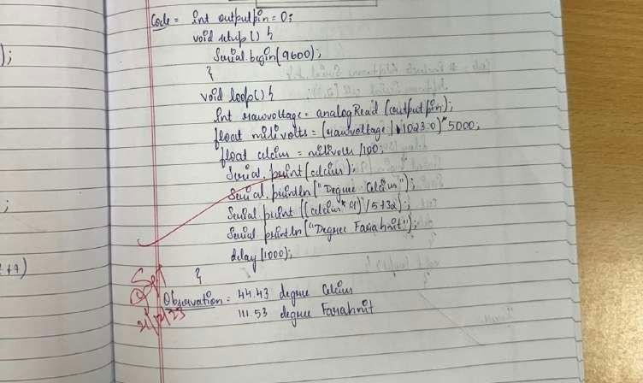

**Observation:**Sensor senses the temperature of the surroundings as 21C

Program no: **13** Program Title: **GSM CALLING** Date:28/12/2023

**Aim:** Call using Arduino and GSM Module – to a specified mobile number inside the program.

# Hardware/components Required

Arduino Uno board - 1 USB Cable - 1

GSM module SIM slot Jumper wires

# Circuit Diagram / Pin connection:

GSM Tx –>Arduino Rx (Here pin 2) GSM Rx –>ArduinoTx. (Here pin 3)

Make the ground common between Arduino and GSM modem.

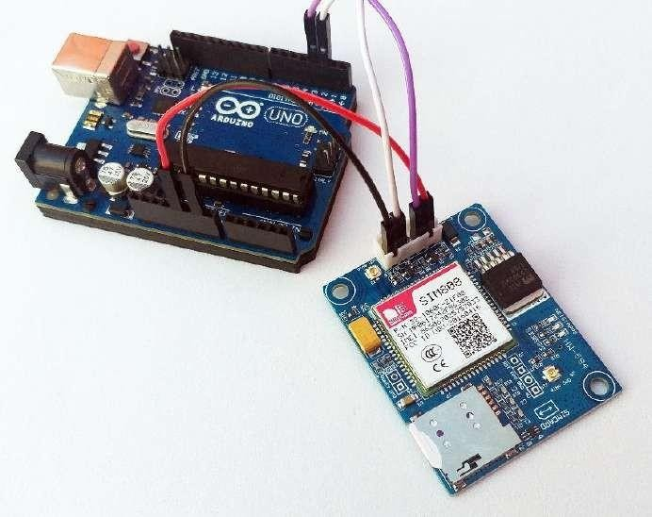

# Code:

#include <SoftwareSerial.h> SoftwareSerial cell(2,3); // (Rx, Tx)

void setup() {

cell.begin(9600); delay(500); Serial.begin(9600);

Serial.println("CALLING ");

# cell.println("ATD+9538433364;"); // ATD – Attention Dial

delay(20000);

}

void loop() {

}

# Handwritten code pic:

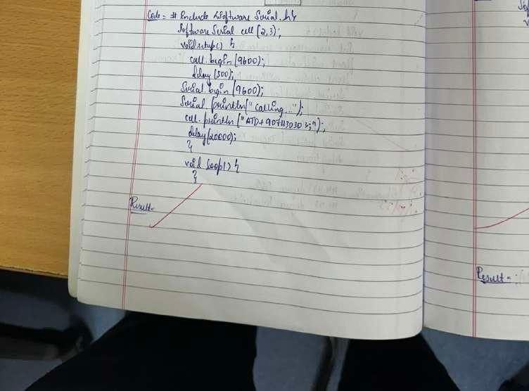

**Observation:**Calling to GSM module , you’ll get beep sound

Program no: **14** Program Title: **GSM CALLING FIRE ALERT** Date:11/01/2024

**Aim:** Call a specified mobile number mentioned in the program using Arduino and GSM Module when a flame sensor detects “fire”.

# Hardware/components Required

Arduino Uno board - 1 USB Cable - 1

GSM module SIM slot Flame sensor Jumper wires

# Circuit Diagram / Pin connection:

GSM Tx –>Arduino Rx (Here pin 2) GSM Rx –>ArduinoTx. (Here pin 3)

Make the ground common between Arduino and GSM modem.



# Code:

#include <SoftwareSerial.h> SoftwareSerialcell(2,3);

void setup()

{ cell.begin(9600); delay(500); Serial.begin(9600);

}

void loop()

{ intval=analogRead(A0); Serial.println(val); delay(1000);

if (val<50)

{

Serial.println("CALLING ");

# cell.println("ATD+919742980606;");

delay(10000);

**cell.println("ATH"); // Attention Hook Control**

}

}

# Handwritten code pic:

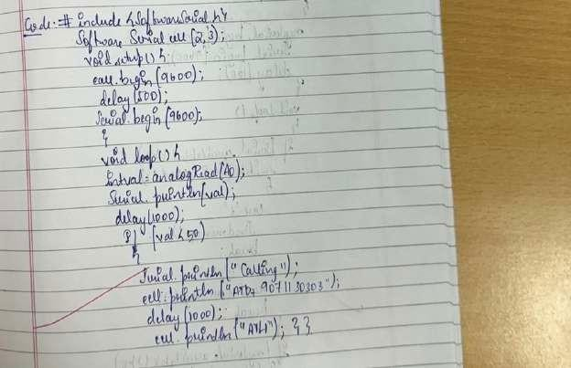

**Observation:**When there is a flame,a particular specified number will get a call as an alert.

Program no: **15** Program Title: **SMS SERVICE USING GSM** Date:11/01/2024

# Aim:

1. **Send SMS using Arduino and GSM Module – to a specified mobile number inside the program**

# Receive SMS using Arduino and GSM Module – to the SIM card loaded in the GSM Module.

**Hardware/components Required**

Arduino Uno board - 1 USB Cable - 1

GSM module SIM slot Jumper wires

# Circuit Diagram / Pin connection:

GSM Tx –>Arduino Rx (Here pin 2) GSM Rx –>ArduinoTx. (Here pin 3)

Make the ground common between Arduino and GSM modem.



# Code:

#include <SoftwareSerial.h> SoftwareSerial mySerial(2, 3);

void setup()

{

mySerial.begin(9600); // Setting the baud rate of GSM Module Serial.begin(9600); // Setting the baud rate of Serial Monitor (Arduino) delay(100);

}

void loop()

{

if (Serial.available()>0) switch(Serial.read())

{

case 's':

SendMessage(); break;

case 'r':

RecieveMessage(); break;

}

if (mySerial.available()>0) Serial.write(mySerial.read());

}

voidSendMessage()

{

# mySerial.println("AT+CMGF=1"); //Sets the GSM Module in Text Mode //AT+CMGF,

**SMS Format**

delay(1000); // Delay of 1000 milli seconds or 1 second

**mySerial.println("AT+CMGS=\"+919742980606\"\r"); // AT+CMGS, Send Message**

// Replace withyour mobile number delay(1000);

# mySerial.println("I am SMS from GSM Module");

// The SMS text you want to send

delay(100);

# mySerial.println((char)26);// ASCII code of CTRL+Z , to terminate the

**message** delay(1000);

}

voidRecieveMessage()

{

**mySerial.println("AT+CNMI=2,2,0,0,0"); // AT+CNMI, New Message Indications**

// AT Command to recieve a live SMS delay(1000);

}

# Handwritten code pic:

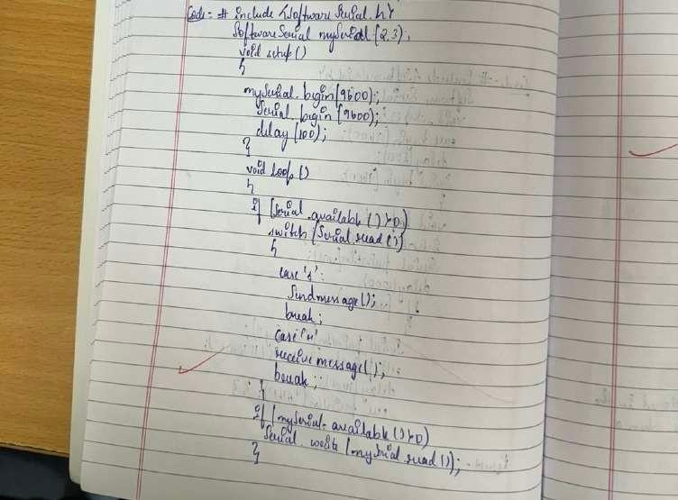

**Observation:**According to the code, messages will be sent and received when ‘s’ and ‘r’ are pressed through serial monitor respectively.

Program no: **16** Program Title: **BLUETOOTH MASTER SLAVE** Date:18/01/2024

**Aim:** To control the LED in the master device by client device.

# Hardware/components Required

Arduino Uno board - 2 USB Cable - 1 Jumper wires

LED-1

HC-05 bluetooth module-2

# Circuit Diagram / Pin connection:

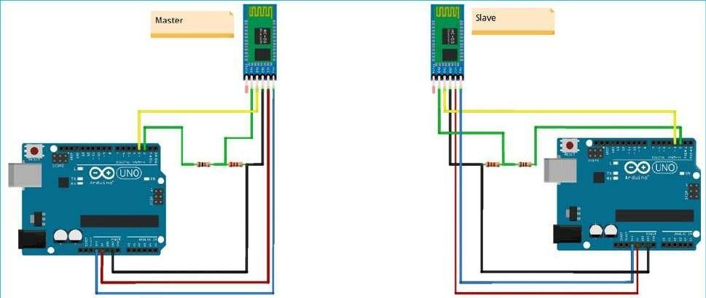

**Slave Mode:**

The HC-05 bluetooth module can also act as a slave. There are fewer commands to set this up:

# AT+ORGL Reset to defaults AT+RMAAD Clear any paired devices AT+ROLE=0 Set mode to SLAVE

**AT+ADDR Display SLAVE address //+ADDR:98d3:33:807822 Master Mode:**

To configure the module as Bluetooth Master and to pair with another bluetooth module follow these steps. First we need to put the module into command mode Enter these

commands in order:

AT+RMAAD Clear any paired devicesAT+ADCN

# AT+ROLE=1 Set mode to Master

**AT+CMODE=0 Allow master to ONLY connect to bound address (slave). This allows the master to automatically connect to the slave when switched on AT+PSWD=1234 Set PIN. Should be same as slave device**

# AT+BIND=<address> Set bind address to the slave address AT+LINK=<address> Connect to slave.

**AT+INIT**

**Note:** If it shows any Error, then check if both the bluetooth modules are blinking in sync. If so then both the bluetooth modules are synchronized.

**BT-Slave Program:**

#include <SoftwareSerial.h> SoftwareSerial BTSerial(10, 11); // RX | TX

void setup() { Serial.begin(9600);

BTSerial.begin(38400); // HC-05 default speed in AT command more }

void loop() {

// Reading the button if(Serial.available())

{

String message = Serial.readString(); Serial.println (message); BTSerial.write(message.c_str());

}

}

**BT-Master Program:**

#include <SoftwareSerial.h>

SoftwareSerial BTSerial(10, 11); // RX | TX #define ledPin 9

String message; int potValue = 0;

void setup() { pinMode(ledPin, OUTPUT); digitalWrite(ledPin, LOW);

Serial.begin(9600);

BTSerial.begin(38400); // HC-05 default speed in AT command more }

void loop()

{ if(BTSerial.available() > 0)

{

// Checks whether data is comming from the serial port // Reads the data from the serial port

message = BTSerial.readString();

// Controlling the LED if(message.indexOf("SWITCH ON")>=0)

{

digitalWrite(ledPin, HIGH); // LED ON

}

else if(message.indexOf("SWITCH OFF")>=0)

{

digitalWrite(ledPin, LOW); // LED OFF

}

else

{

Serial.println("Noting to do");

}

delay(100);

}

delay(10);

}

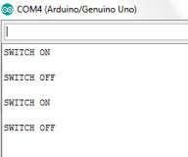

# Handwritten code pic:

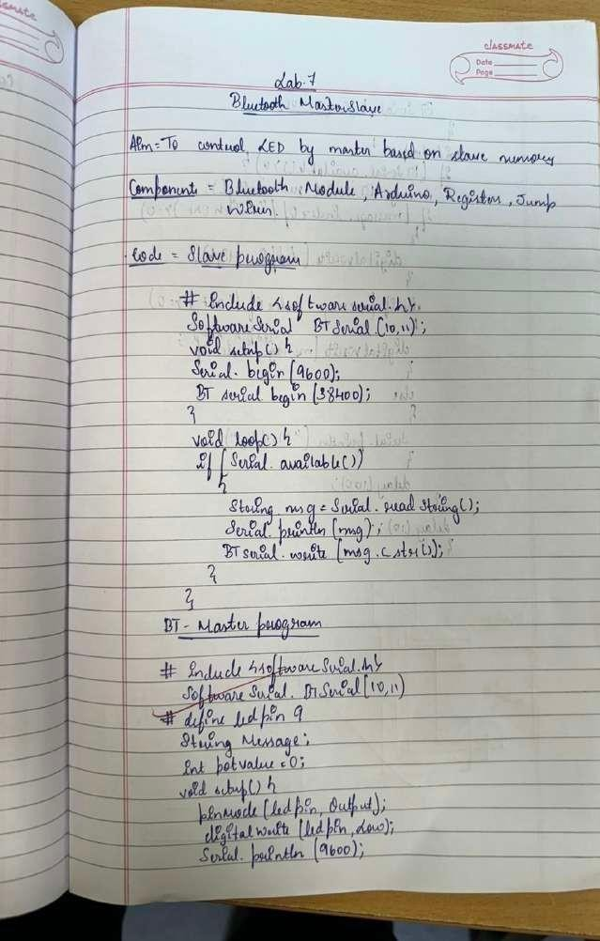

**Observation:**Whenever Client device sends the message “SWITCH ON”,LED turns ON and turns OFF if the message is “SWITCH OFF” otherwise it prints “Nothing to do” in the serial monitor.