Computer Science Pong Lab – THE GAME Lab Value - 100

Lab Goal : This lab was designed to teach you more object oriented programming and how to write a very simple game.

Lab Description : Now that Block, Ball, and Paddle have all been tested numerous times, we can put them all together to make the Ping Pong Game. The hardest part of the game is getting the paddles to hit the ball. I am giving you some logic to make the Ball hit the left paddle. You must then create the logic to make the Ball hit the right paddle. You will use Pong.java to write the final game.

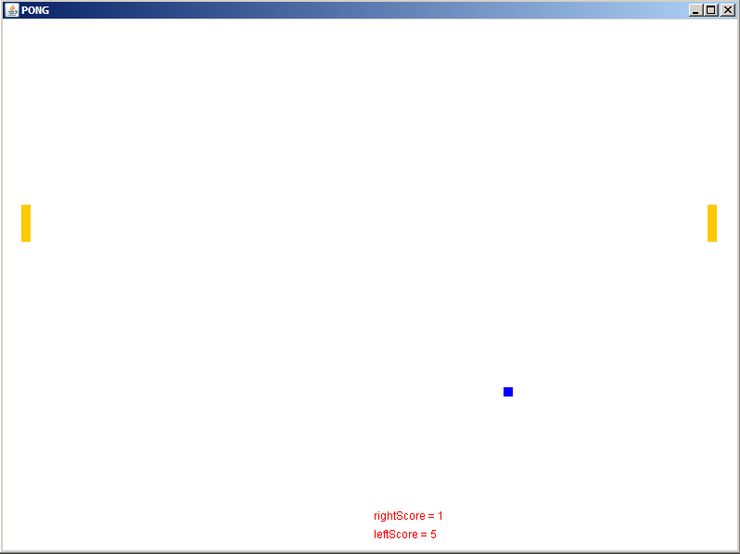
Basic logic to see if the Ball
collides with the left Paddle

if( (ball’s x <= left paddle’s x +left paddle’s width+abs(ball x Spd)
&&
( balls’s y >= left paddle’s y &&
balls’s y <= left paddle’s y + left paddle’s height ||
ball’s y + ball’s height >= left paddle’s y &&
ball’s y + ball’s height < left paddle’s y + paddle’s height ) )
{
if( balls’s x <= left paddle’s x +left paddle’s width – abs(ball x Spd )
set Y speed to negative of current speed
else
set X speed to negative of current speed
}

PONG GAME REQUIREMENTS

1. Get the Ball to bounce off the left paddle and right paddle with no bugs. If the Ball sticks to the paddle at any time, that is a BUG.

2. Add in scoring. Every time the ball gets past a paddle the other paddle/player gets a point.

3. Create the following Collidable interface. Have Ball implement this interface as it will be doing all of the colliding.

public interface Collidable
{
boolean didCollideLeft(Object obj);
boolean didCollideRight(Object obj);
boolean didCollideTop(Object obj);
boolean didCollideBottom(Object obj);
}

These methods will receive objects and determine if a collision has occurred between this object and the other object.
Move the collision detection code from paint into the appropriate method. Make calls to the new methods.

PONG GAME EXTENSIONS

1. Create a Wall class that is an extension of Block. Then, make new instance variables for all 4 Walls. Finally, rewrite your code so
that you actually check to see if the Ball collides with the Walls rather than will fixed number boundaries.

2. Save a copy of your Pong game and turn it into BreakOut. BreakOut was a cool 80s game with a field of Blocks at the top, a ball,
and a paddle that moved across the bottom of the screen. The ball bounced off of the paddle and hit the Blocks. Once a Block was hit, that Block would disappear.

3. Save a copy of your Pong game and turn it into AirHockey. AirHockey is a very cool game with Paddles that can move up, down,
left, and right. Goals are placed on each side and scoring occurs when the puck makes it into a goal.

