Computer Science STARFIGHTER – THE STARTUP Lab Value - 100

Lab Goal : This lab was designed to teach you more about OOP and using Abstract Classes and Interfaces.

Lab Description : Write a first person shooter game. You are the StarFighter and your job is to destroy all of the enemy ships that enter your space. The StarFighter ship and enemy ships will share lots of the same properties. This lab provides the perfect opportunity to use abstract classes and interfaces.

Task One – Write the MovingThing class. MovingThing will implement the Locatable interface. Make sure you think it through and that it compiles. Test it thoroughly.
Task Two – Extend the MovingThing class to make the Ship class.
Task Three – Use StarFighter and OuterSpace to test the Ship class. The Ship should move all around the screen in all 4 directions.
Task Four – Extend the MovingThing class to make the Alien class.
Task Five – Test the Alien class. The Alien class should move side to side only. Aliens do not move up and down.
Task Six – Make your Ship shoot some type of Ammo. You must make an Ammo class that extends MovingThing.
Task Seven – Make your Ship shoot and destroy the Alien.
Task Eight – Make new class called Aliens. Aliens should contain a matrix of Alien references.

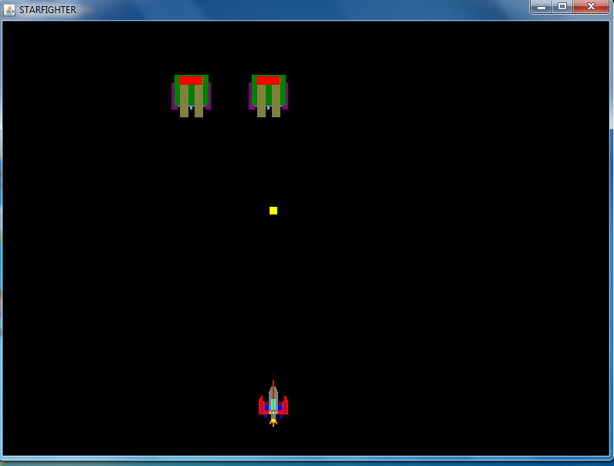
KEYS TO CONTROL THE SHIP

h - left
j - right
u - up
n - down

