JBuilder Setup

Open JBuilder, create a new project, say “tradingPartner.jpx”,

Add packages to the project

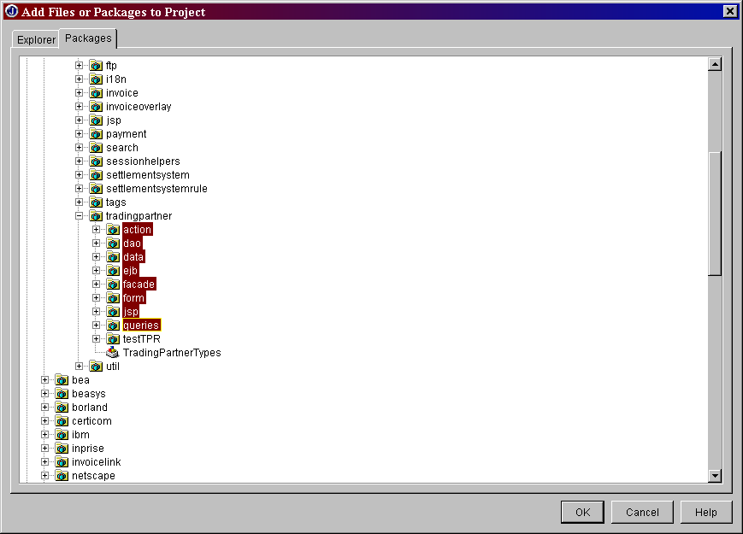

Modify the [Project Properties]

Modify [Paths] Settings

[output path] to ant compiled classes on my machine it’s (C:/projects/netmarket/build/classes)

[Working directory] (C:/projects/netmarket/data/javasrc/TradingPartner/com/bceemergis/einvoicing/tradingpartner)

[Source/Default] (C:/projects/netmarket/data/javasrc/TradingPartner)
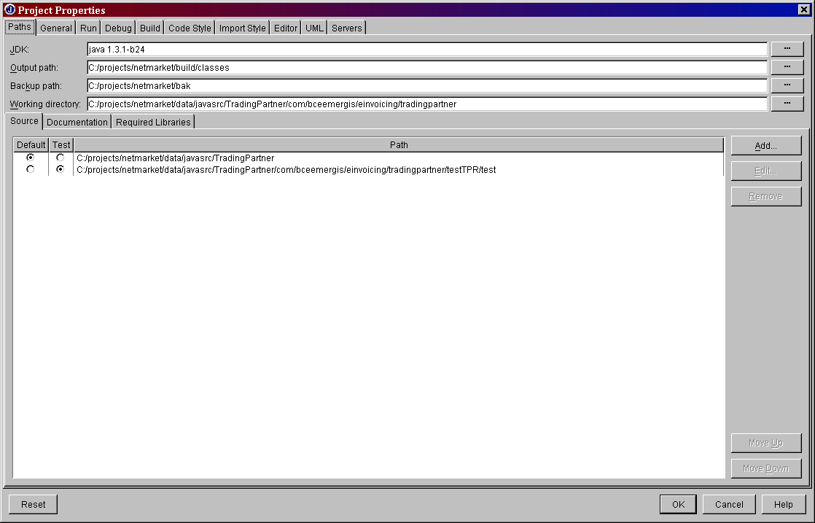

Modify [Debug] Settings

check [Enable remote debugging]

check [Attach]

change the host name if necessary

make sure [Transport / Type] is (dt_socket) and [Transport / Address] is (8888), which is the same value with your modified Weblogic startup file

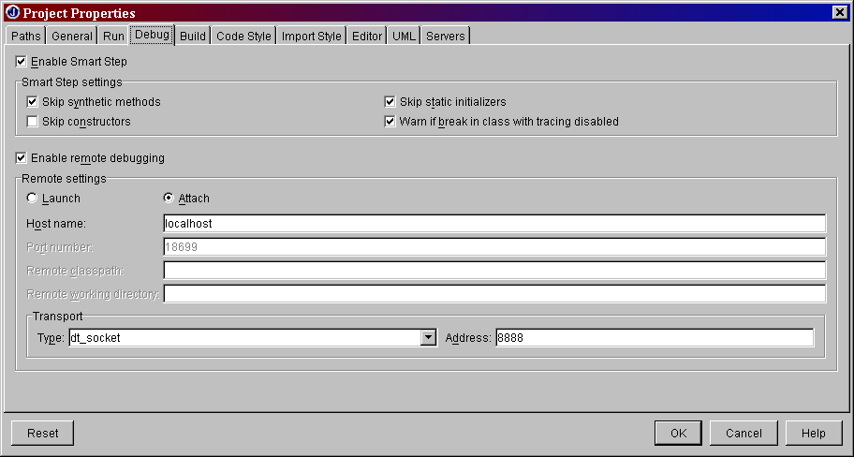

Modify [Build] Settings

make sure [java /Debug Options:] is (source, line, and variable information) or you can choose other option depends on your requirement

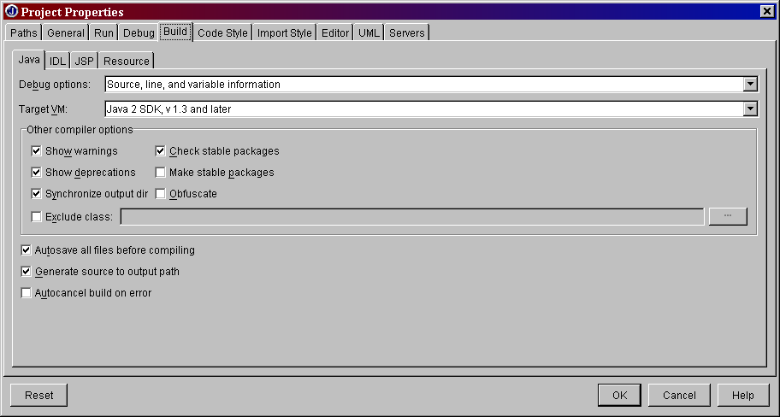

Add Breakpoints

This process should be repeated for as many breakpoints as you want in this debug session.

Go to [Run / Add Breakpoint / Add Cross Process Breakpoint]

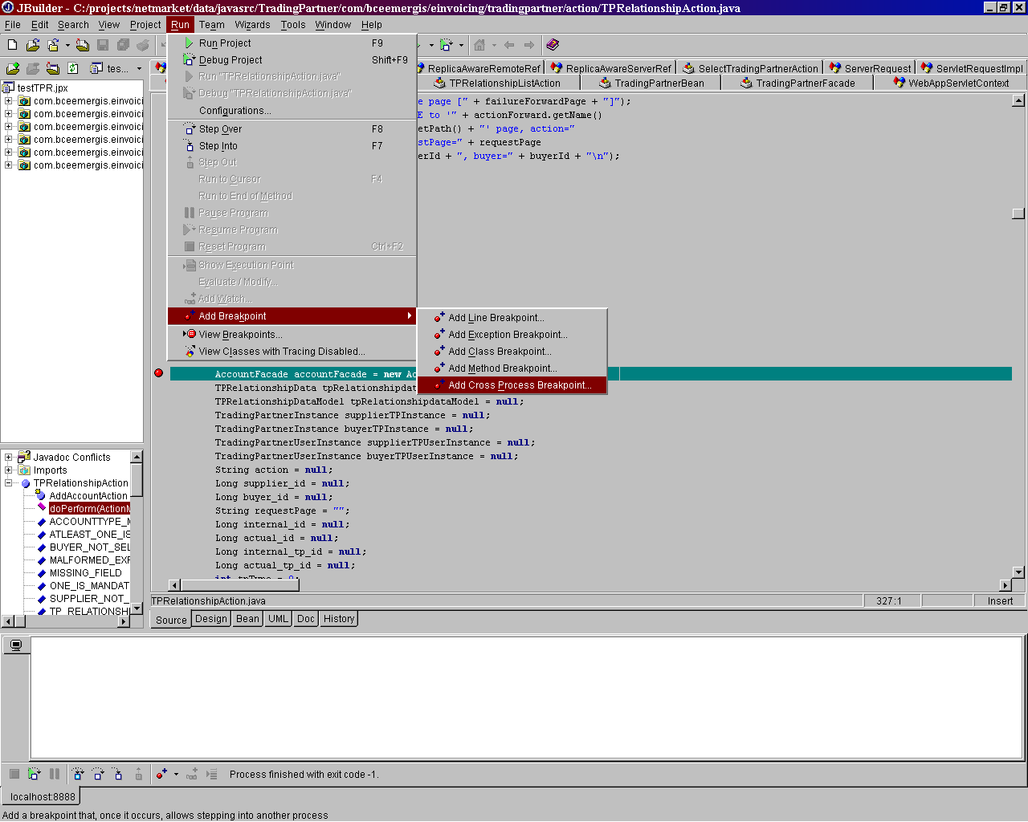

Add break point in the server

select the class that you want to debug
select the method that you want to debug (if you don’t select, the debug will stop at every method in this class)
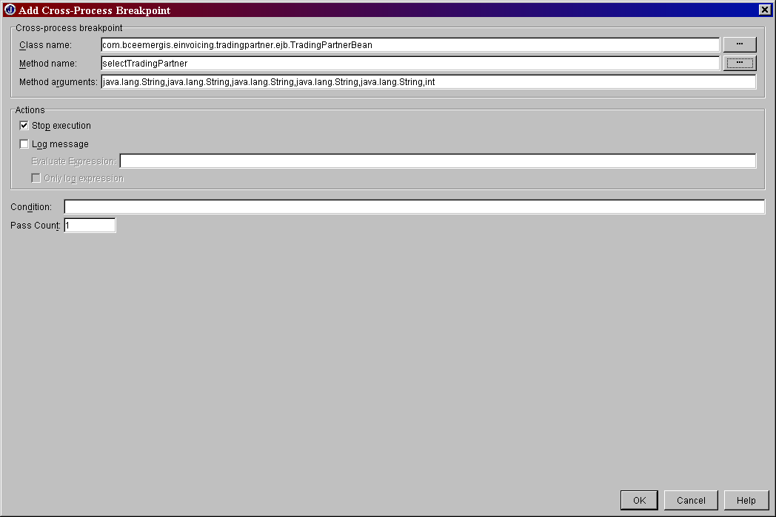

Put break point in the JBuilder pane.

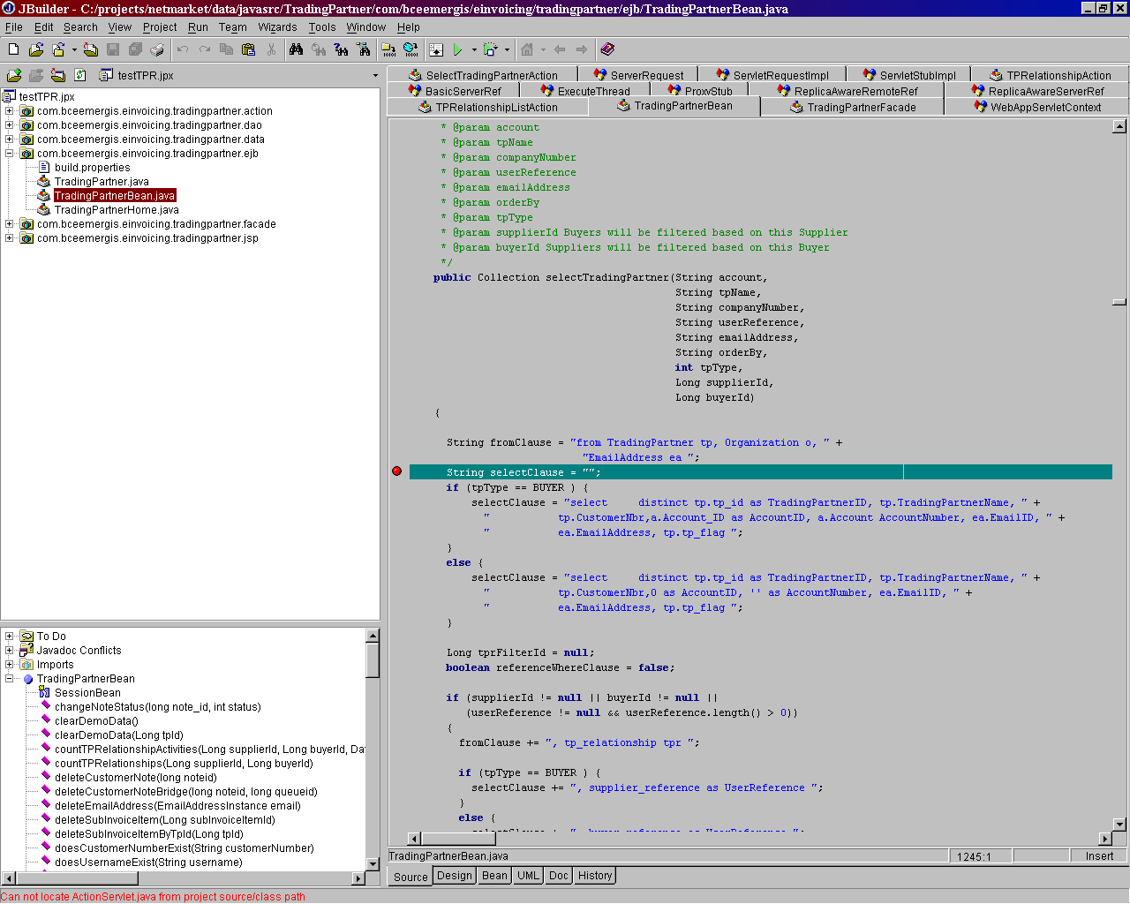

Run debug

Select [Run / Debug Project] to initiate a debug session in JBuilder.

Login to the application and you can debug into action class, façade and EJB now

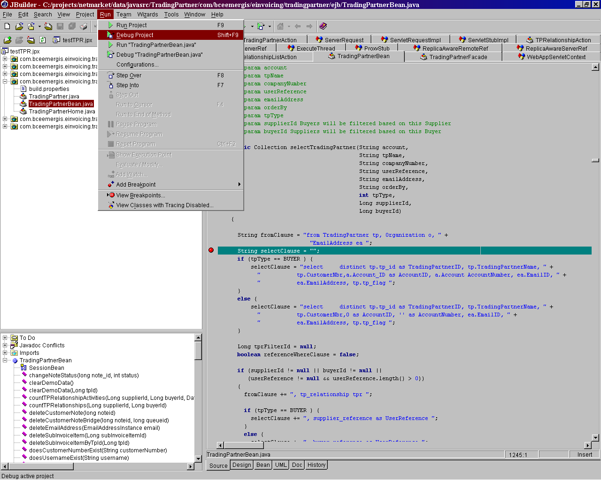

Sample startWebLogic.cmd

@echo off

setlocal

set PRODUCTION_MODE=false

set WLS_PW=changeme

set BEA_HOME=c:\bea

set JAVA_HOME=%BEA_HOME%\jdk131

set WL_HOME=%BEA_HOME%\wlserver6.1

set ORACLE_HOME=c:\Oracle\Ora81

set SC_DIR=C:\bea\wlserver6.1\config\merge\serverclasses

set APP_DIR=C:\bea\wlserver6.1\config\merge\applications

set JAVA_OPTIONS=-classic

set JAVA_MEMORY_OPTIONS=-Xdebug -Xnoagent -Djava.compiler=NONE -Xrunjdwp:transport=dt_socket,address=8888,suspend=n,server=y -Xms256m -Xmx512m

set LOCALCLASSPATH=%WL_HOME%\lib\weblogic.jar;%APP_DIR%;%APP_DIR%\invoicer\bundles;%APP_DIR%\invoicer\buyer\bundles;%APP_DIR%\invoicer\config\bundles;%APP_DIR%\custservweb\bundles;%APP_DIR%\custservweb\byer\bundles;%APP_DIR%\custservweb\config\bundles;%SC_DIR%\xmlx.jar;%SC_DIR%\xml4j.jar;%SC_DIR%\xml.jar;%SC_DIR%\xerces.jar;%SC_DIR%\xalan.jar;%SC_DIR%\w3c.jar;%SC_DIR%\twofish.jar;%SC_DIR%\rowset.jar;%SC_DIR%\mail.jar;%SC_DIR%\log4j.jar;%SC_DIR%\license.bea.61;%SC_DIR%\junit.jar;%SC_DIR%\jsse.jar;%SC_DIR%\js.jar;%SC_DIR%\jaxp.jar;%SC_DIR%\jakarta-regexp-1.2.jar;%SC_DIR%\fop.jar;%SC_DIR%\dj750ej.jar;%SC_DIR%\dj750ec.jar;%SC_DIR%\dj750UrlFile.jar;%SC_DIR%\crimson.jar;%SC_DIR%\com;%SC_DIR%\classes12_01.zip;%SC_DIR%\bsf.jar;%SC_DIR%\NetComponents.jar;%SC_DIR%\DebugLoggerStartup.jar;

set DOMAIN_NAME=merge

set PATH=%JAVA_HOME%\bin;%WL_HOME%\bin;%WL_HOME%\bin\oci817_8;%ORACLE_HOME%\bin;%PATH%

set CLASSPATH=%LOCALCLASSPATH%

cd %WL_HOME% & %JAVA_HOME%\bin\java %JAVA_OPTIONS% %JAVA_MEMORY_OPTIONS% -Dweblogic.Domain=%DOMAIN_NAME% -Dweblogic.Name=myserver -Dbea.home=%BEA_HOME% -Dweblogic.management.password=%WLS_PW% -Dweblogic.ProductionModeEnabled=%PRODUCTION_MODE% -Dweblogic.management.discover=false -Djava.security.policy==%WL_HOME%\lib\weblogic.policy weblogic.Server

