Configure JBuilder 7 and Weblogic for Debugging

Modify Weblogic Startup File
Modify the WebLogic startup file and edit the start command to include the following VM parameters, or replace -hotspot with:
-classic -Xdebug -Xnoagent -Djava.compiler=NONE -Xrunjdwp:transport=dt_socket,address=8888,suspend=n,server=y

By changing suspend=n to suspend=y, the WebLogic server will suspend immediately at startup. It will not resume execution until you start remote debugging on your EJB source code by selecting Run / Step Into and then Run / Resume Program. Normally you do not need to suspend WebLogic at startup.

For local testing and debugging purposes, the Weblogic startup file local/startWebLogic.cmd in CVS has the above VM parameters incorporated. Invoke this file to begin a weblogic session.

JBuilder Setup

Project Properties
In JBuilder open an EJB component project such as identitymanager.jpx. In ProjectProperties, select the Run tab, highlight the Application configuration for the project, click on Edit, and select the Debug tab.

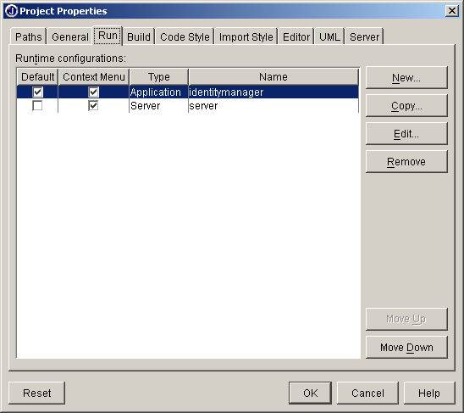

With the Debug tab selected:
- check Enable Remote Debugging
- check Attach
- change the host name if necessary (the default is localhost for local machine)
- make sure Transport / Type is dt_socket and Transport / Address is 8888

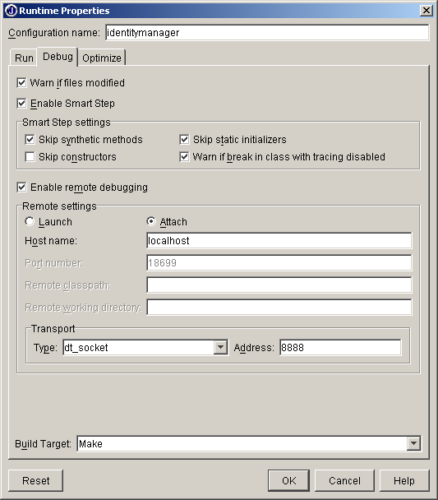

With the Build tab selected, activate the Java tab and make sure the value of Debug Options is Source, line, and variable information (or choose another option depending on your requirements).
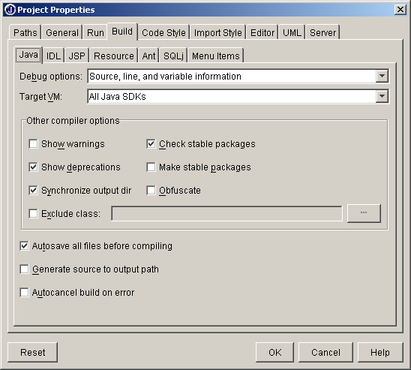

Set Breakpoints

Under the Run menu Add Breakpoint / Add Cross Process Breakpoint:

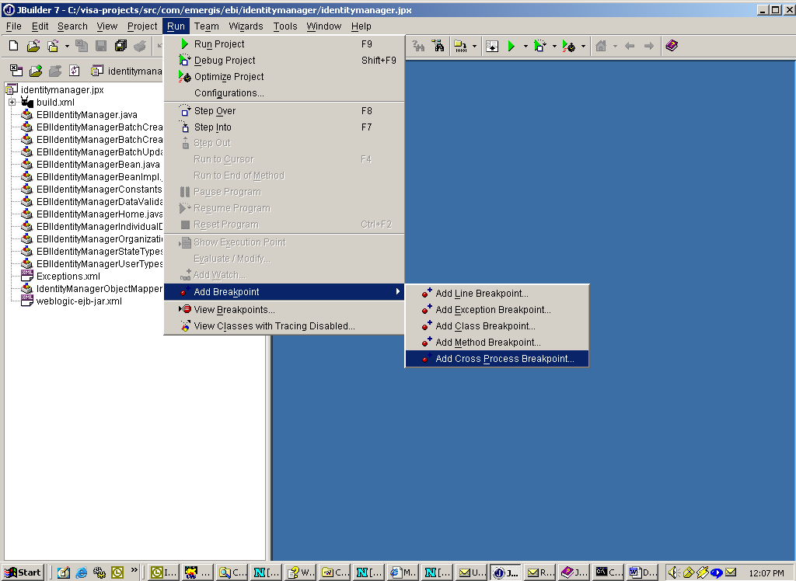

Using the Browse (…) buttons, select the class that you want to debug and then select the method that you want to debug. Repeat this process for each of the methods in which you wish to set Breakpoints.

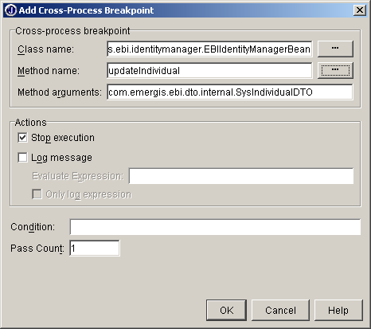

When finished setting Cross-process breakpoints, the breakpoint lines need to be set in the source code display window:

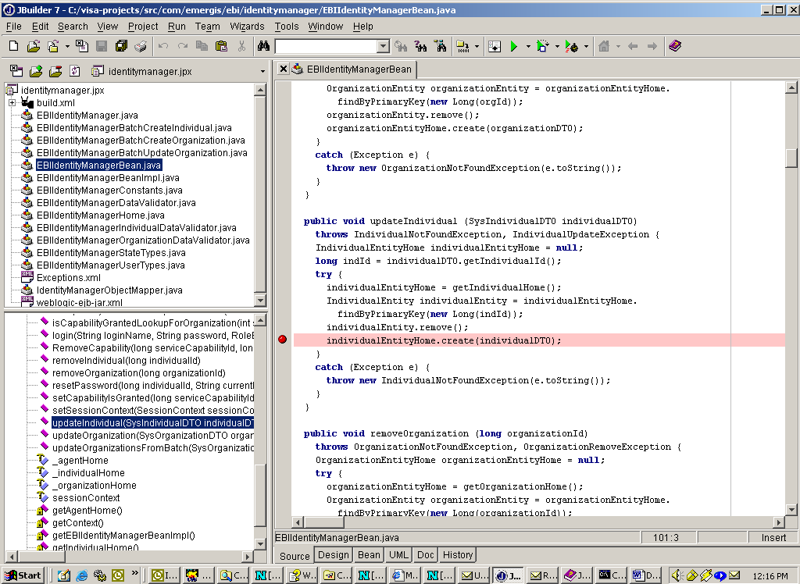

Initiate the Debug Session
Select Step Into from beneath the Run menu (see graphic) and then Resume Program (button in lower left corner of your window, with the localhost:8888 tab selected) to initiate a debug session with the remote WebLogic server process.

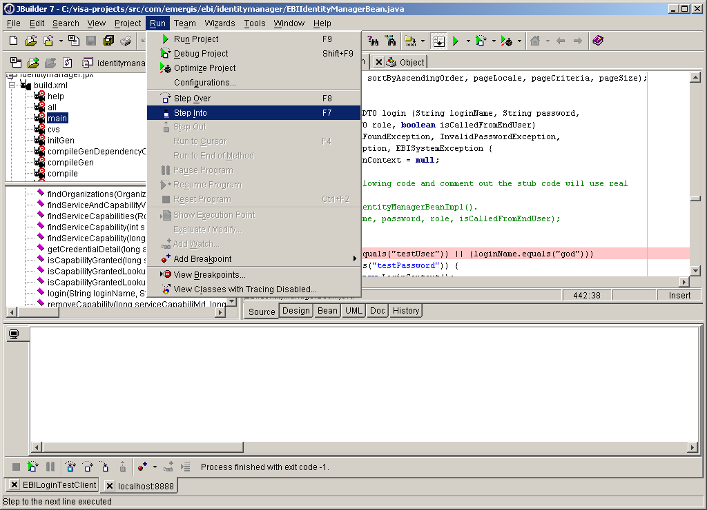

Now you are ready to run your client program in JBuilder and debug into your application server code running in the remote WebLogic process. The WebLogic execution will break where the cross-process breakpoint is specified at the line with a source-code breakpoint. You can step through the program execution from the breakpoint in JBuilder.

