Q3 SOlution using storyboard drag and drop :
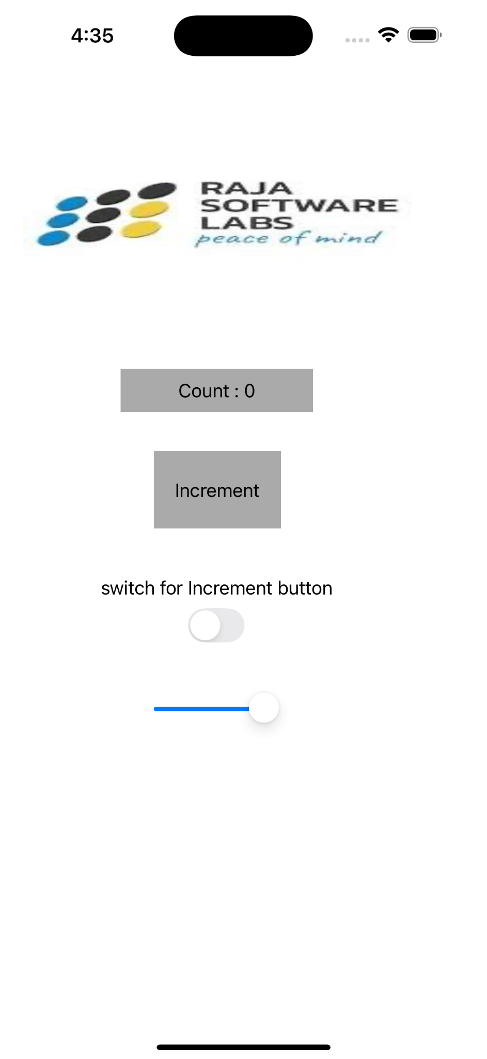
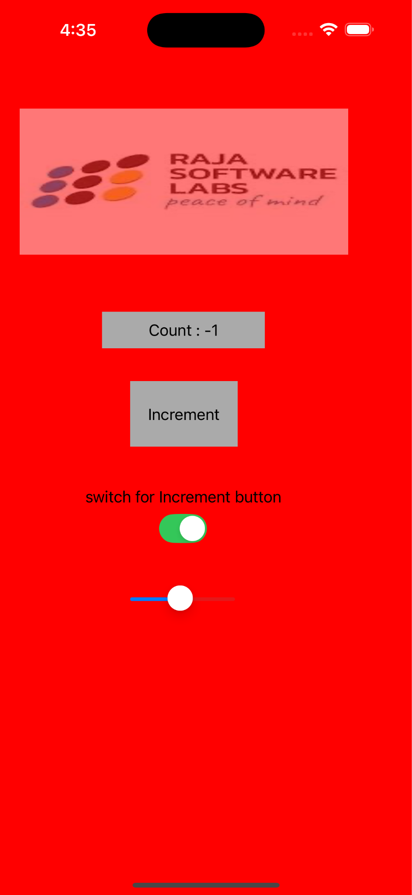
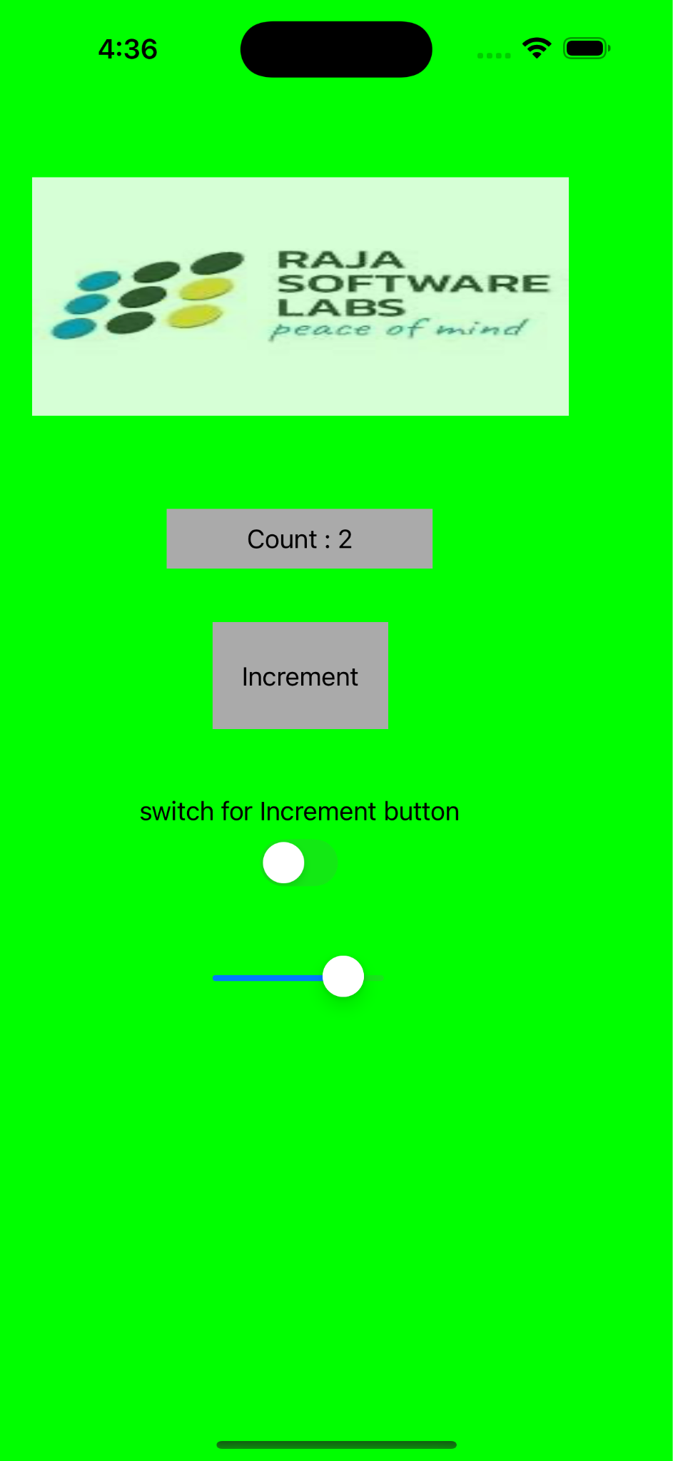
Code: ViewController.h

#import <UIKit/UIKit.h>

@interface ViewController : UIViewController

@property (weak, nonatomic) IBOutlet UILabel *countLabel;
@property (weak, nonatomic) IBOutlet UIButton *incrementButton;
@property (weak, nonatomic) IBOutlet UIImageView *imageView;
@property (weak, nonatomic) IBOutlet UISwitch *toggleSwitch;
@property (weak, nonatomic) IBOutlet UISlider *opacitySlider;

@property (assign, nonatomic) NSInteger count;

- (IBAction)incrementButtonTapped:(UIButton *)sender;
- (IBAction)screenTapped:(UITapGestureRecognizer *)sender;
- (IBAction)switchValueChanged:(UISwitch *)sender;
- (IBAction)sliderValueChanged:(UISlider *)sender;

@end

ViewController.m
#import "ViewController.h"

@interface ViewController () <UIGestureRecognizerDelegate>
@end

@implementation ViewController

- (void)viewDidLoad {
[super viewDidLoad];

self.count = 0;
[self updateUI];

UITapGestureRecognizer *screenTap = [[UITapGestureRecognizer alloc] initWithTarget:self action:@selector(screenTapped:)];
screenTap.delegate = self;
screenTap.cancelsTouchesInView = NO;
[self.view addGestureRecognizer:screenTap];

[self.toggleSwitch setOn:YES animated:NO];
self.incrementButton.enabled = YES;
self.opacitySlider.minimumValue = 0.0;
self.opacitySlider.maximumValue = 1.0;
self.opacitySlider.value = 1.0;
}

- (IBAction)sliderValueChanged:(UISlider *)sender {
self.imageView.alpha = sender.value;
}

- (IBAction)switchValueChanged:(UISwitch *)sender {
self.incrementButton.enabled = sender.isOn;
self.incrementButton.alpha = sender.isOn ? 1.0 : 0.5;
}

- (IBAction)incrementButtonTapped:(UIButton *)sender {
self.count++;
[self updateUI];
}

- (IBAction)screenTapped:(UITapGestureRecognizer *)sender {
self.count--;
[self updateUI];
}

#pragma mark - UIGestureRecognizerDelegate

- (BOOL)gestureRecognizer:(UIGestureRecognizer *)gestureRecognizer shouldReceiveTouch:(UITouch *)touch {
if (!self.toggleSwitch.isOn) {
return NO;
}

if ([touch.view isDescendantOfView:self.incrementButton]) {
return NO;
}
if ([touch.view isKindOfClass:[UISwitch class]]) {
return NO;
}
if ([touch.view isKindOfClass:[UISlider class]]) {
return NO;
}

return YES;
}

- (void)updateUI {
self.countLabel.text = [NSString stringWithFormat:@"Count : %ld", (long)self.count];

if (self.count == 0) {
self.view.backgroundColor = [UIColor whiteColor];
} else if (self.count >= 1) {
self.view.backgroundColor = [UIColor greenColor];
} else {
self.view.backgroundColor = [UIColor redColor];
}
}

@end

