**COMP 4421 (Fall 2018) Assignment 2**

|  |  |  |
| --- | --- | --- |
| **MOHAMAD, Randitya Setyawan** | **20316273** | **rsmohamad@ust.hk** |

**Exercises**

1. **Opening and Closing**

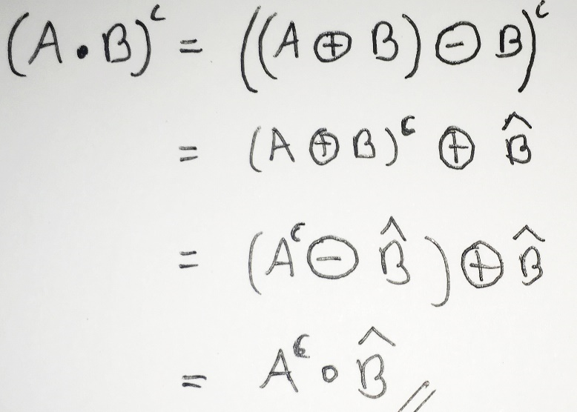

1. **Dilation**

**A dilate B1**

|  |  |  |  |  |  |  |  |
| --- | --- | --- | --- | --- | --- | --- | --- |
| **0** | **0** | **0** | **0** | **1** | **1** | **1** | **1** |
| **0** | **0** | **0** | **1** | **1** | **1** | **1** | **1** |
| **0** | **0** | **0** | **1** | **1** | **1** | **1** | **1** |
| **0** | **1** | **1** | **1** | **1** | **1** | **1** | **1** |
| **1** | **1** | **1** | **1** | **1** | **1** | **1** | **0** |
| **1** | **1** | **1** | **1** | **1** | **0** | **0** | **0** |
| **1** | **1** | **1** | **1** | **1** | **0** | **0** | **0** |
| **1** | **1** | **1** | **1** | **0** | **0** | **0** | **0** |

**A dilate B2**

|  |  |  |  |  |  |  |  |
| --- | --- | --- | --- | --- | --- | --- | --- |
| **0** | **0** | **0** | **0** | **0** | **1** | **1** | **0** |
| **0** | **0** | **0** | **0** | **1** | **1** | **1** | **1** |
| **0** | **0** | **0** | **1** | **1** | **1** | **1** | **1** |
| **0** | **0** | **1** | **1** | **1** | **1** | **1** | **0** |
| **0** | **1** | **1** | **1** | **1** | **1** | **0** | **0** |
| **1** | **1** | **1** | **1** | **1** | **0** | **0** | **0** |
| **1** | **1** | **1** | **1** | **0** | **0** | **0** | **0** |
| **0** | **1** | **1** | **0** | **0** | **0** | **0** | **0** |

**A erode B1**

|  |  |  |  |  |  |  |  |
| --- | --- | --- | --- | --- | --- | --- | --- |
| **0** | **0** | **0** | **0** | **0** | **0** | **0** | **0** |
| **0** | **0** | **0** | **0** | **0** | **0** | **0** | **0** |
| **0** | **0** | **0** | **0** | **0** | **0** | **0** | **0** |
| **0** | **0** | **0** | **0** | **0** | **0** | **0** | **0** |
| **0** | **0** | **0** | **0** | **0** | **0** | **0** | **0** |
| **0** | **0** | **0** | **0** | **0** | **0** | **0** | **0** |
| **0** | **0** | **0** | **0** | **0** | **0** | **0** | **0** |
| **0** | **0** | **0** | **0** | **0** | **0** | **0** | **0** |

**A erode B2**

|  |  |  |  |  |  |  |  |
| --- | --- | --- | --- | --- | --- | --- | --- |
| **0** | **0** | **0** | **0** | **0** | **0** | **0** | **0** |
| **0** | **0** | **0** | **0** | **0** | **0** | **0** | **0** |
| **0** | **0** | **0** | **0** | **0** | **1** | **0** | **0** |
| **0** | **0** | **0** | **0** | **0** | **0** | **0** | **0** |
| **0** | **0** | **0** | **0** | **0** | **0** | **0** | **0** |
| **0** | **0** | **1** | **0** | **0** | **0** | **0** | **0** |
| **0** | **0** | **0** | **0** | **0** | **0** | **0** | **0** |
| **0** | **0** | **0** | **0** | **0** | **0** | **0** | **0** |

**Programming**

1. **Hough Transform**

|  |  |
| --- | --- |
| **Filename** | **Image** |
| **1_marked.jpg** |  |
| **2_marked.jpg** |  |
| **3_marked.jpg** |  |
| **4_marked.jpg** |  |
| **5_marked.jpg** |  |
| **6_marked.jpg** |  |

1. **Image Warping**

|  |  |
| --- | --- |
| **Filename** | **Image** |
| **1_warped.jpg** |  |
| **2_warped.jpg** |  |
| **3_warped.jpg** |  |
| **4_warped.jpg** |  |
| **5_warped.jpg** |  |
| **6_warped.jpg** |  |