web server with NGINX on an AWS EC2 instance

1. Launch an EC2 Instance
- Log in to your AWS Management Console.
- Navigate to EC2 and launch a new instance:
  - Choose an Amazon Machine Image (AMI) (e.g., Amazon Linux 2 or Ubuntu).
  - Select an instance type (e.g., t2.micro for free tier eligibility).
  - Configure instance details, add storage, and configure security groups (ensure port 80 is open for HTTP access).

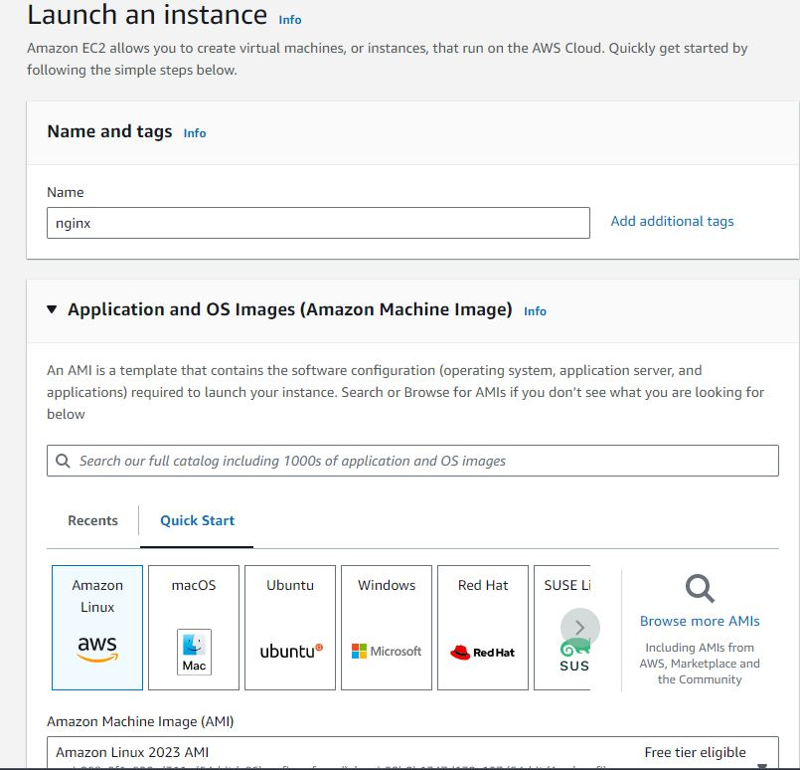
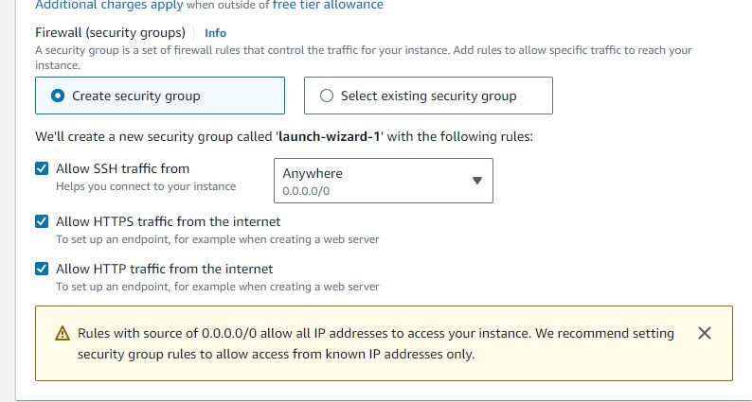

2. Connect to Your EC2 Instance
- Once your instance is running, connect to it using SSH (Secure Shell):
  - Use a terminal or SSH client (e.g., PuTTY for Windows).
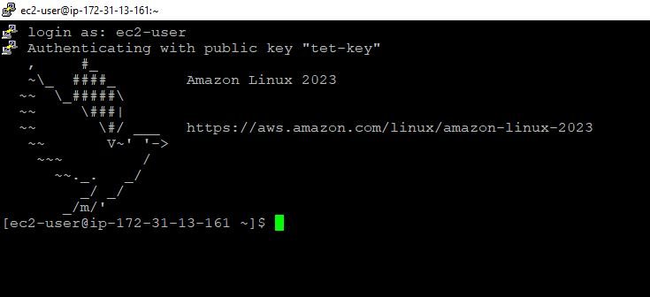

3. Install NGINX
- Update the package list and install NGINX:
  - For Amazon Linux 2:
sudo yum update -y

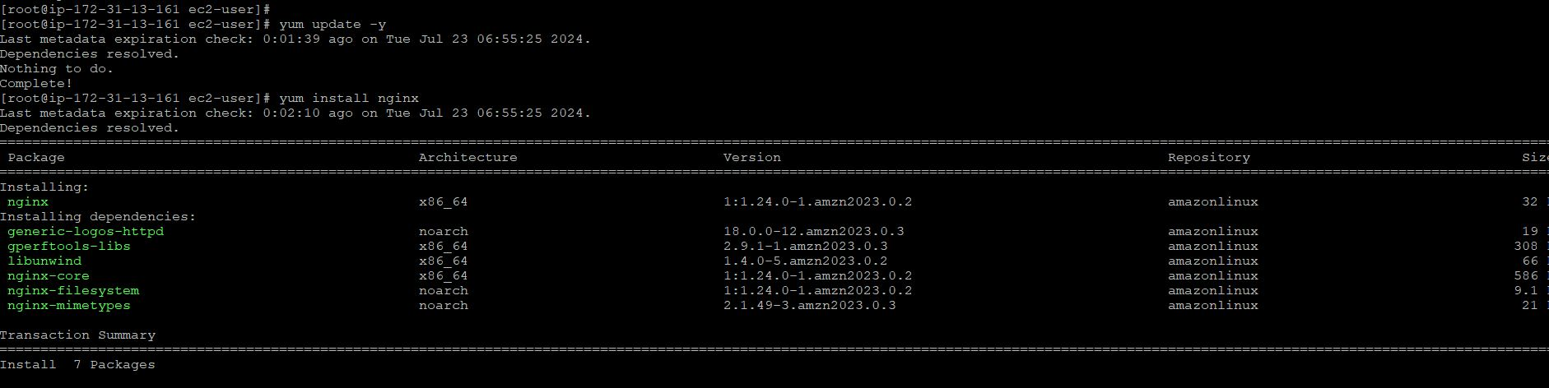

4. Create a New Configuration File
- Navigate to NGINX's configuration directory and create a new configuration file:
cd /etc/nginx/conf.d
sudo vi text.conf

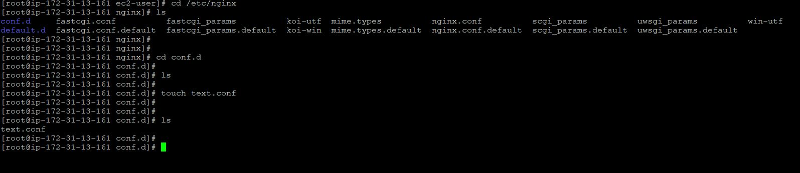

In the text.conf file, configure a basic NGINX server block:
server {
listen 80;
server_name your-ip;

location / {
root /usr/share/nginx/test;
index index.html;
}
}

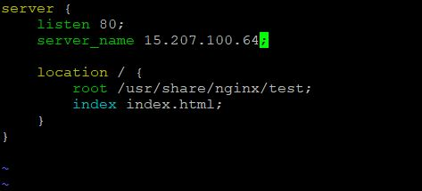

Replace your-ip or your-public-ip with your EC2 instance's public IP address or domain name.
- Save and exit the text editor (Esc, :wq, then Enter)
5. Create New Folder
Go to the root location: cd /usr/share/nginx
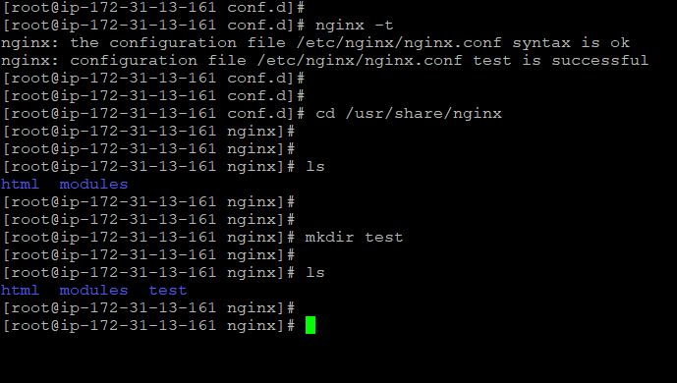
Create a folder named test: mkdir test

6. Inside Folder test
cd test
Create an HTML file:
touch index.html
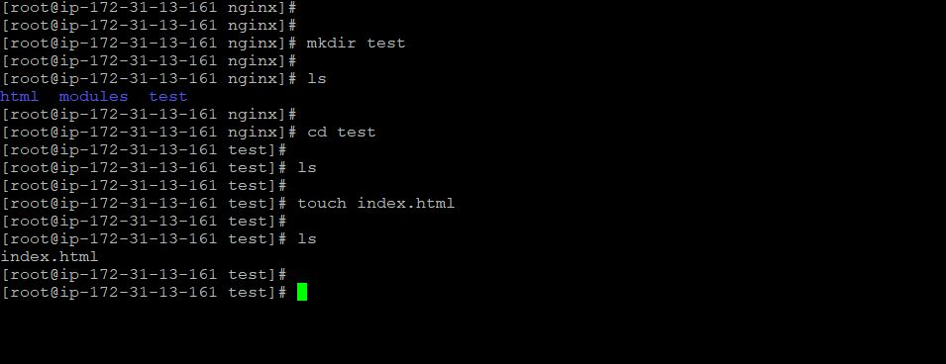
vi index.html
Write HTML code (for example):
hi, I am nginx coming from new configuration files.
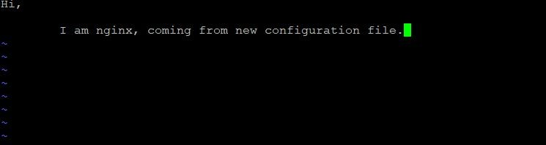

Test NGINX Configuration
Check for any syntax errors in your NGINX configuration:
- sudo nginx -t
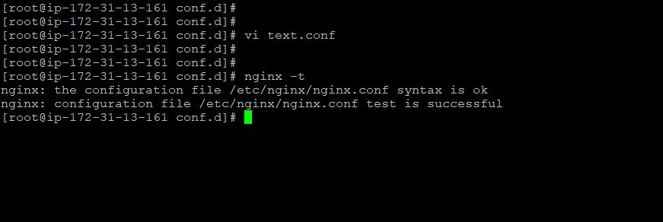
Start NGINX
Apply your new configuration by starting NGINX:
sudo systemctl start nginx
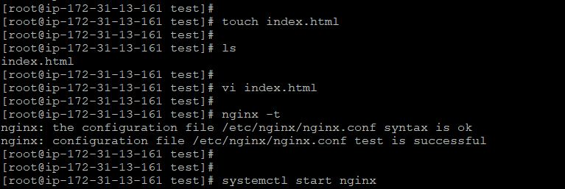

Access Your Website
- Open a web browser and enter your EC2 instance's public IP address or domain name. You should see your index.html page served by NGINX.
