Rock, Paper, Scissors Name ______________________
AP Computer Science 32 points Date ______________ Period ___

RockPaperScissors.java For this assignment, you will create a program that plays the game “Rock, Paper, Scissors.”

Background
Rock, Paper, Scissors (also known by several other names, see http://en.wikipedia.org/wiki/Rock_paper_scissors) is an extremely popular hand game most often played by children. Often, it is used as a method of selection similar to flipping a coin or throwing dice to randomly select a person for some purpose. Of course, this game is not truly random since a skilled player can often recognize and exploit the non-random behavior of an opponent; for instance, if you notice that your opponent chooses Paper most frequently, you may choose Scissors (which beats Paper) most often in an effort to win.

Rules of the Game
The objective of Rock, Paper, Scissors is to defeat your opponent by selecting a weapon that defeats their choice under the following rules:

- Rock smashes Scissors (Rock wins)
- Scissors cut Paper (Scissors wins)
- Paper covers Rock (Paper wins)
- If players choose the same weapon, neither win and the game is played again

Program Specifications
Write a program for a user to play Rock, Paper, Scissors against the computer. The first one to 2 wins the game.

Each round of the game will have the following structure:
- The program will prompt the beginning of the round and ask the user for his/her weapon choice.
- The computer will choose a weapon (Rock, Paper, Scissors), but its choice will not be displayed until later so the user doesn’t see it.
- The two weapons will be displayed on the screen and compared to determine the winner (or a tie) and the results will be displayed by the program.
- The next round will begin, and the game will continue until the user or computer wins 2 games.
- The computer will keep score and print the score after each round.
- When the game ends, the computer will announce the winner and ask the user to play again.

At the beginning of the round, the user should be prompted for his/her input. The computer should read the integer value of the choice.
- Rock
- Paper
- Scissors

At the beginning of each round your program should ask the user for an input. If the user inputs something other than 1, 2, or 3, the program should detect the invalid entry and ask the user to make another choice.

Your program should remember the game history (whether the user wins, the computer wins, or the round is tied).

At the end of the game, the user should be prompted to play again. The user can choose “y” for yes or “n” for no.

It may be beneficial to create constant values to represent each weapon for easy reference in the program (it also helps other people reading and grading the code to understand your logic).

static final int ROCK = 1;
static final int PAPER = 2;
…

public static void main (String[] args)
{
int playerChoice;

// code to read player’s choice

if (playerChoice == ROCK)
// do something
}

Submit RockPaperScissors.java on VISION
A Sample Game

Welcome to Rock, Paper, Scissors.
- Rock
- Paper
- Scissors
Choose your weapon (1, 2, or 3): 2

Choice: Paper
Computer: Scissors

Computer wins that round. Score: 0 – 1

- Rock
- Paper
- Scissors
Choose your weapon (1, 2, or 3): 7
Invalid choice. Choose your weapon (1, 2, or 3): 1

Choice: Paper
Computer: Paper

Tie!! Score: 1 – 1

- Rock
- Paper
- Scissors
Choose your weapon (1, 2, or 3): 1

Choice: Paper
Computer: Rock

You win that round!! Score: 1 – 1

1. Rock
2. Paper
3. Scissors
Choose your weapon (1, 2, or 3): 1

Choice: Scissors
Computer: Rock

Computer wins that round. Score 1 – 2.
GAME OVER. You lost.
Play again (y/n)? n

Extension #1 (+1 point): Rock, Paper, Scissors, Lizard, Spock
(as seen on the Big Bang Theory)

RockPaperScissorsLS.java Once your game of Rock, Paper, Scissors works successfully to specification, extend your game to include two additional choices: “Lizard” and “Spock.” The game plays exactly like the original game, under the following extended rules:

- Rock crushes Scissors and crushes Lizard
- Paper covers Rock and disproves Spock
- Scissors cuts Paper and decapitates Lizard
- Lizard eats Paper and poisons Spock
- Spock smashes Scissors and vaporizes Rock

One can see by careful study that the extended game is fair, as is the original game; each choice beats two other choices and loses to two others. In addition, the presence of two additional choices reduces the chance that the two players will make the same choice (which results in a tie).

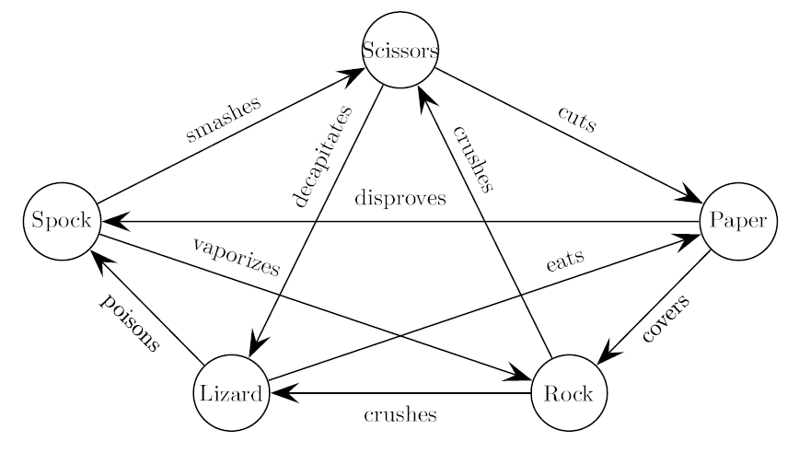

At the beginning of the round, the user should be prompted for his/her input. The computer should read the integer value of the choice.
- Rock
- Paper
- Scissors
- Lizard
- Spock

At the beginning of each round your program should ask the user for an input. If the user inputs something other than 1, 2, 3, 4, or 5, the program should detect the invalid entry and ask the user to make another choice.

Submit RockPaperScissorsLS.java on VISION

Extension #2 (+4 Points): Computer Always Wins

RockPaperScissorsCheater.java Revert back to your original RockPaperScissors.java game. The computer should always win. The challenge, however, is to not make it obvious that the computer wins each game. There still needs to appear that the computer is making its choice randomly. This is extremely important if multiple games are played.

Sample Games
Round 1 User Wins 1 – 0
Round 2 Computer Wins 1 – 1
Round 3 Tie 1 – 1
Round 4 Tie 1 – 1
Round 5 Computer Wins 1 – 2

Round 1 Computer Wins 0 – 1
Round 2 Tie 0 – 1
Round 3 Tie 0 – 1
Round 4 Computer Wins 0 – 2

Round 1 Tie 0 – 0
Round 2 Computer Wins 0 – 1
Round 3 Player Wins 1 – 1
Round 4 Computer Wins 1 – 2

(+2 point) Submit RockPaperScissorsCheater.java on VISION.

(+2 point) Submit a written explanation of your strategy for the computer winning every game on VISION.
AP Computer Science Name ___________________
RockPaperScissors 32 points Date __________ Period ___
Grading Rubric

Structure | Points
Displays menu each round | / 3
Prompts and reads users choice | / 3
Display user and computer’s choice | / 3
Display winner of each round | / 3
Display score after each round | / 3
Plays the next round | / 3
Display winner of the game | / 3
Correctly plays game again | / 3
Debugging / Testing
Does not allow other integer input (multiple times) | / 2
Does not allow other String input to play again (multiple times) | / 2
A tie does not receive a point (multiple times) | / 2
Style
Code is commented | / 1
Uses clear and logical variable and method names | / 1
Extension #1: Rock, Paper, Scissors, Lizard, Spock (+2) | / 0
Extension #2: Computer Always Wins (+2) | / 0
Extension #2: Written Explanation (+2) | / 0
Total | / 32

