manual verification:
- afbq/v1/epdf/case_1
- afbq/v1/spdf/case_1
- agob/v1/epdf/case_1
- agob/v1/spdf/case_1
- arbk/v1/s_pdf/case_1
- arbk/v3/e_pdf/case_1
- arbk/v4/e_pdf/case_1
- arbk/v4/s_pdf/case_1
- arbk/v5/e_pdf/case_1
- bimb/v1/s_pdf/case_1
- bimb/v2/e_pdf/case_1
- bimb/v3/e_pdf/case_1
- bimb/v3/s_pdf/case_1]
- bkrm/v1/e_pdf/case_1
- bkrm/v1/s_pdf/case_1
- bkrm/v2/e_pdf/case_1
- bkrm/v2/s_pdf/case_1
- bmmb/v1/e_pdf/case_1
- bsna/v1/s_pdf/case_1
- cibb/v1/e_pdf/case_1
- cibb/v1/s_pdf/case_1
- cibb/v2/e_pdf/case_1
- cibb/v3/e_pdf/case_1
- cibb/v3/s_pdf/case_1
- cibb/v4/e_pdf/case_1
- cibb/v5/s_pdf/case_1
metadata date check fail
- arbk/v1/e_pdf/case_1
- arbk/v2/e_pdf/case_1
- bsna/v1/e_pdf/case_1
- cibb/v5/e_pdf/case_1

attribute error no file_account_number:
- arbk/v2/s_pdf/case_1
safe convert error:
- arbk/v3/s_pdf/case_1
- 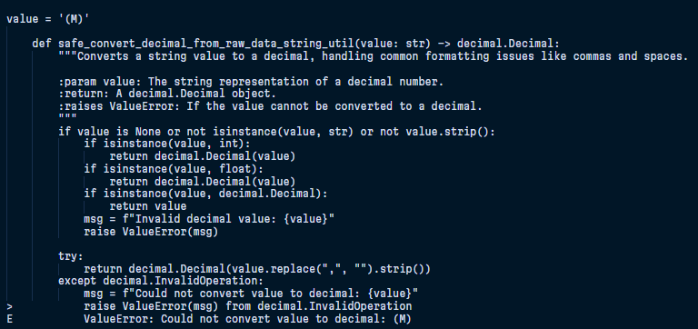

- arbk/v5/s_pdf/case_1

- 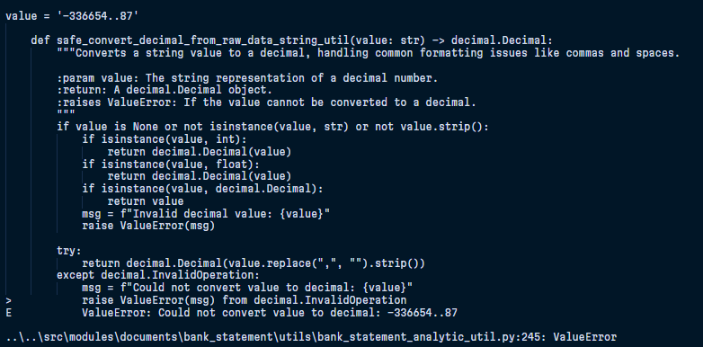

- bimb/v2/s_pdf/case_1

- 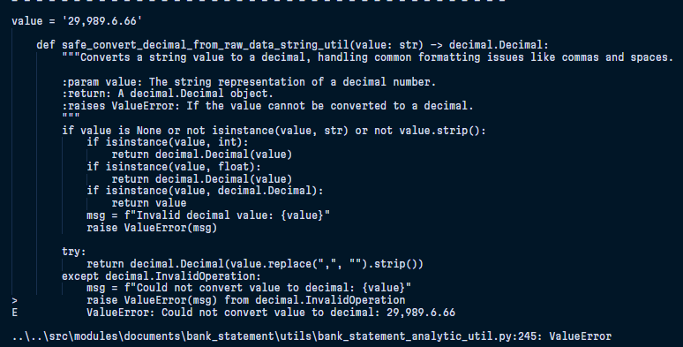

- cibb/v2/s_pdf/case_1
- 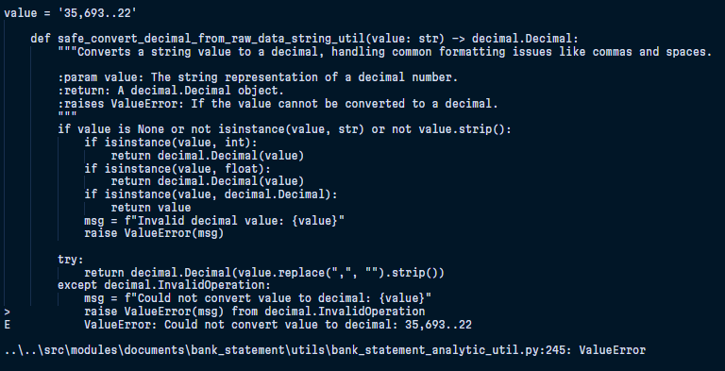

- cibb/v4/s_pdf/case_1

- 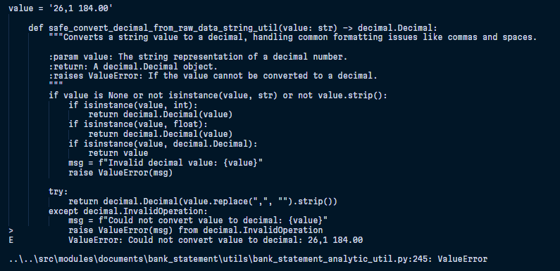

Import template error

- bimb/v1/e_pdf/case_1
- 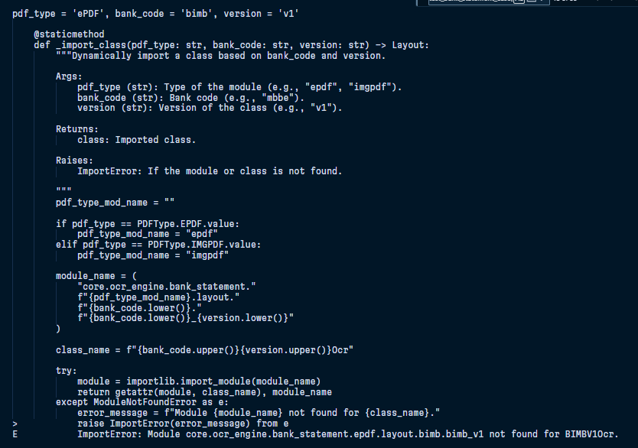

- bmmb/v1/s_pdf/case_1

- 