**https://wiki.saucelabs.com/display/DOCS/Troubleshooting+Sauce+Connect**

**SAUCE LAB POC**

Docker git: <https://github.com/rajbirsood/sauce_lab_poc/blob/master/dockerfile>

Clone it.

**Build docker file**:

docker build . -t sauce_connect_poc

docker image ls

REPOSITORY TAG IMAGE ID CREATED SIZE

sauce_connect_poc latest 36524d8ded14 18 hours ago 592MB

**run the container**

docker run -it sauce_connect_poc

#export SAUCE_USERNAME=rajbsood

#export SAUCE_ACCESS_KEY=********************

or

#sc -u rajbsood -k *************

**To check network connectivity**

<https://wiki.saucelabs.com/display/DOCS/Troubleshooting+Sauce+Connect>

telnet saucelabs.com 443

**Login to IBM CLOUD**

PS C:\sandbox\sauce_lab_poc> ibmcloud login --sso

API endpoint: https://api.eu-gb.bluemix.net

One Time Code (Get one at https://iam.eu-gb.bluemix.net/identity/passcode)>

Authenticating...

OK

Select an account:

1. IBM (90488ffecf50473ba57279d415e24aef)

2. Ted Bauer's Account (547c003b17058cb5305d4ebef2768ea6) <-> 759637

Enter a number> 1

Targeted account IBM (90488ffecf50473ba57279d415e24aef)

Targeted resource group Default

API endpoint: https://api.eu-gb.bluemix.net

Region: eu-gb

User: rajbsood@in.ibm.com

Account: IBM (90488ffecf50473ba57279d415e24aef)

Resource group: Default

CF API endpoint:

Org:

Space:

**Push docker image to ibmcloud Registry**

**Login to IBMCLOUD REGISTRY**

PS C:\sandbox\sauce_lab_poc> **ibmcloud cr login**

Logging in to 'registry.eu-gb.bluemix.net'...

Logged in to 'registry.eu-gb.bluemix.net'.

**ADD NAMESPACE**

<https://console.bluemix.net/docs/services/Registry/index.html#index>

PS C:\sandbox\sauce_lab_poc**> ibmcloud cr namespace-add cloudservices-shared**

Adding namespace 'cloudservices-shared'...

Successfully added namespace 'cloudservices-shared'

**List namespace**

**ibmcloud cr namespace-list**

Listing namespaces...

Namespace

mykube

rajkey

**cloudservices-shared**

**TAG THE VALIDATED IMAGE IN THE IBM CLOUD CONTAINER REGISTRY**

**docker image ls**

cff943fe80b3

docker tag cff943fe80b3 **registry.eu-gb.bluemix.net/cloudservices-shared/rajbsoodsauce-ubuntu-1604-5**

PS C:\sandbox\sauce_lab_poc> docker image ls

REPOSITORY TAG IMAGE ID CR

EATED SIZE

registry.eu-gb.bluemix.net/cloudservices-shared/rajbsoodsauce-ubuntu-1604-5 latest cff943fe80b3 20

minutes ago 594MB

**BUILD and PUSH YOUR DOCKER CONTAINER TO THE IBM CLOUD DOCKER REGISTRY**

PS C:\sandbox\sauce_lab_poc> **ibmcloud cr build -t registry.eu-gb.bluemix.net/cloudservices-shared/rajbsoodsauce-ubuntu-1**

**OK**

**IMAGE LIST**

PS C:\sandbox\sauce_lab_poc> **ibmcloud cr image-list**

Listing images...

REPOSITORY TAG DIGEST

NAMESPACE CREATED SIZE SECURITY STATUS

registry.eu-gb.bluemix.net/cloudservices-shared/rajbsoodsauce-ubuntu-1604-5 latest e529993

1518a cloudservices-shared 2 minutes ago 248 MB No Issues

registry.eu-gb.bluemix.net/mykube/hello-containers-20180830082838078 1 ad35581

**SET YOUR K8S CLUSTER CONTEXT IN PREPARATION FOR RUNNING YOUR DOCKER CONTAINER**

[**https://console.bluemix.net/containers-kubernetes/catalog/cluster**](https://console.bluemix.net/containers-kubernetes/catalog/cluster)

**docs here**

[**https://console.bluemix.net/docs/containers/cs_tutorials.html#cs_cluster_tutorial**](https://console.bluemix.net/docs/containers/cs_tutorials.html#cs_cluster_tutorial)

**verify that the container-service and container-registry plug-ins are properly installed, run the following command:**

PS C:\sandbox\sauce_lab_poc> **ibmcloud plugin list**

Listing installed plug-ins...

Plugin Name Version

container-registry 0.1.329

container-service/kubernetes-service 0.1.575

dev 2.1.4

key-protect 0.1.1

sdk-gen 0.1.12

cloud-functions/wsk/functions/fn 1.0.22

**To check clusters**

PS C:\sandbox\sauce_lab_poc> **ibmcloud cs clusters**

Using user provided API endpoint: https://containers.bluemix.net

OK

Or

using

PS C:\sandbox\sauce_lab_poc> **ibmcloud ks clusters**

OK

Name ID State Created Workers Location Version Resource Group Name

PS C:\sandbox\sauce_lab_poc>

Creating clusters with the IBM Cloud CLI

<https://console.bluemix.net/docs/containers/cs_clusters.html#clusters_cli>

or using web ui

<https://console.bluemix.net/containers-kubernetes/catalog/cluster/create>

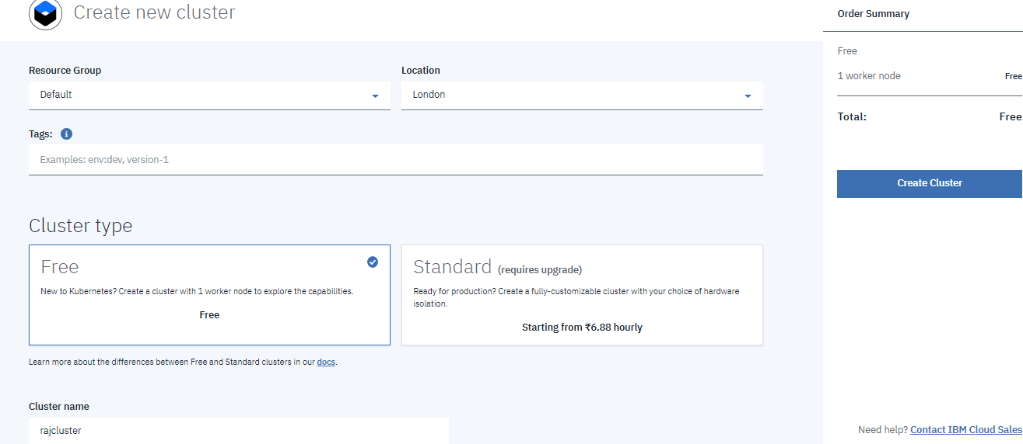

ibmcloud login -a <https://api.eu-gb.bluemix.net>

ibmcloud cs region-set uk-south

ibmcloud cs clusters

ibmcloud cs cluster-config rajcluster

export **KUBECONFIG**=%HOMEPATH%\.bluemix\plugins\container-service\clusters\rajcluster\kube-config-mil01-rajcluster.yml

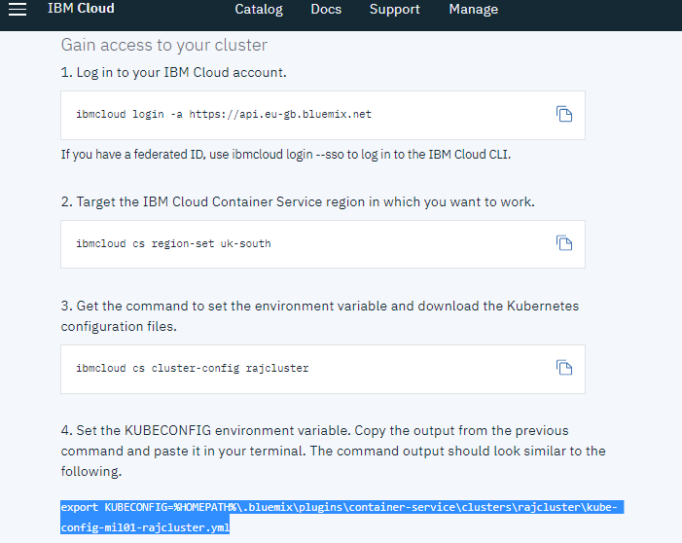

PS C:\sandbox\sauce_lab_poc> **ibmcloud cs clusters**

OK

Name ID State Created Workers Location Version Resource

Group Name

rajcluster a3e881b555ee4fb19a4ffd604e3de8e9 deploying 2 minutes ago 1 London 1.10.11_1536 -

PS C:\sandbox\sauce_lab_poc>

PS C:\sandbox\sauce_lab_poc> ibmcloud cs cluster-config rajcluster

OK

The configuration for rajcluster was downloaded successfully.

Export environment variables to start using Kubernetes.

SET KUBECONFIG=C:\Users\rajbir_sood\.bluemix\plugins\container-service\clusters\rajcluster\kube-config-mil01-rajcluster.

yml

**In powershell**

$env:KUBECONFIG=”C:\Users\rajbir_sood\.bluemix\plugins\container-service\clusters\rajcluster\kube-config-mil01-rajcluster.yml”

**CREATE A KUBERNETES DEPLOYMENT**

<https://console.bluemix.net/docs/containers/cs_tutorials_apps.html#cs_apps_tutorial>

kubectl run hello-world-deployment --image=registry.<region>.bluemix.net/<namespace>/hello-world:1

PS C:\sandbox\sauce_lab_poc> kubectl run rajbsoodsauce-ubuntu-1604-5 --image registry.eu-gb.bluemix.net/cloudservices-sh

ared/rajbsoodsauce-ubuntu-1604-5

**deployment.apps/rajbsoodsauce-ubuntu-1604-5** created

PS C:\sandbox\sauce_lab_poc> kubectl get deployment

NAME DESIRED CURRENT UP-TO-DATE AVAILABLE AGE

**rajbsoodsauce-ubuntu-1604-5** 1 1 1 0 1m

**EXPOSE THE DEPLOYMENT AS A NODEPORT SERVICE**

PS C:\sandbox\sauce_lab_poc> kubectl expose deployment rajbsoodsauce-ubuntu-1604-5 --port=8080

service/rajbsoodsauce-ubuntu-1604-5 exposed

PS C:\sandbox\sauce_lab_poc> kubectl get pod

NAME READY STATUS RESTARTS AGE

rajbsoodsauce-ubuntu-1604-5-6f6864747f-wx9hc 0/1 **CrashLoopBackOff**  5 4m

**DEPLOY YOUR K8S CLUSTER POD**

PS C:\sandbox\sauce_lab_poc> cat .\sauce_ubuntu.yml

|  |
| --- |
| apiVersion: v1 |
|  | kind: Pod |
|  | metadata: |
|  | name: rajbir-sauce-ubuntu-1604-5 |
|  | namespace: default |
|  | spec: |
|  | containers: |
|  | - name: rajbsoodsauce-ubuntu-1604-5 |
|  | image: registry.eu-gb.bluemix.net/cloudservices-shared/rajbsoodsauce-ubuntu-1604-5 |
|  | ports: |
|  | - containerPort: 8000 |
|  | command: ["/bin/bash"] |
|  | args: ["-c", "while true; do echo hello; sleep 20; done"] |
|  | restartPolicy: OnFailure |

PS C:\sandbox\sauce_lab_poc> **kubectl create -f sauce_ubuntu.yaml**

pod/rajbir-sauce-ubuntu-1604-5 created

**VERIFY THAT YOUR POD SUCCESSFULLY DEPLOYED**

PS C:\sandbox\sauce_lab_poc> **kubectl get pods**

NAME READY STATUS RESTARTS AGE

rajbir-sauce-ubuntu-1604-5 1/1 Running 0 1m

**ACCESS YOUR POD**

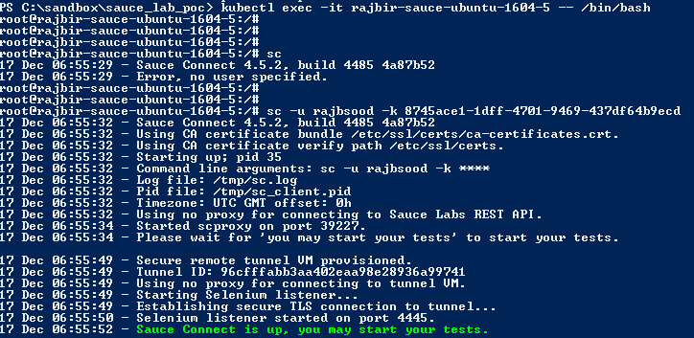

Tunnel is opened for testing

**VERIFY THAT YOUR SAUCELABS NETWORK TUNNEL IS WORKING**

