Binary Elementwise Fusion — New Design (Discriminator-Based)
This document describes the design for binary-inclusive elementwise kernel fusion that replaces the seed/grow/merge rule set on binary-fusion-fbody. The design has been validated end-to-end against placeholder ops in crates/luminal_cuda_lite/src/tests/discriminator_experiment.rs (26 tests, all passing) before any changes to real kernel types.

What broke in the old design
The old rule set seeded every elementwise op with a singleton fused form (U(x) ⇔ FE(U(FS(x)))). Each seed rule’s LHS pattern matched its own RHS — U(?x) matches U(FS(x)) with ?x = FS(x) — so each repeat iteration mints another nested layer:
iter 1: FE(Sin(FS(x)))
iter 2: FE(Sin(FS(FS(x))))
iter 3: FE(Sin(FS(FS(FS(x)))))
…
This is the cascade. Combined with separate FS enodes per rule firing, the diamond DAG ended up with FS_a₁ and FS_a₂ for the same external tensor a, breaking the start_count == 2 invariant. Five FS enodes after repeat 5, linear growth in iteration count, e-graph explosion, and non-deterministic extraction.

The new design in one sentence
Add a Bool inside discriminator field to every kernel op’s egglog sort. Pair-fuse rules pin both the outer and inner ops to inside = false; their RHS produces fused-inside copies with inside = true. The structural mismatch makes the LHS pattern incapable of re-matching its own output, so cascade is provably impossible.
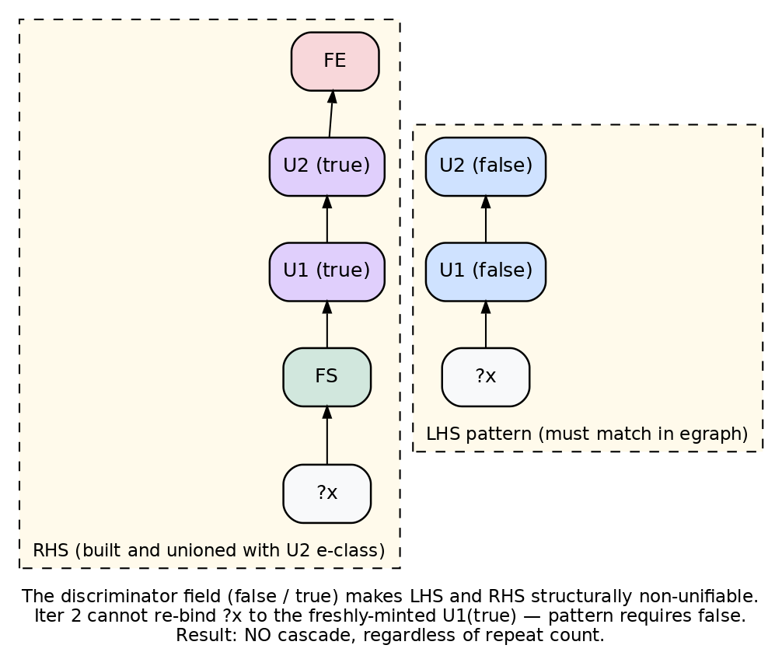
Discriminator concept
The diagram shows a unary-unary pair-fuse rule. The LHS pattern requires both U1 and U2 to carry (false). The RHS builds an FE(U2(true)(U1(true)(FS(?x)))) chain and unions it with the LHS root. On the next iteration, the pattern would need to bind to U2(true) or U1(true), but the discriminator forbids that — same-bindings re-firing is hash-cons no-op, different-bindings re-firing is structurally blocked.

Color legend
- FE (red) — FusionEnd marker, region output
- FS (green) — FusionStart marker, region external input
- Op (false) (blue) — original op outside any fused region
- Op (true) (purple) — fused-inside copy of an op
- External input (grey) — ?a, ?b, ?x etc.
- Inner ref (yellow) — e-class reference to an upstream FE’s body

The four base cases (pair-fuse rules)
Every adjacent pair of compatible elementwise ops is one base case. There are four shapes depending on whether each side is a unary or binary.

Base 1 — unary → unary (U2(U1(?x)))
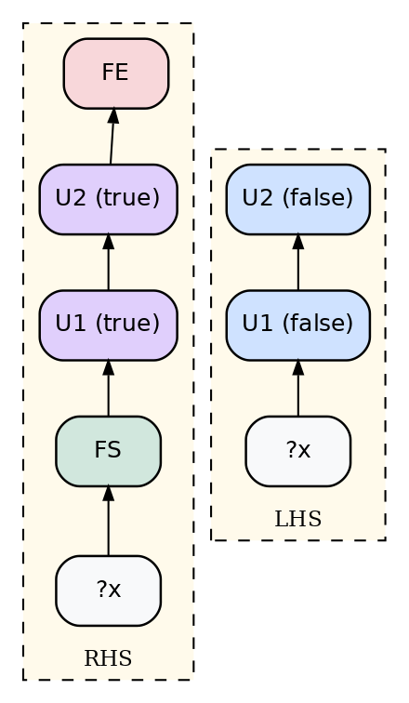
Base 1: U → U
Egglog rule:
(rule
((= ?u1 (U1 ?x false))
(= ?u2 (U2 ?u1 false)))
((let ?fs (FS ?x))
(let ?u1_in (U1 ?fs true))
(let ?u2_in (U2 ?u1_in true))
(let ?fe (FE ?u2_in))
(union ?u2 ?fe))
:name "pair-fuse-U1-U2")
Tested with Sin(Sqrt(x)). After repeat 5: 1 FS, 1 FE. Same input case Sin(Sqrt(x)) collapses naturally because there’s only one external tensor.

Base 2 — binary → unary (U(B(?a, ?b)))
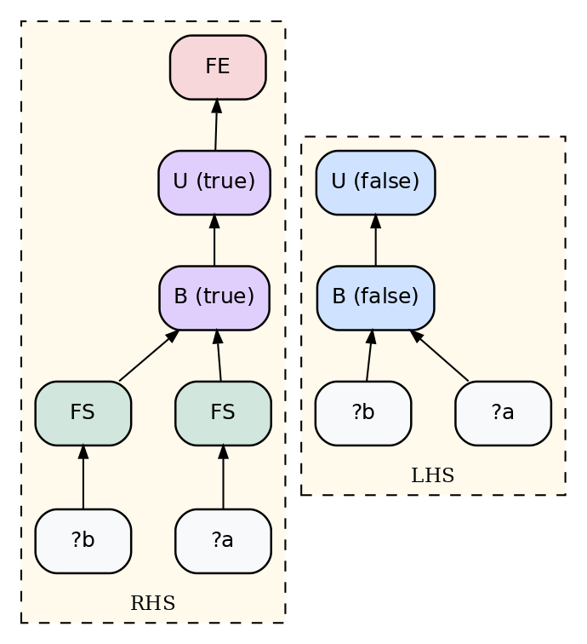
Base 2: B → U
(rule
((= ?b (B ?a ?bb false))
(= ?u (U ?b false)))
((let ?fs_a (FS ?a))
(let ?fs_b (FS ?bb))
(let ?b_in (B ?fs_a ?fs_b true))
(let ?u_in (U ?b_in true))
(let ?fe (FE ?u_in))
(union ?u ?fe))
:name "pair-fuse-B-U")
Tested with Exp(Add(a, b)). After repeat 10: 2 FS, 1 FE. Shared input Exp(Add(x, x)) collapses to 1 FS via congruence — both FS(?a) and FS(?b) enodes have the same child e-class, so hash-cons folds them.

Base 3 — unary → binary (B(U(?a), ?b))
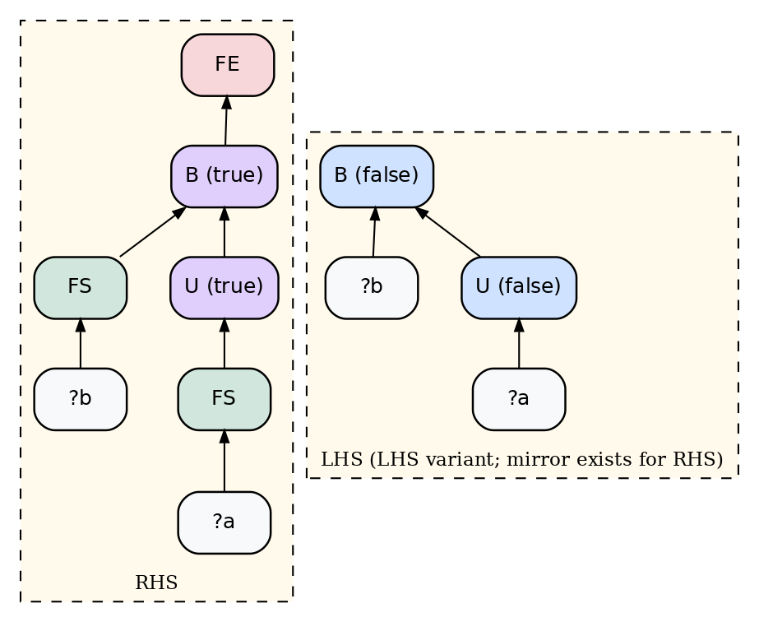
Base 3: U → B (LHS variant)
(rule
((= ?u (U ?a false))
(= ?b (B ?u ?bb false)))
((let ?fs_a (FS ?a))
(let ?fs_b (FS ?bb))
(let ?u_in (U ?fs_a true))
(let ?b_in (B ?u_in ?fs_b true))
(let ?fe (FE ?b_in))
(union ?b ?fe))
:name "pair-fuse-U-B-LHS")
This case has a mirror because binary args are positional in egglog patterns: B(?b, U(?a)) needs its own rule with the positions swapped. Tested with both directions plus a coexistence test (LHS+RHS rules in the same program produce 2 shared FSes via congruence and 2 distinct FEs).
The asymmetry: only the binary’s external input gets an FS at the binary level. The unary’s input has its own FS one level deeper. Total FS count is still 2 (one per distinct external tensor), determined by tensor count, not edge count.

Base 4 — binary → binary (B_outer(B_inner(?a, ?b), ?c))
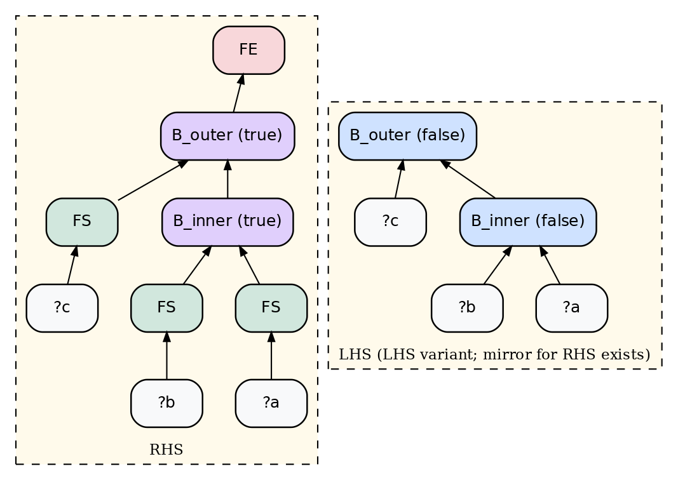
Base 4: B → B (LHS variant)
(rule
((= ?bi (B_inner ?a ?b false))
(= ?bo (B_outer ?bi ?c false)))
((let ?fs_a (FS ?a))
(let ?fs_b (FS ?b))
(let ?fs_c (FS ?c))
(let ?bi_in (B_inner ?fs_a ?fs_b true))
(let ?bo_in (B_outer ?bi_in ?fs_c true))
(let ?fe (FE ?bo_in))
(union ?bo ?fe))
:name "pair-fuse-B-B-LHS")
LHS + RHS mirror needed (same reason as base 3). Tested with Mul(Add(a, b), c) and Mul(c, Add(a, b)). After repeat 10: 3 FS, 1 FE. Shared-input case Mul(Add(x, x), x) collapses to 1 FS.

The grow rule
Pair-fuse only handles 2-op fusions. To get a 3+ op region we need a rule that extends an existing region past one more compatible op.
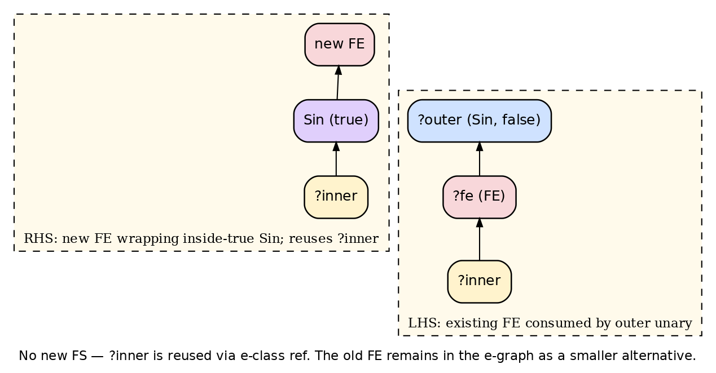
Grow: FE → outer unary
(rule
((= ?fe (FE ?inner))
(= ?outer (Sin ?fe false)))
((let ?inside (Sin ?inner true))
(let ?new_fe (FE ?inside))
(union ?outer ?new_fe))
:name "grow-FE-Sin")
Key properties:
- ?inner is reused via e-class ref — no new FS is minted when growing past a unary.
- The pattern requires ?outer to have inside = false, so grow can’t fire on already-inside copies. Discriminator-blocked from cascading exactly like pair-fuse.
- The old FE remains in the e-graph as a smaller fusion alternative. Cost-based extraction prefers the bigger FE.
A separate grow rule per outer op kind is needed (one per unary, two per binary for LHS/RHS). For binary grow, the new external input gets its own FS at the binary level — same idiom as the binary pair-fuse cases.

The merge rule
When two FEs feed a binary on either side, both regions can be collapsed into one.
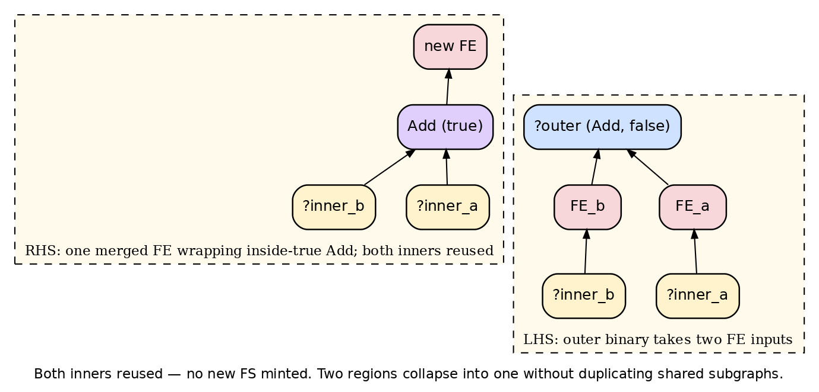
Merge: two FEs at binary
(rule
((= ?fe_a (FE ?inner_a))
(= ?fe_b (FE ?inner_b))
(= ?outer (Add ?fe_a ?fe_b false)))
((let ?inside (Add ?inner_a ?inner_b true))
(let ?new_fe (FE ?inside))
(union ?outer ?new_fe))
:name "merge-FEs-Add")
Both inners are reused — no new FS minted. This is the rule that makes the diamond DAG fuse into one region: the outer Add of out = w + v consumes w’s FE (from the Mul branch, after pair-fuse + grow) and v’s FE (from the Sin branch, after pair-fuse), and merge collapses them.

Putting it all together — the diamond DAG
The diamond was the test case the old design failed on:
t = a + b
u = exp2(t)
v = sin(t)
w = u * a ← reuses external a
out = w + v
Five ops, two distinct external tensors {a, b}. The reuse of a was the source of the FS_a₁ / FS_a₂ spurious-duplicate problem: each rule firing minted its own FS for a and they never unified.
With the new design, after running pair-fuse + grow + merge to fixpoint:
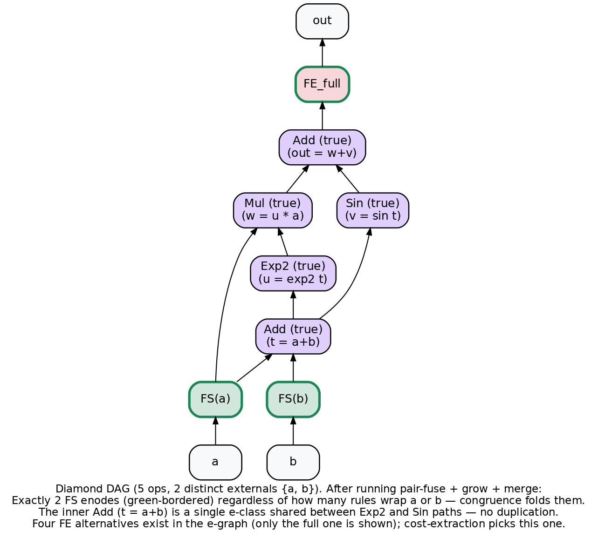
Diamond DAG resolved
Quantity | Value | Why
Distinct FS enodes | 2 (FS(a), FS(b)) | Congruence/hash-cons folds every wrap of the same external tensor regardless of which rule produced it
Distinct FE enodes | 4 | Four alternatives: {Add,Exp2}, {Add,Sin}, {Add,Exp2,Mul}, full diamond. Cost-extraction picks the full one.
Shared inner Add | 1 e-class | The inner t = a+b is a single e-class shared between the Exp2 and Sin paths — no duplication
Stability under repeat 20 | identical to repeat 5 | Discriminator blocks all cascade paths
The egglog (check ...) proves the full 5-op fused term is in out’s e-class — (FS a) appears 3 times in the term but resolves to one enode in the e-graph.

Tradeoff: alternative-FE accumulation
There’s one cost the design pays: for an N-op chain, pair-fuse fires on every adjacent pair and grow extends each pair forward, producing one FE per contiguous subchain of length ≥ 2. That’s N(N−1)/2 FE enodes — quadratic in chain length.
Chain length N | FE alternatives | Realistic?
5 | 10 | yes (typical LLM elementwise chain)
10 | 45 | yes
20 | 190 | borderline
100 | 4950 | unlikely in practice
These are not cascade duplicates. Each represents a distinct fusion choice with a distinct output value (FE_{Add,Exp2} produces exp2(a+b), FE_{Add,Exp2,Mul} produces exp2(a+b)*a — different runtime values, different e-classes). Cost-based extraction ranks them and picks the biggest.
For practical model code (chains of ~5-10 ops, DAG widths of similar order) this is well within egglog’s capacity. If we ever need to tighten further, two options:
- Egglog (subsume ...) in the grow rule’s RHS to mark the old FE as not-for-extraction once it’s been grown past.
- Materialized “is-root” relation to gate pair-fuse on outer ops that are not yet inside any region — encodes negation by reflection on the e-graph.
Both add machinery. Recommend deferring until measured.

What changes in the real KernelFoo types
The discriminator is the only structural change. For each kernel op (every existing KernelSin, KernelAdd, etc.) in crates/luminal_cuda_lite/src/kernel/other_ops.rs:
- Add a bool field to the egglog sort signature. Concretely, sort() would append ("inside", BOOL) to the field list.
- Add a corresponding Rust field (defaults to false for ops created by the frontend; true for fused-inside copies emitted by rules).
- Update existing rules that pattern-match the kernel op to either pin the new field to false or take it as a don’t-care ?inside_dontcare variable.
- Codegen ignores the field for emission — an inside Sin compiles to the same CUDA as an outside Sin. The field only matters during egglog rule firing.
Replace the current FusionEnd::rewrites() with the seven rule families described above:
- 4 pair-fuse families (one per base case shape) × 2 directions for binary ops where applicable
- 1 grow-unary family (one rule per unary op kind)
- 2 grow-binary families (LHS and RHS variants)
- 1 merge family (one rule per binary op kind)
Then un-ignore test_fused_region_starts_match_distinct_external_tensors and update test_diamond_dag_fuses to expect start_count == 2 (the design invariant the old rule set couldn’t deliver).

Validation summary
Test harness: crates/luminal_cuda_lite/src/tests/discriminator_experiment.rs
26 tests, all passing, covering:
Group | Tests | Headline result
Baseline (no discriminator) | 1 | FS=5 after repeat 5 (cascade confirmed)
Base case 1 (U→U) | 4 | FS=1, FE=1 stable; 3-op chain stable; check passes
Base case 2 (B→U) | 3 | FS=2, FE=1; same-input → FS=1
Base case 3 (U→B, LHS+RHS+coexist) | 6 | FS=2, FE=1 each; coexist → 2 shared FS, 2 FE
Base case 4 (B→B, LHS+RHS+coexist) | 6 | FS=3, FE=1 each; all-shared → FS=1
Forward grow rules (3-op + 4-op chain + binary grow) | 3 | FS minimal, FE quadratic; full fusion reachable
Merge at binary | 1 | Two branch FEs collapse to one
Diamond DAG | 2 | FS=2, FE=4, stable across repeat 5/repeat 20
The diamond DAG result is the design’s primary proof point: it reproduces the topology that broke the old rule set and shows the new design satisfies the start_count == 2 invariant without any manual canonicalization.

