Binary Elementwise Fusion — Rule-by-Rule Review
Source: crates/luminal_cuda_lite/src/kernel/other_ops.rs, FusionEnd::rewrites() (lines ~2265–2475).

Notation
- FE = FusionEnd marker op (single input). Drawn red.
- FS = FusionStart marker op (single input). Drawn green.
- U = any unary in {Sin, Sqrt, Exp, Exp2, Log2, Recip}. Drawn blue.
- B = any binary in {Add, Mul}. Drawn purple.
- External inputs (a, b, x) drawn grey.
- Inner refs (inner, inner_a, inner_b) drawn yellow — these are e-class references to the body of an upstream FE, reused without re-wrapping.
The rules use (union ?lhs ?rhs), so both forms end up in the same e-class. They are equivalent, not directional rewrites. Variables prefixed ? are e-class references in egglog; reusing the same ?x means the same e-class, not a duplicated subtree.

Rule families and counts (22 rules total)
# | Family | Count | Pattern shape
1 | Seed Unary | 6 | U(x) ⇒ FE(U(FS(x)))
2 | Seed Binary | 2 | B(a, b) ⇒ FE(B(FS(a), FS(b)))
3 | Grow FE→Unary | 6 | U(FE(inner)) ⇒ FE(U(inner))
4 | Grow FE→Binary, FE on LHS | 2 | B(FE(inner_a), b) ⇒ FE(B(inner_a, FS(b)))
5 | Grow FE→Binary, FE on RHS | 2 | B(a, FE(inner_b)) ⇒ FE(B(FS(a), inner_b))
6 | Merge | 2 | B(FE(inner_a), FE(inner_b)) ⇒ FE(B(inner_a, inner_b))

Rule 1 — Seed Unary
For each unary U:
LHS (matched pattern):
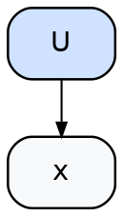
Rule 1 LHS
RHS (created and unioned with LHS root):
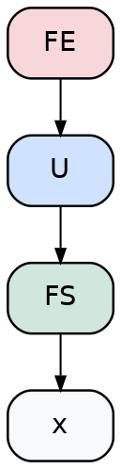
Rule 1 RHS
What it does. Inserts a singleton “fused” form for every unary occurrence in the graph.
Issue (cascade / self-rematching). The pattern U(?x) is structural — it matches ANY U(?something). After this rule fires, the e-class of U(x) contains FE(U(FS(x))). Inside that new term, the inner U(FS(x)) is still a U(?something), so the pattern re-matches with ?x = FS(x):
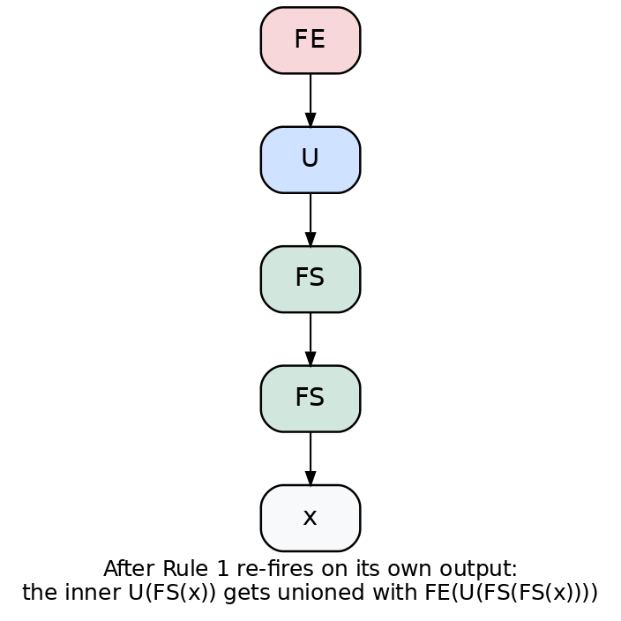
Cascade
…and unions the new form with the inner U(FS(x)). That contaminates the inner e-class with FE-rooted forms, so when downstream rules look at the inner of any FE, they may pick one of these nested forms. Each repeat 10 iteration in the schedule adds another nesting layer. This is the documented “cascade wart.”

Rule 2 — Seed Binary
For each binary B:
LHS:
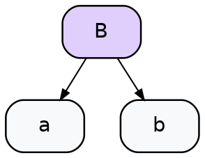
Rule 2 LHS
RHS:
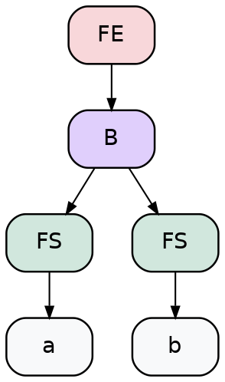
Rule 2 RHS
Issue. Same self-rematching as Rule 1. The pattern B(?a, ?b) re-matches the inner B(FS(a), FS(b)) of its own output, with ?a = FS(a), ?b = FS(b). Each re-firing wraps an additional FS layer.

Rule 3 — Grow FE → Unary
For each unary U:
LHS:
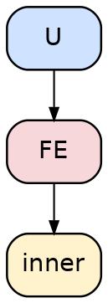
Rule 3 LHS
RHS:
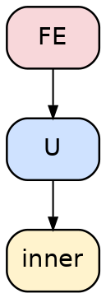
Rule 3 RHS
What it does. Relocates the FE past a unary, absorbing the unary into the region. Does not mint a new FS — inner is reused directly.
Issue (fan-out duplication). When the same FE_t is consumed by two different unaries (e.g., the diamond’s t feeding both Exp2 and Sin), this rule fires independently for each consumer. We end up with two FE-rooted e-classes (FE(Exp2(t_inner)) and FE(Sin(t_inner))) that share the same t_inner e-class. Combined with Rule 6 below, that gives the merge step multiple structurally-distinct ways to extract the unified form — which is the source of the diamond non-determinism.

Rule 4 — Grow FE → Binary, FE on LHS
For each binary B:
LHS:
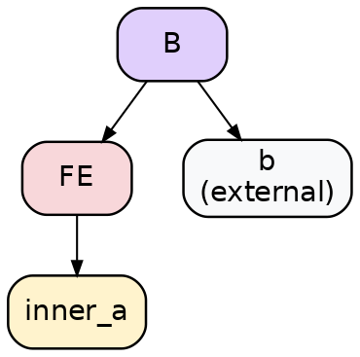
Rule 4 LHS
RHS:
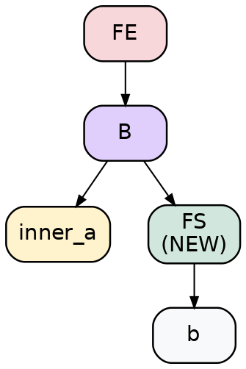
Rule 4 RHS
Issue (FS multiplication). This mints a brand-new FS node every time it fires (highlighted in the RHS as FS (NEW)). There is no canonicalization rule unifying two FS nodes that wrap the same source tensor. If b’s e-class is the same external tensor that an earlier rule already wrapped in FS_b1, this firing produces FS_b2 — a distinct e-node — and both stick around.
In the diamond: the outer Add(a, b) is wrapped by Seed Binary creating FS_a1, FS_b1. Later, Mul(u, a) triggers this rule (LHS variant) and creates FS_a2 for the same a. The fused region’s extracted tree shows 3 FS nodes for {a, b} when the design says 2.

Rule 5 — Grow FE → Binary, FE on RHS
Mirror of Rule 4:
LHS:
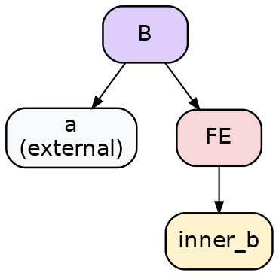
Rule 5 LHS
RHS:
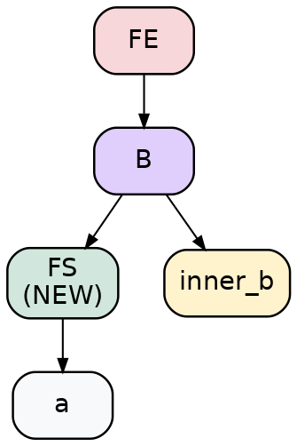
Rule 5 RHS
Same issue as Rule 4.

Rule 6 — Merge
For each binary B:
LHS:
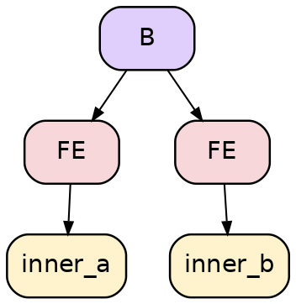
Rule 6 LHS
RHS:
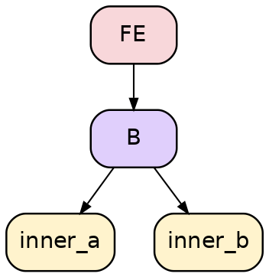
Rule 6 RHS
What it does. When two regions meet at a binary (both inputs are FEs), this collapses them into one region — no new FS minted, the binary just feeds from each region’s inner directly.
Issue (extraction non-determinism). inner_a and inner_b are e-class references. If they happen to share an underlying e-class (the diamond case: inner_a and inner_b both transitively reference t’s e-class), the extractor — which picks one e-node per e-class per call — can produce different surface forms across runs. Each form is correct, but they look different, hence the random extractor needs ~200 samples to reliably surface the canonical one.

Worked example: the diamond DAG
Source program:
Inputs: a, b
t = a + b
u = exp2(t)
v = sin(t)
w = u * a ← reuses external a
out = w + v
Sequence of rule firings (one valid order):
- Rule 2 fires on t = Add(a, b). Creates FS_a1, FS_b1, and FE(Add(FS_a1, FS_b1)). t’s e-class now contains both forms.
- Rule 3 fires on Exp2(FE_t) — relocates the FE past Exp2.
- Rule 3 fires INDEPENDENTLY on Sin(FE_t) — relocates a separate FE past Sin. Both share t’s inner e-class.
- Rule 4 fires on Mul(FE_u, a) — mints a fresh FS_a2 wrapping a, distinct from FS_a1.
- Rule 6 (Merge) fires on out = Add(w, v) — both w and v are FE e-classes, so they collapse into one outer FE.
Final fused form:
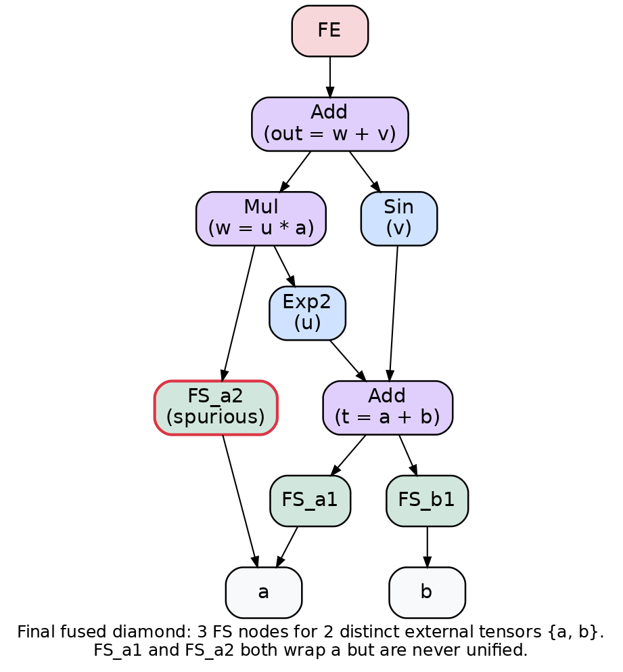
Diamond
Observations:
- 3 distinct FS nodes (FS_a1, FS_a2, FS_b1) for 2 distinct external tensors {a, b}. FS_a2 (highlighted with red border) is the spurious duplicate. This is what makes test_fused_region_starts_match_distinct_external_tensors need #[ignore] and the resolve_source workaround in the test harness.
- The inner Add e-class is shared between Exp2 and Sin paths in the egraph. But during extraction, each parent context picks an e-node independently, so the surface tree may show two structurally-different encodings of the same e-class. Combined with the cascade nesting, this gives many equivalent extracted forms — driving non-determinism.

Summary of issues, ranked
- Self-rematching in Seed rules (1, 2). The patterns U(?x) and B(?a, ?b) match their own outputs, producing nested-FS cascades. Bounded only by repeat 10. Drives the “explosion” in egraph size.
- No FS canonicalization. Each invocation of Grow-FE→Binary (Rules 4, 5) mints a fresh FS. Different rule firings that wrap the same source tensor produce distinct FS e-nodes that never get unified. Drives the FS-count-too-high problem on reused inputs.
- Fan-out + Merge ⇒ extraction non-determinism (Rules 3, 6). When a shared term feeds multiple consumers and a merge later joins those branches, extraction of the unified form has many structurally-distinct equivalent encodings. The random extractor samples among them, so test results vary across runs.
- No “already inside a region” guard. None of the rules check whether their input is already part of a fused region. Every elementwise op gets touched by Seed; every adjacency gets re-touched by Grow even after it’s been absorbed.

Possible directions to consider
- Drop Seed rules. Singletons aren’t worth fusing. If we only fire pair-fuse rules (binary↔unary, binary↔binary, etc.), the cascade goes away because the pattern requires a specific neighbor topology that the rule’s own output doesn’t satisfy.
- FS canonicalization rule. FS(?x) ≡ FS(?x) for distinct FS e-nodes whose child e-class matches. Egglog should fold these via congruence as long as they have identical fields (shape, strides, dtype, child e-class). Worth verifying this isn’t already happening and being defeated by a field mismatch.
- Replace markers with a single multi-input op (generalized KernelFusedElementwise). Trades elegance for representational sharing — the body becomes one structured field, no DAG-via-tree-rewriting issues.

