

Philippine Christian University
Sampaloc I, Dasmariñas, Cavite
https://dasma.pcu.edu.ph
Configuring SSH Remote Access on Ubuntu Server
Objective
Set up an Ubuntu Server with SSH (Secure Shell) remote access and connect to it from a host desktop machine using Bridged Network mode.
Operating System Installation
Install Ubuntu Server
1. Start the VM and boot from the Ubuntu Server ISO
2. Follow the installation wizard:
o Profile setup: Create a user account (e.g., server / server123)
o Install OpenSSH server: Check this option (Important!)
o Selected software: None (Standard Ubuntu Server)
3. Wait for installation to complete and reboot
Network Configuration
Configure Network Mode
For VirtualBox:
1. Power off the VM (if running)
2. Go to Settings → Network
3. Adapter 1: Enable Network Adapter
4. Attached to: Select Bridged Adapter
5. Name: Select your host's physical network adapter (Wi-Fi/Ethernet)
6. Click OK
For VMware:
1. Power off the VM
2. Go to VM Settings → Network Adapter
3. Select Bridged mode
4. Click OK
Install/Verify SSH Server
Server: Install SSH on the server (if not already installed):
• sudo systemctl status ssh – for checking the SSH status.
• sudo apt update – updating the your server.
• sudo apt install openssh-server -y –installing the SHH.
• sudo systemctl enable ssh – enabling the SSH to your unit. (SERVER/DESKTOP)
• sudo systemctlstartssh – starting the SHH to your unit. (SERVER/DESKTOP)
Bridged makes the server behave like a separate PC in your LAN.
1. Find the Server’s IP
Inside the VM, run:
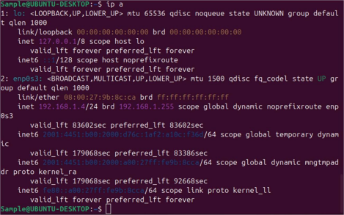From the desktop, connect to the server: ssh username@192.168.1.120
2. Connect from Desktop
From your host desktop:
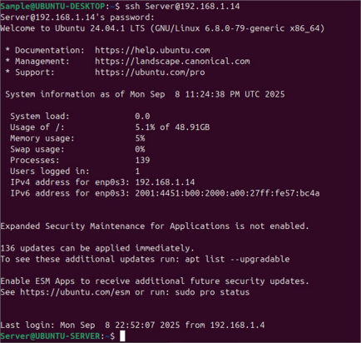
Submission Requirements
1. Screenshots (labeled clearly):
• VM network settings showing Bridged Adapter
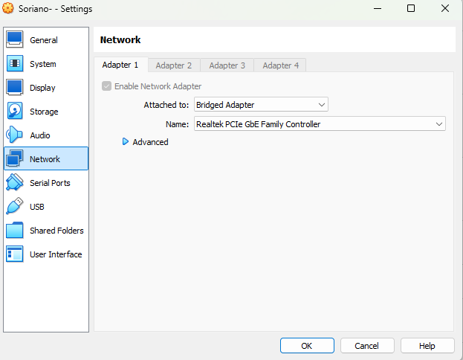
• Server IP address (output of ip a or hostname -I)
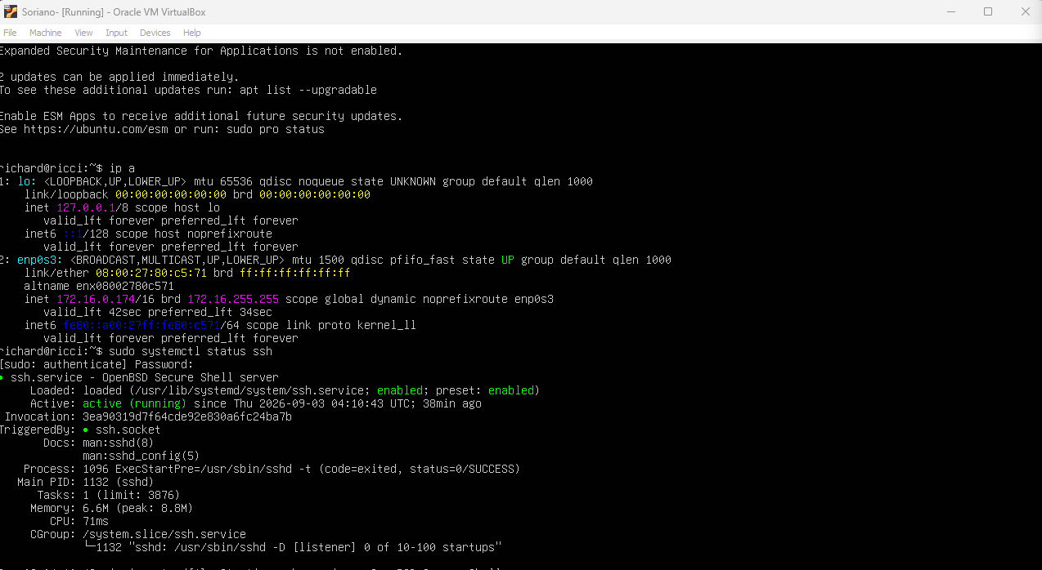
• SSH service status (sudo systemctl status ssh)
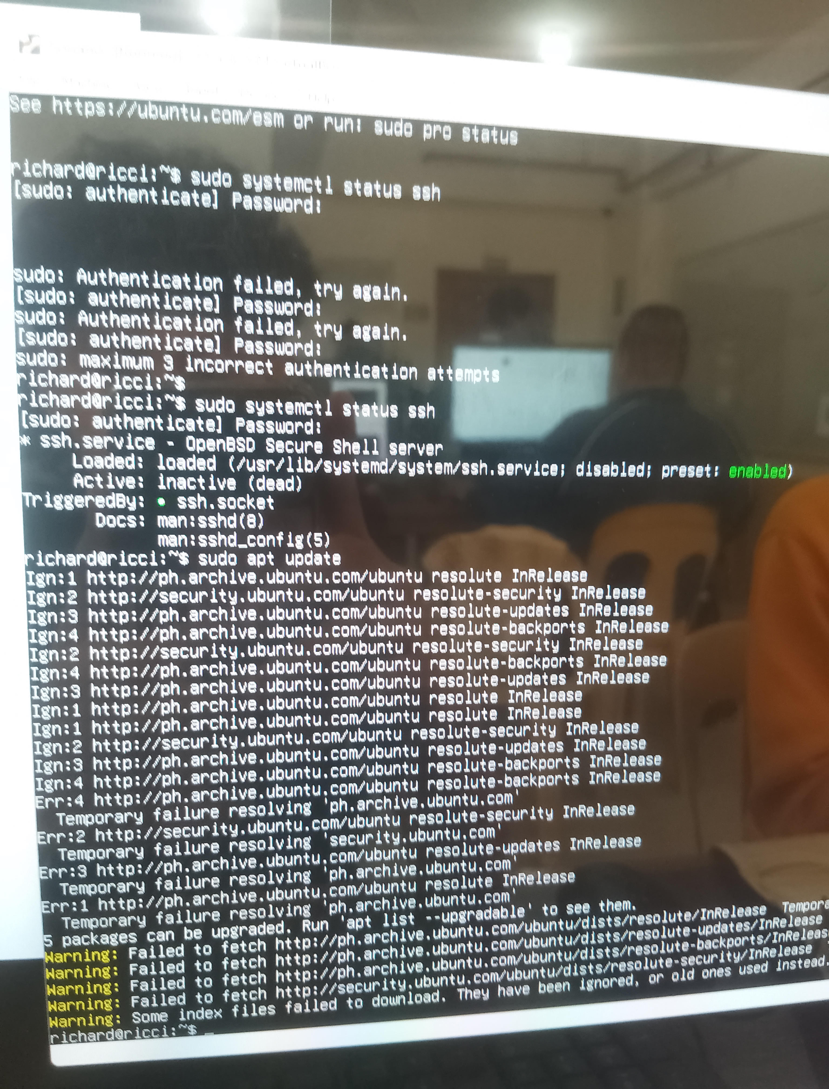

• Successful SSH connection from host
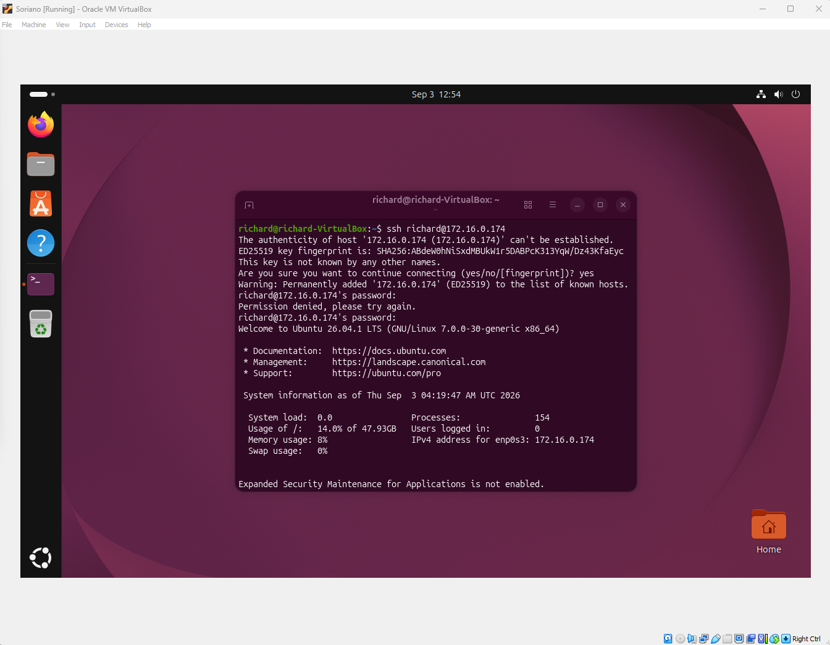
• Verification commands executed inside VM
2. Submission Format:
• Single PDF file
• Include name, student ID, and date
• All screenshots with brief explanation
• Upload to your portfolio website.
UBUNTU SERVER SSH REMOTE ACCESS LAB
Name: Soriano, Richard S.
Student ID: 20221891D
Course/Year/Section: BSCS3A
Date Submitted: September 9, 2026
Instructor: Johneros P. Puyo
1 OBJECTIVES (5 POINTS)
Check all that apply:
 Create and configure a Virtual Machine with Ubuntu Server
Configure Bridged Network Adapter for network access
Determine and verify the server's IP address
Install OpenSSH Server and enable the service
Establish successful SSH connection from host machine
Execute verification commands to confirm remote access
2 HARDWARE & SOFTWARE REQUIREMENTS (5 POINTS)
Item | Specification
Host Operating System | Windows
Virtualization Software  (VirtualBox/VMware) | Oracle
Ubuntu Server Version | 26.04.1
VM Name | richard
RAM Allocated | 4 GB
Storage Allocated | 100 GB
Network Mode | NAT
SSH Client Used | openssh

3 VM CONFIGURATION
Setting | Value
VM Name | UBUNTU-SERVER
OS Type | Ubuntu (64-bit)
Memory | 4000 MB
Hard Disk | 100 GB
Network Adapter | Bridged

4. NETWORK CONFIGURATION
Commands Executed:
Server IP Address: 172.16.0.174
Network Interface: Physical
6. REMOTE CONNECTION
Connection Details:
Parameter | Value
Server IP | 172.16.0.174
Username | richard
SSH Port | 22

