**Credit Card, ACH, and ClickToPay**

**with EMV Terminal Processing**

**Installation and Use**

**Release 0608**



**Copyright © 2012-2020 – Accounting Systems, Inc.**

## ****Overview****

The APSPays Credit Card and ACH Processing modification allows for the processing of credit card and ACH payments using many of the Sage 100 stock programs. Credit cards and ACH information can be applied as deposits or payments as pre-authorizations or post-authorizations during A/R Invoice Data Entry, A/R Cash Receipts Entry, S/O Sales Order Entry and S/O Invoice Data Entry. This modification allows credit card and ACH payments to be processed through APSPays systems only.

It is important to note that APSPays does not alter the way that credit cards and ACH work in Sage 100. The procedure for entering, saving and using credit cards and ACH information in Sage 100 is the same with APSPays as it is with the standard Sage 100 installation. We have taken great care to not change those processes.

### APS Vault

APSPays Credit Card and ACH Processing for Sage 100 uses the APS Vault to ensure that customer credit card and ACH information is never stored in the Sage 100 tables, even for a moment. When a new credit card or ACH is entered, either through A/R Customer Maintenance or on-the-fly for a sales order, invoice or cash receipt, a pop-up window allows the user to enter the credit card or ACH, which is immediately stored in encrypted form in the APS Vault, which is fully PA-DSS compliant, secure and reliable. The vault then returns a unique ID which is stored in the Sage 100 ERP tables for future use. None of the customer’s sensitive credit or ACH information is ever available to the Sage 100 User from that time on. Only the last four numbers of the card along with the expiration date, or the last four of the Bank Routing and Account Numbers are stored in Sage 100 ERP tables. To use either payment type from that time on, the user references a nickname that is tied to the secure entry in the APS Vault.

### APS ClickToPay

When you install APSPays, you will also get the APS ClickToPay feature. This new feature, which requires setup by APS, provides a convenient way for customers to pay invoices online by clicking a link on the invoice that is emailed to them. If you choose to use APS ClickToPay you do not have to set up APSPays credit card processing. By doing this, you will no longer accept credit cards directly into your Sage 100 system and no vault information will be stored in your Sage 100 database. This minimizes the PCI scope for your company.

### Hosted Form Processing

APSPays now supports Hosted Form processing, where if you enter the card information, it is never in the Sage 100 system. You will enter card information into a web page that is secured by SSL TLS 1.2 or higher and stored in the APS secure cloud, and only a token with the validated address is returned for storage in Sage 100.

### EMV Terminal Processing

APSPays now has electronic terminals that follow the EMV (Eurocard, MasterCard, Visa) chip and swipe support, such as the Ingenico iPP320. These terminals plug into the USB port of your computer and depending on the payment type selected will automatically link to Sage to process the card. This allows Sage to be fully PCI/PADSS compliant as no card information enters the Sage 100 system.

Table of Contents

Overview 2

APS Vault 2

APS ClickToPay 2

Hosted Form Processing 2

EMV Terminal Processing 2

Installation 4

Getting Started 6

New Install at This Version 6

Upgrading from Earlier APSPays Versions 10

Processing Credit Cards and ACH Payments 14

Company Maintenance 14

Accounts Receivable Options 15

Payment Types 15

Customer Maintenance 17

A/R and S/O Invoice Entry 21

Accounts Receivable Cash Receipts Entry 24

Sales Order Entry 26

Sales Order Invoice Credit Memos 30

Expired Authorizations in Invoices 32

EMV Card processing 34

APSPays Credit Card and ACH Settlement Report 38

APS ClickToPay Setup 39

Enable APS ClickToPay in Company Maintenance 40

Modify Invoice Forms for APS ClickToPay 42

Select Customers for APS ClickToPay 45

APS ClickToPay Daily Processing 46

Processing ClickToPay Transactions through Cash Receipts 47

ACH Declines for Click To Pay 49

Installing the EMV terminal 53

Setting up EMV services to run automatically 58

Using Hosted Form Card Swipe on RDS/Terminal Server and Citrix 59

APS Software Warranty 63

## Installation

*\*\*\* If you wish to test APSPays Credit Card and ACH Processing and do not intend to use it in your live system, do not install it on your production Sage 100 ERP system. It is better to create a test environment for this purpose. \*\*\**

This modification is delivered in one executable file, APSC2P###Setup@@.EXE for installation on your Sage 100 ERP system. **Note: The “###” referenced above in the EXE is the Sage 100 ERP version level.** The “@@” refers to the APSPays revision number.

Installation:

1. *Version* - Make sure your Sage 100 ERP version matches the version of APSPays Credit Card Processing install file.
2. *Backup* – Backup your Sage 100 ERP data and programs before proceeding.
3. *Start Install* - Exit Sage 100 ERP, then execute the install file, APSC2P###Setup.EXE, by double clicking or right clicking and selecting Open. You will see a panel like the one below.  
     
    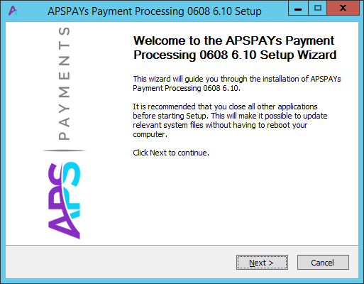
4. *Installation* – When you press the Next button, the following screen will display, allowing you to select the MAS90 folder where you are installing this modification. This folder should be on your server, not on your local drive.   
    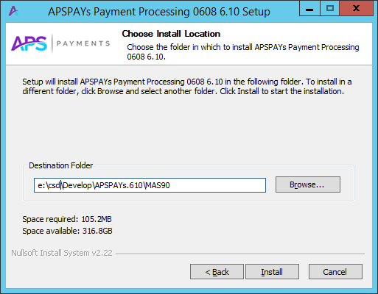   
     
   When a valid Destination Folder has been entered, the Install button will be enabled. Click on the Install button to proceed with the installation.
5. *Start Sage 100* – Start up Sage 100 in the normal fashion.
6. *Role Maintenance* – Since new options may be added to the menus, you will need to visit Role Maintenance on the Library Master Main menu and give rights to those tasks to the appropriate roles.
7. *Company Maintenance Data Conversion*– Once the installation is complete, it is important that you run a data level conversion. Use Company Maintenance to convert the data to the current level.
8. *Customizer Utilities* – If you have made Custom Office changes to any of the screens, it is a good idea to run the Customizer utilities to update screens to the current level.

### Getting Started

There are two separate procedures to get started, depending on whether you have used APSPays at an earlier version, or are just making the transition to APSPays from an earlier version of Sage 100 using APSPays.

Use procedures listed in **New Install at This Version** section if you:

* Have a current version of Sage 100 and have never used APSPays before or…
* Are upgrading from a prior version of Sage 100 and have never used APSPays before.

Use procedures listed in **Upgrading from Earlier APSPays Version** section if you:

* Are upgrading from a previous version of Sage 100 and have been using APSPays before.

### New Install at This Version

#### Verify that Sage 100 is fully installed and functional at the new version

If this is an existing Sage 100 install, proceed to step 2 below.

If this is an upgrade from a previous version of Sage 100 and did not have APSPays installed, upgrade the Sage 100 data fully to the new version as instructed by Sage. Once the data is migrated and converted, then continue with step 2 below.

#### Install APSPays Credit Card and ACH Processing

Follow the steps to install APSPays Credit Card and ACH Processing as described in the **Installation section** of this document.

#### Company Maintenance – Run the Data Conversion

When APSPays Credit Card and ACH Processing is first installed, it adds new fields to several tables. This change requires that the data be converted for all companies before you can proceed. While in Company Maintenance, click the Convert button in the upper right corner to complete the data conversion for this company, or all companies*. If credit card processing is already enabled, you do NOT need to disable it*. Simply do the data conversion.

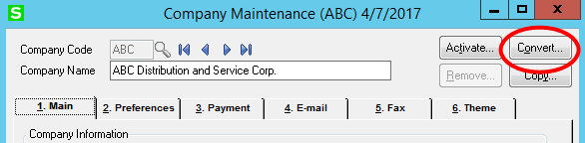

Note: The Company Data Conversion is not always necessary, so do not be alarmed if you try to convert and are told that no data conversion is necessary.

#### Convert Credit Cards – A/R Setup Menu

If you do not plan to process credit cards in Sage 100 and only plan to use ClickToPay, you can skip this step.

Two new options have been added to the A/R Setup menu. Select one of these options to convert cards and to activate APSPays. If you are using credit cards and ACH in Sage 100, select the first of the two options, Convert Cards and Activate APS.

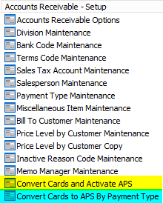

Either option will both convert cards from Sage Payment Solutions and, optionally, activate APSPays for immediate use. You choose which option to use based upon whether you have multiple merchant accounts with Sage Payment Solutions.

**Convert Cards and Activate APS** – Choose this option if you are not using Sage Payment Solutions or if you have only one Sage Payment Solutions merchant account. This task allows you to convert cards and ACH information from one Sage Payment Solutions account without actually enabling APSPays. If you have many cards or ACHs stored in the SPS vault, it can take a very long time to copy them all to the new vault, so this program can be run at any time, and can be run over and over. It will take the information in the A/R Payment Type and A/R Customer Credit Card tables and will find the referenced cards in the Sage Payment Solutions vault and make a new entry in the APS vault for that card or ACH. This new information is stored in a new table until you are ready to go live with APSPays.

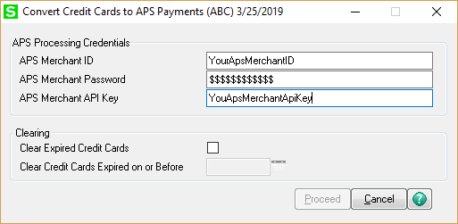

If you have only one merchant account, you can skip the next section and go directly to the section “Proceeding with the card conversion”.

**Convert Cards to APS by Payment Type** – Choose this option if you have multiple Sage Payment Solutions merchant accounts or will have multiple APS merchant accounts. In this case, the A/R Payment Type will indicate which merchant account you will use when you charge a credit card or ACH account, so you will enter the appropriate APS merchant account and password for each credit card and ACH payment type you have on file. You do not have to enter the Sage Payment Solutions credentials because they are stored with the payment type already.

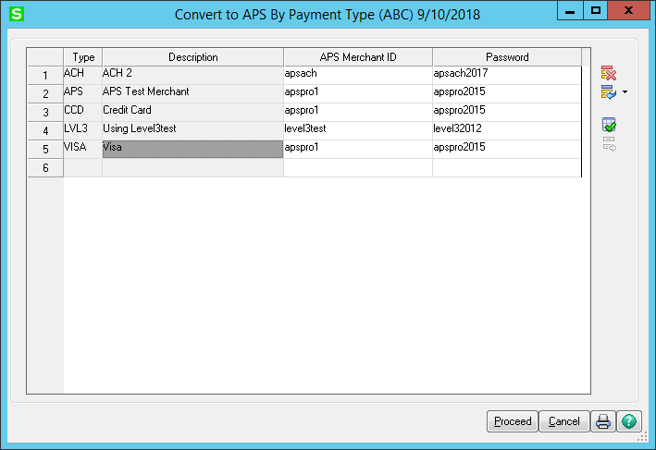

**Proceeding with the Card and ACH Conversion** - When you have entered your APS Merchant ID and APS Merchant Password, click **Proceed**. At this point Sage will want to load the Sage Exchange 2.0 Desktop on your workstation. This is normal, and it is required. After all cards are converted, and you have switched to APS, you can remove the Sage Exchange Desktop.

If Sage Exchange 2.0 is not already running, you may see a prompt like the following:

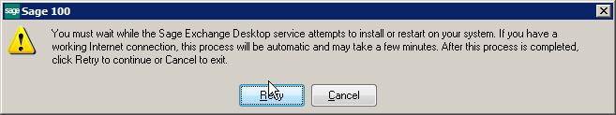

Allow Sage Exchange 2.0 to install the click the Retry button. You will know that Sage Exchange has installed because the little green “SE” icon will appear in your system tray.

*Note*: If Sage Exchange 2.0 fails to install itself, go to www.sageexchange.com/install and select the Sage Exchange v2.x download. Installing Sage Exchange 2.0 may require a reboot.

Once Sage Exchange 2.0 is loaded the card conversion program will pop up this window, telling you what it is about to do:

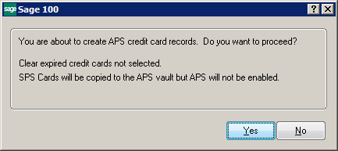

Note that the last sentence says “SPS Cards will be copied to the APS vault, but APS will not be enabled.” *What this means is that you can run this program again and again to copy cards and ACHs into the APS vault*. Some merchants have tens of thousands of cards and ACH to convert, so they can run this program while users are in the system. It will convert any cards and ACH that have not yet been converted, but it will allow those payments to continue to be used with Sage Payment Solutions. If you add more cards or ACH information the next day, you can run again, and it will convert only the new payments.

Once the program has finished copying cards and ACH accounts to the APS vault, it will display the following question:

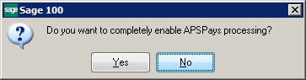

***\*\*\*THIS IS IMPORTANT\*\*\****  
Do not say “Yes” to this prompt until you are ready to go live with APSPays and quit using Sage Payment Solutions. This is the final step in the conversion and it is not easily reversed.

Once you are ready to go live with APSPays, just click “Yes”. A second prompt will pop up to verify that you really, truly want to completely switch to APSPays.

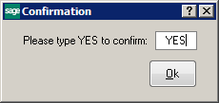

To make sure you absolutely are ready, the program requires to type the word “YES” to continue. Once you have done this and you click “Ok”, everything will be switched over to APSPays.

You can now look at Company Maintenance to turn on Level III processing.

### Upgrading from Earlier APSPays Versions

If you are moving from an earlier version of Sage 100 you must follow these steps.

#### Contact APSPays to Enable Vault

* If you are already running APSPays Credit Card and ACH Processing at an earlier version, then you already have a Merchant ID and Password in the original system that is assigned to one or more A/R Payment Types.
* If the version you are running is 4.40 or 4.50, you **must** contact APSPays to make sure that your Merchant ID is set up to store credit cards and ACH information in the APS Vault. In the 2013 and above systems, no credit cards or ACH information is stored on your local computer. It is all stored securely in the APS Vault. For security reasons, APSPays turns off the merchant’s vault in the 4.40/4.50 versions because those versions can’t use it. They must turn it on and enable it for the 2013 and above versions.
* When upgrading from **4.40/4.50**, you must install the current standard APS Pays version and perform installation steps 1 through 9 (step 5 *Update SY_Company Table* batch file update must be done) *before* installing the APSC2P module. You should fully migrate cards before installing C2P.

#### Install APSPays Credit Card and ACH Processing in the Sage 100 System

Install APSPays Credit Card and ACH Processing in the new Sage 100 system following the instructions in the Installation section shown earlier in this document.

#### Migrate system files and data

#### Migrate the system files and data from the earlier version of Sage 100 to the new installation following the instructions provided by Sage.

#### Reinstall APSPays Credit Card and ACH Processing

This is an important step. Following the instructions above, install APSPays again. Failure to do this will result in menu and other errors because the migration overlays many system records with the old versions.

#### Enable APSPays Credit Card and ACH Processing

A new option has been added to the Library Master Setup menu.

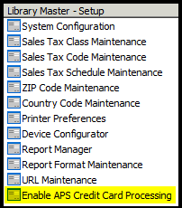

When you run this task, a window pops up to allow you to enable APSPays Credit Card and ACH Processing.

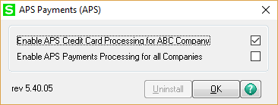

You can choose to enable APSPays Credit Card and ACH Processing for only the current company, or for all companies. When you check either or both boxes, a warning will pop up telling you not to forget the next step.

This Enable function will simply make APSPays Credit Card and ACH Processing the default credit card and ACH payment system. It does not enable credit card and ACH processing for the company. That must be done in the Company Maintenance after APSPays Credit Card and ACH Processing has been activated.

#### Company Maintenance – Run the Data Conversion

When APSPays Credit Card and ACH Processing is first installed, it adds new fields to several tables. This change requires that the data be converted for all companies before you can proceed. While in Company Maintenance, click the Convert button in the upper right corner to complete the data conversion for this company, or all companies.

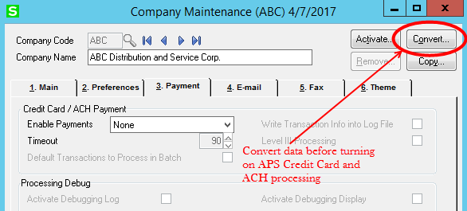

#### Company Maintenance – Enable CC and ACH Processing

The final step is to re-enable credit card and ACH processing in Company Maintenance. On the Payment tab of Company Maintenance, select the type of payments you want to enable in Sage 100.

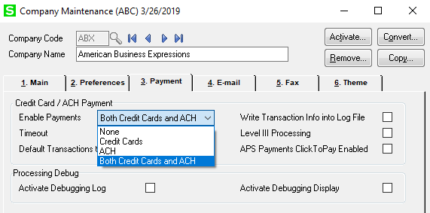

This message will pop up:

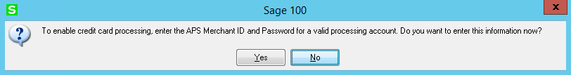

Once you click “Yes”, you can enter the APS Merchant ID, password, and API Key as shown in the screen below:

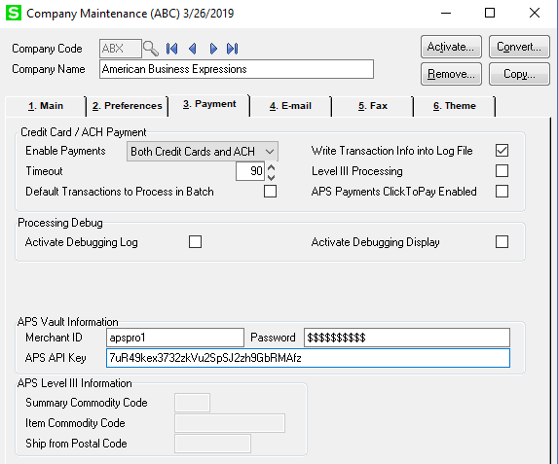

Once you enable credit card and ACH processing for the company, make sure that the **APS Merchant ID, password,** and **API Key** are correct.

When you click Accept, APS will test the merchant ID and password and you *may* see this error:

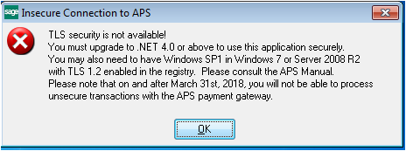

If so, then either your server or workstation does not have the minimum patches installed. As of March 31, 2018, the APS gateway will no longer support less than TLS 1.2 transactions. This issue exists for Windows 7 and Server 2008 R2 that do not have SP1 (Service Pack 1) installed.

Please see:

<https://support.microsoft.com/en-us/help/3140245/update-to-enable-tls-1-1-and-tls-1-2-as-a-default-secure-protocols-in>

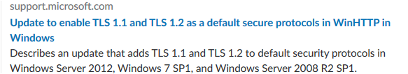

Your IT Support specialist can update and set the needed registry settings.

A useful website for testing your TLS cypher suite:

[www.howsmyssl.com](http://www.howsmyssl.com)

All six test groups should show green (good).

## Processing Credit Cards and ACH Payments

Most of the procedures and screens for processing credit cards and ACH Payments are no different with APS than they are with your current credit card or ACH processing system, if you are using one.

### Company Maintenance

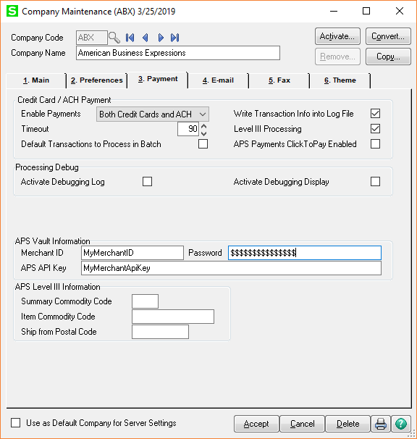

**Write Transaction Info into Log File** - check this box if you want to write APS transactions information into a log file. The log file APS_TRAN<year+month>.log will be created in the MAS_XXX folder (XXX represents the Sage 100 company code).

**Level III processing** - Check this box if you want to enable Level III processing. Once you enable Level III processing for the company, enter the **Summary Commodity Code**, **Item Commodity Code** and the **Ship from Postal Code**.

*Note:* If you have chosen Level III processing, make sure that you go to the appropriate Payment Types in Payment Type Maintenance and check the box to “**Allow Corporate Cards**” (only available for the Credit Card Payment Method). Normally APS will supply the values for Level III processing in their setup email to you.

## Accounts Receivable Options

Right after a conversion, or in some cases when activating a company for APS, you will need to activate the **Allow Credit Card** option on the **Entry** tab:

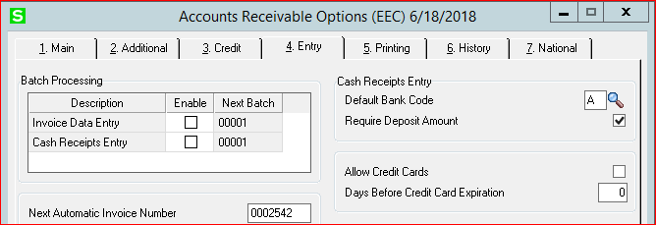

Otherwise you will not have access to credit card functions.

### Payment Types

Once APSPays has been activated and the company credit card and ACH processing has been enabled, eight new fields will be visible at the bottom of the panel when you edit or add a Payment Type for credit cards or ACH payments.

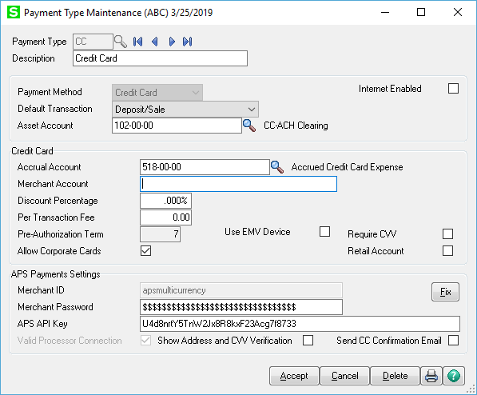

*Note*: **Accrual Account** and **Asset Account** are required for Credit Card and ACH Payment Types.

Once the Payment Type is set up, it can be used during data entry in A/R Invoice Data Entry, Cash Receipts entry, S/O Sales Order Data Entry and S/O Invoice Data Entry. When this Payment Type is used, you will be able to either select a stored credit card or ACH payment type or enter the customer’s payment information into a pop-up web page. None of the sensitive payment information is stored on your computer or within Sage 100.

*Note*: If you are planning to use this payment type for Level III processing, be sure to check the “**Allow Corporate Cards**” field show in the screen above (only available for *Credit Card* payment method but does not apply to EMV cards).

**Use EMV Device** – Check this if you will be using a chip reader on any workstation. If checked, this payment type can *only* be used on chip readers. The reason for this is that a chip reader is a “card present” transaction and gets the best rates. You should set up another payment type for credit cards taken over the phone or online so that you can use Level III to get the best rates for your transactions. Also, Require CVV will turn off and Retail Account will turn on if checked.

**Require CVV** – this is checked by default unless you select *Use EMV Device*. This will require the CVV code to be entered when vaulting (saving) cards and when manually entering any new card. If you uncheck this, you will see the following message:

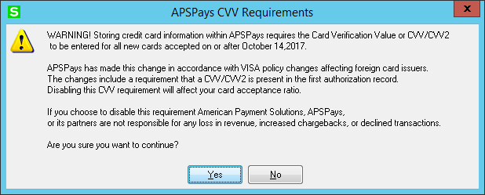

Be *very* sure when you turn this off – it can have repercussions on your card fees and charge backs.

**Retail Account** – This indicates that your merchant account is set up as Retail, which handles cards on file differently. APS will advise you if you need to check this. Most accounts are MOTO or eCommerce and will not need this checked. Automatically checked for EMV payments. You can also check this for card swipe with Hosted Form which will automatically display the card swipe form.

**Merchant ID** – This is the APS merchant id. Supplied by APS. When credit card or ACH information has been entered for a payment type, the **Merchant ID** multi-line will be disabled in Payment Type Maintenance for this payment type.

**Merchant Password** – This is the APS password for this merchant account.

**APS API Key** – this is the API key APS now uses for Hosted Form and EMV transactions.

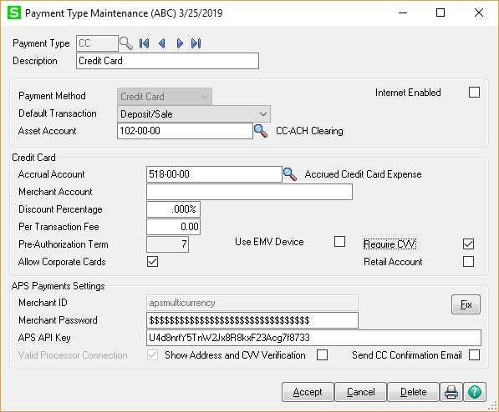

To enable the **Merchant ID** multi-line, press the **Fix** Button. The **Fix** button is visible on the Payment Type Maintenance panel only if the appropriate security event is set up.

APS can send a confirmation email to the email address on the card on file. If the card is not on file, the system will use the email address from the order or invoice header (or the customer email if from cash receipts). To enable the confirmation email sent from the APS Gateway, check the “**Send CC Confirmation Email**” checkbox.

### Customer Maintenance

On the Additional panel in Customer Maintenance a button labeled **Credit Cards/ACH…** will take you to a stock Sage 100 screen to enter and edit customer credit cards or ACH information. From this screen, you can select a payment type, then add cards or ACH information. Each payment option is given a nickname that you will see. Once you have entered credit card or ACH information, you will only see the nickname, the last four digits of the card number and its expiration date, or the last four digits of the Routing No. and Account No. You will never have access to the full card number or bank account information again from within Sage 100.

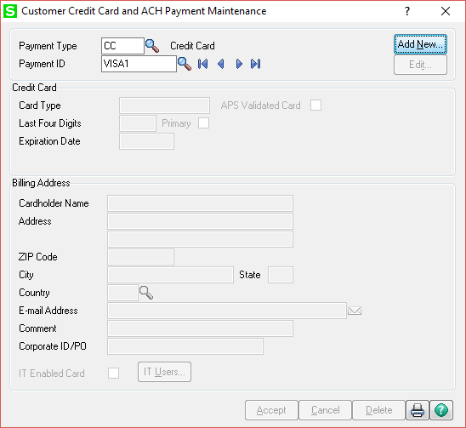

To add a new card or ACH, enter a **Payment ID**, or nickname, then click the **Add New** button in the upper right corner. A small web page screen like the following will appear. This screen is used for data entry only and will not store the card or ACH information on your system. This screen communicates directly with the APS Vault to store all sensitive card and ACH information there.

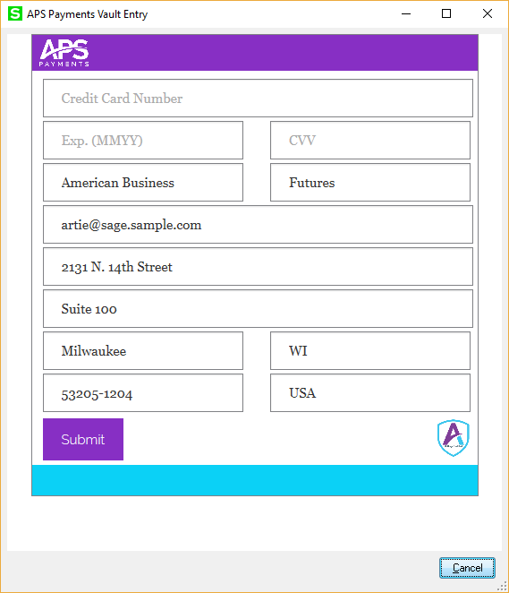

Click the Submit button to post. Click the Cancel button to exit without posting.

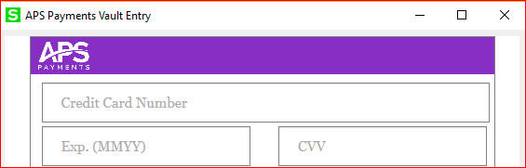

Fields in grey you must enter, or the submission will be rejected:

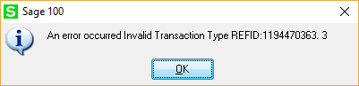

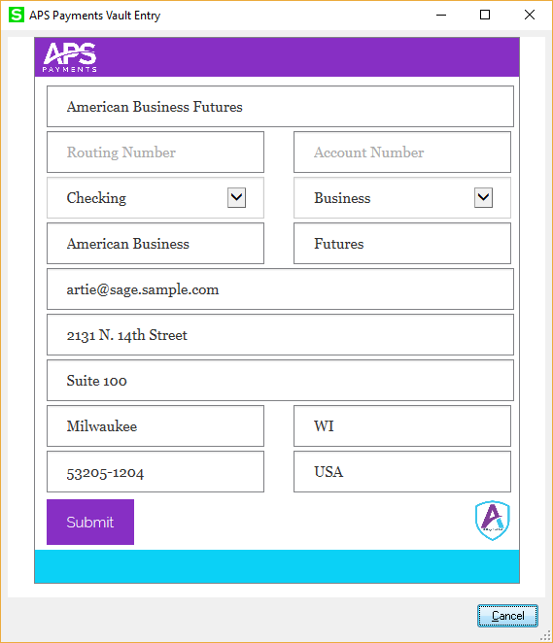

For ACH, you will need the routing number, the account number, and is the account a personal or business checking or savings account.

Each new card or ACH that you enter here can be used anywhere in the Sage 100 system that credit cards and ACH are allowed.

You can also edit existing cards on file, say to update the address or the expiration date:

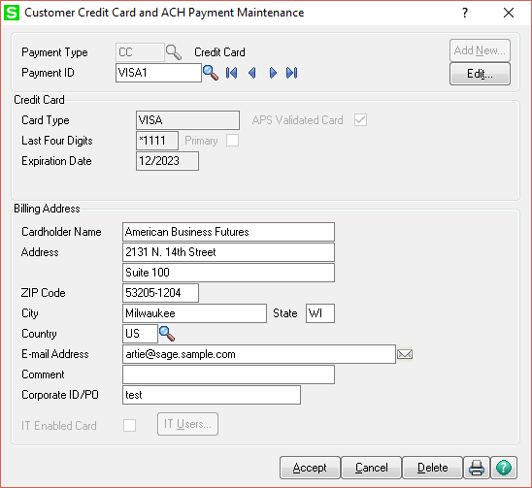

The screen will display the information that the system has on file, along with a masked card number. This allows you to update the expiration date and address in the card vault at APS.

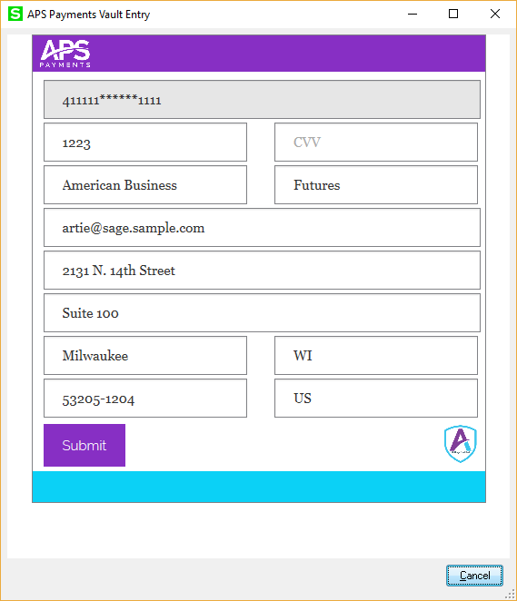

As before, click Submit to post the update or Cancel to discard the change.

## A/R and S/O Invoice Entry

For A/R and S/O invoices there is a tab to the right of the Totals tab where you can select the credit card or ACH payment to use, or enter a new **Payment ID**.

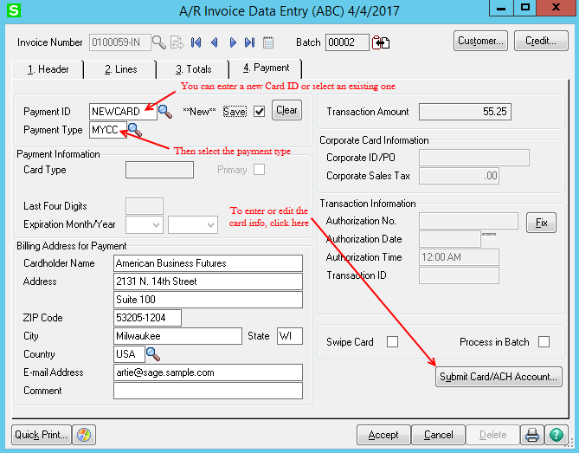

For the **Payment ID**, you can select one of the saved options, or you can enter a brand-new **Payment ID** to enter new card or ACH information and save it. If you enter an existing **Payment ID**, the **Payment Type** will fill in automatically. If you enter a new ID, click the **Save** check box to be able to use that same payment for this customer later.

*Note*: To refund a credit card on a Sales Order Credit Memo Invoice, the customer’s credit card must be saved in Sage 100.

**Billing Address for Card** – A new feature that comes with APSPays will automatically fill in the Billing Address for the Card or ACH from the sales order or invoice header if the customer address is blank. In the standard Sage 100 system, the Cardholder or Account Name and Address are copied from the customer record in A/R. If the customer name and/or address are blank, then the Cardholder or Account Name and Address would remain blank and the user would have to fill them in manually. A new feature in APSPays will not leave the Cardholder or Account Name and Address blank but will copy the Bill-to Name and Address from the document header into the Cardholder or Account Name and Address fields. This is useful if you have a “dummy” customer that is used repeatedly for counter sales where you do not wish to save the customer information.

**Submit Card/ACH Account -** Once you have selected the credit card or ACH ID, or enter a new Payment ID, click the **Submit Card/ACH Account** button. This will either show the existing card or ACH information or allow you to enter a new card or ACH. If it is an existing card or ACH, you will only see the last four digits of the card number, or the last four digits of the Routing and Account Number.

If you select an existing credit card or enter a new Payment ID for a credit card or ACH, then Accept the invoice or order, the credit card entry window will pop up requiring you to submit the card or enter the new ACH information, unless you have already used the Submit Card/ACH Account button.

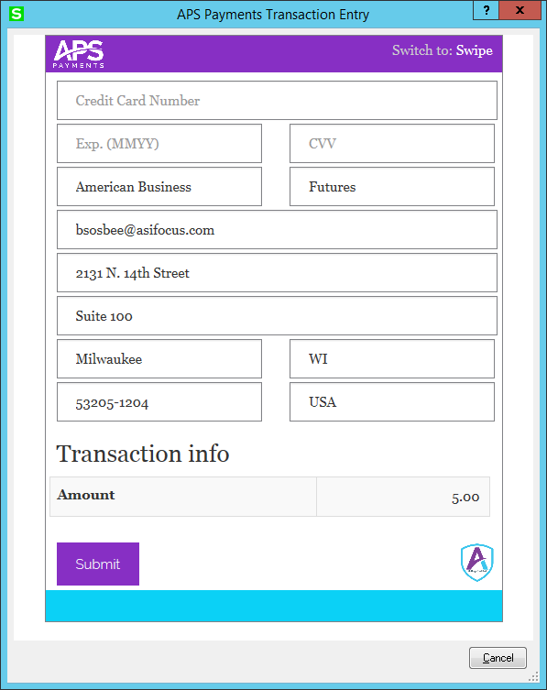

This image shows the Credit Card Information window where you are entering new card information. When you click the **Submit** button that information will be sent directly to the APS Vault and will never be stored on your local system, except for the last four digits of the card and the expiration date. Unless changed in *Payment Type Maintenance* you must enter the **Validation Code** (CVV or CVV2) to process the transaction. This is a required field unless **Require CVV** is turned off.

If the payment type is marked as a Retail payment type, the card swipe screen will show.

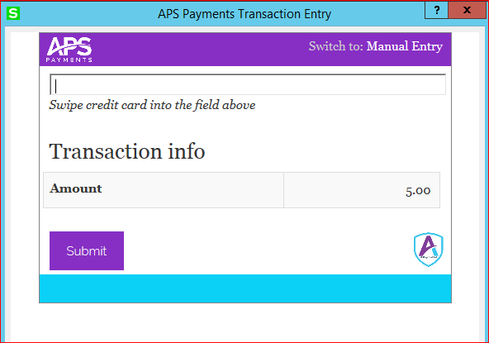

Use this with a Magtek or similar card swipe. Swipe the card and the program will automatically continue and process the card. If the card swipe is unreadable, you can switch back to Manual Entry mode by clicking on Manual Entry at the top right of the screen.

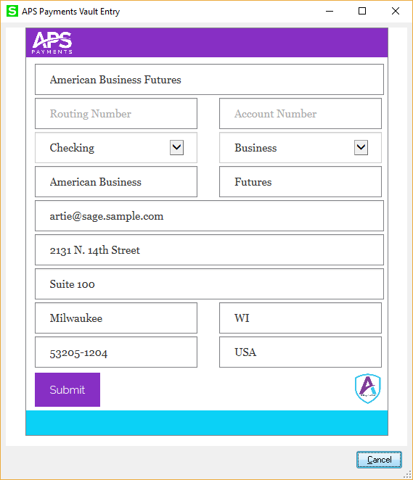

This image shows the ACH Information window where you are entering new ACH information. When you click the **Submit** button that information will be sent directly to the APS Vault and will never be stored on your local system, except for the last four digits of the Routing Number and Account number, as well as the account Type.

*Note*: Credit Cards cannot be used on Credit Memo Invoices entered in AR Invoice Data Entry.

### Accounts Receivable Cash Receipts Entry

When creating a new deposit for A/R Cash Receipts, there is a field for Credit Card and ACH Deposit Amount.

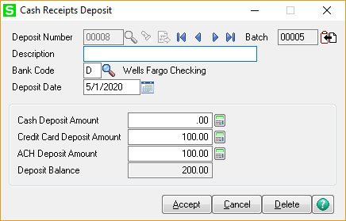

You can combine credit card, ACH and cash payments on the same deposit.

For each payment that is included in the deposit, you first select the customer, then select the Deposit Type, either Cash or Credit Card or ACH as show in the image below.

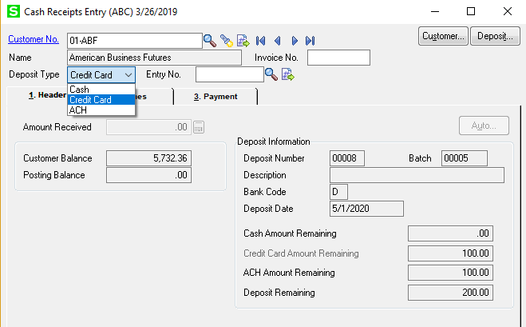

Once you select Credit Card or ACH as the **Deposit Type**, you can continue to enter the details of the deposit, including invoices paid or G/L accounts to charge to. Before you can save this deposit, though, you must go to the Payment tab and select an existing **Payment ID** to charge, or enter a new **Payment ID**.

As you saw with the Payment tab for invoices, you can enter a new **Payment ID** or select an existing ID. If you select an existing ID, the **Payment Type** will be filled in automatically. Otherwise you must select a valid **Payment Type** that is set up for credit cards or ACH. Don’t forget that you can check the **Save** box to permanently store the card or ACH for this customer in the APS Vault.

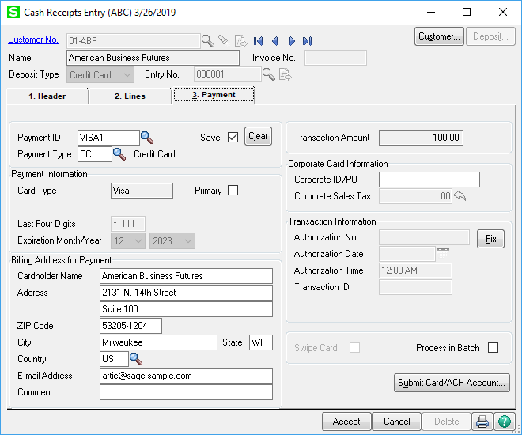

When you click the **Accept** button in Cash Receipts Entry, or click the **Submit** **Card/ACH Account** button, the credit card or ACH information will be displayed so that you can enter new card or ACH information or edit the expiration date and validation code on a stored card. If you need to change the billing address for the card, you must do it on this screen before clicking the **Submit** or the **Accept** button.

### Sales Order Entry

On the Totals panel of the order select the appropriate **Deposit Payment Type** that is being used. In the example below, we have selected *Credit Card*. As soon as you select *Credit Card*, you are taken directly to the Payment tab.

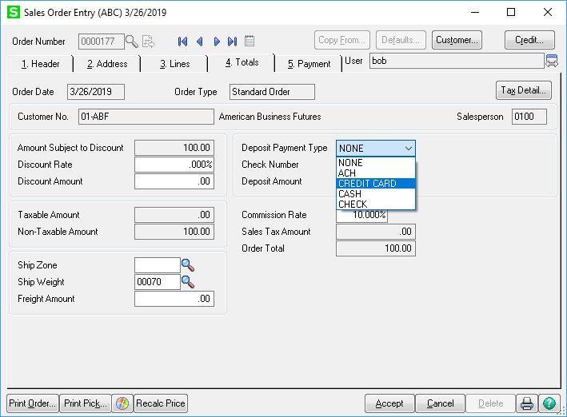

On the screen below we have already selected a stored card. There are two possible credit card transactions available for a sales order. Under Transaction Information you can select either *Deposit* or *Payment* (or Pre-Authorization) as the **Transaction Type**.

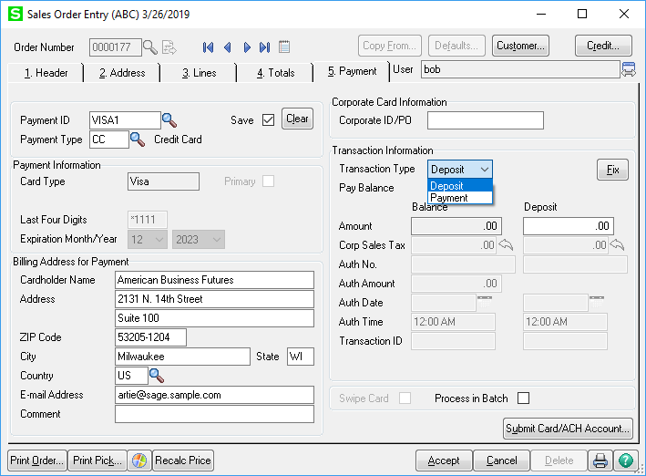

If you select Deposit, the credit card will be charged as soon as you **Submit** the card or **Accept** the order. In the image below (left), checking the **Pay Balance** checkbox will charge the invoice balance to the credit card. If a deposit amount is entered, the Auth Amount will adjust to the difference of the Invoice Amount Less Deposit. When submitted, the credit card will be charged for the deposit amount, and an additional screen will pop up for a Pre-Authorization for the remaining balance. The remaining balance will be charged when an invoice is created and updated.

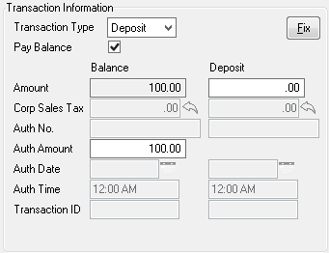 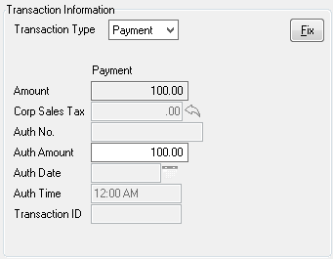

If the *Payment* type is selected (image above, right), a preauthorization transaction will occur to confirm the card is valid and has enough credit to make the sale. The credit card is not charged at the time the card is submitted.

*Note*: The Auth Amount defaults to the order balance but can be manually changed to an amount higher or lower than the order balance. When an invoice is created and updated, the entire invoice balance will be captured.

In the example below, we have selected *ACH* as the **Deposit Payment Type**. As soon as you select *ACH*, you are taken directly to the Payment tab. On the screen below we have already selected a stored card.

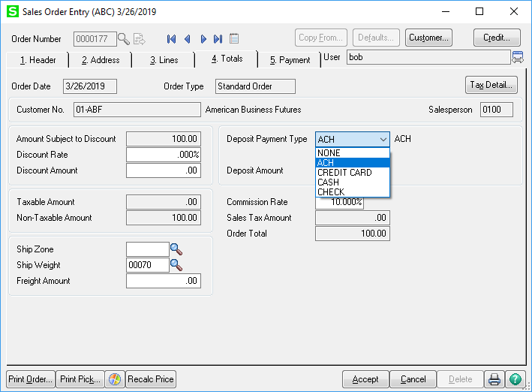

On the screen below we have already selected a stored ACH ID. Once you have selected your existing **Payment ID**, or entered a new Payment ID, click **Accept** to save the order. For ACH Payments, there is no need to click the **Submit Card/ACH Account** button.

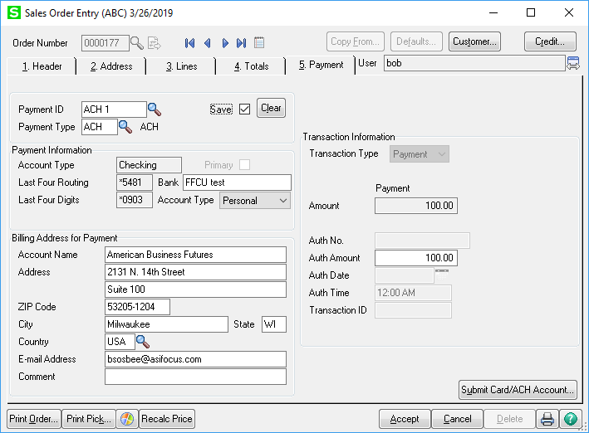

If you click the **Submit Card/ACH Account** button, the program will check that the ACH information on file is valid and that is all. Clicking **Submit** does not send a preauthorization or payment request to the customer’s bank. If entering in new ACH information, the fields will be blank or available for editing as seen on the right. Click **Submit** to send the bank account information to the APS Vault. The Sales Journal processes ACH payments at the end of the day.

### Sales Order Invoice Credit Memos

In order to process a credit refund within Sage 100, the original invoice must have been paid using a Credit Card, the customer’s card is saved in Sage 100, and an Apply to Invoice Number must be selected referencing the original invoice.

*Note*: To prevent fraudulent transactions, credit card processing does not post a credit to a card without applying the credit memo to the associated invoice.

In the image below, a credit memo invoice has been created for a standard invoice paid by credit card. The invoice type has been changed to Credit Memo and the original invoice has been selected in the Apply to Inv No. field. When the Apply to Invoice is entered, Sage populates the credit card information on the Payment tab based on the original invoice the credit memo is being applied to.

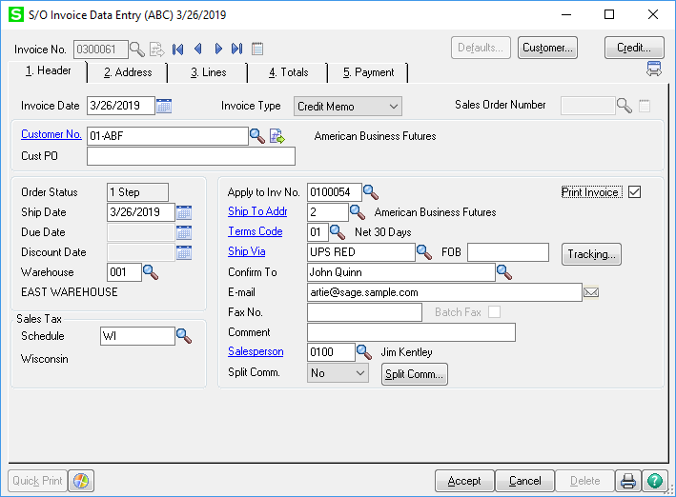

Go to the lines tab and enter the items to be credited. Enter all the quantities and costs as positive amounts. Clicking **Accept** to save the credit memo invoice will automatically authorize the credit return to the credit card. You are not required to click the **Submit Card/ACH Account** button like a standard Sales Order or Invoice.

The screenshots below show the populated Totals and Payment Tabs with the **Deposit Payment Type** of *Credit Card* and the **Payment ID** of the credit card the refund is charged to.

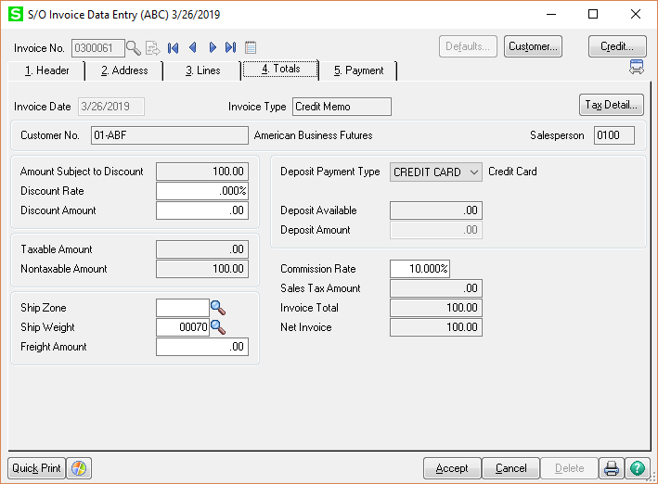

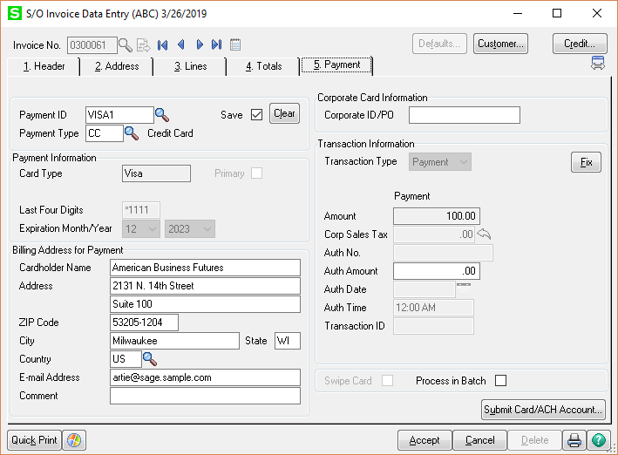

When you have completed your batch of invoices to be posted, update the *Daily Sales Reports/Updates* (Sales Journal).

### Expired Authorizations in Invoices

When the preauthorization has expired (aged beyond the term set in the Payment Type Maintenance), it will appear on the Payment Tab of Sales Order Invoice Data Entry.

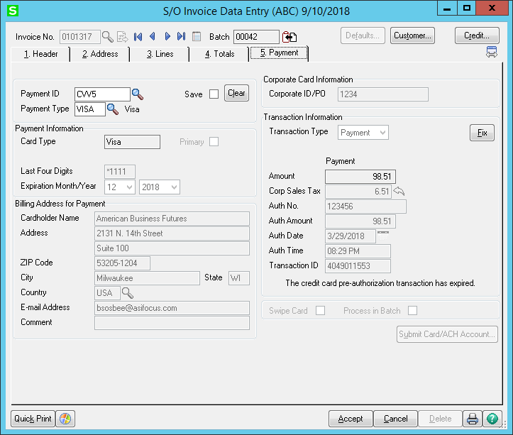

Clicking Accept will display this message:

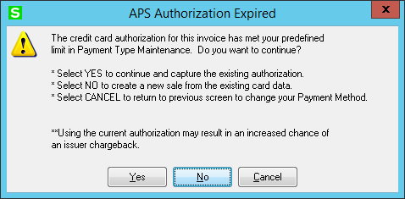

Clicking on the **Yes** button will use the existing expired authorization. As the screen indicates, this can result in an issuer chargeback. *Note: if you accept the invoice after selecting this option, then go back into the invoice you will see the APS Authorization Expired message again and can change your selection.*

Clicking on the **No** button will hold the existing card data but will void the existing authorization (to release the hold on funds) during the sales journal and using the existing card data will create a new sale transaction (as a deposit) during the sales journal. *Note: if you accept the invoice after selecting this option, then go back into the invoice you will see the APS Authorization Expired message again and can change your selection.* You will see the following message:

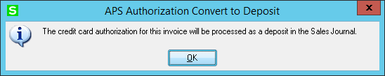

Clicking on the **Cancel** (or the  button on the top right of the APS Authorization Expired screen) will immediately void and remove the existing authorization to release the funds. You will see the following message:

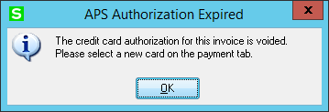

You must select a new payment ID or enter a new payment type. This is the method for immediately cancelling a preauthorization instead of letting it expire as the system normally does.

### EMV Card processing

To use an EMV terminal, such as the Ingenico iPP320, it must be first configured and installed on your terminal, along with at least one EMV payment type. Please see the section “Installing the EMV terminal.”

You may use the EMV terminal in Cash Receipts, A/R Invoice, Sales Order Entry, and S/O Invoice Entry.

The system will check to see if the services for EMV are running. If not, you will see a message when you first go into the program where it will ask you if you want to start the services:

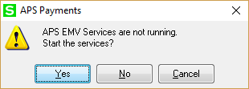

Selecting **Yes** will start the services which will reboot the EMV terminal and set it up for use. This is the same as clicking **Start** in the *APS EMV Services Status* program. It will take about a minute to start the services.

Selecting **No** will turn off the EMV functions for this workstation and normal Hosted Form operation will still work. You will not be able to do card chip or swipe processing, but all other APS functions will work.

Selecting **Cancel** will exit back to the menu.

The critical part will be when you select the EMV Payment Type in the Payments Tab:

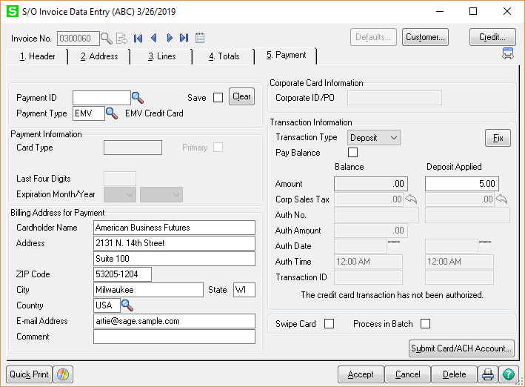

Click **Submit** or **Accept** to initiate the EMV chip reader. A web page will appear:

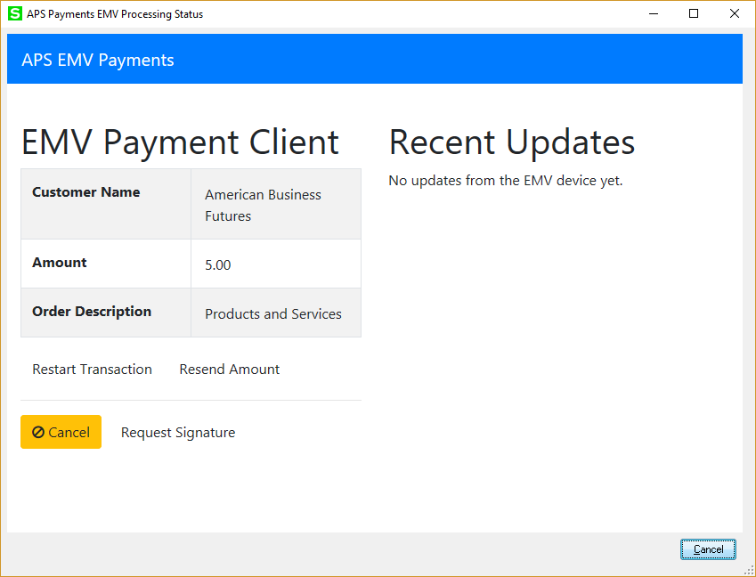

Unless you click the  button, the EMV terminal does not know you have cancelled the transaction. Otherwise your customer is following the instructions on the terminal. If you click the small  button, the transaction may need to be manually cancelled on the terminal.

For your customer, the EMV terminal will display a message sequence like below.

When waiting between transactions:

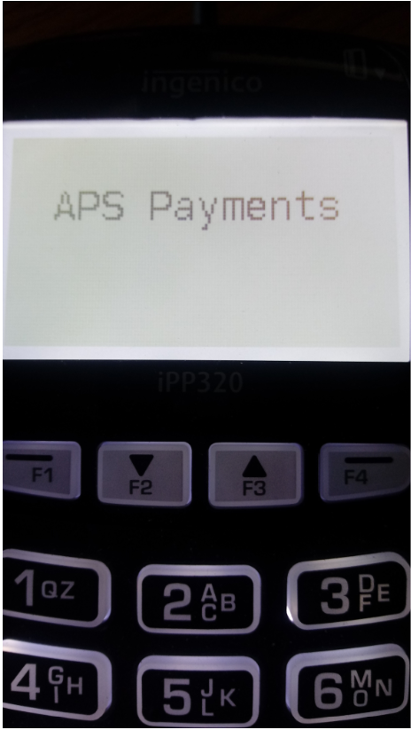

When ready to process the card:

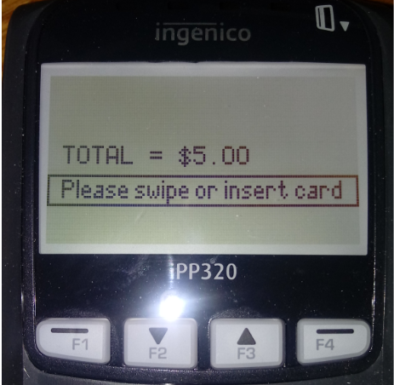

Customer slides in a card:

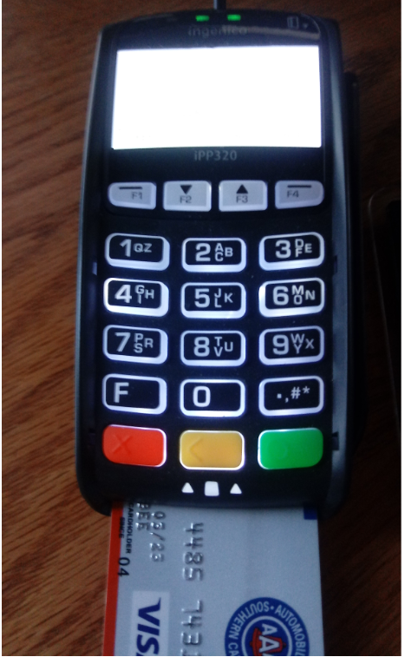

The terminal will ask the customer to confirm the amount or cancel:

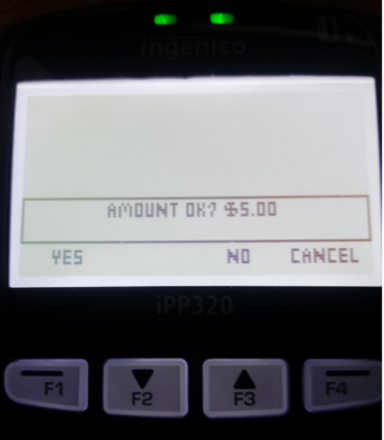

After approval, the terminal asks the customer to remove their card:

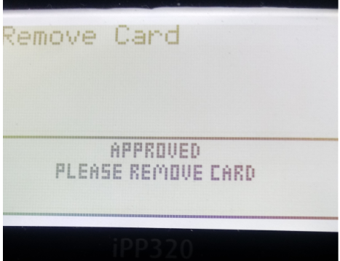

The web page will see the approval, sends it to Sage, and closes.

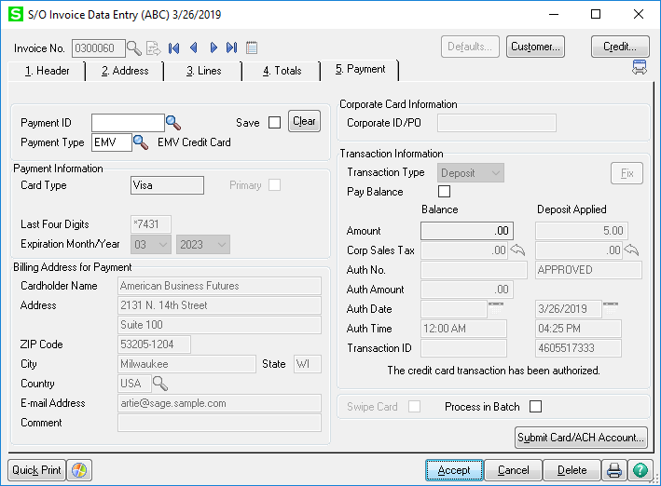

Note for A/R invoice entry, the transaction is a sale with immediate capture.

For both Sales Order and Sales Invoice, selecting Payment will get an authorization, which will be captured in the Sales Journal. However, it can expire, and you cannot exceed the amount authorized. The preferred method for EMV payments is to use Deposit which does an immediate capture of the funds as a deposit.

## APSPays Credit Card and ACH Settlement Report

To facilitate reconciling deposits from the credit card or ACH bank, a new settlement report is on the A/R Reports menu:

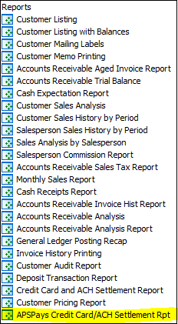

The APSPays Credit Card and ACH Settlement Report allows you to select a merchant account, your detail level preference, and a date range, then will retrieve the settled transactions for that account within the date range.

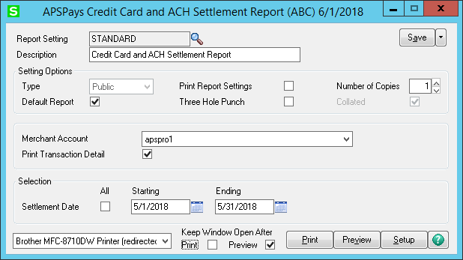

Once you selected the **Settlement Date** range, the program will retrieve all the settled transactions for that **Merchant Account** and match those transactions up to the journal where the transaction was completed and will print out the settlement transactions grouped by journal. The format for the report is identical to the standard *Credit Card and ACH Settlement Report*.

## APS ClickToPay Setup

You can enable and use APS ClickToPay without enabling credit card processing for Sage 100.

APS ClickToPay is enabled on a company-by-company basis. Once enabled, the feature will send invoice information to the secure APS ClickToPay gateway when you print invoices for the chosen customers. The invoice the customer receives via email will contain a link that the customer can click to make a payment online. The APS ClickToPay gateway processes the payment and provides all the payment information to the Sage 100 cash receipts as if those invoices were paid with cash or check.

* Setting up APS ClickToPay for your company involves the following steps:
* Enable APS ClickToPay in Company Maintenance.
* Make sure that Paperless Office is set up so that the APS ClickToPay link can be sent to the customer.
* Modify the Crystal Reports invoice forms to print the APS ClickToPay payment link.
* Select which customers are to receive links or not.

### Enable APS ClickToPay in Company Maintenance

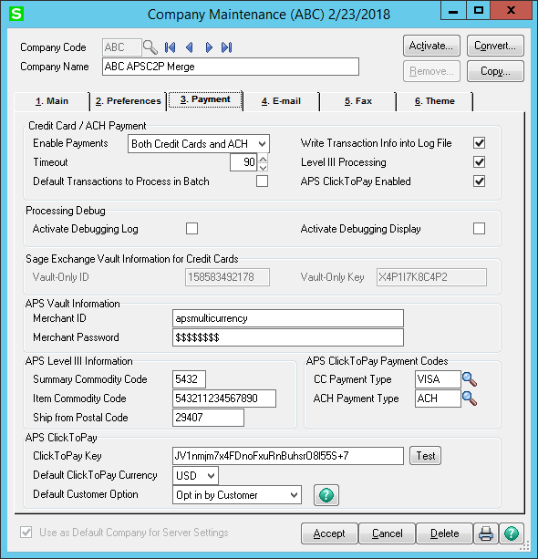

Check the “**APS ClickToPay Enabled**” box to turn on APS ClickToPay. This will open the APS ClickToPay section at the bottom of the screen and show the additional fields.

APS Level III Information is required for the lowest fees. You must enable Level III Processing and enter the APS supplied Level III fields for the ClickToPay gateway.

Two payment types are selected to properly import payments into cash receipts for ClickToPay.

**ClickToPay Key** *–* The ClickToPay Key is generated by APS. This key is used to allow Sage 100 to communicate with the APS ClickToPay gateway. Once you have entered the **ClickToPay Key** you can click the “**Test**” button to make sure that communication is working.

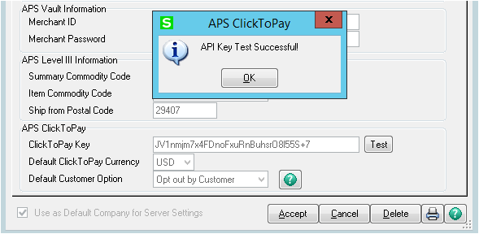

**Default Currency** – Use the drop box to select the default currency for this company. You may only select currencies that are supported by the APS ClickToPay gateway, which APS maintains.

**Default Customer Option** – APS ClickToPay allows you to select or deselect the option by customer. This company parameter gives you to option of deciding which will be the default setting for a customer.



* *Opt out by Customer*: If you choose “*Opt out by Customer*”, then all customers will be selected for APS ClickToPay unless you check the box in Customer Maintenance.
* *Opt in by Customer*: If you choose “*Opt in by Customer*” all customers will be excluded from APS ClickToPay unless you check the box in Customer Maintenance.

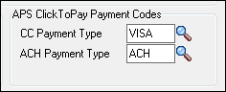

**CC Payment Type** – This is the payment type for credit card payments made on the ClickToPay gateway. When these payments are imported, they will post as if they were processed through Cash Receipts and flow into history. However, if you do credit memos on the invoices, the system will not try to retrieve this credit card information from the invoice which is normal for payments processed through Cash Receipts. Note that the payment types listed in the lookup are specific to the company selected in Company Maintenance.

**ACH Payment Type** – Only applies if you have selected *ACH* or *Both* in the **Enable Payments** section or Sage won’t allow ACH payments of that type to be set up. As with the *CC Payment Type* above, this will process any ACH transactions done on the gateway as if processed in Cash Receipts. Note that you do **not** have to have Sage or APS active, only that **Enable Payments** are turned on to process the ACH transaction.

### Modify Invoice Forms for APS ClickToPay

To modify the Crystal forms, you must be familiar with Crystal Reports. Your Sage partner can help you with this step.

We included in the \mas90\REPORTS folder two sample invoice forms for A/R and S/O that show the needed fields. These are:

* AR_Invoice1ClickToPay.rpt
* SO_Invoice1ClickToPay.rpt

Because of the limitations of Sage’s PDF processing, hyperlink buttons do not work reliably depending on the PDF reader. However, the full hyperlinks (URLs) do work, but are long and bit unsightly. However, you can print the hyperlink in white font. This will make the hyperlink invisible to the human reader but the PDF reader (usually Adobe Acrobat Reader) will recognize the link and allow the customer to click on it. We also provide a graphic “Pay Here” to link with as well.

APS adds three fields to the Crystal worktable:

* D531_C2PLinkCode which identifies the invoice to the gateway. Not normally used in forms, we include it for special reporting.
* D531_C2PUrlLink which contains the full URL to link for the invoice on the gateway. This field is the one the customer will click on and is therefore critical.
* D531_C2PCustomer which allows you to suppress the URL if the customer is opted out of ClickToPay.



Here is an example from the SO_Invoice1ClickToPay.rpt:

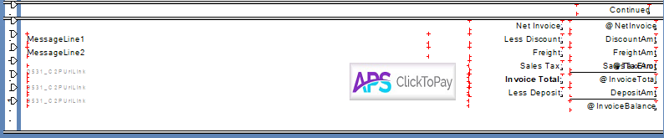

The D531_C2PUrlLink lines are in this case set on three lines and printed in white font so that if you click anywhere in the indicated area the PDF reader will see the URL and either open your web browser or ask if it can. ***Note:*** *You must make the field long so that all the URL will print. To ensure that the “hidden” field doesn’t overlay, select “move to back” for the field.*

The “Pay Here” image is also set as a hyperlink as some PDF readers will accept it as a button and open a browser to the invoice.

Note that you do have to show the entire hyperlink, so the full URL is passed to the browser. It is easier for the customer to click on the hyperlink if it not a small area. In the example above, we put the URL link line in three times to make sure it was clickable. You can put this in any part of the header or footer of the invoice. Be sure to select “move to back” so the field doesn’t overlay other fields, and you may have to set the field to “can grow.”

Examples of how to set up the hyperlink URL fields:

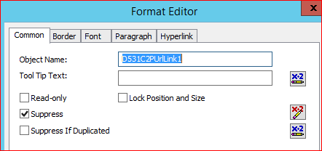

For **each** of the hyperlink lines, you will need to add the suppress function with a formula.

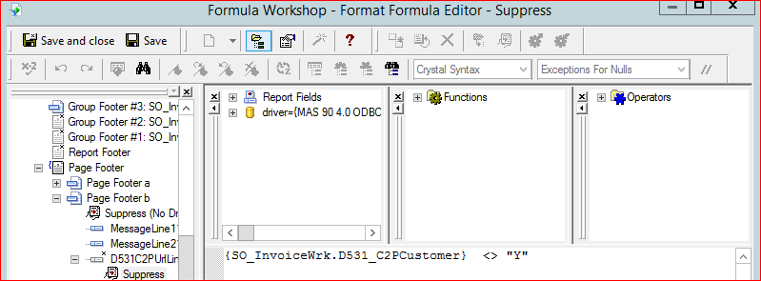

Save and close, then select the **Font** tab, reduce the font to 8, and change the color to White.

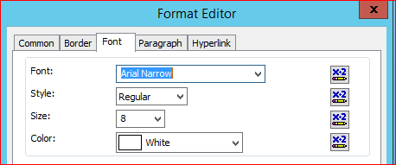

Click **OK** to save the changes. This makes the field “invisible” normally, but still seen by the PDF reader. Be sure to select “*To Back*” under **Move** for the field.

Next, insert the Pay Here button as a picture. You can find the graphic in the \mas90\ASI folder as apsC2P_payhere.jpg. We provide other picture formats in case you need to adjust the graphic. We recommend that you put the picture on top of the hyperlink lines as in the example so if the PDF reader doesn’t accept the button hyperlink, the underlying lines will trigger the hyperlink and the browser should open.



As with the URL hyperlink lines, you will need to add the suppression logic.

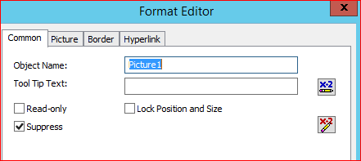

We use the same formula:

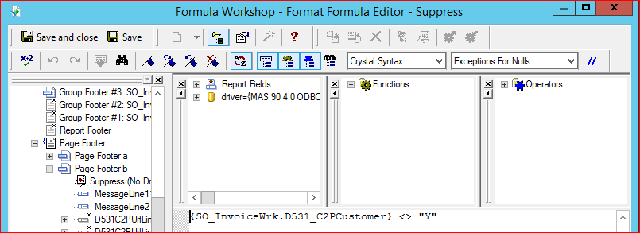

However, on the **Hyperlink** tab:

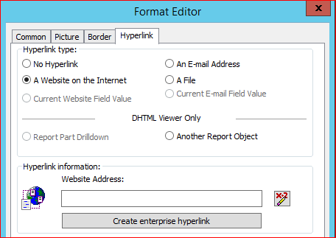

The formula is simple – it is the URL link.

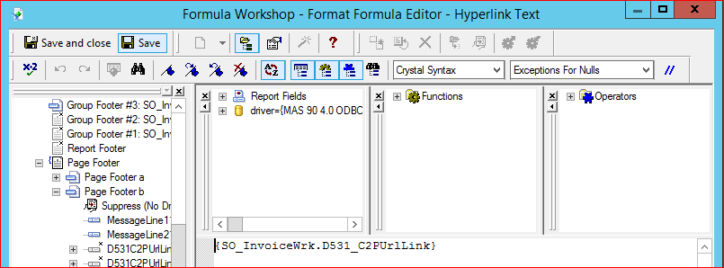

Click Save and Close, then OK to save the changes. Then save the Crystal form.

### Select Customers for APS ClickToPay

There is a new check box on the Customer Maintenance main panel that will allow you to “opt in” or “opt out” that customer for APS ClickToPay.

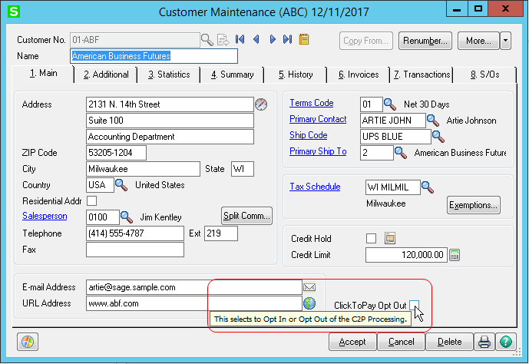

In the screen above, you can see the check box for “ClickToPay Opt Out”. Since the Company Maintenance Default Customer Option was set to “Opt out by Customer”, all customers will be included in APS ClickToPay unless you individually check the box to opt out. If the Company Maintenance Default Customer Option was set to “Opt in by Customer”, this check box in Customer Maintenance would look like this:



## APS ClickToPay Daily Processing

Once the setup for APS ClickToPay is complete, the daily processing is quite simple. There should be no significant change to the standard tasks. As each invoice (and only invoices) are entered, the invoice is uploaded in real time. If you enter a credit memo that is applied to an invoice, but invoice has not yet been paid on the C2P web site, the credit memo amount will be applied to the invoice, so the correct balance is shown for the open invoice on the web site. Once it is paid in full such credits are only applied to the invoice in A/R.

When an invoice is printed, the APS Pay Here link will be included on the PDF that is sent to the customer. There is no intervention needed to make this happen, if the customer option is set, and the forms have been modified to correctly include the link. ClickToPay will upload the final invoice to the gateway during the Sales Journal (both A/R and S/O). It will also upload the invoice data when the invoice is printed from history if there is a balance due on the invoice and it was not previously processed by ClickToPay.

After the invoice is uploaded and the customer receives the PDF invoice, the customer can then pay the invoice on the ClickToPay gateway. To retrieve and post these transactions you must retrieve them through Cash Receipts.

We recommend that you at least once a day perform the Cash Receipts download of payments taken on the gateway.

### Processing ClickToPay Transactions through Cash Receipts

First, you will need to start a new deposit and select the bank code to use if not the default bank code. ClickToPay will not load into an existing deposit.

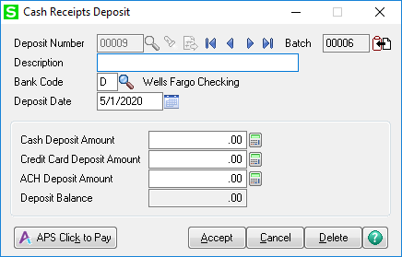

Click on the **APS Click to Pay** button or click Ctrl-k.

If there are no payment to post, you will see the following:

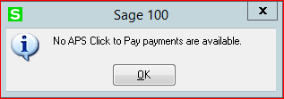

Otherwise, the deposit will load and if the **Description** is blank it will fill it in:

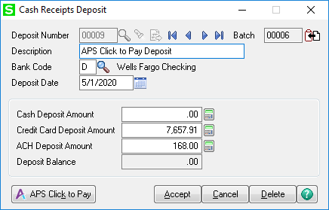

APS will go out to the ClickToPay gateway and return all unposted credit card and ACH deposits for Cash Receipts to post. Please run this *first* before adding other deposit transactions into this deposit or run ClickToPay as a separate deposit batch.

The cash deposit is posted against the invoice that was paid on the web site. You may have hundreds of invoices in a download. You may want to do this more than once per day.

At this point simply run the Cash Receipts journal to post the transactions.

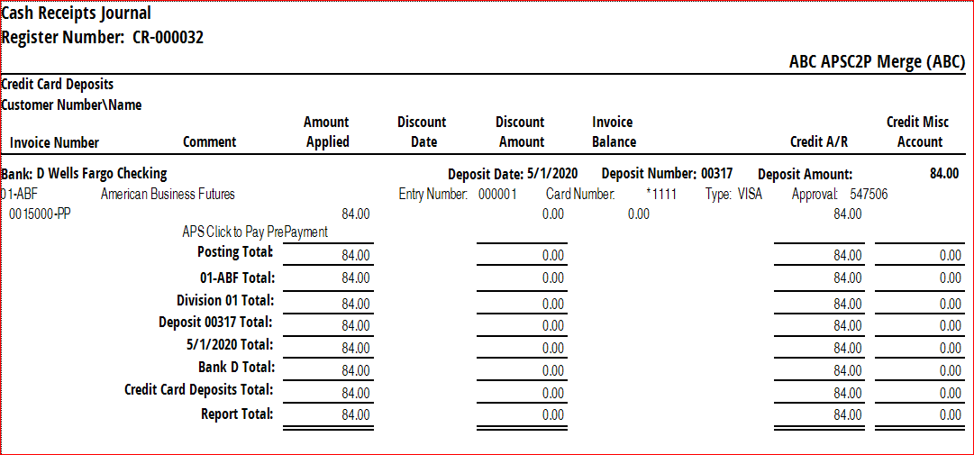

Example deposit from ClickToPay. Note the entry number used. That sequence is per deposit and resets for the next deposit as it is the sequence in which the transactions were downloaded.

*Note:* This is not the same as the settlement date of the funds. As with standard credit card/ACH processing, the payment types should post to a Credit Card/ACH clearing account. When the funds are deposited into your bank account you would do cash receipts to transfer the funds from the clearing account into the correct bank account as you would normally do for credit cards and ACH payments.

### ACH Declines for Click To Pay

Unlike credit card transactions, ACH transactions may decline 2-3 days later when the bank returns the transaction as Non-Sufficient Funds (NSF). As such, you need to record the NSF.

Typically, the email from APS will look something like this:

Subject: American Payment Solutions Electronic Check Status Update for ABC Company – apspro1

American Payment Solutions Electronic Check Status Update for ABC Company – apspro1

A total of $0.00 has been settled for apspro1.

Total No. of Electronic Check Charges Settled: 0

Total Electronic Checks Charges Settled: $0.00

Total No. of Electronic Check Refunds Settled: 0

Total Electronic Checks Refunds: $0.00

Total No. of Failed Electronic Check Charges: 1

Total Failed Electronic Checks Charges: $196.02

Total No. of Failed Electronic Check Refunds: 0

Total Failed Electronic Check Refunds: $0.00

Total No. of Electronic Check Notifications: 0

-------------------------------------

Failed Transactions

-------------------------------------

Failure: R03: No Account/Unable to Locate

Date: 07/21/2018 22:47:23

Transaction ID: 4198070304

Customer Name: American Business Futures

Account Number: *****3041

Order ID: 14201CR

Order Description: Payments and other fees

Amount:

With Click To Pay, you can process the NSF debit memo and it will put it back up on the Click To Pay gateway for the customer to pay with an alternate payment method.

This also allows you to add the NSF fee to the invoice for the customer to pay.

Create the debit memo in the same module it was created in (SO or AR):

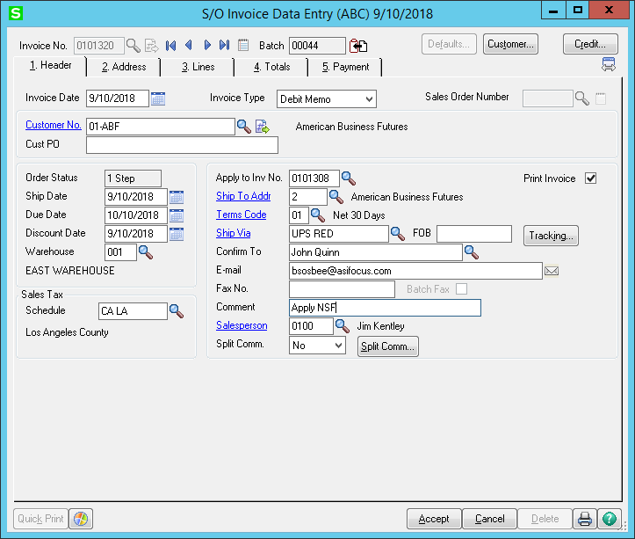

Be sure to set the tax code the same and specify the invoice in the **Apply to Inv No.** field.

Next, enter the NSF fee and a miscellaneous line to reverse the clearing deposit

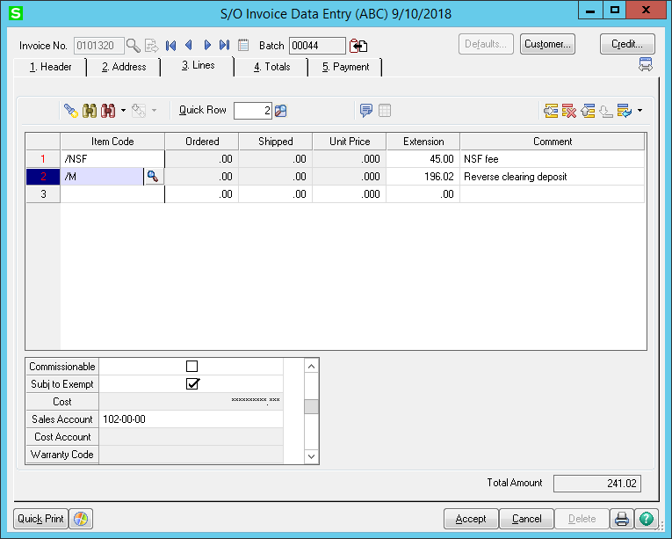

Note that the Sales Account for the /M line is the CC-ACH Clearing Account. You may want to create a code like the /NSF to state “Reverse payment” or similar.

Be sure to set **Deposit Payment Type** to *NONE* on the totals tab:

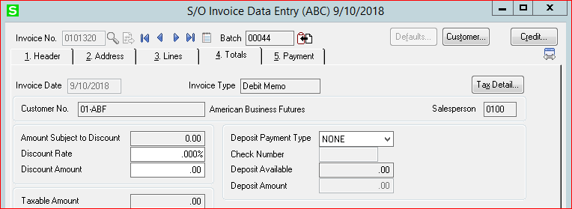

This will create the debit memo on the Click To Pay gateway with the original amount plus the NSF fee for the customer to pay.

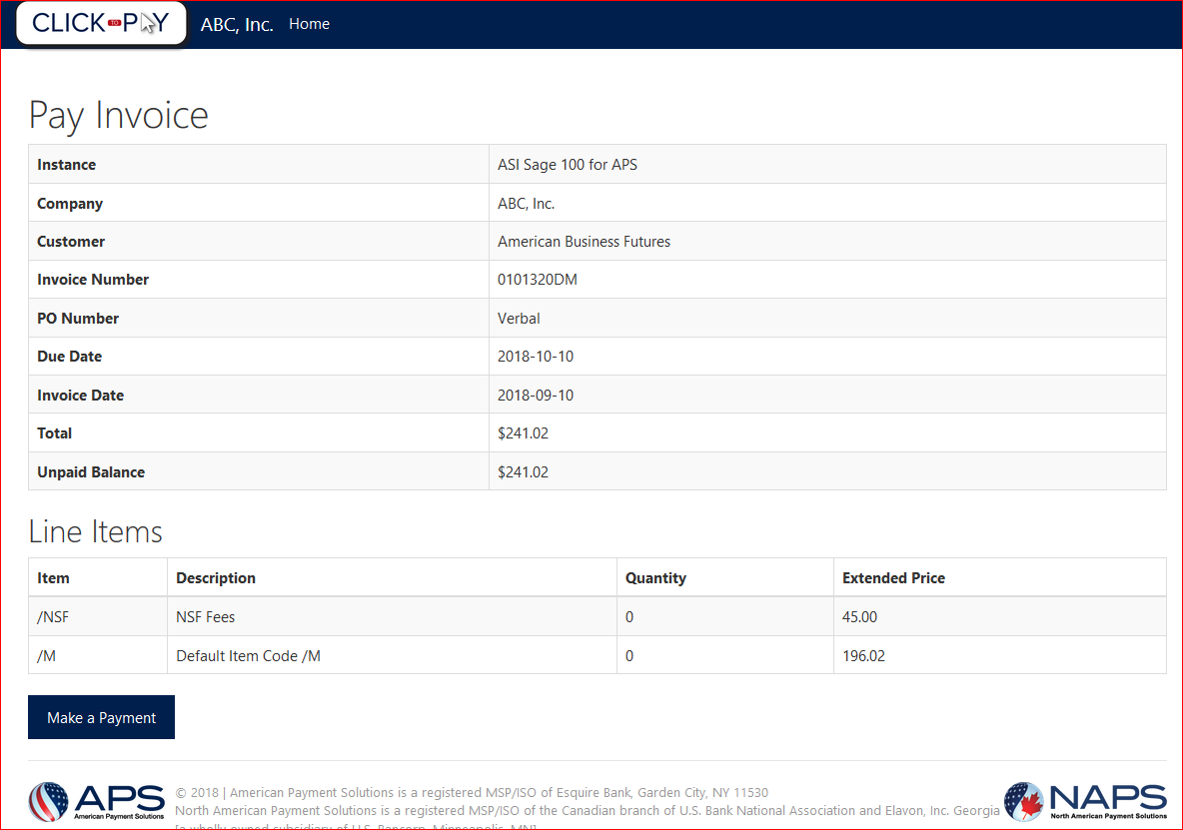

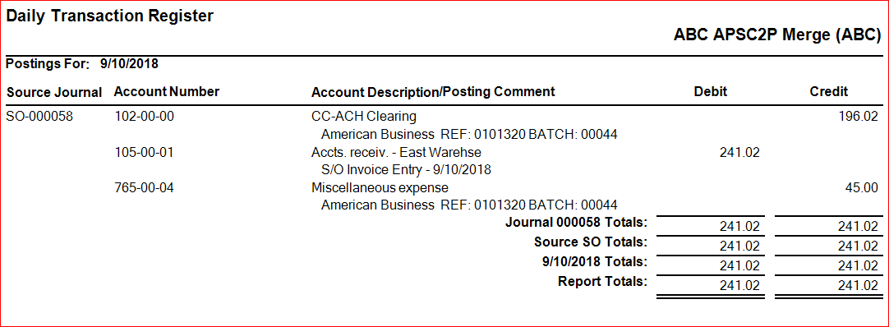

This will reverse the deposit in the clearing account and post the updated A/R as well as the NSF fee (if you choose to charge it). This same procedure works for Checks and regular ACH transactions, but unless the customer is set to upload to Click To Pay the transactions will not appear there.

You will need to apply the deposit received for the debit memo in Cash Receipts since the debit memo doesn’t exist as a separate invoice. This tracks the activity to the original invoice for auditing purposes.

Alternately, you can simply create the invoice as a standard one step invoice with a comment line linking this invoice to the original invoice. This would allow the deposit to apply automatically but may not be correct for auditing purposes.

## Installing the EMV terminal

Typically, you will receive from APS the Ingenico iPP320 EMV terminal which will look something like this:



On the underside of the terminal will be the device serial number you will need for the configurator in Sage. It will look something like this:

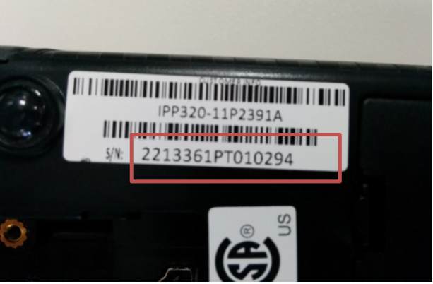

Plug the pin pad into the USB 2.0 or 3.0 port on workstation the terminal will be used on. Windows should recognize it and auto install the needed drivers.

Open the Windows *Devices and Printers* screen and scroll down to the bottom.

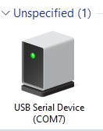

Right click on this device and select *Properties*.

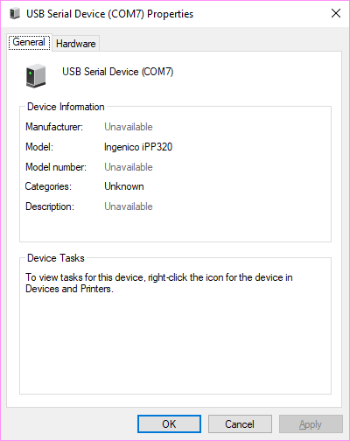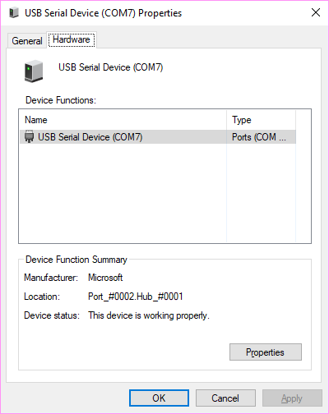

This confirms that it sees the Ingenico iPP320 and tells you what COM port the device is assigned to. Click on the *Hardware* tab, and then double click on the *USB Serial Device* to open the *Properties* screen:

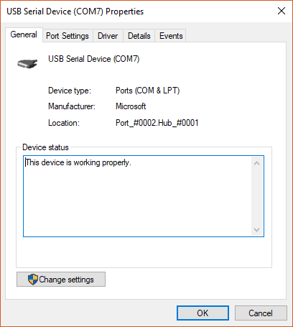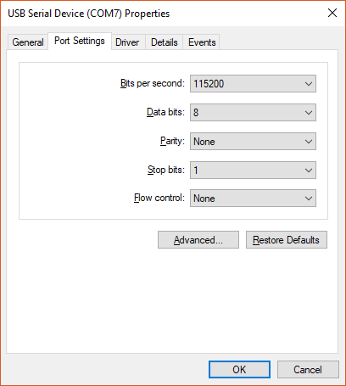

Click on the *Port Setting* tab. This should default to settings shown. On some older PC it might be a lower setting. If so, you will need to copy or write down the settings shown.

At this point you can cancel out of these screens. Make sure you are able to install software, either as an Administrator or you have the ability to install software as administrator for your PC.

Log into Sage as a Sage admin user, and for each company that will be using the EMV terminal in Sage, you must set up at least one EMV payment type in *Accounts Receivable > Setup > Payment Type Maintenance.*

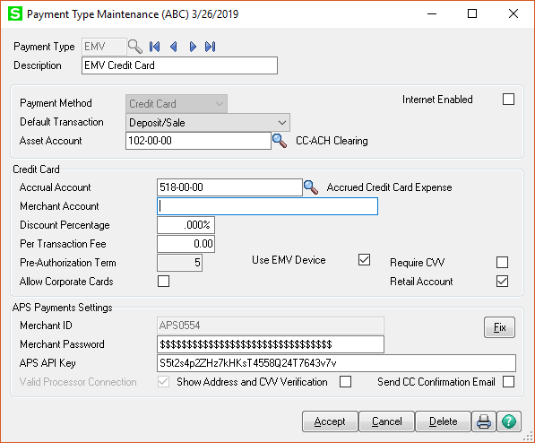

APS Payments may assign a specific merchant ID for your EMV terminal(s). Be sure to use that in a separate payment type and click the **Use EMV Device** checkbox. You will note that it turns off the **Require CVV** checkbox and turns on the **Retail Account** checkbox.

Note that at present we cannot send email information over in EMV transactions, so deselect the **Send CC Confirmation Email** checkbox as no email will be sent.

This payment type becomes a “card present” payment type. Because this is the trigger for EMV, at least one EMV Device payment type must be set up before you can configure the terminals in Sage. Setting up an EMV payment type enables EMV.

Next, on the workstation that the Ingenico terminal is plugged in to, go to *Library Master > Setup Menu > APS Terminal Maintenance.*

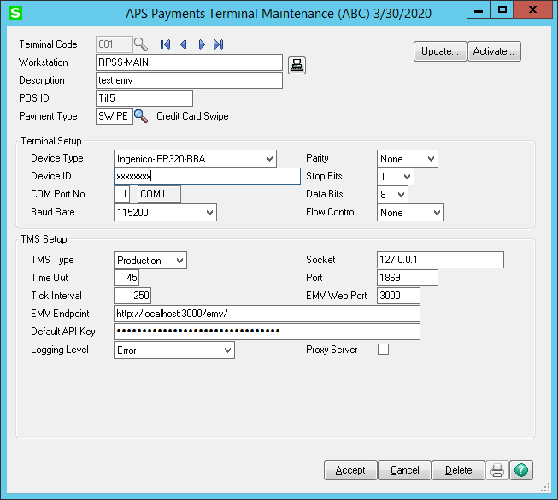

**Terminal Code** – Any three-digit alphanumeric code (0-9, A-Z) to assign the terminal code. Only one may be assigned to any workstation.

**Workstation** – This is the Windows name for the workstation. It should automatically populate, but if it is accidentally cleared or changed, click the  button to reload it. This is a required field.

**Description** – Your description of the workstation.

**POS ID** – This will load with “Till” plus the Sage terminal number. Example: Till1

**Payment Type** – This is the payment type linked for EMV. If you have multiple locations that may have multiple merchant IDs, select the EMV payment type linked to your workstation’s location.

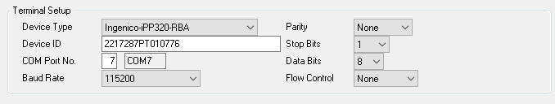

**Device Type** – Drop down list of the supported EMV terminals. Defaults to the Ingenico-iPP320.

**Device ID** – This is the code from the underside of the terminal that identifies the terminal to the TMS servers. This is a required field.

**COM Port No.** – The physical COM port number from the Windows *Devices and Printers* screens earlier. You only must enter the number, it will display the correct port name to the right.

The next five settings should default to the values in the *Devices and Printers* screens.

**Baud Rate** – The speed of the port.

**Parity** – Data checking protocol.

**Stop Bits** – Also part of the data checking protocol.

**Data Bits** – Length of the data word.

**Flow Control** – How the data is throttled to keep it in synch. It is either *None* for software control (the default) or one of the hardware flow control methods in the list.

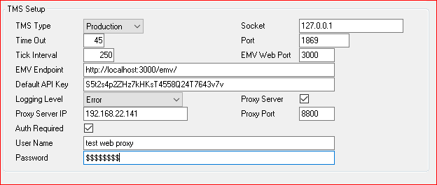

All the above values should automatically default. The **Default API Key** will load from the *Payment type* selected above.

**TMS Type** – Options are *Production* or *Test.* You will only use *Production.*

**Time Out** – Time in seconds before the terminal will time out with no activity after a transaction is started.

**Tick Interval** – Time in milliseconds the terminal services will check for status changes on the terminal.

**Socket** – IP address of the workstation terminal services. Always 127.0.0.1 for localhost.

**Port** – Port the workstation terminal services runs on at the *Socket* IP address.

**EMV Endpoint** – Local URL used by Sage to talk to the EMV terminal services.

**Default API Key** – API key that synchronizes the terminal to the merchant’s account.

**Logging Level** – Amount of detail the EMV terminal server service tracks for troubleshooting if needed. Defaults to *Error* which is errors only.

The following are using only if your network uses a proxy server. Consult your IT services professional if you need to use this.

**Proxy Server** – Click on this to activate and show the Proxy Server fields.

**Proxy Server IP** – the IP address of the proxy server.

**Proxy Port** – The port used by the proxy server. Typically, 8800.

**Auth Required** – Check this if your proxy server requires authentication.

**User Name** – Enter the user name for the proxy server.

**Password** – Enter the user password for the proxy server.

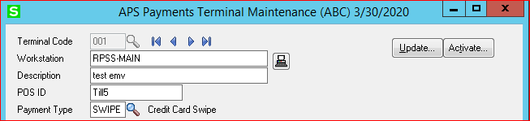

**Activate** button – This will take the setting from this screen and install the necessary software and configure it. You may see Windows display a warning or request to allow the software to be installed. Click Yes to continue and allow the package to install.

It will install the requisite .NET programs and set up the configuration of the terminal for this terminal only. If the workstation is on a Sage Advanced or Premium system, it will copy the software to the workstation Sage setup and install it there. You must do this from the workstation the EMV terminal is installed on.

**Update** button – This will only update the settings to configure the terminal after installation.

After installation, the terminal will be ready to start up. Go to *Library Master > Utilities > APS EMV Services Status.*

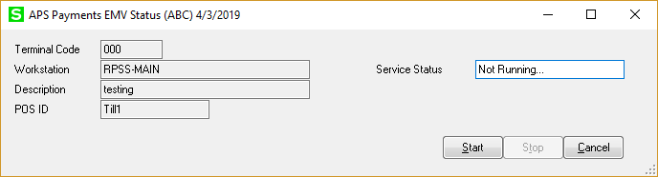

Click on the **Start** button to start up the services if they are not running. The first time you start the services Windows *Firewall* may pop up to verify if you want to run the services. Click Yes.

Starting the terminal for the first time or restarting it can take up to a minute because the terminal must be restarted physically to insure the current security files are loaded. As such we recommend that the service be started either first thing in the morning or use the Windows task scheduler to Stop and Start the services before work each day.

Once the terminal has finished its start up, the **Service Status** will change to *Running* and you can cancel out of the program.

### Setting up EMV services to run automatically

Under the workstation \mas90\ASI\EMV folder, there are two batch files, *run.bat* and *stop.bat*. This information is for the IT services professional to set this to run automatically for the user.

**Run.bat** – This batch file starts the services. If you run it from Windows *Task Scheduler*, be sure to start it in the directory it is in. The scheduled task must have at least the user’s permission levels to run the services.

**Stop.bat** – As with *Run.bat*, it must be run in the directory that is resides in. This batch file kills the running services. In a scheduling scenario, run this first, allow five minutes, then run *Run.bat.*

## Using Hosted Form Card Swipe on RDS/Terminal Server and Citrix

Both Terminal Services and Citrix will interfere with a card swipe unless certain settings are set *at the workstation.* For Terminal services, you must set your connection to flow Windows Key Combination to the remote computer as part of your connection. Otherwise Terminal Services will “drop” critical bits of data and the card will not be readable.

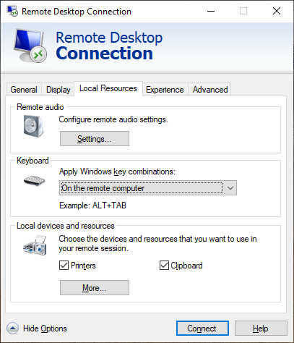

Citrix has a similar setting, consult your IT admin for this setting.

If Sage 100 is installed on the terminal server, and it is a **Windows Server 2012**, your IT admin will need to help you with the Internet Explorer Enhanced Security Settings, which can prevent the hosted form from even displaying. If on a separate server RDS/Terminal Server, these steps must be done on BOTH servers.

First, IE Enhanced Security will need to be turned off. A Local/Domain Windows Administrator will need to turn it off.  That can be done through Server Manager > Local Server > IE Enhanced Security Configuration.

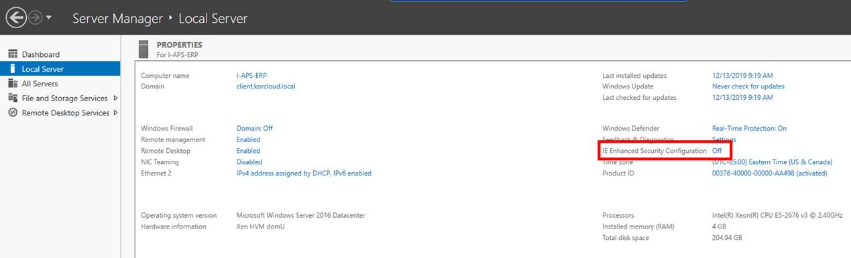

When logged into the terminal server as a non-admin and the user pulls up Internet Explorer, their screen will look like this:

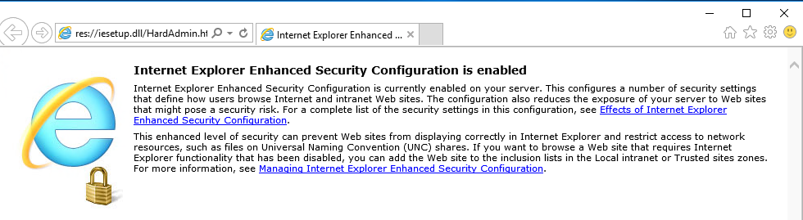

To fix it, click on the gear icon in the upper right corner and go to Internet Options.

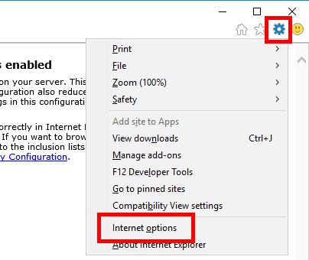

Go to the Advanced Tab and click the Reset button:

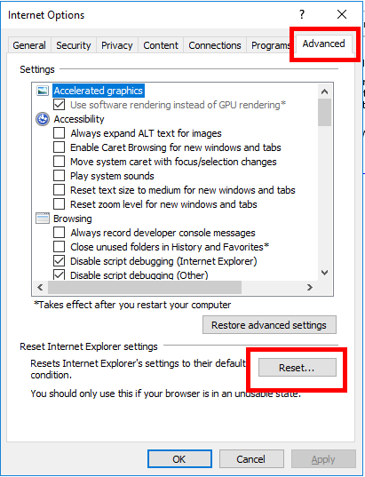

Check the box for “Delete Personal Settings” and click Reset:

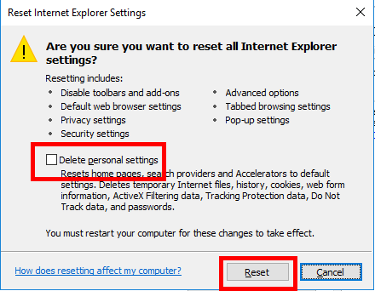

The following box will appear, and when it’s finished, click Close.  Close the IE browser for the changes to take effect.

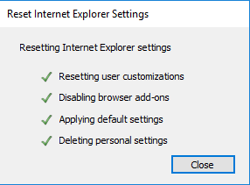

These steps will need to be done for EVERY INDIVIDUAL USER that is using Sage and uses card swipe in an RDS/Terminal Server environment using Windows Server 2012.  This is not required on a local workstation.

## APS Software Warranty

At the time of delivery, APS warrants its software, when used properly, shall perform substantially in accordance with the documentation, and that the software has been provided in a proper and professional manner. APS does not warrant or represent that the use of the software will be uninterrupted and without error. User agrees to notify APS of any software-related errors or defects within ninety (90) business days of delivery. APS may, at its sole discretion, correct the error or defect by reworking the original task, modification of the implemented software or issuing a credit on the users account not to exceed the original purchase price of the software.

APS will have no responsibility under this warranty for any software that has been modified, lost, stolen or damaged by accident, abuse or misapplication.