Sage 100 ERP

APS ClickToPay Gateway

# Administrator’s Guide

Copyright © 2017-2018 – Accounting Systems, Inc.

## Overview

The APS ClickToPay gateway receives and stores invoices from the ERP system and allows customers to log in to the AP ClickToPay portal and pay those invoices. When invoices are paid securely on the APS ClickToPay customer portal, the payment is sent back to the ERP cash receipts as if check or cash, relieving the ERP system from having to manage credit cards, paid it. APS ClickToPay benefits the customer by making it easier to pay invoices while. For the merchant, using APS CLickToPay reduces scope for PCI compliance, as long as the merchant uses it instead of taking credit card payments directly.

## Definitions

APS ClickToPay Gateway – The gateway is a combination of secure database, web services and web pages, hosted in Amazon Web Services that accept invoice information, store that invoice information securely, accept payments from the customers, and provide that payment information back to the cash receipts function of the ERP system.

ERP Instance – Often referred to as simply “Instance”, this is the installation of the ERP client system. Typically, a single instance will represent a single APS merchant, but each instance will typically have one or more “Companies” in it. Each ERP instance gets a unique API Key to use as the credentials to send and receive information from the APS ClickToPay gateway.

Company – Within a typical ERP instance there are companies defined, each of which will have its own general ledger accounting records, inventory and customers. Each company is typically a separate account and/or legal entity and is identified by a company code.

API Key (C2P) – (Perhaps we should call this the ClickToPay Key) The ClickToPay API key is assigned to an ERP instance and allows the programs in that instance to send transactions to the APS ClickToPay gateway and retrieve information from the APS ClickToPay gateway.

APS API Keys (Merchant) – This is the API key which is used by the APS ClickToPay programs, NOT the ERP system. These API keys are assigned by the APS payment gateway (not the ClickToPay gateway) and are linked to the companies that are set up in the gateway. Each APS API Key represents a separate Merchant ID in the APS payment gateway and is used for authentication when the APS ClickToPay programs communicate with the back end payment gateway.

Transaction – When the ERP system connects to the APS ClickToPay web service to send a query or upload an invoice, that communication is a transaction. Each transaction consists of a specifically formatted request to the gateway API and a response from the gateway API. There are several transactions allowed between the APS ClickToPay gateway and the ERP system, including *Invoices/create*, *Invoices/logExternalPayment*, *Invoices/query*, *Payments/markRetrieved*, and *Payments/query*. These transactions are described in a separate document provided to authorized ERP developers.

Currency Code – The APS ClickToPay gateway can receive payments in multiple currencies, identified by a currency code. Each instance and company has its own list of valid currency codes. Each new invoice sent from the ERP system specifies the currency code for that invoice and any payment against that invoice must be received in that currency. For obvious reasons, the currencies allowed in the ClickToPay transactions must also be supported in both the APS payment gateway and in the ERP instance/company.

Portal URL – This refers generally to the website that APS will use to set up instances and that the customer will navigate to in order to make a payment. The URL for the APS ClickToPay portal is <https://portal.APSClickToPay.com>.

API URL – This refers to the web address where the APS ClickToPay gateway listens for transactions being sent from the ERP system. The URL for the API URL is <https://API.APSClickToPay.com>.

C2P Link Code – The link code is the unique identifier that the APS ClickToPay gateway assigns to the invoice which is created. This link code is sent back to the ERP system to be used when offering a clickable link to the customer. In most cases, the ERP system will print an invoice and email a PDF of that invoice to the customer. On that PDF, the ERP system will provide the full URL, including the CP2 Link Code, so that the customer can click the link. This will open a page on the APS ClickToPay portal where the customer can view the invoice and make a payment.

## Typical ClickToPay Process

Once you have completely set up the ERP instance in the APS ClickToPay administrative portal and the merchant’s ERP instance has been appropriately configured, the process for using APS ClickToPay looks like this:

* When the invoice is printed, the ERP will send an Invoice/create transaction to the APS ClickToPay web service. This transaction will include the customer information, the invoice information and all the detailed line information. All the invoice data is stored in the APS ClickToPay gateway database and a C2P Link Code is generated to uniquely identify that invoice. That C2P Link Code is then sent back to the ERP system. The ERP system will typically use that C2P Link Code to create a full URL to print on the invoice. It will also store the C2P Link Code on the invoice in the event that it needs to be reprinted later.
* The customer receives an email and an attached PDF for the invoice. Both the email and the PDF will have a URL and an APS “Pay Here” link. When the customer is ready to pay the invoice, he/she can click on the link which will open a browser page to <https://portal.APSClickToPay.com> showing that specific invoice. At this point the customer can choose to pay the invoice. APS ClickToPay uses three-step redirect from the APS Payment Gateway to take either credit card or ACH payments. The customer has the option of creating a secure account on the gateway to save credit card or bank account information for later use.
* In the background on the APS ClickToPay gateway, when the customer enters a payment, the programs will communicate with the APS payment gateway using the APS API Key assigned to the company.
* When the ERP user/merchant is ready to process cash receipts, a button on the cash receipts data entry page will start a download process. During this process the ERP instance will send a Payment/query transaction to the APS ClickToPay web service. This will download all the recent payments so that the ERP programs can create cash receipts payments for those invoices. For each payment record created, the ERP program will send a Payments/markRetrieved transaction back to the APS ClickToPay gateway to indicate that this payment does not need to be downloaded again. The cash receipts process in the ERP system can then continue in the normal fashion. The invoice has now been paid as if cash or check had been received.

## Setting Up an ERP Instance for APS ClickToPay

To set up a new ERP instance to use APS ClickToPay, you first use your browser and navigate to the APS ClickToPay porta, https://portal.APSClickToPay.com. There you will log in with an administrator’s account. Each user at APS will have a separate account for security reasons. The account show below is not valid and is for illustration purposes only.

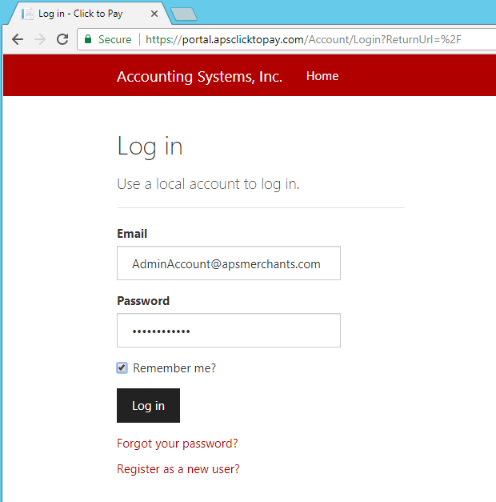

Once logged in, you will only have one option, Instances, as show on this screen.

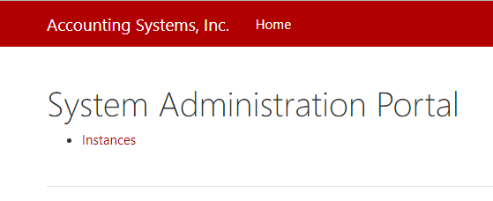

Once you click on the Instances link, you will see a list of all the existing instances.

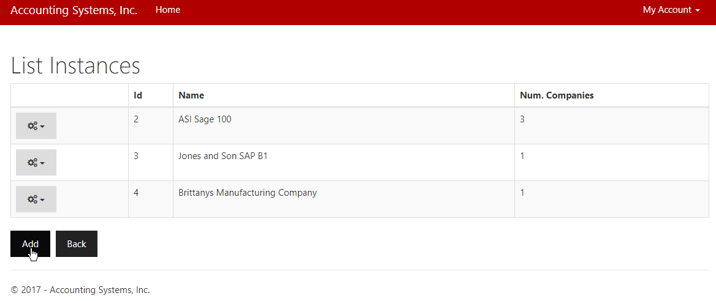

You have options to the left of each instance that allow you to:

* Edit: Change the descriptive name of the instance.
* Manage: Add, change or remove companies, APS keys and currencies for the instances.

Below the list of instances, you can click the “Add” button to create a new instance.

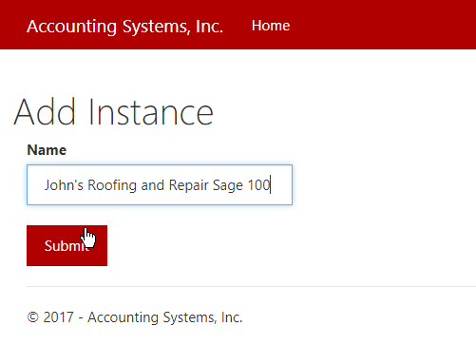

In the Name, you can put whatever descriptive information you need. This name is for the human beings reading the list. It can be changed later using the instance edit feature mentioned previously.

When you click Submit, the new instance will be created and you can proceed to Manage that instance to add the ERP Company codes linked to this instance and generate a new ClickToPay Key, also known as the API Key (C2P).

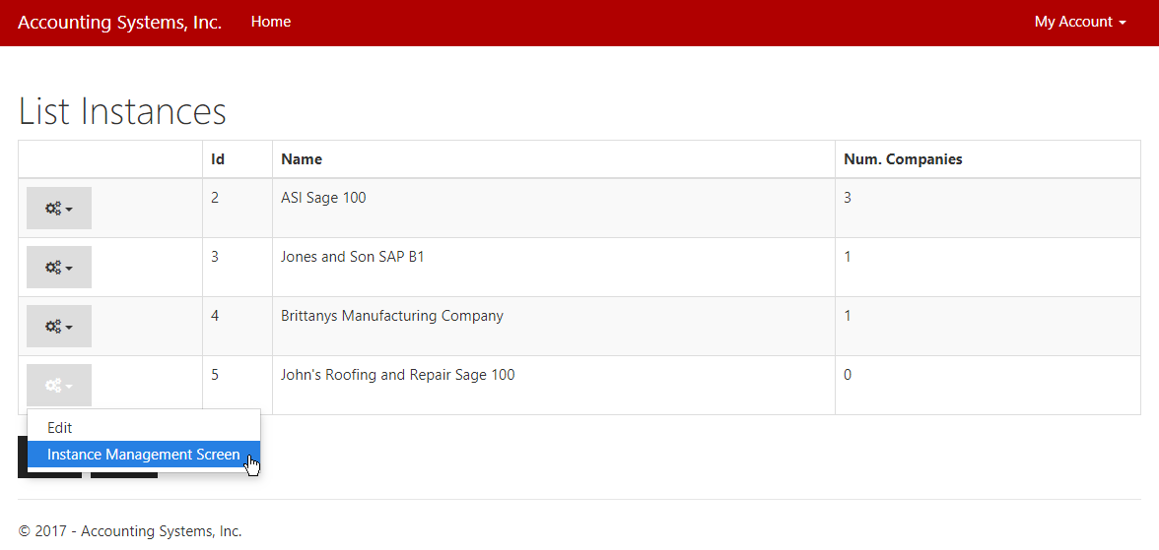

The Instance Management Screen offers you all the management options available for each instance.

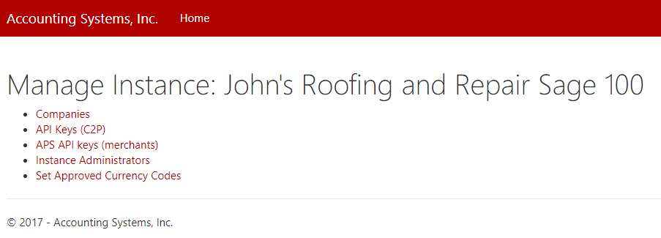

In order, you should:

* Add the ERP Companies
* Generate the ClickToPay Key (APS Key C2P) that will be given to the ERP system for authentication when communicating to the gateway. Only one ClickToPay Key is required for the instance, though you can create multiple if you wish.
* Assign the APS API Keys for the various companies. The APS API Key is generated in the APS payment gateway for each merchant company. That API key is then assigned to the company record in the APS ClickToPay gateway.
* Set the approved currency codes. You get to decide what currencies are allowed for each instance and for each company within that instance. Once these are set, if a transaction from the ERP specifies a currency which is not in the list for the company, that transaction will be refused with a meaningful message. The currencies entered should be limited to the currencies supported by the back end APS payment gateway.

#### Add the ERP Companies

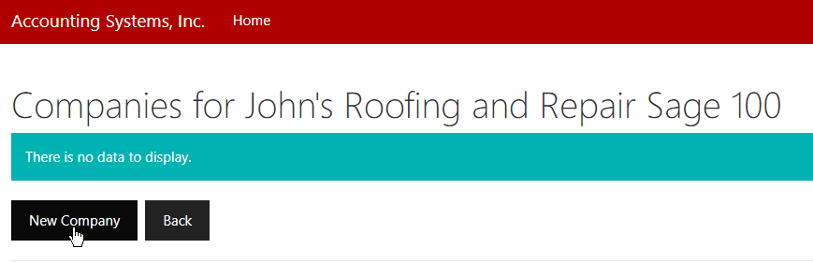

The the “New Company” link to add a new company. This will allow you to enter the Code and Name for the ERP company.

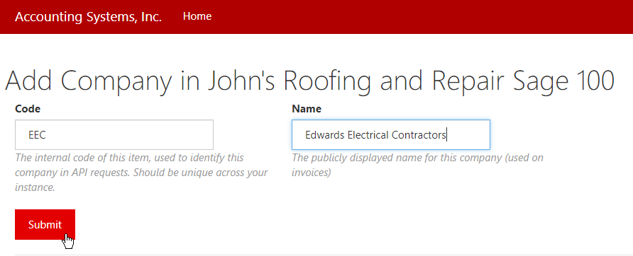

The code is very important. It must match exactly the ERP company code When the ERP programs send a transaction to create a new invoice or query payments, they will specify a company code, which must exist, exactly, in the APS ClickToPay gateway.

The Name is for humans to use. It’s useful for the Name to match what the ERP system calls the company, but the APS ClickToPay gateway does not validate that, nor does it care.

#### Generate ClickToPay Key

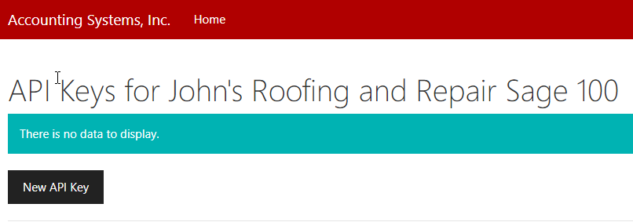

Click on the New API Key to create a new ClickToPay key for this instance. You do not get to enter a key because it is generated by the APS ClickToPay gateway to be unique and secure.

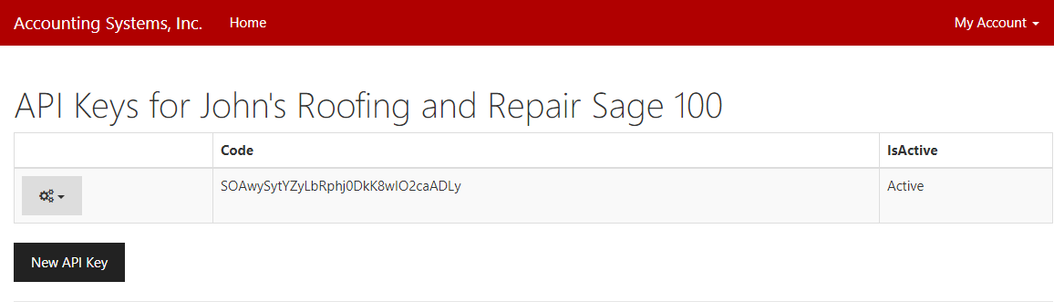  
The value under the Code column is the ClickToPay Key. This is the value that must be given to the ERP system so that it can be authenticated. In the event that the ClickToPay key is compromised or forgotten, the existing key can be deleted and a new key can be assigned and given to the ERP administrator.

#### Assign APS API Keys

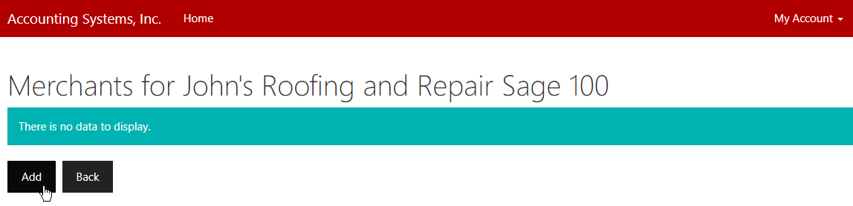

Click the Add link to create a new APS API Key record.

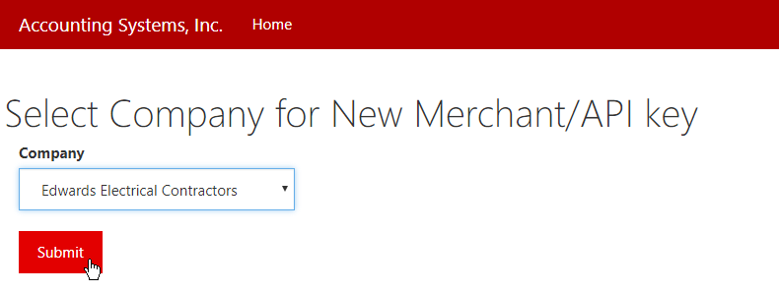

Select one of the companies previously created. In our case we have only one company, but much of the time the ERP system will have multiple companies. Each ERP company will have it own APS API Key to authenticate to the APS payment gateway.

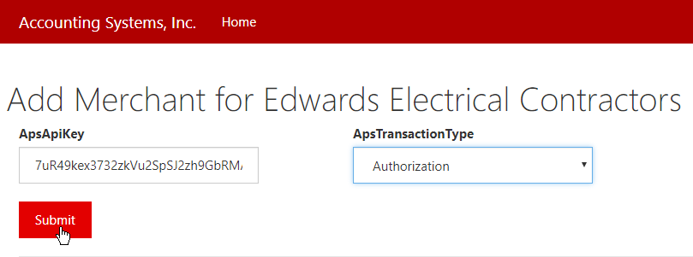

In the ApsApiKey column paste the security code that you generated in the APS payment gateway for this merchant ID. On the ApsTransactionType select authorization. When you have correctly entered the APS API Key, click Submit to save it. Do the same for all the companies in the ERP system.

#### Set Approved Currency Codes

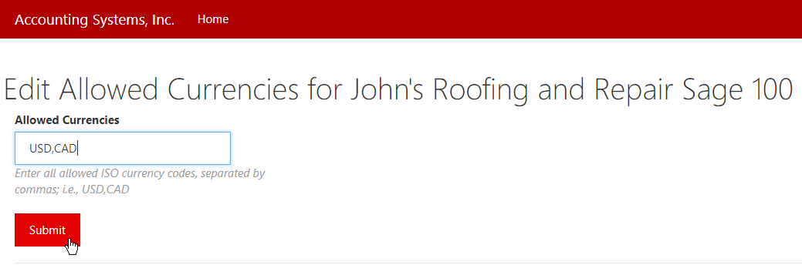

Enter a comma-delimited list of the currencies which are valid for the instance. Enter these as ISO standard three-letter alphabetic currency codes as defined here: <https://www.iso.org/iso-4217-currency-codes.html>.

## APS Software Warranty

At the time of delivery, APS warrants its software, when used properly, shall perform substantially in accordance with the documentation, and that the software has been provided in a proper and professional manner. APS does not warrant or represent that the use of the software will be uninterrupted and without error. User agrees to notify APS of any software-related errors or defects within ninety (90) business days of delivery. APS may, at its sole discretion, correct the error or defect by reworking the original task, modification of the implemented software or issuing a credit on the users account not to exceed the original purchase price of the software.

APS will have no responsibility under this warranty for any software that has been modified, lost, stolen or damaged by accident, abuse or misapplication.