APSPays For Sage 100

Installation & User Guide

Version 1.6

Contents

Overview 3

APSPays Vault 3

EMV Devices 3

ClickToPay 3

Hosted Form 3

Disclaimer 3

Chapter 1: Installation 4

System Requirements 4

Installation of the APSPays Addition 5

Preparing Sage 100 6

Card Conversion and Activating APS 7

Upgrading from Existing Sage Version 10

Updating the APSPays Addition 13

Chapter 2: Configuration & Setup 15

APSPays Gateway Setup - Credits 15

Company Maintanence 16

Payment Type Maintanence 17

Accounts Receivable Options 19

ClickToPay Setup (Optional) 20

EMV Setup (Optional) 25

Checking emv terminal status 28

DSD Multicurrency (Optional) 29

Chapter 3: Payment Method Maintenance 30

Creating New Customer Payment Methods 30

Editing or Deleting Customer Payment Methods 31

ClickToPay (Optional) 32

Chapter 4: Sales Order Module 33

Sales Order Entry 33

Invoice Data Entry 35

ClickToPay Invoicing (Optional) 37

Chapter 5: Accounts Receivable Module 38

Cash Receipts Entry 38

Chapter 6: Voids & Refunds 40

Voids 40

Sales Order Credit Memos 41

Chapter 7: Report & Reconciliation 42

APSPays Credit Card and ACH Settlement Report 42

ClickToPay Daily Processing (Optional) 44

Chapter 8: Uninstall Process 46

Complete APS Payments Transaction Processing 46

Remove the APSPays Addition 46

Chapter 9: Resources 47

APSPays Gateway User Guide 47

APSPays Login 47

APSPays Sandbox 47

Testing Information 47

Payment Processing Essentials 48

Credit Card Processing Players 48

Authorization vs Capture 48

Authorization Expiration 49

Settlement 49

Chargeback 49

AVS and CVV/CVV2 49

Contact Information 50

Customer Service 50

Integrations Team 50

# Overview

Thank you for choosing APS Payments for your integrated payment processing solution. This guide should be followed in sequential order as it contains all the steps necessary to install, configure, and process with your APS Payments Certified Integration on the Sage 100 ERP platform.

It is important to note that the APSPays Addition does not alter the way payments are handled in Sage 100. The practices for entering, saving, and applying payment information in Sage 100 are the same with APSPays as it is with a standard Sage 100 installation. We have taken great care to not change those processes. All integrated features available in the APS Payments Certified Integration exceed the PCI Council’s requirements. This is a fully PA-DSS compliant service.

## APSPays Vault

The APSPays Gateway uses the APSPays Vault to ensure that customer payment information is never stored in the software solution.

## EMV Devices

The APSPays Addition supports credit card terminals that follow the EMV IP protocol. The EMV devices will require an additional Internet cable at each workstation to process.

## ClickToPay

The APS Payment’s ClickToPay feature allows buyers to pay their ERP invoices conveniently online. While the APS Payments Integration Team is happy to help with the company-level configuration of this feature, the required Crystal Reports modifications should be completed by a Sage 100 Reseller.

## Hosted Form

The APSPays Addition supports Hosted Form processing and is secured by SSL TLS 1.2 or higher.

## Disclaimer

The APSPays plugin, its software, and all content found on it are provided on an “as is” and “as available” basis. APS Payments does not give any warranties, whether expressed or implied, as to the suitability or usability of the plugin, its software or any of its content. APS Payments does not certify compatibility with other third-party products including Shipping Modules, Warehouse Management Systems, or other software solution non-native to a standard ERP implementation. APS Payments will not be liable for any loss, whether such loss is direct, indirect, special, or consequential, suffered by any party as a result of their use of this APSPays plugin, its software or content. Any downloading or uploading of material to your website, accounting software, or other software solutions is done at the user’s own risk and the user will be solely responsible for any damage to any computer system or loss of data that results from such activities. Should you encounter any bugs, glitches, lack of functionality or other problems with the plugin, please let us know immediately so we can rectify these accordingly. Your help in this regard is greatly appreciated.

# Chapter 1: Installation

### System Requirements

The APSPays Addition supports Sage 100 versions 2013 through 2019, Certain features are not available for all versions. Please contact APS Payments for additional details.

The C/I, G/L, ACCOUNTS RECEIVABLE, and SALES ORDER modules must be installed and implemented.  Sage 100 Software must be installed as per the official Sage 100 OSPCM guidelines for operating systems level and recommended machine requirements.  APS Payments works with all standard Sage 100 software, but compatibility with third party modifications must be verified with APS Payments proactively.

The MAS90 folder and subfolders must have full rights for the users to create/modify/erase temporary files and logs.

Both server and workstations should be currently patched, support TLS 1.2, and be able to access the Internet.  Any firewall and proxy security must allow access to APSPays Gateway.

The workstation OS must be 64-bit to support EMV processing.

Anti-Virus Exclusions and Settings:

Exclude the MAS90 and Crystal Reports directories on the server and workstations from any “active protection” or “real-time scanning” settings.

Exclude the following files from any “active protection” or “real-time scanning” settings: .M4T; .M4L; .M4P. PVX; .RPT;. SOA; PVC; .UI; .DD; .DDE; .DDF; .LIB; .XEQ

Disable any aggressive scanning utilities that may interfere with operations.

Disable the scanning of Network Drives. If there is a mapped drive on the workstation to the MAS90 directory exclude the mapped drive from the “active protection” or “real-time scanning” settings.

Norton Anti-Virus: disable Smartscan Technology.

Symantec Anti-Virus: disable Tamper Protection as this can cause extreme lockups; change the Proactive Threat Scanning from “DEFAULT” to “Once A Day”; change the scan settings to “files that have been modified” instead of “files that have been accessed”; avoid installing the Symantec End Point Client directly onto the server as the scans will slow all of the server processes.

### Installation of the APSPays Addition

In addition to this manual, a zip file necessary to the set up the APSPays Addition has been sent. Load and save this zip file in an easy-to-find location.

**\*NOTE\*** This download should only be initiated while all users are logged out of Sage 100 and all services stopped. You should have a recent instance backup and temporarily disable any active Anti-Virus Software. Please let your APS Representative know if you were previously processing with EBizSolutions as their module must be uninstalled before the steps below can be initiated.

1. Locate the APSPays Addition. Right-click the file and choose “Run as Administrator”.

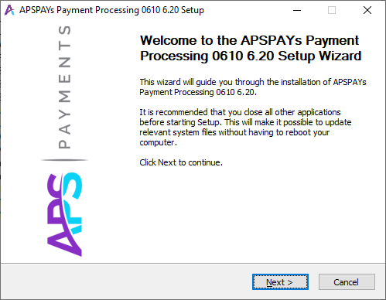

1. Follow the **Next** prompts until a screen displays to locate and select the MAS90 folder for the Sage 100 instance this customization is being installed to.

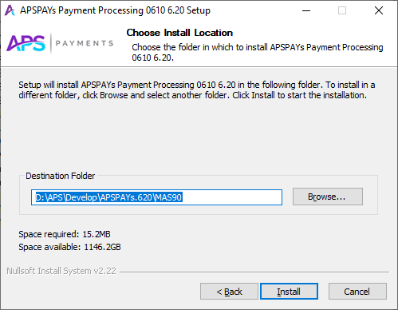

1. Once a valid Destination Folder has been entered, the **Install** button will be enabled. Click **Install** to proceed.
2. After installation, if you previously had APSPays version 608 or higher, go to the MAS90\ASI folder and click on the RemoveEMV.bat file to remove the old EMV files.

### Preparing Sage 100

Start the Sage 100 ERP and log in as an Administrative user.

1. Company Maintenance Data Conversion**–** Navigate to **Library Master> Main> Company Maintenance** and use the **Convert** button on the top right to bring all data to the current level.

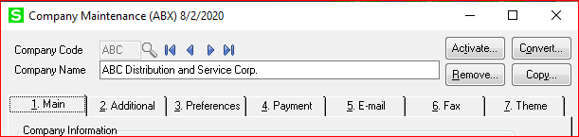

1. Role Maintenance- Navigate to **Library Master> Main> Role Maintenance** and add the new APS permissions to the appropriate roles. These are located under **Accounts Receivable** and **Library Master**, both on the **Tasks** **and Security Events** tabs.
2. Customizer Utilities – Navigate to **Custom Office> Utilities** and **Rebuild Customizer Log** and **Update Custom Panels to Current Level**.

### Card Conversion and Activating APS

To convert Credit Card and ACH Data use one of the two options that have been added to the **Accounts Receivable > Setup** menu

**Option 1: Convert Cards and Activate APS** – Choose this option if a single APS Payments merchant account is being integrated to a single Sage 100 company, even if there are no card records to be converted.

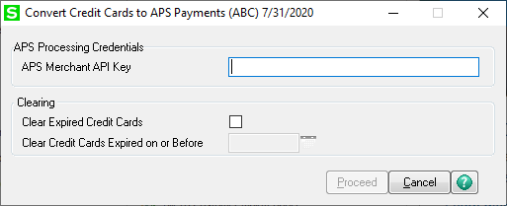

**APS Merchant API Key**– Gateway API Key. Enter the API Key provided by APS Payments.

**Option 2: Convert Cards to APS by Payment Type** – Choose this option if multiple APS Payments merchant accounts are being integrated into a single Sage 100 company.

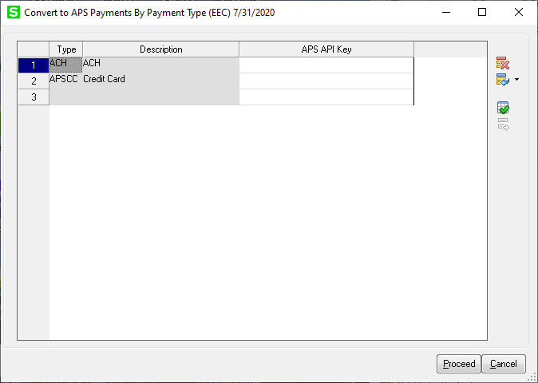

**APS Merchant API Key**– Gateway API Key. Enter the API Key provided by APS Payments.

Proceed with Card and ACH Conversion:

1. Once the APS Merchant API key(s) are entered, click **Proceed**. After clicking **Proceed** you will see a list of files being checked before the next step.

**\*NOTE\*** Sage Exchange Desktop/Paya Connect Desktop is required to run at this point. If SED/PCD is not available, it will need to be installed to continue.

1. Once Sage Exchange Desktop/Paya Connect Desktop is loaded, the card conversion program will prompt for confirmation. Select **Yes**.

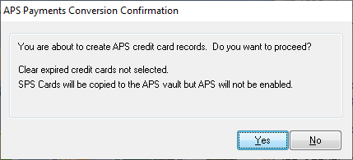

Activate APS:

1. Once the program has finished copying cards and ACH accounts to the APSPays vault, it will display the following question:

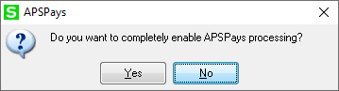

1. Type **Yes** and click **Ok** if you are ready to go live with the APSPays Addition.

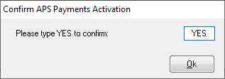

### Upgrading from Existing Sage Version

If you are moving from Sage v4.4 or v4.5 to Sage v2013+, you must contact APS Payments to enable the APSPays Vault. You must also install the standard APSPays version and perform the installation before installing an APSPays Addition that includes ClickToPay, EMV and the Hosted Form.

1. Install the APSPays Addition in the Sage 100 System following the install steps detailed here.
2. Migrate System files and data following the instructions provided by Sage 100.
3. Reinstall the APSPays Addition.
4. Update the SY_Company table following instructions here.
5. Enable the APSPays Addition - A new option has been added to the **Library Master>Setup** menu.



To run this task and Enable APS Credit Card Processing, choose the company or companies that will need access to the customization.

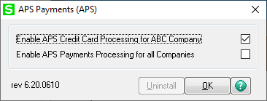

**\*NOTE\*** This function will make APSPays Addition the default credit card and ACH payment system but does not enable credit card and ACH processing for the company.

1. Company Maintenance Data Conversion –Navigate to **Library Master> Main> Company Maintenance** and use the **Convert** button on the top right to bring all data to the current level.

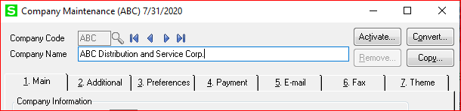

1. Enable CC and ACH Processing- Re-enable credit card and ACH processing in Company Maintenance. On the **Payment** tab of **Company Maintenance**, select the type of payments to be enabled in Sage 100.

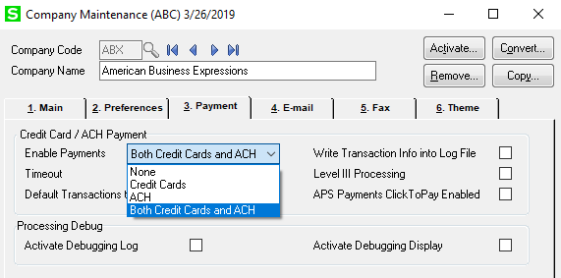

1. Confirm the APS Merchant ID and APS Merchant Password after selecting **Credit Cards, ACH, or Both.**

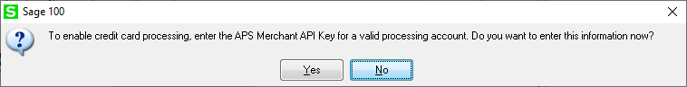

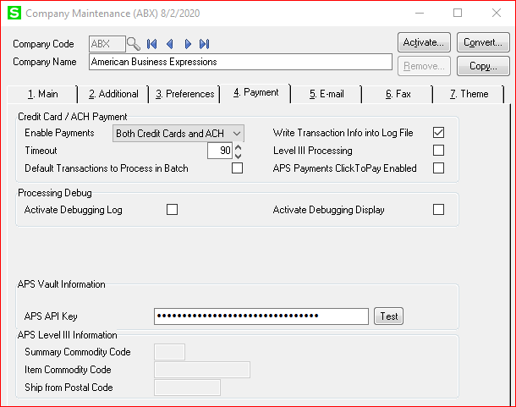

**Write Transaction Info into Log File** (checkbox)- check this box to write APS transaction information into a log file. The log file APS_TRAN.log will be created in the MAS_XXX folder and is a critical tool in troubleshooting transaction errors.

**Level III Processing** (checkbox) - check this box enable Level III processing.

**APS Payment Click To Pay Enabled** (checkbox) – check this box to enable Click To Pay processing.

**APS Merchant API Key**– Gateway API Key. Enter the API Key provided by APS Payments. Click the Test button to the right of the field to verify the key entered is valid.

**Summary Commodity Code** - Level III processing requires a Summary Commodity Code to be sent with each authorization or sale. This value will be provided by APS Payments.

**Item Commodity Code** - Level III processing requires an Item Commodity Code to be sent with each detail line. This value will be provided by APS Payments.

**Ship from Postal Code** - Level III processing requires the Ship From Postal Code to be sent with each authorization or sale. Enter the postal code or ZIP code from which you typically ship items.

### Updating the APSPays Addition

**\*NOTE\*** This download should only be initiated while all users are logged out of Sage 100 and all services stopped. You should have a recent instance backup and temporarily disable any active Anti-Virus Software.

1. Locate the APSPays Addition. Right-click the file and choose “Run as Administrator”.



1. Follow the **Next** prompts until a screen displays to locate and select the MAS90 folder for the Sage 100 instance this customization is being installed to.



1. Once a valid Destination Folder has been entered, the **Install** button will be enabled. Click **Install** to proceed.
2. Company Maintenance Data Conversion**–** Navigate to **Library Master> Main> Company Maintenance** and use the **Convert** button on the top right to bring all data to the current level.



1. Customizer Utilities – Navigate **to Custom Office> Utilities** and **Rebuild Customizer Log** and **Update Custom Panels to Current Level**.

# Chapter 2: Configuration & Setup

### APSPays Gateway Setup - Credits

There are critical steps to setting up appropriate user permissions in order to process some functions within an ERP integration. For more information regarding gateway setup and administrative permissions, please contact [gatewaysupport@apspayments.com](mailto:gatewaysupport@apspayments.com) .

**\*NOTE\*** Do not adjust any other permissions or password for the SAGE100 SAGE100 User.

1. Navigate to https://secure.apspaymentgateway.com/merchants/login and provide the username and password for an administrative user.
2. Navigate to **Settings > User Accounts** > Select the SAGE100 SAGE100 user



1. Select the **+** API Access to expand the options.
2. Check the box next to **Create New Credits**. This is a critical permission required for issuing Credit Memos within the APSPays Addition.

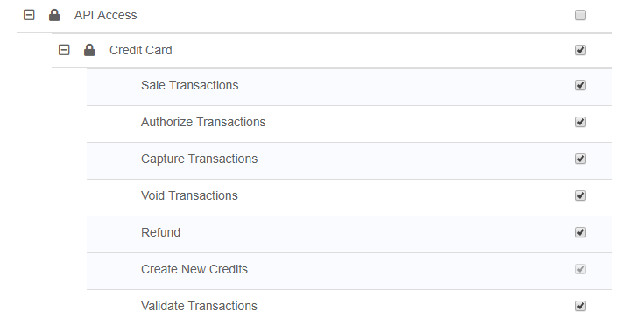

1. Scroll down and click **Save.**

### Company Maintanence

Referencing the integration email sent by APS Payments, enter the final configuration details into **Library Master> Main> Company Maintenance**.

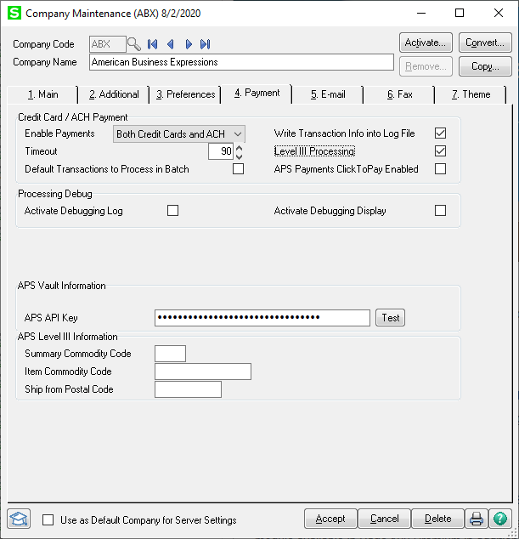

**Write Transaction Info into Log File** (checkbox)- check this box to write APS transaction information into a log file. The log file APS_TRAN.log will be created in the MAS_XXX folder and is a critical tool in troubleshooting transaction errors.

**Level III Processing** (checkbox) - check this box enable Level III processing.

**Summary Commodity Code** - Level III processing requires a Summary Commodity Code to be sent with each authorization or sale. This value will be provided by APS Payments.

**Item Commodity Code** - Level III processing requires an Item Commodity Code to be sent with each detail line. This value will be provided by APS Payments.

**Ship from Postal Code** - Level III processing requires the Ship From Postal Code to be sent with each authorization or sale. Enter the postal code or ZIP code from which you typically ship items.

### Payment Type Maintanence

Configure the additional options available within Sage 100’s **Payment Type Maintenance**.

**\*NOTE\*** Accrual Account and Asset Accounts are required for Credit Card and ACH Payment Types.

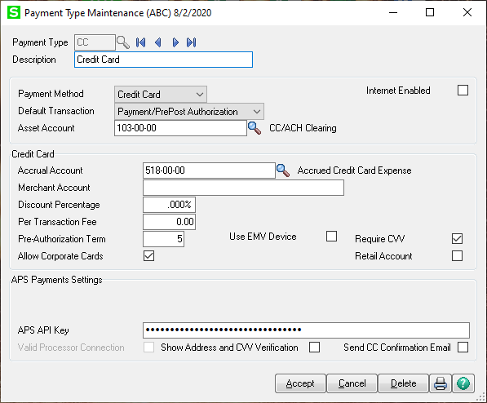

**Allow Corporate Cards-** Check this box to complete Level III processing setup.

**Use EMV Device-** Check this if you will be using an EMV Device on any workstation. [EMV Setup](#_EMV_Setup_(Optional)) must be completed before this box can be checked. If selected, **Require CVV** will be automatically disabled and **Retail Account** will automatically be enabled.

**Require CVV-** This will require entry of the CVV code with each Credit Card transaction. This is not supported on EMV Payment Types.

**Retail Account-** If your merchant account is set up for retail, a validation transaction will not be sent when new cards are added to Customer Credit Card Maintenance. This is a required setting if using an EMV device.

**APS Merchant API Key**– Gateway API Key. Enter the API Key provided by APS Payments.

**Valid Processor Connection-** Confirms the Merchant ID and Merchant Password int eh APS Processing Settings are correct.

**Fix-** Use this button only if instructed by APS Payments if the Valid Processor Connection box is not checked.

**Show Address and CVV-** Prompts two additional popups after transaction submittal to display AVS and CVV results.

**Send CC Confirmation Email-** The APSPays Gateway can send a confirmation email to buyers who have provided an email address. This feature is not supported on EMV transactions.

### Accounts Receivable Options

To activate the Credit Cards option within the appropriate Sage 100 Screens, navigate to **Accounts Receivable> Setup> Accounts Receivable Options** and check the box on tab 4. **Allow Credit Cards**.

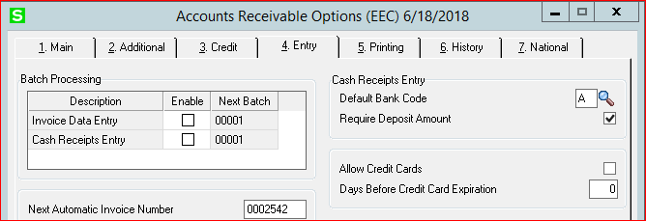

**\*NOTE\*** This setting cannot be applied with users in any of the Accounts Receivable modules.

Optionally, you may want to uncheck **Require Deposit Amount** if you will be running mostly Credit Cards or Click To Pay.

### ClickToPay Setup (Optional)

1. Additional configuration fields are required on **Company Maintenance** if ClickToPay is enabled.

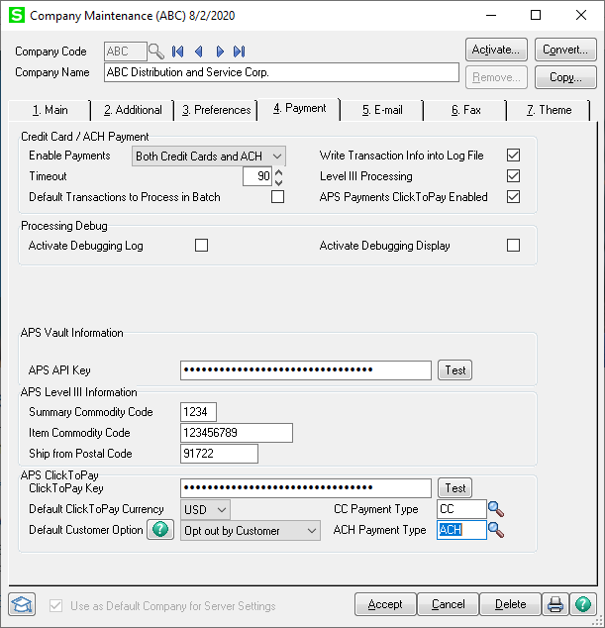

**ClickToPay Key** *–* The ClickToPay Key is generated by APS Payments. This key is used to allow Sage 100 to communicate with the APS ClickToPay Gateway. Once you have entered the **ClickToPay Key** you can click the **Test** button to make sure that communication is working.

**Default Currency** – Use the drop box to select the default currency for this company. You may only select currencies that are supported by the APS ClickToPay gateway, which APS maintains.

**Default Customer Option** – APS ClickToPay allows you to select or deselect the option by customer.

**Opt out by Customer**- If selected, all customers will be active for APSPays ClickToPay, unless manually opted-out at Customer Maintenance.

**Opt in by Customer-** If selected, all customers will be inactive for APSPays ClickToPay, unless manually opted-in at Customer Maintenance.

**CC Payment Type** – Assigns ClickToPay credit card transactions to a Sage 100 Payment Type.

**ACH Payment Type** – Assigns ClickToPay ACH transactions to a Sage 100 Payment Type.

**\*NOTE\*** Level III processing is required for ClickToPay.

1. Additional invoice configuration is required if ClickToPay is enabled. It is recommended that a Sage 100 partner assist with this step.

Included in the \mas90\REPORTS folder are two sample invoice forms for ACCOUNTS RECEIVABLE and SALES ORDER that show the needed fields. These are• **AR_Invoice1ClickToPay.rpt** and • **SO_Invoice1ClickToPay.rpt.**

Sage 100’s PDF processing limitations negatively impact hyperlink buttons functionality and full hyperlinks (URLs) work but are long and unsightly. Printing the hyperlink in white font will make the hyperlink invisible to the human eye but operative for the PDF. A “Pay Here” graphic is available as well.

APS adds three fields to the Crystal worktable:

•

**D531_C2PLinkCode**- identifies the invoice to the gateway. Included for reporting.

•**D531_C2PUrlLink** – critical as it contains the full URL to link for the invoice on the gateway.

•**D531_C2PCustomer**- facilitates suppression of the URL if the customer is opted out of ClickToPay.

Here is an example from the SOInvoice1ClickToPay.rpt:

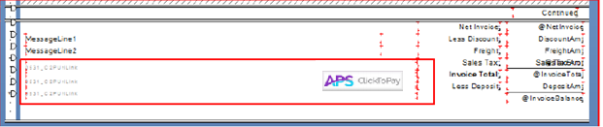

The **D531_C2PUrlLink** lines in this case set on three lines and printed in white font so that if clicked anywhere in the indicated area the PDF reader will see the URL and open a web browser.

**\*NOTE\*** The field must be long enough to encompass the complete URL to print. To ensure the hidden field does not overlay, select “move to back”.

The “Pay Here” image is also set as a hyperlink as some PDF readers will accept it as a button and open a browser to the invoice.

Examples of how to set up the hyperlink URL fields:

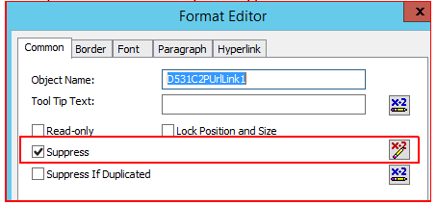

For eachof the hyperlink lines, you will need to add the suppress function with a formula.

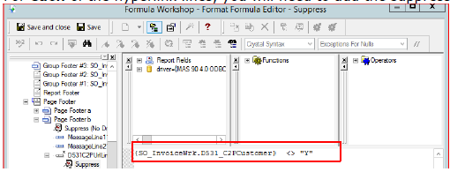

Save and close, then select the **Font** tab, reduce the font to 8, and change the color to white.

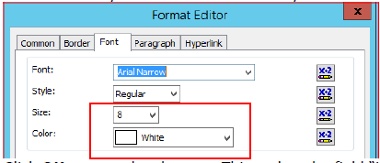

Click **OK** to save the changes. This makes the field “invisible” normally, but still seen by the PDF reader. Be sure to select “To Back” under Move for the field.

Next, insert the “Pay Here” button as a picture. The **apsC2P_payhere.jpg** graphic is available in the \mas90\ASI folder, along with other picture formats to allow for adjustments. It’s recommended that the picture be placed on top of the hyperlink lines as in the example. This allows the underlying lines to trigger the hyperlink and the browser should the PDF reader not accept the button hyperlink.

As with the URL hyperlink lines, add the suppression logic.

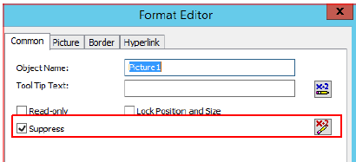

We use the same formula:

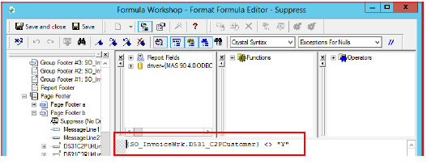

However, on the **Hyperlink** tab:

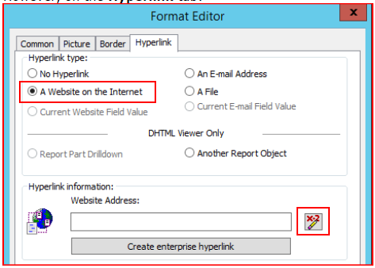

The formula is simple – it is the URL link. 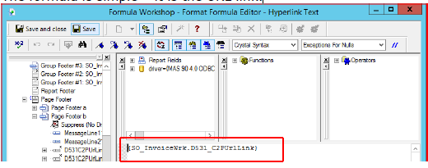

Click **Save and Close**, then **OK** to save the changes. Finally, **Save** the Crystal form.

### EMV Setup (Optional)

Before the EMV device can be configured within Sage 100, please plug the terminal into an available RJ45 cable at the workstation. The EMV device needs power and a connection to the Internet.

Once connected, the terminal will boot up and contact the APS gateway. On the terminal screen, it will look something like this:

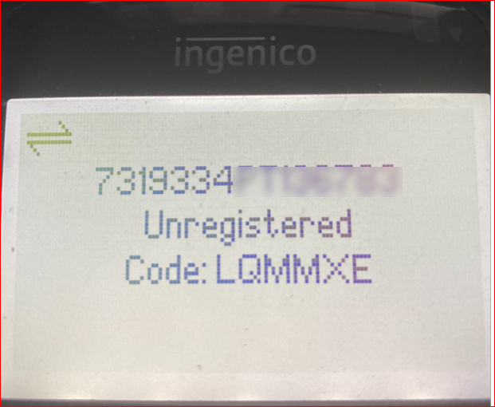

Now you are ready to complete EMV setup within Sage 100.

1. Configure an EMV Payment Type within Sage 100’s Payment Type Maintenance by checking **Use EMV Device**. Each company using an EMV device will require a unique EMV payment type in **Accounts Receivable > Setup> Payment Type Maintenance.**

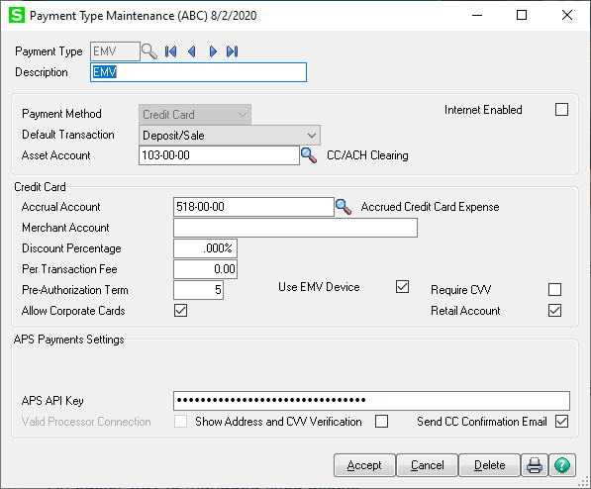

**\*NOTE\*** This step only needs to be completed once per Sage company. If configuring additional workstations, start on the next step.

1. Complete **APS Terminal Maintenance** under **Library Master**> **Setup**.

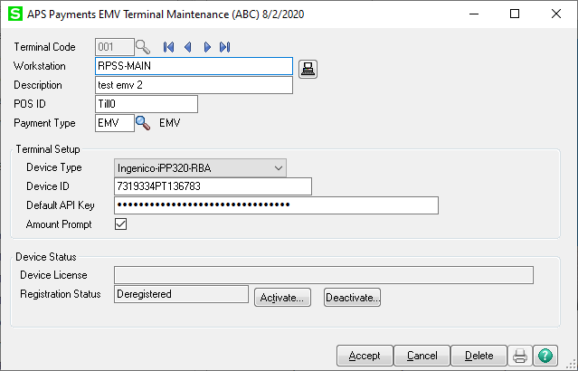

**Terminal Code** – Any three-digit alphanumeric code (0-9, A-Z). Only one may be assigned to any workstation.

**Workstation** – This is the Windows name for the workstation. If needed, use the  button to load this value.

**Description** – Friendly name or nickname for the workstation.

**POS ID** – This will load with “Till” plus the Sage 100 terminal number.

**Payment Type** – This is the payment type linked for EMV. If you have multiple locations that may have multiple merchant IDs, select the EMV payment type linked to your workstation’s location.

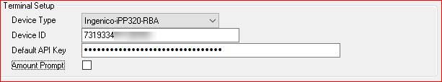

**Device Type** – Drop down list of the supported EMV terminals. Defaults to the Ingenico-iPP320.

**Device ID** – This is the 15+ alphanumeric serial number from the screen of the terminal. This identifies the terminal to the APS Gateway.

**Default API Key** – API key that synchronizes the terminal to the merchant’s account.

**Amount Prompt** – Check this for the terminal to ask the customer to confirm the amount before the terminal will continue.

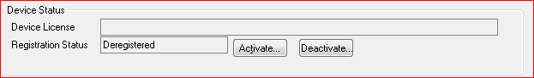

Use the **Activate** button to prompt you for the Code on the terminal screen. *Note*: This code changes every five minutes until the terminal is activated.

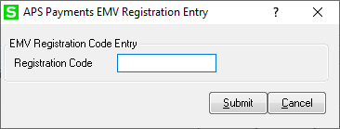

**Registration Code** – this will be a six-digit alphabetic code. Click **Submit** to register the terminal in the APS Gateway. Once registered, the terminal will look something like this:

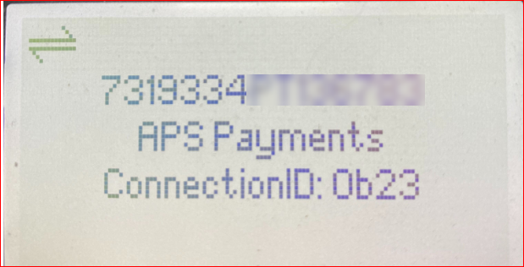

And the Device Status in the Workstation Setup will show the **Device License** and the terminal status.

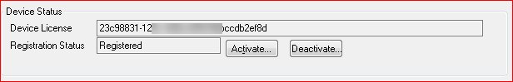

Clicking **Deactivate** will de-register the terminal. The terminal will reset and begin displaying the Code field to later register the terminal.

### Checking emv terminal status

Navigate to **Library Master > Utilities > APS EMV Services Status**.

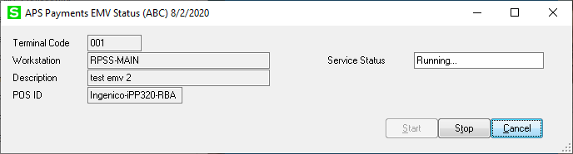

This program will display the terminal status for the workstation the program is running on. If no terminal is set up for this workstation it will display a message that you must run *Terminal Setup* to see the status of the terminal.

**Start** – This button will initiate the Registration process and display the terminal registration screen to enter the six-digit code from the terminal:



Like in the *Terminal Maintenance* screen, clicking **Submit** will register the terminal and once registered, the **Service Status** field will display Running…

**Stop** – This de-registers and reboots the terminal.

**Cancel** – This exits the program.

### DSD Multicurrency (Optional)

If Multi-Currency from DSD, Inc. is installed in your Sage 100 instance, configuration in **Company Maintenance** will determine how APSPays sends transactions to the gateway.

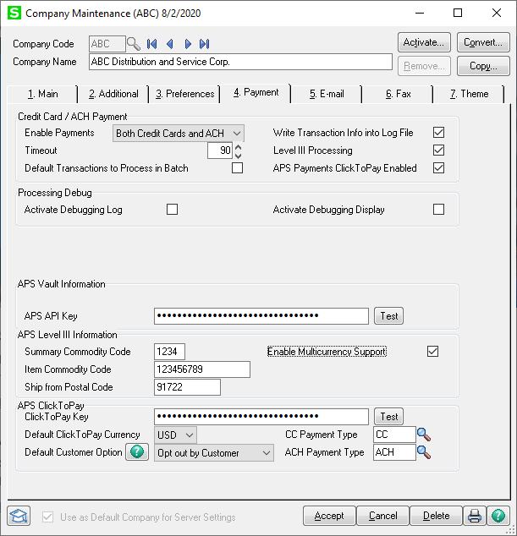

**Multi-Currency Enabled** – If checked, APSPays will specify the processor for the currency of the transaction.

**Multi-Currency Disabled** – If unchecked, APSPays will always use the default processor, regardless of the currency.

# Chapter 3: Payment Method Maintenance

### Creating New Customer Payment Methods

1. Navigate to **Accounts Receivable> Main> Customer Maintenance**.
2. On tab 2 select the **Credit Cards/ ACH** button to open the Customer Credit Card and ACH Payment Maintenance window.

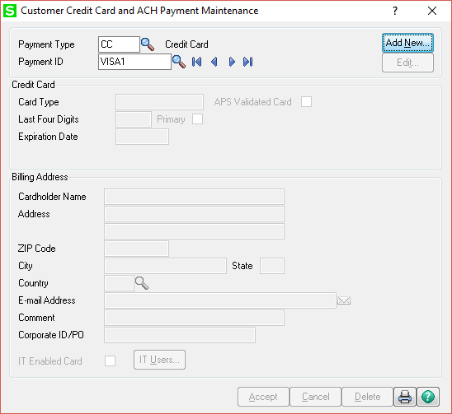

1. To add a new card or ACH, select a **Payment Type** and create a **Payment ID**-

**Payment Type-** Set in **Accounts Receivable> Setup> Payment Type Maintenance**, this field assigns the accounts and processing specifics for the tender type.

**Payment ID-** Friendly name or nickname for the payment detail record.

1. Enter the buyer’s payment details on the APSPays Addition window and **Submit.**

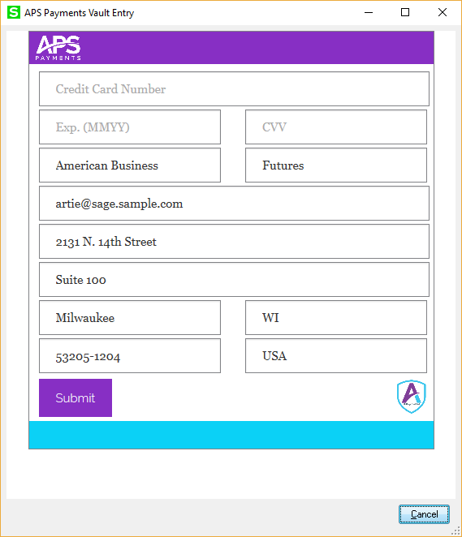 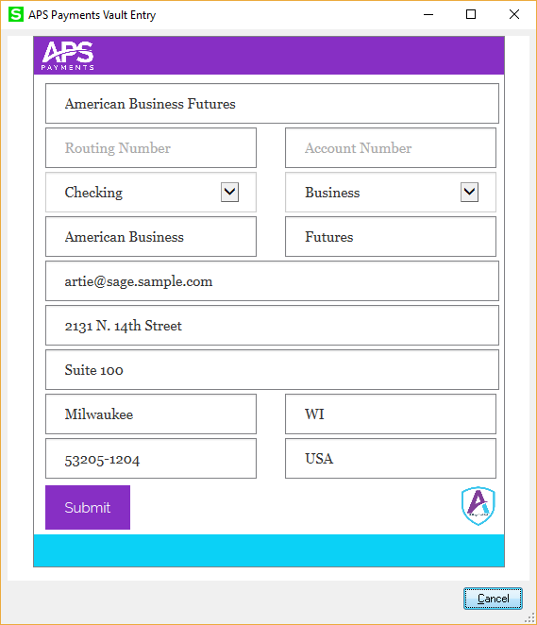

### Editing or Deleting Customer Payment Methods

1. Navigate to **Accounts Receivable> Main> Customer Maintenance**.
2. On tab 2 select the **Credit Cards/ ACH** button to open the Customer Credit Card and ACH Payment Maintenance Window.
3. Enter or select the **Payment ID** that needs to be edited or deleted and click **Edit** to update buyer payment details or **Delete** to permanently remove them.

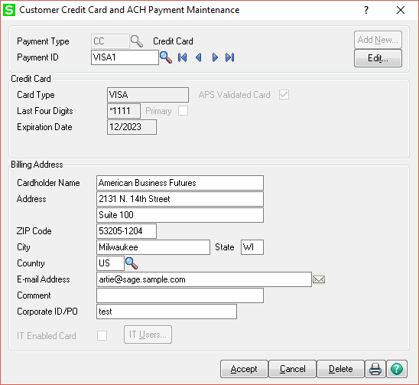

1. When editing a customer payment method, any card details apart from card number can be updated. Click **Submit** to save your changes or **Cancel** to discard the changes.

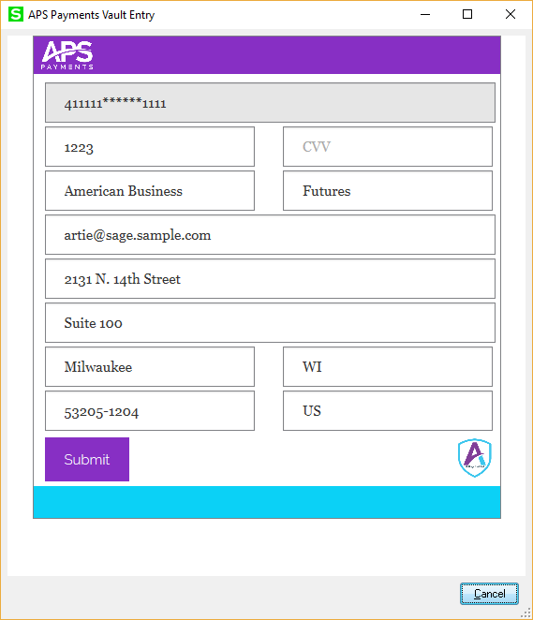

### ClickToPay (Optional)

Customer level “Opt-in” or “Opt-out” is maintained within **Accounts Receivable> Main> Customer Maintenance.**

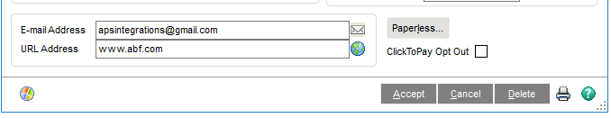

Customer Maintenance will display one of two options; or **ClickToPay Opt In** based upon the settings in Company Maintenance. For additional information please see the ClickToPay set up section.

# Chapter 4: Sales Order Module

### Sales Order Entry

1. Create a sales order or choose a sales order that has already been created but the buyer has not been charged.
2. On the “Totals” Tab, select **Deposit Payment Type** of Credit Card, ACH or EMV if you are ready to charge the customer.

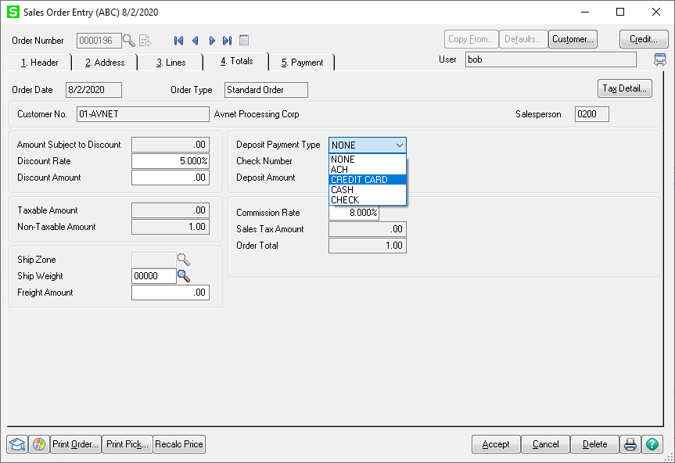

**\*NOTE\*** Choosing NONE as the Deposit Payment Type will allow you to charge the customer at the invoice level, if desired.

1. Select the **Payment** Tab

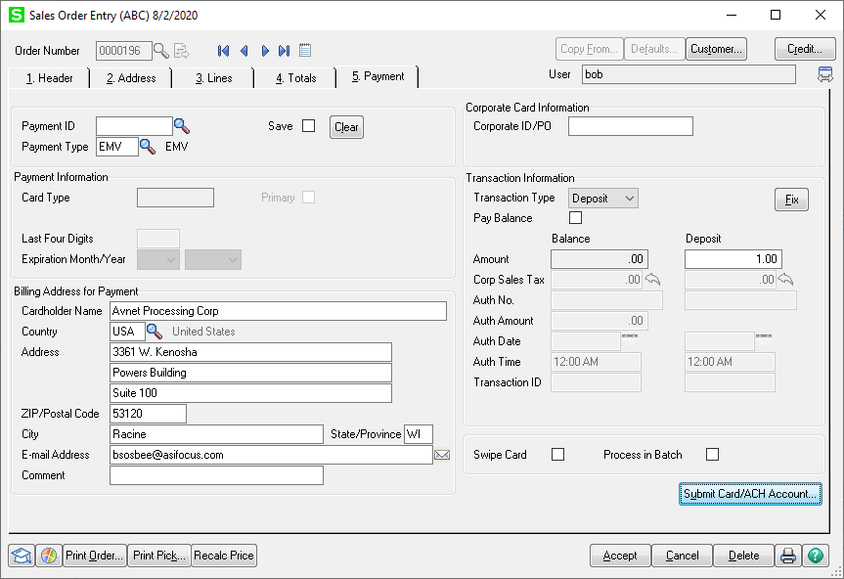

1. Enter a **Payment ID** for saved ACH or CC information - Select a previously saved record or enter a new Payment ID for new card or ACH information. Clicking the **Save** checkbox will save this for future use.

Enter the Payment Type for EMV or one-time transactions using the EMV Terminal.

1. Choose a Transaction Type-

**Payment-** Authorization. Places a pending transaction on the buyer’s account to be captured/completed at the Invoice.

**Deposit-** Sale. Can be used if the document total is final. EMV and ACH transactions should use this transaction type.

1. Click **Submit Card/ACH Account –**

If this is a new card or ACH, enter the appropriate account details on screen. For existing card or ACH information, verify accuracy and **Accept.** Transaction results are displayed on the previous entry screen.

If this is an EMV transaction, the terminal will display the amount and your customer will receive standard terminal prompts to complete the transaction. Please note you have 5 minutes (300 seconds) to complete the transaction or the process will decline.

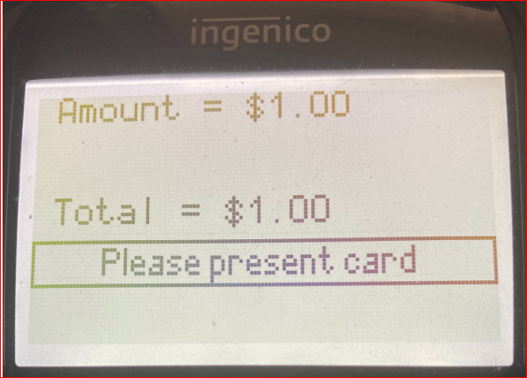

1. Upon successful payment, the terminal will return to the standby screen and you’ll receive a transaction status below the transaction details.

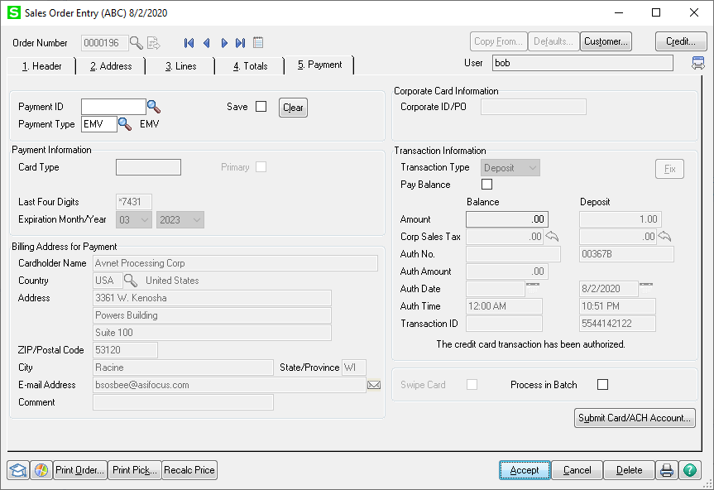

### Invoice Data Entry

1. Create an Invoice or choose an Invoice that has already been created.
2. **If a Deposit was run on the Sales Order**- make any necessary adjustments to the Invoice and **Accept**. Updating the Sales Journal will run an additional transaction if additional funds are due and the “Pay Balance” option was selected on the Sales Order.

**If a Payment was run on the Sales Order**- make any necessary adjustments to the Invoice and **Accept**. Updating the Sales Journal will finalize the transaction total with the buyer’s bank.

**If no transaction was collected on the Sales Order**- make any necessary adjustments to the Invoice and on the “Totals” Tab, select **Deposit Payment Type** of Credit Card or ACH.

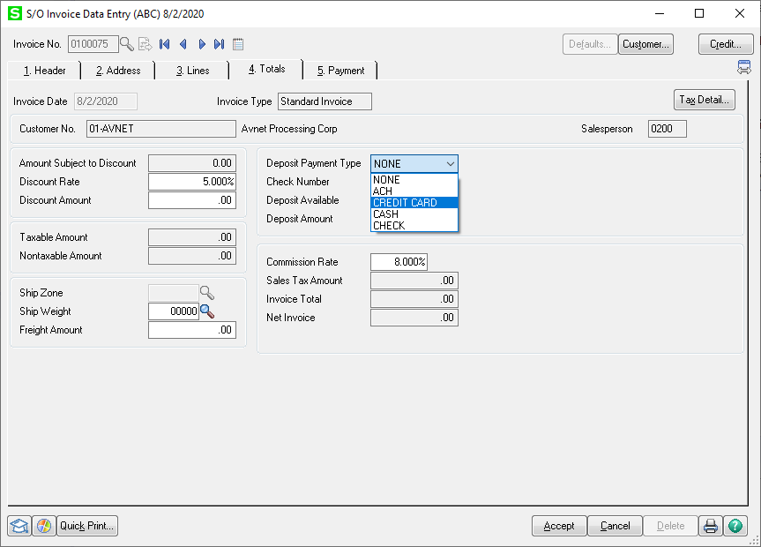

1. Select the **Payment** Tab.

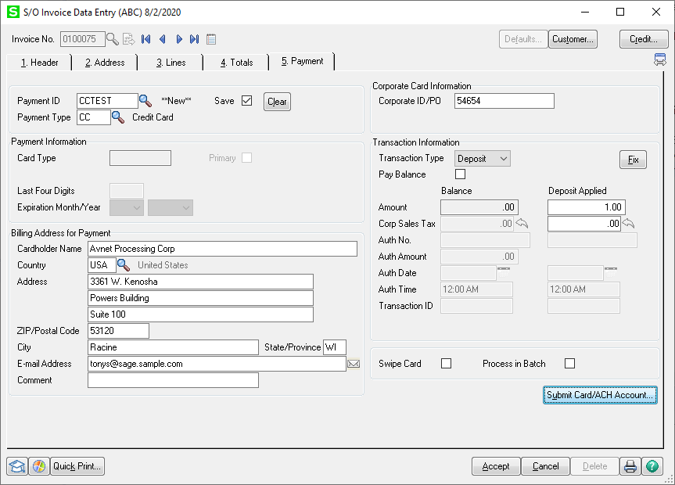

1. Enter a Payment ID for saved ACH or CC information –

Select a previously saved record or enter a new Payment ID for new card or ACH information. Clicking the **Save** checkbox will save this for future use.

Enter the Payment Type for EMV for one-time transactions.

1. Choose a Transaction Type-

**Payment-** Authorization. Places a pending transaction on the buyer’s account to be captured/completed at the Invoice.

**Deposit-** Sale. Can be used if the document total is final. EMV and ACH transactions should use this transaction type.

1. Click **Submit Card/ACH Account –**

If this is a new card or ACH, enter the appropriate account details on screen. For existing card or ACH information, verify accuracy and **Accept.** Transaction results are displayed on the previous entry screen.

If this is an EMV transaction, the terminal will display the amount and your customer will receive standard terminal prompts to complete the transaction. Please note you have 5 minutes (300 seconds) to complete the transaction or the process will decline.



1. Upon successful payment, the entry window will close and you’ll receive a transaction status below the transaction details.

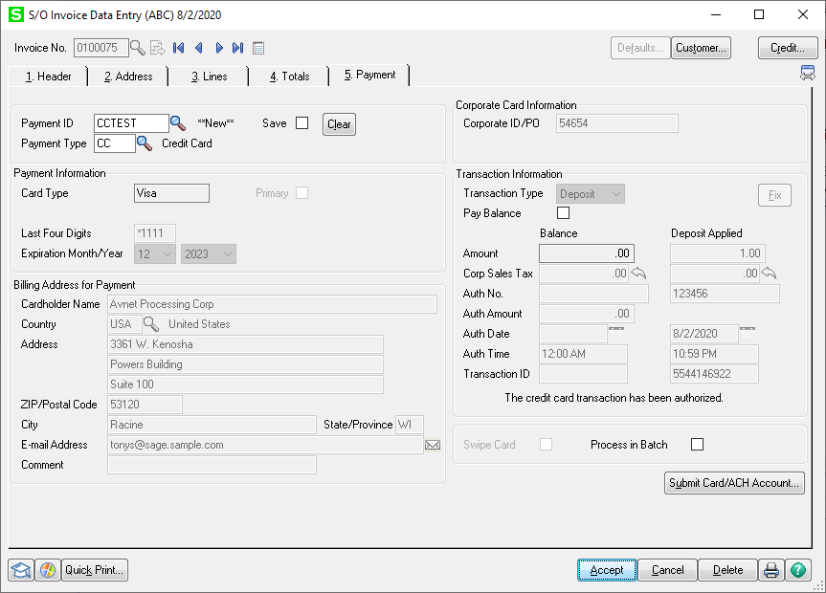

### ClickToPay Invoicing (Optional)

1. Create invoices following your standard workflow, with **NONE** as the **Deposit Payment Type**.
2. Printing the invoices electronically will generate the invoice emails that include the APS ClickToPay link for buyers “opted-in” to the service.



# Chapter 5: Accounts Receivable Module

### Cash Receipts Entry

1. Create a new Cash Receipts Deposit and enter the deposit amount in the appropriate tender type’s row.

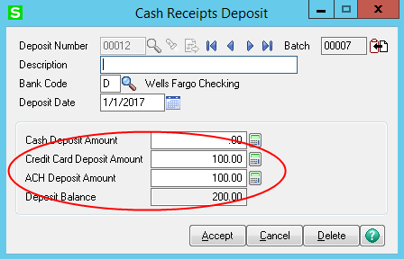

1. Select the **Customer** and **Deposit Type**; either Credit Card or ACH as shown below.

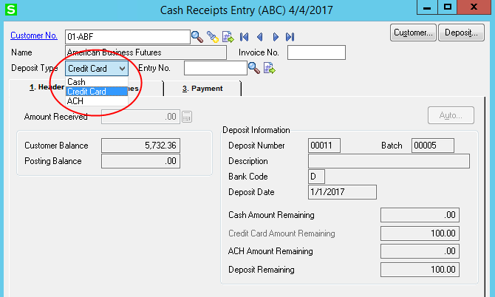

1. Enter the details of the deposit, including invoices paid or G/L accounts to charge to.
2. Navigate to the **Payments** tab and enter a Payment ID for saved ACH or CC information - Select a previously saved record or enter a new Payment ID for new card or ACH information. Clicking the **Save** checkbox will save this for future use.

Enter the Payment Type for EMV or one-time transactions

1. Click **Submit Card/ACH Account –**

If this is a new card or ACH, enter the appropriate account details on screen. For existing card or ACH information, verify accuracy and **Accept.** Transaction results are displayed on the previous entry screen.

If this is an EMV transaction, the terminal will display the amount and your customer will receive standard terminal prompts to complete the transaction. Please note you have 5 minutes (300 seconds) to complete the transaction or the process will decline.



1. Upon successful payment, the entry window will close and you’ll receive a transaction status below the transaction details.
2. **Submit** and **Accept.**

# Chapter 6: Voids & Refunds

### Voids

Transactions that need to be reversed prior to settlement are eligible for a VOID. This workflow requires the Sage 100 document to be deleted and re-entered.

1. Select the Sales Order or Invoice that contains the transaction that needs to be voided and click the **Delete** Button.

**\*NOTE\*** Your Sage 100 user must have the appropriate permissions to complete this task.

1. You will be prompted with the following options:

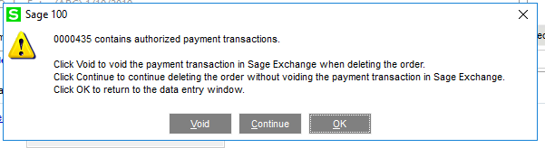

**Void-** Voids the payment transaction with the APSPays Gateway.

**Continue-** Continue with deleting the order without voiding the payment transaction with the APSPays Gateway.

**OK-** Return to the data entry window without deleting the order or voiding the payment transaction with the APSPays Gateway.

Where you just want to void the deposit or authorization, go to the **Payments** Tab and click on the **Clear** button and press **Accept.** This will invoke the void screen above but will not delete the order or invoice.

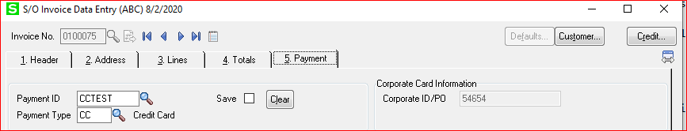

### Sales Order Credit Memos

In order to process a refund within Sage 100, the original invoice must have been paid using a saved payment method and the CREDIT permission must be added within the APSPays Gateway here.

1. Within **Sales Order> Invoice Data Entry**, create a document with an **Invoice Type** of Credit Memo.
2. Select the Invoice to apply the refund to in the **Apply to Inv No.** Field.

**\*NOTE\*** To mitigate fraudulent transactions, credit card processing does not post a credit to a card without applying the credit memo to the associated invoice. EMV transactions are not supported for this document type.

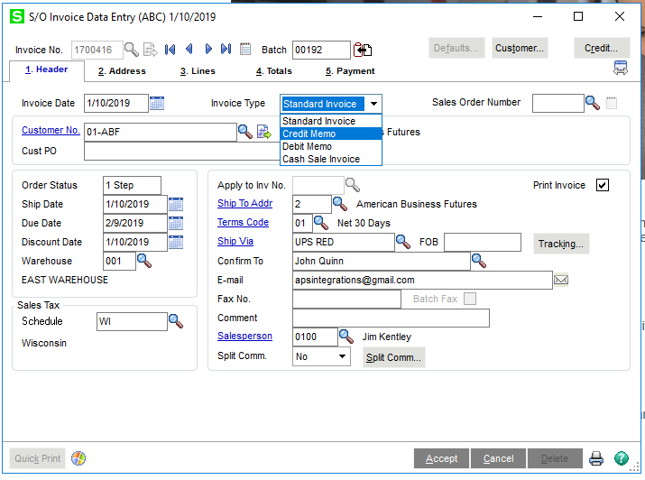

1. Enter the items to be credited on the Lines tab as positive amounts.
2. Clicking **Accept** to save the credit memo invoice will also queue the refund transaction to be issued when the Daily Sales Reports/Updates (Sales Journal) is run.

# Chapter 7: Report & Reconciliation

### APSPays Credit Card and ACH Settlement Report

To facilitate reconciling deposits from the credit card or ACH bank, a new settlement report is on the **Accounts Receivable**> **Reports** menu.

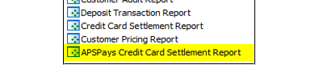

**\*NOTE\*** The workstation must run Internet Explorer 10 or higher to run the APSPays Settlement Report.

The APSPays Credit Card and ACH Settlement Report allows you to select a merchant account, your detail level preference, and a date range, then will retrieve the settled transactions for that account within the date range.

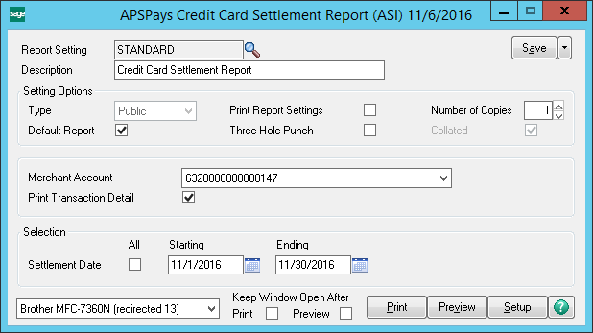

With the date range selected, the program will retrieve all the settled transactions for that merchant ID and match those transactions up to the journal where the transaction was completed and will print out the settlement transactions grouped by journal. The format for the report is identical to the standard Credit Card and ACH Settlement Report.

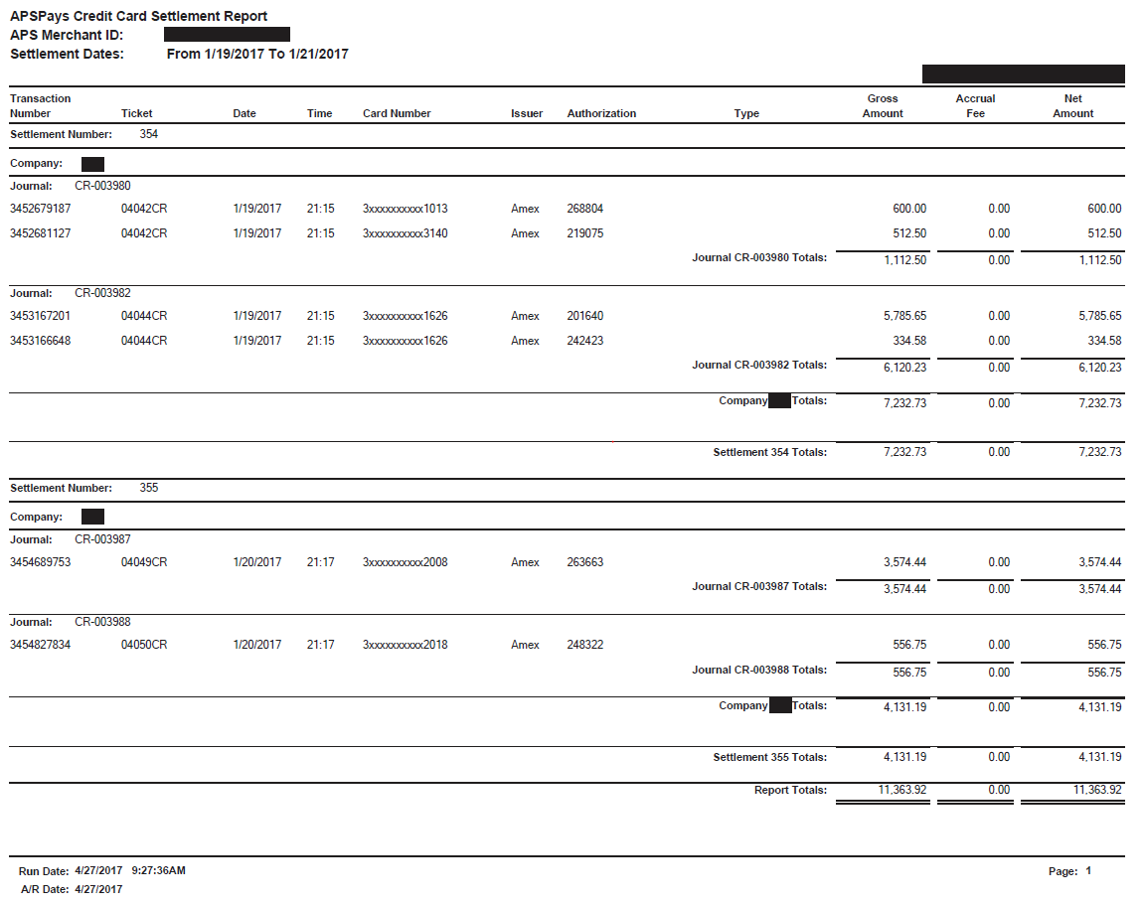

### ClickToPay Daily Processing (Optional)

ClickToPay reconciliation requires that a Cash Receipt Journal be created to import the payments into Sage 100. Its recommended that this import is performed at least once a day

1. Start a new Cash Receipts deposit and select the bank code to use if not the default bank code. ClickToPay will not load into an existing deposit.

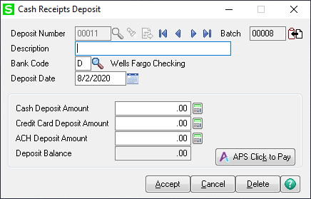

1. Click on the **APS Click to Pay** button on the bottom left to start the import.

If there are no payments to import, you will receive the popup below.



Otherwise, the deposit will load and populate the deposit totals. Once imported, the entries are available for review but may not be edited.

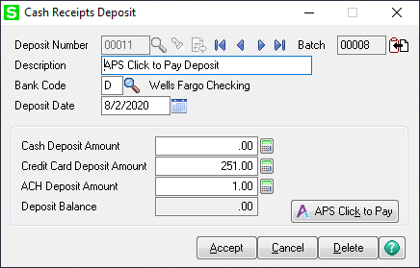

\***NOTE**\* If Multi-Currency from DSD, Inc. is installed in your Sage 100 instance, you must select the currency of transactions to be imported.

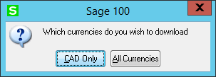

1. Run the Cash Receipts Journal to post the transactions.

# Chapter 8: Uninstall Process

### Complete APS Payments Transaction Processing

Before uninstalling APSPays from the Sage 100 instance, all open authorizations should be captured or voided.

### Remove the APSPays Addition

1. The APSPays Addition can be uninstalled from Sage 100 by going to **Library Master > Setup > Enable APS Credit Card Processing**.
2. On that screen, you will see an **Uninstall** button. Click it.
3. Once the uninstall is complete, the Sage 100 partner **must** reinstall AR and SO module from the Sage 100 CD Media, reinstall any Product Updates and reinstall any other third-party modules.

# Chapter 9: Resources

## APSPays Gateway User Guide

All merchants utilizing an APSPays Gateway Integration are provided direct access to the APSPays Gateway, which includes online reporting tools, security options and a virtual terminal.

The complete APSPays Gateway User Guide is available for download [here](https://apsmerchants.sharepoint.com/Shared%20Documents/Forms/AllItems.aspx?id=%2FShared%20Documents%2FIntegrations%2FAPSPays%20Certified%20Applications%2FAPSPays%2FAPSPays%5FUser%5FGuide%5Fv12%2Epdf&parent=%2FShared%20Documents%2FIntegrations%2FAPSPays%20Certified%20Applications%2FAPSPays&p=true&originalPath=aHR0cHM6Ly9hcHNtZXJjaGFudHMuc2hhcmVwb2ludC5jb20vOmI6L2cvRWZuaGtGX2JKZTVIc2pEZEJpb05XLU1CQVFjUjlXQTNubG1RYklpUkZyZVB0Zz9ydGltZT1NOUV5bGFjVDJFZw).

## APSPays Login

To access the APSPays Gateway, please navigate to: https://secure.apspaymentgateway.com/merchants/login and provide the username and password when prompted. Google Chrome is preferred, but any modern web browser can be used.

APSPays Gateway users can email [gatewaysupport@apsmerchants.com](mailto:gatewaysupport@apsmerchants.com) to request a password reset.

## APSPays Sandbox

APS Payments has provided a shared sandbox environment for merchants whose complex software solutions require extended testing.

**\*NOTE\*** Payment information sent to this sandbox environment cannot be transferred to a live environment. To prevent loss of cardholder data, please contact APS Payments if you have any questions or concerns.

### Testing Information

|  |  |
| --- | --- |
| Backend Login | [https://secure.apspaymentgateway.com/merchants/login.php](https://nam04.safelinks.protection.outlook.com/?url=https%3A%2F%2Fsecure.apspaymentgateway.com%2Fmerchants%2Flogin.php&data=02%7C01%7C%7Ccf8e1f6c24d14405d2a408d5d07e6e68%7C84df9e7fe9f640afb435aaaaaaaaaaaa%7C1%7C0%7C636644163820474068&sdata=8xxxY5zFjcrV%2BGZJ9tUjzczeZZfJhr5ywBaB3Auxwp8%3D&reserved=0) |
| API Key | U4d8nrtY5TnW2Jx8R8kxF23Acg7f8733 |
| Username | apsmulticurrency |
| Password | Start123 |
| Processor ID 1 | apsusd     (This processor is configured for U.S. currency) |
| Processor ID 2 | apscad     (This processor is configured for Canadian currency) |
| VISA | 4111111111111111 |
| MasterCard | 5431111111111111 |
| Discover | 6011601160116611 |
| American Express | 341111111111111 |
| Credit Card Expiration | 10/25 |
| Account (ACH): | 123123123 |
| Routing (ACH): | 123123123 |
| Amount | 1.00 (Amounts under 1.00 generate failure). |

The following information can be used to simulate a decline and or evaluate AVS & CVV responses.

• To cause a declined message, pass an amount less than 1.00.

• To trigger a fatal error message, pass an invalid card number.

• To simulate an AVS *(Address Verification System)* match, pass 888 in the address1 field (77777 for zip).

• To simulate a CVV *(Card Verification Value a.k.a 3-4-digit code)* match, pass 999 in the CVV field.

## Payment Processing Essentials

### Credit Card Processing Players

**Cardholder-** If you have a credit or debit card, you’re already familiar with the role of the cardholder. A cardholder is someone who obtains a bankcard (credit or debit) from a card issuing bank. They then present that card to merchants as payment for goods or services.

**Merchant-** A merchant is a business that maintains a merchant account that enables them to accept credit or debit cards as payment from customers (cardholders) for goods or services provided.

**Issuer**- An issuing bank, otherwise known as the cardholder bank, is the bank that has provided the credit or debit card to the cardholder.

**Card Associations-** Card Associations, otherwise known as Card Brands act as a custodian and clearing house for their respective card brand. The primary responsibilities of the Card Association are to govern the members of their associations, including interchange fees and qualification guidelines, act as the arbiter between issuing and acquiring banks, maintain and improve the card network and their brand. Example: VISA, Mastercard, American Express and Discover.

**Payment Gateway-** A Payment Gateway facilitates the transfer of information between a payment portal and the front-end processor or acquiring bank. APS Payments has its own gateway call APSPays that interacts directly with your software solution.

### Authorization vs Capture

An Authorization is a request to an issuing bank to place a hold on funds. Generally, the authorization request is step 1 of a 2-step processes that results in funds be transferred to your depositing bank. An authorization request alone does not result in payment.

Once an issuer approves the authorization request, a capture request can be sent to solidify the transaction. At this point the transaction, which is identified by the original authorization code, can be placed in queue for settlement.

The capture request can be completed simultaneously with the authorization and is known as a sale. This is common practice in a retail or B2C environment but is less frequent with manufacturers or wholesale distributors. Merchants can hold the authorization for a short period to allow adjustment to be made to the final amount.

### Authorization Expiration

An authorization does not have an indefinite shelf life and is specific to your industry classification. Per VISA core operating rules, Aggregated Transactions in a Card-Absent Environment is valid no later than 7 days from the date on which the authorization was received. However, its ultimately up to the issuer to honor the authorization, APS Payments recommends that most authorizations are sent for settlement within 3 calendar days from the original date of authorization.

### Settlement

Settlement is the process in which captured transactions are submitted to be funded. Your APSPays Gateway completes this process at a set time. At this point, all transaction details are final.

### Chargeback

A Chargeback is the return of funds to a customer who is disputing a charge. Chargebacks can be a stressor for merchants but there are a few ways to help protect yourself.

A merchant’s most effective chargeback protection is to supply as much detail regarding the transaction as possible. Details such as Billing Address and CVV/CVV2 are critical factors during the chargeback process. Merchants who supply the Billing Address and CVV/CVV2 can take advantage of APSPays Gateway’s Address Verification and Card Identification Controls to help manage the per-transaction risk.

### AVS and CVV/CVV2

Address Verification Services (AVS) is a service to combat fraudulent activity in a card absent environment by cross-referencing the cardholder’s billing address information with the card issuer’s records. AVS is widely supported by Visa, MasterCard and American Express in the USA, Canada and United Kingdom.

AVS verifies the numeric portions of a cardholder's billing address. For example, if the address is 101 Main Street, Highland, CA 92346, in the United States, AVS will check 101 and 92346.

Card Verification Value (CVV/CVV2) is an anti-fraud security feature to help verify that you are in possession of your credit card. For Visa/Mastercard, the three-digit CVV/CVV2 number is printed on the signature panel on the back of the card immediately after the card's account number. For American Express, the four-digit CVV number is printed on the front of the card above the card account number.

Why is this important?

Many banks approve transactions even if they recognize that the address information or Card Verification Value (CVV/CVV2) included with the transaction doesn’t match what they have on file. APSPays Gateway offers customizable Address Verification System (AVS) and CVV/CVV2 rules that reject transactions based on response codes returned by the issuing bank. This helps ensure that only authorized users of a credit card are able to make purchases.

What happens when the address or security code don’t match?

If the issuing bank’s response triggers one of your AVS or CVV rules, the APSPays Gateway will reject the transaction (“GATEWAY REJECTED: AVS REJECTED”) and send a void request to the issuing bank.

Keep in mind that some banks don't recognize void requests immediately.

Can I change my AVS and CVV Security Options?

APS Payments does not recommend operating your APSPays Gateway without AVS and CVV settings but recognizes certain business needs may warrant adjustments to the default settings. Instructions to do so are below:

Address Verification: <https://vimeo.com/200899769>

Card ID Verification: <https://vimeo.com/200899749>

**\*NOTE\*** Transactions without proper AVS and CVV security checks are at higher risk for chargebacks, which may result in financial loss.

## Contact Information

### Customer Service

The APS Payments Customer Service Team is your first point of contact for general inquiries.

**Phone:** 888.685.1900

**Email:** [apscsr@apspayments.com](mailto:apscsr@apspayments.com)

### Integrations Team

The APS Payments Integration team is your first point of contact regarding Software support or APSPays Gateway questions.

**Phone:** 888.685.1900

**Email:** [Integrations@apspayments.com](mailto:Integrations@apspayments.com)