The influence of the Southland Current on circulation patterns within Pegasus Bay

Rafael G. Soutelino¹ and Brett Beamsley¹
¹ MetOcean Solutions LTD, New Plymouth, New Zealand; r.soutelino@metocean.co.nz

The present work evaluates the influence of the Southland Current on the Pegasus Bay (PB) inner and mid shelf circulation using different nesting setups for realistic hydrodynamical hindcasts performed with the Regional Ocean Modelling System (ROMS). A four-nest approach is confronted against a two-nest one, both compared against measured data. The results highlight the importance of the gradual downscaling from the ocean basin to the inner shelf to appropriately introduce remote forcing effects (Figure 1). The results further corroborate previous statements that oceanic circulation and its variability has a high order impact in the local flow regime at the inner PB, showing direct and indirect impacts of neglecting such mechanism in light of measured data.

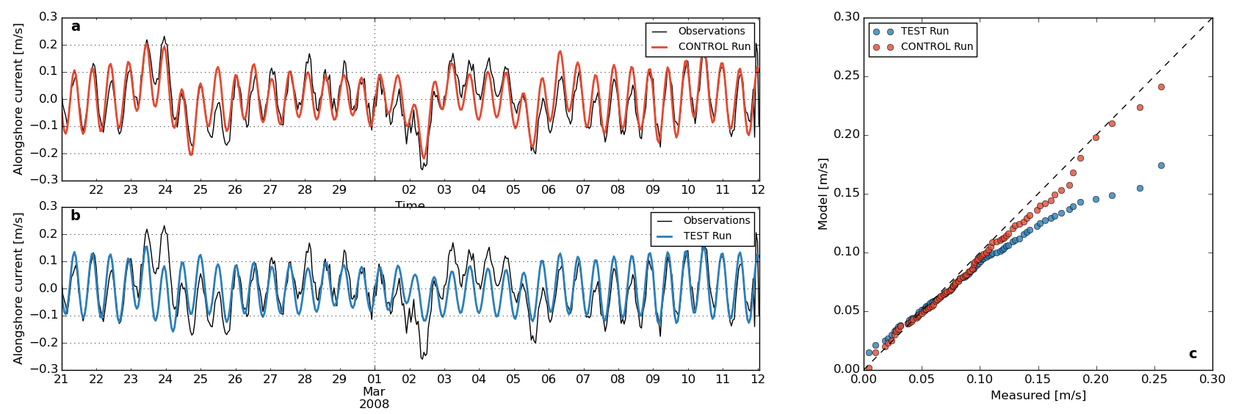
Figure 1: Comparison of the simulation results for CONTROL (red) and TEST (blue) simulations and in situ depth-averaged current measurements. (a) and (b) shows raw time series of the measurements and respective experiment. Note how the CONTROL run (a) has better skill in representing the residual currents that adds up to the tidal flow. The TEST run is clearly underestimating the alongshore current magnitude in stronger residual flow events (c), while the CONTROL simulation shows good overall agreement.

Keywords: Pegasus Bay, Southland Current, coastal sub-inertial currents, modelling.

