Centered Cambria 16 Point Font Italicized:
Testing PowerPaste by Cutting and Pasting from Microsoft Word 2011 for Mac into RSpace Documents using Mozilla Firefox

This | is | a | table
 | .jpg Molecule: |  | .tiff Design:
 | 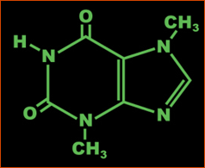 |  | 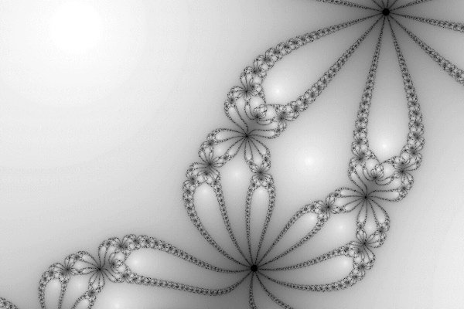
 | Some Text: |  | .png Nebula:
 | The quick brown fox jumps over the lazy dog.  The quick brown fox jumps over the lazy dog.  The quick brown fox jumps over the lazy dog.  The quick brown fox jumps over the lazy dog.  The quick brown fox jumps over the lazy dog.  The quick brown fox jumps over the lazy dog.  The quick brown fox jumps over the lazy dog.  The quick brown fox jumps over the lazy dog.  The quick brown fox jumps over the lazy dog.  The quick brown fox jumps over the lazy dog.  The quick brown fox jumps over the lazy dog. |  | 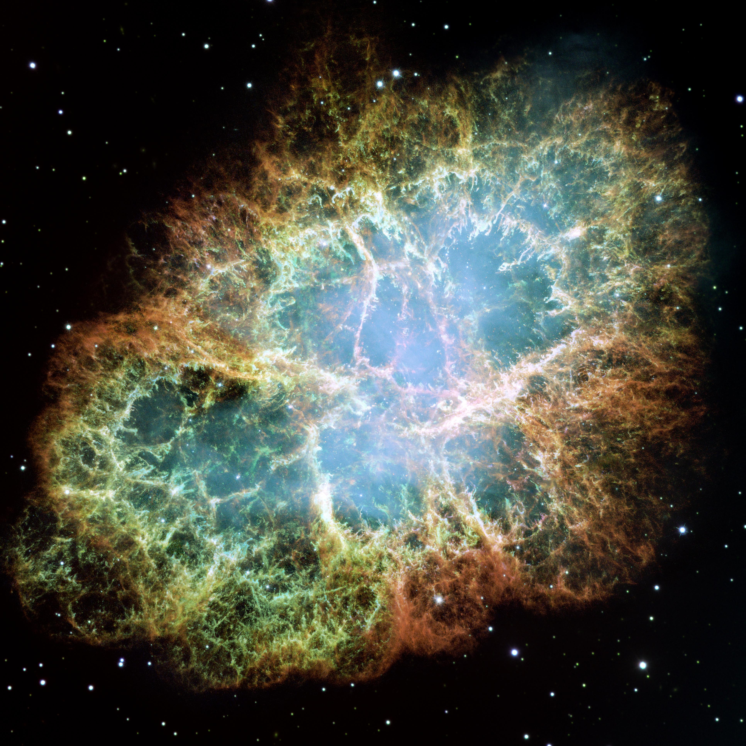
Centered text in merged cells written in Comic Sans

Bold Helvetica

this | is | a
new | table | without
any | fancy | images

this | is | a
new | table | without
any | fancy | images
with | BOLD | BORDERS

Centered Cambria Text
The quick brown fox jumps over the lazy dog. The quick brown fox jumps over the lazy dog. The quick brown fox jumps over the lazy dog. The quick brown fox jumps over the lazy dog. The quick brown fox jumps over the lazy dog. The quick brown fox jumps over the lazy dog. The quick brown fox jumps over the lazy dog. The quick brown fox jumps over the lazy dog. The quick brown fox jumps over the lazy dog. The quick brown fox jumps over the lazy dog. The quick brown fox jumps over the lazy dog. The quick brown fox jumps over the lazy dog. The quick brown fox jumps over the lazy dog. The quick brown fox jumps over the lazy dog. The quick brown fox jumps over the lazy dog. The quick brown fox jumps over the lazy dog. The quick brown fox jumps over the lazy dog. The quick brown fox jumps over the lazy dog. The quick brown fox jumps over the lazy dog. The quick brown fox jumps over the lazy dog. The quick brown fox jumps over the lazy dog. The quick brown fox jumps over the lazy dog. The quick brown fox jumps over the lazy dog. The quick brown fox jumps over the lazy dog. The quick brown fox jumps over the lazy dog. The quick brown fox jumps over the lazy dog. The quick brown fox jumps over the lazy dog. The quick brown fox jumps over the lazy dog. The quick brown fox jumps over the lazy dog. The quick brown fox jumps over the lazy dog. The quick brown fox jumps over the lazy dog. The quick brown fox jumps over the lazy dog. The quick brown fox jumps over the lazy dog.

Left Aligned Arial Text
The quick brown fox jumps over the lazy dog. The quick brown fox jumps over the lazy dog. The quick brown fox jumps over the lazy dog. The quick brown fox jumps over the lazy dog. The quick brown fox jumps over the lazy dog. The quick brown fox jumps over the lazy dog. The quick brown fox jumps over the lazy dog. The quick brown fox jumps over the lazy dog. The quick brown fox jumps over the lazy dog. The quick brown fox jumps over the lazy dog. The quick brown fox jumps over the lazy dog. The quick brown fox jumps over the lazy dog. The quick brown fox jumps over the lazy dog. The quick brown fox jumps over the lazy dog. The quick brown fox jumps over the lazy dog. The quick brown fox jumps over the lazy dog. The quick brown fox jumps over the lazy dog. The quick brown fox jumps over the lazy dog. The quick brown fox jumps over the lazy dog. The quick brown fox jumps over the lazy dog. The quick brown fox jumps over the lazy dog. The quick brown fox jumps over the lazy dog. The quick brown fox jumps over the lazy dog. The quick brown fox jumps over the lazy dog. The quick brown fox jumps over the lazy dog. The quick brown fox jumps over the lazy dog. The quick brown fox jumps over the lazy dog. The quick brown fox jumps over the lazy dog. The quick brown fox jumps over the lazy dog. The quick brown fox jumps over the lazy dog. The quick brown fox jumps over the lazy dog. The quick brown fox jumps over the lazy dog. The quick brown fox jumps over the lazy dog.
Right Aligned Helvetica Text
The quick brown fox jumps over the lazy dog. The quick brown fox jumps over the lazy dog. The quick brown fox jumps over the lazy dog. The quick brown fox jumps over the lazy dog. The quick brown fox jumps over the lazy dog. The quick brown fox jumps over the lazy dog. The quick brown fox jumps over the lazy dog. The quick brown fox jumps over the lazy dog. The quick brown fox jumps over the lazy dog. The quick brown fox jumps over the lazy dog. The quick brown fox jumps over the lazy dog. The quick brown fox jumps over the lazy dog. The quick brown fox jumps over the lazy dog. The quick brown fox jumps over the lazy dog. The quick brown fox jumps over the lazy dog. The quick brown fox jumps over the lazy dog. The quick brown fox jumps over the lazy dog. The quick brown fox jumps over the lazy dog. The quick brown fox jumps over the lazy dog. The quick brown fox jumps over the lazy dog. The quick brown fox jumps over the lazy dog. The quick brown fox jumps over the lazy dog. The quick brown fox jumps over the lazy dog. The quick brown fox jumps over the lazy dog. The quick brown fox jumps over the lazy dog. The quick brown fox jumps over the lazy dog. The quick brown fox jumps over the lazy dog. The quick brown fox jumps over the lazy dog. The quick brown fox jumps over the lazy dog. The quick brown fox jumps over the lazy dog. The quick brown fox jumps over the lazy dog. The quick brown fox jumps over the lazy dog. The quick brown fox jumps over the lazy dog.

Justified Times New Roman Text
The quick brown fox jumps over the lazy dog. The quick brown fox jumps over the lazy dog. The quick brown fox jumps over the lazy dog. The quick brown fox jumps over the lazy dog. The quick brown fox jumps over the lazy dog. The quick brown fox jumps over the lazy dog. The quick brown fox jumps over the lazy dog. The quick brown fox jumps over the lazy dog. The quick brown fox jumps over the lazy dog. The quick brown fox jumps over the lazy dog. The quick brown fox jumps over the lazy dog. The quick brown fox jumps over the lazy dog. The quick brown fox jumps over the lazy dog. The quick brown fox jumps over the lazy dog. The quick brown fox jumps over the lazy dog. The quick brown fox jumps over the lazy dog. The quick brown fox jumps over the lazy dog. The quick brown fox jumps over the lazy dog. The quick brown fox jumps over the lazy dog. The quick brown fox jumps over the lazy dog. The quick brown fox jumps over the lazy dog. The quick brown fox jumps over the lazy dog. The quick brown fox jumps over the lazy dog. The quick brown fox jumps over the lazy dog. The quick brown fox jumps over the lazy dog. The quick brown fox jumps over the lazy dog. The quick brown fox jumps over the lazy dog. The quick brown fox jumps over the lazy dog. The quick brown fox jumps over the lazy dog. The quick brown fox jumps over the lazy dog. The quick brown fox jumps over the lazy dog. The quick brown fox jumps over the lazy dog. The quick brown fox jumps over the lazy dog.

