**AU Solidity Bootcamp**

Contents

Resources 2

# W7 - Storage Slots

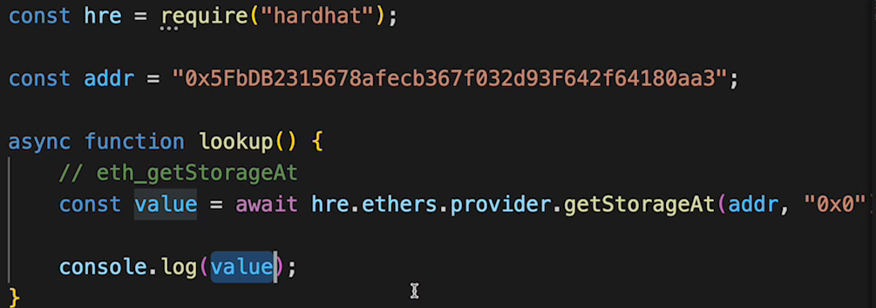

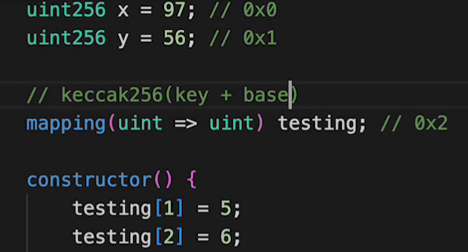

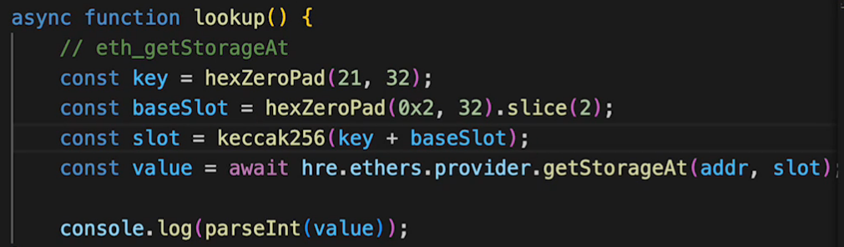

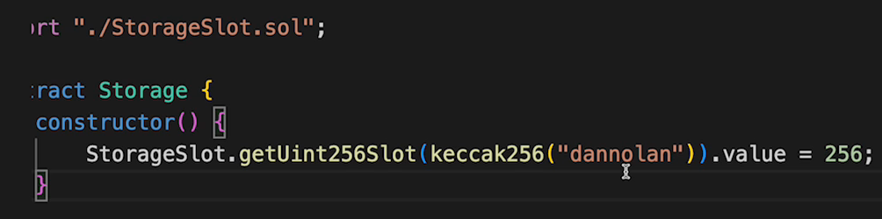

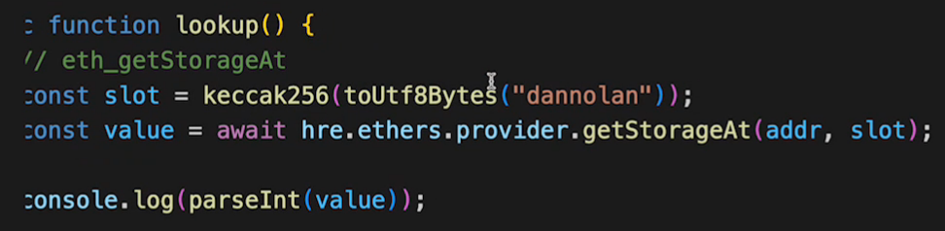

# W7 - Delegatecall

**Calldata:**

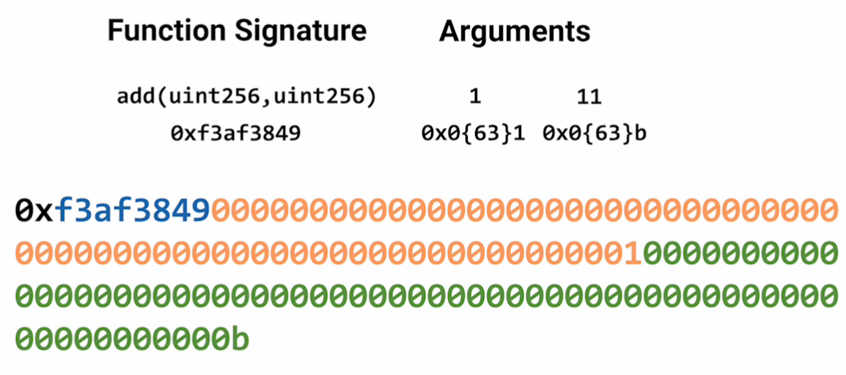

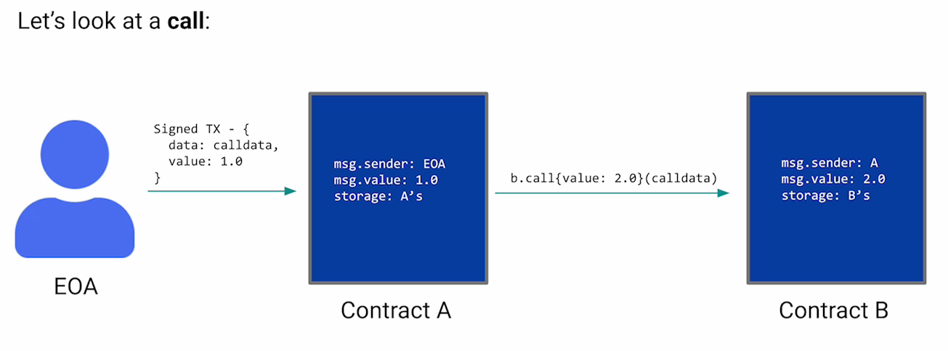

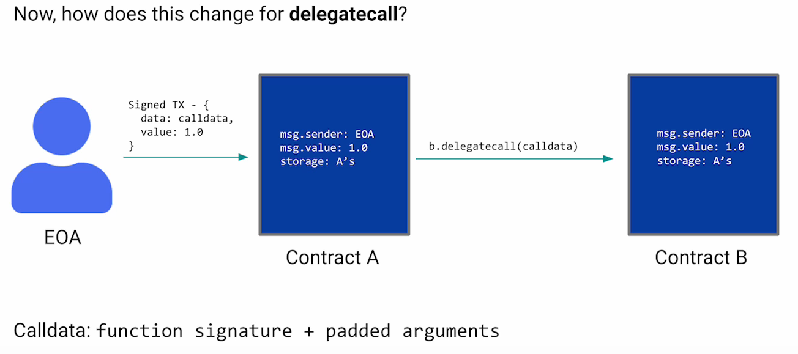

Acting on ContrA storage with ContrB code => careful - very dangerous, ContrB could be any contract and change our storage!

**Use case: Proxy contract (for SC upgrades):**

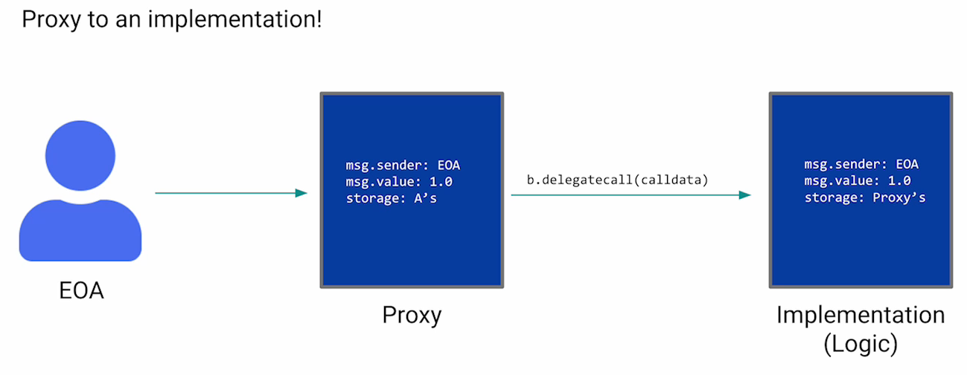

The "Clones" are minimal proxies - they are only 4 bytes in size:

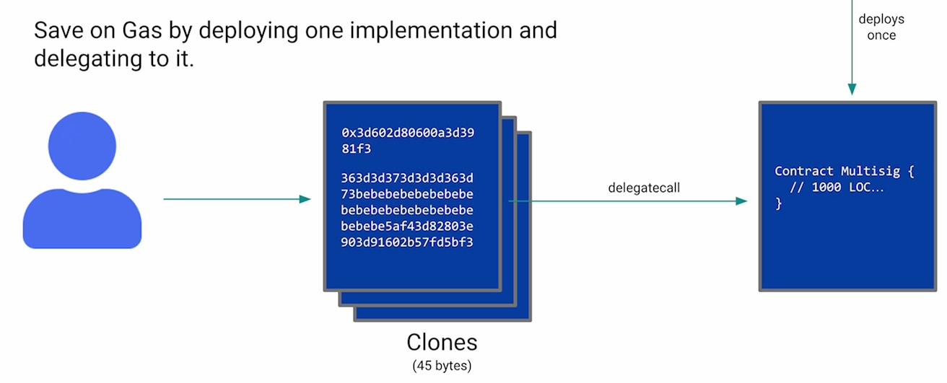

**Other use case: Upgrades:**

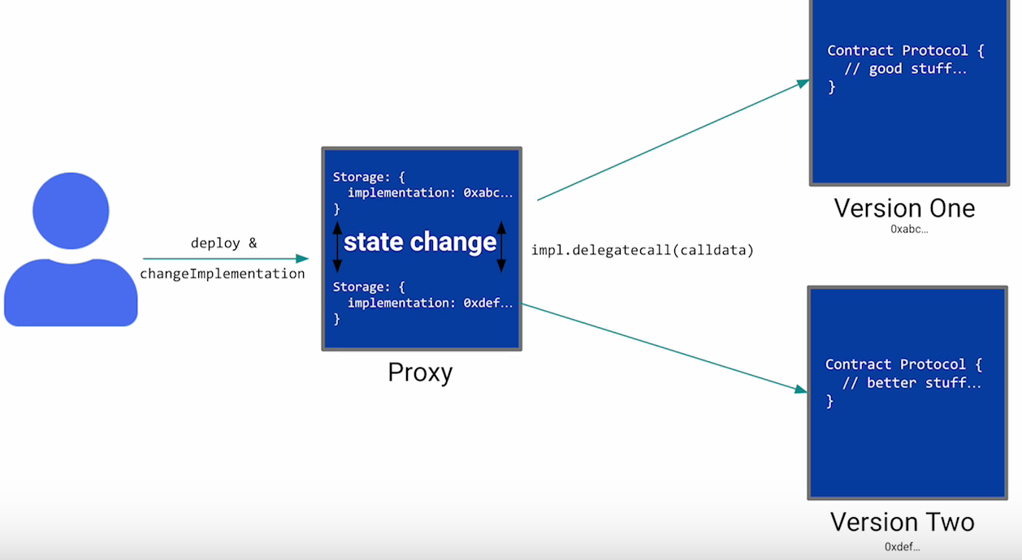

# W7 - Evolution of Proxies

Storage always lives in the proxy, the actual code is located in the (upgradeable) implementations. To modify the storage (which is living on the proxy), we need to use delegatecalls.

Use StorageSlot library & store your data as indicated (at a specific addr we define => keccak(impl)...) => NOT on addr 0x1, 0x2...:

All storage data is defined in Logic1, Logic2... => via delegatecall, the corresponding values are on the Proxy starting at the defined storage slot.

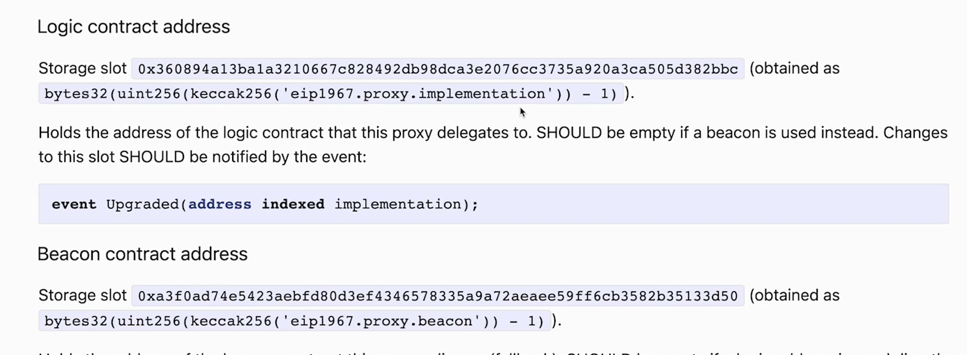

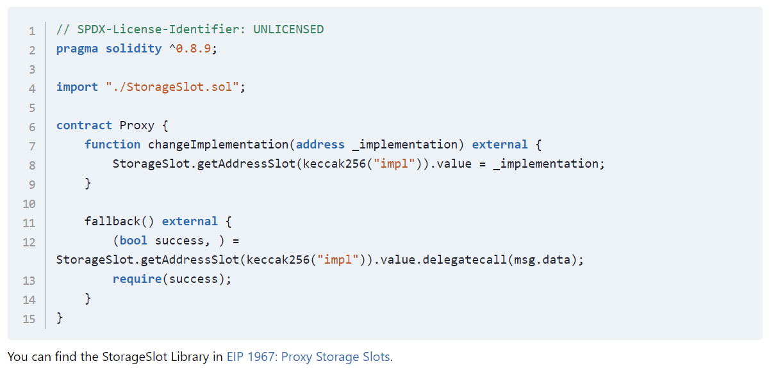

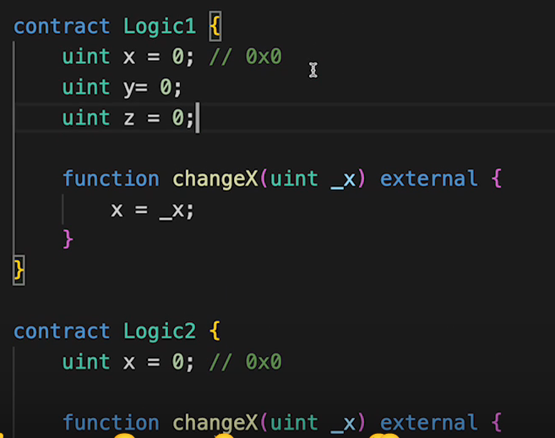

On Proxy, we only have 1 method: implementation, but we don't have change() => we can use the following trick, to get all methods defined on Logic1... also available on Proxy : specify the Logic1 contract (with all methods we need) as arg1 & the address of the deployed proxy as arg2:



