**Practical 2**

**Distributed Operating System**

**Name - Ritesh Parkhi**

**Roll No. – 46**

**Batch – 3**

**AIM:**

Construct a program to demonstrate the concept of logical clock synchronization in a distributed environment using Lamport Logical clock.

**THEORY:**

A **Lamport logical clock** is an incrementing counter maintained in each process. Conceptually, this logical clock can be thought of as a clock that only has meaning in relation to messages moving between processes. When a process receives a message, it resynchronizes its logical clock with that sender (causality).

The algorithm of Lamport Timestamps can be captured in a few rules:

* All the process counters start with value 0.
* A process increments its counter for each event (internal event, message sending, message receiving) in that process.
* When a process sends a message, it includes its (incremented) counter value with the message.
* On receiving a message, the counter of the recipient is updated to the greater of its current counter and the timestamp in the received message, and then incremented by one.

Looking at these rules, we can see the algorithm will create a minimum overhead, since the counter consists of just one integer value and the messaging piggybacks on inter-process messages.

One of the shortcomings of Lamport Timestamps is rooted in the fact that they only partially order events (as opposed to total order). Partial order indicates that not every pair of events need be comparable. If two events can’t be compared, we call these events concurrent. The problem with Lamport Timestamps is that they can’t tell if events are concurrent or not. This problem is solved by Vector Clocks.

**PROGRAM:**

*// C program to illustrate the Lamport's*

#include <stdio.h>

*// Function to find the maximum timestamp*

*// between 2 events*

*int* max1(*int* a, *int* b)

{

*// Return the greatest of th two*

    if (a > b)

        return a;

    else

        return b;

}

*// Function to display the logical timestamp*

*void* display(*int* e1, *int* e2,

*int* p1[5], *int* p2[3])

{

*int* i;

    printf("\nThe time stamps of "

        "events in P1:\n");

    for (i = 0; i < e1; i++) {

        printf("%d ", p1[i]);

    }

    printf("\nThe time stamps of "

        "events in P2:\n");

*// Print the array p2[]*

    for (i = 0; i < e2; i++)

        printf("%d ", p2[i]);

}

*// Function to find the timestamp of events*

*void* lamportLogicalClock(*int* e1, *int* e2,

*int* m[5][3])

{

*int* i, j, k, p1[e1], p2[e2];

*// Initialize p1[] and p2[]*

    for (i = 0; i < e1; i++)

        p1[i] = i + 1;

    for (i = 0; i < e2; i++)

        p2[i] = i + 1;

    for (i = 0; i < e2; i++)

        printf("\te2%d", i + 1);

    for (i = 0; i < e1; i++) {

        printf("\n e1%d \t", i + 1);

        for (j = 0; j < e2; j++)

            printf("%d\t", m[i][j]);

    }

    for (i = 0; i < e1; i++) {

        for (j = 0; j < e2; j++) {

*// Change the timestamp if the*

*// message is sent*

            if (m[i][j] == 1) {

                p2[j] = max1(p2[j], p1[i] + 1);

                for (k = j + 1; k < e2; k++)

                    p2[k] = p2[k - 1] + 1;

            }

*// Change the timestamp if the*

*// message is received*

            if (m[i][j] == -1) {

                p1[i] = max1(p1[i], p2[j] + 1);

                for (k = i + 1; k < e1; k++)

                    p1[k] = p1[k - 1] + 1;

            }

        }

    }

*// Function Call*

    display(e1, e2, p1, p2);

}

*// Driver Code*

*int* main()

{

*int* e1 = 5, e2 = 3, m[5][3];

*// message is sent and received*

*// between two process*

*/*dep[i][j] = 1, if message is sent*

*from ei to ej*

*dep[i][j] = -1, if message is received*

*by ei from ej*

*dep[i][j] = 0, otherwise*/*

    m[0][0] = 0;

    m[0][1] = 0;

    m[0][2] = 0;

    m[1][0] = 0;

    m[1][1] = 0;

    m[1][2] = 1;

    m[2][0] = 0;

    m[2][1] = 0;

    m[2][2] = 0;

    m[3][0] = 0;

    m[3][1] = 0;

    m[3][2] = 0;

    m[4][0] = 0;

    m[4][1] = -1;

    m[4][2] = 0;

*// Function Call*

    lamportLogicalClock(e1, e2, m);

    return 0;

}

**OUTPUT:**

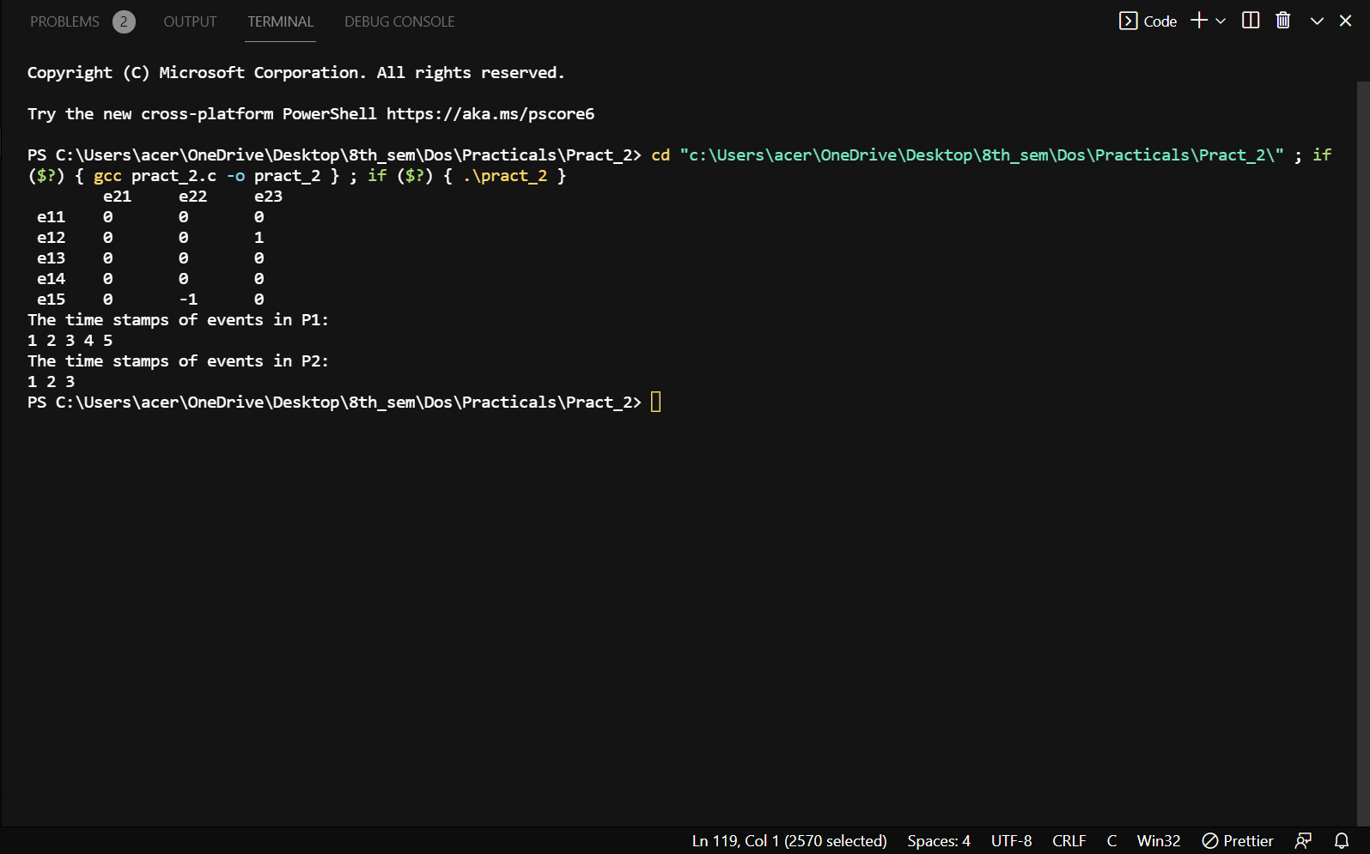

**CONCLUSION:**

Hence we successfully studied about Lamport Logical Clock commands.