DIRECTORS DEALINGS
Quant Research Briefs 01 & 02
Brief 01 — Do the live signal tiers separate winners from losers out-of-sample?
Brief 02 — Where else might alpha live? (combinations, size, price, sector, seasonality)

Prepared by Quant Researcher · 2026-06-03 · Validation pass — no production code or DB writes
Data: _backtest_results.csv (run bt_20260603T103447Z, 1,979 firing rows) + read-only /tmp copy of directors.db. Stdlib Python only.
EXECUTIVE SUMMARY — the one thing to take away
Out-of-sample, the signal taxonomy does not separate winners from losers, and the base rate it draws from is negative. The average flagged director buy returned −1.85% net (−0.75% gross) versus its own sector benchmark over 21 trading days, with a 36% hit-rate — and that underperformance deepens to −3.9% gross by T+90. No live tier beats this baseline out-of-sample, and the claimed seniority ordering (T1 ≥ T2 ≥ T3 ≥ T4; T0 highest) is contradicted — it inverts.
Recommendation: do not refine, re-tune, or extend the tiers yet. First explain why the average flagged buy lags its benchmark (regime, universe selection, or residual data-timing). Building Brief-02 features on a negative, non-separating base is refining noise.

Brief 01 — Tier separation, validated out-of-sample

Three headline answers
1. Which tiers survive out-of-sample? → None.
Of 13 live signals, only four have ≥30 matured firings in the test half at T+21 (F1, S1, T3, T4); the other nine are INSUFFICIENT-N. None of the four testable signals beats the baseline. At T+90 only F1 and S1 are even borderline-testable, and neither beats baseline. Zero tiers show incremental out-of-sample edge over a generic director buy.
2. Does the seniority ordering hold? → No; it inverts.
Observed test-half net CAR runs the opposite way to the taxonomy: T4 (−1.4%) > T3 (−3.4%) > T2 (−7.0%) > T1 (−10%). T0 (“cluster combo”, claimed strongest) prints −8.7% — near the bottom. Senior tiers are small-N, so this is “contradicted, not proven” — but there is no support, in either half, for seniority paying.
3. Single most important keep/kill → Fix the base rate before touching the tiers.
The baseline itself is negative and non-separating out-of-sample. Re-tuning a tier whose parent population is negative just fits the negative sample harder. If forced to simplify now, the only data-supported move is to collapse the role tiers into one “director buy” flag — not to add granularity.

Pre-registration (written before pulling CARs)
Predicted directions are logged so the result cannot be back-fitted. The null being tested: each tier is positive, beats the generic-buy baseline, and respects the asserted ordering.
Tier | Economic claim | Predicted sign | Predicted rank
T1a/T1b | CEO/Founder, CFO — most-informed insiders | strongly + | highest role tier
T2 | Other exec — informed | + | ≥ T3
T3 | NED — less operational insight | mildly + | ≥ T4
T4 | Other / catch-all — weakest | ~flat to mild + | lowest role tier
S1 | Cluster buy — insiders agreeing | + | ≥ generic buy
T0 | Cluster + senior role — best of both | strongly + | highest overall
F1 | First-time buy — new conviction | + | ≥ generic buy
Hypotheses tested this pass: 13 signals × 2 windows = 26 comparisons. (The brief scoped 7×2=14; the live taxonomy has grown to 13 signals, so the multiple-comparison surface — and the haircut — is larger.)

Cohort & method
- Universe: 987 distinct firing events. One fingerprint can trigger several signals; CAR is identical per fingerprint, so the baseline dedupes to one row per fingerprint.
- Effective date: fired_at (the disclosure/firing timestamp) — the market reacts to the filing, not the trade date.
- Time split (60/40 by event): train = events on/before 2025-12-09; test = events after. Firing range 2025-06-02 → 2026-04-20.
- Cost model (confirmed exactly as briefed): non-AIM = 100bps (50bps round-trip spread + 50bps stamp); AIM = 50bps.
Window maturity is the binding constraint. T+90 needs ~4.3 months of post-entry prices; “today” is 2026-06-03, so most test-half firings have not matured to T+90:
Half | Events with T+21 | Events with T+90
Train (≤ 2025-12-09) | 593 | 592
Test (> 2025-12-09) | 393 | 92
Only 92 test-half events have matured to T+90 — the reason most T+90 verdicts are unknowable this pass.

Baseline — the comparator every tier must beat
The baseline is the pooled set of distinct firing events: “the average system-flagged director buy.” It is negative and, crucially, not outlier-driven (the 5%-trimmed mean is −1.06%; removing the single best trade barely moves it). Because CAR already subtracts a sector-matched benchmark, this is director-bought names lagging their own sector index — not simply “the market fell.”
Net CAR | Train T+21 | Test T+21 | Train T+90 | Test T+90
Mean | −1.68% | −1.85% | −5.39% | −1.36%
Median | −2.23% | −2.14% | −6.48% | −7.18%
Hit-rate | 40% | 36% | 33% | 28%
Mean, top removed | −1.7% | −2.3% | −5.7% | −3.7%
N | 593 | 393 | 592 | 92

Per-tier results — test half, T+21, net of cost
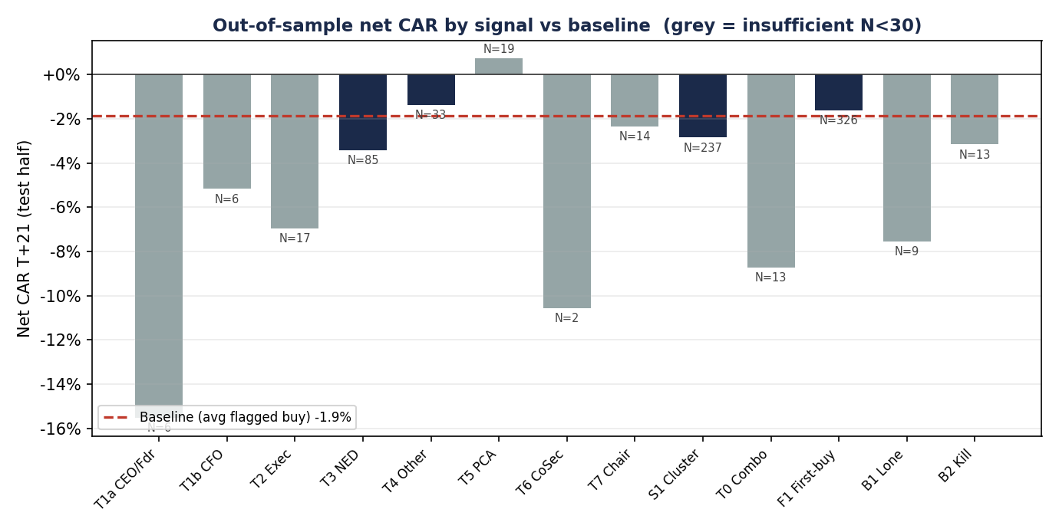
Navy = sufficient N (≥30); grey = insufficient N. Red dashed line = baseline (−1.85%). No bar clears the baseline.
Signal | Test N | Mean T+21 net | Median | Hit | vs base | Verdict
F1 first-time buy | 326 | −1.61% | −2.13% | 37% | +0.24% | NOISE
S1 cluster buy | 237 | −2.85% | −2.34% | 34% | −1.00% | NOISE
T3 NED buy | 85 | −3.42% | −2.43% | 27% | −1.57% | NOISE
T4 other buy | 33 | −1.38% | −2.04% | 30% | +0.47% | NOISE
T5 PCA buy | 19 | +0.72% | +0.10% | 53% | +2.57% | INSUFF-N
T2 exec buy | 17 | −6.96% | −8.26% | 24% | −5.11% | INSUFF-N
T7 chair buy | 14 | −2.34% | −2.42% | 36% | −0.49% | INSUFF-N
T0 cluster combo | 13 | −8.73% | −12.93% | 15% | −6.88% | INSUFF-N
B2 crowded-cluster kill | 13 | −3.17% | −6.70% | 23% | −1.31% | INSUFF-N
B1 lone conviction | 9 | −7.54% | −7.00% | 11% | −5.69% | INSUFF-N
T1a CEO/founder | 6 | −15.53% | −14.65% | 0% | −13.68% | INSUFF-N
T1b CFO | 6 | −5.17% | −4.61% | 33% | −3.32% | INSUFF-N
T6 company sec | 2 | −10.56% | −10.56% | 0% | −8.71% | INSUFF-N
Baseline (test, T+21, net): N=393, mean −1.85%, median −2.14%, hit 36%. “vs base” = tier mean minus baseline mean.
Verdict key: EDGE = beats baseline, consistent train→test, survives outlier removal, N≥30 (awarded to nothing). NOISE = N≥30 but at/below baseline. INSUFFICIENT-N = fewer than ~30 matured test firings.
At T+90 (net, test): only F1 (N=70, −1.22% vs baseline −1.36% → NOISE) and S1 (N=53, −4.31% → NOISE) approach N≥30; every other signal is INSUFFICIENT-N at T+90.

Ordering check — does seniority pay?
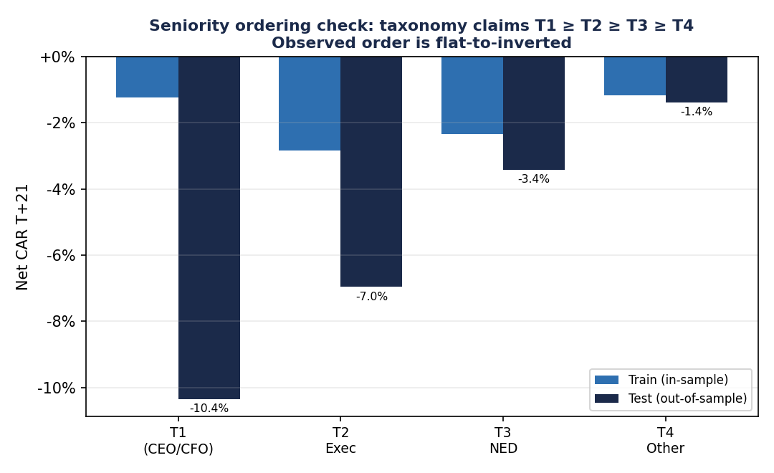
The taxonomy claims T1 ≥ T2 ≥ T3 ≥ T4. In the test half the order inverts; in the train half it is flat. T1/T2 are small-N.
Group (T+21 net) | Train | Test | N (test) | Claim
T1 (CEO/Founder + CFO) | −1.8% | −10.3% | 12 | highest
T2 (Exec) | −2.8% | −7.0% | 17 | 2nd
T3 (NED) | −2.3% | −3.4% | 85 | 3rd
T4 (Other) | −1.2% | −1.4% | 33 | lowest

Drift vs reversal — the underperformance compounds
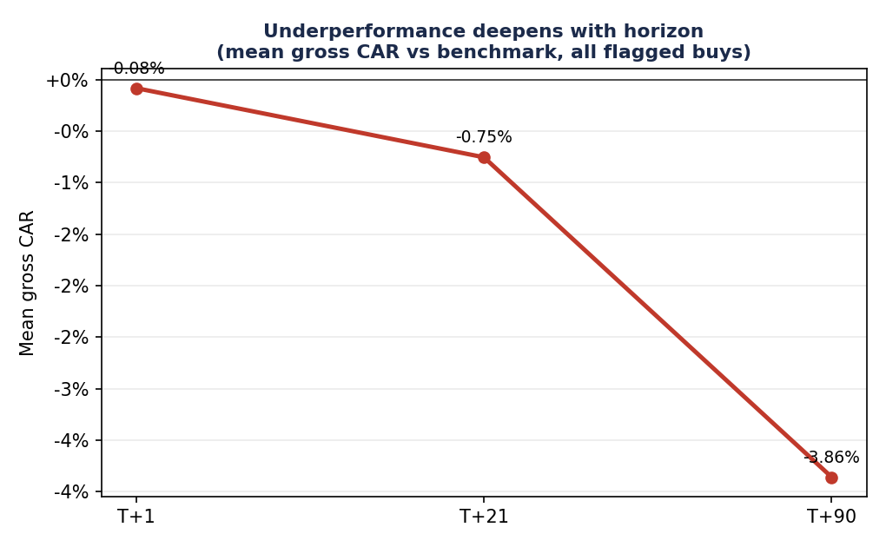
Mean gross CAR vs benchmark across horizons (all flagged buys). There is no announcement pop that fades — the relative loss simply grows with holding period.

Robustness
- Outlier dependence: baseline and the two large tiers (F1, S1) barely move when the single best trade is removed — the negative read is central, not tail-driven. The lone positive (T5) flips negative on top-removal, i.e. it is outlier-propped.
- Concentration: the 987 “events” are far from independent — PRU appears 70×, BATS 30×, RR 27×. Effective N is well below headline N, widening every confidence interval.
- Regime: CAR subtracts a sector benchmark, so a uniformly negative CAR is not “the market fell.” It holds across both train and test halves.
- Multiple comparisons: 26 looks. With a negative-to-flat field, nothing clears even an uncorrected bar, so the haircut is academic — but it would have killed T5 (N=19) regardless.

Verdict & recommendation
Verdict: NOISE / INSUFFICIENT-N across the board.
No live tier demonstrates out-of-sample edge over a generic flagged buy at T+21 or T+90. The seniority ordering is unsupported and directionally inverted. The baseline test-half edge is −1.85% ± ~1.3% (2 s.e.); the only sufficient-N tiers sit within or below that band. This is a clean negative result, not a marginal one.
- Keep the data pipeline; do not trust the tiers as alpha. Treat T1–T7, S1, T0 and F1 as descriptive labels, not validated edge, until the base-rate question is resolved.
- Do not re-tune thresholds yet — re-tuning a tier whose parent population is negative just fits the negative sample harder.
- Run the base-rate diagnostic before Brief-02 features: (a) is it a 2025-26 UK regime where insider-bought names lagged cap-weighted sector indices; (b) universe selection (corpus skews to a few mega-caps and Main-Market names); (c) residual entry-timing error. Loop in the Trader on (a)/(b) and the Data Integrity Auditor on (c).

Brief 02 — Where else might alpha live?
This is an ideation pass: transaction size, relative buy size, cluster breadth, price history, sector, and time of year. Per the overfitting mandate, every cut below is pre-registered with a direction, and — because the sample base rate is negative and concentrated — every positive-looking cut is treated as a hypothesis requiring pre-registered out-of-sample confirmation, never as “edge found.”
Honesty note on multiple comparisons
Nine hypothesis families with sub-buckets = 30+ cuts on ~987 events (effective N much lower given PRU/BATS/RR concentration). At that search width, one or two cuts will look “significant” by chance alone. Nothing in this section is a recommendation to build — it is a ranked list of what to pre-register and test out-of-sample next.

What each hypothesis showed (gross CAR T+21 unless noted)
Hypothesis | Direction? | Finding | Status
Transaction size (£) | predicted + | Inverted: bigger buys did WORSE (<£10k −0.4% → >£1m −4.0%; test half >£1m −13%). Robust across train+test. | Negative effect — robust
Relative buy size | predicted + | “Normal” (0.5–1.5× own median) least-bad (+0.4%); outsized worse. Max N=46. | Insufficient-N
Cluster breadth | predicted + | Mild: 4+ directors least-bad (−0.7%) vs 2 directors (−1.7%). Still all negative. | Weak, directional
Sector | none (mined) | Large dispersion: Materials +5.0% (hit 90%, N=20), Utilities/Financials +; Industrials −3.7%, Staples −1.3%. | Lead hypothesis*
Seasonality (month) | none | June +2.2%, August −4.2% — but each month appears ONCE in 11 months of data. | Untestable
Disclosure lag | predicted + | Fast (−1.1%) ≈ slow (−2.5%); slight worse-with-slower. Small N for slow. | Weak / null
Drift vs reversal | diagnostic | Loss deepens T+1 → T+21 → T+90. No fade-able pop. Argues against long holds. | Confirms Brief 01
AIM vs Main | none | Only 16 AIM events (flag under-populated). Cannot conclude. | Blocked (data)
Value % of mkt cap | predicted + | market_cap_gbp empty for all 763 tickers — cannot compute. | Blocked (data)
*Lead hypothesis = most interesting, but data-mined across sectors and single-window — the most likely to be overfit. Pre-register and confirm OOS before any belief.

Bigger buys did worse
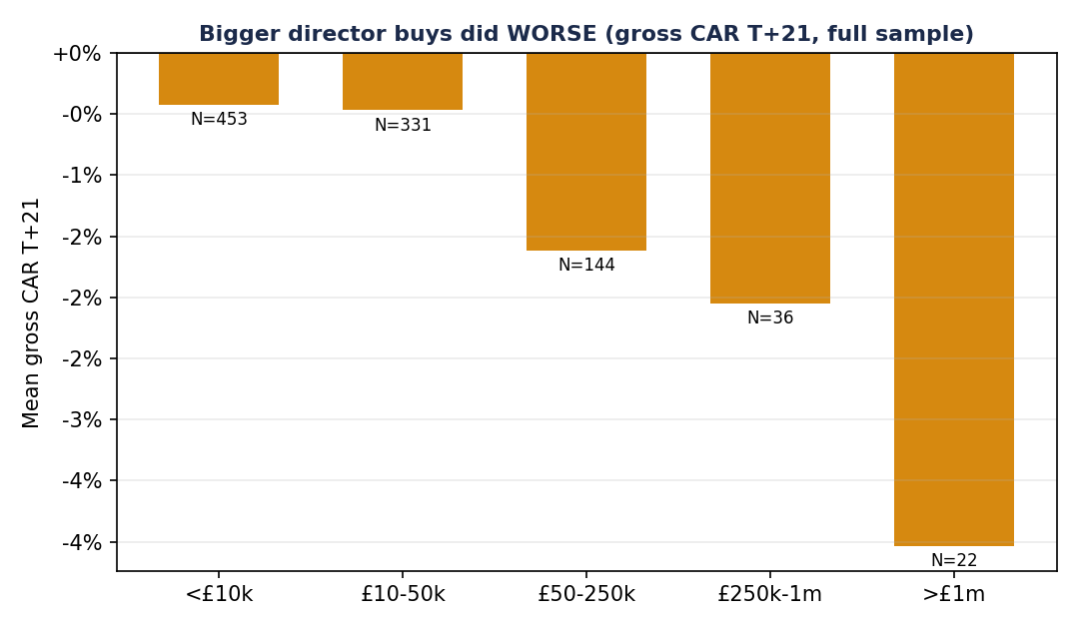
Counterintuitive but robust across both halves: larger director buys preceded larger relative losses. Likely large buys cluster in big-cap names that lagged, or are distressed-support buys — worth a conditioning study, but it is not a positive-alpha cut.

Sector dispersion — the one place to look next
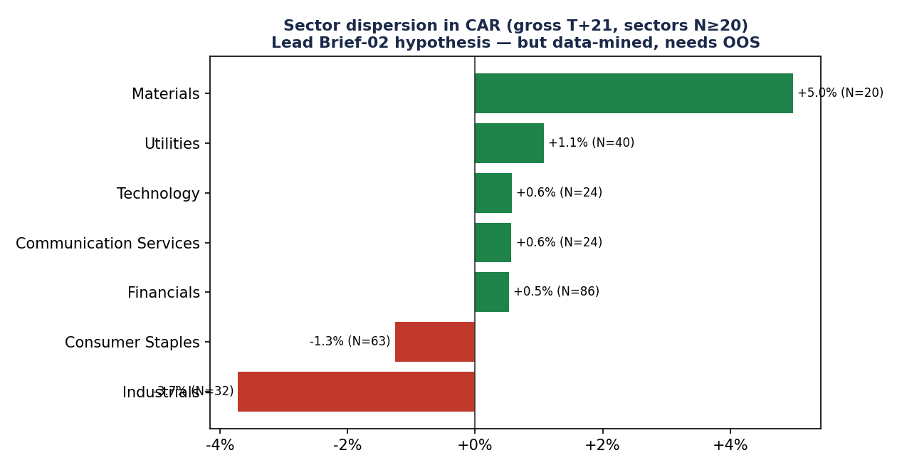
Director buys in Materials/Financials/Utilities beat their own sector index; Industrials/Staples lagged. Because CAR is benchmark-relative, this is stock-selection within sector, not sector beta — which is what makes it interesting. But N is small and the cut was mined across 7+ sectors.
If one Brief-02 idea is promoted to a pre-registered test, make it this
Hypothesis: director buys carry positive relative edge in some sectors (Materials, Financials, Utilities) and negative in others (Industrials, Consumer Staples). Test design: lock the sector grouping now, then evaluate strictly on firings after today's data cut-off; require the sign to persist and N≥30 per sector before any belief. Pair with the Brief-01 base-rate diagnostic — if the whole base is a regime artifact, the sector cut is too.

Ideas that are blocked on data (hand to Back-end / Data Integrity)
- Value as % of market cap — tickers_meta.market_cap_gbp is empty for all 763 tickers. This is arguably the single most promising un-tested feature (a £100k buy means more at a £20m firm than a £20bn one); it needs a market-cap backfill before it can be evaluated.
- AIM-status conditioning — is_aim is set for only 10 of 763 tickers; almost certainly under-populated, which also means the 0.5% stamp may be over-applied in the cost model.
- first_time_buy column — is 0 for all 4,684 transaction rows (dead column); the F1 signal must compute first-time status elsewhere. Anyone reading the column directly is misled.

Limitations of this pass (always present)
- T+90 is barely testable out-of-sample. Only 92 test-half events have matured to T+90; per-tier only F1/S1 approach N≥30. Re-run this brief in ~3 months when late-2025/early-2026 firings mature.
- Small, concentrated corpus. ~987 events, but PRU/BATS/RR dominate; effective independent N is much lower. Every confidence interval is wider than the row counts suggest.
- Baseline is the pooled-firings set, not literally “every BUY.” The prices table was FUSE-truncated this session, so I did not re-derive CARs for non-firing buys (would risk divergence from backtest.py). The chosen baseline is conservative; a true all-BUY baseline (built Windows-side) could shift the comparator slightly.
- Data-quality flags surfaced incidentally (hand to Data Integrity Auditor): dead first_time_buy column; is_aim set for only 10/763 tickers; market_cap_gbp empty for all tickers.
- Entry-timing caveat. MEMORY.md records an announced_at/MTM bug and parser issues partially fixed in this corpus. Raw returns look sane (median 0%, symmetric tails), so gross entry pricing is not obviously broken — but a residual timing error would bias CARs and cannot be fully excluded.
- Read-only, no writes. All queries ran against a /tmp copy of the DB; the CSV was read fresh (run bt_20260603T103447Z). No write-path scripts were executed.
Full machine-readable write-up: docs/research/quant-01-tier-separation_2026-06-03.md

