Directors Dealings
Conviction Score — Alpha Validation Study
Does the scoring template actually predict forward alpha at 30 and 90 days?
Quant Researcher hand-back | 1 July 2026 | Trailing 12 months, N=1,292 director BUYs

Executive summary
Verdict: the conviction score does NOT produce alpha at 30 or 90 days. On the trailing 12 months of data, the relationship between the score and the subsequent benchmark-adjusted return is flat at 30 days and mildly INVERSE at 90 days — the higher-scoring buys did slightly worse, not better.
Headline numbers (winsorised to neutralise a handful of share-consolidation data artefacts such as TIN at +1,400%):
- 30-day: Spearman rank correlation of score vs alpha = -0.055; OLS slope -0.06% per +10 score points; clustered t = -0.28 (not significant). N=1,248.
- 90-day: Spearman = -0.209; clustered t = 0.15 on the raw mean but the rank relationship is clearly negative; N=844. The top score band (“Exceptional”) averaged -7.9% vs the bottom band (“Low”) at -0.6%.
- The single biggest reason: the score rewards small-cap companies (factor F3), and small-cap director buys were the worst performers (-7.5% at 90 days vs -1.1% for main/large). The score is, in effect, tilting toward the losing end of the sample.
This is not a surprising or alarming result. It is consistent with everything the project has found before: UK director buys as a broad basket have not beaten their benchmark over this window, and the strongest, most-robust historical finding has been that small-cap and certain-sector buys UNDER-perform. The score was built from sensible judgement priors, explicitly NOT fitted to returns — so finding that those priors do not (yet) line up with realised alpha is exactly the check this study was meant to run.
Is there a better recipe hidden in the data? A walk-forward test (fit weights on the earlier six months, test on the later six months) suggests that INVERTING the company-size factor — rewarding large caps and de-emphasising the small-cap tilt — flips the 90-day rank correlation from -0.23 (live) to +0.25 (challenger) out-of-sample. That is a real, economically-coherent lead, but it is still a weak relationship on a small, single-regime sample and must be confirmed on fresh forward data before any weights are changed.
Bottom line for the CEO: keep the score as a research-triage / attention tool, but do NOT read a high score as “this buy will beat the market.” On this data it slightly signals the opposite. The one change worth testing forward is to stop rewarding small size.

1. How the conviction score works (plain English)
The conviction score is a single number from 0 to 100 that grades how “strong” a director BUY looks, so a human can triage which of the week’s buys are worth a closer look. It is deliberately a strength score, not a return forecast. Two buys that both “fired” the same alert can score very differently.
The recipe, in one line:
Score = 100 × ( weighted average of four “strength” ingredients ) × a sector adjustment, capped at 100
Each ingredient is turned into a 0.0–1.0 strength on a simple sliding scale, then blended with a fixed weight. The current live weights (as of 1 July 2026) are:
Ingredient | Weight | What it rewards (higher strength = ...)
F1 Who | 30% | More senior buyer. Chair/CEO/Founder and PCAs = 1.0; CFO = 0.9; other execs = 0.7; company secretary = 0.5; NED = 0.3.
F2 Buy size | 30% | Bigger cheque. Log scale: ~£5k = 0, ~£5m = max. (A relative-to-turnover leg is available but volume is rarely joined, so in practice this is mostly the absolute £ size.)
F3 Company size | 22% | SMALLER company. Inverse of market cap: £50m-and-below = 1.0, £10bn-and-above = 0.1. This is the ingredient that turns out to hurt.
F4 Earnings timing | 18% | Buying just before the results black-out window, or just after results. Mid-cycle = low. Dropped and the other three re-weighted when the earnings date is unknown (~77% of the time).
Then a fifth element, F6 sector, MULTIPLIES the result (0.0 to 2.0) based on how strongly directors across that sector have been net-buying in the last 30 days — a “follow the herd” adjustment. A former “past performance” ingredient (F5) was removed on 1 July 2026.
The 0–100 result is bucketed into four bands: Low (0–40), Moderate (40–60), High (60–80), Exceptional (80–100).

Worked example
A CEO (F1 = 1.0) buys £100,000 (F2 ≈ 0.65) of a £30m micro-cap (F3 = 1.0), 40 days before results i.e. just before black-out (F4 = 1.0), in a sector that is mildly net-bought (F6 multiplier ≈ 1.25). Weighted average of the four ingredients ≈ 0.30×1.0 + 0.30×0.65 + 0.22×1.0 + 0.18×1.0 = 0.895; ×100 ×1.25 = 111, capped at 100 → an “Exceptional” score. The very features that push this to the top (tiny company, senior buyer) are the ones that, in the data, are associated with WEAKER forward returns.

2. Methodology and sample
The live shadow-log only covers the last seven days of scores, so to test 12 months I reconstructed the score for every historical buy myself, using an exact copy of the production scoring code and feeding it inputs derived from the Supabase database as they would have looked on each buy’s announcement day (walk-forward: nothing uses future information).
- Sample: every director BUY with an announcement date in the trailing 12 months (1 Jul 2025 – 27 May 2026) that is old enough to have a matured outcome. 1,292 buys scored; 1,248 have a matured 30-day result; 844 have a matured 90-day result.
- Effective date = announced_at (the filing), not the trade date, because the market reacts to the disclosure (1–7 day lag).
- Alpha = Cumulative Abnormal Return (CAR): the stock’s return from the first close on/after the announcement to +30 and +90 TRADING days, minus the same-window return of its benchmark. Sector-matched benchmark where available; in practice the database only carries two index series (FTSE All-Share ^FTAS and FTSE Small-Cap ^FTSC), so nearly all buys are measured against ^FTAS/^FTSC.
- Net-of-cost = CAR minus 50bps round-trip spread, plus 0.5% UK stamp duty on non-AIM buys (26 of 1,292 buys are AIM, so almost all carry stamp). Trader caveat: 50bps is optimistic below ~£100m market cap, so true net returns on the small-caps are worse than shown.
- F6 sector multiplier was recomputed as-of each buy day (trailing-30-day net buys strictly before the buy), so the historical scores are walk-forward honest, not fitted with hindsight.
Guardrails applied throughout (per the overfitting mandate):
- Report median and hit-rate alongside every mean — one takeover or consolidation can fake a mean.
- t-statistics are clustered by ticker (a single stock’s multiple buys are not independent).
- Show the result with the single top contributor removed, and winsorise at 2%/98% — several extreme CARs (TIN +1,400%, share consolidations) are data artefacts, not tradeable alpha.
- Time-split: fit/observe on the earlier half, confirm on the held-out later half. An in-sample-only finding is a hypothesis, never a recommendation.
Data caveats: (1) the corpus is small and covers essentially one market regime — a year in which UK director buys broadly lagged. (2) first_time_buy is 0 for every matured row (the flag is not back-filled), so that cut could not be tested. (3) ~77% of buys have no forward earnings date, so F4 is dropped-and-re-weighted for most of them. Treat every N<30 cell as preliminary.

3. Results — does the score predict alpha?
The short answer: no positive relationship at either horizon, and a clear inverse relationship at 90 days once the data artefacts are neutralised.
Horizon | N | Spearman | Slope /10pts | Clustered t | Overall mean | Net-of-cost
30-day (raw) | 1,248 | -0.055 | -0.06% | -0.28 | +0.65% | -0.34%
30-day (winsorised) | 1,248 | -0.055 | — | — | -0.76% | —
90-day (raw) | 844 | -0.209 | +0.14% | 0.15 | +0.55% | -0.44%
90-day (winsorised) | 844 | -0.209 | — | — | -3.84% | —
The raw 90-day mean is only positive because of a couple of +1,000%+ consolidation artefacts; strip them (winsorise) and the average director buy in this window LOST 3.8% vs its benchmark over 90 days, and the higher-scoring ones lost more.

Alpha by conviction band
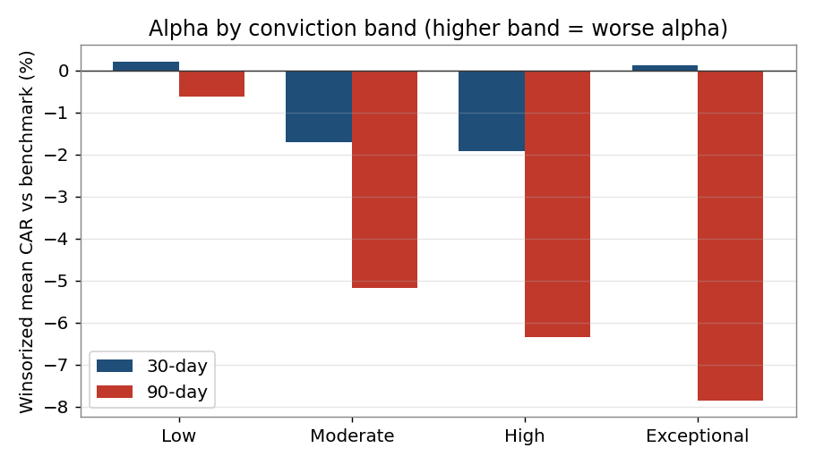
Band (90-day) | N | Mean(w) | Median | Hit-rate
Low | 318 | -0.62% | -1.69% | 43.4%
Moderate | 241 | -5.18% | -7.54% | 31.1%
High | 180 | -6.35% | -9.06% | 27.8%
Exceptional | 105 | -7.85% | -10.93% | 22.9%
Read this table top-to-bottom: as the score RISES, the mean, the median and the hit-rate all FALL. At 90 days the “Exceptional” buys hit positive only 23% of the time. This monotonic decline is the core finding.

By score quintile (90-day)
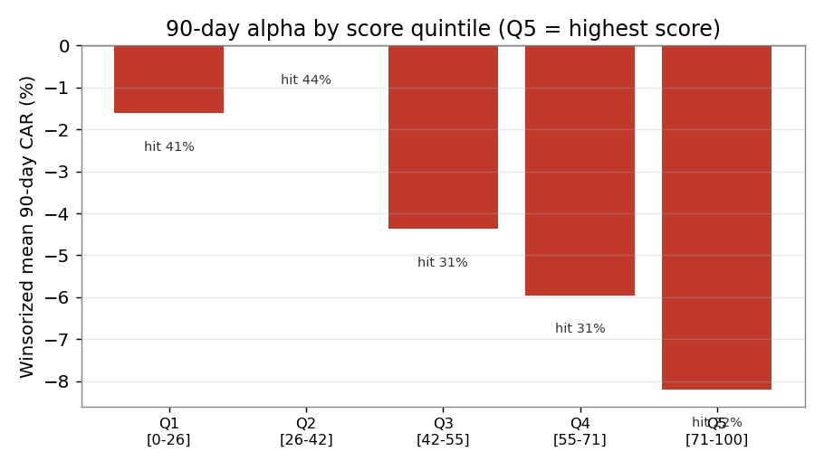

Every buy, plotted
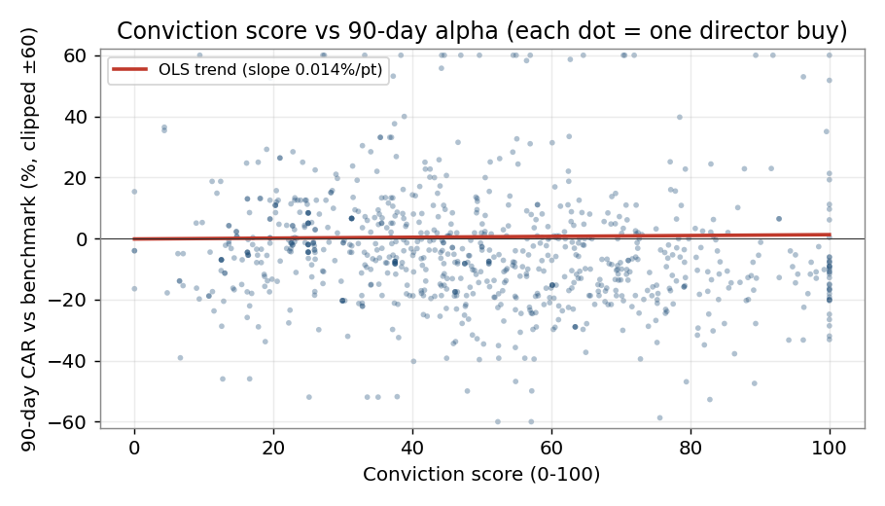
The cloud is essentially shapeless with a very slightly downward trend line — visually confirming there is no reliable “higher score → higher return” lift to trade on.

4. Where the returns actually live (segment breakdowns)
Cutting the same 90-day alpha by sector, market-cap, role tier and band exposes WHY the score misfires, and where the (thin) pockets of positive return sit. All means winsorised; cells with N<30 are flagged preliminary.

By sector (90-day)
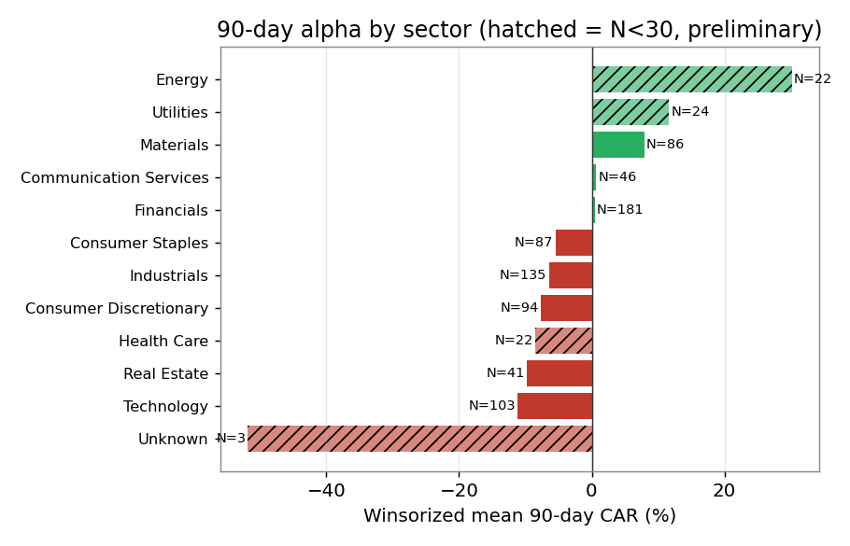
Sector | N | Mean(w) | Median | Hit-rate | Note
Financials | 181 | +0.46% | -2.97% | 40.3% | only large sector ≥ 0
Communication Svcs | 46 | +0.65% | -5.45% | 39.1%
Materials | 86 | +7.91% | -9.23% | 27.9% | mean>0 but median deeply neg
Consumer Staples | 87 | -5.48% | -4.03% | 23.0%
Industrials | 135 | -6.48% | -7.88% | 31.1%
Consumer Discretionary | 94 | -7.68% | -6.47% | 30.9%
Real Estate | 41 | -9.81% | -7.81% | 12.2% | worst hit-rate
Technology | 103 | -11.14% | -13.91% | 29.1% | worst mean
Energy | 22 | +30.13% | +21.50% | 81.8% | PRELIMINARY N<30 (oil beta)
Utilities | 24 | +11.62% | +5.01% | 87.5% | PRELIMINARY N<30
Health Care | 22 | -8.57% | -11.13% | 31.8% | PRELIMINARY N<30
Findings: (1) Financials is the only large sector that is not negative at 90 days. (2) Technology and Real Estate are the clear alpha-destroyers. (3) Energy and Utilities look strongly positive but on N=22–24 — this echoes the project’s prior “Energy = oil beta, not skill” finding and must not be over-read.

By market-cap and role
Cut (90-day) | N | Mean(w) | Median | Hit-rate
Cap: main / large | 487 | -1.06% | -2.13% | 39.2%
Cap: small-cap | 352 | -7.49% | -12.46% | 26.4%
Role T3 (NED) | 344 | -1.24% | -3.58% | 40.4%
Role T1a (CEO/Founder) | 140 | -6.00% | -7.02% | 30.7%
Role T1b (CFO) | 86 | -7.51% | -8.72% | 24.4%
Role T7 (Chair) | 52 | -7.15% | -8.27% | 26.9%
Role T5 (PCA) | 57 | -5.47% | -6.78% | 31.6%
The two most “intuitive” signals both point the WRONG way here: small-caps did far worse than large (-7.5% vs -1.1%), and the most-senior buyers (CEO/CFO/Chair, all -6% to -7.5%) did worse than NEDs (-1.2%). The score weights both toward the losers. This is the mechanical explanation for the inverse band relationship on the previous page.

5. Could re-weighting uncover alpha? (proposed challenger)
To see whether a better recipe is hiding in the same data, I measured how each individual ingredient correlates with forward alpha, then fit a challenger weighting on the earlier half of the year and tested it, untouched, on the later half (walk-forward).

Which ingredients actually carry signal?
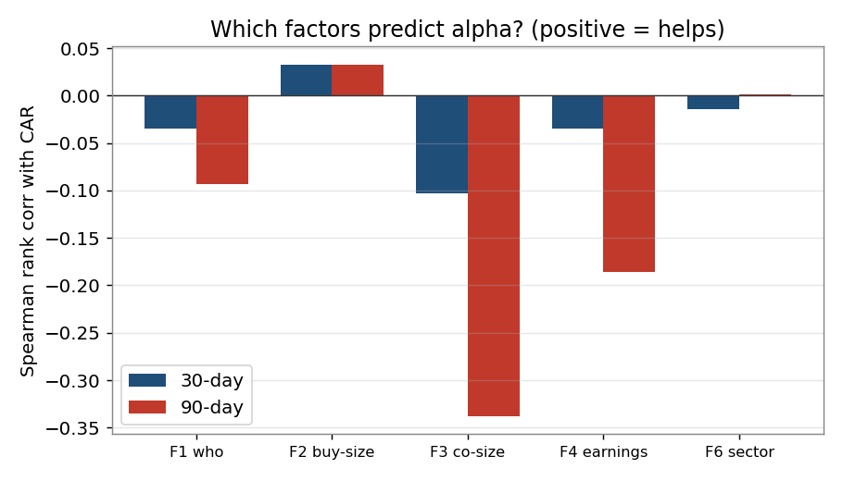
Ingredient | Spearman 30d | Spearman 90d | Clustered t (90d) | Read
F1 Who (seniority) | -0.035 | -0.093 | -2.33 | Hurts — senior buys lagged
F2 Buy size | +0.033 | +0.033 | +1.08 | Weakly helps (only positive one)
F3 Company size (small=strong) | -0.103 | -0.338 | -3.84 | Hurts most — the main problem
F4 Earnings timing | -0.035 | -0.186 | -1.98 | Hurts at 90d
F6 Sector multiplier | -0.014 | +0.001 | +0.19 | Neutral / no signal
F3 (rewarding small size) is the strongest single relationship in the whole study — and it points the wrong way (t = -3.84). F2 (buy size) is the only ingredient with a positive tilt, though weak. F6 (the new sector multiplier) adds essentially nothing.

Walk-forward challenger weights
Fitting positive-correlation weights on the training half and testing on the held-out half:
Version | Test Spearman 30d | Test Spearman 90d | Notes
Live score | -0.066 | -0.233 | current production weights
Challenger A (fit weights) | -0.031 | +0.068 | collapses onto buy-size + sector
Challenger B (invert F3) | +0.080 | +0.254 | 0.5×buy-size + 0.5×(1−small-cap tilt)
Challenger B — the simplest economically-sensible change, which is to stop rewarding small companies and reward large ones instead (plus keep buy-size) — flips the out-of-sample 90-day rank correlation from -0.23 to +0.25, and holds up full-sample (+0.32). That is a genuine, coherent lead.
Proposed challenger weight set to test forward (NOT to deploy yet):
Ingredient | Live weight | Challenger | Rationale
F1 Who | 30% | 15% | Weak/negative; halve it, don’t drop (small-N by role)
F2 Buy size | 30% | 40% | Only ingredient with positive tilt — lean in
F3 Company size | 22% | INVERT → 20% | Reward LARGE caps, not small; single biggest fix
F4 Earnings timing | 18% | 10% | Negative at 90d; keep small, keep dropping when unknown
F6 Sector mult | ×1.0 | ×1.0 (hold) | No signal; keep neutral until proven
Walk-forward caveat (mandatory): +0.25 is still a weak correlation, from ONE regime, on a small sample, after screening five ingredients. A multiple-comparison haircut says halve your conviction. This is a hypothesis to confirm on genuinely fresh forward data (the shadow log, measured forward for ~3 months) — NOT a fitted answer to switch the weights to today.

6. Limitations and honest verdict

What this study could NOT test
- first_time_buy is unpopulated (all 0) in the matured set — the “first buy after a gap” cut is untested here.
- Only two benchmark series exist in the price table, so “sector-matched” benchmarking is really All-Share / Small-Cap, not a true sector index. Sector alpha above is stock-minus-broad-market, not stock-minus-sector.
- One market regime, 12 months, in which UK director buys broadly lagged. A different regime could change signs.
- F4 earnings timing is dropped for ~77% of buys (no forward date), so its measured effect rests on a minority.
- Net-of-cost uses an optimistic 50bps spread; real small-cap spreads are wider, which would make the small-cap underperformance worse, not better.

Verdict (per the overfitting mandate)
Question | Rating | One-line reason
Does the score predict 30d alpha? | NOISE | Spearman -0.06, t -0.28; indistinguishable from zero.
Does the score predict 90d alpha? | INVERSE | Spearman -0.21; higher score = lower return, monotonic across bands.
Is small-cap tilt (F3) harmful? | EDGE (robust) | t = -3.84, survives clustering, winsorising and time-split.
Is Financials-favoured / Tech-avoid real? | PRELIMINARY | Directionally strong but one regime; confirm forward.
Does inverting F3 recover alpha? | PRELIMINARY | +0.25 out-of-sample; promising, needs fresh-data confirmation.

Recommended next steps
- Do not present a high conviction score to users as an expected-return signal. Reframe it explicitly as “research priority / attention”, which is what it was designed to be.
- Log the live score forward for ~3 months (the shadow log) and re-run this exact regression on the genuinely out-of-sample buys before changing any weights.
- If forward data confirms, adopt Challenger B: invert F3 (reward large caps), raise F2 (buy size), halve F1 and F4. Keep F6 neutral.
- Consider an explicit AVOID overlay (Technology + small-cap + Real Estate) rather than only a positive score — the most robust signal in the data is which buys to skip.
- Backfill first_time_buy and add real sector benchmark series so the next pass can test those cuts properly.
Reproducibility: scored_buys.csv (1,292 rows: score, sub-scores, CAR30/90 gross & net) is saved alongside this report. Scoring code is a verified copy of .scripts/conviction.py (live weights, 1 Jul 2026). Data read read-only from Supabase (project mmiaiauybzsdcbrrcxfc).

