LMRFC parameter extraction and map display files and processing

* Params_final_calb: This folder contains the .csv files created by the python extraction script (*extract_hydro_params_LMRFC_calb.py*) containing all of the parameter values for the calibration basins.
* Params_sa: This folder contains the .csv files created by the python extraction script (*extract_hydro_params_LMRFC_sa.py*) containing all of the parameter values for the LMRFC basins in the original SA CHPS configuration.
* shapefiles: Contains three shapefiles used in the ArcMap (map_display.mxd) project to generate regional parameter maps.
  + blank_basins: original basins shapefile from maplayerfiles in CHPS config (no parameter values in table)
  + param_basins: this shapefile is the original basins .shp file with the joined .xlsx SAC-SMA parameter table.
  + s_01ap14.shp: state boundary .shp file for map display
* CHPS_param_map_config: This folder contains the updated CHPS configuration .xml files to display the SAC-SMA parameter maps in the map and spatial display (layers).
* *extract_hydro_params_LMRFC_calb.py:* This python script extracts SAC-SMA/UNITHG/LAG-K parameters values from the CHPS calibration output (exported .xml mods) and creates .csv files with all parameters. NOTE: this script differs from the extract_hydro_params_LMRFC_sa.py by using the output UH and SACSMA calibration mods in the CHPS SA calibration version which has a slightly different format than the original SA .xml moduleparfiles. Important: the user must edit the code “user input section” to specify the location of the input and output locations. Example:

#-----------------------------------------------------------------------------

########################## START USER INPUT SECTION ##########################

RFC = 'LMRFC'

param_source = 'final_calb' # choices: 'final_calb'

uh_plots = 'off' # choices: 'on' or 'off' to create a .png figure for each basin

# input directory: enter location of ModuleParFiles directory below ->

folderPath = 'P:\\NWS\\Calibration_NWS\\LMRFC\\Working Calib Files'

#output directory: enter ouput directory for .csv files below ->

csv_file_out = 'P:\\NWS\\Reports\\LMRFC\\LMRFC_deliverables\\SAC_param_maps' + '\\Params_' +param_source

########################## END USER INPUT SECTION ############################

#-----------------------------------------------------------------------------

* *extract_hydro_params_LMRFC_sa.py:* This python script extracts SAC-SMA/UNITHG/LAG-K parameters values from the CHPS configuration .xml files located in the Config->ModuleParFiles directory and ouputs a .csv file with all parameters. NOTE: this script only works with the original CHPS stand alone moduleparfile .xml files... not the CHPS calibration parameter mods. Important: the user must edit the code “user input section” to specify the directory location of the input and output locations. See example above.
* LMRFC_SACSMA_Params_updated.xlsx: This spreadsheet contains the original stand alone SAC-SMA parameter values for each basin with the new calibrated basin values (replaced the old parameter values). This spreadsheet is joined with the blank basins shapefile to create the final parameter map figures
* map_display.mxd: This ArcMap project contains the template used to create regional parameter maps for the LMRFC. Note that the user must manually change the display symbology to the desired parameter to view each SAC-SMA parameter.

Creating the LMRFC Regional Parameter Maps

1. Run the extract_hydro_params_LMRFC_sa.py and the extract_hydro_params_LMRFC_calb.py (if there are new calibration mods).
2. In the newly created output LMRFC_SACSMA_Params_xxxxxxx.csv files, create a new column to the right of the “BASIN” column. Name the new column “NAME” and enter the formula =LEFT(A2,5) in the next cell. This creates a column with the 5-character basin name that will be used in the subsequent join.

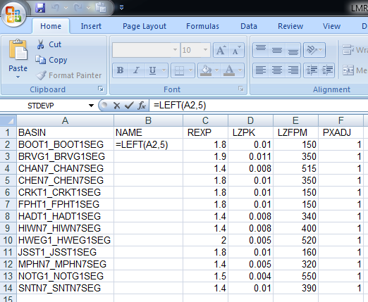

1. Change the cell types of the all the columns containing numbers (e.g. REXP, LZPK, LZFPM, PXADJ …) from the original “General” to “Number” format and save the file as an excel spreadsheets (.xlsx).
2. If you are using new parameter mods you will need to copy the original SA parameters from the LMRFC_SACSMA_Params_sa.xlsx and paste the data under the new basin parameter values in the LMRFC_SACSMA_Params_final_calb.xlsx. Use the “Remove Duplicates” tool under the Data tab to remove the old basin parameter rows (new data should remain at the top). Save the new excel spreadsheet.
3. Open ArcMap and load the blank basins (lmrfc_map_basins.shp) shapefile. Under the lmrfc_map_basins.shp properties click on the join tab and add the join to the spreadsheet created in the last step using the NAME field:

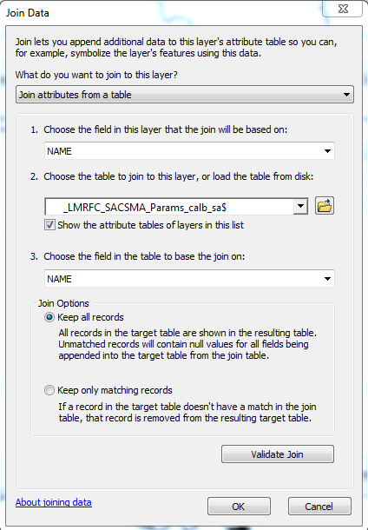

1. Validate the join and click OK
2. Check the Attribute Table for a valid join and check for any “<null>” or missing data.
3. To make the shapefile join permanent for future use, right click on the layer and under Data -> Export Data you can export a new shapefile with the joined table.
4. Use the layer properties tabs “Symbology” and “Labels” to change which parameter is displayed and the color schemes and label properties.
5. The new shapefile can be added to the Config->MapLayerFiles directory to view the parameter map in CHPS. The SystemConfigFiles->Explorer.xml and DisplayConfigFiles->SpatialDisplay.xml files control the parameter map display in CHPS.

Example Figure from the map_display.mxd

