Im2 dataset

Queryimage rose

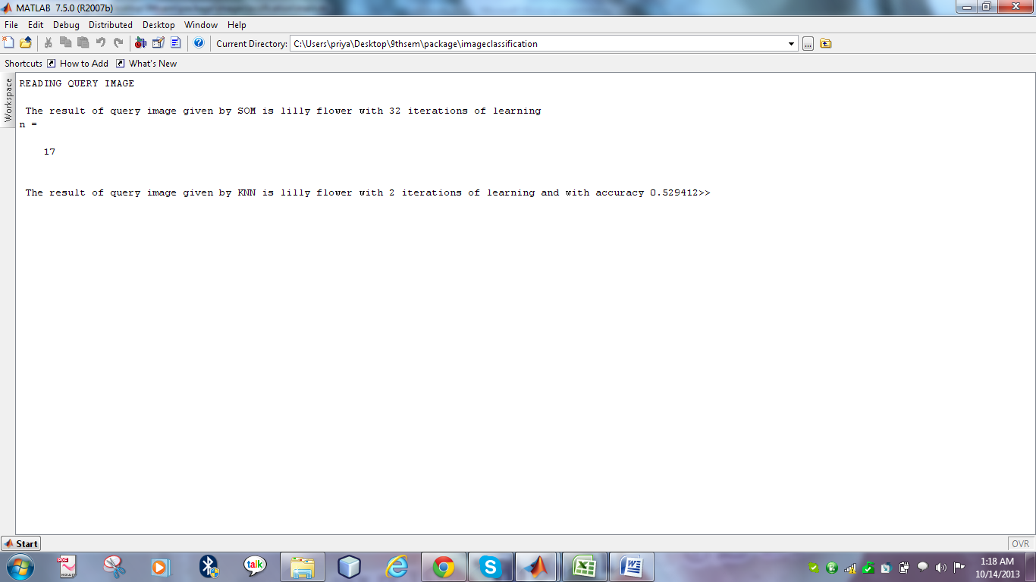Im2 lilly

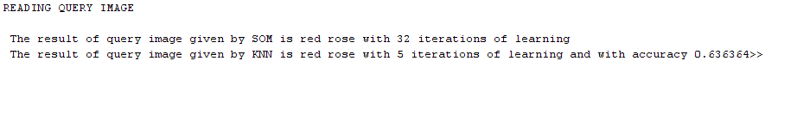Database rose

Dblilly

