E-R Diagram mapping practice

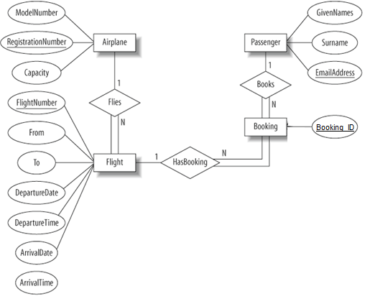

# Task 1

Step1:

Airplane(RegisterationNumber, Capacity, ModelNumber)

Flight(FlightNumber, From, To, DepatureDate, DepartureTime, ArrivalDate, ArrivalTime)

Booking(Booking_ID)

Passenger(EmailAddress, Surname, GivenNames)

Step2: 해당 없음

Step3: 해당 없음

Step4:

Flight(FlightNumber, From, To, DepatureDate, DepartureTime, ArrivalDate, ArrivalTime, FlightRegistrationNumber)

Booking(Booking_ID, Booking_FlightNumber, Booking_EmailAddress)

Step5: 해당 없음

Step6: 해당 없음.

Step7: 해당 없음.

최종:

Airplane(RegisterationNumber, Capacity, ModelNumber)

Flight(FlightNumber, From, To, DepatureDate, DepartureTime, ArrivalDate, ArrivalTime, FlightRegistrationNumber)

Booking(Booking_ID, Booking_FlightNumber, Booking_EmailAddress)

Passenger(EmailAddress, Surname, GivenNames)

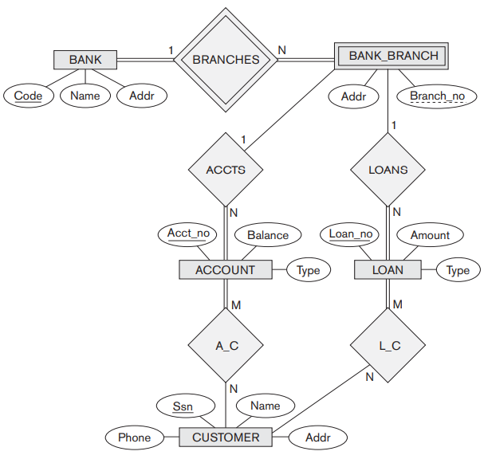

# Task 2

Step1:

BANK(Code, Name, Addr)

BANK_BRANCH(Branch_no, Addr)

ACCOUNT(Acct_no, Balance, Type)

LOAN(Loan_no, Amount, Type)

CUSTOMER(Ssn, Name, Phone, Addr)

Step2:

BANK_BRANCH(Acct_no, Loan_no, Branch_no, Addr)

Step3: 해당 없음

Step4:

BANK_BRANCH(Acct_no, Loan_no, Branch_no, Addr, Bank_Code)

ACCOUNT(Acct_no, Balance, Type, Account_Branch_no)

LOAN(Loan_no, Amount, Type, Loan_Branch_no)

Step5:

A_C(Acct_no, Ssn)

L_C(Loan_no, Ssn)

Step6: 해당 없음

Step7: 해당 없음

최종:

Bank(Code, Name, Addr)

Bank_Branch(Acct_no, Loan_no, Branch_no, Addr, Bank_Code)

Account(Acct_no, Balance, Type, Account_Branch_no)

Loan(Loan_no, Amount, Type, Loan_Branch_no)

Customer(Ssn, Name, Phone, Addr)

A_C(Acct_no, Ssn)

L_C(Loan_no, Ssn)

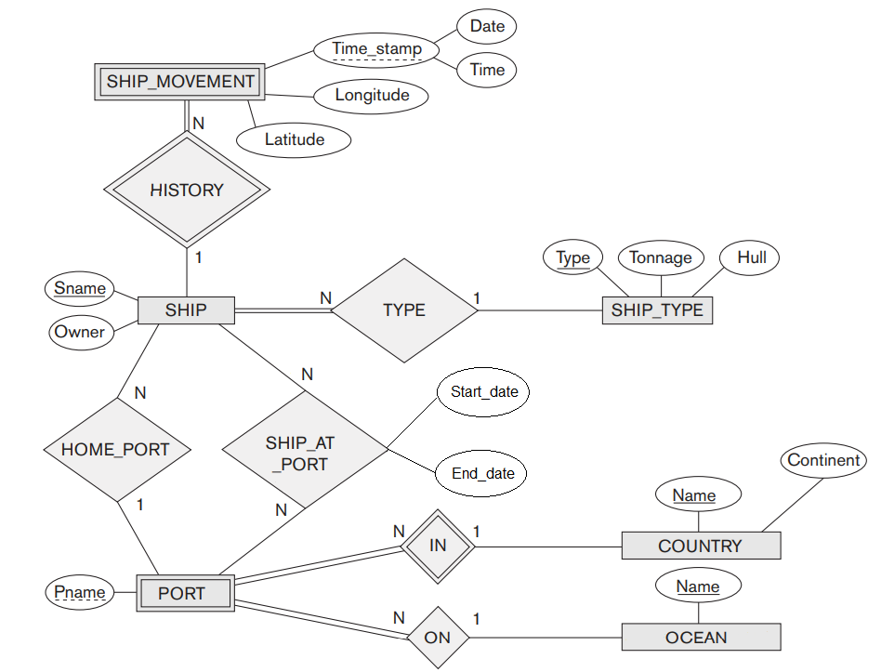

# Task 3

Step1:

SHIP_MOVEMENT(Date, Time, Longitude, Latitude)

SHIP(Sname, Owner)

PORT(Pname)

SHIP_TYPE(Type, Tonnage, Hull)

COUNTRY(Name, Continent)

OCEAN(Name)

Step2:

SHIP_MOVEMENT(Sname, Date, Time, Longitude, Latitude)

PORT(Sname, COUNTRYName, OCEANName, Pname)

Step3: 해당 없음

Step4:

SHIP_MOVEMENT(Sname, Date, Time, Longitude, Latitude, SHIP_Sname)

SHIP(Sname, Owner, SHIP_Pname, SHIP_TYPE_Type)

PORT(Sname, COUNTRYName, OCEANName, Pname, COUNTRY_Name, OCEAN_Name)

Step5:

SHIP_AT_PORT(Sname, Pname, COUNTRYName, OCEANName, Start_date, End_date)

Step6: 해당 없음

Step7: 해당 없음

최종:

SHIP_MOVEMENT(Sname, Date, Time, Longitude, Latitude, SHIP_Sname)

SHIP(Sname, Owner, SHIP_Pname, SHIP_TYPE_Type)

PORT(Sname, COUNTRYName, OCEANName, Pname, COUNTRY_Name, OCEAN_Name)

SHIP_TYPE(Type, Tonnage, Hull)

COUNTRY(Name, Continent)

OCEAN(Name)

SHIP_AT_PORT(Sname, Pname, COUNTRYName, OCEANName, Start_date, End_date)