§

JPC makes every effort to ensure the accuracy of all the information (the “Content”) contained in the publications on our platform. However, JPC make no representations or warranties whatsoever as to the accuracy, completeness, or suitability for any purpose of the Content. Any opinions and views expressed in this publication are the opinions and views of the authors, and are not the views of or endorsed by JPC. The accuracy of the Content should not be relied upon and should be independently verified with primary sources of information. JPC shall not be liable for any losses, actions, claims, proceedings, demands, costs, expenses, damages, and other liabilities whatsoever or howsoever caused arising directly or indirectly in connection with, in relation to or arising out of the use of the Content.

This article may be used for research, teaching, and private study purposes. Any substantial or systematic reproduction, redistribution, reselling, loan, sub- licensing, systematic supply, or distribution in any form to anyone is expressly forbidden. Terms & Conditions of access and use can be found at: http://promotionalcommunications.org/index.php/pc/about/submissions

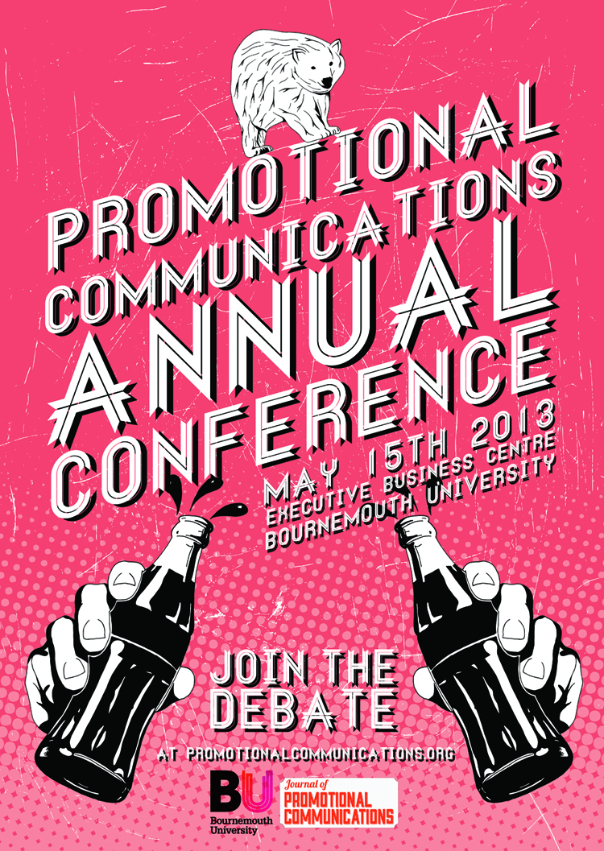

PLEASE SCROLL DOWN FOR ARTICLE

To cite this article: MacRury, I. 2017. Branded Content: Rupture, rapture and reflections. *Journal of Promotional Communications*, 5 (3), 248 – 259.

This article was downloaded by:

On:

Publisher:

Address:

**Journal of Promotional Communications**

Publication details, including instructions for authors and subscription information: [http://promotionalcommunications.org/ind ex.php/pc/index](http://promotionalcommunications.org/ind%20ex.php/pc/index)

**Branded content: rupture, rapture and reflections**

Author name: Iain MacRury

**Iain MacRury[1]**

Branded Content: Rupture, rapture and reflections[2]

To cite this article: MacRury, I. 2017. Branded Content: Rupture, rapture and reflections. *Journal of Promotional Communications*, 5 (3), 248 – 259.

Introduction

This is primarily a discussion about change, a topic relevant to many industries and, particularly, to students as they prepare for exciting but potentially uncertain futures[3]. It is an occasion to think about the implications and emergence of some new promotional idioms such as branded content, sub genres such as ‘native advertising’, and to consider some new generation, high profile, promotional media forms, notably vlogging.

New formats are a function of industrial, institutional and technological change. These pose particular challenges for the generation of students graduating into an industry and professions in a period of some flux, and where industries such as PR or Advertising are often characterized as dying or being re-born (Alonso 2017, Himpe 2006; MacRury 2018a & 2018b).

This has a social context too. Increasingly individuated and networked, mobile, multi-screening, disillusioned and unsure in themselves, consumers generate big data sets and larger uncertainties. Volatility also reflects wider social changes in communication and psychosocial life. Many of us grapple with new ways of being together meaningfully in the face of abundant, instantaneous and global communicative opportunities and were institutional and communicative forms shift under our feet and before our eyes.

Liminal Moments

A useful term in thinking about institutional and social change is ‘liminality’, which refers to states of uncertainty and transition in identities and cultural relationships. In this context, Victor Turner’s conceptions of liminal periods; threshold moments and their attendant social meanings are enlightening. Here is part of Turner’s (1969/2011) evocative account of liminality:

Liminal entities are neither here nor there; they are betwixt and between the positions assigned and arrayed by law, custom, convention, and ceremonial. As such; their ambiguous and indeterminate attributes are expressed by a rich variety of symbols in the many societies that ritualize social and cultural transitions. Thus, liminality is frequently likened to death, to being in the womb, to invisibility, to darkness, to bisexuality, to the wilderness, and to an eclipse of the sun or moon (Turner 2011: 95)

The idea of the liminal here underpins a characterization of a narrative where industries such as advertising (imagined here as social institutions) cultivate and confront liminality. They focus on *rupture* with the past, then become entranced or confused in the *rapture* of new possibilities, or, and at the same time, become anxious with the loss of established ways of doing things. Finally, some degree of *reflection* tempers, contains and processes both fear and over exuberance about ‘the new,’ or ‘the next big thing’. Reflection must also deal with anxiety about what has been lost or damaged in renewal.

I want to dub this as a *3Rs narrative*, “rupture, rapture and reflection,’ and to think of these as the 3Rs of living with change.[4] New ‘characters’, values and new ‘genres’ emerge in such processes. Here we will focus on branded content (a strange new hybrid genre), and think, of vloggers (new ‘characters on the scene’) as amongst the many new marketing personae whose place in the promotional communicative world need to be thought about – and re-valued, reflected upon.

Disruption and reformation are characteristic dynamics in the narratives of many contemporary institutions, advertising and marketing agencies included. Creative and cultural industries are self-consciously sites of innovation and change and especially susceptible to new trends such as ‘branded content.’ The many and various enterprises, and the people working within them, whose tasks are to do with image, sound, voice, knowledge and ideas, and so, too, with the affective life connected with their circulation, all now confront and contribute in a new and notable period of flux.

Rupture: contents and discontents

The Internet revolution has paved the way for a new style of journalism which A renewed and emphatic focus on content stands amongst the many movements disturbing the working patterns, identities, and practices of the promotional industries and brand communications; especially PR, Advertising and Marketing more broadly, ‘Content is King!’ declared Bill Gates in 1996, and so it goes on (Jefferson 2017; Olenski 2017).

But what is content? This is a challenging question. The new habit of tagging miscellaneous creatives with the term ‘content creator’ hints at a partial answer in a larger enquiry. “Content creator” suggests, as a role title, the further dissolution of professional and craft boundaries, distinctions that used to help define content in terms of specifying formats and relationships (Sennett 2009). Comedian Stewart Lee is scathing of the idea of brands as cultural communicators. But his use of the term “Content Provider” in his recent tour’s headline (Lee 2016) foregrounds a relevant feeling in this unlikely context, i.e. it registers the loss of more dignified and dignifying professional epithets for those who create and share ideas. In any field of practice – he was a comedian, he does thoughtful journalism, but now he is a *content provider*.

Communications activities in creative industries might typically be described in terms of the *forms*, and the processes of formation, that shape the work at hand; advertising copywriting, artistic direction, journalism, comedy, miscellaneous writing genres and so on: or by the channels, institutions, and media that formerly informed content, and contained it, gave it a location and a name; TV, newspapers, magazines, radio.

Form, seems now to recede a little, flattened. This flattening is in favor of *content*, a dispersible mass of digital ‘stuff’ primarily now mainly distinguishable and valued by virtues of search- and share-ability at the user-consumer end. Content and form maintain vestigial links in practice, in reception and enunciation. But digitization has shifted the terms. Now is a moment of a new liquidity in content (see Bauman 2008) and disequilibrium in the roles and relations of cultural creativity.

Rupture: Changing and Challenging Assumptions

Promotional industries are struggling to adapt in this context. Radical reallocations in marketing budgets (MacRury 2018a), from traditional to online media are disruptive and destructive of old forms. New priorities destabilize media publishers, agencies, and advertisers alike. Consumers, as ever, see a meld of new and old formats. As an object of research, these consumers, millennials, silver surfers, shoppers and clickers, remain elusive, recalcitrant enigmas, half-understood – just content consumers.

Communications now move with greater agility across the multiple (and rapidly multiplying) communicative platforms characteristic of the digital era. Rigid forms seem to constrain content (e.g. old posters and print ads) and so diminish the fluency with which ‘the message’ or big idea (Hegarty 2011) can move in and in between digital spaces; from PC to mobile screen, from social media to television, indoor, outdoor, from live event to virtual reality.

This prompts notable ruptures with past thinking and past practices. Standing aims and principles inform organizations and minds – persuasion and influence are persistent ambitions. Similarly, craft skills and values still inform reformatted practices. Nevertheless, the older *forms* of promotion are in recession and the flow of content is on the rise.

In the promotional industries, this is very evident. Marketing ‘buzz’ is both bite sized and byte-sized. Copywriters are now digital story tellers. Media planning extends into ‘curating’ across platforms. Digital creativity shifts into the realm of the algorithm and the chat-bot; marketing intelligence confronts artificial intelligences as processual shifts begin to marginalize some human components in the marketing task. Yet the counterpoint to digital reprocessing of ad communication and planning systems is a continuing pursuit of empathic ‘touchpoints’. Real voices, faces, people, insights and places. “Meaning” as such. These are some of the paradoxes to explore in thinking about branded content and vlogging.

Rapture 1: Branded Content: continuity and change

So, in the past decade, industry commentators have become heavily preoccupied with terms such as “branded content”, “content marketing” and “content creation”. Traditional genres and formats such as the 30-second TV commercial or the glossy double page display advertisement, familiar from ‘legacy’ media, have become decentered within the cosmology of the promotional communicator. Still heavily present – they nevertheless seem of the past. What does this mean for students entering the promotional industries? One part of the challenge is to think content and not form.

The term ‘branded content’ has crept into both general and professional marketing idioms. The idea captures a set of marcoms practices that are far from new, including certain kinds of sponsorship, advertorials, and event-led advertising. IMC (Integrated Marketing Communication) is a forerunner and frame for developments around branded content.

Core to the conception of branded content is that a brand communication is integrated within the flow of cultural communications; news, entertainment or information. Notably, branded content becomes, to some extent, *continuous within* and not *supplementary to* the main message. The brand shadows the message; or even constitutes it. The brand does not so much interrupt but instead imbricates whatever is going on; story, event, exposition, thought; here, there, onscreen or over the page.

*The Guinness Book of Records* is a popular and long-standing example, and soap operas, as we knowingly remind each other, gained their name from the close association between early TV productions and detergent manufacturers. Arguably, even, BBC Radio 4’s *The Archers*, in its public informational modes, is a forerunner of some forms of branded content, as it was initially produced in collaboration with the Ministry of Agriculture, Fisheries and Food and conveyed institutional ‘messaging’ on behalf of that ministry in an enticing format. But that was in the days before government messaging was *branded*.

In its contemporary forms branded content is a consideration, especially, in relation to new *commercial intentions* and relationships and on account of presence and intensity. This is the case even while brand communications are now associated with formally public as well as private communications interests. Advice on financial management may appear in the news. It is quietly authored by Barclays bank. A keep fit think piece may be sponsored by a new piece of fitness tech. An essay on women’s prisons may have origins in the launch of a major new TV series (Main 2017). This is a new settlement in the boundaries between editorial and advertising.

Today, and in renewed guises, ‘branded content’ points to some deep-seated changes in the media-marketing and promotional mix (see What’s new in publishing (2016). There is change in the organization, development, presentation and in the reception of communication. For instance, in browsing panels of now ever-present stories in online news feeds, curated by publishers, bearing the names of old newspapers (*The Guardian*, *The Times*, *The Daily Mail*) and paid for by brands, there is an effective index to a new income stream for publishers – who establish internal branded content producing agencies such as *Guardian Labs*, having lost so much traditional advertising income and cover sales. The flow of money and influence here is independent of traditional models governing advertiser-funded revenue in bought media space; classified and display, commercial breaks and so on.

Often, too, the production of these branded messages is unconnected to traditional advertising agencies. The ad forms are relinquished. Meanwhile, consumers are invited to a new reading relationship. The flow of attention is not broken up or punctuated by the formal bounded-ness that marks off editorial and advertising communication. Instead brand and news permeate one another, in a new rhetoric that subtly binds exposition and advocacy. This invites reflection, regulation and some definition.

Defining branded content

Considered here as a development in marketing, branded content is contiguous with new practices in journalism and entertainment cultures, signaling some blurring of boundaries across professional domains. This is structural change, as well as incremental. Branded content now has its own industry body, The BCMA (Branded Content Marketing Association) which operates in the UK and globally to develop and enhance this element in the promotional communications mix (see <http://www.thebcma.info/>). The BCMA have contributed to defining branded content in a field of adjacent and competing practices, and with a view to developing professional standards. The BCMA were central in the development of some working definitions.

**Fig 1: Branded Content: definitions and multiple variants of a complex phenomenon**

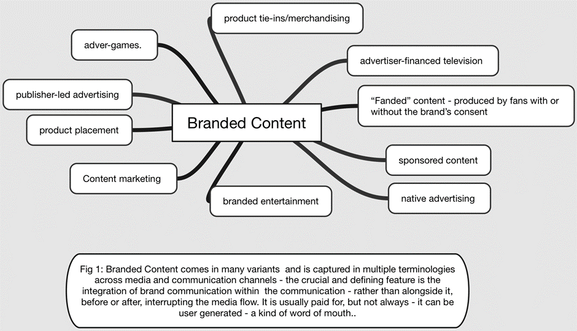

Figure 1 shows a complex of cross-over and related terms for branded content practices. It is vague phenomenon in terms of precise definitions. This includes ‘native advertising’. Native advertising is where advertisers ‘go native’ in the forms of newspapers or other media is growing – while remaining promotional of a brand.

forecasts predicting marketers will spend $4.3 billion on native advertising in 2015, a 34% increase from this year, according to eMarketer. That number is expected to reach $8.8 billion by 2018 (Sebastien 2014)

Defining these growth areas is part of the work of reflection on change. Some useful work has been done to contain the variety of meanings and to distinguish between aspects of a broad area of practice. Drawing on collated industry experts’ views Asmussen et al 2016, alongside the BCMA and IPSOS MORI propose the following definition:

From a managerial perspective, branded content is any output fully/partly funded or at least endorsed by the legal owner of the brand which promotes the owner’s brand values, and makes audiences choose to engage with the brand based on a pull logic due to its entertainment, information and/or education value. (Asmussen et al 2016)

This ‘managerial’ definition jostles alongside a ‘holistic’ definition, that describes branded content that might extend beyond the wishes and intents of brand owners.

user- generated content associated with a particular brand in a negative sense which does not promote the legal brand owner’s values is still considered branded content from a holistic but not from a managerial perspective (Asmussen et al 2016)

Elsewhere (MacRury 2018b) I have suggested the term ‘fanded’ content to capture the largely positive, if unofficial, circulation of brand ideas and imagery within fan communities – much of which garners attention and, potentially, equity for the brand. This extends beyond formal cultural-fandom (music, fiction and film) and into the fandom of cultural goods and brands (anything from Thomas the Tank Engine to Lego to Volkswagen cars).

These formal, informal and quasi formal circulations of branded content contribute in an environment where traditional media-based forms of promotion can lose traction and credibility. Another, even vaster scale enterprise is evident in online video blogging, or ‘vlogging’. Another set of legacy media channels are outflanked by new alignments, networks and technologies, a further resource of confusion and rapture for traditional audiences and modes of evaluation.

Rapture 2: The Vlogger trend

Facebook, Instagram and YouTube foreground the promotional industry’s communications dilemmas. Social media are built on a back-end system of abstract algorithmic ad serving, data-based personalization and the complex encoding of individual and social groups. This promises data functions previously belonging to market-research, media planning and buying – segmentation and media planning based targeting – and attendant income streams.

The front end of social media systems is often an inviting and intimate space of playful connection and empathic sharing, a compelling focal point for the collation and distribution of attentiveness; marvelous for marketers. However, it represents a huge diversion away from the formal and former expertise of advertising agencies as well as a massive delayering of the media system. These social media-based networks bypass one to many mass audience, and main media routes, on and off screen. They favor asynchronous quasi-one-to-one networked communication. Video-based marketing, a species of vlogging is a case in point. The vlogosphere is a rich seam that traditional agencies risk missing out on.

Vloggers replace celebrity endorsers and perform an ordinary, quasi-authentic, humanity (often on behalf of goods) but outside the traditional circuits of promotional media. This is, in its primitive forms, fresh, logo-free, un-generic and de-commodified endorsement that has shed the off-putting hallmarks of commercial communication and marketing persuasion.

Significant budgets now accrue to vlogger channels and agencies are forming around vlogger talent – to structure deals with advertisers and brand owners. *Glean Futures* is one of a number of agencies. They talk about ‘digital first talent,’

This is a phrase we've coined to describe individuals who have built considerable audience & influence on social media channels. We live in a world driven by clicks, follows, likes & comments. It's by these metrics of engagement that we measure success. We only manage quality talent who are among the top social creators in the world, dedicated and passionate individuals who are determined to be professional and accountable while exploring their potential in all areas of media and merchandising (<https://www.gleamfutures.com/>)

The cool countercultures of vlogging are becoming established and mainstreamed. A new set of faces and places for the marketer budgets to chase.

For somebody unaware of the power of new forms of communications and new media channels and, one of the most surprising publications to come across was *The Ultimate Vloggers Guide* (Jones 2017). This publication, one of a number of similar books, takes the form of a classic “annual’, a format familiarly targeted at fans and enthusiasts in the tween years. It is surprising that YouTubers have now attained such a status, alongside football stars, teen mags and favorite TV. The book is described as follows:

From vlogging in their bedrooms to building global fan bases and conquering the world, it's been another crazy year for everyone's favourite Internet stars. Catch up with what's-what in the world of vlogging in this brilliant unofficial YouTube annual, jam-packed with facts, fun activities, cool crafts, profiles, posters, quizzes, trivia and more! YouTube fans everywhere will want to put down their cameras and pick up this book! (<https://www.amazon.co.uk/Ultimate-Vloggers-Guide-ultimate-unofficial/dp/1783706201>)

It stands as one of a number of publications dedicated to the celebration and exploration of vloggers. These YouTubers represent a kind promotional counterculture while, at the same time, fulfilling many of the central tasks and gestures of branded communication. Vloggers represent a liminal moment wherein many of the organizing principles for the dissemination of marketing ideas are rephrased, reframed and re-phased, even while underpinning aims (to persuade, sell, and to garner attention) remain intact. It marks a fundamental shift for the old industry.

Newspaper reports capture the intensity of vlogger fan-ship:

A video blogger who became a [YouTube](http://www.mirror.co.uk/all-about/youtube) sensation says he is having to turn his book tour into a ticketed event because of the chaos that it triggered.

Up to 8,000 screaming fans showed up at Waterstone's in London's Piccadilly Circus when Alfie Deyes promoted his bestseller *The Pointless Book*, forcing him to find another way to meet his fans.

A flavor of rapturous hysteria that has for some time now surrounded vloggers is available in this phone captured film of Deyes, the celebrity blogger here making a personal appearance at London’s ExCEL Centre.[5]

Of course, these manifestations of rapturous popularity are also now focused on traditional media formats, books and other publications. The reach of the blogger phenomenon can best be captured by looking at some of the metrics around engagement with blogger and output and social blade is a strong source for such data, and a further indication of the commodification professionalization of the vlogger space.

The aspiration and the promised success attendant upon the vlogging phenomenon is not to be taken at face value. Vlogging is an accessible option for enterprising work, but aside from a few notable and high profile exceptions the typical experience of bloggers is that it neither delivers financial success nor any kind of career as such. This, even when sponsorship is actively sought.

It is clear that bloggers are providing significant new options and channels for marketers and seeking to reach youth audiences – and a new route to create or leverage celebrity. Indeed, one of the challenges for the wider vlogger communities is to continue to be able to authentically represent the organic tone and the approachability that has become the hallmark of the genre. Vlogging has become part of what is recognized increasingly as a highly orchestrated commercial phenomenon and with clear connections to traditional marketing agendas. They are not just the boy or girl next door.

It would be a mistake to overstate the influence of vloggers solely, as a stand-alone phenomenon. This is even the case where one can point to eye-watering financial settlements and where the numbers of views of seemingly quite casually produced YouTube videos has come to rival performance many traditional media marketing metrics. But Vloggers are significant within a new media ecology however – part of its moment of rapture. Vloggers provide one key, too, to reflecting on the long-standing desire audiences for novelty, intimacy, trust and lively entertaining media and marketing – consumers wanting conversation not conversion.

Reflection: liminality and change

The most important moment alongside rapture and rupture, is the moment or modality of reflection. Reflection is an important part of what education does. It is part of their duty towards education, in terms of providing it, but also in terms of carrying education is forward into new professional environments. Education includes not just techniques but also ethics. Thought of what marketing graduates bringing into the field is a capacity not only to understand present and future development, but also to apply principles and reflections on evolving practices. In an environment where content is king, and where traditional methods for regulating and containing content within professional guidelines and regulatory bodies has become a challenge, the value of reflective practice increases.

How might the changes mentioned above, branded content and vlogging, impact the quality of communications environments and capacities more broadly? There are challenges now for traditional operational business models and habitual practices in marketing communications

There are problems for traditional agencies the clients and brands trying to understand and navigate a new environment no problems regulators and consumers and audiences

There was a broader potential problem about the media ecology around naming and regulating new – quasi formal – promotional content-led modes of communication (vlogging and branded content for instance).

Aide memoire: rupture, rapture, reflection

It is helpful to look out for three dynamic in a changing environment. These are not, necessarily linear in terms of a series of events, but, instead, represent moments that seem to ebb and flow in the life of an organization or industry. They can be co-present in a process or a debate and, even, in developing a strategy or a project within a group.

One is the sense of *rupture*. In this example, there is an assertive recognition or promotion of the idea that older, legacy forms of promotional communication are becoming obsolete and that business models and professional demarcations are no longer adapting to or focusing work to the task at hand in effective ways – not fulfilling marketing and branding aims. There is a feeling that established practice is 'history' and that innovation is urgently needed - or the agency, institution, an individual, a brand, or even the industry will 'die.' This corresponds to Turner’s notion of separation and liminality.

Then there is the sense of *rapture*. A complex process of change, elaboration, and renewal - seeking, speculating, and testing new ideas, perspectives, identities and framings is entered into. Ideas are toyed with and honed (or rejected) within iterative processes. Trends, fashions and new terminologies abound. Established roles become obsolete. Hybrid and new roles/ forms spring up. New alignments of skills and agencies develop. "Agile' and temporary 'interstitial' arrangements are tested. New solutions are touted and efforts made to colonize the future. There is a frenzy of messianic excitement about the next big thing (Big data, programmatic, branded content, vlogging).

There is also anxiety. There is nostalgia and defense of the 'old' ways and fears of throwing the baby out with the bathwater. Efforts point to finding a settlement. This may or may not come with the moment of active *reflection*. Just as Turner talks about ‘integration’ of differing priorities and aims. There is a rebalancing of past, present and future approaches and an integration and adaption of institutional structures, communicative forms, consumer expectations and habits. This is often explored through changing regulations and devising new containers for hybrid forms such as branded content and vlogging. What was novel is becoming normative - until the next wave of change begins, with the next generation of technologies, graduates and ideas.

**Fig 2: Rupture, Rapture and Reflection – aide memoire to help navigate change in an era of industry wide-cultural disruption**

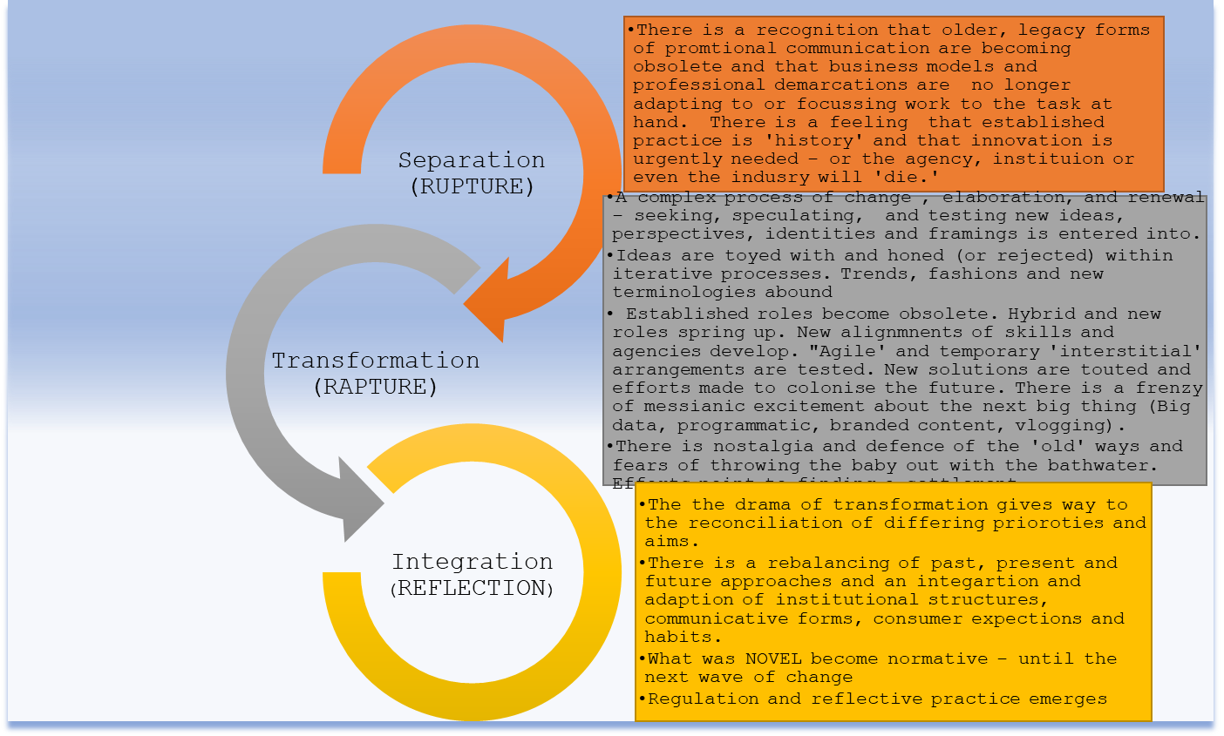

Conclusion: Liquid advertising and containing new content

One useful way to conceptualize this period of change is to think within the terminology inspired by the idea of liquid modernity (Bauman 2008). Which is to say we might talk of contemporary marketing communications as liquid “advertising”. Reflection in future times will be about seeing to sustainably contain a volatile and ‘liquid’ advertising and promotional community – around meaningful and sustainable communications practices that protect the public sphere as a common good and nurturing resource.

Renewed uncertainties continue to mark a marketing-professional ecology that seems porous and disorganized. This makes for quite a prospect. New threats and opportunities for students seeking soon to contribute in and to understand industry sectors abound. The boundaries and nomenclatures that have mapped and distinguished, say, advertising, PR, event management, publishing and journalism, all shift fast. It is a blur at times. This marks another notable chapter in the multi-dimensional unfolding of ‘convergence.’

In its turn, the promotional industries must wonder about what talents and skills in needs. There will need to be a renewed set of reflections on the skills, knowledges, dispositions and capabilities needed to function in this revised communications space. New professional identities will emerge where reflective practitioners work to make sense and to function effectively and sustainably. Educators, too, must adapt and reflect. Regulators wishing to protect the marketing ecology against and the discreditable or confusing modes of new communication will need to help contain this exciting but disturbing era of flux.

References

Alonso, D. (2017). *The old ad agency is dead, long live the ad agency* Available at: <https://artplusmarketing.com/the-old-ad-agency-is-dead-long-live-the-ad-agency-35336f3d21e> [Accessed 7 Jul. 2017].

Asmussen, B., Wider, S., Williams, R., Stevenson, N., Whitehead, E. & Canter, A (2016). *Defining branded content for the digital age. The industry experts’ views on branded content as a new marketing communications concept*. A collaborative research project commissioned by the BCMA and conducted by Oxford Brookes University and Ipsos MORI. Published in June 2016.

Bauman, Z. (2013). *Liquid Modernity*. Wiley.

Hegarty, J. (2011). *Hegarty on advertising: turning intelligence into magic*. London, Thames & Hudson.

Himpe, T. (2006). *Advertising is dead, long live advertising!*. Amsterdam: BIS.

Lee, S. (2016). *Content Provider: Selected Short Prose Pieces, 2011–2016*. Faber & Faber.

MacRury, I., 2018a. “Advertising Creativity”. In: Powell, H., Hardy, J. and MacRury, I., eds. *The Advertising Handbook 4th Edition*. Routledge.

MacRury, I., 2018b. “What is an Advertising Agency in the 21st Century?” In: Powell, H., Hardy, J. and MacRury, I., eds. *The Advertising Handbook 4th Edition.* Routledge.

Main, S. and Main, S. (2017). How The New York Times Is Building the Ideal Branded Content Studio. [online] *Adweek.com*. Available at: <http://www.adweek.com/digital/how-the-new-york-times-is-building-the-ideal-branded-content-studio/> [Accessed 22 Dec. 2017].

McAlone, N. (2017). These are the 18 most popular YouTube stars in the world — and some are making millions. [online] *Business Insider*. Available at: <http://uk.businessinsider.com/most-popular-youtuber-stars-salaries-2017>

Reutersinstitute.politics.ox.ac.uk. (2017). [online] Available at: <https://reutersinstitute.politics.ox.ac.uk/sites/default/files/2017-06/Reuters%20Institute%20Digital%20News%20Report%202015%20Sponsored%20Content%20Press%20Release.pdf> [Accessed 20 Dec. 2017].

Rockett, K. (2014). YouTube blogger Alfie Deyes mobbed by 8,000 screaming fans. [online] *Mirror*. Available at: <http://www.mirror.co.uk/news/uk-news/youtube-blogger-alfie-deyes-mobbed-4293469> [Accessed 13 Nov. 2017].

Sebastian, M. (2014). Native Ad Spending To Jump Despite Marketer Reservations. [online] *Adage.com*. Available at: <http://adage.com/article/digital/native-ad-spending-jumps-marketers-reservations/295956/> [Accessed 20 Dec. 2017].

Sennett, R. (2009). *The Craftsman*. Penguin Adult.

Turner, V. W., et al. (2011). *The Ritual Process: Structure and Anti-Structure*. Aldine Transaction.

Whatsnewinpublishing.co.uk. (2016). A new journalism combines marketing and editorial content. *What’s new in publishing*. [online] Available at: <http://whatsnewinpublishing.co.uk/2016/10/05/a-new-journalism-combines-marketing-and-editorial-content/> [Accessed 22 Dec. 2017].

1. Professor Iain MacRury, Deputy Dean Research and Professional Practice, Faculty of Media and Communication, Bournemouth University.
2. Some of the work in this paper was supported via the AHRC Branded Content Network - AH/N007719/1 PI Jonathan Hardy, Co-I Iain MacRury
3. This paper was originally given as a keynote at the Bournemouth University Promotional Communication Conference 2017, an event which features final year students presenting their dissertation projects.
4. Some will be unfamiliar with references to the 3Rs, originally Reading, Writing and Arithmetic.
5. At least in terms of sound and mood, there are comparisons to be made with earlier public cultural moments for instance even, Beatlemania. <https://www.youtube.com/watch?v=ngbcN2iiAb8>