**BRANDING THE PRESIDENT: AN INVESTIGATION INTO THE MANIPULATIVE TACTICS EMBEDDED WITHIN A CANDIDATE’S BRAND IDENTITY**

**Introduction**

The growing importance of marketing has transformed the modern political arena. Much like commercial industries, political parties now utilise marketing strategies to improve their public image and appeal to potential voters (Scammell 1999; Lees-Marshment and Lilleker 2005). Research has revealed that this shift into a marketing induced environment has lowered the impact of policy based discussion, and given power to the emotive imagery conveyed by the political actor (Smith and French 2009). Not only has this image centric approach shaped the way in which a candidate is portrayed, it has also influenced how a voter thinks, providing a cognitive shortcut to assist in a voter’s electoral decision (Westen 2008). One marketing facet which strengthens this shortcut and a candidate’s emotive appeal is branding. This marketing sub-concept helps to entice voter decisions by strategically constructing messages and imagery within the audience’s mind (Scammell 1999). At the core of this image inducing strategy lies the brand identity.

This paper aims to contribute to existing studies about the power of branding within a political context by focusing on the strategic deployment of manipulative features within the brand identity. Drawing on branding and rhetoric literature (Kumar, Dhamija, and Dhamija 2016; Martin 2014), this research offers importance through its deconstruction of the brand identity from a verbal context, as opposed to the visuals seen through advertisements as well as through a close examination of the interrelationship of the two concepts. To achieve such objectives, this study analyses a selection of speech transcripts from Donald Trump and Hillary Clinton during the 2016 presidential election, comparing their strategic use of branding.

The 2016 presidential election was selected as the focal point of this investigation due to its current relevance within society. The controversial nature of the event made headlines worldwide, as “one of the most shocking U.S. elections in modern political history” (Berenson 2016). Therefore, the 2016 presidential election makes a compelling case study for the examination of the concept of political branding in relation to rhetoric; one that can provide insight on how persuasive language can shape the appeal of political brand identity.

**Theoretical framework**

“Political candidates are inexorably engaged in a marketing game, so turning presidential candidates into commodities via branding was the next logical step.” (Zavattaro 2010, p. 126)

The high success rate that marketing induced within the commercial environment, prompted a significant increase in research combining the marketing concept with political sciences (Needham and Smith 2015; Baines and Harris 2011). In a practical sense, the theory of political marketing originated within the United States where parties began to infuse different marketing aspects within their political strategies (Kavanagh 1995). The domineering presence of the commercial technique within the political sphere has led theorists to investigate deeper into the marketing framework. Although limited, research has identified that the presence of branding is significantly increasing within political literature, indicating its growing importance within politics (Lewandowski 2013). Researchers have argued that the political process is moving away from highlighting policy issues, and instead directing voter attention towards the candidate’s image (Ormrod et al 2013). As an attempt to differentiate their image from their competition, tactical branding strategies are being employed, creating distinctive identities for all candidates (French and Smith, 2010; Smith, 2009). To validate the use of branding, theorists suggest that integrating the construct within a candidate’s communication plan can add a strategic level to the campaigning process. Further, driving the promotion of the political actor’s preferred identity through recognisable symbols and slogans (De Chernatony and Riley 1998; Lilleker 2010). Politicians are also using branding to develop a group of conceptions within the voter’s mind, helping to make the candidate seem more compelling and interesting (Feldwick 1991; Hollis 2008). By producing a combination of tangible and intangible elements, including visual features and emotional wrappers, branding can help strengthen a candidate’s image (De Chernatony and Riley 1998; Scammell 1999; Lees-Marshment and Lilleker 2005; Smith 2001).

America’s approach to politics is becoming increasingly image centred, focusing on the candidate’s appeal through their persona as opposed to what they can achieve (Lock and Harris 1996; Spiller and Bergner 2011). Scholars have found that the emotions developed towards a candidate’s brand can act as a key predictor of voter behaviour, whereby the device creates cognitive shortcuts to aid the voter’s electoral decision (Westen 2007). Furthermore, with the simplification of “political realities” (Nee 2011, p. 6), and the growth of valence politics, candidate brands are inadvertently reducing the need to form a strong policy plan (Smith and French 2009). Here, the significance of branding is illustrated through the weakening power of policy focused statements within a political race (Seidman 2010; Smith and French 2009). However, despite branding showing its importance within modern day politics, there is still a lack of understanding towards the features of the construct (Harris and Lock 2010; Butler et al 2011). The emergence of the “candidate-as-a-brand” concept offers opportunity to examine deeper into the facets which build a political brand (Van Steenberg 2015, p.5). Research surrounding the brand identity within a political climate remains limited. The importance of this feature lies in its ability to control brand projection which, if done successfully, can have a positive effect on the candidate’s perceived image (De Chernatony 2006).

A search focused on brand identity within a political context finds an appropriate framework developed by Scammell (2007), and simplified by Adolphsen (2008). Scammell identified the conceptual and practical natures of the identity construct through the Model of Brand Distinctiveness (Scammel 2007). Comprised from elements of a brand’s internal structure, Scammell found a distinct link between a candidate’s functional perception, (*boundary conditions*), which focuses on policy objectives and competence; and the emotional attractions (*brand differentiators*), which shows the authenticity and approachability of the candidate (Scammell 2007). Although the model merges all the details which encompass the overall brand image, the dissection of the selected components allows for an understanding of the preferred brand identity of the political actor (Scammell 2007). The boundary conditions embody the functional value that the political brand is trying to convey; whilst the brand differentiators establish the cultural, social, and psychological aspects the candidate wants to evoke (Scammel 2007).

Much like the commercial environment, politicians must anticipate the needs of the market. However, in the case of politics this process can be extremely unpredictable. Various competing forces have an influential stance over voter attitudes making it harder for a candidate to consistently align with the needs of the audience (Newman 1999). Political actors must therefore find an efficient way to identify with the voter, and create a strong relationship that can withstand the influence of external threats, such as the media. Despite aiding differentiation, branding also allows candidates to inspire the public on an emotional level (Lewandowski 2013). Theorists suggest that a brand’s ability to evoke emotion as part of the political appeal allows the candidate to form a personal connection with voters (Smith 2001; Dean et al 2015; Kumar et al 2016). A focus on emotions, as opposed to attributes, allows politicians to construct meaning through their brand strategy, eliciting a higher rate of consumer confidence (Thompson et al 2006). The strength of emotions has been investigated within political literature, identifying them as a defining aspect of political power, helping to effectively convey messages and determine audience behaviours (Castells 2011). Therefore, having emotional devices embedded within a candidate’s brand can be a powerful feature in a political actor’s communication strategy (Kumar et al 2016). However, concern arises with the ability of this emotional appeal to shift into manipulation. Barberio and Lowe (2006), suggest that public opinion can easily be manipulated through brand features. The strategic deployment of value-based phrases and persuasive symbols to increase support can be dangerous. The political system’s integration with branding based strategies can create a barrier, disguising a candidate’s true aim through emotive language (Newman 1999).

**Rhetoric: Metaphors and mythology in political discourse**

Rhetoric is a central component of politics, yet does not take a central role in literature pertaining to the political marketing environment (Krebs and Jackson 2007). The persuasive nature of the device appears through its capacity to utilise the power of words to affect a situation; influencing the audience’s response (Kennedy 1994; Kochin 2009). Kennedy (1994, p.3) infers that rhetoric is used to “influence the actions of others in what seems the best interest of ourselves”. Thus, when applying the device to politics, the focus remains on what the political actor wishes to achieve and the persuasive features they employ to achieve it (Brown 2014). Moreover, Charteris-Black (2005) reinforces the influential aspect of rhetoric, through the inseparable connection the linguistic device has with persuasion. He emphasises the dualistic nature of the concepts, inferring that an audience can only be persuaded if the speakers’ rhetoric is effective.

A common theme emerging throughout the assessed literature was the focus on Aristotle’s *Art of Rhetoric*. Aristotle argued that a defining feature of rhetoric was its ability to utilise language as a means of persuasion (Sizemore 2008). To explore this notion, Aristotle famed three genres of speech which were focused on the “canon of intervention” (Sizemore 2008, p.4) in the influential process (Covino and Jolliffe 1995). They were devised as a means to understand the nature of persuasion, and how to implement it; which is of special importance when referring to a political campaign. By understanding why a voter may be persuaded, a candidate is better able to repeat the process (Sizemore 2008).

The first perspective of Aristotle’s rhetoric focuses on *logos*, better known as the “appeal to reason” (Savolainen 2014, p.100). Logos is an essential feature within a political argumentative strategy as it concerns the reasoning behind future events, using logic to lead the audience to a specific conclusion (Martin 2014). The second element, *ethos*, centres on the speaker’s character (Wrobel 2015), and their ability to evoke a sense of authority (Amossy 2001). In politics, candidates must convey an authoritative persona; persuading the audience of their suitability for the role. The final genre recognised by Aristotle was *pathos*, the process of evoking emotion from the audience. Generating emotions such as concern and faith can give context to a politician’s argument, increasing the persuasive effect (Martin 2014). When relating back to previous discussion, emotions appear not only beneficial within rhetoric but also within the branding process; thus, making this an important area of focus.

Centred on the theme of emotions, Jowett and O’Donnell (2012) suggest that for a political actor to elicit change within a reluctant society, they must connect the shift to a former belief (anchor). The theorists proposed that by evoking a familiar emotion within an unfamiliar message, a candidate can induce new attitudes and behaviours from the audience (Jowett and O’Donnell 2012). The degree of persuasion within a message is heightened through the strength of the connection made with the recognisable ‘anchor’, allowing voters to identify with new ideas. This process of utilising an identifiable element to induce change shows similarities to the metaphorical device.

## *Metaphor*

Frequently observed within political discourse, a metaphor is one of the most significant tropic features to occur within rhetorical analysis (Martin 2014). As a persuasive technique, metaphors have been widely studied within literature (Belt 2003), yet little research studies its effect on politics and branding combined, more specifically the brand identity.

Research indicates that the persuasive device is a common feature within political communication, and is used to shape public opinion on certain topics (Grand 1994; Lakoff, 1996; Patent, 2000). The abstract nature of a political event prevents it from being fully experienced, thus metaphorical expressions are embedded to aid political arguments (Mio 1997). A metaphor is viewed as an effective way to induce a suggestive representation of a candidate’s character, which is achieved by influencing audience emotions (Lankoff and Johnson 1980; Charteris-Black 2005). The importance of the device within a political context lies in the ability to influence how the voter thinks, and subsequently, acts (Penninck 2014). Here, metaphors shorten the voter’s reconstruction of a candidate’s argument by drawing on common experiences to form a connection in the voter’s mind (Charteris-Black 2005). These cognitive associations have been conceptualised as the Cognitive Metaphor Theory (Lakoff and Johnson 1980), which explores the cognitive role of metaphorical language (Deignan 2005). The process concerns the mediation of the conscious (emotions) and unconscious (cognition) channels of persuasion; employing two distinct elements; the vehicle and the topic (Charteris-Black 2004; Lakoff 1993; Lakoff and Johnson 1980; Paivio and Clark 1986). During the persuasive method, the characteristics of the familiar ‘vehicle’ are attached to the unfamiliar ‘topic’, activating emotional arousal (Belt 2003). The frames created through this metaphorical process increase the probability of voter conformity, as the emotion-inducing content often arouses voter attention (Belt 2003; Marcus et al 2000). These associative emotions are evoked without the awareness of the audience; displaying a form of influence otherwise known as *pathos* (Lesz 2011). The imagery induced by emotions, provoke the same response to the intended message as they do to the familiar belief (Martin 2014). Thus, when a political experience is referred to as a ‘journey’, a comparison is made between political affairs and travelling to a destination (Martin 2014).

A method of identification, otherwise known as the Metaphorical Identification Procedure was conceptualised by the Pragglejaz Group (2007) and later developed by Steen et al (2010) as the Metaphor Identification Procedure Vrije Universiteit (MIPVU). The approach is used to recognise metaphor-related words by identifying their indirect meaning (Steen et al 2010). The method poses advantages when the presence of a metaphorical concept is undecided. MIPVU offers an objective solution by proposing the use of a dictionary to understand the basic sense of the word, allowing the comparison to be made with its implied abstract meaning (Marhula and Rosinski 2014). This process has aided in the recognition of dominant metaphorical themes within research.

Two recurring themes which can often be seen within political literature are the conflict frame and the strategy of fear. Typically, the conflict frame creates a conceptual model of two opposing sides, often seen within fairytales (Lakoff 1991; Ferrari 2007). The disproportion of the sides entices a politician to use the archetype of the hero, who typically must ‘defeat’ the enemy (Belt 2003). The one-sided depiction of a battle, presents justification for the politician’s actions, thus persuading the voter of the candidate’s pure intentions (Lesz 2011). The strategy of fear uses contrasting emotions to depict two opposing spaces. Evoking anger through the connection to an external space; whilst placing confidence in an internal space will metaphorically positions the emotions inside and outside the given country (Lesz 2011; Ferrari 2007). This puts anger and confidence on opposing sides of the same manipulative strategy (Ferrari 2007). Further, the reoccurring negative feelings evoked towards external threats can generate a narrative behind a campaign message, which has the potential to develop into a political myth (Charteris-Black 2005).

## *Mythology*

Mythology is another persuasive tool often employed within political discourse which develops from metaphorical language. Edelman (1975) was one of the first scholars to assess this persuasive feature in the political climate. He proposed that political discourse utilises myths as a means of power, forming effective narratives which instil emotion and meaning into unknown circumstances. Significance lies with the features ability to offer narrational explanations within a disordered world, producing an appeal to reason, aligning with Aristotle’s genre of logos (Esch 2010). The mythological interpretations made by the audience significantly aids in their perceptions of the candidate, making the political actor’s portrayed identity easier to assess (Peru-Balan and Bahneanu 2014). A common narrative running through politics is the myth of ‘unity’, which evokes a sense of solidarity and the belief that together victory can be achieved (Charteris-Black 2005).

Furthermore, scholars argue that political myths have the power to access the consciousness of society, convincing voters through their persuasive nature (Peru-Balan and Bahneanu 2014). The explanatory feature of the device creates a shared meaning among a group; influencing beliefs, behaviours and attitudes towards differing situations (Flood 1996). The compelling nature of mythology has long been assessed as a fundamental element of the propaganda state (Zhong and Zhang 2016). Literature defines propaganda as the manipulation of communication as a means of persuasion, influencing the audience to adopt the beliefs of the propagandist (Walton 2007). Clear similarities can be seen through this definition and that of mythology in political discourse. Scholars have observed that widespread events such as war would not be fought without the compliance of the public, and therefore myths are employed to create a shared understanding, securing societal cooperation (Jackson 2005). Evidently, the manipulation of language through narrative influences audiences to adopt the political actor’s preferred beliefs. Thus, the investigation of mythology, in a political brand context, would offer insight into the field of propaganda, politics and branding.

Having reviewed the relevant literature, this research focuses on the manipulation of rhetoric to shape a candidate’s brand identity. Studies suggest that extending the political branding framework into the persuasive communication field will be valuable in furthering its importance within political and brand research (Lewandowski 2013). Literature concerning the brand identity and rhetoric identifies that a political actor can deliberately manipulate both variables to influence audience emotions. A comparison of the two recognises that both concepts draw upon a similar theme of control. Thus, when combined, the political party can manipulate their identity to alter brand perceptions, whilst further influencing audience emotions by deliberately using rhetoric within it. An investigation into the combined efforts of rhetoric and branding will help to examine the extent manipulative techniques are consciously embedded within a candidate’s portrayed brand identity.

Thereupon, the exploration of previous literature pertaining to branding and rhetoric has assisted with the following research questions and hypotheses.

RQ1: To what extent can the brand identity be detected in the speeches of the 2016 presidential election candidates?

RQ2: How frequent are metaphorical and mythological devices employed within each candidate’s detected brand identity?

RQ3: Is the brand identity inexorably linked to manipulative tactics?

Theory suggests that a distinct brand identity will provoke a more cohesive image, generating higher brand loyalty (Vytautas et al 2007; Srivastava 2011). If this assertion is accurate then in principle the investigation should show that the winning candidate has the most distinct identity. Therefore, leading to the first hypothesis:

H1: Donald Trump’s brand identity is more distinct than Hillary Clinton’s.

Furthermore, if rhetoric is effective in manipulating audience emotions and behaviours, then the prevailing candidate should also have more rhetorical techniques embedded within their brand identity. Thus, it is hypothesised:

H2: Donald Trump will contain more rhetorical techniques within his brand identity than Hillary Clinton.

**Methodology**

This study investigates the extent to which rhetorical techniques have been incorporated within Trump and Clinton’s brand identities; exploring also the frequency and strategic use of metaphorical and mythological devices. To explore the relationship of the research dimensions, brand identity and rhetoric, a mixed-model research style has been established. By taking an integrative approach to the research design, a logical link has been developed between the source and message (Neuendorf 2017). Scammell’s (2007) Model of Brand Distinctiveness has been used to analyse political speeches (message) through the combination of Computer Aided Text Analysis (CATA) and human-coding (Neuendorf 2017). The intention behind this stage of research was to detect the candidates brand identity and use the features identified to aid a rhetorical analysis. A multi-layered quantitative content analysis on political speeches with a mixed method rhetorical analysis of the assumed brand identity were conducted in order to analyse and explain the relationship dynamics between branding and rhetoric (Kumar 2005). NVivo 11 was used to examine the candidates’ speeches, providing theme groupings and frequency measurements.

For the scope of this research, purposive sampling was employed to enable the strategic selection of speech transcripts. This technique allowed that samples were retrieved from distinct locations and periods of the presidential election. Transcripts from each candidate were selected chronologically, from the start, including national conventions, the mid-point, and the final month of the election. This gave a wider view of the candidate’s brand, which had the potential to change over time. Purposive sampling also helped to validate the brand identity. Speeches were specifically selected to correspond with their competitors in terms of location. This was done to prevent critics proposing that the brand identities were only distinct because candidates were addressing differing audiences. By analysing speeches from similar locations, the differences recorded provided a reliable view of the political actors’ true brand identity. However, despite the strategic selection of transcripts, it should be recognised that some aspects of the speeches would have been tailored towards the audience.

Furthermore, a 2015 analysis of party affiliation identified the politically undetermined states. In particular, Ohio, Pennsylvania and Florida were all competitive locations. By selecting these specific areas, we aimed to avoid party affiliation bias, which may have disrupted the content of the speeches. Yet, despite being competitive areas it should be acknowledged that Trump won all three states through the popular vote.

The transcripts under examination were:

DT1: Donald Trump: Republican National Convention, Cleveland, OH, 21st July 2016

HC1: Hillary Clinton: Democratic National Convention, Philadelphia, PA, 28th July 2016

DT2: Donald Trump: Rally, Pensacola, FL, 9th September 2016

HC2: Hillary Clinton: Rally, Orlando, FL, 21st September 2016

DT3: Donald Trump: Rally, Gettyburg, PA, 22nd October 2016

HC3: Hillary Clinton: Rally, Cincinnati, OH, 31st October 2016

**Findings**

For the primary tier of investigation, the candidates’ brand identity was distinguished using the Model of Brand Distinctiveness (Scammell 2007). The model helped to identify any distinction between the candidates’ identity that would later give an indication of their brand strength. The analysis conducted calculated the frequency with which each variable occurred within the transcripts; a mean average was then taken across the speeches and used to quantify the distinctiveness of each candidate’s core offerings. The distinctiveness score was calculated by the difference between the two percentage means in favour of the candidate with the highest mean average.

The first component assessed was the boundary conditions (this incorporates the political   
product of each candidate). During this section of the model, the most discussed attribute for each candidate was isolated, and selected for further investigation.

## [Insert Table 1: Political Product]

Table 1 illustrates the frequency of the candidates’ policy centred discussion. This feature   
concentrates on the product core, which in the commercial environment encompasses the   
tangible benefit a consumer receives when purchasing a product (De Pelsmacker et al 2007). With regards to political branding, the core element is seen through the emphasis each   
candidate places on policy focused areas. To maintain a strong brand identity, the candidate would ideally like to differentiate their product from their competitor (Laforet 2010).

As displayed in Table 1, Trump places a great amount of emphasis on the political system (9.84%), closely followed by the economy (9.35%) and immigration (9.09%). Despite maintaining similarities through economic discussion, Trump offers a highly distinct product for the audience to consider. The unique focus on the political system distinguishes Trump from his competitor, producing a strong differential advantage. In contrast, Clinton’s focus is dominantly on economic matters (9.19%), which fails to offer any form of exclusivity. Although this was discovered to be her primary source of discussion, she lacked any distinction in her product offering, damaging the appeal of her brand. Clinton’s second strongest area, equality (7.65%), presented distinct context-determined outliers. A recent Florida shooting in a LGBTQ nightclub may have influenced the topic of discussion during Clinton’s Orlando rally, producing a higher frequency of content surrounding equality.

The second component assessed was the brand differentiators; this concentrates on the   
personality and emotions of each candidate. In this portion of the model, the candidates’   
identities were selected through their distinctiveness score as this gave the most accurate portrayal of the brand identity within this analysis.

[Insert Table 2: Personality trait]

The results produced an interesting depiction of the candidates’ portrayed personalities. As seen in Table 2, Trump’s most frequently regarded trait was his patriotic nature. The characteristic encompassed an average of 5.90% of his speech which was significantly greater than his opponent at 2.55%. Commonly associated with presidential figures, Trump’s patriotism tied in well with his political product, signifying his determination to fulfil his slogan and ‘Make America Great Again’. The distinctiveness score revealed within Trump’s core personality was calculated at 3.35%, meaning Trump’s patriotism was addressed 3.35% more than his opponent.

With regards to Clinton, her dominant personality trait was displayed through her inclination to incorporate her family within her speeches (4.26%). Often the stories shared were related back to her parents, giving strength to Clinton’s family orientated appeal. The focused personality trait produced a statistical distinctiveness of 3.06%. Unlike the political product, Clinton’s differentiation in her personality is close to that of her competitor’s.

[Insert Table 3: Emotional wrapper]

The overall emotional wrapping of the candidate is illustrated in Table 3. Unsurprisingly, it was revealed that both candidates had a negative undertone within their speech which was often focused towards the opponent. Despite covering a large proportion of the content (Trump: 8.37%; Clinton: 10.36%), this emotion was not assessed in the secondary tier of investigation due to other emotional appeals offering a higher distinctive rating. Candidate specific patterns emerged through the analysis, revealing Trump’s focus on evoking a sense of faith to secure his appeal for change (9.16%). The investigation identified a vast   
difference between the competitors with this emotion, giving Trump an emotional   
distinctiveness of 8.55%. A further dominating appeal was Clinton’s use of fear and intimidation. The emotion encompassed an average of 5.28% of Clinton’s speech, often triggered by instilling fear into the audience to sway voting behaviours. Clinton gained a distinctiveness score of 2.21%.

[Insert Figure 1: Overall Brand Distinctiveness of each candidate]

[Insert Figure 2: Brand Identity Segment Distinctiveness]

Figure 1 summarises the extent to which the candidates differ in terms of their distinctiveness, clearly demonstrating the strength of Trump’s brand identity (21.74%). The figure displays the combined distinctiveness of the brand identity variables highlighted for further investigation. Figure 2 reveals where the candidates were most distinctive, focusing on the key variables in the separate segments of the applied model. Evidently, Clintons political product is negatively portrayed at -0.15%, as the frequency of her economic discussion was less than her opponent. The chart clearly exposes Clinton’s lack of product significance and emotional wrapping within her brand identity, which may have weakened her stance when placed against her opponent. These findings correspond directly to Hypothesis 1 stating that Trump’s brand identity is more distinctive than Clinton’s and thus, it was accepted.

The secondary tier of investigation analysed the assumed brand identity for   
rhetorical features, addressing Hypothesis 2. The findings revealed the frequency of   
manipulative elements that were embedded within the brand identity. The metaphorical   
technique was quantified during the analysis, and further supported through a descriptive   
assessment of key metaphorical themes.

[Insert Figure 3: Metaphor frequency in brand segments]

Evidently, metaphors were a highly incorporated feature within the brand identity, as seen in Figure 3. However, the results clearly identified a much higher frequency of the rhetorical device within Trump’s brand identity as opposed to Clinton’s. At 111 metaphors, Trump utilised more than double the amount employed by Clinton (48); leading to the acceptance of Hypothesis 2 that Trump would contain more rhetorical techniques within his brand identity than Clinton. Furthermore, Trump dispersed the persuasive feature more equally across the brand components than his competitor, who focused most her metaphorical language within the political product (37).

With regards to the type of metaphors used, Figure 4 displays a refined view of the metaphorical themes discovered. The thematic selection depicts the intensity of Trump’s metaphorical use, in which he leads all but five categories. The strongest variance of the five, being the finance theme, accurately supports the identified political product of Clinton.

[Insert Figure 4: Comparison of metaphors]

Clearly, both candidates had an inclination toward construction metaphors used to provide   
imagery towards the candidates’ goal of ‘building’ America. However, the meaning behind the theme has proven to differ between the opponents. Clinton often infers the plan to ‘build’ an economy, which may imply the intent to develop on what Obama had already achieved (status-quo). In contrast, Trump’s word choice to ‘re-build’, signifies a new start, further emphasised through his desire to ‘Make’ America Great Again.

The difference in metaphor use is depicted in Figure 5 and Figure 6. Created by NVivo, the   
diagrams visualise the similarity clusters of the metaphorical themes for each candidate. As previously discussed, the opponents utilised similar metaphoric themes in alternative ways, enabling them to arouse different emotions from the audience. Trump’s cluster of journey, construction and battle could depict the trials and tribulations that must be faced to ‘Make America Great Again’. In contrast, Clinton’s cluster of journey and restriction could portray her mission to relieve the suppressed individuals of the nation.

[Insert Figure 5: Trump’s metaphor theme cluster]

[Insert Figure 6: Clinton’s metaphor theme cluster]

Moreover, during the investigation, mythological narratives were hard to quantify. Therefore, each candidate’s domineering myth was recorded through key words, and then   
descriptive detail of further narratives employed was identified. When assessing both brand identities, two distinct themes were revealed. The strongest political myth discovered was employed by Trump. Present within his slogan, *Make America Great* *Again,* Trump’s ties to the ‘Golden Age’ myth are evident throughout his brand identity, forming a strong sense of congruency across his campaign. Despite only referring to words such as ‘again’ 20 times, an undertone of nostalgia plagued his identity. A less prevalent myth employed by Trump, was that of the Valiant Leader, which is evident through his desire to ‘fix’ and ‘protect’ the nation.

In comparison, Clinton’s most prevalent myth was that of ‘unity’, which is evident within her slogan, *Stronger Together*. Yet, despite Clinton’s campaign being centred on a sense of   
solidarity, she lacked emphasis of the myth within her brand identity. Figure 10 demonstrates the severity of Clinton’s inconsistency.

[Insert Figure 7: Dominant myth frequency]

Evidently, Clinton’s reference to any unifying expressions was limited (2). When evaluated against Trump, the investigation revealed the extent of Clinton’s myth limitation.   
Figure 7 shows that Trump employed a greater frequency of unifying expressions (7) within his brand identity despite it not being his dominant narrative. This finding could provide supporting evidence to why Clinton’s campaign slogan did not arouse as much attention as her opponent’s (Cohen 2016).

**Discussion**

In this section, we further discuss our findings by addressing the main research questions set in this study.

Responding to RQ1, i.e. an investigation of the brand identity in the speeches of the 2016 presidential election candidates, our key findings illustrated the contrast between the competitors and their utilisation of the brand feature. Interestingly, Trump’s brand identity was significantly stronger; encompassing a distinctiveness score of 21.74% compared to Clinton’s 5.12%. The disparity displays the extent of the contrast between the competitors however greater insight can be gathered through a deeper investigation into the separate identity segments.

During the investigation, a clear connection was discovered across Trump’s brand identity;   
producing a cohesive message for the audience to unpack. The political product proposed the idea of a reformed governmental system, which aligned with Trump’s emotional wrapper, faith in change. By continually evoking a sense of faith in the change he was trying to elicit, Trump could strengthen his political offering, securing cooperation to transform the ‘corrupt’ system. Moreover, the conveyed patriotic personality deepens the interest in change by portraying Trump as an authentic, valiant leader, who will ‘rebuild’ America.

In contrast, Clinton’s identity appeared inconsistent across each of her brand segments. Her   
political product of economic matters was not supported by her emotional wrapper of fear and intimidation. Instead of focusing her identity towards a singular message, Clinton emotionally wrapped her identity through fear of the opponent, increasing the focus on Trump’s campaign. Furthermore, Clinton’s emphasis on family did not assist in strengthening her presidential appeal or her ability to lead the country. Overall, these findings highlight Clinton’s inability to clearly shape her brand identity and focus on a single goal.

As previously acknowledged within literature, by conveying a distinct identity, the candidate is more likely to produce a similar perceived image and greater brand loyalty (Vytautas et al 2007; Srivastava 2011). Evidently, in the case of the 2016 presidential election, more specifically the sample states assessed, this statement accurately portrays the event outcome. The consistency and distinctiveness of Trump’s brand identity could potentially be a contributing factor to why he won all three states through the popular vote.

That brings us to our second research question and the frequency of metaphorical and mythological devices within each candidate’s detected brand identity. As demonstrated by the confirmation of hypothesis 2, metaphors and myths were embedded within both candidates’ brand identity. However, their placement and quantity differed between the political actors. Clinton’s inclination to embed most of her metaphorical language within her political product (37) illustrates the outdated approach she embodied. As highlighted through literature (Smith and French 2009), political policies are weakening, making them less likely to be the defining factor that determines voter behaviour. Thus, by placing much of the rhetorical device in the product segment, Clinton may have depleted the overall persuasive effect of her brand identity.

Trump elicited a different approach within his brand strategy by strategically deploying the   
rhetorical device across his identity. Despite most metaphors being revealed within the political product (47), Trump utilised 44 metaphorical phrases within his emotional wrapper. The significance of this metaphorical placement is evident through the overarching presence   
emotions had within the literature review, and their manipulative effect within the fields of branding and rhetoric (Barberio and Lowe 2006; Martin 2014). By consistently using metaphors within the emotional segment of the brand identity, Trump could fully utilise the power of emotions to arouse audience attention (Marcus et al 2000). The assessment of metaphorical language within his emotional wrapper revealed the prominence of the construction and destruction themes. The strategic deployment of these two metaphors evoked the imagery of two opposing forces within the same emotive appeal, eliciting a sense of internal conflict. The thematic tension adds a narrative pull to Trump’s brand identity, reflected through his ‘fight’ against the system and plea for change. The narrational effect has a similar nuance to that of the conflict frame discussed within the literature review (Lakoff 1991). This finding demonstrates the way in which Trump exploits the branding technique to strategically manipulate the audience through an emotion driven strategy.

With regards to the mythological features employed, the investigation exposed highly significant findings. Interestingly, both candidates had a preference to include the base of their mythological narratives within their campaign slogans. As slogans are used to secure a   
recognisable brand identity (Dahlén and Rosengren 2005), the inclusion of a myth within them would have helped to strengthen the political actors’ overall brand appeal. Moreover, the presence of a myth at the core of the candidates’ brand speaks widely of their intentions, with the rhetorical feature being closely linked to propaganda (Zhong and Zhang 2016). Trump’s superiority with this persuasive technique lies in his ability to turn the Golden Age myth into a call for action. By stating ‘we can make American great again’, Trump is appealing to the audience’s imagery of a ‘great’ past to elicit action towards a ‘great’ future. In comparison, Clinton’s myth of ‘Unity’ lacked reinforcement within her brand identity, leaving the audience with a fragmented message to unpack. By inconsistently using the myth, Clinton illustrated instability within her brand narrative, decreasing the overall persuasive effect of the rhetorical feature.

Finally, to answer RQ3 (Is the brand identity inexorably linked to manipulative tactics?) the findings on brand identity and the rhetorical analysis were combined. The examination led to an invaluable discovery, linking the portrayed identities within the 2016 presidential election directly to the literature surrounding manipulation. The connection provided evidence in favour of the claim that the brand identity is inexorably linked to manipulative tactics. However, it should be acknowledged that the degree to which this manipulation is implemented differs between the candidates. As Clinton’s brand identity appeared inconsistent and weak in comparison to her opponent, it was hard to detect the strategic use of manipulation, despite metaphors and myths being present.

A strong relationship was identified between Trump’s brand identity and Aristotle’s *Art of   
Rhetoric;* whereby each identity dimension had a clear link to Aristotle’s genre of speech*.* The utilisation of emotive language within Trump’s political product enabled him to incite action against the ‘rigged’ political system. Through frequently employing the ‘game’ metaphor as a ‘vehicle’ of thought, Trump could increase recognition and emotional arousal towards the ‘topic’ of the corrupt system (Lakoff and Johnson 1980; Belt 2003). This emotive outcome was achieved by manipulating the negative emotions society is conditioned to feel towards ‘cheaters’, and redirecting them towards politicians. The metaphorical process helped to unify societal thought towards the recognisable ‘anchor’ of governmental corruption; producing a logical reason (*Logos*) for Trump’s proposed change (Jowett and O’Donnell 1992; Martin 2014). Subsequently, the unconscious beliefs of the public were converted into conscious actions, bringing the audience to a unified conclusion. (Charteris-Black 2005; Lakoff and Johnson 1980).

The need for change was further reinforced through the emotional wrapper within the brand identity. Here, Trump could provide emotional context to his argument by eliciting the imagery of an internal conflict, reflecting the state of the political system (Martin 2014). As previously discussed this was achieved by utilising the contrasting metaphorical themes, construction and destruction. Moreover, the core of the emotional wrapper was based around a sense of faith, often provoked by Trump’s slogan, Make America Great Again. The mythological appeal of the ‘Golden Age’ narrative within the slogan intensified the emotions portrayed to the audience, which may have helped to elicit a similar emotional arousal in return (*Pathos*).

An assessment of the final brand dimension highlighted how Trump’s identity assisted in the construction of his political character (*Ethos*). The personality segment enabled Trump to   
strategically manipulate how he was portrayed throughout his campaign, supporting his   
proposal for change. The deployment of the Valiant Leader myth enabled Trump to assume the archetype of the ‘hero’, further validated through his patriotic appeal. Trump shaped his ‘heroic’ personality by employing emotion inducing battle metaphors, which enticed the audience to believe in his leadership. By expressing the will to ‘fight’ for America, and bring ‘victory’ he created a positive undertone to the battle concept, securing faith in his ability to transform the system for the better.

Evidently, the depiction of Trumps brand identity, combined with Aristotle’s Art of Rhetoric,   
illustrates the way in which a candidate can intentionally utilise theory to induce a reaction. The importance of this finding lies in the literature supporting Aristotle’s rhetoric, viewing it as a means to understand and re-implement persuasion. Thus, when incorporated within the brand identity, the persuasive process can help shape the candidates brand appeal. Figure 8 visualises the way in which Trump strategically shaped his brand identity through Aristotle’s genre of speech.

[Insert Figure 8]

**Conclusion**

This paper focused on the prominent concepts of branding and rhetoric with the primary aim to measure the extent to which the selected rhetorical devices were embedded within the brand identity; further exploring the relationship between the branding construct and the manipulative use of rhetorical features. The findings highlighted the domineering presence of rhetoric within the brand identity. True to the aim of this study, the findings quantified this presence, identifying 138 of the assessed rhetorical features within Trump’s brand identity, and 51 within Clinton’s. This showed the disparity between the candidates, which is also evident through the distinctiveness of their brands (Trump: 21.76%; Clinton: 5.51%).

Despite metaphors and myths being utilised by both candidates, the political actors differed in their tactical deployment of the rhetorical techniques. Consistent with the power shift from policy focused to emotionally induced; Trump was found to strategically deploy metaphoric aspects more evenly across his political product and emotional wrapper than Clinton. Further evaluation identified the potential for the brand identity to conceal manipulative tactics. Through assessment of Trump’s brand strategy, it was evident that his identity helped to convey a message, whereby specific features of Aristotle’s genre of speech could be embedded. This demonstrates the way in which Trump shaped his brand around rhetoric. On the other hand, Clinton displayed a weak brand identity with the strategic decisions behind her deployment of rhetoric being indistinct.

This research establishes a clear link between brand strategy and rhetoric, providing insight to the 2016 U.S election. The primary research highlights the potential weakness of Clinton’s brand and rhetorical strategy in comparison to Trump. If investigated further, this could offer contributing evidence to the unexpected outcome of the 2016 presidential election. The combined theoretical approach that was adopted for the purpose of this study provides new insights in examining political branding and highlights the congruency of the two co-existing constructs namely rhetoric and political identity. Furthermore, the study identifies the importance of the emotion facet within the brand identity, which should be explored further within political brand literature.

Nevertheless, there are certain limitations to this project. Firstly, we suggest that future research into this realm should assess more state speeches. Researchers can also adopt a comparative approach by examining previous presidential elections to identify whether a statistically significant relationship develops between the distinctiveness of a brand identity; their use of rhetoric; and the outcome of an election. Gathering this information could help provide an understanding of the importance of branding in a political context, and how the strategic deployment of manipulation may strengthen the outcome across time. Secondly, it proved that the quantification of the myth feature was particularly challenging. As the rhetorical device is based on narrative, it was hard to come to an accurate numerical conclusion. In future research, myths could be assessed through a combined approach (quantitative and qualitative) highlighting the key narratives displayed within the brand identity. Finally, given the importance of the new and social media within political campaigning, future research should include an examination of different online platforms. This will allow further assessment into the brand identity and rhetoric, focusing on their transference across different modes of communication.

**References**

Adolphsen, M., 2008. *Branding in Election Campaigns: Just a Buzzword or a New Quality of Political Communication?* [online]. MA: London School of Economics.

Amossy, R., 2001. Ethos at the crossroad of disciplines: Rhetoric, pragmatics, sociology. *Poetics Today*, 22(1), 1-23.

Baines, P. and Harris, P., 2011. Marketing in the 2010 British General Election: Perspectives, prospect and practice. *Journal of Marketing Management* [online], 27(7–8), 647–655.

Barberio, R. and Lowe, B., 2006. Branding: Presidential politics and crafted political communications. *Paper presented at the annual meeting of the American Political Science Association*, Philadelphia, August 31.

Belt, T.L., 2003. *Metaphor and political persuasion* [online]. PhD: University of Southern California

Berenson, T., 2016. *Donald Trump Wins the 2016 Election* [online]. Time. Available from: <http://time.com/4563685/donald-trump-wins/> [Accessed 28 April 2017].

Brown, T., 2014. *The rhetoric and of conflict in political theory.* PhD: Texas A&M University.

Butler, P., Collins, N. and Speed, R., 2011. The Europeanisation of the British political marketplace. *Journal of Marketing Management* [online], 27(7/8), 675–690.

Castells, M., 2011. *Communication Power*. Oxford: Oxford University Press.

Charteris-Black, J., 2005. Politicians and Rhetoric: The Persuasive Power of Metaphor. Basingstoke: Palgrave Macmillan.

Cohen, M., 2016. *The Failure of “Stronger Together”* [online]. Medium Corporation. Available from: https://medium.com/soapbox-dc/the-failure-of-stronger-together-650c6a5020ef [Accessed 10 May 2017].

Covino, W. and Jolliffe, D., 1995. *Rhetoric: Concepts, Boundaries, Definitions.* Boston: Allyn and Bacon.

Dahlén, M. and Rosengren, S., 2005. Brands affect slogans affect brands? Competitive interference, brand equity and the brand-slogan link. *Journal of Brand Management* [online], 12(3), 151-164.

De Chernatony, L. and Riley, F., 1998. Defining a 'Brand': Beyond the Literature with Experts' Interpretations. *Journal of Marketing Management,* 14, 417-443.

De Chernatony, L., 2006. *From brand vision to brand evaluation: The strategic process of growing and strengthening brands*. 2nd edition. Oxford: Elsevier Ltd.

Deignan, A., 2005. *Metaphor and Corpus Linguistics*. Amsterdam: John Benjamins.

De Pelsmacker, P., Geuens, M. and Van den Bergh., 2007. Marketing communications: A European Perspective. 4th edition. Harlow: Pearson Education Limited.

Edelman, M., 1975. Language, myths, and rhetoric. *Trans-Action*, 12, 14-21.

Esch, J., 2010. Legitimizing the "War on Terror": Political Myth in Official-Level Rhetoric. *Political Psychology* [online]*,*31(3), 357-391.

Feldwick, P., 1991. *Advertising works 6*. Henley-on-Thames: NTC.

Ferrari, F., 2007. Metaphor at work in the analysis of political discourse: investigating a 'preventive war' persuasion strategy. *Discourse & Society* [online]*,* 18(5), 603-625.

Flood, C., 1996. *Political myth: A theoretical introduction*. Hamden, CT: Garland Publishing Inc.

French, A. and Smith, G., 2010. Measuring political brand equity: A consumer oriented approach. *European Journal of Marketing*, 44(3/4), 460–477.

Grand, S., 1994. *The Battle for Imagery: Visual Metaphor and Televisual Persuasion in The Gulf War* [online]. PhD: University of Southern California.

Harris, P. and Lock, A., 2010. Mind the gap: the rise of political marketing and a perspective on its future agenda. *European Journal of Marketing* [online], 44(3/4), 297–307.

Hollis, N., 2008. *The global brand: How to create and develop lasting brand value in the world market*. New York: Palgrave Macmillan.

Jackson, R., 2005. *Writing the war on terrorism: Language, politics, and counter-terrorism*. Manchester, England: Manchester University Press.

Jowett G.S. and O'Donnell, V., 2012. *Propaganda and Persuasion*. 5th edition. London: Sage.

Kavanagh, D., 1995. *Election campaigning: The new marketing of politics*. Oxford: Blackwell.

Kennedy, G., 1994. *A New History of Classical Rhetoric*. Princeton, NJ: Princeton University Press.

Kochin, M., 2009. *Five Chapters on Rhetoric: Character, Action, Things, Nothing, and Art*. University Park, PA: Pennsylvania State University Press.

Krebs, R.R. and Jackson, P.T., 2007. Twisting Tongues and Twisting Arms: The Power of Political Rhetoric. *European Journal of International Relations* [online], 13(1), 35-66.

Kumar, A., 2005. Abu Ghraib follow-up stories: Political climate and construction of a legitimate controversy within the cultural-ideological boundaries of the U.S. press. *Paper presented to the Communication Theory and Methodology Division of the Association for Education in Journalism and Mass Communication,* San Antonio, TX.

Kumar, A., Dhamija, S. and Dhamija, A., 2016. Political Branding: The New-Age Mantra for Political Leaders and Parties. *IUP Journal of Brand Management* [online], 13(4), 46-53.

Laforet, S., 2010. *Managing Brands.* London: McGraw-Hill Higher Education.

Lakoff, G. and Johnson, M., 1980. *Metaphors We Live By*. Chicago: University of Chicago Press.

Lakoff, G., 1991. Metaphor and War: The Metaphor System Used to Justify War in the Gulf. *Peace Research* [online], 23, 25-32.

Lakoff, G., 1996. *Moral Politics: What Conservatives Know that Liberals Don’t.* Chicago: University of Chicago Press.

Lees-Marshment, J. and Lilleker, D.G., 2005. *Political marketing: A comparative perspective. Manchester*: Manchester University Press.

Lesz, B., 2011. *To shape the world for the better: an analysis of metaphors in the speeches of Barack Obama* [online]. MA: University of Tromsø.

Lewandowski, A., 2013. ObamaTM: Political branding and participation in the U.S presidential election [online]. MA: Georgetown University.

Lilleker, D., 2010. *Key Concepts in Political Communication*. London, UK: Sage.

Lock, A. and Harris, P., 1996. Political marketing—vive la différence! *European Journal of Marketing*, 30(10/11), 14–24.

Marcus, G., Neuman, W.R. and MacKuen, M., 2000. *Affective Intelligence and Political Judgment.* Chicago: University of Chicago Press.

Marhula, J. and Rosinski, M., 2014. *Identifying metaphor in spoken discourse: Insights from applying MIPVU to identifying metaphor in spoken discourse* [online]. Poland: University of Warsaw.

Martin, J., 2014. *Politics and Rhetoric: A Critical Introduction*. Oxon: Routledge.

Mio, J., 1997. Metaphor and Politics. Metaphor and Symbol [online], 12(2), 113-133.

Nee, C., 2011. *What Makes a Presidential Campaign Logo Effective: Best Practices and a Semiotic Analysis of the Logos of Barack Obama, George W. Bush and John McCain* [online]. MA.

Needham, C. and Smith, G., 2015. Introduction: Political Branding. *Journal of Political Marketing* [online], 14, 1-5.

Neuendorf, K., 2017. The content analysis guidebook. 2nd edition. California: Sage publication.

Newman, B., 1999. *Handbook of Political Marketing.* California: Sage Publications.

Ormrod, R.P., Henneberg, S.C. and O’Shaughnessy, N.J., 2013. *Political marketing theory and concepts*. Thousand Oaks, CA: Sage.

Paivio, A. and Clark. J., 1986. The Role of Topic and Vehicle Imagery in Metaphor Comprehension. *Communication and Cognition,* 19, 367-387.

Patent, J., 2000. What linguistics can tell us about affirmative action discourse. *Proceedings of the seventh annual Symposium About Language and Society - Austin. Texas Linguistic Forum,* 43, 165-175.

Penninck, H., 2014. *An analysis of metaphor used in political speeches responding to the financial crises of 1929 and 2008* [online], MA: Universiteit Gent.

Peru-Balan, A. and Bahneanu, V., 2014. The Archetype and Political Branding: Cultural Background in Persuasion. *Cogito* [online], 6(2), 60-71.

Pragglejaz Group, 2007. MIP: A Method for Identifying Metaphorically Used Words in Discourse. *Metaphor and Symbol* [online], 22(1), 1-39.

Savolainen, R., 2014. The use of rhetorical strategies in Q&A discussion. *Journal of Documentation* [online], 70(1), 93-118.

Scammell, M., 1999. Political Marketing: Lessons for Political Science. *Political Studies*, 47(4), 718-739

Scammell, M., 2007. Political Brands and Consumer Citizens: The Rebranding of Tony Blair. *The Annals of the American Academy of Political and Social Science* [online], 611(1), 176-192.

Seidman, S., 2010. Barack Obama’s 2008 Campaign for the U.S. Presidency and Visual Design. *Journal of Visual Literacy* [online], 29(1), 1-27.

Sizemore, W., 2008*. Branding rhetoric and the 2008 presidential campaign* [online]. MA: Lamar University.

Smith, G., 2001. The 2001 General Election: Factors Influencing the Brand Image of Political Parties and their Leaders. *Journal of Marketing Management*, 17 (9/10), 989-1006.

Smith, G., 2009. Conceptionalizing and using brand personality in British politics. *Journal of Political Marketing* [online], 8(3), 209–232.

Smith, G. and French, A., 2009. The political brand: A consumer perspective. *Marketing Theory* [online], 9(2), 209-226.

Spiller, L. and Bergner, J., 2011. *Branding the candidate*. Santa Barbara: Praeger.

Srivastava, R.K., 2008. Brand equity how realistic is it? *International Journal of Indian Culture & Business Management* [online], 3, 33-45.

Steen, G., Dorst, A., Herrmann, B., Kaal, A., Krennmayr, T. and Pasma, T., 2010*. A Method for Linguistic Metaphor Identification*. Amsterdam: John Benjamins Publishing Company.

Thompson, C.J., Rindfleisch, A. and Arsel, Z., 2006. Emotional branding and the strategic value of the Doppelganger strategic brand. *Journal of Marketing* [online], 70(1), 50–64.

Van Steenburg, E., 2015. Areas of research in political advertising: a review and research agenda. *International Journal of Advertising* [online],34(2), 195-231.

Vytautas, J., Aiste, D. and Regina, V., 2007. Relationship of brand identify and image. *Engineering Economics* [online], 5(1), 69-79.

Walton, D., 2007. *Media Argumentation, Dialectic, Persuasion, and Rhetoric*. Cambridge: Cambridge University Press.

Westen, D., 2007. *The political brain: The roll of emotion in deciding the fate of the nation*. New York: Public Affairs.

Wróbel, S., 2015. Logos, Ethos, Pathos. Classical Rhetoric Revisited. *Polish Sociological Review* [online]*,*3(191), 401-421.

Zavattaro, S.M., 2010. Brand Obama. *Administrative Theory & Praxis* [online], 32(1), 123–128.

Zhong, L. and Zhang, J., 2016. Political Myth as Strategic Communication: Analysis of Chinese Dream’s Rhetoric and English News Media’s Interpretation. *International Journal of Strategic Communication* [online], 10(1), 51-68.



Table 1: Political product



Table 2. Personality trait



Table 3: Emotional wrapper

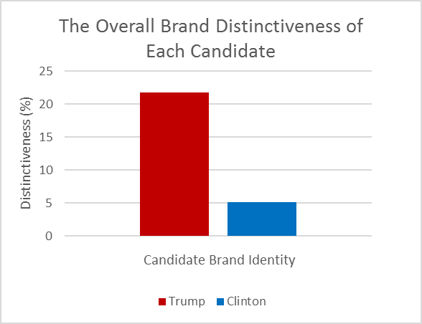

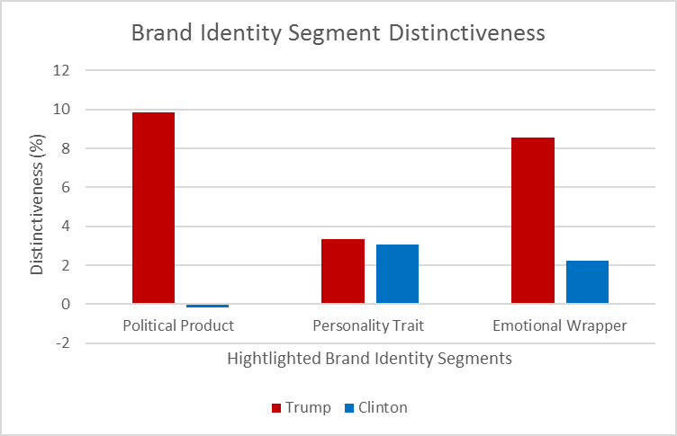Figure 1: Overall Brand Distinctiveness of each candidate

Figure 2: Brand Identity Segment Distinctiveness

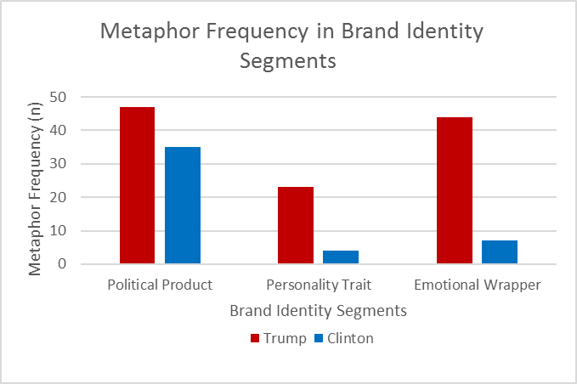

Figure 3: Metaphor frequency in brand segments

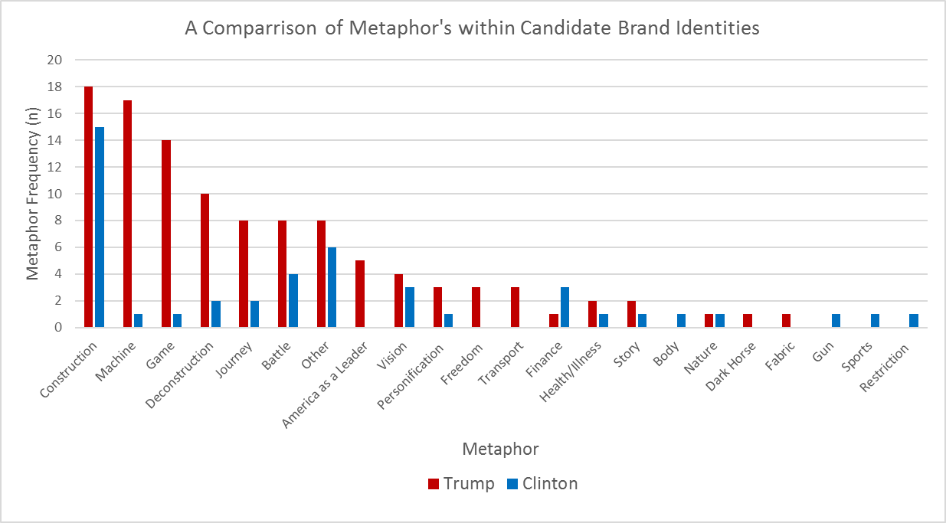

Figure 4: Comparison of metaphors

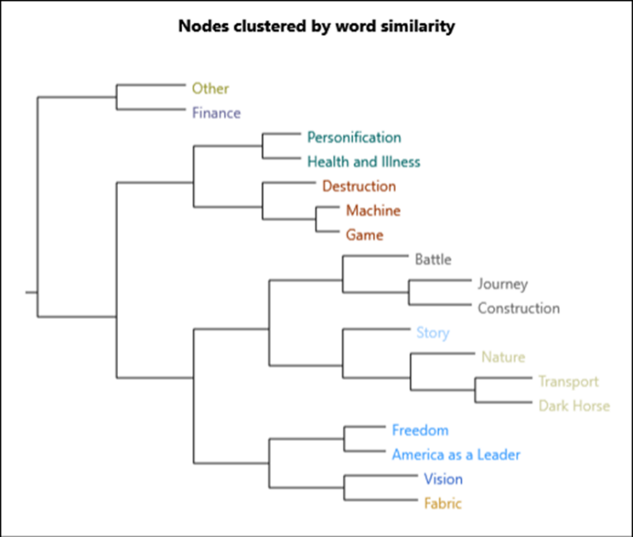

Figure 5: Trump’s metaphor theme cluster

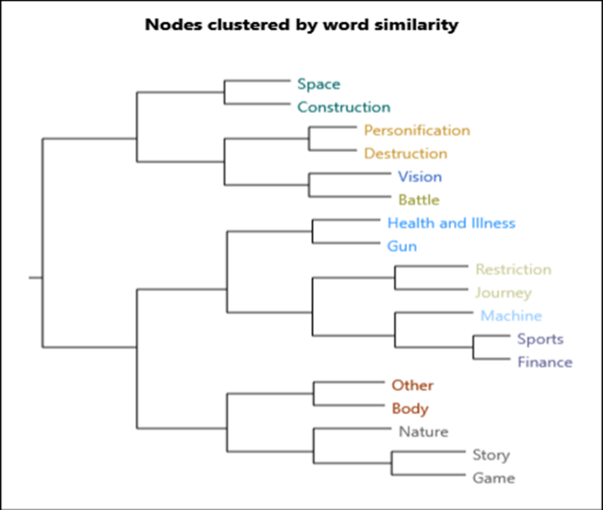

Figure 6: Clinton’s metaphor theme cluster

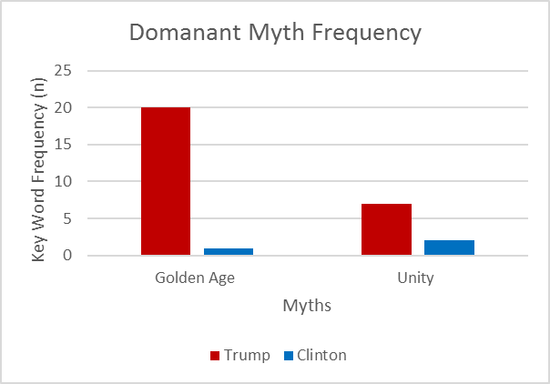

Figure 7: Dominant myth frequency

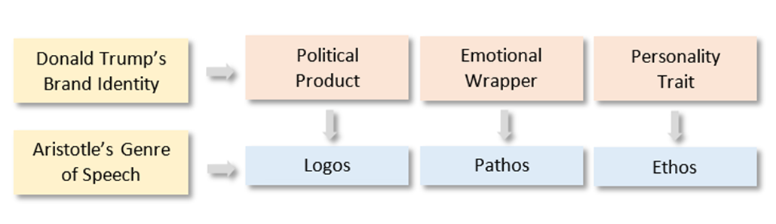

Figure 8