

An exploration into brand identity and brand image, and their relationship, in a modern film brand: A case study of J.K. Rowling’s Wizarding World

Leo Jordan BA (Hons) Marketing Communications, Faculty of Media and Communication: CMC Academic Group Jill Quest Senior Lecturer, Faculty of Media and Communication: CMC Academic Group Primary Contact: Jill Quest 01202 965244 jquest@bournemouth.ac.uk



December 11, 2017

Bournemouth University

Talbot Campus, Poole, Dorset, UK, BH12 5BB

Title Page

An exploration into brand identity and brand image, and their relationship, in a modern film brand: A case study of J.K. Rowling’s Wizarding World.

Abstract

This study explores brand identity, brand image and their relationship within the modern film brand of J.K. Rowling’s Wizarding World (JKRWW). The research builds upon literature into media and film brands (e.g. O'Reilly and Kerrigan 2013; Andreea 2013; Farhana 2014) as well as applying the body of academia around the relationship of brand identity and brand image (e.g. Aaker 1991; Kapferer 2004; de Chernatony 1999; Nandan 2005) to the area of film brands. A qualitative methodology is adopted consisting of ten in-depth interviews, three with film managers to understand brand identity, and seven with film consumers to understand brand image. Findings reveal the importance of the writer in the creation of JKRWW’s film brand identity and highlight how consumers relate to the brand’s characters regarding the brand image. There is a strong congruence between identity and image within the JKRWW brand which is to be recommended within film branding.

(149 words).

**Key words:** Brand Image, Brand Identity, Film Brands, Media Brands, Film Franchises.

# INTRODUCTION

In a world where cinematic box office figures are inconsistent and unpredictable (Hjort 2012) film studios are investing more resources into developing franchise and film brands (Bloomberg 2007). The strength of a powerful, well-known and trusted franchise is unquestionable (Mintel 2016). This has created a shift in the industry (Garrahan 2014) meaning film franchises have become powerful media brands on which studios widely rely to deliver larger, and less risky, profits. It is therefore vital to develop understanding of these brands.

Brand identity includes everything a company creates for a meaningful and unique interpretation of a brand (Kapferer 1986). Brand image on the other hand, refers to the set of beliefs held about that brand (Kotler 1993). Consequently, their relationship is vital. Furthermore, scholars argue congruence between the two concepts is needed to create a strong brand with loyal customers (Nandan 2005).

Significant academic research has taken place into understanding the relationship between brand identity and image (e.g. Nandan 2005, Graeff, 1997). However, there has been very little research around media brands and specifically film brands (O'Reilly and Kerrigan 2013). Similarly, while the well-established corporate media brands, for example, Disney or FOX, have become an area of enquiry over the recent years (Grainge 2007), there has been little academic research into their portfolios, and the film brands which create the largest, least risk bearing, profits for studios (Bloomberg 2007). Furthermore, due to their “unique peculiarities” (Siegert et al. 2015, p. 2) it has been speculated that researching and developing an understanding of media brands is not as simple as just applying previous brand management research. For this reason, this research will explore brand identity, image and their relationship within a modern film brand.

This research uses the film brand of JK Rowling’s Wizarding World (JKRWW) as a case study for exploration. Originating as Warner Bros’ hugely successful film brand, Harry Potter, the property has developed to become known today as ‘JK Rowling’s Wizarding World’, encompassing a wide range of media activity and new films such as the 2016 Fantastic Beasts and Where to Find Them.

The film brand category is valued at $25 billion dollars (Time 2016) and has been studied since its birth from various scholarly angles due to its immense popularity and impact on culture worldwide (Collider 2016). The Harry Potter texts have been studied from a literary stance in terms of how they, and consequently the brand, portray individual identity (Dorigato et al. 2015), religion (Feldt 2016) and gender (Karlsson and Olin-Scheller 2015). In addition to this, the brand has been studied from narrative psychology (Brown and Patterson 2010) and fandom (Alderton 2014) perspectives.

More relevant to this paper, is the study of the marketing and advertising of the franchise by Brown (2001) who proposed, as the first films were being released, its marketing approach was representative of a trend of ‘retro orientated’ marketing of film brands. The more recent research of Gaplin (2016) focuses purely on the production and visual style of the film. While it is clear that these are critical elements to a film brand, major drawbacks of these approaches are that they fail to consider a wider variety of elements which make a film brand’s identity and image. O'Reilly and Kerrigan (2013) suggest there are nine artistic and commercial areas which make up a film brand. This indicates deeper research considering both a more holistic and more analytical view of brand in terms of both identity and image is needed.

# LITERATURE REVIEW

## Media Branding

It has been argued that the power that successful media brands carry is indisputably valuable (Chan-Olmsted 2011). Research has shown perceptions of branding and branding practices to be an important management function (Chan-Olmsted and Kim 2001) confirming that managers are aware of the positive implications successful branding can have upon their bottom line profits. However, the area of media brands and researching around the management of these brands largely “remains a confused field, particularly concerning its scope, purpose and methods” (Küng 2007 p.21), indicating further study is required to enhance understanding on an academic level. Scholarly research, for example the research of Doyle (2015), has largely focused on the conglomerate firms and their corporate brand (Grainge 2007). It has largely failed to explore sub-brands, for example, the film brands that corporate media organisations manage. Exploration within this area would clearly be beneficial to the growing body of media branding literature.

## Brand Identity

Brand identity is a concept first mentioned by Kapferer (1986) who proclaimed that it includes everything a company desires for a meaningful and unique interpretation of the brand. Aaker (1991) adds to this, claiming that identity is the sum of brand meanings which can be expressed as a product, organisation, symbol or person, or a combination of all four. Emphasising Kapferer’s (1986) idea, it is thought a brand identity must pay attention to a differentiation that can offer sustainable competitive advantage to a company (Ghodeswar 2008). Therefore, it has been reasoned that the development of an identity, something which strongly relies on internal stakeholders (de Chernatony 1999), and coherent communication of this to potential consumers, is essential for a firm’s success. This point is stressed by Aaker (1991) and Keller (1993) who regard the creation and maintenance of brand identity is fundamental in building strong, successful brands.

In Layman’s terms, brand identity can be defined as “how a company seeks to identify itself” (Nandan 2005, p.265), indicating it originates from the company. However, Hatch and Schultz (2004) proclaim it is influenced by anyone who has an effect on the creation, maintenance, and change of a brand, including external stakeholders. Recent research (e.g. da Silveira et al. 2013; Brown et al. 2003) has posited consumers often take an active role as contributors to brand identity, due to the increasingly dynamic market environment. Brand identity is therefore becoming a more dynamic concept. Da Silveira et al. (2013) propose there are mutually influencing inputs from managers and other social constituents, for example consumers. However, this proposal relies on the assumption that brand identity is a socially constructed notion. Although it is clear brand identity has a social dimension, with the power to bring people together (Bernstein 2007), most research suggests the company is solely responsible for the creation of brand identity (Burmann et al. 2009) and that it remains a static concept (Kapferer 1986, Aaker 1996, de Chernatony 1999). Despite this, even when firms thoroughly define their brand identity, it is not guaranteed that the recipients will perceive the brand as intended (Siegert et al. 2011).

Several scholars (e.g. Aaker 1991; Kapferer 2004; de Chernatony 1999) have proposed frameworks suggesting the components which must be considered in creating and understanding a brand identity. An alternative interpretation to the four components Aaker (1991) lists is offered by Kapferer (2004). His widely referenced ‘brand identity prism’ (Figure 1), offers six intangible facets of brand identity: personality, physique, culture, relationship, reflection and self-image. Grounded in communications theory, Kapferer’s (2004) framework is consistent with the idea that “brands can exist only then when they communicate” (Janonis et al. 2007, p.73). Hence, the physique and personality facets have the role of the sender or ‘brand originator’, while the reflection and self-image represent the recipient or ‘brand receiver’ (Andreea 2013). Additionally, the vertical division highlights social expression of the brand through the facets on the left side, while the right side addresses the spirit of the brand by echoing the opposite side (Andreea 2013). While Kapferer’s model is widely accepted by scholars (Andreea 2013; Farhana 2014), critics of his approach to brand identity have argued the use of non-self-explaining sub-concepts such as personality or relationship is overly convoluted (Walser 2004). This lead to de Chernatony (1999) proposing an adapted model conceptualising the brand's identity in terms of vision and culture which, in turn, “drive its desired positioning, personality and the subsequent relationships” (p.166).

INSERT FIGURE 1

Comparing the frameworks proposed by seminal brand scholars, (Aaker 1991; Kapferer 2004; de Chernatony 1999) the facets they all share, are, personality, culture and relationship (Farhana 2014). Consequently, these facets can be argued as the most critical components in brand identity. Personality refers to the “human characteristics associated with the brand” (Aaker 1997 p.347), culture is defined by the values and principles upon which a brand acts (Kapferer 2004) and relationship means the bond between brand and consumer (de Chernatony 1999).

## Brand Image

A brand image can be defined as **“**the set of beliefs held about a particular brand” (Kotler 1993, p.269) and is constructed of consumers’ perceptions of a brand, formed during the process of decoding brand identity facets (Roy and Banerjee 2014) and reflected by the brand associations held in their memory (Keller 1993). Therefore, the brand image encapsulates the total impression an entity makes on the minds of others (Dichter 1985) and can be seen as a “true outcome of brand identity” (Janonis 2007 p.73). Keller (1993) asserts that to establish a successful brand image requires favourable, strong and unique associations. Furthermore, it has been suggested there is a lack of research around which kinds of brand associations are most beneficial or detrimental to the brand itself (Keller and Lehmann 2006). The research of Lutz (1991) and Faircloth et al. (2001) suggests that attitudes of consumers are the most important factor in consumers’ overall evaluation of a brand and, consequently, the creation of a brand image. Additionally, Gardner and Levy (1955) suggest that the overall personality or character of a brand is more important to the customer than the technicalities of the product.

An area of conflict in research lies in identifying the source of a company’s brand image, and where it is managed. Some argue the consumer is passive in the creation and management of brand image and companies can largely control their brand image (Park et al. 1986). On the other hand, opposing scholars argue the brand image only resides in the mind of the consumer, and this is where the image is created automatically, based on experiences with the brand (Bullmore 1984). Therefore, it can be presumed, based on the body of academia, while brand image is ultimately conceived in the minds of consumers, it is possible for brands to influence this through controlling consumer’s experiences with the brand through, for example, communications (Meenaghan 2007). This is emphasised by Graeff (1997) with his theory that the potential situation in which a product is consumed is paramount to the creation of brand image. Therefore, research exploring how much brand image can be influenced by the context in which it is consumed would be beneficial to academia.

## Relationship of Brand Identity and Brand Image

Scholars have argued brand analysis should view identity and image as intrinsically intertwined concepts (Konecnik and Go 2008). However, other literature suggests that identity and image should remain separate constructs, but a clear congruence and harmony between the two is needed in creating a strong brand with loyal customers (Nandan 2005). This research reinforces the notion that identity and image are multifaceted constructs (Dobni and Zinkhan 1990). Due to this, a drawback of much of the literature into the relationship between Identity and Image lies within inconsistencies in definitions of both constructs (Graeff 1997). This emphasises the importance of clearly defining the concepts to be explored as will be addressed within the following section, Media/Film Brand Identity and Image.

Despite the variable opinions of scholars discussed above, the idea that aligning the values and behaviour between brand and consumer creates a more powerful brand is consistent across academia. Furthermore, it has been suggested that further research investigating this congruence of these two concepts and how much this can be influenced by companies is necessary (Keller and Lehmann 2006).

## Media/Film Brand Identity and Image

With the above discussion of the nature and relationship of brand identity and brand image in mind, for the purposes of this paper, it important to define them in the particular context of a film brand. The following definitions are proposed:

*Film Brand Identity* - how a studio, marketer, or stakeholder aims to uniquely identify its offering to the consumer.

*Film Brand Image* - the set of beliefs held about a film or film franchise and its brand, in the mind of the consumer.

Farhana (2014) proposes brand identity in a media brand “plays a significant role to strike the right chord in the consumer’s mind” (p. 36) and thus can create long lasting impressions or short-term quick noise. Furthermore, Gerth (2010) suggests this identity is frequently hidden as media brands often may not call specifically what they are doing ‘brand management’, therefore making the brand identity less palpable often than that of a traditional brand. Andreea (2013) and Farhana’s (2014) studies explore media brand identity in the context of theatre and magazine brands respectively.

O'Reilly and Kerrigan’s (2013) research indirectly addresses the identity and image of media brands on a ‘film level’, and applies the ‘brandscape’ concept to the film brand. Considering both branding and film brand literature, a film brand can be defined as the intangible “artistic and commercial” construct (O'Reilly and Kerrigan 2013, p.774) that includes “name, term, design, symbol or any other feature that identifies” (Dibb et al. 1997, p.264) and endorses a film and all other relevant offerings, services or products around the film. Brandscapes have been defined as a cultural space in which brand meanings develop and are circulated within an ideological setting (Thompson and Arsel 2004). Sommer (2015) suggests that when applying a brand identity approach to the media, media product characteristics must be considered. Thus, O'Reilly and Kerrigan (2013) propose the film brand is made up from nine cultural and commercial categories (figure 2). This comprehensive approach can be praised as it incorporates areas of the film brand which previous film brand academia (e.g. Brown 2001; Brown and Patterson 2010; Gaplin 2016) and wider media brand research (e.g. Grainge 2007; Küng 2007) failed to include.

INSERT FIGURE 2

Looking more closely at the nine components of the film brand (figure 2), parallels can be drawn, and comparisons made between this and the brand identity prism (Kapferer 2004) discussed above. Due to a film brand being both an “artistic and commercial” construct (O'Reilly and Kerrigan 2013, p. 774) it is claimed the components cater to both sides of the brand. An example of this can be seen in the People and Characters sections. Aaker (1991) speaks of ‘brand as person’, widely referred to by other scholars as brand personality, as if the brand were a human being. In the context of film brands however, personification of the brand is made more possible due to the brand often consisting of contributions from a variety of real and imaginary human beings: both the people associated with the film brand (e.g. actors and director) and the characters they play. Furthermore, Guzmán and Paswan (2009) posit that brand personality dimensions are more prominent in entertainment and film brands meaning they can become “cultural anchors” (p. 79).

Contrasting the ‘film brandscape’ with the seminal brand identity frameworks proposed by Kapferer (2004), Aaker and Joachimsthaler (2000) and de Chernatony (1999), it is clear that one of the major drawbacks of the framework is its limited consideration of the intangible components that make up a brand. Practitioners and academics alike stress that a “brand is more than the sum of its parts” (Walser 2004) and argue that a brand’s identity is the product’s essence, its meaning (Kapferer 2004). In addition to this, Dupont and Augros (2003) proclaim films have become symbolic. Therefore, O'Reilly and Kerrigan (2014) suggest that research exploring the intangible symbolisms on top of the tangible components is required. Consequently, by combining key intangible facets of brand identity, discussed above, with O'Reilly and Kerrigan’s (2014) film brandscape framework a deeper exploration of the film brand’s identity and image can be conducted.

O'Reilly and Kerrigan’s framework overlooks much of the historical research into communications in general, upon which, it is widely accepted, much of brand identity and image theory draws (Kapferer 2004; Andreea 2013; Janonis et al. 2007). Kapferer (1986) emphasises how the brand identity is encoded by the company, or ‘brand originator’ and the brand image is decoded by the consumer or ‘brand receiver’. Consequently, with this linear route of the brand identity and image in mind, O'Reilly and Kerrigan’s (2013) framework can be developed to incorporate both encoding and decoding of the brand identity. Additionally, the possible dynamic nature (da Silveira et al. 2013, Brown et al. 2003) of branding should not be ignored and highlights the importance of adding a feedback loop from the consumer who may now have influence over a brand identity.

## Conceptualisation of the Film Brand Identity and Image

Using and developing the work of O'Reilly and Kerrigan (2013) overcomes problems of ignoring factors of the film brand as previous research has done (Brown and Patterson 2010; Gaplin 2016). The concept of O'Reilly and Kerrigan’s (2013) ‘brandscape’ has also been adapted to include where both the film’s brand identity and brand image fit based upon previous literature discussed.

INSERT FIGURE 3

## Literature Gap

While research into brand identity and image in the context of media brands has been conducted (Andreea 2013; Farhana 2014), gaps in literature have been highlighted in the lack of research exploring this specifically within the context of a film brand. Similarly, film brands have become an area of enquiry academically (O'Reilly and Kerrigan 2013) but there is an absence of research combining seminal ideas (Aaker 1991; Kapferer 2004; de Chernatony 1999) around the concepts of identity and image as well as more contemporary approaches to film brands.

# 

# RESEARCH AIMS AND OBJECTIVES

## Research Aim

To explore brand identity and image, and their relationship, within the context of a modern film brand.

## Research Objectives

1. To gain insight into the brand identity of the JKRWW brand from the company perspective.
2. To have an in-depth understanding of the brand image of the JKRWW brand from the consumer perspective.
3. To explore the congruency between the brand identity and brand image of JKRWW.

# Methodology

Consistent with an interpretivist philosophy (Proctor 2005) this study used an inductive approach. A mono method qualitative design was deemed appropriate to explore people’s diverse options and perceptions (Punch 2005). Qualitative data yielded rich insights (Cresswell 2007) and themes and patterns in the data were identified to reach a conclusion (Thomas 2006). Key research (e.g. Andreea 2013; Farhana 2014) use qualitative methods in exploring brand identity and image in a media brand, thus further indicating the suitability of this method. In addition, Dobni and Zinkhan (1990) maintain that broader research into brand image has largely used quantitative methods, failing to discover opinions and perceptions more deeply, leaving an opening for research using a qualitative approach.

To enable the research to effectively explore participants’ perceptions, experiences and opinions, (Patton 1990) ten in-depth interviews were conducted. The brand image sample frame consisted of a mixture of seven men and women aged 18-28 with an interest in JKRWW (figure 4). Three were with members of marketing departments responsible for creating and marketing the JKRWW brand to understand brand identity and seven were with consumers of the JKRWW brand to understand brand image. Conducting the interviews in the participant’s home or workplace, where possible, provided the warm and comfortable setting required (Cresswell 2007)**.** All interviews lasted for between 50 minutes and 1 hour and were structured by an interview guide designed around the key facets of film brand identity and image, as discovered from the literature reviewed and proposed within the conceptual framework.

INSERT FIGURE 4 HERE

A non-probability sampling method, a form of purposive sampling, enabled use of the researcher’s knowledge and judgment to select respondents who were best suited to enable the study to meet its research objectives (Proctor 2005) as opposed to reverting to chance (Malhotra and Birks 2006). This sampling method was therefore deemed suitable for both rich and insightful data to be collected and was employed in the generating both the brand identity and brand image sample frames.

In line with the well-recognised approach of Miles and Huberman (1994), recordings from each interview were transcribed and thematic coding was used to reduce the data into themes. This was achieved using the research aim and objective (Proctor 2005) as well as the key tangible and intangible facets of film brand identity and image discovered earlier. Both a priori (predetermined) themes, such as ‘genre’ and ‘music’, and emergent (unexpected) themes, such as ‘relatability’ and ‘storyline’, were used to categorise the data and identify key findings.

Foreseeable limitations in this study’s methodology were apparent in the qualitative nature of the study and the interpretivist stance. Due to the qualitative method of interviews used, it is possible the conformability of the study may have been reduced by researcher bias in both gaining and analysing the data (Given 2008). Furthermore, the interpretivist stance adopted by the researcher meant that someone else analysing the same data may interpret it in a different way and draw different conclusions (Creswell 2007). Nevertheless, it was concluded that the limitations in this study were relatively minimal and, where needed, methodological decisions were appropriately justified by previous research and literature.

# FINDINGS, DISCUSSION AND ANALYSIS

The three research objectives are used to structure this section. Interviews collected data concerning the facets of the film brand proposed in the conceptual framework. Within brand identity, ‘people’ surfaced as particularly salient from WB’s point of view and a new, emergent theme, ‘storyline’, was also prominent. In brand image, the themes of ‘brand relationships’, ‘relatability’ and ‘subcultural ties’ were frequently discussed.

Objective 1

To gain insight into the brand identity of the JKRWW brand from the company perspective.

The film brand identity was found to be how the company, in this case WB, seeks to identify each of its individual film brands, rather than its corporate brand. One WB manager, Charlie, said that the studio comprised of “*several huge franchise brands all with very different identities*’’. This conflicts with the view of Nandan, who argued that brand identity was “how a company seeks to identify itself”(2005, p.265). The general view of the WB managers agreed with the definition of film brand identity proposed by the present author earlier. Contrary to argument of Gerth (2010), all the WB professionals interviewed spoke of managing the brand in a way somewhat like traditional brand management. This confirms Chan-Olmsted and Kim’s (2001) view that branding practices are an important management function within the media industry.

### People

J.K. Rowling was found to be the most important person to the brand, by a considerable margin. One manager explained,

“*We call her out on everything… they’ve established what they call a kite mark… and the very fact that her name is on it there says to me that she is the most important asset*.” (Charlie)

Interestingly, J.K. Rowling was often referred to as an ‘asset’. While as the writer, she is concerned with the artistic side of the film brand, it is clear the studio value her for the commercial value she adds. This develops academic knowledge, such as the work of O’Reilly and Kerrigan (2013), by indicating where in the development of the brand these two areas may be created and connected. However, it contradicts the findings of Burmann et al. (2009) and Kapferer’s (1986) by indicating the company is not solely responsible for the creation of brand identity, as here, it is the writer, not the studio who holds the strongest influence.

It was found that the transference of JK Rowling’s liberal personal values to the brand was vital in creating its identity. By placing her name on any brand communications, WB hope to instantly create both an identity and integrity, based around her and what she stands for. This finding supports Thompson and Arsel (2004) whose theory suggests brand identity is often formed around an ideological setting. The finding also confirms Hatch and Schultz’s (2004) theory by suggesting that anyone who has an influence on the creation, maintenance, and change of a brand has a strong influence over its brand identity. It also indicates who may be most influential in creation of brand identity within JKRWW. Furthermore, this finding sheds light on how Aaker’s (1991) ‘brand as person’ theory could be applied to a film brand.

### Music

The use of light and magical music, where possible, across all brand touch points was found to be used to establish the brand identity in two ways. Firstly, for newcomers to the brand it establishes a feeling of mystery, magic and lightness. Secondly, for established consumers it acts as what Charlie called a ‘*sonic cue*’, acting as a connection between all areas of the brand, supporting O’Reilly and Kerrigan’s (2013) idea that music can act as a “brand cue” (p. 774). Furthermore, they speculated that music is uniquely important to a film brand. By using familiar music from previous films when marketing new ventures, it is hoped the music is so ingrained in the identity of the brand that it reinforces to consumers the origin of the new product and evokes positive memories.

### Locations, Country of Origin (COO) and Brand Relationship

Quintessential ‘Britishness’ was found to be the key to all locations within JKRWW, as Gabi, the international franchise manager said; *“I think the Britishness is a huge thing for Harry Potter”.* Managers claimed ‘Britishness’ brought charm to the brand for foreign consumers, and pride and ‘connectedness’ for British consumers. The idea that the world created in the film brand ‘lives among us’ was also found to be a key aspect of JKRWW’s identity, indicating the ‘brand relationship’ which may have formed and a cultural tie the brand may hold for consumers, as discussed further in objective two. This finding presents an alternative view point to that of Burmann et al. (2009) by indicating there is a reliance upon factors external to the company, such as pre-constructed ideas in the minds of consumer, in creating brand identity. Consequently, this develops the work of Bernstein (2007) by indicating where the social dimensions of brand identity may lie in the context of a film brand.

### 

### Brand Extensions and Placed Brands

Values of quality and premium-ness were found to be key in the brand extensions, such as the studio tour, stage show and merchandise. With a strong set of values intentionally being transferred from brand to extension regularly, it’s thought the identity is reinforced and the brand can remain very relevant years after films are released. It was found these extensions have often become artistic entities in themselves. This challenges O’Reilly and Kerrigan’s (2013) idea that brand extensions sit firmly on the commercial side of the film brand. Furthermore, avoidance of product placement was seen to be a deliberate decision aimed at reinforcing the artistic integrity of the brand’s identity;

“*The feature very much stands as its own powerhouse, it is an established franchise so it doesn’t need to have that endorsement.*” (Clara)

### Brand Personality, Brand Culture, Brand Relationship, Genre, Storyline and Characters

The brand personality was found to often transfer strongly from the tangible facets associated with the JKRWW, namely the people (as discussed earlier), characters and, the emergent theme, storyline. Storyline is an area that is largely absent from research around brand identity in film brands, but was significant in this study, with managers commenting the brand’s identity “*would be nothing without its story.*” (Charlie) Furthermore, the key areas of personality created in JKRWW’s identity were ‘family’, ‘courage’ and ‘inclusivity’. Inclusivity was also emphasised by not confining the films to a narrow genre. The idea that everyone is welcome was a notion which came up regularly and is summarised in this quote,

“…*there’s kind of like a family about it, you’re being invited into another world.*” (Charlie)

Similarly, the role of culture was found to be largely reliant on the transference of values and attributes from the people and characters involved. The connectedness aimed to be created between brand and consumer was found to be reliant upon the stories, which are both fundamentally created and encoded by J.K. Rowling. This challenges Kapferer’s (1986) by suggesting the writer encodes the brand identity and plays the part of the ‘brand originator’ in this case.

Summary

It is very interesting, and a potential contribution to knowledge, that this exploration into brand identity has highlighted how key tangible areas of the film brand, such as people, and new facets such as storyline, have strong impacts on the intangible areas of the film brand, as proposed in the author’s conceptual framework. Furthermore, some aspects of the brand’s personality, for example its positive representation of family, have attempted to encourage the development of something close to a ‘Harry Potter’ subculture rather than merely a collection of consumers.

Objective 2

To have an in-depth understanding of the brand image from consumers.

Subculture(People, Locations, Music, Brand Extensions)

An overarching theme was identified in which cultural ties and a subculture played a strong part in the creation of JKRWW brand image. This subculture meant a fundamental part of the brand’s image was that it connected people to each other and became as Liam described it, “*a conversation starter*”. This firmly supports Bernstein’s (2007) theory that brand image has the power to bring people together. Furthermore, a strong emphasis was placed on the importance of the people with whom the brand was consumed, and the locations in which it was shared by participants. As shown in the below quote, many participants had fond memories of watching the films in family homes;

“*My old house, where I’d be wrapped up in a blanket watching the films religiously!*” (Jack)

This finding develops the ideas of Graeff (1997) and Bullmore (1984) by highlighting the specific importance of the social situation at the time of consumption to the brand and the transference of associations between the people consuming the brand. Therefore, in the case of JKRWW, the values of ‘inclusion’ and ‘family’ have been transferred to the film brand’s image. Additionally, brand extensions, such as the WB Studio Tour and the stage show, which involved experiences that could be consumed with friends or family, were found to play a further key role in strengthening the consumers’ associations with JKRWW.

“[at the studio tour] *you feel like you're in it and it’s so fun sharing that with people who you’d watched the films with*.” Tony [*sic*]

This finding further builds upon the work of Guzmán and Paswan (2009) who propose the brand image within a film brand can act as a ‘cultural anchor’, by indicating that people connect, in the case of JKRWW, on a subcultural or community level. Furthermore, it was found that music had the ability to elicit strong emotions within consumers and remind them of these positive nostalgic feelings and the people they had shared the brand with in the past, thus further linking the subcultural ties that JRWW held for consumers.

“[the music is] *very nostalgic so I’d think of childhood and stuff, I’d think of like, you just kind of, it takes you back.*” (Sarah)

This develops the work of Dibb et al. (1997) by adding music to their list of brand identifiers. Music is clearly particularly important in the formation of brand image in film.

### Placed Brands

A less salient but still notable finding was that JKRWW’s avoidance of product placement was regarded as highly positive by participants. This develops the findings of O’Reilly and Kerrigan (2013) who merely look at placed brands from a financial point of view and fail to consider the possibly negative effect this on the film brand.

“[the fact there is no product placement]… *makes it a bit more credible, it is its own brand and it doesn’t need to jump on somebody else’s hype.*” (Sarah)

### Brand Personality and Brand Culture

‘Mysterious’, ‘inviting’, ‘whimsical’ and ‘layered’ were the most common personality traits attached to JKRWW. In contrast to the research of Gardner and Levy (1955), it was found consumers of JKRWW valued the product, (the films), more than the overall personality of the brand. This suggests an area where film brands differ from more conventional product brands. However, product and personality were found to be highly intertwined and hard to separate as areas of the film brand in this case.

Similarly, when exploring the role of culture within JKRWW’s brand image, consumers found it hard to separate this intangible concept from the film itself. This lead to consumers identifying the ‘brand culture’ with the values of characters they most strongly associated with the films themselves, thus providing an interesting link to salient findings from the brand identity:

“…*it holds very strong family values, that’s from the story, it’s all about him trying to create and have a family. Big strong family values, loyalty and friendship.*” (Beth)

### Brand Relationship, ‘Relatability’, Storyline, Characters and COO

Consumers reported a strong bond between themselves and JKRWW. Most consumers saw the brand as an old friend, with many referencing comfort and nostalgia:

“*It’s just a nice reliable source that’s always there, it’s comforting… and makes me happy.*” (Jess)

The relatability and connectedness participants found with both the storyline and characters of JKRWW was found to be a primary area in building brand image. It was found that the connection between consumer and brand, enabled deeper brand relationships to be formed over a long period of time.

“…*watching Harry essentially going through secondary school, that was at the same time as I was going through secondary school, I was making the same transactions. I think it’s like I feel connected to it because it’s so relatable.*” (Kyle)

It was found that the majority of participants felt they could relate more to a film brand than a more conventional product or brand, a previously under-researched area. In the case of JKRWW, this was strengthened for respondents with the British COO the brand held. Many participants identified storyline as the most important area in brand image creation. This finding adds to the research of Janonis et al. (2007) by suggesting that the more a brand communicates with customers, the stronger the relationship can become. In the case of JKRWW, by having characters and storylines to which the consumer of the film brand can relate, the relationship is strengthened. Furthermore, it could be speculated, consistent with Keller’s (1993) school of thought, stronger associations could be formed to JKRWW due to the relatability of the films demonstrated in Kyle’s response.

The dynamic nature (da Silveira et al. 2013) of brand image was confirmed with consumers feeling a two-way flow in their ‘relationship’ with the brand via dialogues on social media sites. This challenges Park et al. (1986) theory that consumers are passive in the creation and management of brand image.This develops the work of Roy and Banerjee (2014) by demonstrating there are different levels to how much a brand identity is decoded and that it impacts creation of a brand image within a film brand.

Summary

The subcultural or community ties highlighted within this exploration into brand image within JKRWW are of particular prominence due to their sizeable impact upon the creation of brand image and how they make the brand a conversation starter and reference point. The lack of research around this area previously means this provides a useful contribution to knowledge. Similarly, the theme of ‘brand relationship’ and the notion of ‘relatability’ is of particular interest as it spanned across multiple other facets of the film brand, such as characters and storyline, thus both extending and developing academic knowledge to date.

Objective 3

To explore the congruency between the brand identity and brand image of JKRWW

While the ‘brand relationship’ between consumer and brand has been discussed in depth in the previous two objectives, this objective is exploring the congruence (or lack of it) between the two concepts, brand identity and brand image.

The research suggests the congruency between brand identity and brand image of JKRWW was very high. However, there were some areas of the film brand where this congruence was less. It was found that brand image, created in the minds of consumers of JKRWW, was more reliant upon the brand identity, created by J.K. Rowling and WB than the identity was reliant upon the image. However, the two concepts, in the case of JKRWW, were fundamentally intertwined and reliant upon each other, thus developing Konecnik and Go’s (2008) theory to the context of film brands.

### Prominent Congruencies

The strongest areas of congruence between JKRWW’s brand identity and image were identified as associations around ‘brand relationships’ and ‘subcultural ties’. As highlighted throughout objective 1 and 2, these areas of prominence were particularly strong within the film brand. Consequently, it could be speculated that a strong congruence between identity and image, as JKRWW clearly has, may result in as stronger bond with consumers in terms of ‘brand relationship’.

“*It feels like* [the brand and I] *are on the same page, I think that’s why I feel so connected to it.”* (Tony)

While this points in the direction of an interesting contribution to knowledge of these concepts within film brands, as shown, both the concepts and the relationship between them, are dynamic in nature (da Silveira et al. 2013), therefore the direction of this strong congruence cannot be fully understood without further research.

A strong linkage was also found in many other facets of the film brand between brand identity and “the set of beliefs held” (Kotler 1993, p.269) by the customers, the brand image. These were identified as people, locations, COO, music, brand extensions, placed brands and culture. Consequently, as shown, brand identity and image were strongly correlational with many areas of JKRWW, which, if considering Nandan’s (2005) theory, would suggest the brand is in a very strong and successful position.

### Prominent Incongruences

The main points of dissimilarity were found in the associations around the genre of JKRWW. It was identified that the brand managers aimed for the genre to be largely unclassified, as demonstrated by Clara “*It's a cinematic event, it isn't a genre! (*Laughs*)*” and this increases the ‘inclusivity’ of the brand. However, the consumers of the brand held strong associations of fantasy when asked about genre. The finding of a dissonance between these two areas was interesting and largely inexplicable. However, further probing of consumers found the concept of genre to be more fluid than other areas of the film brand explored.

# CONCLUSION

This research intended to explore brand identity and image, and, consequently, the relationship between the two concepts within a modern film brand. This study has responded to Küng’s (2007) observation regarding the confusion within the management of film brands and defined the scope, purpose and methods of this research. By conducting explorative, qualitative primary research in the form of in-depth interviews with both managers and consumers of the brand, the congruence between brand identity and image was analysed and the findings demonstrate useful theoretical implications and practical recommendations.

Key findings around brand identity revealed the importance of people, specifically the writer and creator of the stories, in the creation of JKRWW’s brand identity. The direct impact that this had on the creation of the intangible areas of brand identity such as personality, culture and relationships was also highlighted. This lead to values of ‘family’, ‘courage’ and ‘inclusivity’ being identified as integral to JKRWW’s brand identity.

Findings from exploring JKRWW’s brand image highlighted the importance of the depth of ‘brand relationship’ which had been created between JKRWW and consumers due to the ‘relatability’ they found in the characters and storylines. This finding is of particular interest, and may offer a new perspective to film brands and a potential contribution to wider film brand knowledge. As suggested at the beginning of this paper, film and media brands have “unique peculiarities” (Siegert et al. 2015, p. 2) when comparing them, in research terms, to more conventional brands. Consequently, the prominence of the theme of ‘relatability’ experienced by consumers of JKRWW within many of the areas of the film brand, especially in their comparisons to ‘conventional brands’, may indicate from where some of these unique aspects of a film brand may emerge. Another of these ‘unique peculiarities’ can be seen in the subculture that has been created among consumers of JKRWW.

These findings concluded that the congruence between identity and image of JKRWW was very strong. It was proposed that the strength in congruity may have enabled a stronger bond with consumers in terms of ‘brand relationship’ to be formed. However, the two concepts were not fully harmonious in the case of JKRWW. Areas of conflict between the two concepts were found to lie in associations around the genre of JKRWW with managers of the brand and consumers clearly having different feelings around categorisation of this area of the brand.

## 

## Revised Conceptual Framework

INSERT FIGURE 5 HERE

The conceptual framework which guided this study, has been further developed as a result of the findings to aid future research around film brands (figure 5). The layout and direction of flow of the framework was an effective structure for exploring brand identity and image within film brands. Within the original conceptual framework, it was considered that brand relationship was a facet of the film brand. However, the findings suggest it may play a deeper role within, and be a consequence of, multiple facets of the film brand. Multiple areas of the film brand such as People, Characters, Brand Extensions, Locations and COO, as well as emergent areas such as Storyline, often linked back to this overarching theme of a deep ‘brand relationship’ or connection between brand and consumer. Therefore, it is now proposed that ‘brand relationship’ is a concept which feeds out of the larger body of facets of the film brand. Furthermore, the facets ‘storyline’ and ‘relatability’ have been added to the framework, as these were the key emergent themes the research produced. Finally, due to the similarity the research found between ‘locations’ and ‘COO’ these have been grouped together.

## Managerial Implications

As was proposed by Mintel (2016) in the introduction of this paper, the strength of a powerful, well-known and trusted franchise is unquestionable. This research has shown that with a strong congruence between its brand identity and image, a film brand can become incredibly powerful in the minds of consumers thus proving the relevance of Nandan’s arguments (2005) to the context of film brands.

This case study has shown, that the depth of the offering and the level of connection and ‘brand relationship’ a film brand can strike between itself and its consumers is significant. Additionally, this paper has also provided managers, through its revised conceptual framework, a guide to components which are vital in creating a film brand’s identity and consequently hold strong impact on its brand image, as well as a visual display of how this process works. By building on research from seminal branding scholars (e.g. Aaker 1991; Kapferer 2004; de Chernatony 1999) and applying their work to the world of film brands this paper has provided marketing and brand managers within the film industry with a concurrent application of past branding literature to their line of work.

Finally, in the case of JKRWW, the role of the relatability of people and characters, and the transference of values from these areas to the wider film brand was found to be a key area of its brand image. Therefore, in marketing the film brand further, WB could consider utilising this by placing an emphasis on the stories of individual people, for example J.K. Rowling, or characters, in their marketing.

## Limitations and Recommendations for Future Research

As little research into brand identity and image within film brands had previously been conducted academically this research makes an interesting initial exploration into this subject. However, it became apparent during the research that due to only exploring one film brand, with the case study of JKRWW, findings were often specific to this case and therefore less generalisable across film brands. Consequently, further research in this area could take a more comprehensive approach by considering a range of film brands and explore whether a strong congruence between the brand identity and brand image leads to strong ‘brand relationships’.

Due to the age of participants interviewed, many had grown up with the characters in the films which may have meant they found the characters them more relatable; they were thus able to form a stronger relationship or bond with the brand. To understand if this is the case, further research could investigate JKRWW with a more demographically mixed sample, representative of the entire population of consumers.

The use of the conceptual framework, while guiding the research and formation of the interview guide in an effective manner and ensuring the study was grounded in past literature, occasionally limited the boundaries of the in-depth interviews. Although techniques such as ‘shared leadership’ were used to counter this, a less rigid and inflexible conceptual framework, which future research may want to consider using, might yield alternative findings.

Finally, this study relied upon qualitative research which can be commended for its ability to explore participants’ feelings and attitudes (Punch 2005). However, it would be beneficial for future research to consider quantitative methods to empirically test some of the key findings around film brand identity and image that this research has uncovered.

## Summary

This research has emphasised the importance of harmony between brand identity and image in maintaining a strong film brand and highlighted the nuances within both the brand identity and image of JKRWW. It has also provided a potentially significant contribution to knowledge by indicating that a strong congruence between the brand identity and brand image within a film brand may lead to stronger ‘brand relationships’ to be formed between film brand and consumer. It is hoped this study will fuel further research into media brands, film brands and the concepts of brand identity and image in the future.

7643 words

# 

# References

Aaker, D. and Joachimsthaler, E., 2000. *Brand Leadership*. New York: Free Press.

Aaker, D., 1991. *Managing Brand Equity*. San Francisco: Jossey Bass.

Aaker, D., 1996. *Building strong brands*. London: Simon & Schuster, Free Press.

Aaker, J. L., 1997. Dimensions of Brand Personality. *Journal of Marketing Research*, 34 (3), 346-356.

Alderton, Z., 2014. ‘Snapewives’ and ‘Snapeism’: A Fiction-Based Religion within the Harry Potter Fandom. *Religions*, 5 (1), 219-267.

Andreea, C., 2013. Exploring Kapferer’s Brand Identity Prism Applicability in Theatre. *International Journal of Advances in Management and Economics*, 2 (2), 18-23.

Bernstein, J. S., 2007. *Arts Marketing Insights: The Dynamics of*. San Francisco: John Wiley & Sons, Inc.

Bloomberg, 2007. *Film Franchises Ensure Hollywood Success*. New York: Bloomberg. Available from: <https://www>.bloomberg.com/news/articles/2007-08-08/film-franchises-ensure-hollywood-successbusinessweek-business-news-stock-market-and-financial-advice [Accessed 3 February 2017].

Brown, S. and Patterson, A., 2010. Selling stories: Harry Potter and the marketing plot. *Psychology & Marketing*, 27 (6), 541-556.

Brown, S., 2001. Marketing for Muggles: Harry Potter and the Retro Revolution. *Journal of Marketing Management*, 17 (5), 463-479.

Brown, S., Kozinets, R, V. and Sherry Jr, J, F., 2003. Teaching old brands new tricks: retro branding and the revival of brand meaning*. Journal of Marketing,* 67 (3), 19–33.

Bullmore, J., 1984. The Brand and its Image Revisited. I*nternational Journal of Advertising*, 3, 235-238.

Burmann, C., Jost-benz, M. and Riley, N., 2009. Towards an identity-based brand equity model. *Journal of Business Research*, 62 (3), 390–397.

Chan-Olmsted, S. and Kim, Y., 2001. Perceptions of Branding among Television Station Managers: An Exploratory Analysis. *Journal of Broadcasting & Electronic Media*, 45 (1), 75-91.

Chan-Olmsted, S., 2011. Media branding in a changing world: Challenges and opportunities 2.0. *The International Journal on Media Management*, 13, 3-19.

Collider, 2016. *How ‘Harry Potter’ Became An Escapist Saga for Millennials in a Post-9/11 World*. Collider, Available from: http://collider.com/harry-potter-impact-on-millennials-post-911/ [Accessed 13 February 2017].

Cresswell, J. W., 2007. *Qualitative inquiry and research design: Choosing among five approaches*. 2nd ed. California: SAGE.

da Silveira, C., Lages, C. and Simões, C., 2013. Reconceptualising brand identity in a dynamic environment. *Journal of Business Research*, 66 (1), 28–36.

de Chernatony, L., 1999. Brand Management through Narrowing the Gap between Brand Identity and Brand Reputation. *Journal of Marketing Management*, 15 (1-3), 157–79.

Dibb, S., Simkin, L., Pride, W.M. and Ferrell, O.C., 1997, *Marketing: Concepts and Strategies.* 3rd ed. Houghton Mifflin: Boston.

Dichter, E., 1985. What's In An Image. *Journal of Consumer Marketing*, 2 (1), 75-81.

Dobni, D. and Zinkhan, G.M., 1990. In Search of Brand Image: A Foundation Analysis. *Advances in Consumer Research*, 17, 110-119.

Dorigato, L., Philip, G., Bongelli, R. and Zuczkowski, A., 2015. Knowing, Unknowing, Believing stances and characters' dialogic identities in the Harry Potter books. *Language & Dialogue*, 5 (1), 62-89.

Doyle, G., 2015. Brands in International and Multi-Platform Expansion Strategies. *In:*

Dupont, N. and Augros, J., 2003. Cinema and Marketing: When Cultural Demands Meet Industrial Practices. *InMedia, The French Journal of Media and Media Representations in the English-Speaking World*, 3, 1-7.

Easterby-Smith, M., Thorpe, R., Jackson, P. and Lowe, A., 2008. *Management Research*. 3rd ed. London: Sage.

Faircloth, J., Capella, L. and Alford, B., 2001. The Effect of Brand Attitude and Brand Image on Brand Equity, *Journal of Marketing Theory and Practice*, 9 (3), 61-75.

Farhana, M., 2014. Implication of Brand Identity Facets on Marketing Communication of Lifestyle Magazine: Case Study of A Swedish Brand. *Journal of Applied Economics and Business Research*, 4 (1), 23-41.

Feldt, L., 2016. Harry Potter and Contemporary Magic: Fantasy Literature, Popular Culture, and the Representation of Religion. *Journal of Contemporary Religion*, 31 (1), 101-114.

Galpin, S., 2016. Harry Potter and the Hidden Heritage Films: Genre Hybridity and the Power of the Past in the Harry Potter Film Cycle. *Journal of British Cinema & Television*, 13 (3), 430-449.

Gardner, B. G. and Levy, S. J., 1955. Harvard Business Review. *The Product and the Brand*, 33-39.

Garrahan, M., 2014. The rise and rise of the Hollywood film franchise. *Financial Times*, 12 December 2014, Available from: <https://www.ft.com/content/192f583e-7fa7-11e4-adff-00144feabdc0>

Gerth, M., 2010. Brand management of small regional media companies. *European Media Management Education Association annual conference on The Changing Ecology of the Media*. London: European Media Management Education Association.

Given, L. M., 2008. *The Sage encyclopedia of qualitative research methods*. USA: Sage Publications.

Ghodeswar, B. M., 2008. Building brand identity in competitive markets: a conceptual model. *Journal of Product & Brand Management*, 17 (1), 4-12.

Graeff, T.R., 1997. Consumption Situations and the Effects of Brand Image on Consumers' Brand Evaluations. *Psychology & Marketing*, 14, 49-70.

Grainge, P., 2007. *Brand Hollywood: Selling Entertainment in a Global Media Age*. London: Routledge.

Guzmán, F. and Paswan, A. K., 2009. Cultural Brands from Emerging Markets: Brand Image Across Host and Home Countries. *Journal of International Marketing*, 17 (3), 71-86.

Hatch, M. J. and Schultz, M., 2004. *Organisational Identity*. Oxford: Oxford University Press.

Hjort, M., 2012. *Film and Risk.* Michigan: Wayne State University Press.

Janonis, V., Dovalienė,, A. and Virvilaitė, R., 2007. Relationship of Brand Identity and Image. *Engineering Economics*, 1 (51), 69-80.

Kapferer J. N., 2004. *The new strategic brand management: Creating and sustaining brand equity long term*. 3rd ed. Kogan Page: London.

Kapferer, J. N., 1986. *Beyond positioning, retailer’s identity*. Brussels: ESOMAR.

Karlsson, M. and Olin-Scheller, C., 2015. 'Let's party!' Harry Potter fan fiction sites as social settings for narrative gender constructions. *Gender & Language*, 9 (2), 167-188.

Keller, K. and Lehmann, D., 2006. Brands and Branding: Research Findings and Future Priorities. *Marketing Science*, 25 (6), 740-759.

Keller, K. L., 1993. Conceptualizing, measuring, and managing customer-based brand equity. *Journal of Marketing*, 57 (1), 1-22.

Konecnik, M. and Go, F., 2008. Tourism destination brand identity: The case of Slovenia. *Journal of Brand Management*, 15 (3), 177–189.

Kotler, P., 1993. *Marketing Management: Analysis, Planning, Implementation and Control*. 8th ed. United States: Prentice Hall.

Küng, L., 2007. Does Media Management Matter? Establishing the Scope, Rationale and Future Research Agenda for the Discipline. *Journal of Media Business Studies*, 4 (1), 21-39.

Lincoln, Y.S. and Guba, E.G., 1985. *Naturalistic Inquiry*. Newbury Park: SAGE.

Lutz, R. J., 1991. The Role of Attitude Theory In Marketing. *In:*Kassarjian, H. H. and Robertson, T.S. (eds) *Perspectives in Consumer Behaviour* 3rd ed. Englewoods Cliffs NJ: Prentice Hall.

Malhotra, N.K. and Birks, D.F., 2006. *Marketing Research: An applied approach*. 3rd ed. Harlow: Prentice Hall

Miles, J. and Huberman, M., 1994. *Quantitative Data Analysis*. UK: Sage Publications.

Meenaghan, T., 1995. The role of advertising in brand image development, *Journal of Product & Brand Management*, 4 (4), 23–34.

Mintel, 2016. Cinemas - UK - November 2016. London: Mintel Group. Available from: <http://academic.mintel.com/display/748820/>

Nandan, S., 2005. An exploration of the brand identity–brand image linkage: A communications perspective. *Journal of Brand Management*, 12 (4), 264–278.

O'Reilly, D. and Kerrigan, F., 2013. A view to a brand: introducing the film brandscape, *European Journal of Marketing*, 47 (5), 769 – 789.

Patton, M. Q., 1990. *Qualitative Evaluation And Research Methods*. 2nd ed. USA: Sage.

Proctor, T., 2005. *Essentials of marketing research*. 4th Edition. UK: Pearson Education Limited.

Roth, M. and Romeo, J., 1992. Matching Product Category and Country Image Perceptions: A Framework for Managing Country-Of-Origin Effects, *Journal of International Business Studies*, 23 (3), 477-489.

Roy, D. and Banerjee, S., 2014. Identification and measurement of brand identity and image gap: a quantitative approach, *Journal of Product & Brand Management*, 23 (3), 207 – 219.

Siegert, G., Förster, K. and Chan-Olmsted, S., 2015. *Handbook of Media Branding*. New York: Springer.

Siegert, G., Gerth, M. A. and Rademacher, P., 2011. Brand identity-driven decision making by journalists and media managers — The MBAC model as a theoretical framework. *International Journal on Media Management*, 13 (1), 53-70.

Sommer, C., 2015. Media Brand and the Advertising Market. *In:*Siegert, G., Förster, K. and Chan-Olmsted, S., eds. *Handbook of Media Branding*. New York: Springer, 97-110.

Thompson, C.J. and Arsel, Z., 2004, The Starbucks brandscape and consumers’ (anti-corporate) experiences of globalization, *Journal of Consumer Research*, 31, 631-43.

Time, 2016. Harry Potter's $25 Billion Magic Spell. *Time*, 6 April 2016, Available from: http://time.com/money/4279432/billion-dollar-spell-harry-potter/ [Accessed 25 April 2017].

Walser, M., 2004. *Brand Strength: Building and Testing Models Based on Experiential Information*. Washington: Island Press.

**Figures**

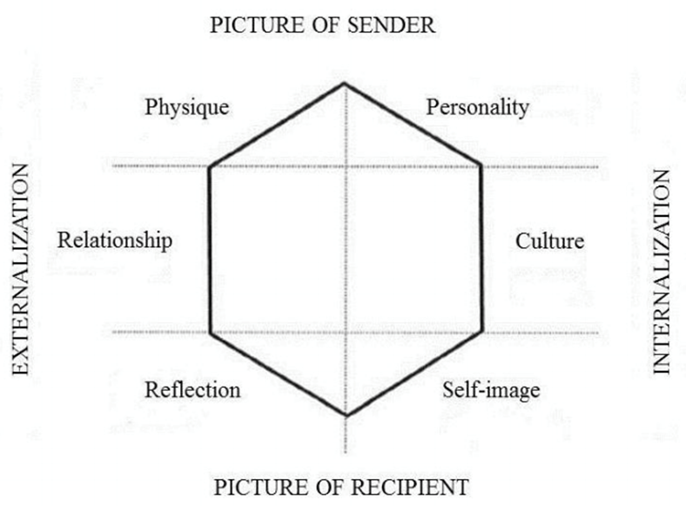

Figure 1: Brand Identity Prism

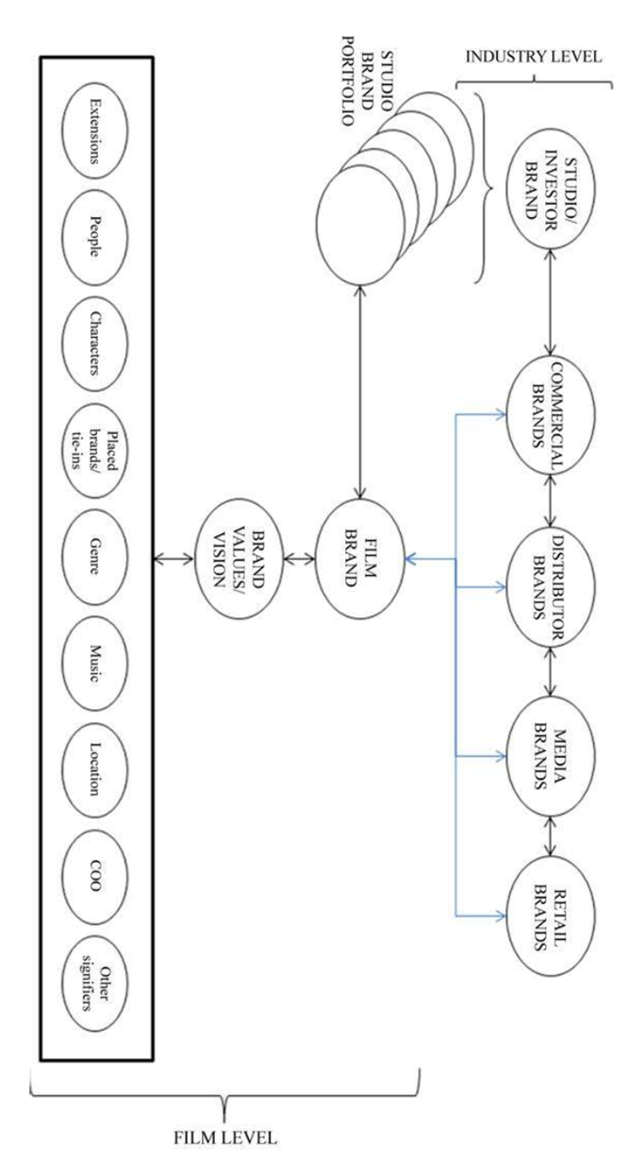

Figure 2. The Film Brandscape (O'Reilly and Kerrigan 2013)

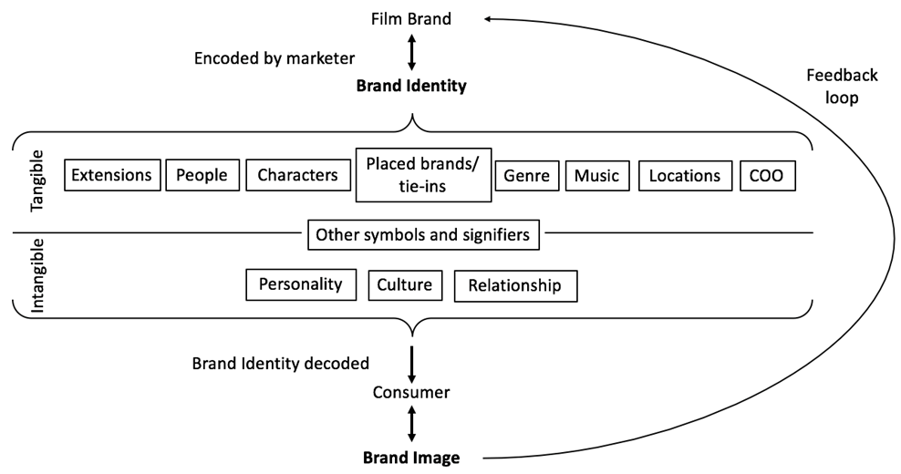

Figure 3. Conceptual Framework: Film Brand Identity and Image

|  |  |  |  |  |  |
| --- | --- | --- | --- | --- | --- |
| **Area** | **Date** | **Pseudonym** | **Age** | **Gender** | **Occupation** |
| **Brand Identity** | 20/03/17 | Clara | 35 | F | EMEA Marketing Manager (WB) |
| 28/03/17 | Charlie | 29 | M | UK Marketing Manager (WB) |
| 30/03/17 | Gabi | 33 | F | International Franchise Manager (WB) |
| **Brand Image** | 17/03/17 | Jack (PILOT) | 22 | M | Delivery Driver |
| 02/04/17 | Beth | 20 | F | Unemployed |
| 02/04/17 | Jess | 24 | F | Student |
| 05/04/17 | Sarah | 27 | F | Teaching Assistant |
| 05/04/17 | Kyle | 28 | M | Designer |
| 08/04/17 | Tony | 18 | M | Social Media Assistant |
| 08/04/17 | Liam | 25 | M | Gardener |

Figure 4. Sample Frame

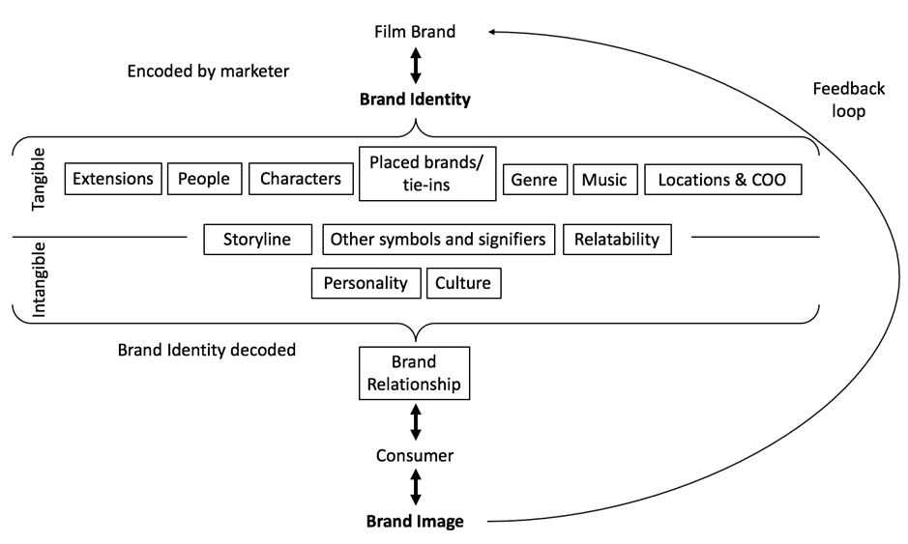

Figure 5 : Revised Conceptual Framework

Word counts for other projects

Sam Jasmine Callum Leo

Abstract 151 146 147 145

Intro 400 683 627 581

Lit review 1793 2591 2267 2364

Methodology 597 954 1181 2476 **

Findings and Disc 4170 2765 2994 2872

Conclusion 704 889 925 1346 **

Total 7815 8028 8141 9999