**Journal of Promotional Communications**

Publication details, including instructions for authors and subscription information: <http://promotionalcommunications.org/index.php/pc/index>

**Introduction**

Janice Denegr-Knott and Caroline Hodges

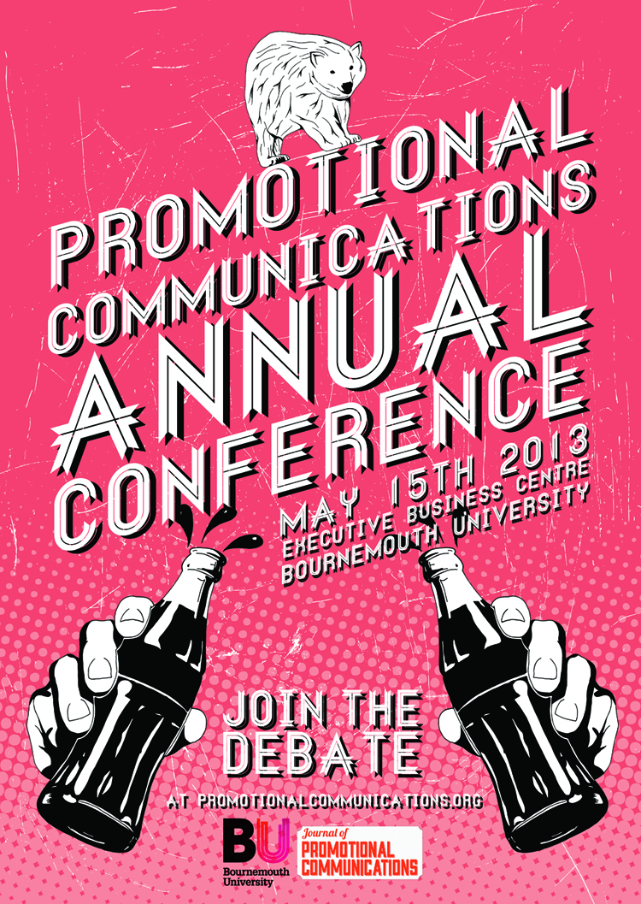

PLEASE SCROLL DOWN FOR ARTICLE

To cite this article: Denegri-Knott, J. and Hodges, C. 2013. Introduction. *Journal of Promotional Communications*, 1 (1), 1-3

JPC makes every effort to ensure the accuracy of all the information (the “Content”) contained in the publications on our platform. However, JPC make no representations or warranties whatsoever as to the accuracy, completeness, or suitability for any purpose of the Content. Any opinions and views expressed

in this publication are the opinions and views of the authors, and are not the views of or endorsed by JPC The accuracy of the Content should not be relied upon and should be independently verified with primary sources of information. JPC shall not be liable for any losses, actions, claims, proceedings, demands, costs, expenses, damages, and other liabilities whatsoever or howsoever caused arising directly or indirectly in connection with, in relation to or arising out of the use of the Content.

This article may be used for research, teaching, and private study purposes. Any substantial or systematic reproduction, redistribution, reselling, loan, sub- licensing, systematic supply, or distribution in any form to anyone is expressly forbidden. Terms & Conditions of access and use can be found at: http://promotionalcommunications.org/index.php/pc/about/submissions

**Introduction**

**Janice Denegri-Knott**

**and Carrie Hodges**

INTRODUCTION

Janice Denegri-Knott, Carrie Hodges, *Introduction,* *Journal of Promotional Communications,* Issue 1, 1-3

Web address



As Editors of the ‘Journal of Promotional Communications’, we are excited to launch the inaugural issue of this online journal. The compendium of work that follows includes an exciting mix of approaches, both conceptual and methodological, that are expertly put to work by seven talented student researchers in the fields of marketing, consumer culture, advertising and public relations. The work presented here is exemplary of the kind of high level expertise required in advanced economies (Reich 2002); one emphasising discovery, or the creation of knowledge, and the other focusing on exploiting or communicating this knowledge or discovery. We like to see the students, whose work is showcased here, as ‘symbolic analysts’ or reflective practitioners, who are imaginative, creative and displaying a critical understanding of their disciplines. The outputs of their intellectual labour will provoke and invigorate discussions in academic and practitioner circles: for the enlightened managed communications practitioner there is real insight to be found in the papers making up this first edition in terms of how best engage tricky audiences; for researchers, worthy of note explorations into emerging contexts that speak to contemporary concerns. We hope that the work published in this journal has the potential to challenge existing attitudes, ideas and practices and inspire new ways of studying, researching and practising promotional communications.

Broadly all papers are attendant to the theme of People and Promotional Communication. It is important to note that while the articles here adhere to their discipline’s preference for terms such as markets, consumers or publics, fundamentally, these papers deal with people. In that regard all papers make much of People in their exploration of both the production and consumption of promotional communications in contemporary Britain. In invoking a sense of People we see a certain preoccupation to bring to the fore the humanness and everydayness in the production and consumption of promotional communications. By that we mean a distinct focus on critically assessing the weight of the representation of People in Promotional communication, whether we are dealing with gender (Biloshmi), shared childhood memories (Knight), idealised lifestyles (O’connor), or in the various ways in which People negotiate advertising messages and their interactions with brand owners (Clark, Young, Callum) and politics (Pentland).

The first article, by Ana Blloshmi, addresses the theme of Promotional Communication and People by exploring the issue of advertising and representation, specifically, advertising and feminism within the particular context of 'ironic sexism' in post-feminist advertising and its different appeals to male and female consumers. The author uses the concept of 'ironic sexism’ to underpin her semiotic analysis of a variety of historical and contemporary adverts from the US and the UK. She argues that a second wave work on advertising images such as Williamson (1978) and Goffman (1976) remains relevant today, whilst through applying McGuigan’s argument on capitalism’s incorporation of resistance to the patriarchal gaze, the author also suggests that ironic sexism is being discarded in favour of an unadulterated patriarchal gaze.

The second article, by Chloe Knight, is also concerned with issues of advertising and representation, specifically the representation of childhood memories in TV advertising campaigns targeting adults. Conceptually, the paper presents an analysis of the relationship between childhood associations in advertising, visual rhetoric and the production of meaning, and explores this via in-depth interviews with 13 men and women aged between 20-50. Whilst childhood association is often used as a strategy to encourage an audience to engage with advertising, the research uncovered incongruent meanings between such association and products and services targeted at adults, which, in some cases, led to negative brand association. The author draws on previous work from Gkiouzepas and Hogg (2011) to support her argument for more careful and considered usage of visual metaphor in advertising to ensure the relevance of and the relationship between the image and the brand is clear.

Our third paper continues the theme of Promotional Communication and People, considering issues of representation within the context of consumer research. Amy O'Connor's article explores the consumer desires of Low Capital Consumers (LCCs). A sophisticated case is made to supplement existing work on social class and the patterning of consumption, which has traditionally focused on material consumption, by focusing on taste regimes in consumer imagination instead. Based on findings from in-depth phenomenological interviews, the data analysis questions the nature of LCC taste based on working class aesthetics, and the struggle over taste, emphasising instead the nature of resignation in failed desires and the role still placed by higher standing consumers in the reproduction of taste (cultural intermediaries). The author argues for greater understanding of LCC desire for authentic cultural objectives and new experiences, as well as a more authentic representation of LCC groups within consumer research and marketing practice.

The fourth paper in this issue, from Katie Young, also explores consumer culture theory to offer a solid qualitative analysis of Spotify users' experiences of access-based consumption versus ownership of digital music. The author grounds the need for the research on recent assumptions made in the literature which suggest that for digital virtual goods, access suffices. This article uncovers interesting insights into Spotify users' experiences with music owned and  
music accessed, with the core argument being that whilst ownership remains important today, it is manifested differently. The paper concludes that the tangible or functional organisation of the material gives the music meaning as opposed to an emotional ownership, and that clear distinctions between what is owned and what goods are accessed are needed.

Felicity Pentland's paper, which follows, explores the issue of promotional communication and People by exploring the relationship between young voters and the political process in the UK context, employing a mixed-methods approach. Young voters distanced themselves from politics as a consequence of perceived lack of understanding, as well as negative views of politics. Ways of overcoming such barriers are proposed including more focus on and an improved citizenship curriculum within secondary education, as well as politicians communicating with young people 'on their level', and the introduction of online voting. The author argues that young people are not apathetic, ambivalent voters and are instead open to participation and engagement with politics as long as politicians are perceived to be trustworthy.

Issues of trust are also addressed in the penultimate contribution from Joanna Clark, this time within the context of organisation - consumer relationships. Using a well-known computer company as a case study, the research explores the relationship between UK Millennials' consumer goals and their choice of social media as a complaint channel and, within this context, how power is distributed online between consumers and organisations. This article contributes to the literature on consumer complaints by categorising social media as a semi-interactive complaint channel, which allows Millennials a platform to exert power over organisations. The key contribution offered is the conceptualisation of social media complaints in order to evaluate the relationships between the aims and motivations of complainant and choice of complaint channel used (both interactive and remote).

On the theme of how organisation-consumer interaction through social media, the final paper on the subject of In-App Advertising by Callum Raines picks up on a very real market trend, critically exploring consumer attitudes towards In-App Advertising. The author uses Tsang et al.'s 2004 model of consumer attitudes towards mobile advertising to research the relationship between attitudes towards In-App advertising and behaviour. The paper makes a convincing case for why the model is significant for the scholarship and practice of In-App advertising, and proposes a possible adaptation - the 'Integrated In-App advertising model'. Overall, the paper suggests a general sense of public frustration towards In-App advertising. Recommendations are offered as to how marketers might best address issues with consumer irritation and, therefore, encourage positive attitudes towards In-App advertising as entertainment.

We end this opening editorial by extending our appreciation to all students who submitted work for consideration. As would be expected, each paper underwent a thorough peer-review process, and the threshold for publication was very high. We also wish to thank our peer reviewers for assisting us with the review process and to the BU Fusion Fund for supporting the online publication of the first issue of the Journal of Promotional Communication.

REFERENCES

Reich, R.B. (2002) *The future of success*. London: Vintage.