JPC makes every effort to ensure the accuracy of all the information (the “Content”) contained in the publications on our platform. However, JPC make no representations or warranties whatsoever as to the accuracy, completeness, or suitability for any purpose of the Content. Any opinions and views expressed

in this publication are the opinions and views of the authors, and are not the views of or endorsed by JPC The accuracy of the Content should not be relied upon and should be independently verified with primary sources of information. JPC shall not be liable for any losses, actions, claims, proceedings, demands, costs, expenses, damages, and other liabilities whatsoever or howsoever caused arising directly or indirectly in connection with, in relation to or arising out of the use of the Content.

This article may be used for research, teaching, and private study purposes. Any substantial or systematic reproduction, redistribution, reselling, loan, sub- licensing, systematic supply, or distribution in any form to anyone is expressly forbidden. Terms & Conditions of access and use can be found at: http://promotionalcommunications.org/index.php/pc/about/submissions

**Journal of Promotional Communications**

Publication details, including instructions for authors and subscription information: http://

**To Access or to Own?: Exploring Market-Mediated, Access-Based Consumption of Digital Music**

Katie Young

Published online:

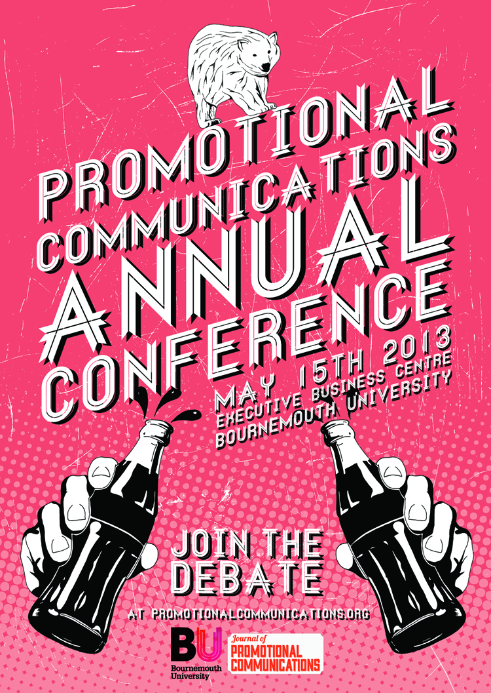

PLEASE SCROLL DOWN FOR ARTICLE

To cite this article: Young, K. 2013. To Access or to Own: Exploring Market-Mediated, Access Based Consumption of Digital Music. *Journal of Promotional Communications*, 1 (1), 68-84

**Katie Young**

**To Access or to Own?: Exploring Market-Mediated, Access-Based Consumption of Digital Music**

*The purpose of this paper is to explore consumers’ experiences of market-mediated, access to digital virtual goods (DVGs), more specifically, of digital music. In-depth interviews with ten adult Spotify users were conducted, lasting on average forty minutes. The study revealed that ownership is still important to the participants whilst in the context of digital music, however it was manifested differently. Our participants expressed notions of re-materialisation, ownership as a form of control, co-use of both accessed and owned items with defined boundaries between the two, and lastly, concerns regarding the fragility of access-based consumption. In light of the findings, this highlights potential issues for the industry, to facilitate and maximise customer enjoyment in access-based consumption of digital music.*

Keywords: Access-based consumption, ownership, digital virtual goods, digital music, possession

INTRODUCTION

Young, K. 2013. To Access or to Own: Exploring Market-Mediated, Access Based Consumption of Digital Music. *Journal of Promotional Communications*, 1 (1), 68-84



The digital music market experienced growth of 8% globally in 2012 (IFPI report 2012), with Spotify reporting to have 2.5 million paying subscribers worldwide. Building its business around developments in technology and the subsequent expansion in consumer choice, Spotify is one of the original music streaming services, enabling market-mediated access to a large variety of digital online music on a number of devices. Consumers are able to decide whether they access a restrictive service for free, or a flexible service at a cost. The purpose of this paper is to explore consumers’ experiences accessing digital music through market mediated conduits. This is important to explore, not only considering the growing proliferation of digital virtual goods (DVGs)(e.g. Denegri-Knott and Molesworth 2010; Maguadda 2012), but because it addresses an important debate in the literature. This debate is concerned with the limitations imposed with access-based consumption and the consequential desire to own the items. For example, existing research claims that the expanding proliferation of DVGs (DVGs) can be connected to the diminution of desire for ownership (see Arnould and Thompson 2005; Bhardi and Eckhardt 2012; Chen 2009). Bhardi and Eckhardt (2012) uncovered that consumers fail to experience ownership, purposefully avoiding appropriation with accessed objects due to the use-value and subsequent formalities attached. This supports their previous research into liquid possessions and the three liquid characteristics; temporary situational value, use-value and immateriality (Bardhi et al. 2012). At present, there are a limited number of studies surrounding access-based consumption, with few key authors within the field. No studies have yet covered the exploration of access-based consumption within the context of DVGs, highlighting a gap in the research and opportunity for the study.

Sociology of technology studies documenting consumer experiences as owners of DVGs, show that there is evidence to suggest that ownership is paramount. Maguadda (2012) and Lehandovirta et al. (2009) note the inseparability of the digital from the material, notably in digital music, which raises the question of possible similarities in the way we think about DVGs and material goods. Molesworth and Watkins (2012) also find evidence of this, and note that consumers can build attachments to DVGS, yet are concerned with their fragility, hence were supported by ownership of material goods such as hard drives and CDs. In further engaging in this debate and understanding the conditions needed for owning DVGs, the aim of this paper is to document Spotify users’ experiences of access and ownership of digital music.

LITERATURE REVIEW

The literature review will cover the main arguments in regard to access versus ownership in both material and DVGs. The first section will cover existing access-based consumption literature, leading onto the access versus ownership debate. The second part of the literature review will provide a thematic review of DVGs literature with the above debate in mind.

The Access Versus Ownership Debate

Access-based consumption refers to consumption by which consumers access or achieve temporary time with the use of an object or service (Durgee and O’Connor 1995; Rifkin 2000). Most notably, Chen (2009) instigated one of the most recent studies into access-based consumption within the context of art, shortly followed by Bhardi and Eckhardt (2012) within the context of car sharing. Chen’s study (2009) challenged the belief that possession is the ultimate expression of consumer desire (Marx 1930), described by Belk et al. (2003, p.329) as being, “bodily passions and mental reflection.” The research separated the consumption modes of access and ownership in order to examine them individually, assessing the fundamental requirement to own. The study concluded that desire was different from perceived value, with desire and illusions as the driving forces behind consumption. Although the study highlighted important notions of desire as illusions over perceived value, there is further opportunity for exploration into market-mediated, access-based consumption, especially within the context of digital music. Bardhi and Eckhardt’s (2012) research into access-based consumption explored how consumers of a car rental scheme, Zipcar, related to the rented object within a short-term context. The study challenged the romanticised view of access, understood as a form of collaborative consumption, instead exposing it to be the reverse. The study uncovered distrust and a lack of psychological attachment to the accessed objects, in addition to proposing six dimensions of access-based consumption; temporality, anonymity, market mediation, consumer involvement, type of accessed object, and political consumerism.

Ownership on the other hand has been linked to more psychologically involved process where individuals exert control over goods, in time transforming them into meaningful possessions. According to Kopytoff 1986, owned goods are seen to have a biographical life, beginning with the purchase of a commodity, involving little or no emotional value and solely centered on money (Belk 2007). In order for the object to become meaningful to the consumer, individual importance must be projected onto the item (Miller 1987). An object can often form part of the extended self, with the consumer utilising it to project their own values and taste to others (Richins 1994; Schouten 1991; Csikszentmihalyi and Rochberg-Halton 1981; Belk 1988; Ahuvia 2005). Possession rituals such as cleansing, storing and displaying are also often evident (McCracken 1986; Belk et al. 1989) as a means of showing pride for the item and singularising it from other mundane items. As a result, these items are less likely to be shared with others if strong psychological attachment has been established (Belk 1985; Epp and Price 2010; Lastovicka and Fernandez 2005). Further to feeling possessive over material objects, Belk et al. (1989) propose that consumers often make items sacred, separating the meaningful from the mundane. If a consumer wishes to collect or gift music, it exhibits the form of sacrilisation through the seven actions proposed by Belk et al (1989); through ritual, pilgrimage, quintessence, gift giving, collecting, inheritance and external sanction. Culture can also be used as a tool to project the meaning of good’s and cognitive order onto to others (Appadurai 1986; Richins 1994).

Csikszentmihalyi and Rochberg-Halton (1989) also state that the cultivation of objects results in the imprinting of an individual’s own meanings onto the goods, in order to achieve goals. This moves the object beyond the exchange value (de-commodification) in order for it to be singularised, yet this implies that personal authority is first required in order to de-commodify - something that cannot legally apply to an accessed object. To singularise an object (Appadurai 1986; Kopytoff 1986), it must be removed from a public situation to that of a consumer’s private situation. Towards the end of an object’s life, the owner often finds that external forces affect the personal meaning once formed, resulting in the re-evaluation, maintenance of, and possible disposal of items (Kopytoff 1986; Epp and Price 2010). Owners of goods often find it difficult to part with objects due to forming strong emotional attachment (Belk 1988), and often avoid contamination with new owners where there is little common identity (McCracken 1986). Alternative ways of coping with the loss of a cherished object occur through disengagement, or the realisation of a ‘new, desired self’ (Lastovicka and Fernandez 2005). In relation to the debate surrounding ownership and access, the practices as discussed above are often related to objects with material and tangible attributes. Further to this, these goods have undergone a clear market exchange (Belk 2007), whereby money has been traded for clear ownership of the goods. This reduces the instability of the item (Slater 2002), and encourages consumers to project their own meaning framework in order to create distinctions (Belk et al. 1989). This form of possession enables freedom and responsibility toward the object; the owner has the right to regulate or deny access; to use, sell, and retain any proﬁts yielded from the object’s use; and to transform its structure if desired (Snare 1972). It also empowers the possessor to gift the item to others if required (Mauss 1970), even revealing a little self-identity in the process (Csikszentmihalyi and Rochberg-Halton 1981). This area may be problematic to users accessing digital music collections, due to the fact they need to invest extensive amounts of psychological resources (Csikszentmihalyi and Rochberg-Halton 1981) into an entity enforcing stringent restrictions (Harwood and Garry 2010). If a possession is not fully or lawfully owned by the end consumer, it poses the question to what extent it can be sacred to the consumer and flexible enough to enable the ownership rituals as mentioned above. The nature of temporary access to digital music via Spotify may limit the ability for customers to project own meaning onto the goods, and deprive consumers of the psychological benefits associated with ownership (Siddiqui and Turley 2006). These practices will be further explored in the present study, as curatorial practices may prove problematic to the ambiguous nature of digital music (Denegri-Knott and Molesworth 2010; Douglas and Isherwood 1979; Fournier 1998).

Digital Virtual Goods

DVGs are defined to represent a range of activities related to digital technology such as e-commerce, the imaginary, digital worlds and stand-alone videogames (Denegri-Knott and Molesworth 2010). Although digital virtual activities are often contained in the virtual, authors such as Maguadda (2012) have highlighted the similarities and interdependence of the material world and that of the digital. The term re-materialisation has been proposed by Maguadda (2012) to describe the various ways in which the digital virtual is intertwined with material devices. Consumers may also purchase new material products in order to improve the digital experience, such as sound systems and gaming chairs. Although the digital virtual is argued to represent a liminal space between the imagined and reality (Shields 2003), this liminality also infers the relationship between the material and digital and the reliance on social life and culture (Denegri-Knott and Molesworth 2010; Maguadda 2012). Continuing with the theme, authors such as Denegri-Knott and Molesworth (2010) recognise DVGs as mechanisms to actualise consumer desires within the material world. Óskarsson (2012) also argues that emotional investments within digital worlds are similar to those in the material world and can have clear positive or negative results to real life scenarios. With this in mind, DVGs can be used to fulfill needs and pursue fantasies (Lehdonvirta et al. 2009; Denegri-Knott and Molesworth 2010). Experiences within digital virtual worlds and the experiences associated with DVGs should be viewed in a similar way to how consumers interact with material items. In support of this argument, Denegri-Knott et al. (2011) found that consumers were able to form attachments to DVGs, mirroring those experienced in the material world (Kirk and Sellen 2008). In a later study by Molesworth and Watkins (2012) it was found that although attachment to digital goods was formed and the desire to own was apparent, concerns about their fragility and safety were noted. Participants often referred back to the material goods in their life in order to protect and stabilise the use of the digital virtual (Molesworth and Watkins 2012; Denegri-Knott and Molesworth 2010).

The goods locked into the digital virtual are argued to lack the sensual texture and tangibility often associated with the material (Fırat and Dholakia 1988). It is perceived by these authors that if sensual texture cannot be obtained, it disallows consumers to project their own meaning onto items, in order to successfully appropriate. The nature of DVGs is considered to leave consumers unsatisfied due to the lack of transference to the real world (Siddiqui and Turley (2006). Ritzer (2001) also views the digitisation of consumerism as dehumanised, whereby satisfaction from human action cannot be gained. In terms of accessing digital music, this may affect consumers’ ability to apply emotion and meaning. If consumers are seeking to possess DVGs, which are not legally their own, failing to appropriate could occur, resulting in frustration and reduced enjoyment. Siddiqui and Turley (2006) similarly believe that the contamination of goods associated with material goods cannot be achieved due to the legal status of virtual assets (Lehdonvirta et al. 2009; Bhardi and Eckhardt 2012), thus depriving consumers of emotional quality. However, it should also be noted that despite the lack of traditional ownership involved, scholars have recognised that DVGs are frequently traded in the digital and material world (Lehdonvirta et al. 2009).

It seems difficult to judge whether or not consumers view material and DVGs in a similar way, and whether or not they actually desire to own these goods they are choosing to access. The necessity to understand the emergent consumption practices within the context of DVGs is paramount, as material goods are becoming digitised with the consequences to consumers unknown.

METHODS

The purpose of the research paper is to explore consumer experiences relating to market-mediated, access-based consumption of digital music. As we were exploring feelings and practices involved with the use of accessed digital music, an interpretive, qualitative research approach was utilised. Qualitative research does not create promises in regard to increasing the transparency of a research topic (Gummesson 2005), nor give rigid instructions to the researcher. It does however offer a “conscious search for meaning and understanding” (Gummesson 2005 p. 311), promoting in-depth awareness of the issues and phenomena studied (De Ruyter and Scholl 1998). The chosen approach has been supported and utilised by other consumer researchers (Arnould and Thompson 2005; Goulding 1998; Thompson and Troeseter 2002; Denegri-Knott and Molesworth 2010; Molesworth and Watkins 2012). Interpretive research techniques draw meaning from the deep assumptions and narratives created by respondents within the world around them. By accessing meanings assigned to the world surrounding participants, the researcher creates formations of other people’s viewpoint of the world (Denzin and Lincoln 2005; Geertz 1973; Orlikowski and Baroudi 1991). Following interpretive research norms, the sampling plan was focused, with the criteria for recruiting the ten participants based on the fundamental requirement of having a sufficient stock of experience to share. With this in mind, ten participants were sought via a non-probability snowball sample (Babbie 2010), identifying one unit of the preferred population and seeking to further leverage the relevant contacts until the sample size was achieved. Social networking sites were exploited as a way to attract the original participant, who would then spread the message to personal contacts. The aim was not to achieve a large sample that could be generalised (Faugier and Sargeant 1997), but to explore individual differences within the experiences.

The sample consisted of active and knowledgeable Spotify users (see Table 1). It was important to discuss experiences with an active and experienced sample due to the complex and detailed narratives sought (Goulding 1998). This sampling approach is consistent with existing work and preferences, carried out by authors such as Bhardi and Eckhardt (2012), Denegri-Knott and Molesworth (2010; 2012), Maguadda (2012) and Molesworth and Watkins (2010). Our respondents ranged in age, profession and location, living in mid-sized towns in the South East and South West of England. From February to March 2013, we conducted one-to-one semi-structured in-depth interviews with a total of five women and five men in the Bournemouth and London area. In-depth interviews can be argued as a method of building a solid rapport with the consumer, further easing the participants into talking freely about experiences until they have exhausted their stock of experiences (Cresswell 2007; Thompson et al. 1989). The interviews ranged from between twenty-three to fifty-nine minutes in length, with the average interview lasting approximately thirty-seven minutes. All interviews were recorded in order to enhance accuracy and reliability at a later stage (Kvale 1994), resulting in three hundred and seventy-one minutes of recording (approximately six hours). We used a natural setting for increased depth and intimacy, in order to encourage the participants to relax and become more at ease with the researcher. Participants had access to a device used to access the music streaming service, such as a laptop or mobile phone. Reference was often made to the devices throughout the interview, supplying the researcher with additional photographic and anecdotal evidence and towards claims and statements provided by the participants in regard to usage (See Figures 2, and 3). The interview began with a general question about their life in order to explore the situational context of the participant’s existence; gaining biographical information (McCracken 1990) such as “If you could please begin by telling me a little bit about yourself?” The interview ran on general themes rather than solid questions as noted of importance by Kvale (1994), prompting a general conversation with the participant and enabling them to communicate experiences in their own words. Feelings and experiences were explored with open-ended questions or prompts such as “what was the best experience you have had with Spotify?”, “What was the worst, how did it make you feel?” And, “how would you feel if you were denied access to your Spotify music?” From the six hours of data, interviews were interpreted. This was implemented by way of a part-to-whole reading, made up of individual transcripts, followed by the identification of global themes (Denegri-Knott and Zwick 2012) McCracken 1988; Miles and Huberman 1984; Thompson et al. 1989). In addition to the interpretation, five pieces of photographic data and two pages of supplementary notes from the interviews were examined (Kvale 1994; Peñaloza 1994). Transcripts of the interviews were typed as soon as the interviews were completed in order to preserve emergent themes and overall thoughts (Muniz and O’Guinn 2001).

Although the chosen research methods were in line with existing scholars within the field, possible limitations of these were considered. The researcher had little personal desire to associate with the service of Spotify, with little understanding of the service before the research was conducted. Being somewhat naïve in regard to the service helped to reduce any personal bias, as prior expectations were absent. This may have enabled the researcher to remain open and inquisitive of the experiences given by the participants, yet limitations of this could be the possible lack of understanding surrounding Spotify and the restrictions it could have imposed during interviews.

**Table 1 Respondent Profiles**

|  |  |  |  |  |  |
| --- | --- | --- | --- | --- | --- |
| **Respondent** | **Age** | **Occupation** | **Location** | **Spotify Use** | **Spotify Playlists** |
| Benjamin | 23 | Web Designer | Bournemouth | Premium | 3000  15 |
| Sandra | 18 | College Student | Rochester, Kent | Premium | 700  6 |
| Tom | 22 | Student | Bournemouth | Unlimited | 260  7 |
| Logan | 22 | Student | Bournemouth | Premium | 1592  111 |
| Shane | 22 | Student | Bournemouth | Premium | 432  15 |
| Jack | 22 | Student | Bournemouth | Premium | 3289  51 |
| Annabel | 22 | Student | Bournemouth | Heavy | 275  12 |
| Rose | 22 | Student | Bournemouth | Heavy | 4434  6 |
| Leah | 21 | Student | Bournemouth | Premium | 500  10 |
| Tim | 24 | Software Engineer | London | Premium | 5032  16 |

FINDINGS AND DISCUSSION

## 

In this section, themes emerging from the ten interviews conducted will be discussed. Unlike existing research questioning the need to own DVGs (Arnould and Thompson 2005; Belk et al. 1989; Bhardi and Eckhardt 2012; Chen 2009), suggesting that ownership is redundant, we found that Spotify users still valued ownership, and that ownership could still be considered an expression of consumer desire. The core themes consist of a discussion of how consumers re-materialise digital music via their engagement, the centrality of control in asserting ownership and the comingling of access and ownership as key modes of consumption in digital music via Spotify.

Re-Materialising Digital Virtual Music

Re-materialisation is a process by which participants enjoy experiences in the digital virtual, via use of material artefacts like portable music devices. Often, participants would find use for material goods, in addition to purchasing the new material artifacts, such as speakers. In line with Maguadda’s work (2012), the importance of material objects in shaping consumers’ experiences with DVGs is apparent, with material concerns always being evident. When we visited Logan, she spoke positively about her fond memories of listening to a CD on a player. This nostalgia about the former material presence of music within her life signaled a feeling of disappointment. Logan, a 21-year-old Marketing student from Bournemouth University and an avid music fan, described how she had not listened to her own CD music collection for years. Instead, Logan had in her own words, ‘replaced it’, with accessing digital music via Spotify.

“I don’t really listen to that anymore because of Spotify, so I don’t really, I can’t even remember the last time I bought a physical CD which is really sad.”

There was an obvious sense of missing the material records and CDs, which may have been displaced by external forces such as digitisation (Maguadda 2012). This also supports Lastovicka and Fernandez’s version of ‘not me’ and ‘never me’ divestment rituals (2005), with Logan recognising that her separation from the material may be for the better. Here we see that Logan longs for the owned goods she once had present in her life, which were now replaced by the accessed.

Whilst visiting Jack it was clear that he had a preference to own a material CD. Jack is a 21-year-old Business and Finance student at Bournemouth University, who has grown up with CDs and vinyl in his family home and views them as a normal. Although Jack demonstrated understanding towards others’ views surrounding the inconvenience and subsequent divestment of material music (CDs), he supported his own argument for maintaining his material collection of music.

“I don’t think anybody wants to buy CDs anymore, it’s not convenient, but for me it’s more of a, ‘if that’s a good album, I want to have it physically… that is like my music collection… I still buy CDs though.”

He explained that as a keen fan of music and a regular radio presenter at his University, music was extremely important to him and he enjoyed displaying his extensive collection of CDs. It is only when Jack grasps the material and physical object that he feels as though the music is his.

“Once I put them [CDs] on my laptop, that’s it, but In the back of my mind it’s mine? Like it hasn’t got any, erm, like if my laptop breaks, I’ve still got my CDs if my iPod breaks I’ve still got my CDs. It’s a physical thing.”

Further to this, Jack also sought the digital album artwork associated with digital music, as it simulated that of the material CD cases that he owns. Here, we recognise that Jack is attempting to make direct comparisons with his accessed music, to that of his owned music. Jack spoke about how he enjoyed displaying his CDs in his bedroom whilst at home with his parents. This display, storage and grooming of his cherished possessions, is something that he feels he perhaps could not achieve with digital versions of songs. Although we see evidence of Jack appreciating the digital artwork associated with the accessed digital music, we see no attempt by Jack to maintain or display this as he would with his material goods. In terms of the ownership versus access debate, Jack still longs and prefers to own music, and does so through the maintenance of his materially owned music collection.

“It’s the one thing I really like about Spotify, because the artwork is always there. Its’ like looking at a CD…yeah I’m quite traditional in that sense, I like my CDs, so anything which is related to that or feels like I'm looking at a CD which I'm not, I like that.”

This tells us that although he is not obtaining the same pleasures from the digital album artwork that he would from his material, he still longs to feel a sense of ownership. Jack is seen to actively use his material goods in order to make accessing his digital music more enjoyable, which also supports the desire to own. It would be interesting to see if service providers such as Spotify aid and encourage participants to display digitised versions of music, as Jack already does with his material

Logan, who was interviewed at the University, spoke fondly of her experiences with Spotify and the innovative ways it has enabled her to use other new technologies. Logan lives with her long-term boyfriend and they both enjoy the use of a separate material commodity, an interactive and collaborative speaker system called Sonos.

“Well I have one too but my boyfriend also has it, it’s like a Sonos system which is a wireless speaker system… so I’ve got an app on my iPhone called SONOS and you can play your music and it just magically plays. Yeah, it’s amazing.”

Not only does Logan use the material commodity of her iPhone and laptop, but also, she is also encouraged to purchase new material commodities in order to enhance her enjoyment of accessing the digital music (Maguadda 2012). The independent technology of Sonos is a perfect example of the use of the material in order to maximise the enjoyment of the accessed. With participants all reliant on material goods such as a laptop, iPhone, or iPad in order to enjoy digital music, the importance of this as highlighted by Maguadda (2012) is apparent. In terms of ownership, accessing digital music seems more enjoyable when it is teamed with associations with that of owned, material goods, gesturing that once again, ownership is indeed important for consumers.

Co-existence of Access and Ownership

Within the theme of co-existence and ownership, we will be discussing the two manifestations. Firstly, we find that there is a drive towards the co-existence of the owned and accessed goods. The second is the movement of creating defining boundaries or an internal order between the accessed and owned goods, in what is ‘mine’ and what is not (Belk et al. 1989). Participants within the study displayed evidence of maintaining and enjoying both owned music and accessed music. Most respondents continued to download digital music illegally, yet still displayed notions of perceived ownership over this despite no monetary exchange being involved. Participants would refer to accessed and owned music as separate entities, with clear boundaries set. With these boundaries in place, participants would project their own meanings onto the ‘owned’ goods (Csikszentmihalyi and Rochberg-Halton 1981; Appadurai 1986; Richins 1994). This occurred by manipulating where and how the owned music was stored, the frequency it was listened to and the appearance of the file in terms of neatness and legibility. When we think of the reasons behind this, it may be due to the digital format of the music file, and the lack of restrictions involved such as the ability to gift (Mauss 1970). In addition, the flexibility of the format may have contributed in order to make this object more important to others; therefore supporting notions of sacrilisation (Belk et al. 1989). It was clear to see from Jack’s personal surroundings that he was a very organised person, with artefacts presented in a thoughtful way, with special emphasis placed on his guitar and stereo. Whilst discussing how Jack enjoyed listening to music, he stated that he took pride in arranging the music on his laptop in a way that distinguished the accessed from the owned.

“I keep them separate because in my iTunes, I’ve got all my old stuff like the stuff I’ve been collecting since I was a little kid, and then with my Spotify it’s all current stuff. With my current stuff its more disposable music, so I’ll listen to it and it’s in trend, in trend music, whereas my iTunes stuff is my ‘I can listen to that whenever’ classic music.”

Here, we recognise that Jack is creating distinguishable boundaries between music that was ‘owned’ by him, and music that was ‘accessed’. By referring to the accessed music as ‘disposable’, the boundaries seem of importance to Jack in order to separate the meaningful from the ordinary (Belk et al. 1989; Douglas and Isherwood 1979) and project own meaning onto material goods (Czikszentmihalyi and Rochberg-Halton 1981).

Further support for the notion of treating accessed music differently to that of owned music is Tom, a 22-year-old student. Living with two other housemates, Tom spoke about his experiences with organising his iTunes library, and how he prefers to organise his owned and accessed music separately.

“When I first went onto Spotify and started playing the playlists and stuff, there was a playlist with music off my laptop, I could have moved that around into playlists but I deleted it all because I didn’t want it blurring in… I still have some of the same songs I have on my Spotify library that I have on my iTunes library.”

Tom did not want to contaminate his sacred and owned items to those which he felt profane (Belk et al. 1989), even though it would result in duplications on his computer and lead to excessive consumption (Denegri-Knott and Molesworth 2010). It may seem awkward to think of a digital song appearing twice on a computer, however these were the lengths that the participants would go to in order to prevent blurring these boundaries.

Ownership in Terms of Control

Our third theme discusses the use of ownership as a form of control. Participants would maintain and exert possessiveness over owned digital music, in an attempt to make up for the lack of control experienced with accessed digital music (Molesworth and Watkins 2012). It was also noted that participants would attempt to apply meaning over the accessed goods whilst using Spotify, mainly via use of playlists. Whilst listening to accessed music through Spotify, participants often talked about how they had dedicated psychological effort into organising music as best as they could (Denegri-Knott and Molesworth 2010). One example of this is Logan, a 22-year-old student who subscribed to Spotify a few years ago as a recommendation from a friend. Logan had created over one hundred playlists on Spotify in an attempt to organise and project personal meaning to her accessed music collection.

“I: Yeah, and I presume you have loads of playlists?

P: Yeah, exactly I’ve got like probably near 100 now

I: Wow, OK

P: It’s ridiculous and I can’t find everything I want.”

Respondents reflected the notion as depicted by Logan; strongly attached to playlists through the act of ‘making it their own’ and separating it from the commodity format as seen in large libraries of music (Richins 1994; Belk 1985; Appadurai 1986; Kopytoff 1986). By creating personal playlists and transferring music to a place of personal significance and meaning (Richins 1994; Kopytoff 1986), respondents were attempting to make the music unique to them and more of their own. In support of Campbell (2005), ‘craft consumption’ may be supported in this instance, as Logan and Jack, whom both had numerous playlists, felt the music in them was more meaningful (see Figures 1 and 2).

**Figures 1 and 2- Playlists**

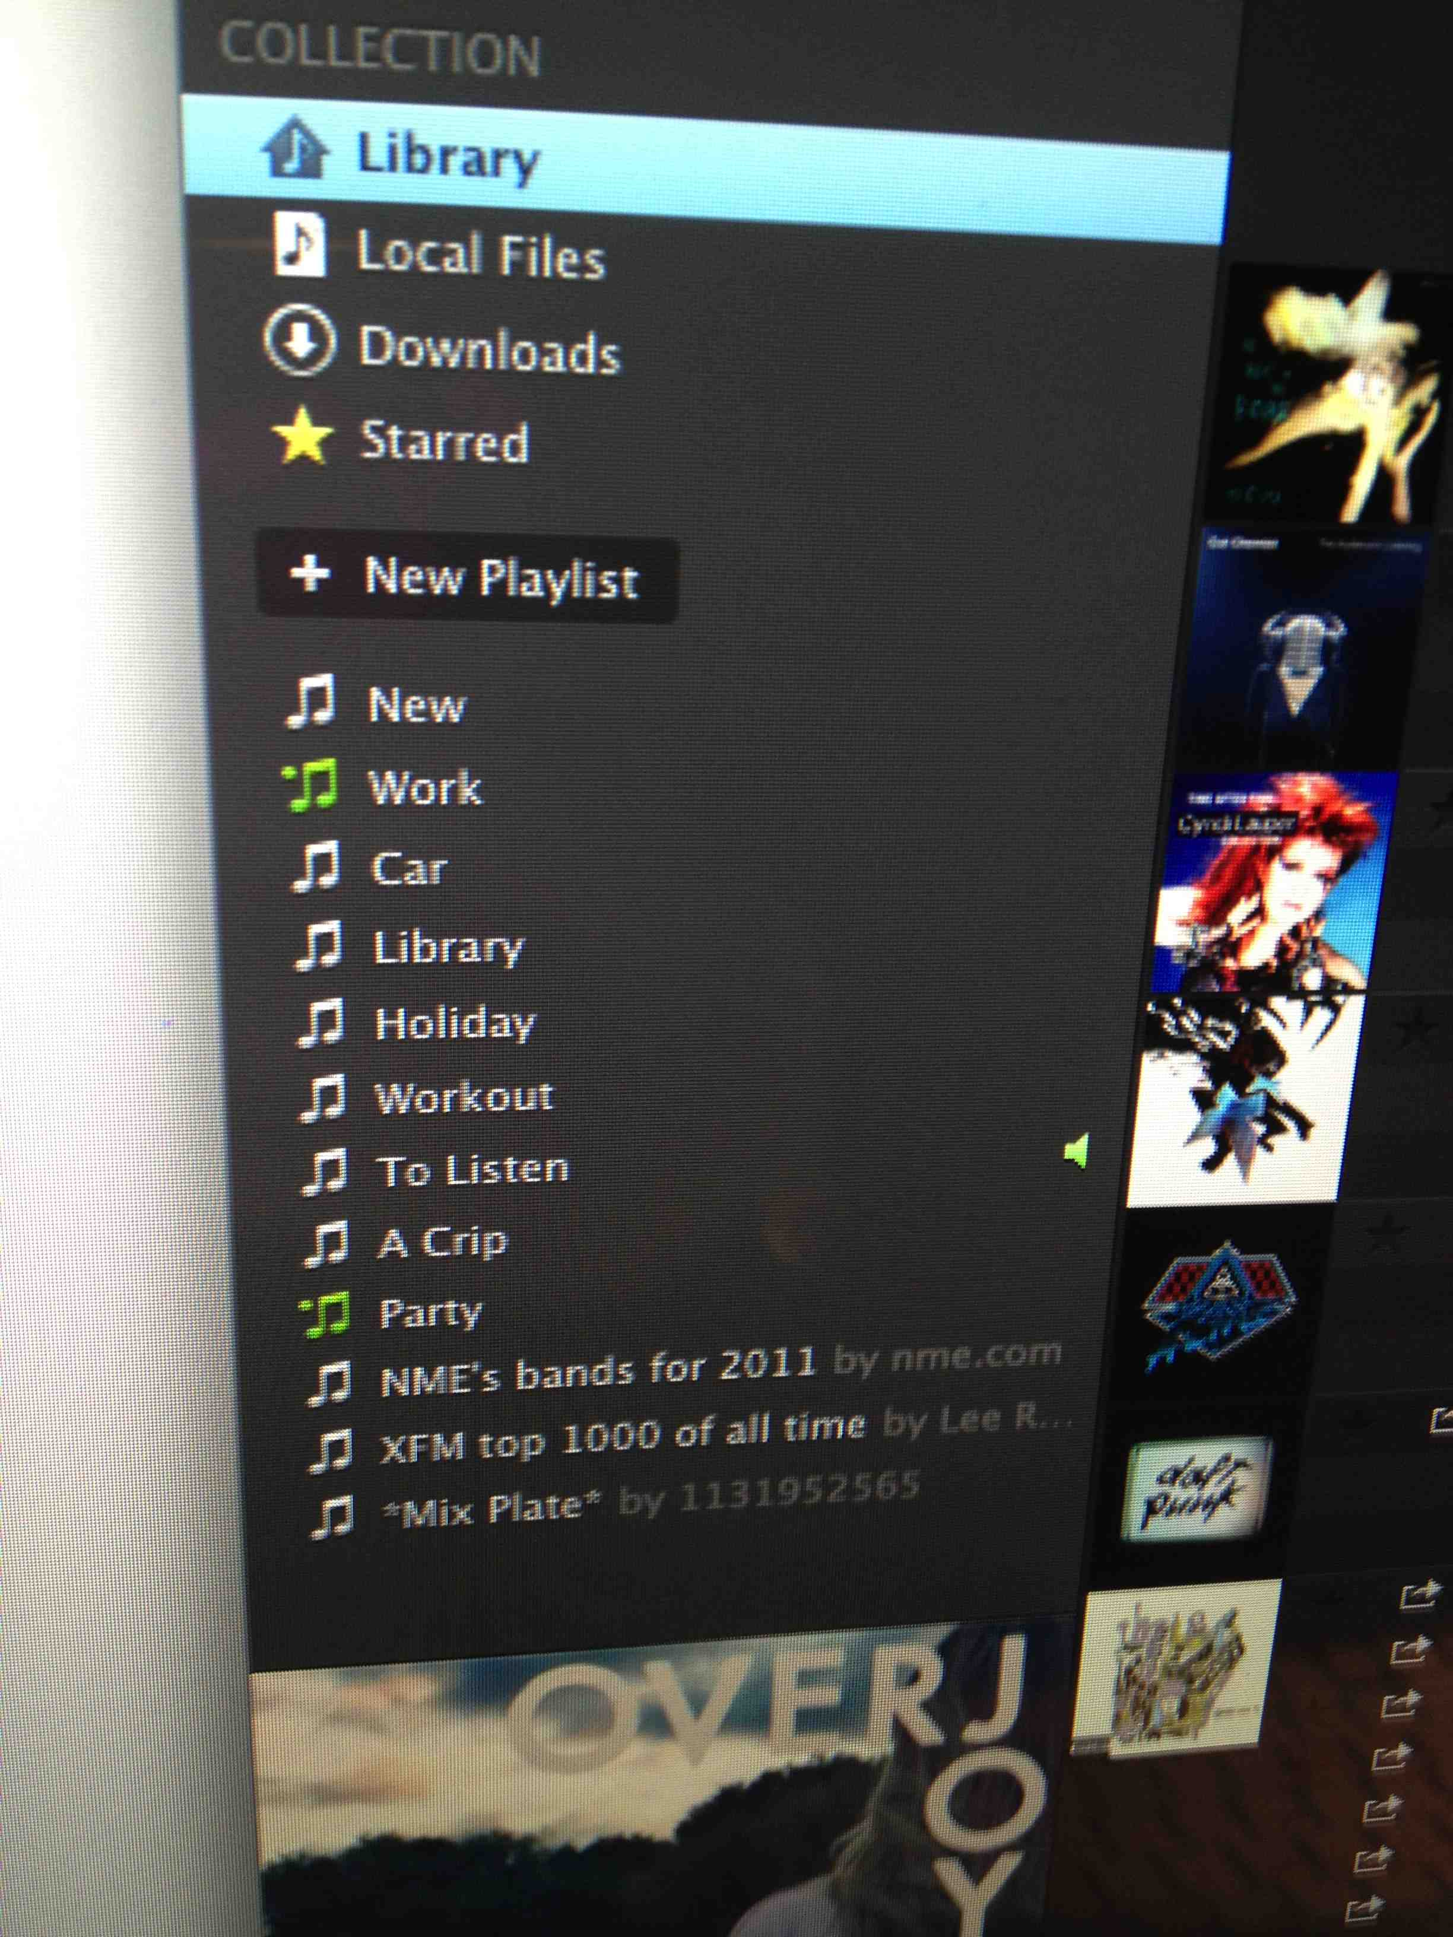 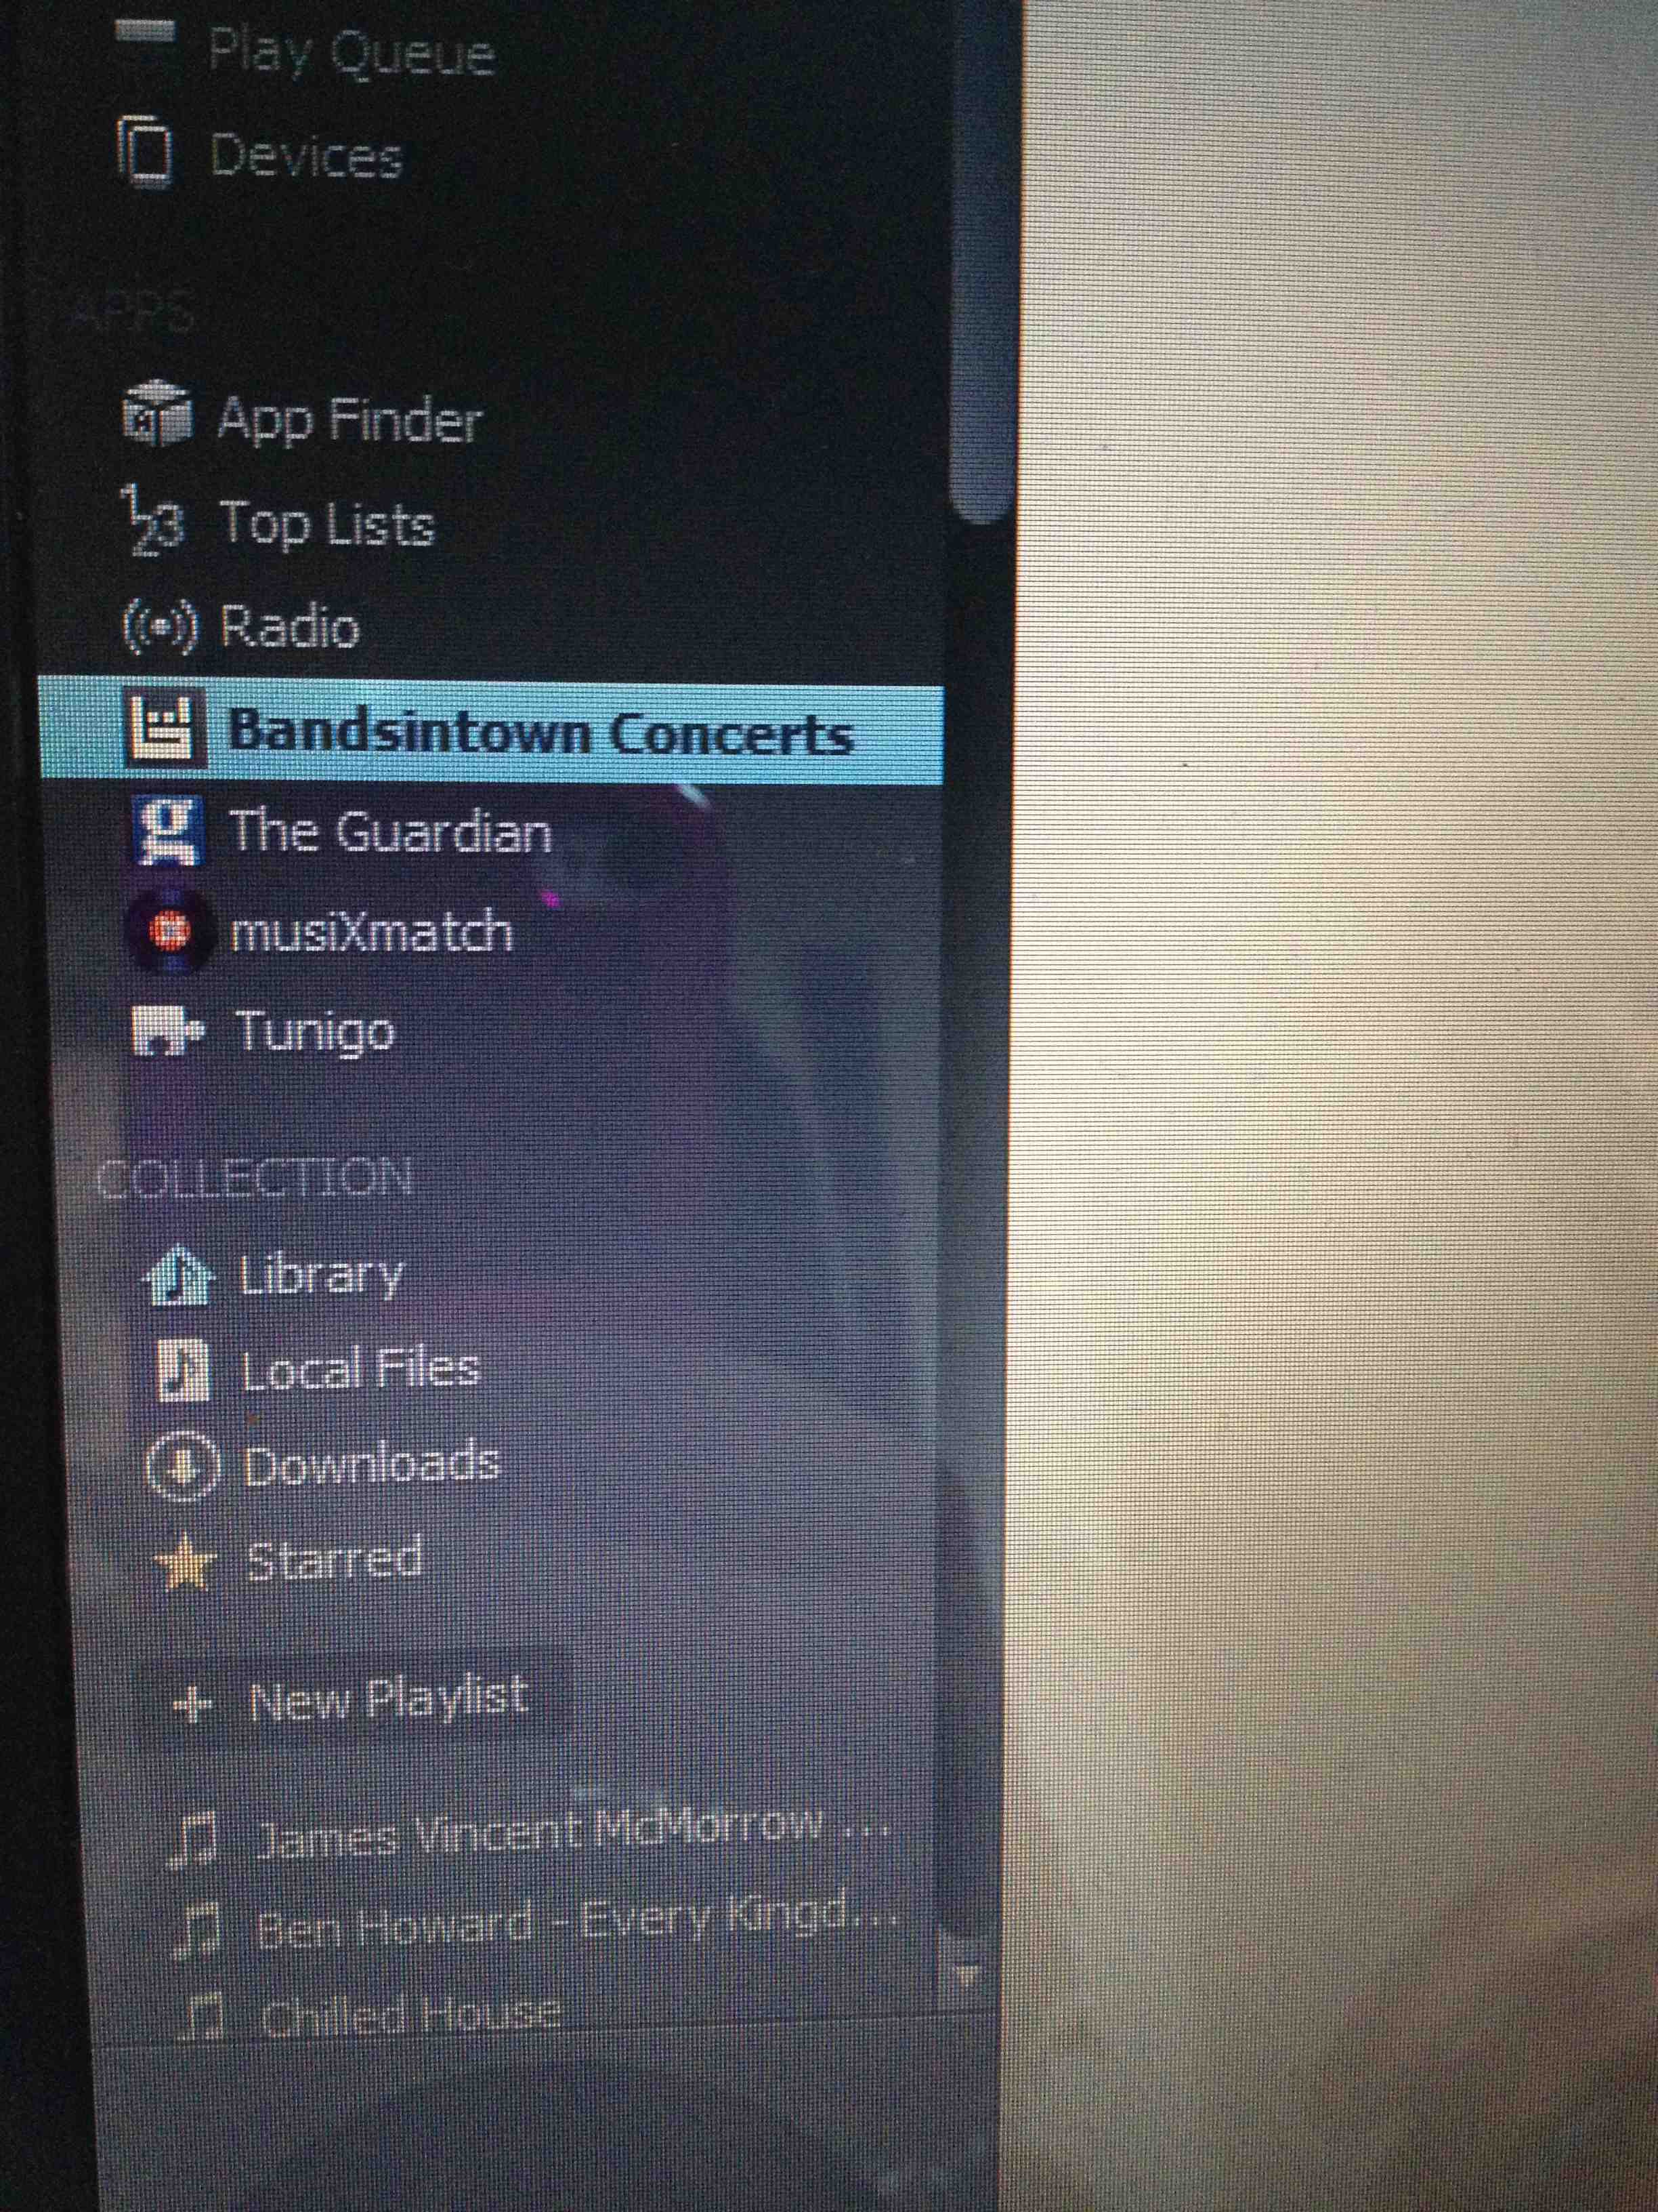

Across the interviews, participants displayed annoyance and frustration that they could not alter or manipulate the accessed music as they could with their owned music. In terms of ownership and access, participants clearly communicated that although they are happy with the appearance of the service, they still long for a way to maintain some form of control over the goods. Such accounts of control emerged whilst talking to Logan.

“Something that’s really infuriating, is that you can’t edit your playlists? You can’t like move them if that makes sense? And you can’t then like it’d be really nice to alphabetise them or something like that. Now they’ve changed it so it used to be every new playlist you added would go right to the bottom so your oldest ones would be at the top and then the further down you got would be your newer ones, and then they swapped it now so the new ones go to the top.”

As such, Spotify did not enable Logan the level of control she desired, in order to gain the feeling of ownership over the digital music. This story suggests that access can both add to and detract from the experience for users, and brings to light a conflict in the desire for users to personalise DVGs (Denegri-Knott et al. 2010). In line with existing scholars in the field, it was found that participants sought the ability to stamp their ownership on goods, through singularisation and appropriation (Appadurai 1986; Kopytoff 1986), cultivation (Richins 1994) and sacrilisation (Belk et al. 1989).

The focus now turns to how participants connected with owned music, or perceived ownership through illegally downloaded music. In other words, participants found ways to exert any viable means of controlling content, even when one was not an owner. Below is an account from Tom, an unlimited user of Spotify who lives with two other female housemates at University. Music is an important focus in Tom’s social life, with him enjoying it the most when incorporated in social situations such as parties. Tom enjoyed not only customising the song title’s of his owned music collection, but also altered the digital album covers to photographs of his friends to reflect periods in his life that related to the song.

“I used to like tidy it up, changing the album name so they’d all group together and also change the start and finish times, I’d do that. And the album covers as well actually, you could change the picture so you could get rid of the picture of whoever the singer was and put pictures of my friends. Certain songs were from certain places and you could make your own album from when you went to a place.”

Snare (1972) highlights key issues surrounding the ownership of goods; owners have rights to deny access, use, to gift (Mauss 1970) and transform the structure. With participants frustrated with the inability to transform the structure of the accessed goods, this clearly displays the desire to own and the frustration involved in the ability to meet personal preference. These findings are in line with those of Molesworth and Watkins (2012), who found that participants would purchase mundane material items in an attempt to compensate for the lack of control with the digital. Participants often felt the same way, with the need to find alternative ways of feeling in control, even when the material is not legally owned.

Fragility

This leads onto the final theme, fragility. The theme of fragility refers to the ever-present notion of possible loss, and the temporal nature of accessed goods as perceived by the participants. In line with Molesworth and Watkins (2012), participants expressed concerns that the digital music contained in the accessed service of Spotify were vulnerable to loss. With participants consistently aware of an over-reliance on Spotify and accessing music via this method, many formed back-up methods, such as maintaining their own music collection and ensuring that they did not become over-reliant on the service. Whilst speaking to Logan about what would happen if she were to lose access to her Spotify account, she immediately referred back to the owned music she had existing on her iPhone.

“I got enough music on my iTunes to probably keep me going for a bit, but like you say depending on how long the downtime was I’d be really quite fuming and probably quite annoyed… Yeah definitely a lot of trust in Spotify because if anything were to happen to their company, or you know I would be quite bummed that I’ve lost all of that music because I would feel that if I were to then go back to actually buying music, I’d have like a lot to catch up on? It’s a really weird way of looking at it.”

Interestingly, Logan was concerned about ‘catching up’ on the music and time she would have missed out on, having replaced her owned music with accessed instead. This signifies a form of vicarious ownership is apparent, which may in turn affect the enjoyment of the goods if we refer back to appropriating digital goods (Kopytoff 1986; McCracken 1990; Molesworth and Watkins 2012).

Shane, a 21-year-old student studying PR, has an eclectic taste in music, which he developed as a result of his exposure to living in South Africa when he was young. Shane describes his regular use of iTunes in comparison to Spotify as more of a habit, due to the way his computer works and the maintenance of his other material and associated items (Maguadda 2012).

“It’s still on my computer but just its just on there. Yeah I always plug my phone into my computer for like stuff for updates and stuff and just to update my iTunes so, normally, and obviously when I download stuff illegally then I’ll update my iTunes playlist and account.”

Maguadda (2012) recognises the reliance on the material in order to enjoy the digital. Despite the fact that Shane enjoyed listening to accessed music via Spotify, he noticed that he would first turn to his owned music as a result of habitual practices, linked to his use of technology. Shane would ensure that his Spotify account remained up to date, yet at the same time would ensure that his iTunes account were similarly organised and current in the event that the accessed music ceased to exist one day.

“I think I use iTunes instead of Spotify on most occasions because I have iTunes and that is mine, and that is on my computer but with Spotify if no one keeps buying it and they don’t make any money they can stop that and then my payments stop and then I don’t have that music and the playlists won’t actually be there.”

Again, referring to playlists almost as a personalised and special mode of listening to music, Shane expressed his reasons for placing little trust in the service and therefore maintaining his own music collection via iTunes.

Another finding to discuss was that participants viewed access-based goods as precarious on the one side, yet viewed it as containing guarantees that owned music did not. The participants all displayed evidence of reluctance in the disposal of iTunes music, having been paid for or owned, yet were more comfortable in disposing accessed music, as it would be easy to retrieve if necessary. Logan, as mentioned earlier, speaks about this:

“You’d feel like deleting it but it’d be really pointless because you’d have paid for it and throwing away your money, but with Spotify if you deleted something you know you could always go back and get it.”

Logan did not express any form of attachment towards her Spotify music collection, due to the ease of retrieval at a later stage, signalling that she is unconcerned about losing digital material. Other participants shared this view of feeling comfortable with ‘losing’ accessed material in comparison to owned and it being more ‘disposable’. In line with the findings of Denegri-Knott and Molesworth (2010), there is a sense of loss over time invested, rather than anything else. Arguably, this can be viewed as an expression of ownership over the accessed goods, as participants are clearly recognising that their time has been invested into the service (Richins 1994; McCracken 1986). The highly transferrable nature of digital music, was seen to be elevated more so through the accessed entity. It seemed that in comparison to owned music, participants would feel less guilty about removing these goods from their immediate lives having ‘not paid’ for them and ‘wasting’ money. In this sense, digital music was referred to in a different manner to the disposal of material goods, displaying less dissatisfaction and concern throughout the disposal process than would be shown with owned goods. In relation to existing divestment literature, Lastovicka and Fernandez (2005) state that when a consumer divests a good, they effectively lose extensions of themselves (Belk et al. 1989;Young and Wallendorf 1989). Although we recognise that participants do refer to the accessed goods as ‘invested time’ (Denegri-Knott et al. 2012), we recognise a deviation from the standard biography of goods (Kopytoff 1986), in that consumers were happy to divest from accessed items as they were left in some kind of ‘retrievable space’ instead of a clear cleansing area as proposed by Lastovicka and Fernandez (2005). Participants were not investing time into divestment rituals due to the fact that these items are seen as immortal and ‘always there’, despite the lack of traditional ownership involved.

CONCLUSIONS

The paper aimed to contribute to the current body of literature surrounding access versus ownership, by studying processes surrounding digital music in order to fulfil emotional needs. The context of Spotify was used as a space where accessing digital music is conventional and users are given varying levels of restrictions in order to enjoy the vast music collection available. Drawing from the interpretative data gathered, it was discovered that ownership was still an important issue for participants, but was manifested differently through the uncertainty and fragility of the service, and the somewhat failed attempts to singularise (Appadurai 1986; Kopytoff 1986). The material components associated and used with listening to the digital music affected the ways in which participants stored and enjoyed the music, introducing the first theme of the paper, re-materialisation (Denegri-Knott and Molesworth 2010; Maguadda 2012). Participants would often use and re-use material goods in order to enjoy the accessed, digital music. Moreover, participants would co-use the accessed and owned music, forming clear boundaries between the two in order to separate the sacred from the profane and reduce ambiguity (Belk et al. 1989). Not only did this demonstrate that owned music appeared sacred to them, it proved that blurring of these boundaries would cause angst amongst participants in relation to the enjoyment of the experience. With the decreased ability to control the digital music in access-based consumption, participants would vent frustration that the service did not appear the way they desired it to, therefore reverting back to owned goods in order to maintain some sort of control. Attempts were made to control and singularise the accessed music in the form of playlists, however this was often not enough (McCracken 1990; Miller 1987; Belk et al. 1989). The fourth and final theme of fragility concluded that participants were aware and wary of the amount of time and psychological invested in the accessed service. Participants would also show notions of relaxation in terms of divestment of the accessed music, given that it was more retrievable than owned music, if deleted. Although time and efforts are invested in curating the accessed music, supporting attempts to own, the relaxed approach to divestment challenges existing literature in that it would not prove detrimental to the self to divest the goods (Lastovicka and Fernandez 2005; Epp and Price 2010; Parsons 2006). This also questions whether or not timely and psychological investment into accessed-based consumption, reflecting material notions of ownership, reflects traditional ownership divestment rituals. This area may require further investigation in the future as it poses an interesting debate and re-evaluation of traditional divestment rituals for accessed goods. In terms of implications for industry, the following issues should be considered: If consumers are unable to fully appropriate and relate to accessed goods, companies may be limiting consumers potential to experience ownership, thus hinder their enjoyment. The need for consumers to fill the requirement to own as highlighted in this paper, calls for the need of mechanisms to enable to consumers to customise and display the digital goods. This will ultimately help to encourage a more positive experience and create stronger emotional links to such goods.

REFERENCES

Ahuvia, A.C., 2005. Beyond the Extended self: Loved Objects and Consumers’ Identity Narratives. *Journal of Consumer Research*, 32 (6), 171-184

Appadurai, A., 1986. The social life of things: Commodities in Cultural Perspective. Calbridge: Cambridge University Press, 3-63

Arnould E.J. and Thompson C.J., 2005. Consumer Culture Theory (CCT): Twenty Years of Research. *Journal of Consumer Research*, 31,868–882

Babbie, E., 2010. *The Basics of Social Research.* 5th ed. California : Cengage Learning, 208

Bardhi, F. and Eckhardt, G., 2012. Access-Based Consumption: The Case of Car Sharing. *Journal of Consumer Research*, 39 (4), 881-898

Bardhi, F. Eckhardt, G. and Arnould , E.J., 2012. Liquid Relationship to Possessions. *Journal of Consumer Research*, 39 (3)

Belk, R.W., 1985. Materialism: Trait Aspects of Living in the Material World. Journal of Consumer Research, 12 (12), 265-279

Belk, R. W., 1988. Possessions and the extended self. *Journal of Consumer Research*, 15, 139–168

Belk, R.W., 2007. Why Not Share Rather Than Own?. *The ANNALS of the American of Political and Social Science*, 611 (5), 126-140

Belk, R.W. Ger, G, and Askegaard, S., 2003. The Fire of Desire: A Multisited Inquiry into Consumer Passion. *Journal of Consumer Research*, 30 (3), 326-351

Belk, R.W. Wallendorf, M. and Sherry J.F., 1989. The Sacred and the Profane in Consumer Behavior: Theodicy on the Odyssey. *Journal of Consumer Research*, 16 (6), 1-38

Campbell, C., 2005. The Craft Consumer; Culture, craft and consumption in a postmodern society. *Journal of Consumer Culture,* 5, 23-45

Chen, Y., 2009. Possession and Access: Consumer Desires and Value Perceptions Regarding Contemporary Art Collection and Exhibit Visits. *Journal of Consumer Research*, 35 (4), 925–40

Cresswell, J.W., 2007. *Qualitative Inquiry and Research Design*, Choosing Among Five Approaches. (2nd ed.). Sage Publications: Thousand Oaks.

Csikszentmihalyi, M. and Rochberg-Halton, E., 1981. *The meaning of things: Domestic symbols and the self*. Cambridge: Cambridge University Press

Denegri-Knott, J. and Molesworth, M., 2010. Digital virtual consumption: Concepts and practices. *Consumption Markets and Culture*, 13 (2), 109–132

Denegri-Knott, J. and Molesworth, M., 2012. *Digital Virtual Consumption* (Routledge Studies in Innovation, Organization and Technology). Oxon: Routledge.

Denegri-Knott, J. Watkins, R. and Wood, J., 2012. Transforming Digital Virtual Goods into Meaningful Posessions. In: Denegri-Knott, J. and Molesworth, M., (eds) *Digital Virtual Consumption* (Routledge Studies in Innovation, Organization and Technology), 76-92

Denegri-Knott, J. and Zwick, D., 2012.Tracking presumption work on eBay: reproduction of Desire and the Challenge of Slow Re-McDonaldization. *American Behavioural Scientis*t, 56 (4), 439-458

Denzin, N. and Lincoln, Y., 2005. *The Sage Handbook of Qualitative Research*. 3rd ed. California: Sage

De Ruyter, K. and Scholl, N., 1998. Positioning qualitative market research. *Qualitative Market Research: An International Journal,* 1 (1), 7-14

Douglas, M. and Isherwood, B., 1978. *The World of Goods: Towards an Anthropology of Consumption*. Basic Books: New York

Durgee, J. and O’Connor, G., 1995. An Exploration into Renting as Consumption Behavior. *Psychology and Marketing*, 12 (2), 89–104

Epp, A. and Price, L., 2010. The storied life of singularized objects: Forces of agency and network transformation. *Journal of Consumer Research*, 36 (5), 820–837

Faugier, J. and Sargeant, M., 1997. Sampling hard to reach populations. *Journal of Advanced Nursing*, 26, 790-797

Firat, F.A. and Dholakia, N., 1998. *Consuming People: From Political Economy to Theatres of Consumption*. Routledge: London

Fournier, S., 1998. Consumers and Their Brands: Developing Relationship

Theory in Consumer Research. *Journal of Consumer Research*, 24 (3), 343-373

Geertz, C., 1973. The Interpretation of Cultures. London: Harper Collins

Goulding, C., 2000. Grounded Theory Methodology and Consumer Behaviour, Procedures, Practice and Pitfalls. In: Hock, S.J. and Meyer, R.J., *Advances in Consumer Research. Association for Consumer Research*, 261-266

Gummesson, E., 2003. All research is interpretive. *Journal of Business & Industrial Marketing*, 18 (6-7), 482-492

Harwood, T. and Garry, T., 2010. It’s Mine! Participation and Ownership within Virtual Value Co-creation Environments. *Journal of Marketing Management*, 26 (3–4), 290–301

International Federation of the Phonographic Industry, 2012. Digital music report 2012. Available from: <http://www.ifpi.org/content/library/DMR2012.pdf/> [Accessed 3 February 2013].

Kirk, D. and Sellen, A., 2008. On Human Remains, Excavating the Home Archive. *Microsoft Technical Report*, MSR-TR-2008–8

Kopytoff, I., 1986. The cultural biography of things: Commoditization as process. In: Appadurai, A., (Ed.), *The social life of things: Commodities in cultural perspective*. Cambridge: Cambridge University Press, 64–91

Kvale, S., 1994. Ten Standard Objections to Qualitative Research Interviews. *Journal of Phenomenological Psychology*, 25 (2), 147-17

Law, J., 2004. After Method: Mess in Social Science Research. Routledge: London

Lastovicka, J. L. and Fernandez, K. V., 2005. Three paths to disposition: The movement of meaningful possessions to strangers. J*ournal of Consumer Research,* 31, 813–832

Lehandovirta, V. Johnson, M. and Wilska, T., 2009. Virtual consumerism: Case habbo hotel. *Information, Communication and Society,* 12 (7), 1059–1079

Maguadda, P., 2012. What Happens to Materiality in Digital Virtual Consumption?. In: Denegri-Knott, J. and Molesworth, M., *Digital Virtual Consumption* (Routledge Studies in Innovation, Organization and Technology). Oxon: Routledge, 111-126.

Marx, K., 1930. *Capital.* London: Dent

Mauss, M., 1970. *The Gift: Forms and Functions of Exchange in Archaic Societies*. Cohen & West: London

McCracken, G. 1990. *Culture and consumption: New approaches to the symbolic character of consumer goods and activities.* Bloomington, IN: Indiana University Press

McCracken, G., 1986. Culture and Consumption: A Theoretical Account of the Structure and Movement of the Cultural Meaning of Consumer Goods. *Journal of Consumer Research*, 13 (6), 71-84

Miles, M. and Huberman, M., 1984. *Qualitative Data Analysis*. Beverly Hills CA: Sage.

Miller, D., 1987. *Material Culture and Mass Consumption*. Backwell:

Oxford.

Molesworth, M. and Watkins, R., 2012. Attachment to Digital Virtual Possessions in *Videogames. Research in Consumer Behaviour,* 14, 153-171

Muniz, A.M. and. O’Guinn, T.C., 2001. Brand Community. *Journal of Consumer Research*, 27 (4), 412–32

Orlikowski, W. J. and Baroudi, J. J., 1991. Studying information technology in organizations: research approaches and assumptions. *Information Systems Research*, 2 (1), 1-28

Óskarsson, P.J., 2012. Eve Online as Meaningful Virtual World. In: Denegri-Knott, J. and Molesworth, M., *Digital Virtual Consumption* (Routledge Studies in Innovation, Organization and Technology). Oxon: Routledge, 207-213

Parsons, E. 2006. Dealing in second-hand goods: creating meaning and value. *European Advances in Consumer Research*, 7, 189-194

Peñaloza, L., 1994. Acculturation and Consumer Behavior: Building Cultural Bridges Through Consumption. *Advances in Consumer Research,* 36, 16-19

Richins, M. L., 1994. Special possessions and the expression of material values. *Journal of Consumer Research,* 21 (3), 522–533

Rifkin, J., 2000. *The Age of Access: The New Culture of Hypercapitalism Where All of Life Is a Paid for Experience,* New York: Penguin.

Ritson, M. and Elliott, R., 1999. The social uses of advertising: An ethnographic study of adolescent advertising audiences. *Journal of Consumer Research,* 26 (3), 260–277

Ritzer, G., 2001. *Explorations in the Sociology of Consumption: Fast Food, Credit Cards and Casinos*. Sage: London.

Schouten, J.W., 1991. Selves in Transition: Symbolic Consumption in Personal rites of Passage and Identity Reconstruction. *Journal of Consumer Research*, 17 (3), 412-425

Shields, R., 2003. *The virtual*. London: Routledge

Siddiqui, S. and Turley, D., 2006. Extending the Self in a Virtual World. *Advances in Consumer Research,* 33, 647-648

Slater, D., 1997. *Consumer Culture and Modernity.* Polity: Cambridge

Slater, D., 2002. Markets, materiality and the “new economy”. In: Metcalfe, S. Warde, A. (eds.). *Market Relations and the Competitive Process.* Manchester University Press: Manchester, 95-113

Snare, F., 1972. The Concept of Property. *American Philosophical Quarterly*, 9 (2), 200–206

Swain, J. Heyman, B. and Gillman, M., 1998. Public Research, Private Concerns: Ethical issues in the use of open-ended interviews with people who have learning difficulties. *Disability and Society*, 13 (1) 21-36

Thompson, C. J. and Troester, M., 2002. Consumer Value Systems in the Age of Postmodern Fragmentation: The case of the Natural Health Microculture. *Journal of Consumer Research*, 28 (3) 550-571

Thompson, C. J. Locander, W. B. and Pollio, H. R., 1989. Putting consumer experience back into consumer research: The philosophy and method of existential-phenomenology. *Journal of Consumer Research,* 16 (2), 133–146

Wang, J. Zhao, X. and Bamossy, G.J., 2009. The sacred and profane in online gaming: A netnographic enquiry of online gamers. In: Wood, N.T. and Solomon, M.R., (Eds.), AU:3, *Virtual social identity and consumer behavior*, 109–124

Young, M.M. and Wallendorf M., 1989. Ashes to ashes, dust to duest: conceptualizing consumer disposition of possessions. In: Childers, T.L., (eds) *American Marketing Association Winter Educators’ Conference*, Chicago: American Marketing Association, 33-39