**Journal of Promotional Communications**

Publication details, including instructions for authors and subscription information: http://

**Lethal Consumption: An Exploration into the Use of Death Anxiety within Advertising Communications**

Jennifer Gale

Published online:

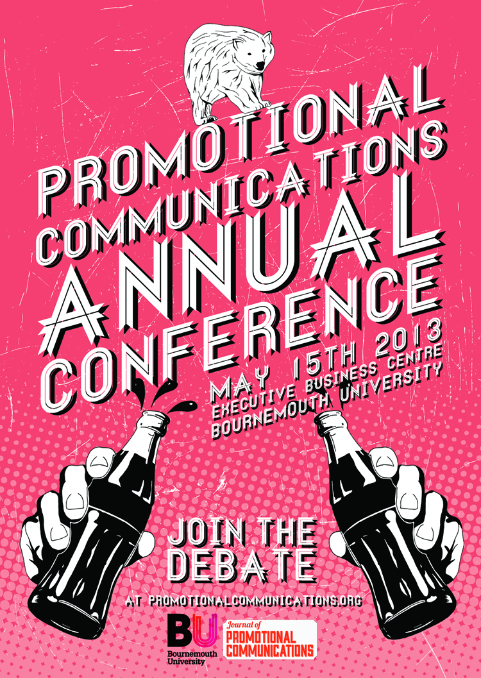

PLEASE SCROLL DOWN FOR ARTICLE

JPC makes every effort to ensure the accuracy of all the information (the “Content”) contained in the publications on our platform. However, JPC make no representations or warranties whatsoever as to the accuracy, completeness, or suitability for any purpose of the Content. Any opinions and views expressed

in this publication are the opinions and views of the authors, and are not the views of or endorsed by JPC The accuracy of the Content should not be relied upon and should be independently verified with primary sources of information. JPC shall not be liable for any losses, actions, claims, proceedings, demands, costs, expenses, damages, and other liabilities whatsoever or howsoever caused arising directly or indirectly in connection with, in relation to or arising out of the use of the Content.

This article may be used for research, teaching, and private study purposes. Any substantial or systematic reproduction, redistribution, reselling, loan, sub- licensing, systematic supply, or distribution in any form to anyone is expressly forbidden. Terms & Conditions of access and use can be found at: http://promotionalcommunications.org/index.php/pc/about/submissions

To cite this article: Gale, J. 2014. Lethal Consumption: An Exploration into the Use of Death Anxiety within Advertising Communications, *Journal of Promotional Communications*, 2 (1): 88-

**Jennifer Gale**

**Lethal Consumption:**

**An exploration into the Use of Death Anxiety within Advertising Communications**

*The purpose of this paper is to explore the use of death anxiety within advertising communications. The paper focuses specifically on whether advertising has the discrete capability to instigate death anxiety amongst subjects and how this might manifest and it additionally looks to discover whether a group’s materialistic tendencies can act as a variable in determining their susceptibility to death anxiety invoked by advertising. Before and after projective techniques were utilised and results identified that an increase in death anxiety did occur post stimuli, most pervasively amongst subjects deemed to be highly materialistic. Discomfort and confusion were recognized as initial reactions to death within advertising which could look to act as potential predictive measures of death anxiety and the emergence of five themes that indicated the prevalence of death anxiety occurred. These were: Fear; Worry; Catastrophization; Desire for Self Esteem; Blame and Stereotyping.*

Keywords: Advertising, death anxiety, terror management theory, consumption, materialism

INTRODUCTION

Gale, J. 2014. Lethal Consumption: An Exploration into the Use of Death Anxiety within Advertising Communications, *Journal of Promotional Communications*, 2 (1):88-



*“It did what all ads are supposed to do: create an anxiety relievable by purchase.”*

(Wallace 2006, p.296)

Anxiety is considered to be a popular meta-narrative within contemporary mass media that shapes consumer persuasion (Glassner 1999); nonetheless research studies in relation to advertising remain scarce. Furthermore, critics of advertising have long contended that in one form or another, advertising attempts to powerfully shape consumer values and choices (Schudson 2013) through psychological manipulation (Leiss et al. 2005). Although an extensive search into published research has been conducted, it appears that this contention has been left largely under explored. This paper seeks to contribute to a gap in current knowledge by exploring an area of consumer research, focused specifically on the use of death anxiety within advertising to determine whether advertising uses this particular form of persuasion to facilitate consumption.

An Advertising Standards Authority (ASA) report identified three no-go areas for advertisers: death, religion and bad language (McClintock 1996). Death is a sacred and sensitive subject area (O'Donohoe and Turley 2000) that is consistently *‘swept under the* *carpet in our culture’* (Watts 2014). Various campaigns related to drink-driving, cancer or life insurance have alluded to or depicted death (O'Donohoe and Turley 2000). Of particular interest to this study however, is its use in advertising where the product does not necessitate a portrayal of death, instead fulfilling the creative choice of the advertiser and raising the question of why the particular visual direction was chosen and to what effect. This research study utilises four advertisements for representations in connection with death: Heineken (2011), Marc Jacobs (2010), Pom Wonderful (2009), Paul Smith (2013).

Conceptually and empirically, Death Anxiety (DA) has typically been considered as a psychological state (Urien and Kilbourne 2008) which is not necessarily conscious but nevertheless is defined by Becker (1973) as the biggest motivational arouser. Carducci (2009 p.571) states that *‘To understand fully the dynamics of anxiety in advertising, you have to first consider the role anxiety plays as a stimulus and drive’*. The implications of enhancing death anxiety provide reasoning as to why advertisers may look to instill death cues within their communications. Various theorists postulate Terror Management Theory (TMT) as a way in which we are essentially able to ‘buffer’ the anxiety surrounding death (Solomon et al. 1986; Du et al. 2013; Berger & Luckmann 1966), with one aspect of this premise being the drive towards consumption as a means to alleviate death anxiety (Fransen et al. 2008; Choi et al. 2007; Rindfleisch and Burroughs 2004; Maheswaran and Agrawal 2004; Arndt et al 2004; Kasser and Sheldon 2000; Mandel and Heine 1999; Routledge et al. 2003). Established literature has also verified that it is materialistic people who tend to be more anxious than most (Kasser 2002; Norris et al. 2012). This predisposition will also be examined within this research, specifically examining materialism in conjunction with DA.

This present study has two principal aims supported by four objectives. Firstly, to explore whether advertising has the discrete capability to instigate death anxiety amongst subjects and how this might manifest; and secondly, to discover whether a group’s materialistic tendencies can act as a variable in determining their susceptibility to death anxiety invoked by advertising. In light of societal wellbeing, there is a call for research that seeks to uncover symbolic meanings presented in cultural texts (Hirschman and Thompson 1997), along with research that focuses on the potentially damaging unconscious effects that death can have on consumer behaviour (Arndt et al. 2004). As a result this research looks towards addressing these potential ethical implications of the industry.

This paper is divided into four subsequent sections. The first section will present a review of the existing literature surrounding the issue with a design to underpin the study. The methods of the research will then be discussed with a particular focus on the specifically selected projective techniques, and emphasis on the relevant sample. Section three will consist of the key findings of the study, including an emergence of three themes in relation to people’s initial reactions to death in advertising: aversion; discomfort and confusion, and an emergence of five themes that indicate that death anxiety was observed post advertising stimuli of: Fear; Worry; Catastrophization; Desire for Self Esteem; Blame and Stereotyping. The conclusive section will then reflect upon the study with an emphasis on potential implications before suggesting areas for further possible research.

LITERATURE REVIEW

The Relationship Between Advertising and Anxiety

In order to construct a relationship between advertising and death anxiety, this literature review will look at components to determine reasons supporting a relationship, together with implications of DA, before examining whether a particular character trait may inform the likelihood that DA will be prevalent post death advertising stimuli.

William Frankena (1973) defined ethics as a set of moral principles directed at *‘enhancing societal well-being’* (Zinkhan 2013, p.1) in which relative to corporate social responsibility, advertisers are expected to conform to or face judgement from governing bodies. Beauchamp (1984) argues contrary. He states that advertising poses moral questions in its attempt to compromise people’s ability to make a rational and free choice through the exploitation of their vulnerabilities and anxieties. Beauchamp’s standpoint has been widely acknowledged in literature since; crediting the view that advertising substantially endorses and co-generates anxieties in order to provide a solution to relieve it, with no regard to societal welfare (Coutant et al. 2011). Marx (1959) argues that making groups feel inadequate and anxious through commodity fetishism forms the very basis and intricacies of what advertising does in order to facilitate subconscious ‘psychological reinforcement’. Wheatley and Oshikawa (1970) comment that reducing emotional tension is achieved once a purchase has been made. From these studies it can be summated that advertising can provide both the problem and the solution to anxieties in order to endorse consumption

Berger’s (1972 p.153) work postulates this further, arguing that advertising offers an *‘intense yet vague, magical yet repeatable promise offered in every purchase’* and plays upon the premise that by having nothing you will be nothing. Adorno and Horkheimer (1944) provide a foundation to this argument by stating that advertising makes commodities desirable by adding psychological value to them; portraying products as a way to obtain certain feelings. Through extending and reproducing the commodity form (Goldman 1992) advertising of products supposedly provides a way in which anxiety may be reduced by consuming.

Death Anxiety

DA is described as a multidimensional concept characterised by negative feelings such as anxiety, fear and discomfort (Neimeyer 1994). This definition has been perpetuated further by Tomer and Eliason (1996) as the anxiety surrounding the state in which the self does not exist. In Lehto and Stein (2009) it is proposed that DA encompasses emotional, cognitive, and motivational components that can vary by development stage and life occurrences. Although not necessarily a consciously manifested state, it has been said that DA can be initiated through an increased awareness of mortality salience (MS) and manifested in a multiplicity of behaviours including fear, concern and worry. A host of studies that have manipulated death awareness have provoked heightened DA in subjects including Goldenberg et al. (2006); Greenberg et al. (1994); Pyszczynski et al. (2004). What has not yet been tested is whether MS and subsequently DA can be increased by using advertising as a mechanism.

Becker (1973) defined death as the biggest motivational arouser by contending that all of human civilization works as an elaborate, symbolic defense mechanism against the knowledge of our own mortality. Drawing from the works of Freud, Darwin and Nietzshe, Becker adopted a multidisciplinary view that lays down the core motivation of human behaviour by stating that the most basic human instinct is the drive towards self-preservation. DA is therefore described as a state that people fundamentally avoid in order to feel secure and protected from the potentially overwhelming anxiety that comes with death. As stated in the previous section, advertising can be seen to exploit anxiety in order to motivate people. Considering Becker’s argument that death and its associated anxieties is the primary source of motivation and teaming this with persuasion as a fundamental property of advertising, it is clear that *‘representations of death in marketing discourse merit further attention’* (O’Donohoe and Turley 2000 p.101) in order to fully understand whether these two facets are currently used in conjunction in order to shape consumer behaviour.

Terror Management Theory

Terror management theory (TMT) was initially proposed by Solomon et al. (1986) to formulate the way in which anxiety surrounding death can be kept under control. It is founded on the basis that association between a sense of value and psychological security begins early in life; a contention that is also proposed by various other theorists including Bowlby (1969); Horney (1937) and Mead (1934). Fundamentally, the theory proposes we can feel good about ourselves, feel safe and secure by instilling a dual component anxiety buffer. This is formed of (a) cultural worldview, which imbues life with meaning, permanence and stability by providing a set of value standards by which individuals can be evaluated; and (b) self-esteem, achieved by perceiving that one is living up to the standards of value derived from the worldview to which one subscribes (Du et al. 2013).

Culture offers prescriptions for valued behaviour that when fulfilled promise protection and symbolic death transcendence by attaching people to something larger, more powerful, and more eternal than themselves. Berger and Luckmann (1966) assert that as cultural worldviews and self-esteem are socially constructed, TMT only works according to faith validity. Humans place their faith in culturally instilled, socially constructed phenomenon to overcome a sense of anxiety that has the potential to be all encompassing. Maheswaran and Agrawal (2004) argue that defending ones worldview as an answer to DA can result in behaviours such as stereotyping, in group favouritism, nationalism and materialism. Applied to advertising, it is materialism that is of most significance to this study.

Substantial evidence supports the reliability of TMT as an answer to DA. The effect has been tested amongst a wide variety of geographically and demographically diverse samples, for example, with Asian students (Heine et al. 2002), Australian Aborigines (Salzman and Halloran 2004) and in press, municipal court judges (Rosenblatt et al.

1989). There has also been a wide diversity of behaviours explored in relation to TMT including moral judgments and intergroup conflict (see Greenberg et al. 1997 for a review), close relationships and attachment (see Mikulincer et al. 2003 for a review) and guilt and creativity (Arndt et al. 1999). Notable research conducted by Greenberg et al. (1990) documented that where awareness of death had been raised, participants were more favourably inclined towards others of the same religious beliefs. A reverse experiment carried out by Greenberg and Pyszczynski (1997) validated the effects of TMT where self-esteem was raised to see whether this would counter DA. Subjects were given either highly positive or neutral false personality feedback and then shown either a neutral video or a video containing graphic death related scenes. Individuals whose self-esteem had been raised (via positive personality feedback) reported less anxiety in response to the death video than neutral self-esteem subjects. McGregor et al. (1998) similarly found sustained effects of worldviews in their TMT based study where reminding participants of their mortality led people to be more physically aggressive with those who voiced different political beliefs by allocating more hot sauce for the person to consume when participants knew the target did not like spicy foods.

Terror Management Theory and Consumer Behaviour

Examination of TMT in relation to consumer behaviour allows an understanding as to why advertisers may take a vested interest in attempting to instill DA within their communications. It also paves the way for this study in terms of exploring unchartered territory when deciding whether advertising does have a discrete capability to raise DA within a captive audience.

Academic literature provides consideration of the link between TMT and consumer behaviour by initiating a connection between mortality related thoughts and materialistic tendencies. Choi et al. (2007, p.2) drew this conclusion with their study, proposing that materialistic consumption is a way of dealing with DA because material goods confer symbolic meaning that *‘allow individuals to transcend their mortal lives through a seemingly enduring cultural artefact’.* Numerous studies have explored and justified the notion of DA fuelling consumption including Fransen et al. (2008); Rindfleisch and Burroughs (2004) and Maheswaran and Agrawal (2004). A significant hypothesis of this research provides a proposition that as consumerism and materialism are pervasive features of dominant cultural worldviews, and identification with cultural worldviews is increased by the activation of death-related thoughts, this should provide significant increases in consumption and materialistic tendencies after DA is raised. Arndt et al (2004) conceive this form of materialism as an adaptive behaviour which can be influenced by both real life mortality salient events and experimentally enhanced mortality salience and predicted from the perspective of TMT.

*“*When the going gets tough, the tough go shopping....Within a few weeks of Sept 11—and in the teeth of a recession—ordinary Americans shook off their gloom and opened their wallets” (Zuckerman 2002).

The result of this particular study conducted following the American 9/11 terrorist attack suggests that in real-life situations materialistic consumption is a way of dealing with existential anxiety. Kasser and Sheldon (2000) provided that participants in a mortality salient condition had higher financial expectations, suggesting that concerns about mortality can influence economic aspirations and increase the appeal of money and products that imbue their owners with status. Moreover, Mandel and Heine (1999) similarly proposed that MS revealed an increase in items which symbolise value within a person’s culture. Both studies provide a clear explanation as to why advertisers could benefit from raising DA, due to the repercussions of the state. The analysis of TMT in relation to understanding consumer behaviour has also been identified by Routledge et al. (2003) in terms of its affect once entering a non-conscious space in the mind of the audience. This study revealed that although participants indicated higher intentions to purchase products with higher sun protection factors immediately after MS was raised and DA was conscious (possibly reflecting a more rationally oriented response to an item related to health), when thoughts of death were no longer in conscious awareness participants decreased their preference to buy safe sun products, presumably because they were more interested in enhancing self-esteem and adhering to the ‘desirability’ worldview. The focus of the current study is to similarly examine DA on an unconscious level, but to instead look at death implicated within advertising that does not attempt to counteract a negative behaviour such as too much sun exposure. The adverts utilised within this study are for products that do not necessitate a portrayal of death, hoping to explore what the reactions and implications are to death within these.

High Materialism as Predictive Measure of Death Anxiety

Although research has started to develop TMT to explore whether prior involvement or character can have an effect on results, the extent of this examination is currently limited. Choi et al. (2007) provided ego involvement in materials as a moderator of the MS effect and found that there was a strong correlation between the two, with those who see acquisition and possession of material objects in relation to self-concept tending to report greater preference for brand name products. Although other studies have tried to determine the socio-demographic and psychological profile of persons who show more or less anxieties when confronted in some way with death (Norris et al. 2012), there is still much room for scope in terms of what else can play as a predictive measure. No studies to the researcher’s knowledge have explored whether materialism as a character trait can determine levels of death anxieties prevalent after being exposed to advertising. Although anxiety may be a common condition for many consumers, materialistic individuals appear to be more anxious than most. Two similar studies explored anxiety as a mediating role, revealing that there was significant positive correlation between materialism and anxiety in both Kasser (2002) and Norris et al. (2012). Both studies replicated the findings that the adoption of materialistic values may fill a social void in anxiously attached individuals, where relationships with objects are substituted for relationships with people.

Within a capitalist society we are said to be consumers by nature and in support of this Marxist view (1959) the very structure of capitalist societies is based upon materialism. Mick (1996) identified that within capitalism how we choose to consume may inadvertently symbolise materialistic trends. There is complexity to materialism that makes it difficult to define together with considerable inconsistency in application of such definitions. Richins and Dawson (1992, p.307) refer to materialism as *‘a set or constellation of attitudes regarding the relative importance of acquisition and possession of objects in one’s life’*. Capitalistic tendencies suggest that people are focused on making money and amassing wealth to try to overcome feelings of anxiety. This study will explore whether materialism as a dark side variable (Mick 1996) and personality trait can enhance the effects of DA. Using theories and studies provided from the literature described in this research it is proposed to construct a research methodology to assist with addressing such questions.

**Figure 1: Proposed Theoretical Framework**

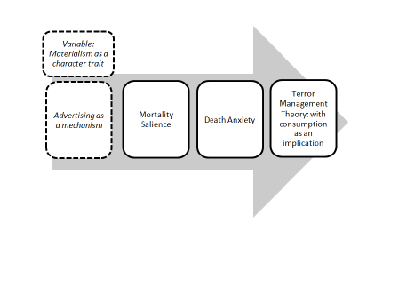

METHODS

**Overall Research Aim**

To investigate a possible link between advertising and its provocation of death anxiety amongst subjects.

In determination of the overall research aim the following objectives are constructed:

**Objective 1:** To examine participants’ initial responses to death within advertising texts.

**Objective 2:** To assess whether advertising has the discrete capability to provoke death anxiety amongst subjects.

**Objective 3:** To determine whether materialistic people are more susceptible to death anxiety that has been motivated by advertising.

**Objective 4:** To explore which forms of death anxiety are aroused amongst participants, if any, and how this is manifested through projective techniques.

The research lent itself to an exploratory nature by building upon already established theory (Jupp 2006.) with the intent to gain insights and familiarity on a subject whilst in a preliminary stage of investigation. This *‘conscious search for meaning and understanding’* (Gummesson 2003 p.311) instigated the need for the research to take on a qualitative methodology in order to satisfactorily meet the four objectives of the study and to gain rich data with the advertising audience at the core (Aitken et al. 2008).

**Table 1: Participant Information**

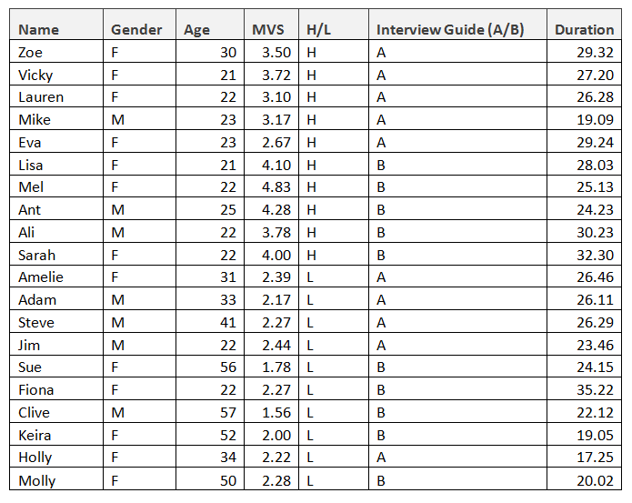

Non probability purposive sampling was used in order to meet inherent resource limitations. The suitability of this method is particularly compatible to preliminary small-scale and in-depth studies (Ritchie et al. 2003; Schutt 2006). Participants were selected upon the proposition of gaining an even spread of high and low materialism amongst the sample. 20 participants from both genders were recruited to avoid specific gender preference, over a wide demographic ranging from 21-57 years old in order to provide a broad sample. Qualitative views were conducted using interviews which lasted between 17-36 minutes with responses following ethics guidelines regarding confidence and anonymity (Denscombe 2003). All of this research followed Bournemouth University ethics and research requirements.

Data Collection

**Figure 3: Interview Process**

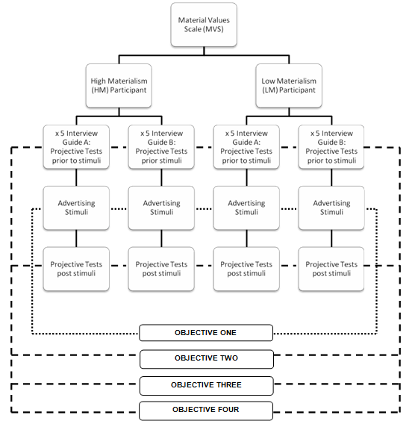

Data collection consisted of two different projective techniques - where a person is given ambiguous stimuli following which interpretation is required. This follows a notion where an individual is more likely to project something of a sensitive, hidden nature about themselves into a description rather than through a formal question/answer response (Ollendick et al. 1994). Due to the instinctive desire to suppress feelings associated with death (Becker 1973), this technique is able to reveal unconscious aspects that may otherwise be unobservable and concealed (Bellak, 1992; Rabin and Haworth 1960). Belk et al. (1997) supported the use of projective techniques, arguing that traditional methods may be limited as they are too direct in their approach. Projective techniques tap into a person’s internal, subjective experiences where previous studies have concluded that defence mechanisms, latent impulses, and anxieties have been inferred (Tuber 2012).

The two projective techniques utilised consisted of the adoption of a Thematic Apperception Test principle (TAT) (Murray 1943) and Rotter Incomplete Sentence Blanks (RISB) (Rotter and Rafferty 1950). One TAT principle and RISB was used prior to the advertising stimuli and another TAT principle and RISB was used post stimuli to detect if a change in DA had occurred. The projective tests were equally opposed amongst the high and low materialism participants, ensuring that in line with trustworthiness the strength of an individual projective technique did not create a bias to the result. The TAT principle consisted of various questions about ambiguous images.

**TAT Images**





Four Rotter Incomplete Sentence Blanks were used within the interviews, chosen from a bank of possible cues. These were:

‘Time...’

‘Most of the time I feel...’

‘Life...’

‘I regret...’

Audio recordings were made to allow the interviewer to focus fully on the interaction at hand (Longhurst 2010). The procedure was also piloted prior to the research (Chenail 2011) which highlighted the ‘before and after’ design component which provided completion of the methodology.

Scale Adoption

Adoption of Richins and Dawson’s (1992) materialism scale (MVS) was employed to screen participants into the two groups of high and low materialism (HM) and (LM), via a 5 point Likert scale (Likert 1932), ascertaining LM participants as 0-2.5 and HM participants as 2.5-5. This also ensured that a balanced allocation between the two conditions of projective tests was in place. Use of the MVS is supported through published research in terms of reliability and empirical usefulness (Richins 2004). The scale has been tested on large and diverse populations (Schrauf and Navarro 2005) giving the ability of data transfer to this study. A recent relevant study into DA (Urien and Kilbourne 2008) also used the MVS providing further credibility for use within this research. Advertising stimuli used half way through the interview stage followed the format of facets around death used in advertising, established by Andrews et al. (2014) as ‘death as beauty’, ‘death wish’ and ‘cheating death’. Print stimuli were used to ensure that the stimuli were readily available at all interviews. Four adverts were chosen from different popular industry sectors including fashion, health and alcohol.

**Advertising Graphics**

Heineken ‘Cheating death is possible’ print ad 2011



Marc Jacobs ‘Monika, Frida and Ann’ print ad 2010



Pomegranate ‘Cheat death’ print ad 2009



Paul Smith ‘A/W 13 underwear collection’ 2013



Analysis of Data

Each interview was transcribed individually and then viewed collectively to draw relations between the similarities and differences of occurrences (Hirschman and Thompson 1997). It has been noted that as a state, anxiety may be readily seen in both the production and the content of the projective testing (Ollendick et al. 1994). It also follows that *‘when one sees issues of worry and unease in projective protocols, one should also be sensitive to the possible coexistence of anxiety’* (Ollendick et al. 1994 p.168). All possible deductions of DA were taken into consideration and documented when analysing the data, including inferences suggested previously in TMT literature. Themes were identified that emerged across the data which worked towards suggesting that the anxiety had become apparent. These were then coded on the basis of an ‘increase’, ‘decrease’ or ‘same’ level of a particular theme, comparing the second projective test to the first and deciphering whether the level of DA raised related to which group the participant was placed into regarding the MVS. The initial responses to the adverts were analysed in order to meet the first objective, with an emergence of themes also prevalent. Analysis of projective techniques is often criticised due to subjective characteristics of the evaluator, who often seeks to interpret a range of occurrences during the interview (Mandler and Sarason 1952). Heron (1996) argues that our values are the guiding reason of all human action; therefore a researcher’s bias must be taken into consideration within the analysis as the researcher cannot be isolated from the phenomenon investigated (Smith, 1989). Nonetheless, the analysis of themes arising from interviewees ‘own words’ coupled with collation of collective similarities of the group has ensured that evaluators bias has been minimised.

ANALYSIS AND FINDINGS

The four objectives of this study, referenced against research methodology and a literature review have been divided into two distinct sections. Section one comprises participants’ initial reactions to death related adverts and this corresponds with objective one. Key themes arising from this objective are aversion, discomfort and confusion. Section 2 seeks to provide findings to objectives 2, 3 and 4 by interlinking responses collectively using the TAT principle projective technique. Key themes that arose from findings related to DA are: fear; worry; catastrophization; desire for self- esteem; blame and stereotyping.

Dismissal of Rotter Incomplete Sentence Blanks (RISB)

It was intended to use RISB’s during the interview stage alongside TAT’s with a view to increase validity by combining results from two different projective techniques. Although a well-established method, the blanks proved too unbounded for participants and data collected was insubstantial. Participants found it difficult to be at ease with the technique, with responses being interspersed with laughter and clichés. As this did not provide rich data streams, it was decided to dispense with RISB’s and therefore analysis is confined to TAT data.

*Section One*

*Objective One: To examine participants’ initial responses to death in advertising texts*.

**Table 2: Initial Response Themes: Aversion, Discomfort, Confusion**

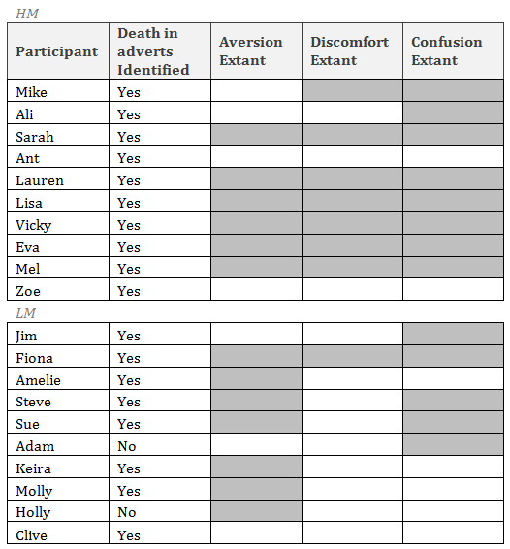

Advertising stimuli was left to individual interpretation with reactions noted and structured into themes from overarching responses expressed. Participants were asked “What do you see in the advert?”, “What do you think is the intended message?” and “How does it make you feel?” Common themes arising from responses were labelled: aversion, discomfort and confusion. Participants were not provoked to gauge the theme of death running within the texts to see whether the advertising texts possessed the discrete capability to elicit MS which could lead to DA being raised. 18/20 respondents noted a presence of death within the adverts. In line with studies undertaken by Goldenberg et al. (2006); Greenberg et al. (1994) and Pyszczynski et al. (2004) motivating death awareness should necessitate heightened DA. However, as only 11/20 participants within the study showed an increase in DA this result looks to counter the suggestion that motivation heightens DA. Differences in reactions from participants do however indicate the type of response which can provide a suggestion that DA will be raised, in excess of what previous studies have noted.

*Theme One: Aversion*

Categorised as a strong dislike or repugnance, aversion was identified as a significant theme, with participants conveying considerable negativity towards the adverts. 6/10 HM subjects reported tones of aversion in their immediate reactions to the adverts. This was embodied by Vicky’s (MVS 3.72) reaction of “Right, that’s disgusting”, further exemplified by a comment from Lauren (MVS 3.10) “So it’s dark and red and there’s a noose around it. I think that’s weird and I don’t think they’re going to sell. I really don’t think they will sell” and Sarah’s (MVS 4.00) reaction “I really hate it”. Interestingly, 7/10 LM subjects reported tones of aversion within their immediate responses, showing an increase in comparison to those deemed to be highly materialistic. This is illustrated by a few interviewees in particular, namely Sue (MVS 1.78) “How do they prove that this will help you avoid death? What evidence have they got that it’s so fantastic? It doesn’t really do much for me as an advert” and Fiona (MVS 2.27) “If anything that would shut me down rather than making me like yeah I want to have those”. As aversion was shown most commonly amongst LM participants and it was the HM participants that showed most DA in their answers, this suggests that aversion does not provide a clear predictor of DA, instead possibly acting as a ‘switch off’ mechanism.

*Theme two: Discomfort*

Discomfort has been described by Neimeyer (1994) as a feeling that works within the multidimensional DA concept. 7/10 HM subjects reported feelings of discomfort when looking at the adverts, exemplified by the following example from Lauren (MVS 3.10) “I think it’s strange and I don’t think it would work. I don’t get the strap ‘cheating death is possible’ does that mean, is that supposed to mean don’t kill yourself drink beer? It’s making me feel uncomfortable”. Significantly, only 1/10 LM subject conveyed feelings of discomfort in their immediate reactions to the stimuli. The contrast with HM participants is particularly noteworthy in terms of emotions stirred amongst the two differentiated groups when viewing death within advertising. This provides an indication that discomfort as an emotion can act as a more distinct predictive measure for DA.

*Theme three: Confusion*

Confusion was the most common themed response to the adverts with 13/20 participants showing an extent of confusion over why death within adverts had been used. 8/10 HM subjects reported feelings of confusion. A response from Eva (MVS 2.67) provides “None of those situations need to be morbid. Beer isn’t a morbid thing, antioxidant juice isn’t a morbid thing, clothing isn’t a morbid thing. So I don’t know why...it’s kind of a weird thing for me that they even use that because for me, positive things are always gonna appeal to me more because it’s things that make you happy or things that make you see life in a better way, not necessarily in a worse way.” Other responses from participants alluding to confusion included Ali (MVS 3.78) “It doesn’t make sense” and Lauren (MVS 3.10) “Why are you cheating death by drinking pomegranate juice? Is it because it’s healthy? I, I don’t get it”.

Only 5/10 LM subjects elicited confusion within their responses indicating a fall relative to HM subjects.

*Section Two*

Objective 2: To assess whether advertising has the discrete capability to provoke death anxiety amongst subjects & Objective 3: To determine whether materialistic people are more susceptible to death anxiety that has been motivated by advertising & Objective 4: To explore which forms of death anxiety are aroused amongst participants, if any, and how this is manifested through projective techniques.

Objective 2 proposed that this study would assess whether advertising has a capability to provoke DA amongst subjects and responses deduced that this applied for the majority of participants. 11/20 participants elicited some form of increased DA during the second session of the interview. Applied by differentiated groups in order to observe Objective 3, DA was considerably higher for HM subjects with 9/10 participants showing signs of an increase in the second TAT. Comparison with the LM subjects identified that only 2/10 within this group showed an increase in DA following the advertising stimuli.

Recognition of participants scoring higher on the MVS and being more susceptible to DA follows studies conducted by Kasser (2002) and Norris et al. (2012). These concluded that materialistic people tend to exhibit higher levels of anxiety in comparison to those who are not. These results add to existing research by confirming that death within advertising has a tendency to raise DA most significantly amongst those deemed to be materialistic (Objective 3). Objective 4 sought to provide an insight into increased DA projection following viewing of death related advertising stimuli. Following Ollendick et al.’s (1994) contention that anxiety may be viewed in the production and the content of projective answers, DA in this study was signified through the way that answers were articulated and in the substance of TAT. Ollendick et al. (1994 p.386) proposed that *‘the validity of projectives is in the strength of the patterns that appear across techniques’.* Key themes that indicated a prevalence of DA emerged as patterns across the data and comprised: Fear; Worry; Catastrophization; Self esteem; Blame and stereotyping.

*Theme One: Fear*

**Table 3: Fear**

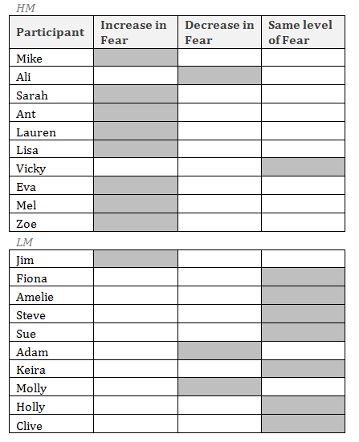

Fear has been conceptualised as a motivational state that gives rise to defensive behaviour or escape. The concept is supported by Barlow (2000), and cohesion to this theme has been recognised during the second TAT. 9/20 of all participants showed increased fear with considerable 8/10 HM participants eliciting increased fear post stimuli. Fear increased through stories describing feelings toward the TAT image. An example provided by HM subject Ant (MVS 4.28) who prior to the advertising stimuli stated that the image made him feel “Quite open, free, I feel like going on holiday cos of his P.O.V” changed considerably in the response to the second image post advertising stimuli to “Really on edge, suspense, fearful, wondering what is going to happen next”.

By contrast, only 1/10 LM participant showed an increase in fear, with the majority of LM participants assuming the same levels of fear in both pre and post TAT’s. LM participant Steve (MVS 2.27) was a typical response by initially stating “Well hopefully he’ll pull her out the way, the motorcyclist will swerve round and it will be okay” and maintaining this level of fear in the second TAT with “I think he would be a lot faster than the parachute and it’s quite a quick thing, I think he would try and get far away from it and open his own. And the guy with the camera will get down okay.”

*Theme Two: Worry*

**Table 4: Worry**

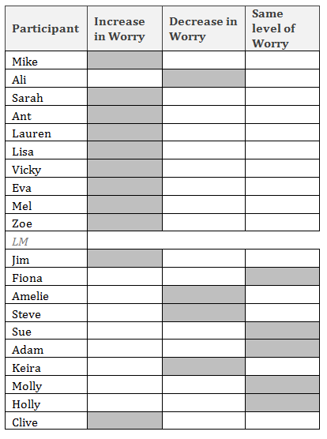

Worry has been identified as an important form of anxiety with content focused on concerns about unpleasant scenarios that might occur in the future (Oathes et al. 2010). Increased worry was shown across 11/20 of all participants between the first and second TAT’s. 9/10 HM participants showed increased worry during the second TAT whereas only 2/10 LM participants did so. Qualitative responses reflecting the changes are exemplified by Lisa (MVS 4.10) who stated during her first TAT when asked how the image made her feel: “Makes me feel a little jealous, I would want to do that. I wish, I think that feeling would be a real wow moment, a breathtaking moment. It’s something I’d like to do.” She then displayed increased signs of worry during the second TAT with: “Um worried for one of them as it looks like they’re going to get hit. Thankful that that’s not me, that I am in a much better place than they are. Feeling pretty safe, no motorbikes coming to get me.”

*Theme Three: Catastrophization*

**Table 5: Catastrophization**

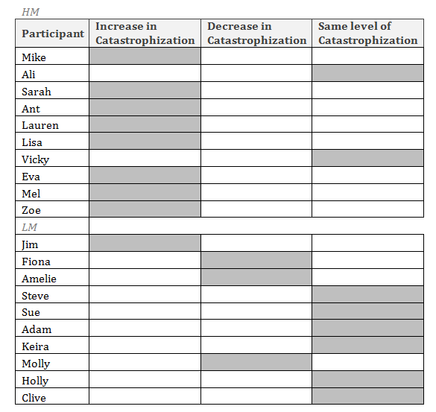

Catastrophizing is a common irrational belief that causes anxiety, essentially built around the idea that something is far worse than it actually is (Braunstein 2004). The theme of catastrophizing is a significant subject explored in the subject of socio-psychology and the results reflect the powerful reaction displayed by participants. 9/20 of all participants showed increased catastrophization, but this was polarised between the two groups. 8/10 HM participants indicated increased catastrophization whereas only 1/10 of the LM group showed enhanced levels. Prior to the advertising stimuli Zoe (MVS 3.50) explained what she thought would happen next as “The guy on the motorbike is wondering what these people are doing but also thinking ‘Oh shit I’m going to have to react’. She’s like ‘Ah we’ve had a fight and I don’t want to come to this party’ and he’s like ‘oh no quick’ but because she’s in a bit of a mood he’s not sure what to do.”

After seeing the adverts her answer to the second TAT took on a more catastrophic tone with “The guy holding on is holding on for dear life and is hopefully going to be able to hold on until they reach the bottom. The one at the top, I think he’s dead or something? I think it might be a carcus. I can’t even see if it’s one or two parachutes. It looks like his life is in the other guys hands. I think he is either dead or will die.” The majority of LM participants tended to show no increased level of catastrophization, conveyed in Adam’s responses (MVS 2.17)

“I think he’s going to pull her towards him and the bikes going to miss them”

And post stimulus.

“I think they will resolve it as they look quite professional, he looks like a professional skydiver so I think they’ll be alright.”

*Theme Four: Desire for Self Esteem*

**Table 6: Desire for Self Esteem**

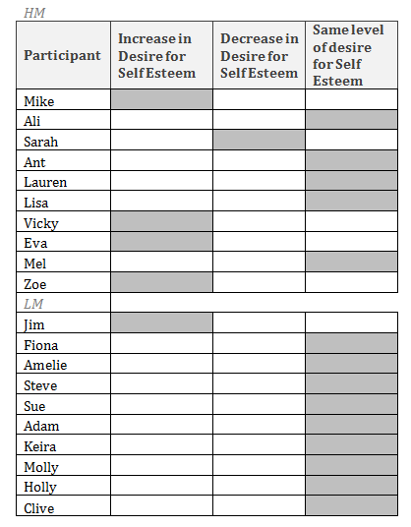

In compliance with TMT the cultural anxiety buffer is a social creation meaning that individuals are highly dependent on others for its validation and maintenance (Berger and Luckmann 1966). During interviews, indications of DA became apparent through the second TAT by recognition in the way that people attempted to construct their answers by searching for approval and acceptance where DA was prevalent. This follows Ollendick et al.’s (1994 p.386) contention that *‘as a drive the effects of anxiety may be evident in the approach to the projective task e.g. behaviours, mannerisms, interpersonal and self-related speech’*. Although only 5/20 of all participants desired more self-esteem between their first and second TAT’s, such changes were heavily skewed toward HM participants, reflecting a score of 4/10. An example is evident in Vicky’s (MVS 3.72) response where the initial reaction was

“It looks like the woman was crossing the road and the man thought that she was about to get hit by the oncoming motorbike so he reached out to try and drag her out of the way”. This transferred into an increase striving for self-esteem during her post stimuli answer with

“I have no idea what’s going on here. This guy is flying, what is that? Do you know? A parachute? He’s holding onto a parachute? Can you say? How is this guy floating? He’s...okay, I don’t know. OK so...yeah?”

Only 1/10 LM participant showed an increase in desire for self-esteem whereas the other LM subjects remained stable.

*Theme Five: Blame and Stereotyping*

**Table 7: Blame and Stereotyping**

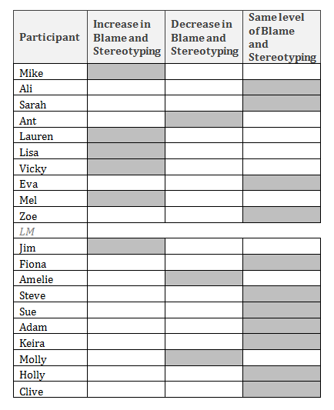

Maheswaran and Agrawal (2004) argued that defending ones worldview as an answer to DA can result in behaviours such as stereotyping and this provided a theme that was recognised by 6/20 of all participants through increased signs. Studies by Greenberg et al (1990) and McGregor et al (1998) found that stereotyping led to more favourable inclination to those within ones perceived group and aggression and blame to those outside of it. Such findings appear parallel with this data. 5/10 HM participants revealed an increase in blame and stereotyping, most notably conveyed in a response from Mike (MVS 3.17) where he initially described his views as

“The blokes probably thinking oh crap I’m going to get run over. Thinking of saving her, but at the same time trying to save his present. The girls probably confused cos she hasn’t seen the bike.”

Mike indicated stronger signifiers of blame during the second TAT as “fear and annoyance at the other bloke who’s gone into his parachute”. The contrast with LM participants is significant because only 1/10 showed an increase in blame and stereotyping.

DISCUSSION

Although this study has limitations due to timescales and format, findings from the qualitative data analysis provide implications between DA and advertising that have not yet been deduced by research previous to this. Relative to objective one, the HM and LM groups responded distinctly differently when looking at initial reactions concerning death in advertising within the study. This provides a new phenomenon expanding upon studies into MS undertaken by Goldenberg et al. (2006); Greenberg et al. (1994); Pyszczynski et al. (2004) by deducing that provocation of DA is perhaps able to be better predicted from the stirring of a specific type of emotion when viewing death in advertising. With reference to table 2, HM participants displayed higher levels of discomfort and confusion, translating these into heightened DA through the projective technique. Such emotions can therefore be inferred to act as clearer predictive measures of DA because of what occurred in succession. Aversion was constructed as a theme across both HM and LM participants, but was shown most prevalently within the LM participants, who did not display similar levels of DA in the interview. The extended deduction from these results is that aversion does not provide a clear predictor of DA but instead may work as a ‘switch off’ mechanism.

Moving onto section 2 and meeting objectives 2, 3 and 4, an indication that DA had been raised was inferred through a diversity of themes, with a clear tendency revealing that HM participants stipulated greatly more DA than LM participants. Table 3 demonstrated that fear had considerably increased for this group; with 8 of the 10 HM participants conforming to an incline. This amplification continued throughout the remaining data with HM participants showing an increase in worry (9/10 participants, table 4), an increase in catastrophization (8/10, table 5), an increase desire for self- esteem (4/10, table 6) and an increase in blame and stereotyping (5/10, table 7). Contrasting these results with LM participants, this differed significantly. The LM group had a tendency to generally stay at the same level within the above themes, showing that their anxiety levels had not been raised via the stimuli and their ability to think on a rational level, in a similar manner to how they had conducted themselves in the initial projective test had remained stable. This new finding, surrounding the susceptibility of HM participants to death within advertising, builds and strengthens previous links that have been made between materialistic people and anxiety (Kasser 2002 and Norris et al. 2012). Questions concerning societal welfare are also raised when taken into an everyday context (Coutant et al. 2011) as it has been suggested by this research that advertising does have a discrete capability to unconsciously place people into a potentially overwhelming anxious state that we fundamentally want to avoid (Becker

1973). The above results and patterns provide compelling evidence that advertising does have an ability to raise DA amongst subjects, with HM participants much more prevalently eliciting this anxiety than LM participants. DA levels became explicit through a variety of themes during the coding process by demonstrating a multiplicity of ways in which anxiety can manifest. Implications from this study also reinforces published literature where TMT may come into effect as a likely result and with participants with heightened DA looking towards consumption as an anxiety buffer (Arndt et al. 2004; Choi et al. 2007; Fransen et al. 2008; Rindfleisch and Burroughs 2004; and Maheswaran and Agrawal 2004.)

**Figure 4: Developed Conceptual Framework**

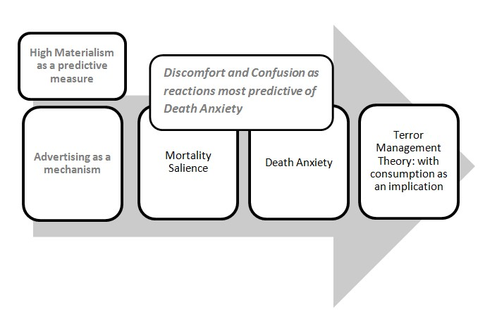

CONCLUSION

The purpose of this paper was to explore the use of DA within advertising, building upon the theory of terror management (Solomon et al. 1986). Although published research was used to structure the study, the researcher did not discover a similar study despite an extensive search. It is therefore considered that this study is unique in its field and has brought to light new material in what is currently an under researched domain. Previous research has identified the diverse consequences of TMT (Greenberg et al. 1990; Greenberg and Pyszczynski 1997; McGregor et al. 1998), paying particular attention to the effect that DA can have on consumption (Fransen et al. 2008; Choi et al.2007; Rindfleisch and Burroughs 2004; Maheswaran and Agrawal 2004; Arndt et al 2004; Kasser and Sheldon 2000; Mandel and Heine 1999; Routledge et al. 2003), whereas this study took a focused look at the instigating role that advertising can play in creating and motivating DA which looks to contribute a new dynamic in addition to the already established framework.

Four objectives were set within the study. Objective 1 sought initial responses to the advertising texts and discovered three predominant themes: aversion, discomfort and confusion. Data within the themes gave varied responses in the predictability of DA, providing further progression to research that has relied solely upon raising death awareness as a means to instigate DA (Goldenberg et al. 2006; Greenberg et al. 1994; Pyszczynski et al. 2004). The projective DA findings answer Objectives 2, 3 and 4 concurrently and are particularly significant as they highlight a potentially worrying aspect of advertising that is presently unrecognised. Main themes that signified a rise in DA were: Fear; Worry; Catastrophization; Desire for Self esteem; Blame and stereotyping. If, as the findings suggest, advertising does have a discrete capability to raise unconscious death anxiety amongst a captive audience, with HM people of particular susceptibility, then further attention must be given to this by governing bodies such as the ASA (2014). Future consideration and research should also be explored around the unconscious arousals that may be stirred through advertising communications, due to the very real repercussions that can occur as result.

Examination of death anxiety within advertising as a topic has much scope for future study, with the potential to explore greater detail through specific mediums such as TV and industry sectors such as fashion. Data from such research will help uncover the extent to which anxiety is being manipulated beyond our conscious awareness.

Given that previous literature lays down the very nature of advertising as anxiety inducing (Beauchamp 1984; Coutant et al. 2011; Marx 1959; Wheatley and Oshikawa

1970; Berger 1972; Adorno and Horkheimer 1944; Goldman 1992) the findings gathered are not unexpected, but instead are a step towards unearthing more about the underlying influence that advertising can have on society. It may prove beneficial for industry to start examining the content of advertising more intimately rather than just accepting or rejecting adverts for their face value. Projective techniques are catered towards investigating the unconscious, so this could be a potential way to screen adverts, prior to them being made public. Although great care has been taken in the selection of subjects and data analysis it is recognised that the study has natural limitations. Researcher bias is inherent within sociological and qualitative projective methods and it is suggested that the study is replicated elsewhere. Themes were formulated by drawing similarities between the data; however this does merit a consideration in terms of transferability to other studies where different researchers may read the projective data slightly differently. A sample size of 20 is small and therefore caution with transference into a wider population is needed. The sample size is, by necessity, set within a regional population of the United Kingdom and therefore reflects such environmental placement. Other cultural or diverse populations may produce different data for consideration.

Notwithstanding the above limitations, further research is suggested to explore such possible variances and used to confirm validity of the results. Within the context of this preliminary study however and with respect to the carefully controlled qualitative interview procedures, it is reasonable to suggest from the study that DA was raised and projected, with a strong leaning towards HM participants, due to the advertising stimuli.

REFERENCES

Adorno, T. and Horkheimer, M., 1944. The Culture Industry: Enlightenment as Mass

Deception. *In Dialectics of Enlightenment*. Stanford: Stanford University Press.

Aitken, R., Gray, B. and Lawson, R., 2008. Advertising effectiveness from a consumer perspective. *International Journal of Advertising* [online], 27 (2), 279 – 2.

Andrews, M., Leeuwen, M. and Baaren, R., 2014. *Hidden Persuasion: 33 Psychological Influences Techniques in Advertising*. Amsterdam: BIS Publishers.

Arndt, J., Greenberg, J., Solomon, S., Pyszczynski, T. and Schimel, J., 1999. Creativity and terror management: Evidence that creative activity increases guilt and social projection following mortality salience. *Journal of Personality and Social Psychology* [online]. 77 (1),

19-32.

Arndt, J., Solomon, S., Kasser, T. and Sheldon, K., 2004. The urge to splurge: A terror management account of materialism and consumer behavior. *Journal of Consumer Psychology* [online]. 14 (3), 198-212.

ASA., 2014. ASA: The UK’s independent regulator for advertising across all media

[online]. Available from: http://www.asa.org.uk/ [Accessed March 17 2014].

Barlow, D.H., 2000. Unravelling the mysteries of anxiety and its disorders from the perspective of emotion theory. *The American Psychologist* [online], 55 (11), 1247-63.

Baudrillard, J., 1970. *The Consumer Society: Myths and Structures*. New York: SAGE Publications Ltd.

Beauchamp, T., 1984. Manipulative Advertising. *Business and Professional Ethics Journal* [online], 3 (3), 1-22.

Becker, E., 1973. *The Denial of Death*. New York: Simon & Schuster.

Belk, R. W., Guliz, G. and Askegaard, S., 1997. Consumer desire in three cultures: results from projective research. *Advances in Consumer Research* [online]. 24, 24-28.

Bellak, L., 1992. *The T.A.T., C.A.T, and S.A.T. in clinical use* 5th edition. Boston: Allyn & Bacon.

Berger, J., 1972. *Ways of Seeing*. London: Penguin Classics.

Berger, P., and Luckmann, T., 1966. *The Social Construction of Reality. London*: Penguin

Books.

Bowlby, J., 1969. *Attachment and loss*. Vol.1. New York: Basic Books.

Braunstein, J. W., 2004. An Investigation of Irrational Beliefs and Death Anxiety as a function of HIV Status. *Journal of Rational-Emotive & Cognitive Behaviour Therapy* [online], 22 (1).

Bryman, A., 2004. *Social Research Methods* 2nd edition. Oxford: Oxford University Press.

Carducci, B. J., 2009. *The Psychology of Personality: Viewpoints, Research, and*

*Applications*. 2nd Edition. NJ: John Wiley & Sons.

Chenail, R., 2011. *Interviewing the Investigator: Strategies for Addressing Instrumentation and Researcher Bias Concerns in Qualitative Research. The Qualitative Report* [online]. 16 (1), 255 - 262.

Choi, J., Kwon, K., and Lee, M. 2007. Understanding materialistic consumption: A terror management perspective. *Journal of Research for Consumers [*online]. 13, 1-19.

Coutant, A., De La Ville, V., Gram, M. and Boireau, N., 2011. Motherhood, Advertising, and Anxiety: A Cross-Cultural Perspective on Danonino Commercials. *Advertising & Society Review* [online], 12 (2).

Denscombe, M., 2003. *The good research guide for small-scale social research projects*

2nd edition. Maidenhead, England; Philadelphia.

Du, H., Jonas, E., Klackl, J., Agroskin, D., Hui, E. and Ma, L., 2013. Cultural influences on terror management: Independent and interdependent self-esteem as anxiety buffers. *Journal of Experimental Social Psychology* [online]. 49 (6), 1002-1011.

Frankena, W., 1973. *Ethics*. 2nd ed. New Jersey: Prentice-Hall.

Fransen, M., Fennis, B., Pruyn, A. and Das, E. 2008. Rest in peace? Brand-induced mortality salience and consumer behavior. *Journal of Business Research* [online]. 61 (10),

1053-1061.

Glassner., B, 1999, *Culture of Fear: Why Americans Are Afraid of the Wrong Things*. New

York : Basic.

Goldenberg, J.L., Hart, J., Pyszczynski, T., Warnica, G., Landau, M and Thomas, L. 2006. Ambivalence Toward the Body: Death, Neuroticism, and the Flight From Physical Sensation. *Personality and Social Psychology Bulletin* [online]. 32 (9), 1264.

Goldman, R., 1992. *Reading Ads Socially.* Sussex: Psychology Press.

Greenberg, J., Jones, E., Simon, S., Solomon, S., Pyszczynski, T. and McGregor, H. 1997. Terror Management Theory and Self-Esteem: Evidence That Increased Self-Esteem Reduces Mortality Salience Effects. *Journal of Personality and Social Psychology* [online].

72 (1) 24-36.

Greenberg, J., Pyszczynski, T. and Solomon, S., 1986. The Causes and Consequences of a Need for Self-Esteem: A Terror Management Theory. In Baumeister, R. *Public Self and Private Self* 189-212. New York : Springer-Verlag.

Greenberg, J., Pyszczynski, T., Solomon, S., Rosenblatt, A., Veeder, M.,Kirkland. S. and Lyon, D. 1990. Evidence for terror management II: The effects of mortality salience on reactions to those who threaten or bolster the cultural worldview. *Journal of Personality and Social Psychology* [online]. 58, 308–318.

Greenberg, J., Solomon, S. and Pyszczynski, T., 1997. Terror management theory of self- esteem and social behavior: Empirical assessments and conceptual refinements. In Zanna, M. *Advances in experimental social psychology [*online]. 29, 61-139.

Gummesson, E., 2003. All research is interpretive. Journal of Business & Industrial

Marketing [online]. 18 (6•7), 482-492.

Heine, S., Harihara, M., Niiya, Y., 2002. Terror Management in Japan. Asian Journal of

Social Psychology [online]. 5, 187-196.

Heineken., 2011. Cheating Death is possible [Advert]. Available from:

http://mediatedtech.blogspot.co.uk/2013/11/heineken-cheat-death.html [Accessed 10

May 2014].

Heron, G., 1996. *Co-Operative Inquiry: Research Into the Human Condition*. Thousand

Oaks, CA: Sage.

Hirschman, E, C. and Thompson, C, J., 1997. Why media matter: Toward a richer understanding of consumers' relationships with advertising and mass media. *Journal of Advertising* [online]. 26 (1), 38 – 43.

Horney, K., 1937. The Neurotic Personality of Our Time. New York: W.W. Norton.

Jupp, V., 2006. *The SAGE Dictionary of Social Research Methods* [online]. Available from: http://srmo.sagepub.com/view/the-sage-dictionary-of-social-research- methods/n75.xml [Accessed May 10 2014].

Kasser, T. 2002. *The High Price of Materialism.* Massachusetts: MIT Press

Kasser, T. and Sheldon, K., 2000. Of wealth and death: Materialism, mortality salience, and consumption behavior. *Psychological Science* [online]. 11, 348-351.

Kesebir, P. and Ying-yi, H., 2009. Existential Anxiety and Essentialism Explain Negative

Reactions Toward Brand Extensions. Advances in Consumer Research [online]. 36, 1016.

Klien, H. and Myers, M., 1999. A Set of Principles for Conducting and Evaluating

Interpretive Field Studies in Information Systems. MIS Quarterly [online]. 23 (1), 67-94.

Lehto, R. and Stein, K., 2009. Death Anxiety: An Analysis of an Evolving Concept. Research and Theory for Nursing Practice: An International Journal [online]. 23 (1).

Leiss, W., Kline, S., Jhally, S. and Botterill, J., 2005. Social Communication in Advertising: Consumption in the Mediated Marketplace.3rd edition. New York: Routledge.

Likert, R., 1932. A Technique for the Measurement of Attitudes. *Archives of Psychology*

[online]. 140, 1–55.

Longhurst, R., 2010. Semi Structured Interviews and Focus Groups. In: Clifford, N., French, S., Valentine, G., 2010. Key Methods in Geography 2nd edition. London: SAGE Publications.

Maheswaran, D., and Agrawal, N., 2004. Motivational and Cultural Variations in Mortality Salience Effects: Contemplations on Terror Management Theory and Consumer Behavior. *Journal of Consumer Psychology* [online]. 14 (3), 213-218.

Mandel, N. and Heine, S., 1999. Terror management and marketing: He who dies with the most toys wins. *Advances in Consumer Research* [online]. 26 (1), 527-532.

Mandler, G. and Sarason, S., 1952. A study of anxiety and learning. *The Journal of*

*Abnormal and Social Psychology* [online]. 47 (2), 166-173.

Marc Jacobs., 2010. Marc Jacobs 2010 F/W Fall Winter. Available from:

http://www.fashionadexplorer.com/p-juergen-teller--c-ad-campaign [Accessed May 10

2014].

Marx., 1959. *Economic and Philosophic Manuscripts of 1844*. Moscow: Progress

Publishers.

McClintock, L., 1996. Offensive weapons?: more brands are courting controversy by going for ads with shock value. *The Free Library* [online] 10 August 1996. Available from: http://www.thefreelibrary.com/Offensive weapons?: more brands are courting

controversy by going for...-a018618320 [Accessed May 10 2014].

McGregor, H., Lieberman, J., Greenberg, J., Solomon, S., Arndt, J., Simon, L. and

Pyszczynski, T. 1998. Terror management and aggression: evidence that mortality

salience motivates aggression against worldview-threatening others. *Journal of*

*Personality and Social Psychology* [online]. 74 (3), 590-605.

Mead, G., 1934. *Mind, Self, and Society*. Chicago: University of Chicago Press.

Mick, D., 1996. Are Studies of Dark Side Variables Confounded by Socially Desirable

Responding? The Case of Materialism. *Journal of Consumer Research* [online]. 23, 106–

19.

Mikulincer M., Florian V. and Hirschberger G., 2003. The existential function of close relationships: introducing death into the science of love. P*ersonal and Social Psychology Review* [online]. 7 (1), 20-40.

Murray, H.A., 1943. *Thematic Apperception Test*. Massachusetts: Harvard University

Press.

Neimeyer, R., 1994. *Death Anxiety Handbook: Research, Instrumentation, and*

*Application.* Washington: Taylor & Francis.

Norris, J., Lambert, N., DeWall, C. and Fincham, F. 2012. Can’t buy me love?: Anxious attachment and materialistic values. *Personality and Individual Differences* [online]. 53 (5), 666-669.

Oathes, D.J., Squillante, C.M., Ray, W.J. and Nitschke, J.B., 2010. *The Impact of Worry on*

*Attention to Threat*. PLOS ONE [online], 5 (10).

O'Donohoe, S. and Turley, D., 2000. Dealing with Death: Art, Mortality and the

Marketplace. *Imagining Marketing* [online], 19, 85-103.

Ollendick, T., King, N. and Yule, W., 1994. International Handbook of Phobic and Anxiety

Disorders in Children and Adolescents. New York: Springer.

Paul Smith., 2013. Sébastien Montaz-Rosset: Paul Smith Underwear A/W 13 featuring Antoine Moineville and Tancrède Melet [Advert]. Available from: http://www.itsnicethat.com/articles/advertising-paul-smith-underwear [Accessed May

10 2014].

POM Wonderful., 2009. Cheat Death. The antioxidant power of pomegranate juice [Advert]. Available from: http://www.theguardian.com/media/2009/apr/08/asa- cheat-death-pom-wonderful-ad [Accessed May 10 2014].

Rabin, A.L. and Haworth, M., 1960. *Projective techniques for children; Child psychology*.

New York: Grune & Stratton.

Richins, M. and Dawson, S. 1992. A Consumer Values Orientation for Materialism and Its Measurement: Scale Development and Validation. *Journal of Consumer Research* [online]. 19, 303–16.

Richins, M.L., 2004. The Material Values Scale: Measurement Properties and

Development of a Short Form. *Journal of Consumer Research* [online]. 31 (1).

Ridenour, C., Benz, C. and Newman, I., 2008. *Mixed Methods Research: Exploring the*

*Interactive Continuum*. Illinois: SUI Press.

Rindfleisch, A., and Burroughs, J. 2004. Terrifying thoughts, terrible materialism? Contemplations on a terror management account of materialism and consumer behavior*. Journal of Consumer Psychology* [online]. 14 (3), 219-224.

Ritchie, J., Lewis, J. and Elam, G., 2003. Designing and selecting samples. In Ritchie, J., & Lewis, J. *Qualitative research practice. A guide for social science students and researchers* 77-108. Thousand Oaks, CA: Sage.

Rosenblatt, A., Greenberg, J., Solomon, S., Pyszczynski, T. and Lyon, D., 1989. Evidence for terror management theory I: The effects of mortality salience on reactions to those who violate or uphold cultural values. *Journal of Personality and Social Psychology* [online]. 57, 681–690.

Rotter, J. B. and Rafferty, J. E., 1950. *The Rotter Incomplete Sentences Blank manual: College form*. New York: Psychological Corp.

Routledge, C., Arndt, J. and Goldenberg, J., 2003. A time to tan: Proximal and distal effects of mortality salience on sun exposure intentions. *Personality and Social Psychology Bulletin* [online]. 30 (10), 1347-58.

Salzman, M. and Halloran, M., 2004. Culture, meaning, self-esteem and the re- construction of the cultural worldview. In Greenberg, J., Koole, S., & Pyszczynski, *The Handbook of Experimental Existential Psychology* [online]. New York: Guilford Press.

Saunders, M., Lewis, P. and Thornhill, A., 2003. *Research method for business students*.

3rd edition. New York: Prentice Hall.

Schrauf, R.W. and Navarro, E., 2005. On using existing scales and tests in the field*. Field*

*Methods* [online]. 17(4) 373-393.

Schudson., M, 2013. *Advertising, The Uneasy Persuasion (RLE Advertising): Its Dubious*

*Impact on American Society.* 1st edition. New York: Routledge.

Schutt, K., 2006. *Investigating the Social World: The Process and Practice of Research.*

*5th edition*. Thousand Oaks: Pine Forge Press.

Smith, J. K., 1989. *The Nature of Social and Educational Inquiry*. Norwood, NJ: Ablex.

Tomer, A. and Eliason, G., 1996. Toward a comprehensive model of death anxiety. *Death*

*Studies*. 20, 343-365.

Tuber, S., 2012. *Understanding Personality Through Projective Testing*. Maryland: Jason

Aronson.

Urien, B. and Kilbourne, W., 2008. On the Role of Materialism in the Relationship

Between Death Anxiety and Quality of Life. *Advances in Consumer Research* [online]. 35,

409-415.

Wallace, D.F., 2006. *Infinite Jest*. 10th edition. New York: Back Bay Books.

Watts, A., 2014. When Death Happens. Conscious Life News [online], 26 February 2014. Available from: http://consciouslifenews.com/when-death-happens-alan-watts/# [Accessed May 10 2014].

Wheatley, J., and Oshikawa, S., 1970. The Relationship Between Anxiety and Positive and Negative Advertising Appeals. *Journal of Marketing Research* [online]. 7 (1), 85-89.

Woodgate, R.L., West, C. H. and Tailor, K., 2013. Existential challenges in children with cancer. In: Inspiration, Innovation, Transformation: 2013 Canadian Association of Nurses in Oncology Annual Conference. October 20-23 2013. Vancouver: p.89.

Zinkhan, G., 2013. Advertising Ethics: Emerging Methods and Trends. *Journal of*

*Advertising* [online], 23 (3), 1-4.

Zuckerman, S., 2002. 9-11-01: Impact on business; American consumers kept economy going; Consumer spending kept economy going. San Francisco Chronicle [online].