JPC makes every effort to ensure the accuracy of all the information (the “Content”) contained in the publications on our platform. However, JPC make no representations or warranties whatsoever as to the accuracy, completeness, or suitability for any purpose of the Content. Any opinions and views expressed

in this publication are the opinions and views of the authors, and are not the views of or endorsed by JPC The accuracy of the Content should not be relied upon and should be independently verified with primary sources of information. JPC shall not be liable for any losses, actions, claims, proceedings, demands, costs, expenses, damages, and other liabilities whatsoever or howsoever caused arising directly or indirectly in connection with, in relation to or arising out of the use of the Content.

This article may be used for research, teaching, and private study purposes. Any substantial or systematic reproduction, redistribution, reselling, loan, sub- licensing, systematic supply, or distribution in any form to anyone is expressly forbidden. Terms & Conditions of access and use can be found at: http://promotionalcommunications.org/index.php/pc/about/submissions

**Journal of Promotional Communications**

Publication details, including instructions for authors and subscription information: http://

**The Future of Brand Marketing - The Era of Creativity is Upon us!**

Christopher Nurko, *Global Chairman of FutureBrand*

Published online:

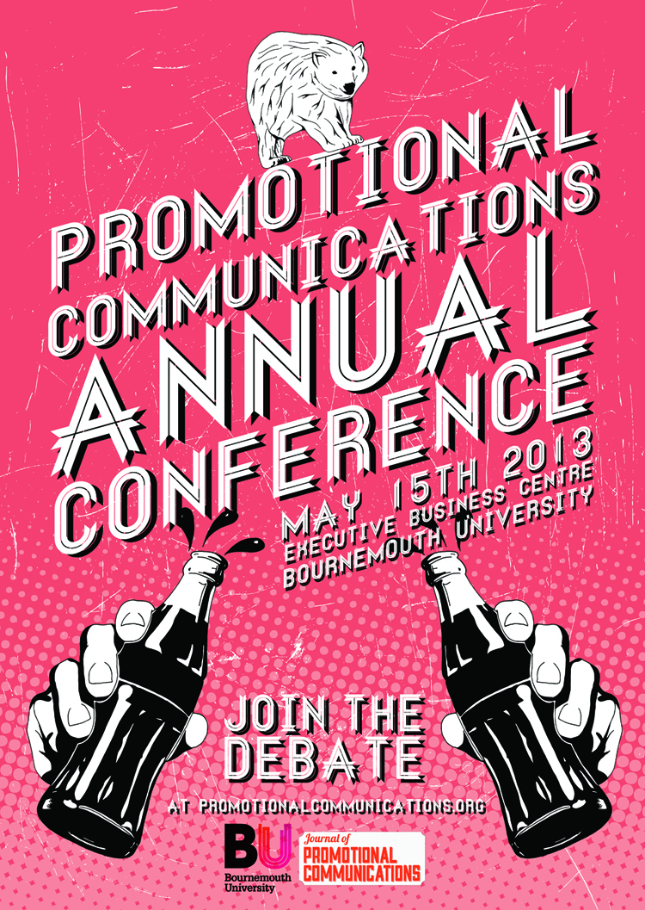

PLEASE SCROLL DOWN FOR ARTICLE

To cite this article: Nurko, C. 2014. The Future of Brand Marketing- The Era of Creativity is Upon Us! *Journal of Promotional Communications*, 2 (1), 1-5

**Chris Nurko, Global Chairman of FutureBrand**

The Future of Brand Marketing - The Era of Creativity is Upon us!

Nurko, C. 2014. The Future of Brand Marketing - The Era of Creativity is Upon Us!

2 (1), 1-5

INTRODUCTION



Today, the world needs creativity. At no other time in history has technology combined with freedom of personal expression, to offer more individuals worldwide a greater capacity, capability and competence to ‘create’. As a ‘Selfie’-interested generation drives social values and norms to embrace the ‘What’s in it for me?’ mantra, Marketing practitioners are challenged to keep up with an accelerating pace of change, fuelled by the increased computing power of silicon chips and daily increasing amount of unique user generated content. As this occurs, the laws and frameworks of privacy, intellectual property and copyright are equally being challenged to adapt and keep up with rapid creative thinking and production. Simply put, today we as consumers have never had as much choice, control and commercial opportunity to consume, create and disseminate information, content and commercial ideas. The challenge – can business and individuals keep up the pace?

The era of creativity is being defined around consumption in ways we never previously realised or even considered. The ubiquity of consumer messages and the rise of middle class consumption norms mean that we as consumers are in a constant state of selection and choice. Far from being passive consumers we are increasingly active producers. In fact, I would argue the term ‘target consumer’ should be replaced by the term ‘user-producer’. And, far from being a receptive audience, we are broadcast producers. The architecture of choice is being created by the search for better, improved and more relevant value. The economics of business and commercial competition demands clear differentiation related to value and competitive advantage. In order to respond and create value, businesses today require more creative marketing and communications to define and drive consumer demand. Marketing and brand creativity is the act of originating and acting upon ideas and initiatives that generate differentiation and interest. Today, in a commercial context, this is a vital driver of economic growth and value for society. Therefore, creativity is in demand in order for user-producers, and branded businesses to survive and thrive. It is in this context that the new era of creativity is dawning.

There are four cornerstones that define the foundation for this new era.

*1. The rise of computing power and content becoming personal.*

One cornerstone is that silicon chip computing power and nanotechnology has enabled digital information and connectivity to be literally placed in the hands of the common man. The rise of devices such as tablets and smartphones has enabled people to connect, create and exchange vast amounts of data. The ability to access Cloud servers means that personal computing can now rival what was formerly only the preserve of large companies and organizations. Correspondingly, this increase in computing power has allowed increased data to be generated, stored, analysed and managed. Data that includes everything from the prosaic personal text or SMS message to the vital life-saving biometrics and medical information of a person’s medical records. Everyday, the amount of new data and content that is generated by individual users and user-producers is increased two-fold. When applied through predictive data analysis and search analysis, this means that people can quickly search, find, edit, collect and curate information faster and more effectively than ever before. In the commercial world, this is referred to as the rise of ‘Big Data’, yet in the everyday consumer world it is an individual’s ‘Digital content signature and footprint’. This ability to connect people and their unique data to content and service providers is transforming Economics as well as commerce, while providing an opportunity for individual and collective value creation.

*2. I can be my own creator and business, and want to earn a living from it.*The second cornerstone is that the hegemony of employment being a choice between white collar and blue collar jobs has now run its course as individuals challenge the conventional approach to ‘work’ and ‘careers’. A new era of entrepreneurship has developed as capital becomes more freely available via crowd-funded finance as well as through start-up venture capital innovation funds. The digital revolution has enabled many new entrepreneurs to enjoy more ‘freelance’ lifestyles that combine regular career related income with the pursuit of ‘sideline’ business ideas. As the ‘Dragon’s Den’ mentality is embraced by many mid-life workers, the rise of 3D printing (or Additive Manufacture), means that new products and goods can be more readily and cost effectively brought to prototype and market. Thus, a new and emerging workforce of ideas and innovation is beginning to exist outside of the conventional corporate and manufacturing ecosystems. The ability to sell, trade and transact online has now facilitated ‘home start up’ as a legitimate employment and vocational option.

*3. I can create my own brands and Marketing to broadcast to the world.*  
A third cornerstone is based upon the premise that the channels and medium of marketing are now freely available to all through the World-Wide-Web and social media channels. The ability to create and manage your own website, Twitter feed and Facebook page has now moved from purely social media usage to increasingly social-economic media value. To create a follower base and media profile provides the means to create a database of potential fans, friends and customers. The exchange of ideas and the ability to amplify ideas via the web has begun to transform as many of these platforms, begin to commercialise their appeal, and user base. Increasingly, through data content, voice and video imagery individuals are able to create brands that can project stature and competence beyond and irrespective of size or scale. Individuals are now able to write, film and broadcast their own advertising; publish their own books and record their own music. By bringing all of this together, and linking it to a unique product or service, individuals have the power to create authentic, original and differentiated goods, services and brands.

*4. Traditional Branding and Marketing is now co-created and community based.*

And finally, the sea change of consumer-producer-user has seen traditional brand owners and manufacturers now embrace the consumer as a critical and central part of value creation. In order to stay relevant and create affinity, brands must now truly engage with not so much an audience, but rather a user-group. Marketing has begun to be more responsive and inclusive asking consumers to help shape, guide, determine and implement more creative and effective products and services. By segmenting and creating more 1:1 relationships with consumers, brand owners not only can tailor their message more effectively, but they create more efficient sales and marketing campaigns that can be measured. The use of social-media and forums to co-create product ideas, innovations and responsive problem solving mirrors the use of communities on-line to act as agents of endorsement, evaluation and reference. As everyone believes their opinion matters, and as digital platforms enable shared opinion and comment to flourish, we collectively enter an era in which opinion forming occurs before a concept is launched or made tangible as a product or good.

In these four cornerstones a new framework is being constructed around our lives. Communications and messages trying to influence user-producer perceptions permeate our everyday consciousness and lives. The plethora of channels and platforms in which we as users engage and communicate, not only amplify the choices, decisions and opportunities that are presented to us via marketing, but also pre-select and edit our choices. The architecture of choice is both open, as well as selective thus creating variable levels of conscious consumption or affinity.

Marketing operates on two levels for today’s consumer. In one sense, it operates as an obvious commercial ‘offer’ designed to broadcast and reinforce features and benefits of products, and services. In another sense, marketing operates rather like graffiti in that it is both ubiquitous and yet invisible. Like graffiti, marketing can either strike a chord through particularly ‘eye catching’ or ‘thought provoking’ concepts, or it is unnoticed as background scrawl on a busy urban landscape. Graffiti is now so much a part of the cultural art scene and backdrop to urban life that we hardly recognise it for the street origin of protest, territoriality or humor from where it emerged. Today’s marketing is very similar. It is either noticed for its creative and thought-provoking relevance, or it is ignored as it disappears into the background of ‘white noise’ and promotional messages. As consumers, we are now conditioned to receive and yet edit marketing messages in a consumer culture. We are bombarded by messages every day across different media and therefore are highly attuned and aware of sales and marketing. Therefore, in an era of creativity brands must work harder and smarter to identify and connect with consumers whilst being mindful of the significant changes in social, digital and economic media.

Brands must use all aspects of creativity today to connect, engage and project their narrative for consumers, to enable their ‘user-producers’ to receive and process messages. Technology has now enabled and subverted memes in pursuit of marketing objectives that create endorsement, affinity and preference. In pursuit of differentiation, brands seek to create both their ideal and authentic self via ‘user’ participation. To succeed, they must adhere to a core set of beliefs and values that underpin a purpose beyond just making profits; in an era of access to information, transparency dictates that companies and brands can not hide nor ‘spin’ anything other than what is true. Today’s stakeholders demand more than just marketing as a package or campaign of seduction to sales. Companies, products and services are now seen holistically as consumers and consumer groups are interested in the people, values and company behind the products and services they choose. A company and brand must preserve a reputation that delivers value to all stakeholders, not merely shareholders, as the concept of ‘shared value’ challenges ‘shareholder value’ as a meaningful objective. In this spirit, creativity in communications and marketing management demands new approaches for brand owners, managers and leaders.

Increasingly blurred lines between products, services and companies are replicated in the blurred lines across categories, shopping aisles and consumer segments. Marketing professionals must apply new skills of diagnostics, analysis, and pattern prediction in order to create the most effective brand strategies. The balance between public, personal and private is being tested continually for what and how brands should demonstrate their USP (unique selling proposition) and UBP (unique buying proposition). Creative thinking in the form of problem solving and innovation will increasingly be in demand, not just in the Marketing or Sales department, but also in management and leadership of firms large and small. Technology advances mean that today all bets are off, and that the commercial brand ‘Goliaths’ of the past are not ‘safe bets’ for the future. The up start creative commercial ‘David’s’ are more likely to succeed. The power of knowledge, content and imagination is undeniable as a source of competitive advantage, and for those that are able to leverage this with purpose and skill the future is bright. Marketing and Communications is about understanding what and how to differentiate companies, products and services so that people can make better choices of value. And, creating future value is the objective for economic growth and continued success. Welcome to the era of creativity.