JPC makes every effort to ensure the accuracy of all the information (the “Content”) contained in the publications on our platform. However, JPC make no representations or warranties whatsoever as to the accuracy, completeness, or suitability for any purpose of the Content. Any opinions and views expressed

in this publication are the opinions and views of the authors, and are not the views of or endorsed by JPC The accuracy of the Content should not be relied upon and should be independently verified with primary sources of information. JPC shall not be liable for any losses, actions, claims, proceedings, demands, costs, expenses, damages, and other liabilities whatsoever or howsoever caused arising directly or indirectly in connection with, in relation to or arising out of the use of the Content.

This article may be used for research, teaching, and private study purposes. Any substantial or systematic reproduction, redistribution, reselling, loan, sub- licensing, systematic supply, or distribution in any form to anyone is expressly forbidden. Terms & Conditions of access and use can be found at: http://promotionalcommunications.org/index.php/pc/about/submissions

**Journal of Promotional Communications**

Publication details, including instructions for authors and subscription information: http://

**‘One White Covers Three Ugliness’: Uncovering Chinese Beauty Practices in a Multicultural Environment**

Athena Dobson

Published online:

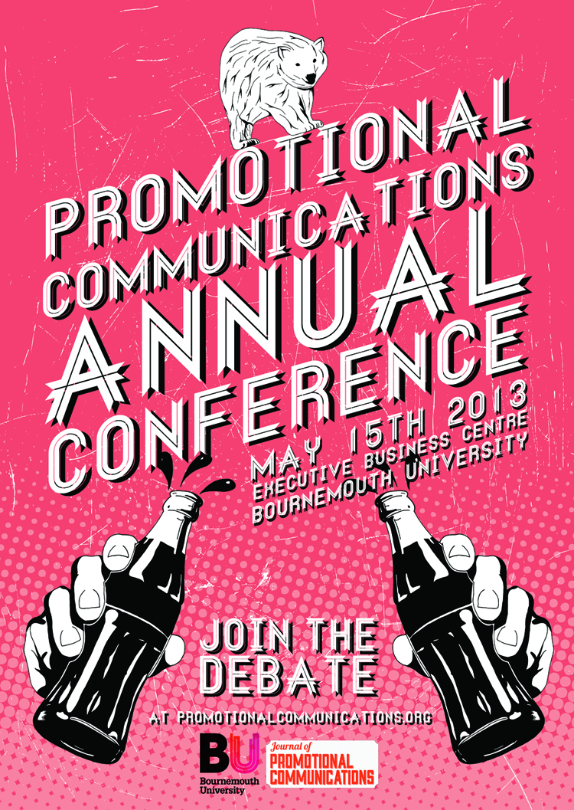

PLEASE SCROLL DOWN FOR ARTICLE

To cite this article: Dobson, A. 2014. ‘One White Covers Three Ugliness’: Uncovering Chinese Beauty Practices in a Multicultural Environment, *Journal of Promotional Communications*, 2 (1)

**Athena Dobson**

**One White Covers Three Ugliness’s:**

**Uncovering Chinese Beauty Consumption Practices in a Multicultural Environment**

*Although increasing numbers of people live in multicultural environments devoid of a dominant culture, little is known about how, in such environments people deal with the products or consumption practices in such multicultural contexts. This study explores the phenomena of cultural pluralism, defined as a pattern of emergent consumption acts that result in the adoption of consumption patterns from several cultures. By means of an ethnographic study, ten female Chinese students studying at a university on the south coast of England participated in this research with the aim of exploring how cultural pluralism strategies are adopted when considering beauty consumption practices in a multicultural environment. Three key themes emerged from the observations, labelled recency or arrival, new environments and media consumption that influence the various levels of cultural pluralism strategies adopted. The report makes specific reference and contribution to consumer subcultures in consumer research.*

Keywords: Chinese, beauty consumption, multicultural environment

INTRODUCTION

Dobson, A. 2014. ‘One White Covers Three Ugliness’: Uncovering Chinese Beauty Practices in a Multicultural Environment, *Journal of Promotional Communications*, 2 (1)



The aim of this interpretive research is to explore how Chinese students adopt cultural pluralism strategies when considering beauty consumption practices in a multicultural environment. Craig and Douglas (2006) define cultural pluralism as a pattern of emergent consumption acts that are a result of individuals adopting products or consumption practices from several cultures. In approaching this topic, the research draws from and contributes to studies of assimilation and acculturation in consumer research (Shergill and Zhao 2009; Berry 2005), consumer subcultures in consumer behaviour literature (Peñaloza 1994; Oswald 1999) and studies of cultural pluralism within cross-cultural research (Demangeot and Sankaran 2012).

The assimilation framework was once, the dominant conceptual scheme guiding consumer subculture studies (Peñaloza 1994), documenting people of various nationalities uniting to form one nation (Park 1914). However, consumer researchers (Oswald 1999; Askegaard et al., 2012) describe the framework as dated as consumer behaviour is predicted on individuals sharing elements of a single culture. Alternatively, two main perspectives prevailed the exploration of individual’s interacting with multiple cultures and consumption practices. The first perspective opts for the language of acculturation (Berry 1992) that calls to account the dynamic change in the way international movements of people co-existed between two cultures (Berry 2005). In extending this framework further within the realm of consumer behaviour, Lee (1993) developed the perspective of consumer acculturation, where one learns to consume in a new environment (Peñaloza 1994). The prevailing difference between acculturation and consumer acculturation is an individual in a new civil society in comparison to a consumer in a new marketplace (Hingorani et al., 2011).

Nonetheless, despite acculturation studies advancing consumer research (Peñaloza 1994), Demangeot and Sankaran (2012) criticize the frameworks dual process of merely documenting two cultures within a dominant setting. Instead, researchers suggest growing numbers of people live in marketplaces of increasing multicultural diversity (Craig and Douglas 2006; Jamal 2003). Despite such criticisms, limited evidence suggests an alternative framework beyond consumer acculturation within the *Journal of Consumer Research.* This presents a gap in consumer research that call for a better understanding of *how* individuals consume products within a multicultural setting (Ustuner and Holt 2007; Askegaard et al., 2012). This study aims to address this gap by contributing the alternate conceptual framework of cultural pluralism within the consumer research realm, defined as “aptly characterising the experiences of people living in multicultural environments” (Demangeot and Sankaran 2012 p. 760).

Further, while cultural pluralism has been traditionally used within the sociological (Haug 1967) and political literature (Niemonen 1999). Demangeot and Sankaran (2012) extended the framework to document the experiences of people living in multicultural environments within the *Journal of Marketing Management.* The research proposed that participant’s culturally plural behaviours fell under four strategies: cultural experimentalism, cultural extensionism, cultural purism and cultural passivity (Demangeot and Sankaran 2012). Nevertheless, their proposed strategic framework is currently limited in the ability to contribute to consumer research. This is due to the four strategies being characterized solely by the provenance of a product as opposed to the symbolic meaning in determining ones use of it. Their research, therefore fails to identify what Askegaard et al., (2012) states is an important issue regarding *how* cultural influences affect the meaning and use of highly standardised products. This study will aim to rectify this issue through redefining the four proposed cultural pluralism strategies that provide the objectives in which the exploration of *how* individuals and groups, such as Chinese students consume products within a multicultural environment.

Moreover, this research aims to contribute to the literature surrounding beauty that currently documents globalised aesthetic appeals in advertising under a quantitative paradigm (Englis et al., 1994). The study contributes a more significant qualitative understanding into *how* beauty is culturally encoded in effect to one’s appropriation of globally recognised products; in spite of an apparent universal desire and pursuit of beauty (Dion 1972). The study also aims to shed light into the white or tan dichotomy surrounding Asian and Western ideals (Xie and Zhang 2012).

The paper is thus, divided into three sections. Firstly, the literature review will provide an analysis of the key concepts and issues surrounding cross-cultural research. This review will then relate to the discussion of varying cultural interpretations of beauty ideals with key gaps identified. Secondly, the methodology will be established, detailing the data collection and analysis techniques to ensure closer comparisons within existing consumer research. Lastly, key findings will detail participant’s experiences that either support or illustrate inconsistences in cross-cultural research. Limitations and avenues for future research will then be concluded in order to contribute further to the understanding of cultural pluralism strategies and the encoding of beauty ideals within consumer behavior.

LITERATURE REVIEW

Assimilation and Acculturation Studies

The assimilation framework, wherein people of various nationalities, cultures and creeds unite to form one nation, was once the dominant conceptual scheme guiding studies of consumer subcultures (Peñaloza 1994). Consumer research long documented Chinese immigrants assimilating to western cultures. For example, Yao (1979) found that Chinese born Americans often celebrated traditional American holidays, such as Independence Day and Thanksgiving. Further, Shergill and Zhao (2009) reported that children from Chinese families living in New Zealand often held a greater influence in family purchasing decisions than those living with parents in China.

In their twenty year review of cross-cultural research, Sojka and Tansuhaj (1995) recognise Pruden and Longman (1972) as one of the first to advance assimilation studies as they began examining race and alienation across multiple subcultures simultaneously within the United States. Their research specifically contrasted high-income Anglo- Americans with low income Mexican and African-American consumers so as to uncover the differentiating behavioural traits and dispositions that were beginning to emerge as a result of multiculturalism. However, consumer research has since (Oswald 1999; Askegaard et al., 2012) suggested the assimilation framework is dated in its assumption that individual behaviour is predicted on groups sharing elements of a single culture. Further, Sojka and Tansuhaj (1995) note the relatively large number of descriptive cross-cultural studies (Pruden and Longman 1972; Leong 1989) that lack theoretical contribution. (Sojka and Tansuhaj 1995).

Consequently, in cross-cultural research, two main conceptual frameworks prevailed the exploration of individual’s interacting with various cultures and consumption practices. The first opts for the language of acculturation coined by Berry in 1918, defined in the anthropological literature as “different cultures coming into continuous first-hand contact, with subsequent changes in original culture patterns of either or both groups” (Redfield et al., 1936 p.149). Whilst conceptualised in 1918, it was not until 1992 that Berry’s acculturation framework was documented within cross- cultural research to provide the necessary theatrical framework in determining individual and group’s co-existence within a new civil society (Berry 1992). Amidst this, Berry proposed four acculturation strategies: assimilation, integration, separation and marginalisation. Despite these strategies providing initial theoretical advances in cross-cultural research, the framework predominantly contributes and applies to the subcultural literature surrounding scientific research, documented within the Journal of Applied Psychology; due to it detailing psychological adjustment and cultural adaptation held by members in their new environment.

Consumer Acculturation

In later years consumer researchers began to extend the framework within the consumer behaviour realm to form consumer acculturation (Peñaloza 1994; Oswald 1999; Askegaard et al., 2012; Ustuner and Holt 2007). Lee (1993) first coined the term consumer acculturation, defined by Peñaloza (1994 p.33) as “the movement and adaptation to the consumer cultural environment in one country by persons from another”. The framework extends acculturation studies beyond scientific literature to instead explore the way individuals and groups consume in a new environment. Lisa Peñaloza (1994) shed initial light in her ethnographic study of Mexican immigrants living in the United States, documented with the Journal of Consumer Research. Peñaloza aimed to advance cross-cultural studies beyond the degree to which immigrants assimilate to American culture, but instead to determine how individuals and groups form integrative consumer identities and practices. Peñaloza found that family households displayed artefacts of both Mexican and American culture. This illustrated integrative forms of consumer identities and practices emerging to form a third, hybrid consumption of the two. Peñaloza’s (1994) study hence aimed to advance consumer research beyond the simplistic notion of cultures assimilating to a single dominant setting.

However, despite initial advances in consumer research, authors (Craig and Douglas 2006 and Demangeot and Sankaran 2012) criticize consumer acculturation for merely comparing two cultures within a dominant setting. Craig and Douglas (2006) note that rather than the convergence or homogenisation of two cultures, growing numbers are instead living in marketplaces of increasing multicultural diversity; consuming products and practices that are deemed culturally plural (Craig and Douglas 2006). In such a culturally plural landscape, consumer researchers (Askegaard et al. 2012; Ustuner and Holt 2007) call for a better understanding of how members consume products within a multicultural setting.

The Phenomenon of Cultural Pluralism

This study contributes the phenomenon of cultural pluralism to the consumer research realm as it calls to account the pattern of emergent consumption acts that result in the adoption of products or consumption practices from several cultures (Demangeot and Sankaran 2012). Cultural pluralism has been extensively used within the sociological (Haug 1967) and political literature (Niemonen 1999) to aptly characterise the experience of people living in multicultural environments. However, more recently, Demangeot and Sankaran (2012) extended the framework within the Journal of Marketing Management. Demangeot and Sankaran’s (2012) documentation of culturally plural consumption practices amongst a vast array of UAE (United Arab Emirates) residents was the first documentation of consumer behavior within this realm. Nonetheless, the documentation offered a rather broad as well as vague perspective of individuals and groups consuming various cultural products within a multicultural environment.

This study therefore aims to extend Demangeot and Sankaran’s (2012) initial efforts beyond this broad perspective, by contributing a narrower and more specific exploration into the types of beauty consumption practices Chinese students adopt in a multicultural setting. Exploring a single culture is imperative to interpretative research, as Berry (2005) suggests researchers who broaden their studies to include all Asian cultures miss culturally specific perspectives. Moreover, this research will extend the documentation of cultural pluraism beyond the Journal of Marketing Management, to offer an alternative framework to acculturation studies within the Journal of Consumer research formally criticized for its simplistic analysis (Craig and Douglas 2006).

Beauty Before the Eyes of the Beholder

A beauty ideal is an overall look that incorporates physical features and a variety of products, services and activities (Glenn 2008). When relating the discussion of cross-cultural studies to the literature encompassing varying cultural interpretations of beauty, Englis et al., (1994) notes that women strive to attain a certain ideal of beauty that is prevalent within their culture. From extreme beauty rituals such as neck elongation among tribal women in Southeast Asia, to western beauty routines such as dieting, exercising, hair colouring and makeup (Xing and Zheng 2011).

Despite initial efforts from Englis et al., (1994) in their documentation of Beauty before the eyes of the beholder, cross-cultural research surrounding the notion of beauty prior to and of the twentieth century fail to culturally encode beauty in relation to cultural values manifesting themselves into beauty practices (Frith et al., 2004). Instead, the most frequently recognised study of its time relative to beauty ideals was the The Dion, Berscheid and Walster social psychology study (1972 cited in Dermer and Thiel 1975 p. 1168) that postulated the power of a physical attractiveness stereotype - what is beautiful is good. Following this theme, social psychologists (Langmeyer and Shank 1995) began documenting scales of source credibility in relation to beauty, reporting physically attractive people to symbolically represent more socially desirable personalities and higher social capital.

The White or Tan Dichotomy

In later research, Frith et al., (2004) contrasted elements of feminine beauty between Asian and Western ideals. A common discourse that began to emerge was the notion of the white or tan dichotomy (Xie and Zhang 2012). Frith et al., (2004) notes that western ideals of beauty post 1988 demonstrate significant positive attitudes towards tanning; perceiving medium to dark suntans as attractive attributes that provides a natural glow (Broadstock et al., 1992). This directly contrasts to Asian ideals, where it was deemed a women’s duty to powder her face white and undergo extremities of swallowing powdered pearls to whiten their skin (Glenn 2008).

Moreover, anthropologist Mikiko Ashikari (2005) is shown to conduct a series of field studies in Asia, she documents the history and cultural relevance of white skin (both naturally and with makeup) to signify not only a beauty ideal but also a symbolic representation of national identity and social capital in Asia. Nonetheless, although described in the literature as ancient Asian traditions, these cultural values and beliefs encompassing a yearning for lightness are far from being an outmoded practice of past colonialism but instead a standard of beauty that has interwoven itself amongst current young Asian women (Ashikari 2005) – for example 50 per cent of Philippine and Chinese women still use skin lightning products today (Glenn 2008). Further, Xie and Zhang (2012 p. 8) note that the old Chinese idiom “Yi Bai Zhe San Chou,” translated as “one white covers up three ugliness’s” is still passed through Chinese generations today (Xie and Zhang 2012 p. 8).

The Consumption of Beauty

In their comparison of feminine beauty between Asian and Western ideals, Frith et al., (2004) explains the various forms of advertising beauty magazines in America. They note that dominant magazines predominantly advertise clothing and fashion, focusing on American bodily beauty ideals such as a sun kissed look. Smaller magazines, specifically aimed at Asian-Americans on the other hand, focus more on women’s facial beauty, advertising cosmetics and skin care products to promote softer, whiter skin (Glenn 2008). Subsequently, Frith et al., (2004) notes that even though women share a dominant cultural reference (i.e. nationality), they do not necessarily share common parameters for defining beauty.

Feminist scholars such as Patzer (1985) were some of the first to note this likelihood of beauty being culturally constituted; however they have also recognised the dominant effect of invasion of other cultures, also referred to as “global cultural flows” (Rokka et al., 2008 p.84). Global cultural flows are cultural ideals of beauty and attractiveness that are communicated and reinforced through mass media to form a global consumer (Rokka et al., 2008). Eckhardt and Askegaard (2009) state in their study of The Global Consumptionscape, that globalisation has become synonymous with forming uniform consumption habits, homogenising tastes and ultimately erasing local cultures. Japanese women, for example, have been shown trading their kimonos for mini-skirts, as well as desiring Caucasian features, such as big eyes and lighter skin tones as a result of engagement with western media (Frith et al., 2004).

Nevertheless, the common discourse of globalisation forming a global consumer is debated amongst cross-cultural researchers (Arnould and Thompson 2005), who indicate local, historical and socio-cultural contexts being used as a resource in consumers making sense of their purchase decisions. Askegaard et al., (2012) documents cultural influences affecting the meaning and use of highly standardised products. For example, Sandikci and Ger (2007) demonstrate that in developing countries, standardised products such as Coca-Cola and candy bars are viewed as luxuries to be enjoyed on special occasion, whereas in most Western cultures these products are viewed as everyday confectionaries. Additionally, despite a strong body of literature arguing that attractiveness appears to be universal (Dermer and Thiel 1975; Langmeyer and Shank 1995; Rokka et al., 2008), cross-cultural research has not always found consistency in evaluations of physical attractiveness (Cash 1981; Isa and Kramer 2003 cited in Rokka et al., 2008 p. 85); resulting in a tension between global mass- mediated consumer culture and localised meanings (Arnould and Thompson 2005).

In spite of such debates within cross cultural research, little has been done to understand how beauty is culturally encoded in effect to one’s appropriation of globally recognised beauty products. There is evidence to suggest past social psychological literature (Dermer and Thiel 1975) documenting globalised aesthetic appeals in advertising, frequently identified through quantitative methods. Nonetheless, research fails to qualitatively delve deep into understanding how cultural perspectives are manifested into daily consumption practices of beauty within a multicultural setting. This study therefore aims to contribute to consumer research by conducting an ethnographic study to aid the exploration regarding how Chinese students adopt cultural pluralism strategies when considering beauty consumption practices in a multicultural environment.

METHODS

The research aims to explore how Chinese students adopt cultural pluralism strategies when considering beauty consumption practices in a multicultural environment. I approached this research with the desire to access and portray an empathetic inside perspective into Chinese participants own interpretation and construction of their world. To achieve this, the research implemented ethnographic research techniques commonly associated with consumer researchers entering the field to investigate people’s experiences surrounding consumption patterns of “other” cultures (Peñaloza 1994 p. 35). Over the course of four months, I immersed myself within the participant’s homes from the beginning of January to the end of April; to collect first-hand observations of ten female Chinese students living at a British University on the south coast of England. British Universities are a revelatory context to the research, since 26% of students are usually from international backgrounds (UKCISA 2013), limiting the impact of a wholly dominant culture.

Two months were initially spent collecting data, over a series of afternoons approximately occurring between 2-6pm. The data was collected through participant observations, semi-structured interviews and in one instance accompanying a participant, named Wang Li, on a shopping trip. This developed a rich cultural engagement with the research since I was able to extend my involvement beyond mere observation, to instead play an active role in conversing and offering opinions to elements of the trip (Peñaloza 1994). The overall collection of data elicited tape- recorded and transcribed interviews (150 pages), handwritten pages of field notes (750 minutes), observation guides (10), photographs of the research setting, whether this be objects, environment or field trip (80) as well as a journal of personal reflections (12 pages) to note the experiences of meeting the ten participants.

Over the course of my time with the participants, it is important to note that as a white British student, I found it difficult to establish rapport, inhibited by doubts regarding my appearance and ability to speak Chinese. I therefore felt like the ‘outsider’ and observed this group to appear self-conscious about being investigated by someone with a differing perspective to their own (Oswald 1999). Misinterpreted representations of data are a particular concern surrounding ethnographic techniques, due to the interpretive nature of studying “other cultures” (Peñaloza 1994). To minimise both participant and ethnographers concerns, I adhered to the recommendations of Ahern’s bracketing interview technique (2005) to develop my interview guide over the course of the first few weeks.

Brunette et al., (2011) refers to bracketing as a method of considering how the participants’ own understandings, values and communication differ to the researcher. Whilst developing the interview guide, I therefore considered how participant’s interpretations of key terms may differ to my own. The guide was analysed with a “bracketeer” (Ahern 2005 p. 35), who in this instance, was represented by a Chinese student uninvolved in the research who suggested appropriate revisions. Subsequently, specific terms were revised so that participants may better understand particular words or phrases. For instance, the term connections were replaced with guanxi, a popular phrase in China, to explain the social relationships between peer members. Participants where therefore asked if they had “experienced a strong sense of guanxi amongst their peers in their new environment?” Questions were also rephrased to allow ample opportunity for participants to talk openly about previous experiences, to provide their own interpretation of terms such as beauty - “Do you remember the first time you applied makeup and how you felt?” The bracketing technique acted as the pilot interview, which endeavoured to reduce concern from participants and previous ethnographic research (Peñaloza 1994, Oswald 1999), therefore increasing validity.

Armed with a revised interview guide, I began establishing my own sense of *guanxi* among participants - one whom sought my assistance in her own data collection. Following the methods of Oswald (1999), in her ethnographic study of Middle- Class Haitian Immigrants, follow-up conversations, also known as member checking, were conducted by phone and email for another two months after the observations to fully ensure the participant’s accounts were accurate. This enabled opportunities to alter misinterpretations, increasing the trustworthiness of the research (Oswald 1999).

An important side note; in the first few weeks of my immersion into the field, my participant sample size began as merely five. Nevertheless, due to the rapport built, participants began to trust me and accepted that my intentions were earnest. Each participant thus suggested one friend willing to contribute to the research. This technique is referred to as snowball sampling (Silverman 2006). This chosen method grew my research and has been deemed appropriate in most previous Chinese literature surrounding cross-cultural research, since Chinese participants place great emphasis on trust amongst friends (Brunette et al., 2011). All participant identities involved in this research have been disguised with pseudonyms. Similar to Kwon’s (2013) ethnographic study of Chinese immigrants adjusting to new universities, the pseudonyms were selected among names commonly born in China to retain cultural intent. Individual consent was also received from all participants, detailing their approval for photographic evidence to be used solely for the purposes of the research.

Once the data had been collected, interview summaries were developed as a data reduction technique to facilitate comparisons across various participants. This method is consistent with consumer research methods utilised by Jayasinghe and Ritson’s (2013) ethnographic study of advertising responses in the family living room. Additionally to data reduction techniques, Jayasinghe and Ritson’s (2013) also applied the comparative coding technique to their research, wherein emergent sentences or paragraphs are documented once they appeared consistent across all interviews. This study followed suit by identifying the three key influential themes of recency of arrival, new environments and media consumption that aid participants in determining their beauty consumption practices. These three influential themes were categorised against Demangeot and Sankaran’s (2012) framework of cultural pluralism strategies to shed light on the influences affecting Chinese students adopting cultural pluralism strategies when considering beauty consumption practices in a multicultural environment.

FINDINGS AND ANALYSIS

Based on the revised strategies, the findings predominantly detail the Chinese participants to frequently adopt cultural purism, cultural experimentalism and cultural extensionism strategies whilst engaging with beauty consumption practices in a British university devoid of a dominant culture; with no strategies of cultural passivity found. These findings are in accordance with Demangeot and Sankaran’s (2012) research who also note cultural experimentalism and extensionism as the most frequently adopted strategies in their research. Nevertheless, since the research found participants to engage with beauty consumption practices deemed rooted to their country of origin than their host culture, this exhibited characteristics of cultural purism strategies. This finding contradicts previous cross-cultural literature that documents participants to assimilate western ideals and practices relative to the host culture. The below section presents the revised strategies amongst the three key influential themes, labelled recency of arrival, environmental factors and media consumption.

Recency of Arrival

In entering each of the participant’s homes, the recency of ones arrival to the UK, illustrated a significant influence to the participant’s experiences and consumption practices whilst living away at a British University. Peñaloza (1994) defines the term, recency of arrival, as a participant’s length of stay in a new environment away from their country of origin. The theme of arrival influencing ones experiences and consumption practices was most prevalent between participants, Zhang Min and Wang Fang. On first entry into each of their homes the first noticeable distinction was the difference in smells. Zhang Min, has been studying in the UK for three years, and lived in a house that had the familiar smell of freshly cooked bread. In inquiring where the smell was coming from, Zhang Min explained how she had just made a fresh loaf that morning using the new bread maker her British housemates had bought her for her 21st birthday just gone. Contrastingly, on entry into Wang Fang’s home, the smell was less so familiar, yet I believe it resembled a mix of Chinese five spice powders and fried rice, since I had arrived at 6pm, what seemingly was their dinner time. Wang Fang had only arrived in the UK six months ago.

Since it was dinner time in Wang Fang’s household, she welcomed me in through the hallway and straight into the kitchen, where all three of her housemates (of Chinese origin) were sat around a wooden table, greeting me as I walked in. They kindly asked if I would join them for dinner, in which we shared some delicious homemade Chicken dumplings. As I had arrived, on a different occasion at Zhang Min’s home at the earlier time of 4pm, all her housemates were in their bedrooms. Nonetheless, Zhang Min insisted that she introduce me to all three. She therefore walked me into all three rooms, one by one, where I was delighted to meet and engage with her housemates in conversation.

When conversing with both them and Wang Fang’s housemates, they explained how they had all chosen to live with one another. It is important to note that Zhang Min therefore actively chose to live with British housemates, whilst Wang Fang sought to live with others of the same nationality. This observation is therefore consistent with previous Chinese acculturation studies that demonstrate participants with a shorter recency of arrival to live with those of a similar background providing them with a sense of familiarity (Cappellini and Ai-wan Yen 2013). Students, on the other hand, who have lived in their new environment for a more substantive amount of time, tend to live with individuals from cultures dissimilar their own, as they begin to “expand their cultural palette” beyond initial cultural purism strategies to instead adopt cultural extensionism strategies as they become accustomed to other cultures (Demangeot and Sankaran (2012 p. 771). Once introductions were complete, both Zhang Min and Wang Fang, welcomed me into their bedrooms, both describing this as the main environment for applying their makeup and skin care brands. On entering Zhang Min’s bedroom, I instantly noticed a large map of the world on the wall. In questioning Zhang Min about the map, she explained how she enjoyed travelling across the world to experience new cultures. During our conversation about her interests and hobbies, Zhang Min’s interest in other cultures became prevalent, and similar to characteristics defined under cultural experimentalism strategies, such as her “continuous desire to seek exposure to products and practices from other cultures” (Demangeot and Sankaran (2012 p. 771).

On the other hand, when entering Wang Fang’s room I instantly noticed the large film poster, titled *A Chinese fairy tale*, above her bed. The poster illustrated four Chinese male characters and a young Chinese woman at the forefront. Wang Fang, immediately offered me a seat at her desk, while she pulled up another chair next to her impeccable draw of beauty products (image 1).

**Image 1 Fang’s Beauty Products**



The draw was neat, yet overflowing with lotions, foundations, sun creams and mascaras to name a few. As Wang Fang applied her foundation, I noticed she was using a *Chanel White Essence* product, labelled whitening modelling effect (image 2).

### Image 2 Wang Fang’s Chanel White Essence

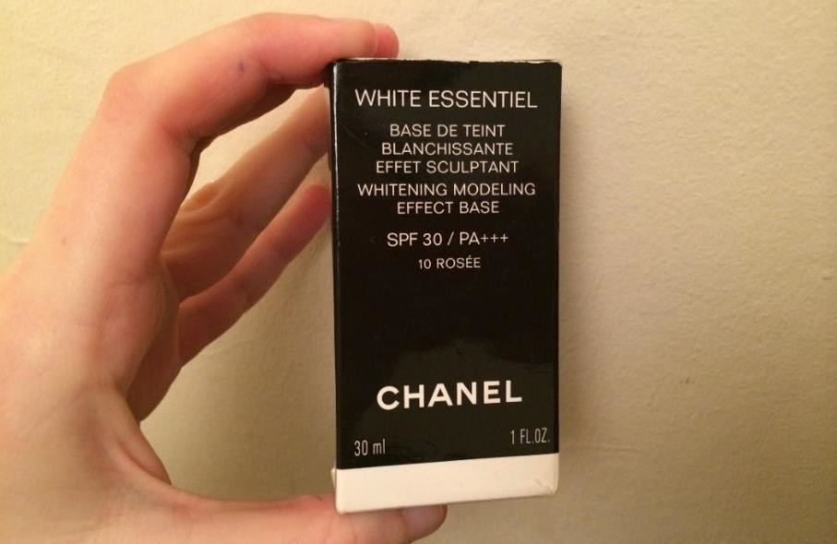

Whilst observing Wang Fang apply this, I inquired into her ideal image of beauty. Wang Fang took a moment and then pointed to the illustration of the young Chinese woman on the film poster, apparently named Li Ji. Wang Fang described Li Ji, as having “beautiful smooth white skin.” As she carried on applying her foundation, she explained how her *Chanel White Essence* makeup aids her own desire for smooth whiter skin as well.

“As an Asian woman, I tend to have lots of scars and a yellow skin tone, so applying a lighter shade of foundation helps to disguise these problems and makes me feel more beautiful.”

In this example, Wang Fang is using the Chanel foundation to both lighten her skin tone and disguise her apparent imperfections. Her beauty consumption practices are therefore deemed relative to cultural purism strategies, as her consumption behaviours illustrate a “strong sense of identification to her country of origin,” (Demangeot and Sankaran 2012 p. 771) previously illustrated within past Chinese literature surrounding a similar *yearning for lightness* (Glenn 2008) as well as “disguise for three ugliness’s” (Xie and Zhang 2012 p. 8). Zhang Min, in contrast, offered a seat on her bed, whist she sat at her dressing table covered in beauty products (image 3)

**Image 3 Zhang Min’s Cosmetics**



My first observation of Zhang Min was her visibly darker skin tone compared to the other Chinese participants I had met. As Zhang Min and I began discussing the types of products I could see on her dressing table, she explained how one of her products, a *Chanel prolumière foundation*, gave her a desired “natural tan.” In asking Zhang Min to explain as to why she desired a naturally tanned complexion, she began by clarifying her awareness of her darker skin complexion compared to her fellow Chinese peers.

“Unlike other Chinese girls here, I like to have a tan, so I know I look darker. When I first came to the UK for study, I wore Elizabeth Arden whitening intense crème, as this is what all girls wore back home. But in England, not so much. Nobody wears skin whitening products here, I don’t even think you can buy them. So I stopped and switched to a more tanned look now. I think I look more attractive now than I did when I first came to England.”

I asked Zhang Min to expand on this notion of “now.” She stated: “in my first year of arrival to the university, I wore whitening crèmes but not anymore.” When asking her the reasons as to why this might be.

“I’m in my final year at university so I’ve been surrounded by other cultures different to my own. I’ve picked up hints and tips from some of my British housemates as well, that’s probably why [….]. I only started wearing my Chanel foundation last year though, so I haven’t worn it this way for too long yet.”

Zhang Min is therefore demonstrating characteristics of “picking up hints and tips from other cultures,” regarding her adoption of beauty consumption practices, relative to cultural experimentalism strategies (Demangeot and Sankaran 2012 p.772). Throughout our conversation Zhang Min, described a desire to try new makeup products and brands from varying cultures. This again demonstrates a sense of “adventure and experimenting” prone to this strategy (p.773). Consequently, Zhang Min, who has studied and lived in the UK for over three years, appears more accustomed to the consumption practices from varying cultures, than Wang Fang, a student who merely arrived in the UK six months ago. Hence, even though Zhang Min and Wang Fang both wear a Chanel foundation, their own culturally inherit ideals alter the symbolic meaning in determining their use of it, influenced by their recency of arrival. These findings are consistent with Peñaloza’s study of Mexican immigrants in the U.S (1994), that document individuals to be more accustomed to the consumption practices of their host environment after a substantially longer stay. Hence, these findings suggest that the longer ones recency of arrival, the more likely they are to extend beyond a culturally purist approach of consumption to instead adopt practices deemed culturally extensive as “their palette expands to other cultures beyond in their own” (Demangeot and Sankaran 2012 p.772).

New Environment

During my time with the participants, I was interested to observe the way individuals purchased beauty products when adapting to a new environment. For the purposes of this research, a new environment is defined as the surroundings an individual chooses to inhabit, including friendship groups (Brunette et al., 2011). Peñaloza (1994) suggests that social interactions are the key influencers in determining the central behavioural processes through which individuals consume. I was eager to explore if my findings were consistent with this body of literature. Hence when Wang Li, a student who is studying in the UK for just under a year invited me on a shopping trip alongside herself and two other friends (of Japanese origin) I was delighted. We agreed to meet just outside the biggest department store in town. On entering the store, Wang Li expressed that she was looking to buy a new concealer, since her Maybelline one that she had bought in China, just ran out (image 4).

**Image 4 Wang Li’s Concealer**

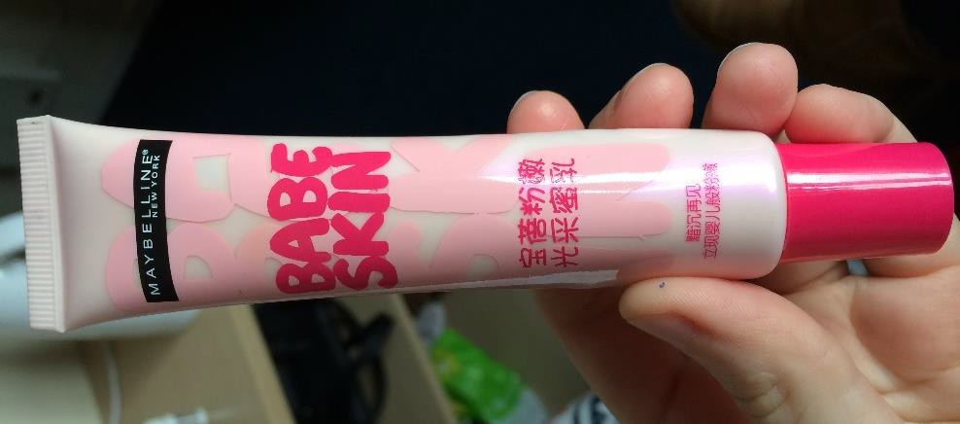

As we wondered around, Wang Li began defining the usual group of friends she socialises with.

“I usually socialise with mostly my Chinese friends, because it’s easy and the language is the same. Also, when I go makeup shopping, like today. I like to have friends with me who like similar types of makeup. I don’t mind bringing my Japanese friends as well sometimes because we all have similar tastes and opinions about what looks good.”

As we continued searching for said concealer, it appeared evident that like most other stores, this one did not seem to stock it either. Just as we were about to leave to look elsewhere, Wang Li’s Japanese friend Cara, explained how, she herself, used a *Dior Le Blanc whitening concealer* to provide a lighter shade under the eyes. Wang Li, agreed to try the product Cara suggested and followed her hastily to the Dior counter. As we began walking, I curiously asked Wang Li, as to why it was so important to have a lighter shade under the eyes. She explained,

“In Chinese culture, big eyes are attractive. Otherwise we look like we have sleepy eyes. By using a lighter concealer it makes our eyes stand out more.”

The notion of Chinese women seeking bigger eyes is consistent with Ashikari’s (2008) field studies in Asian cultures that suggest women born of Chinese origin to often wear contact lenses in order to increase the dilation of their pupils, deemed physically attractive. I asked Wang Li if she had ever tried this and had a picture to show me. She had, and showed said photo of her applying the contact lenses last week. Once we arrived at the counter, a Dior assistant greeted us with a huge smile and asked what we were looking for. Cara explained, and the assistant began rummaging through the draws. She then reappeared holding two various shades of the concealer. One was labelled *lumpide* and the other *nude*. Lumpide was the lighter shade. Wang Li took the products and asked her friends which shade would best suit her skin. Both Cara and other friend, Yaxin agreed that Lumpide was the better shade. Wang Li, therefore trusted her friend’s decision and purchased the replacement concealer.

My overall observation from this shopping trip, was that Wang Li illustrated to adopt cultural purism strategies in her purchase decisions of beauty products, as the utilisation of said Dior concealer, is to increase the proximity of her eyes, relevant to Chinese ideals in the beauty literature (Ashikari’s 2008). A particularly interesting note here is that even though Wang Li was influenced by her friend of a differing nationality, Wang Li had earlier expressed a sense of *gunaxi* and trust among her Japanese friend’s, describing “their tastes as similar to her own.” I was therefore eager to find out, if Wang Li would have accepted the same advice from a different friend.

“Not really because I only go shopping with either my Chinese or Japanese friends, that’s it really. I don’t go shopping with my Philippine or Thai friends because they all have darker skin tones to me so we would disagree too much on what shades to buy.”

Wang Li, is therefore demonstrating to purposely surround herself in an environment with friends, who despite being of differing nationality, still share the same common cultural values and ideals relative to maintaining cultural purism strategies in their beauty purchasing decisions. Nonetheless, on returning to Wang Li’s room, I noticed a Mac bronzer situated in her makeup box. I curiously asked Wang Li where the product had come from. She explained,

“I wear the bronzer now and again on a night out, just to give me a bit more colour in my cheeks. My Spanish friend in class let me borrow it and so I am just trying it out for now. I quite like it though.”

This change in the varying new environment and friendship of her Spanish friend is illustrated to have impacted Wang Li’s consumption of beauty practices, emphasising Peñaloza’s findings on influences between Mexican and American social groups (1994). In expanding her environment and friendship groups beyond the means of her own cultural ideals, Wang Li is therefore beginning to learn to “expand her cultural palate of consumption” (Demangeot and Sankaran 2012 p.772). Wang Li is subsequently extending her consumption practices beyond cultural purism to adopt cultural extensionism strategies.

Media Consumption

The third and final influence was participant’s adoption of media consumption, as their main learning and information source in determining beauty consumption practices (Lu 2001). I use the observation of Xiu Ying in this example to illustrate the evidential shifts from cultural purism to cultural extensionism strategies as a direct result in changes to her media consumption practices and sources of information. During our conversation, Xiu Ying explained how she began wearing makeup whilst in her first year of university in the UK, where she continuously watched Chinese soap programmes featuring 楊丞琳 (Rainie Yang) a Chinese celebrity; described as having “flawless milky skin” (image 5).

**Image 5 - Rainie and Michele**



Xiu Ying, explained how she continued to watch Rainie Yang on television, until midway through her second year, where she switched her media consumption to online tutorials that featured Michele Phan, an American born Viennese L’Oreal representative; described as having “a beautiful healthy glow.” I was curious to explore the reason for the sudden shift in media consumption choices and varied definitions of what Xiu Ying deemed beautiful. Xiu Ying explains,

“One day in class, I saw a girl reading Vogue magazine. A celebrity named Cheryl Cole was advertising a new L’Oreal mascara. Even though the advert was for the eyes, I noticed how perfect her skin was [….]. Her skin was different to Rainie, more natural but still perfect. I then found Michele Phan since I looked up L’Oreal products, who had similar skin to Cheryl. I then began watching her online tutorials and basically stopped watching Rainie on TV.”

This finding illustrates Xiu Ying to have switched her ideal of beauty based on the media consumption habit she now adopts. This was evidenced in her differentiating description of Rainie Yang’s “flawless milky skin”, compared to Michele Phan’s “beautiful healthy glow.” This direct contrast in what Xiu Ying deems beautiful is prevalent within the literature surrounding Asian and western ideals of beauty (Xie and Zhang 2012) and consequently evidences a shift between previous cultural purism strategies to cultural extensionism strategies as a result. Once Xiu Ying had finished showing me a few of Michele Phan’s online tutorials, she began showing me the types of products she wears. During my observations, I noticed she kept an Elizabeth Arden whitening lotion as well as also a Mac bronzer in her makeup draw, similar to Wang Li. I asked Xiu Ying to explain the reasons she had kept both.\

“I don’t wear the lotion anymore. I just wear a foundation and that Mac bronzer now because that’s what Michele Phan wears.”

I thereafter asked Xiu Ying if she used to wear the whitening lotion when she watched Rainie in her Chinese soap operas. She replied, “yes, I used to wear it back then, but now that I watch Michele, I don’t anymore.” This finding is a key representation of how media consumption choices influence and alter Chinese student’s beauty consumption practices within a multicultural environment. Consequently, the finding illustrate how the changing influence in the media consumption habits, influenced Xiu Ying’s ideals of beauty, and changes in consumption practices regarding lighter and darker skin tones - consistent with the white or tan dichotomy (Xie and Zhang 2012). In doing so Xiu Ying is therefore illustrated to shift from a once cultural purism type of consumption to instead adopt cultural extensionism strategies in her consumption practise of Mac bronzer that are beginning to “unfolded slowly in an emergent way” (Demangeot and Sankaran 2012 p.774).

CONCLUSION

This study provides initial insights into new consumption practices emerging in multicultural contexts (Craig and Douglas 2006) that disrupt previous subculture literature wherein individuals assimilate to western ideals (Shergill and Zhao 2009) or acculturate to a single dominant environment (Berry 2005). The research adopted the phenomena of cultural pluraism that aimed to shed light on the more fluid and continuous nature of ethnic consumption (Oswald 1999), offering two distinct contributions to consumer research. Firstly, despite calls to consumer research concerning a better understanding of how individuals consume products within multicultural settings (Ustuner and Holt 2007); limited evidence suggests an alternate framework beyond acculturation studies within the consumer research realm. Addressing this gap, the study extended the framework of cultural pluraism beyond the Journal of Marketing Management to the Journal of Consumer Research, offering initial insight into how individuals consume products within multicultural settings devoid of a dominant culture (Demangeot and Sankaran’s 2012).

Second, the research redefines the four cultural pluraism strategies proposed by Demangeot and Sankaran (2012). The strategies predominately characterises participants consumption patterns solely on the provenance of the product as opposed to the symbolic meaning in determining ones use. Subsequently, the strategies fail to identify how cultural influences affect the meaning and use of highly standardised products (Askegaard and Kjeldgaard 2005), thus limiting the frameworks contribution to consumer research (Ustuner and Holt 2007). This study therefore redefined the strategies that provide the objectives for the exploration of how Chinese students adopt cultural pluralism strategies when considering beauty consumption practices in a multicultural environment. The research implemented ethnographic techniques commonly associated with ethnographic studies in consumer research (Peñaloza 1994 p. 35). I immersed myself within the participant’s homes over the course of four months, documenting observations, stories and experiences.

Limitations and Avenues for Further Research

The immersion within the field, however, was not without its limitations as the phenomenon of cultural pluralism occurs over time and spans more than one nation (Demangeot and Sankaran’s 2012). Subsequently, the first limitation to the research is the amount of time I was able to spend immersed in the field. Ethnographers traditionally spend between one to three years within their field (Peñaloza 1994), hence on reflection, since the consumption practices of immigrants change over time (Oswald, 1999), the research did not allow ample timing for these changes to emerge. Nonetheless, despite undoubtedly a tentative glimpse into the subject matter, the research is consistent with both previous literature encompassing beauty (Glenn 2008; Frith et al., 2005) as well as consumption patterns in multicultural contexts (Demangeot and Sankaran’s 2012). This study can therefore be argued to still shed initial light on the way new consumption practices are emerging as a result of growing numbers living in marketplaces of increasing multicultural diversity (Craig and Douglas 2006).

Second, as stated in the methods, since among many I was labelled the white British girl within the field, I felt very much the ‘outsider’ over the first month of observations. This consequently provided limitations to the data collection since the group were seemingly self-conscious about how their accounts would be interpreted by an ‘outsider’; a limitation similar to Oswald’s (1999) own ethnographic experiences. I endeavoured to change my perception amongst the participants by adhering to Ahern’s (2005) proposed bracketing interview technique to consider how participant’s interpretations of key terms differed to my own. New terms such as guanxi were learnt, establishing my own sense of guanxi with the participants as I was able to build rapport and gain participant’s trust, leading to more open and honest stories being shared that offered rich cultural data detailing their engagement with beauty products.

Taking account of the limitations presented, further research into greater longitudinal studies is essential. Peñaloza (1994) states ethnographers draw from events as they occur. Subsequently, since this research explores cultural pluralism strategies that change over time (Demangeot and Sankaran’s 2012), further studies can offer a more significant contribution to consumer research by researchers immersing themselves initially within the participants country of origin, to gain a better understanding of their consumption patterns prior to immigration (Oswald 1999). Researchers can then accompany the participants to their new environment, suggested in Peñaloza’s (1994) research. In extending the length of time with the participants in their home culture, this could provide a greater testimony to the consumption practices participants previously engaged with. This potentially offers a more significant contribution to consumer research, since recall measures have been deemed inheritably problematic within ethnographic research (Penaloza 1994

REFERENCES

Ahern, K.J. 1999. Ten tips for reflexive bracketing. *Qualitative Health Research*, 9, 407-411.

Arnould, E. and Thompson, C., 2005. Consumer Culture Theory: Twenty Years of Research. *Journal of Consumer Research,* 31, (4), 868-882.

Ashikari, M., 2005. Cultivating Japanese whiteness: The 'whitening' cosmetics boom and the Japanese identity. *Journal of Material Culture*, 10, (1), 73-91.

Askegaard, S. Belk, R. and Scott, L., 2012. *Research in Consumer Behaviour*. Bingley: Emerald Group Publishing.

Berry, J.W., 1992. Acculturation and Adaptation in a new society. *International Migration.* 30, 69-85.

Berry, J.W., 2005. Acculturation: Living successfully in two cultures. *International Journal of Intercultural relations,* 29, 697-712.

Broadstock, M. Borland, R. and Gason, R., 1992. Effects of Suntan on Judgements of Healthiness and Attractiveness by Adolescents. *Journal of Applied Social Psychology*, 22, (2), 157-172.

Brunette, M.K. and Lariviere, M. and Schinke, R.J. and Xing, X. and Pickard, P., 2011. Fit to Belong: Activity and Acculturation of Chinese Students. *Journal of Sport Behaviour,* 34, (3), 207-224.

Cappellini, B. and Ai-wan Yen, D., 2013. Little Emperors in the UK: Acculturation and food over time. *Journal of Business Research.* 66, 968-974.

Craig, C.S. and Douglas, S.P., 2010. Beyond national culture: Implications of cultural dynamics for consumer research. *International Marketing Review*, 23, (3), 322.

Demangeot, C. and Sankaran, K., 2012. Cultural pluralism: Uncovering consumption patterns in a multicultural environment. *Journal of Marketing Management,* 28 (7-8), 760-783.

Dermer, M. and Thiel, D., 1975. When beauty may fail. *Journal of Personality And Social Psychology,* 31, (6), 1168-1176.

Dion, K. Berscheid, E. and Walster E., 1972. What is Beautiful is Good. *Journal of Personality and Social Psychology*, 34, 285-290.

Eckhardt, G. and Askegaard, S., 2009. Re-appropriation in the Global Consumptionscape. *Advances in Consumer Research,* 8, 211.

Englis, B. Solomon, M. and Ashmore, R., 1994. Beauty Before the Eyes of Beholders: The Cultural Encoding of Beauty Types in Magazine Advertising and Music Television. *Journal of Advertising,* 23, (2), 49-64.

Frith, K. Cheng, H. and Shaw, P., 2004. Race and Beauty: A Comparison of Asian and Western Models in Women's Magazine Advertisements. *Sex Roles*, 50, (2), 53-61.

Glenn, E.N., 2008. Yearning for lightness: Transnational circuits in the marketing and consumption of skin lighteners. *Gender and Society,* 22, (3), 281-302.

Haug, M.R., 1967. Social and cultural pluralism as a concept in social system analysis.

*The American Journal of Sociology,* 73, (3), 294–304.

Hingorani, A. Freeman, L. and Agudera, M., Acculturation and Body Image: A cross- cultural, inter-generational qualitative study of Filipino- and Indian-Australians. *Eurpoean Advances in Consumer Research,* 9, 207

Jamal, A., 2003. Marketing in a multicultural world: The interplay of marketing, ethnicity and consumption. *European Journal of Marketing.* 37, 1599-620.

Jayasinghe, L. and Ritson, M., 2013. Everyday Advertising Context: An Ethnography of Advertising Response in the Family Living Room. *Journal of Consumer Research,* 40, (1,) 104-121.

Kwon, Y.Y., 2013. The sociocultural adjustment of Chinese graduate students at Korean universities: A qualitative study. *International Journal of Intercultural Relations,* 37, (5), 536-549.

Langmeyer, L. and Shank, M., 1995. Body and Soul: Beyond Physical Attractiveness- Implications for Consumer Behaviour. *Advances in Consumer Research,* 22, (1), 746- 752.

Lee W., 1993. Acculturation and advertising communication strategies: A cross-cultural study of Chinese and Americans. Psychology and Marketing 10, (5), 381-397.

Leong, S.M., 1989. A Citation Analysis of the Journal of Consumer Research. *Journal of Consumer Research,* 15, 492-497.

Niemonen, J., 1999. Deconstructing cultural pluralism. *Sociological Spectrum*, 19, (4), 401–419.

Oswald, L., 1999. Culture swapping: Consumption and the ethnogenesis of middle-class Haitian immigrants. *Journal of Consumer Research.* 25, 303-318.

Park, R.E., 1914. Racial Assimilation in secondary groups: with particular reference to the negro. *American Journal of Sociology,* 19, (5), 606-623.

Patzer, GL., 1985. 'Beauty' author rebuts critic, *Marketing News,* 19, (24), 2.

Peñaloza, L., 1994. Border crossings: A critical ethnographic exploration of the consumer acculturation of Mexican immigrants. *Journal of Consumer Research.* 21, 32- 54.

Pruden, H.O. and Longman D., 1972. Race, Alienation and Consumerism. *Journal of Marketing,* 36, 58-63.

Redfield, R. Linton, R. and Herskovits, M. J., 1936. Memorandum for the study on acculturation. *American Anthropologist,* 38, 149-152.

Rokka, J. Desavelle, H. and Mikkonen, I., 2008. Negotiating Beauty: Local Readings of Global Cultural Flows, *Advances in Consumer Research*, 2, 84-89.

Sandikci, O. and Ger, G., 2007. Constructing and representing the Islamic consumer in Turkey', Fashion Theory. *Journal of Dress Body And Culture,* 11, (2), 189-210.

Shergill, D.S, and Zhao, M., 2009. Parents' Perception of Teen's Influence on Family Purchase Decisions: A Study of Cultural Assimilation. *Advances in Consumer Research - Asia-Pacific Conference Proceedings,* 8, (7), 83-89.

Silverman, D., 2006. *Interpreting qualitative data: Methods for analysing talk, text and interaction.* London: Sage Publications.

Sojka, J. and Tansuhaj, P.S., 1995. Cross-Cultural Consumer Research: a Twenty-Year Review. *Advances in Consumer Research,* 22, 461-474.

UKCISA., 2013. *International student statistics: UK higher education* [online]. UK Council for International Student Affairs: London. Available from [http://www.ukcisa.org.uk/content/2196/International-students-in-UK-HE#International-](http://www.ukcisa.org.uk/content/2196/International-students-in-UK-HE#International-(non-UK)-students-in-UK-HE-in-2011-12)

[(non-UK)-students-in-UK-HE-in-2011-12](http://www.ukcisa.org.uk/content/2196/International-students-in-UK-HE#International-(non-UK)-students-in-UK-HE-in-2011-12) [Accessed 20 March 2014].

Ustuner, T. and Holt, D., 2007. Dominated consumer acculturation: the social construction of poor migrant women’s consumer identity projects in a Turkish squatter. *Journal of Consumer Research.* 34, 41-56.

Xie, Q. And Zhang, M., 2012. White or Tan? A cross-cultural analysis of skin beauty advertisements between Chin and the US. *Asian Journal of Communications.* 23, (5), 538-554.

Yao, Y., 1979. The assimilation of contemporary Chinese immigrants', *Journal of Psychology,* 101, (1), 107.