**‘Lung cancer? He must be a smoker’ An exploration into how public health and charity anti-smoking and lung cancer campaigns are contributing to the voicelessness and stigmatisation of lung cancer patients.**

**Shauna Mahoney**

Abstract

This paper will focus on lung cancer patients as a marginalised group whose voice is frequently under-represented or misrepresented in marketing communication efforts. By focusing on public health and charity anti-smoking and lung cancer campaigns this paper argues that marketing communication is contributing to the voicelessness of existing lung cancer patients by constructing meaning, which reinforces and encourages social stigma, affecting their ability to obtain and utilise social capital. Societies have a limited carrying capacity for the amount of social problems such as cancer they can address at one time and this also applies to individuals. As a result potential stigmatisers find it difficult to generate compassion for lung cancer patients who they are led to believe are responsible for their own condition, especially when they are faced with many other cancers which receive more public and media attention such as breast and prostate. In this paper I consider the consequences of public heath campaigns for the current sufferers of lung cancer. They generate stigma, lack of status and a sense of having little value being attached to their voice. The subsequent loss of status and discrimination leads to unequal outcomes and a lack of social capital. Without access to these networks and a common objective with those with power lung cancer patients do not have the opportunity, motivation or ability to overcome their voicelessness. The paper finishes by outlining some reflective communication measures that might help address this situation,

**‘Lung cancer? He must be a smoker’ An exploration into how public health and charity anti-smoking and lung cancer campaigns are contributing to the voicelessness and stigmatisation of lung cancer patients.**

**Shauna Mahoney**

Classification of human difference helps us to understand a diverse society by categorising individuals into social groups. However, viewing individuals in terms of social groups can simplify and overlook both the unique differences of each individual and the things that connect us as humans This can become harmful to an individual when negative meaning is constructed around a social group leading to the marginalisation of any and all members of this group. (Williams 2012). This paper will focus on lung cancer patients as a marginalised group whose voice is frequently under-represented or misrepresented in marketing communication efforts. By focusing on public health and charity anti-smoking and lung cancer campaigns this paper argues that marketing communication is contributing to the voicelessness of existing lung cancer patients by constructing meaning, which reinforces and encourages social stigma, affecting their ability to obtain and utilise social capital. For the purpose of this paper I am using Putnam’s (1995, p.665) definition of social capital as, ‘features of social life, networks, norms and trust, that enable participants to act together more effectively to pursue shared objectives’ and Goffman’s (1963, p.3) definition of Stigma as, ‘an attribute that is deeply discrediting’ that reduces the bearer from a whole and usual person to a tainted, discounted one’. Most public health and charity campaigns focus on prevention and frame lung cancer as a preventable death sentence, isolating and, in effect,blaming sufferers for their situation. This stigma has a detrimental effect on the patient’s health, self-perception and social support, leading to a cycle of oppression, behavioural inhibition and voicelessness.

These preventative campaigns focus on encouraging those who smoke to quit. From 1974 to 2015 the number of smokers has more than halved in the UK from 51% of adult men to 22% and 41% of adult women to 17%. This decrease is mainly attributed to the Government’s efforts during this time to increasingly highlight the dangers of smoking and invest time and money into anti-smoking campaigns and public policy changes such as the ban on smoking advertising in 2002 and the ban on the displaying cigarettes in supermarkets in 2012 (Ash 2015). Focusing on individual self-regulation, these prevention campaigns provide individuals with the tools to stop smoking in order to reduce their chances of developing lung cancer (Chambers et. al 2012), however, by doing so exclude current sufferers for whom prevention methods are too late. This decreases the sufferer’s feelings of control and optimism regarding their current health. It also fails to help audiences fully understand lung cancer as a condition by framing it only as a direct consequence of smoking despite there being a number of causes. American Lung Association (2014) argues that this breeds misunderstanding and leads to strained conversations between patients and potential stigmatisers (Farina, Allen, & Saul, 1968 cited Smith 2007). Societies have a limited carrying capacity for the amount of social problems such as cancer they can address at one time and this also applies to individuals. As individuals, we have a limited amount of time, attention and compassion we can devote to problems faced by others, especially if they do not directly affect us (Hilgartner and Bosk 1988). As a result potential stigmatisers find it difficult to generate compassion for lung cancer patients who they are led to believe are responsible for their own condition, especially when they are faced with many other cancers which receive more public and media attention such as breast and prostate.

One example of a preventative campaign is Stoptober. Stoptober is a Government initiative, which provides smokers with advice and support to quit smoking for the month of October. Throughout its campaign Stoptober uses the possibility of developing lung cancer as motivation to quit. This focus on self-efficacy reflects the medicalised view adopted by the UK Government that the mind is in complete control of the body (Gurrieri et. al 2012). This labels individuals who feel unable to control their smoking addiction as being lazy or selfish (American Lung Association 2014) resulting in heightened stigma faced by lung cancer patients during such publicised campaigns (Jinyoung 2014). Additionally this campaign provokes an assumption by audiences that lung cancer is a preventable disease, causing a lack of empathy for lung cancer victims who are blamed for their condition, resulting in an interchangeable association of lung cancer and smoking (American Lung Association 2014). These campaigns then become a situational cue for lung cancer related public stigma (Chambers et. al 2012).

This public stigma is most effective when views are shared and demonstrated on a large scale by many individuals (Schaller, Conway, & Tanchuk 2002 cited Smith 2007). National anti-smoking and lung cancer campaigns are broadcast via a variety of channels in order to reach and shape the opinions of large audiences. The Department of Health uploads its campaign videos onto YouTube as well as broadcasting them on TV, many of which have had over one million views. For example its ‘Mutation’ advert has had 3.2 million views (Department of Health 2012). Although these campaigns need to reach large audiences to increase their effectiveness this also increases the amount of potential stigmatisers. According to Chambers et. al (2012, p. 17) ‘a raised social awareness of lung cancer as smoking related through mediums such as public health campaigns has contributed to stigma-related negative self perceptions of lung cancer patients’.

For lung cancer sufferers the elements of stigma communication found in adverts such as the Department of Health’s ‘Mutation’ provokes feelings of shame and guilt (Chambers et. al 2012). In this advert the narrator states, ‘When you smoke the chemicals you inhale cause mutations in your body and mutations are how cancer starts. Every 15 cigarettes you cause will cause a mutation. If you could see the damage you would stop’ (Department of Health 2012). This communication marks the smokers, links them to inevitable peril and attributes an element of responsibility if these individuals were to develop cancer. The feelings of shame and guilt instigated by this are enhanced by the group stigma patients face as a result of labelling. Public health campaigns combined with public legislation since the banning of public smoking in 2007 identify, exclude and stigmatise lung cancer patients. Victims are seen more as ‘smokers’ than ‘victims of lung cancer’ (Chambers et. al 2012). As patients in a study by Tod et. al (2008, p. 340) noted,

‘Whenever you see warnings about lung cancer, there’s always a cigarette there. I don’t think I’ve seen a warning where there hasn’t been a cigarette, and I think that’s wrong’

Once these individuals have been labelled as smokers modified labelling theory describes how they are subject to uniformed treatment from others (Tod et. al 2008). Labelling in these campaigns provokes societal responses, which restrain an individual to that label, causing them to accept the role and incorporate it into their identity, also known as internalised stigma.

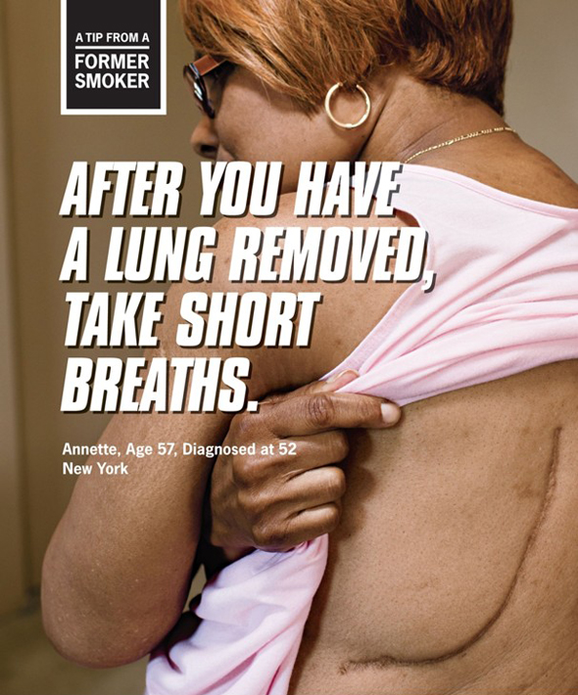

The ‘Tips from a Former Smoker’ campaign (example shown above) is part of a public health prevention campaign, which labels and causes group stigma of lung cancer patients. Although the campaign was created for American audiences, it was picked up by UK press and was circulated to UK audiences via social media. The campaign linked smoking to a host of medical conditions under the umbrella of ‘smokers diseases’. Link and Phelan (2001) describe how this campaign creates an over-simplistic label of ‘smokers’ with links to negative stereotypes. This is in order to increase the effectiveness of these campaigns at stopping people smoking. If the problem is reduced to a simple cause and reaction then it is easy to rectify. If the campaign explained the real complexities and individual factors which could have potentially contributed to the subjects lung cancer then it would be less effective at convincing smokers that smoking is to blame and that they should quit.

Although smokers are able to hide their position as a smoker to reduce stigma, lung cancer is often detected in the late stages, therefore treatment and side effects can make concealing the illness difficult. These conditions, which cannot be hidden from potential stigmatisers, are also known as discredited conditions (Gonzalez 2010). Lung cancer patients inability to hide their condition distinguishes them as a visible target for stigma and means they are more likely to be a victim of enacted stigma than those with discreditable conditions that they are able to hide (Chaudoir et. al 2013). This stigma results in increased social isolation and a decrease in social support for victims (Chaudoir et. al 2013). Gonzalez (2010) argues this contributes to an increase of lung cancer victims experiencing depressive symptomatology. Victims of cancers who usually experience a growth of social support, following diagnosis, such as breast cancer have much lower rates of depressive symptomatology three months after diagnosis (8%) than lung cancer victims (44%). This further negatively affects the patient’s mental ability to escape from the cycle of oppression.

The shame and guilt lung cancer patients who have smoked feel for their own situation is further enhanced by public health campaigns, which demonstrate the consequences of second-hand smoke. In 2008 Roy Castle Lung Foundation released a series of ads, which focused on the dangers of second-hand smoke on children (Toxel 2008). These adverts associated smokers with physical and social peril to those around them, one element of stigma communication identified by Smith (2007). Lung cancer sufferers are encouraged by these adverts to feel a burden of guilt for possible damage they may have inflicted on loved ones. Patients in a study by Chapple et. al (2004) reported increased stigma from friends and family members over possible damage to their health. For example one patient described that his daughter had not contacted him since his diagnosis because she felt dirtied by his diagnosis and another patient described how people he had known for 40 years would cross the road when they saw him.

This damage to self-perception is not restricted to lung cancer patients who have smoked. Patients in Chapple et. al’s (2004) study, who had never smoked, reported being labelled as a smoker regardless. One patient commented that medical professionals marked him on hospital reports as a smoker, no matter how many times he protested. In the end he accepted the role as resisting appears to be futile and wouldn’t change the outcome of his diagnoses and treatment. This demonstrates that the stigma has become so powerful that lung cancer is seen only as a by-product of smoking and therefore all patients should experience this guilt, regardless of their individual situation.

In an attempt to increase the success of prevention campaigns framing is used to position lung cancer as a fatalistic disease. According to Chapple et. al (2004) this has increased the enacted stigma faced by lung cancer patients, as people not only associate them with smoking but also with an inevitable and horrible death. This is supported by Smith (2007) who describes communication which links a certain group to social or physical peril as breeding stigma. Kuyper (2009) describes framing as a process whereby communicators encourage audiences to interpret a situation a certain way by constructing reality using four key methods; problem definition, diagnosis, moral judgement and solution suggestion, which are visible in most social marketing campaigns. This model can be applied to these public health and charity anti-smoking and lung cancer campaigns in order to better understand how they contribute to the stigmatisation of lung cancer patients. Stoptober’s campaign, for example, defines lung cancer as the problem and diagnoses that 90% of lung cancer cases are caused by smoking (NHS 2013). This is then accompanied by a moral judgement that smokers are the ones who get lung cancer and to prevent this the solution is Stoptober’s 28-day challenge.

Harrowing images are frequently used to support these campaign messages and shock those who smoke into quitting, for example the Department of Health’s ‘Mutation’ video mentioned earlier depicted a cancerous tumour growing from a cigarette as it is smoked (Mahdawi 2013). As Gurrieri et. al (2012, p. 132) note, ‘images play a critical role in the construction of identities, beyond mere reflection or portrayal’. As most campaigns associate lung cancer with smoking and a lung cancer diagnosis with death, this affects the way lung cancer patients are treated and the opportunities afforded to them. The rhetorical authority of the images and the source makes critical resistance from patients to resist these stereotypes difficult (Shroeder and Borgerson 2005 cited Gurrieri 2012).

The Roy Castle Lung Foundation (2015) is the only lung cancer charity in the UK. Its aim is to raise awareness, promote further research into prevention and management and provide support and a voice for patients and families. However, many of its campaigns focus on smoking and prevention as opposed to appeals for donations and support to help lung cancer patients live longer.

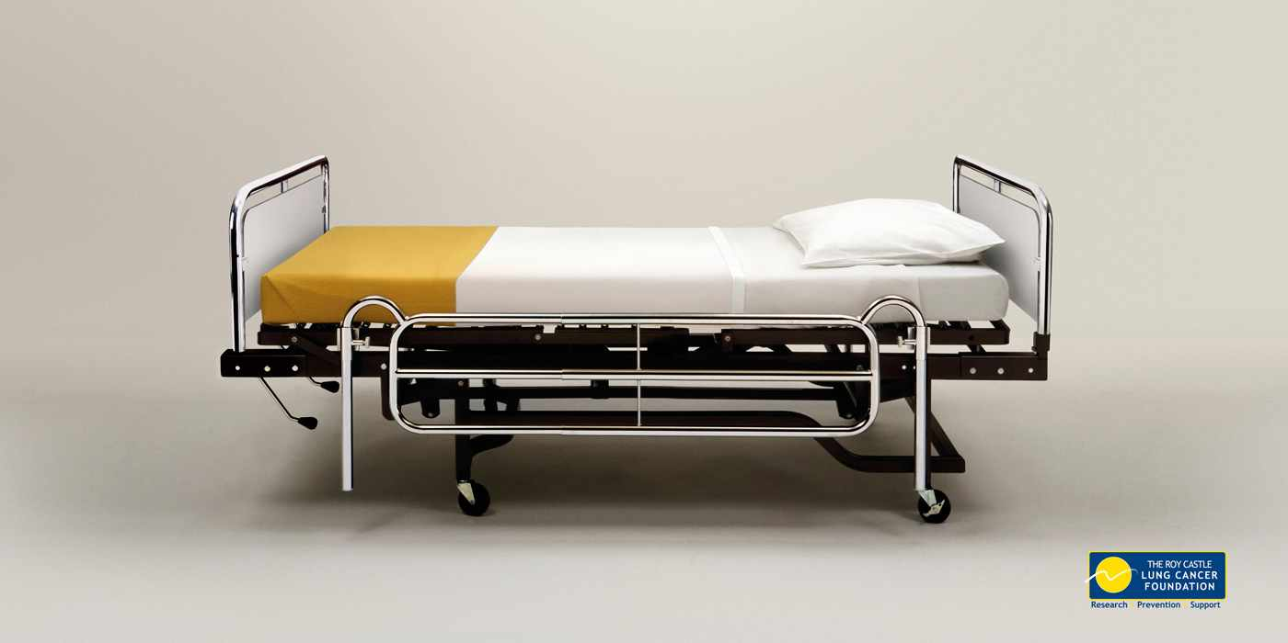

One ad includes an image of an empty hospital bed made to look like a cigarette and entitled ‘Deathbed’ (Denno 2014). Applying Kuyper’s model to this campaign highlights similar framing outcomes to the Stoptober campaign. In this advert death because of lung cancer is the problem and smoking is the diagnosis. The scientific facts become a form of moral judgement: if you smoke you are actively killing yourself and the solution is seen as simply to stop smoking. The repetition of this framing across public health and charity campaigns reinforces the perception of lung cancer as a death sentence. Bresnahan et. al (2009) argues that the existence of these messages which focus on the hopelessness of surviving a lung cancer diagnosis and the unpleasant way in which patients die has resulted in smokers who contract lung cancer facing more stigma than smokers who do not. They are seen by non-smokers as bringing it upon themselves and are a reminder to those who smoke of the potential consequences.

Another way in which public health and charity campaigns can stigmatise lung cancer patients is through evidence of therapeutic nihilism. Therapeutic nihilism in the context of lung cancer is the view that medical treatments are of no value (Chambers et. al 2012). Lung cancer is the most common cause of cancer death in the UK (Cancer Research 2014). This information is frequently used in lung cancer campaigns to encourage those who smoke to quit, however few focus on raising awareness of symptoms or appealing for donations to improve long term survival, despite evidence that around 1300 deaths could be prevented with earlier diagnosis (Abdel-Rahman et. al 2009 cited Ironmonger et. al 2014). As a result these campaigns are criticised for utilising therapeutic nihilism to make prevention campaigns more effective despite evidence of the detrimental effects to existing patients (Gonzalez 2010). For example, 38% of the lung cancer patients in Gonzalez’s study were suffering from depressive symptomology, which could be directly linked to their experiences of stigmatisation. Purtle (2012) argues that stigma is the enemy of public health. It ‘discourages people from seeking care, negatively impacts the quality of health care provided and can cause psychological distress that adversely affects disease trajectories’.

This therapeutic nihilism is evident in public health and charity campaigns. In 2004 the NHS launched a series of anti-smoking adverts including Anthony’s story; a 58-year-old man with lung cancer who would like to remain alive for his daughter’s imminent visit. The episode ends with a message that Anthony died 10 days later and did not get to see his daughter. The advert communicates hope as futile, even for short-term survival. This nihilism acts as a barrier to care and hope for lung cancer patients. Tod et. al (2008) noted patients felt helpless that campaigns were using lung cancer patients to contribute to fatalistic views rather than raise donations for further treatments.

One argument justifying the approach taken by these organisations is that creators of these campaigns have to weigh up the public benefit of a decrease in tobacco-related diseases against the cost of stigmatising current sufferers (Chambers et. al 2012). As a result the interests of the advertisers and lung cancer patients as a minority segment inevitably diverge. These campaigns place a lower value on representing current sufferers, instead negatively portraying and excluding patients who are unable to defend themselves (Gandy 2000).

Furthermore, Smith (2007) argues that stigma attitudes are often expressive. If an individual or group disproves of a certain activity then they will express stigmatising attitudes to those associated with that activity. Both the Government and lung cancer charities hold firm anti-smoking attitudes. As a result their campaigns must reflect this; a focus on helping lung cancer sufferers may be misconstrued as supporting smoking. By containing the voice of lung cancer patients and stereotyping them as death sentences public health and charity campaigns can maintain ‘social order’ and improve the effectiveness of their campaigns encouraging those who smoke to quit (Smith 2007).

One way in which public health campaigns can voice the needs of disease victims is by using a celebrity spokesperson who usually has a personal connection with the issue and therefore can provide an influential and representative voice. Holtz (2003) comments that a celebrity spokesperson provides a disease with credibility and tells the public that it matters. However celebrities are reluctant to front lung campaigns and challenge the stigma even if they have been personally affected. American music artist Warren Zevon, for example, made several public appearances in the last year of his life but failed to represent lung cancer patients and call for better research or treatment. Instead he admitted on a televised interview that he had accepted his fate as his own fault as he had not visited a physician in 20 years. Unlike other forms of cancer whose survival rates have vastly improved over the years, lung cancer does not have an army of survivors to front public health campaigns. As long as campaigns continue to exclude current sufferers and fail to instil hope within audiences that they can help save the lives of lung cancer victims this is unlikely to improve (American Lung Cancer Association 2013). In the UK in order to combat the stigmatisation faced by lung cancer patients a voice of hope is needed. Both sufferers and non-sufferers need to believe that there developments are being made in the search for lung cancer treatments and that survival rates for lung cancer patients are also improving.

There has been some level of growing awareness of the problems with stigmatising lung cancer patients outside of the UK such as the Lung Cancer Alliance’s ‘No one deserves to die’ campaign in the US.

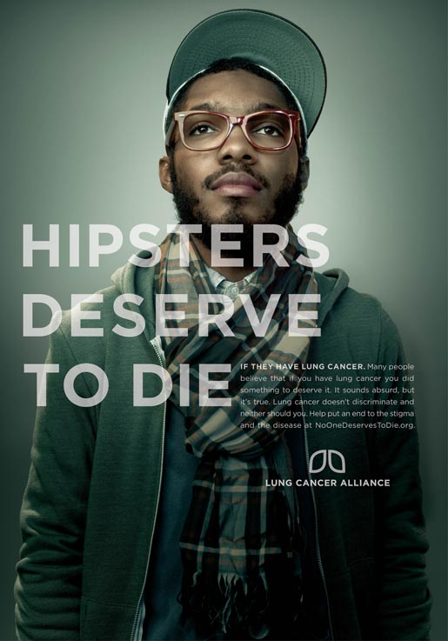

This campaign involved frequently stereotyped groups such as cat ladies with the slogan ‘cat ladies deserve to die’. These shocking statements attracted nationwide attention and disgust. Lung Cancer Alliance then revealed its campaign as in fact ‘No one deserves to die’ with the message ‘lung cancer doesn’t discriminate, neither should you’ (Lung Cancer Alliance 2015). This campaign was successful in raising the stigmatisation of lung cancer as an issue and providing a voice for frustrated lung cancer sufferers, however no similar campaigns exist in the UK to help patients challenge stereotypes. Smith (2007) argues that like stereotypes once learned stigma is resistant to change and as a result these campaigns are unlikely to make much difference to stigma attitudes in the long term, although they may reduce incidents of enacted stigma as stigmatising behaviour becomes more socially unacceptable. The shocking ads prompted an emotive response and achieved widespread media coverage, however (Purtle 2012) argues the campaign is unlikely to produce many benefits for public health. He claims that most people are not consciously aware of their stigmatisation of lung cancer patients enough to actively decode the message the ads are trying to convey.

The consequences and end-result of these campaigns for lung cancer patients can be predicted and explained using Schmidt’s (1994) cycle of oppression model, which she describes as having five areas; stereotype, prejudice, discrimination, oppression and internalised oppression. Link and Phelan (2001) argue that stigmatisation can only occur in a power situation and relies on access to social, economic and political power. Through their use of stigma communication and by focusing on prevention and lung cancer as a self-inflicted death sentence public health and charity campaigns are directly contributing to the voicelessness of these patients by encouraging them and keeping them in the cycle and limiting this access.

The subsequent loss of status and discrimination leads to unequal outcomes and a lack of social capital. Without access to these networks and a common objective with those with power lung cancer patients do not have the opportunity, motivation or ability to overcome their voicelessness. A study by Lanfred et. al (2014) found that social capital and self-stigma were the most influential factors in reducing the empowerment of stigmatised communities. The combination of elements mentioned in this paper therefore contribute to behavioural inhibition, voicelessness and self-censorship (Chapple et. al 2004). Lung cancer sufferers feel less able to express themselves as a result of the way their illness’s are portrayed (Chaudoir et. al 2013).

The very limited research that exists on the role of marketing communications and the effects of stigmatisation of lung cancer patients focuses on the harmful impact of advertisements in supporting and encouraging structural and public stigma. Considering that the priority of public and charity health organisations is to reduce lung cancer cases I would agree with Corrigan et. al (2014) that resultant stigma is an unfortunate byproduct of meeting the needs of majority position. As these campaigns have proven so successful at encouraging smokers to quit, for example over one million smokers had quit due to these campaigns by 2004 (Brooks), this stigma communication is likely to continue. What this paper suggest is future campaigns need to pay due respect and attention to unforeseen consequences and the need to treat the public with a degree of respect where raising awareness of the complexity of lung cancer as a condition is a legitimate aim.

**References**

American Lung Association. 2014. *Addressing the stigma of lung cancer* [online]. USA: American Lung Association.

Bresnahan, M., Silk, K. and Zhuang, J., 2009. You did this to yourself! Stigma and blame in lung cancer.

Cancer Research. 2014. Lung cancer key stats [online]. London: Cancer Research. Available from: <http://www.cancerresearchuk.org/cancer-info/cancerstats/keyfacts/lung-cancer/cancerstats-key-facts-on-lung-cancer-and-smoking> [Accessed Thursday 16th January 2015]

Chambers, S. K., Dunn, J., Occhipinti, S., Hughes, S., Baade, P., Sinclair, S., Aitken, J., Youl, P. and O’Connell, D. L., 2012. A systematic review of the impact of stigma and nihilism on lung cancer outcomes. BMC Cancer [online] 12 (184).

Chapple, A., Ziebland, S. and McPherson, A., 2004. Stigma, shame and blame experienced by patients with lung cancer; A qualitative study. British Medical Journal [online], 328.

Chaudoir, S. R., Earnshaw, V. A. and Andel, S., 2013. “Discredited” Versus “Discreditable”: Understanding How Shared and Unique Stigma Mechanisms Affect Psychological and Physical Health Disparities. *Basic and Applied Social Psychology* [online]. 35, 75-87.

Corrigan, P.A., Kosyluk, K.A., Fokuo, J. K. and Park, J.H., 2014. How does direct to consumer advertising affect the stigma of mental illness? *Community Mental Health Journal* [online], 50 (7), 792-799.

Denno, J., 2014. *Dare outs out latest anti-smoking campaign effort* [online]. London: You Can Now. Available from: <http://www.ycn.org/companies/features/223-dare-puts-out-latest-anti-smoking-campaign-effort> [Accessed Wednesday 14th January]

Department of Health, 2012. Smoking health harms [video, online]. Available from: <https://www.youtube.com/watch?v=QrRwp5KXfrg> [Accessed 6th April 2015]

Gandy, O.H., 2000. Race, ethnicity and the segmentation of media markets. *In:* Curran, J. and Gurevitch, M. Mass media and society. 3rd edition. London: Arnold Publishers

Goffman, E., 1963. *Stigma: Notes on the management of a spoiled identity*. London: Simon and Schuster.

Gonzalez, B. D., 2010. *Depression in lung cancer patients: Role of perceived stigma* [online]. Thesis (Masters). University of South Florida.

Gurrieri, L. Previte, J. and Brace-Govan, J., 2012. Women’s bodies as sites of control: Inadvertent stigma and exclusion in social marketing. *Journal of Macromarketing* [online], 33 (2), 128-143

Hamm, P., 2013. *New Study: California's Tobacco Control Program Saved Over $130 Billion In Health Care Costs* [online]. Washington: Campaign for Tobacco Free Kids. Available from: <http://www.tobaccofreekids.org/press_releases/post/2013_02_13_ca> [Accessed Friday 17th January 2015]

Holtz, A., 2003. *Recruiting celebrities to speak about lung cance*r [online].New York: Oncology times. Available from: <http://journals.lww.com/oncology-times/Fulltext/2003/11250/Recruiting_Celebrities_to_Speak_about_Lung_Cancer.7.aspx> [Accessed Tuesday 13th January 2015]

Ironmonger, L., Ohuma, E., Ormiston-Smith, N., Gildea, C., Thomson, C. S. and Peake, M. D., 2014. An evaluation of the impact of large-scale interventions to raise public awareness of a lung cancer symptom. British Journal of Cancer [online], 112, 207-216

Jinyoung, K., 2014. *Does stigma against smokers really motivate cessation? A moderated mediation model on the effect of anti-smoking campaigns promoting smoker-related stigma on cessation intentions* [online]. Thesis (Masters) University of Wisconsin.

Kuypers, J. A., 2009. *Rhetorical criticism: Perspectives in action*. Lanham: Lexington Books.

Lanfred, M., Zoppei, S., Ferrari, C., Bonetto, C., Van Bortel, T., Thornicroft, G., Knifton, L., Quinn, N., Rossi, G. and Lasalvia, A., 2014. Self-stigma as a mediator between social capital and empowerment among people with major depressive disorder in Europe: The ASPEN study. *The Journal of the European Psychiatric Association* [online], 30 (1), 58-64.

Link, B. G. and Phelan, J. C., 2001. Conceptualizing stigma. *Annual review of sociology* [online], 27, 363-385.

Mahdawi, A., 2013. *Does Australia have the most gruesome public advertising in the world?* [online]. London: The Guardian. Available from: <http://www.theguardian.com/global/2013/may/28/australia-public-advertising-violent> [Accessed Thursday 16th January 2015]

NHS. 2013. *Lung cancer - causes* [online]. London: NHS. Available from: <http://www.nhs.uk/Conditions/Cancer-of-the-lung/Pages/Causes.aspx> [Accessed Thursday 16th January 2015]

Purtle, J., 2012. Does anyone deserve to die of lung cancer? [online]. Philly.com. Available from: <http://www.philly.com/philly/blogs/public_health/Does-anyone-deserve-to-die-of-lung-cancer.html?c=r> [Accessed 6th April 2015]

Putnam, R. D., 1995. Tuning in, tuning out: The strange disappearance of social capital in America. Political Science and Politics [online]. 28, 664-683

Schmidt, S.L., 1994. *The Cycle of Oppression* [online]. Texas: Texas State University.

Smith, R. A., 2007. Language of the lost: An explication of stigma communication. *Communication theory* [online], 17 (4), 462-485

Tod, A.M., Craven, J. and Allmark, P., 2008. Diagnostic delay in lung cancer: a qualitative study. *Journal of Advanced Nursing* [online]. 61(3), 336–343.

Toxel., 2008. *Roy Castle Lung Cancer Foundation Ads* [online]*.* Toxel. Available from:

<http://www.toxel.com/inspiration/2008/12/12/roy-castle-lung-cancer-foundation-ads/> [Accessed Wednesday 14th january 2015]