**Moths to a Flame: Why Are Young British Women Drawn to The Islamic State?**

Bournemouth University 2016

BA (Hons) Public Relations

Contact address:

**Address:** 13 FLINT WAY, ST. ALBANS, AL3 6DU

**E-mail:** [andreafranklsanz@gmail.com](mailto:andreafranklsanz@gmail.com)

**Telephone:** 07972474363

**ACKOWLEDGEMENTS**

This paper would not have been possible without the invaluable help from so many individuals.

Firstly, I would like to express my gratitude to my supervisor Professor Barry Richards for his continuous support, guidance and encouragement throughout my study and research on this topic. Your time and patience has been valued greatly.

Although you remain anonymous in the paper, I would like to thank each and every one of the interviewees who so graciously agreed to participate in my study. I am tremendously fortunate to have had the opportunity to interview you all and appreciate your significant contributions to my research. Thank you for sharing your invaluable knowledge, experience and insights, I have learnt more than I could have imagined.

Finally, I would like to thank my family for their ongoing encouragement and support throughout my studies at Bournemouth University.

**ABSTRACT**

Approximately 55 young British females joined the Islamic State in 2015 alone, and the number continues to accelerate. While the phenomenon of women joining extremist organisations is not new, ISIS have internationally augmented the recruitment of western females with success. The following paper will attempt to contribute to the discussion of why British women are motivated to joining a terrorist organisation like ISIS. The role of social media in reinforcing ideological messages will also be explored, using case studies of British girls that have fled to Syria; including the Halane twins and Aqsa Mahmood. In doing so, the paper utilises a devised conceptual framework of radicalisation, developed from literature and existing research. In particular, special focus is applied to the predisposing factors, taking into account the sociological and psychological causes that may compel an individual to embrace radical ideology. This paper concludes that extreme religious ideology is a significant element to the radicalisation process and has been severely underestimated. In addition, research findings suggest that the core motivations for women joining ISIS are inherently personal, and relate to the human desires of love, belonging and a sense of purpose.

***Key words:*** Radicalisation, Islamic Extremism, Terrorism, Identity Crisis, British, Muslim Women.

*“There is a responsibility to acknowledge these women as threats; if you don’t see them as angry, bloodthirsty and violent, then you won’t see them as that when they come back, which is a huge problem … it’s a simplification of what is happening.”*

**INTRODUCTION**

*“Like a moth drawn to a flame,   
Patching up her broken wings,   
Just to try it once again,  
And the world all thought her foolish,  
For she never seemed to learn,  
But how do you save somebody,  
Who’s convinced that they should burn?”*Hanson (2014, p.72)

An estimated 6,000 foreign fighters from Europe have travelled to Syria and Iraq since 2012, the majority coming from France, Germany and the UK (Kirk, 2016). Since 2013, Britain has been confronted with an unprecedented number of young Muslim females drawn to the Islamic State in Syria. The exact figure of British women in Syria is difficult to determine however, in 2015, 55 known females willingly joined ISIL - like moths to a flame (Tran, 2016).

The ongoing phenomenon of young British women migrating to Syria, aged between 15 and 20 years, have brought this emerging movement into focus. The available research is useful in identifying the number of push and pull factors for joining ISIS, but is challenged by a lack of consensus over the root cause of radicalisation in young Muslim females. Without first-hand experience, it is difficult to gain a precise understanding on the reality of life in Syria and the role of women in the Islamic State. Peresin (2015) states that these limitations restrict understanding on the core motivations for women joining ISIS and more importantly, can underestimate the potential threat of their return. Moreover, this demonstrates the increasing need for further research on the significance of female involvement in ISIS, which is evolving into a new form of terrorism.

The purpose of this paper is to provide an understanding on why young British Muslim women are motivated to join ISIL. In addition, the role of social media will be explored, in terms of its impact on reinforcing the ideological messages communicated by ISIS. In doing so, the paper will utilise a devised conceptual framework, developed from literature and existing research, in an attempt to answer the research questions and outline the incremental stages of radicalisation.

The paper is divided into three core sections. First, an extensive review of existing literature, identifying the gaps for new research. This is followed by a description of research methodology, outlining the design, data collection strategies and research limitations. Finally, a discussion and analysis of findings will be presented from case study examples and ten in-depth interviews. The findings will focus on four core themes, including the predisposing factors (identity crisis and grievances), Islamist ideology, radicalisation online and the motivations for joining ISIS.

This paper will argue that extreme religious ideology is a significant element to the radicalisation process and has been inadequately researched. Furthermore, findings suggest that the core motivations for women joining ISIS are inherently personal, and relate to the basic human desires of love, belonging and a sense of purpose.

**LITERATURE REVIEW**

According to Rumman (2015), jihadi-salafism has surged over the past decade and more recently, has become the fastest-growing Islamic movement in Europe, Near East and South Asia. A number of academics in the field of Islamic extremism point to a multitude of complex processes and stages that lead to ‘jihadisation’, a term coined by Boon et al (2011) to define violent jihad, in both speech and action. These stages are described as a ‘funnel’ by which individuals become progressively more radical as their extreme religious beliefs intensify (Baker-Beall et al, 2015).   
  
The following model will outline the incremental process of radicalisation a British female Muslim may experience, taking into account the sociological and psychological factors that may compel an individual to embrace radical ideology. Although each female may have different personal experiences and trigger points, the following elements are a common denominator to the small proportion of radicalised British women. The first stage of pre-radicalisation covers the situation of an individual before exposure to extremist Islam, who could be directly or indirectly experiencing Islamophobia and underlying issues of identity. The second stage is self-identification as a response to the external sense of persecution, whereby the individual processes feelings of confusion and alienation. Lastly, having absorbed all these feelings, the individual may succumb to being influenced by extremist propaganda and consequently go through a state which leads to radicalisation.

**Stage One: Islamophobia**

Islamophobia and anti-Muslim sentiment has considerably intensified since 9/11, compounded with an increase of terrorist activities linked to extremist Islam. Stolz (2005, p. 548) simplistically defines Islamophobia as “a rejection of Islam, Muslim groups and Muslim individuals on the basis of prejudice and stereotypes”. Zuquete (2008, p.5) further describes Islamophobia as the stigmatisation of all Muslims, “a widespread mindset of fear-laden discourse in which people make blanket judgements of Islam as the enemy, the ‘other’ ”.

The term Islamophobia has been disputed for its loose application to diverse phenomena, from xenophobia to anti-terrorism (Zuquete, 2008). Islamophobia is understood to be far more complex than just a fear or phobia of Islam. Halliday (1999), asserts Islamophobia is a fear of Islam as a faith, when the real problem is negatively stereotyping Muslims as people - “Issues of immigration, employment, racial prejudice, anti-immigrant violence are not specifically religious” (Halliday 1999, p.898). However, contrary to Halliday’s claim, racial and religious discrimination are in a sense interconnected, as many women reported abuse when they appeared “visibly recognisable as Muslim” (Richardson 2004, p.23).

Islamophobic attitudes have considerably intensified and the negative public opinion of Islam has increased levels of resentment, creating further tensions with the Muslim community (Allen and Nielsen, 2002). According to Ansari, (2005, p.87), the social impact of Islamophobia in Britain has been the stigmatisation of all Muslims, creating an enemy within. Many academics (Bleich, 2001; Moore et al, 2008; Alshammari, 2014) have noted the role of irresponsible media coverage, which has led to a prevailing sense of unknown fear and distrust of Muslims. Consequently, this has severely impacted on the British perceptions of Islam and caused a dramatic surge in Islamophobic attacks (Field, 2007). Sherwood (2015) states, anti-Muslim attacks in London increased dramatically - by 70% in 2015 from the previous year.

In particular, women have become targets of Islamophobia, in relation to veiling, which makes them visibly identifiable as Muslim and more vulnerable to becoming known as the ‘other’. Kapur (2002) notes that women are more likely to become victims of Islamophobic attacks than men, because they embody a visible manifestation of Muslim identity. In a study of British Muslim females (Allen, 2014), a prominent driver of Islamophobic attacks was the visibility of their Muslim identity, which acted as a key driver to provocation, discrimination and abuse. Islamophobia was found to impact on the respondents’ perceived and defined identity, subsequently affecting their sense of belonging to Britain. Phillips (2006, p.1) asserts that a sense or direct form of persecution of British Muslims will cause a “withdrawal from social and spatial interactions with the wider British society”. The experiences of Islamophobia by Muslim women have a significant impact on their self-identity, causing them to question who they are as a person and their role within society (Allen, 2014).

**Stage One: Identity Crisis**According to Brubaker & Cooper (2000) there is no clear concept of identity, and the use of fragmented, ambiguous expressions have deprived the term of having any significant meaning. Various conceptions of identity have been widely used to reference a sense of self which can be co-constructed, socially constructed and even historically constructed. Baldwin et al (2014, p.95) argue that “identity is created in the context of our social world, histories and relationships. They are inherently political and religious, affording us more or less power, given the context”. Golubović (2010) similarly states that identity is not granted to us naturally: it is humanly conditioned and defined by our culture and environment. Josselson (1996, p.30) asserts that identity is built on integration and interpretation of an individual’s life: “Identity is how we interpret our own existence and understand who we are in our world”.

Issues of terrorism, radicalisation and extremist ideology have been closely associated with the notion of identity and, more specifically, identity crisis. In an environment where terrorism poses a grave threat, many Muslim Millennials have experienced discrimination and prejudice, resulting in a serious identity crisis. At a time of doubt, when an individual questions “Who am I”, there is often a search for deeper meaning and a sense of vulnerability which can open an opportunity for radicalisation (Al Raffie, 2013). The search for identity has been defined as an identity crisis, which Yoon (2015, p.21) describes as “an acute form of confusion and disorientation that affects individuals, peoples, nations and institutions”. Erikson (1968) defines identity crisis as a period of uncertainty, particularly during adolescence, in which an individual experiences a conflict between their individual identity and their role within society. Throughout the process of radicalisation, there are numerous behaviours and motivations, revolving around identity confusion and manifestations of identity. Subsequently, individuals are considered to be more receptive to extremist ideologies when their self-identity is questioned, placed under strain, or even threatened with annihilation (Maruna et al 2006).

Central discussions (Silber & Bhatt, 2007; Veldhuis & Staun, 2009; Rahimullah et al, 2013) suggest that extreme Islamic radicalisation can be triggered by an identity crisis, which is caused by a number of interconnected factors, including a perceived threat to religious identity. Radicalised individuals gradually become isolated and disconnected from their original social environment and Muslim community (Wali, 2016).

The root cause model of radicalisation (Veldhuis & Staun, 2009) (Appendix 1), asserts that possessing a strong Muslim identity can facilitate a positive sense of identity through self-esteem. Though, only when the individual’s social identity is threatened through real or perceived discrimination, does the likelihood of resentment and hostility increase. Veldhuis & Staun (2009, p.67) further assert, “when society understands and respects different social identities, strong religious identities may become a positive feature, rather than a negative one”.

According to Saltman & Smith (2015), questioning identity and experiencing a sense of conflict are major contributing push factors for women joining ISIS. In British society, the identity of Muslim women is considered to be problematic (Allen 2014). Adolescent females have suffered with personal identity challenges as a result of having to balance the traditional, conservative Muslim values with Western modernity and democracy (Ahmad & Seddon, 2012). Tensions may form when Muslim females attempt to integrate into British society, whilst preserving their religious values. A central and contentious aspect in the debate of Muslim identity is the case of females who wear the hijab, niqab or burka, as a strong identity marker. There are many conflicting views on the matter; Belton & Hamid (2011) argue that dressing with modesty provides Muslim women with a source of freedom and empowerment before Allah. For others, it is also an “expression of defiance” against the wider Islamic identity struggles within the diaspora (Afshar et al, 2005). However, Botz-Bornstein (2015) states that wearing the veil can manifest a rejection of Western values and an identity of emphasised femininity and sexual objectification of women.

The push and pull factors which lead British women to becoming radicalised are multifaceted and cannot be reduced to a single cause. A growing body of academic work suggests those who experience an identity crisis through a sense of discrimination, will inevitably question what it means to be a Muslim in Britain, and consequently re-evaluate their place in society.

**Stage Two: Self-identification**  
While many Muslims are successful in managing their grievances, those who cannot, face significant challenges and have the potential to become radicalised (Veldhuis & Staun, 2009). According to Silber and Bhatt’s (2007) four-stages of radicalisation, this is the self-identification stage, whereby individuals process a combination of feelings and experiences, including social triggers (Islamophobia, a real or perceived sense of alienation), political (international conflict with Muslims) and personal triggers. During this critical period, there is a range of multifaceted changes which an individual may experience before becoming radicalised, such as an exploration of identity, belonging, or an increase in religiosity (Ali, 2008; Hoyle et al, 2015; Pearson, 2015).

During the self-identification stage, the individual may gradually move away from their previously perceived identity and become influenced by internal and external factors, to fortify their needs which may have been threatened. Veldhuis and Staun (2009) state that during this stage, some silently suffer from an internal crisis and even remove all social bonds with family and former friends. Thus, the individual may feel ostracised from society, resulting in a negative impact on their psychological state (Knapton, 2014). This can induce a ‘cognitive opening’ in which the individual becomes more receptive to new ideas and worldviews. Wiktorowicz (2004) asserts that a cognitive opening is the first stage of radicalisation, directly caused by issues of integration, discontent and identity. Wiktorowicz (2004) also states that Muslims may seek further clarity and guidance in response to issues of identity, through “religious seeking” from sources including friends, religious organisations, and social media. Contrary to Wiktorowicz’s view, not all Muslims seeking religious knowledge will join a radical cause, as some may wish to attain self-empowerment through their faith. However, the stronger the religious aspect of their identity becomes, the less integrated they may be (Veldhuis and Staun, 2009). Therefore, individuals become more hostile, and are likely to respond to a perceived threat against their Muslim identity through acts of revenge or terror (Allen, 2014). Flannery (2015, p. 138) states that ISIS propaganda addresses the humiliation experienced from the enemy (the West) and through jihad, self-pride can be restored.

**Stage Three: Radicalisation**  
Having processed inner turmoil, individuals may seek guidance from close networks, online resources, Salafi-based NGO’s or extremist sermons, all serving as “extremist incubators” for many young Muslims living in diaspora communities (Silber and Bhatt, 2007). There are numerous communication outlets which one may use to relieve their personal battles however, social media are widely used by ISIS recruiters to convert and recruit young Muslim females (Kundnani, 2015). Richards (2015) states that extremist ideologies, through cyberspace, are now providing psychologically damaged persons with new ways of managing their inner turmoil. According to Klausen (2015, p.17), ISIS transformed social media into “an offensive strategy of psychological warfare”.

While social media are recognised as one of the key recruitment drivers for female migrants, there is little evidence to suggest that it substitutes the power of face-to-face communication. It is important to note that online propaganda is not singularly responsible for radicalising individuals; human influence must trigger and sustain the process (Koomen and Van Der Pligt, 2015). However, according to Winter (2015), social media have emerged as the decade’s “radical mosque”, reinforcing ideological messages and facilitating direct contact with former or current ISIS migrants. Social media have a substantial influence among women in particular, who receive practical advice from other females who are already in Syria, on how to get there, what to bring and how to bypass security (Peresin, 2015).

In terms of ISIS narrative, the radical views, ideology and rhetoric are effective in filling “identity voids”, with strict guidelines for coping with identity confusion and uncertainty (Peresin, 2015). Saltman and Smith (2015) similarly state that the collectivist force of extremist ideology which ISIS offers, evoke a strong sense of belonging as well as acceptance and stability, which was previously absent in their lives. Havlicek (2015, p.10) emphasises that there are very few sub-cultures or movements like ISIS which claim to offer females so much, including “a sense of adventure, belonging and sisterhood, romance, spiritual fulfilment and a tangible role in idealistic utopia-building”. Furthermore, young Muslim females are vulnerable and more susceptible to this rhetoric if their identities are in question and they feel socially or culturally isolated (Maruna et al, 2006). Living in ISIS territory may consequently be perceived as more attractive than living in their own country. A report by Quilliam Foundation (Rafiq and Malik, 2015) asserts that ISIS propaganda plays on the grievances that women have suffered from the West, and grants the solution of joining “caliphate sisterhood”.   
Research (Saltman and Smith, 2015) suggests the notion of female Muslims travelling to Syria to become “jihadi brides” is simplistic and one-dimensional. “Jihadi bride” is used to describe Western women who “have travelled to Syria to marry a Jihad fighter and live a domesticated lifestyle in ISIS-controlled territory” (Jacoby 2015, p. 526). Moreover, Bloom (2011) argues that we must work past the gender stereotype of female extremists, and instead look at the factors that really influence violence. Bloom (2011, p.9) also states “Many women are just as bloodthirsty as the male members of terrorist groups, but their motivations tend to be intricate, multi-layered, and inspired on a number of levels; anger, sorrow, revenge or religious zeal coalesce”. The idea of being part of the “caliphate sisterhood” is honoured among females, who utilise the sense of belonging as propaganda to attract other females searching for acceptance. In a study by Hoyle et al (2015, p.13) which observes the accounts of female ISIS migrants, “the search for meaning, sisterhood, and identity is a key driving factor for women to travel”. Hoyle states a common factor in the accounts is the belief that migration to Syria is a religious duty, which not only gives them a sense of belonging and sisterhood, but also brings them closer to God.   
  
**Conclusion**

An extensive review of literature has highlighted some of the major discussions in accordance to the phenomena of British women joining the Islamic State. The review has largely concentrated on two particular predisposing social factors, including identity crisis and Islamophobia, which covers the situation of an individual prior to radicalisation. As Hoyle et al (2015) and Pearson (2015) state, the pre-radicalisation factors evoke a range of multifaceted changes including an exploration of belonging or an increase in extreme religious beliefs. This stage is significant in paving the ground for radicalisation, and is often overlooked by academics, researchers and even the media. Furthermore, the connection between the Islamist ideology and motivations for joining ISIS has not been explored enough and debated in literature. As suggested by Rahimullah et al (2014, p.19), “the mechanics of ideological conversion have not been well researched”.

The following conclusions can be deduced:

* Whilst politics and religion are strong drivers for joining ISIS, the basic human needs of love and belonging are often overlooked in research.
* Future research needs to place greater emphasis on the early stages of radicalisation, taking into account the vast sociological and psychological factors that may affect an individual.
* There are insufficient theories to explain why, although many adolescent Muslims experience such issues of discrimination and identity crisis, only a minority proceed to adopt extremist views.

**METHODOLOGY**

The aim of this research is to understand why British females are willingly joining the Islamic State, whilst examining the motivating factors that contribute to the complex dynamics of radicalisation. The following research questions include:

* What are the motivations for UK women joining ISIS-controlled territories?
  + Is the rise of female ISIS migrants related to ideology, experiences of identity crisis or anti-Muslim hatred?
  + What is the role of social media in reinforcing ideological messages?

Since the nature of the paper is exploratory, a triangular approach was applied to the qualitative methods of research. According to Cohen and Manion (1986, p. 254), triangulation is “an attempt to map out, or explain more fully, the richness and complexity of human behaviour by studying it from more than one standpoint”. Altrichter et al (1996, p.117) similarly define triangulation as a way to achieve “a more detailed and balanced picture of the situation”. A triangular approach was best suited for the following research to form an outcome by assessing multi-dimensional perspectives on the issue of British women drawn to ISIS.

Primary research was collated from analysing the social media accounts of British foreign migrants, Salma and Zahra Halane (known as the ‘terror twins’) and Aqsa Mahmood (known as Umm Layth), who are reportedly living in ISIS-controlled territory. The profiles were selected because they have received coverage in the media and are known to actively promote ISIS propaganda online. Schell (1992) states that case studies enable the researcher to retain the holistic characteristics of real-life events, whilst at the same time, further illustrate the issue. Since the majority of accounts have been suspended, excerpts from original tweets and Tumblr blogs were obtained online or from the Saltman and Smith (2015) and Hoyle et al (2015) study.

The themes obtained from the literature review, which include Islamophobia, identity crisis, self-identification and radicalisation online, were further explored through qualitative in-depth interviews. Interviews allow the researcher to develop an understanding of “a social or human problem, based on building a complex, holistic picture, formed with words, reporting detailed views of informants, and conducted in a natural setting” (Creswell 1994, p. 24). An inductive approach was applied to the study design in which patterns, resemblances and regularities are observed to form conclusions around research objectives (Lodico et al, 2010). According to Bernard (2011, p.7), an inductive research approach “involves the search for pattern from observation and the development of explanations – theories – for those patterns through series of hypotheses”.

Due to the discussion of sensitive topics, a semi-structured interview method was appropriate to enable the participant to freely express their opinions, feelings and experiences on the matter. Unlike formal interviews, which follow a firm set of questions, semi-structured interviews aim to collect detailed information on a topic in a conversational style (Galletta and Cross, 2013). A general interview guide (see Appendix) was used to cover a list of open-ended questions to ensure that consistency and direction was implemented across all interviews. However, some questions were tailored differently according to the individual’s level of expertise on a particular theme.   
  
A maximum variation sampling technique was used to recruit participants, which according to Rubin and Babbie (2010, p.150), “captures the diversity of a phenomenon within a small sample to be studied intensively”. A total of ten participants aged between 25 and 54 were chosen from different professional fields, all differing along a spectrum on the issue of Islamic extremism. An epistemological perspective on the research was taken, whereby the researcher samples participants based on their experiences and level of expertise (Mason, 2002). All participants have been known to openly discuss issues of terrorism in the public and academic domain, and they were therefore, identified as valuable contributors to my research. INSERT FIGURE ONE for more details. Due to the nature of the topic, it was imperative that all participants had a level of knowledge and experience, whether direct or indirect, on the matter. The participant demographic criteria were therefore left open (including age, sex and education) and socioeconomic characteristics were not taken into consideration. From March 2015, one-to-one in-depth interviews were carried out, with the average interview lasting 58 minutes.

All interviews were recorded and transcribed to ensure accuracy and consistency in the findings and analysis of results (see Appendix 3 and 4). In addition, consent forms, participant information sheets and an ethics checklist were reviewed and completed by all participants prior to the interview.

An open coding method was used to identify and analyse the research results, in which themes and categories were outlined from the data and stages model outlined in the literature review. Coding, according to Charmaz (2006, p.46), is the “pivotal link between collecting data and developing an emergent theory to explain the data”. A subsequent phase to open coding, known as selective or focused coding (Glaser, 1978), was used to synthesise and explain the large segments of data in a more abstract way. Utilising the process of selective coding was useful in verifying the accuracy of developed concepts.

Quantitative research however, has its limitations like any other research methodology. The most notable limitation for this study is the fact that a sample size of ten participants only realistically represents a fraction of the overall perspective on British women joining ISIS. In addition, it is difficult to fully understand the experiences of young British women without having first-hand communication with them. Naturally, this was limited by the ethical constraints due to the sensitivity of the topic. Nonetheless, the outlined limitations are unlikely to diminish the validity and reliability of the data, as participants were selected based on their direct involvement in profiling real-life examples and case studies. Moreover, due to the credibility of the participants, the research is worthy for consideration.

**FINDINGS & ANALYSIS**

This section will analyse key findings from qualitative data, addressing four core themes in relation to literature. These include:

* Predisposing factors: identity crisis and grievances
* Self-identification: indoctrination of Islamist ideology
* Motivations for joining ISIS
* Radicalisation online

Key insights gained from case studies will be provided in an attempt to voice the feelings of young British women living in ISIS-controlled territory. An objective description of data will also be presented using interviewees’ responses where appropriate. The abbreviation of ‘P1’ is made to reference a specific participant - see Figure 1 in methodology for participant information.

**Predisposing Factors – Identity Crisis**

As discussed in literature (Saltman & Smith, 2005; Velhuis & Staun, 2009; Al Raffie, 2013), identity is a powerful and significant element to the radicalisation process. Identity crisis can be triggered by a range of factors including a direct or indirect form of Islamophobic persecution or a lack of integration. A recurrent discussion is the issue of Muslim Millennial women, who experience a conflict with balancing their conservative Muslim values with British modernity (Ahmad & Seddon, 2012; Allen, 2014). The research results emphasised the importance of identity, highlighting specific issues concerning female Muslim identity which had not been deeply explored in literature.

Participant four, a researcher at the Institute for Strategic Dialogue stated:  
  
 *“It’s difficult for young people and women especially - it’s even more complicated as there are all these layers of identity. For example, what it’s like to be a British Muslim woman in society today, how to express yourself and what femininity means. All those things can create a lot of confusion, especially for someone growing up with an Islamic background. They know they are very different from secular society and living in a country where their religion is not practised by everybody, makes them realise that their social identity is different”.*

This suggests that for many women, the multi-layered elements and differences of identity are viewed as a hindrance rather than a positive aspect. For some, this can trigger a period of uncertainty in which an individual experiences conflict around their manifestations of identity (Erikson, 1968). Participant eight, a professor, writer and human rights activist, stated that identity is about knowing who you are and your place in the world. This reinforces Josselson’s (1996, p.30) definition of identity as “how we interpret our own existence and understand who we are in our world”. P8 illustrated this point with a personal experience from her daughter, who at the time was fourteen years old:

*“There was a period where my daughter was questioning whether she was Swiss or Arab, I also have Yemen and Egyptian roots which makes it even more confusing. Given the fact that I was very much worried that she might be attracted to Islamism as an ideology, I started to tell her about the manipulation tactics these recruiters use. They tell you that you don’t have to choose your identity because your identity is Muslim. Her response really made me realise that for some, this may be a relief. She said: ‘But don’t you see what a good answer that could be, I wouldn’t have to choose if I’m Swiss, Yemeni, Egyptian or Arab’.”*

This personal account powerfully exemplifies the identity issues that many young Muslim females experience today. Despite coming from a stable and enlightening environment, the participant’s daughter still questioned her identity regardless, and acknowledged the “relief” that an individual may experience when their identity conflict is resolved. It also shows how recruiters can manipulate identities to mobilise individuals and serve the purpose of extremist ideology. Participant ten, a representative from a Youth charity combatting violent extremism in London, also stipulated this view:

*“A lot of these teenagers try to fit in an environment where they feel socially and culturally excluded, and radical Islam can be a way for them to find their inclusive identity. Islamism can form part of a complete identity and for many, it’s their religious, political and social identity.”*

It is suggested that Islamism is the “solution” to overcome the identity crisis that adolescents experience because it encompasses every aspect of their identity. As evidenced, instead of national identity formulating part of self-identity, religion has the power to form and satisfy their complete identity. Beit-Hallahmi (2015) states, religious identity is powerful and built upon fundamental beliefs and values, anchored within a sacred and eternal worldview.

It is therefore crucial that Muslim parents take the responsibility to communicate with their children and instil the belief that they are part of British society. P4 emphasised this argument and stated that a mother is the most important role within an Islamic family.

*“The emphasis that is placed on that relationship means that the mother is in such a position of responsibility … one of which is making your kids aware of that cultural identity and how that fits within the community they live in.”*

The impact of family influence has not been specifically explored in literature with regards to potentially radicalising and also de-radicalising Muslim youth, and it is an area which requires further research.

Another aspect of discussion is social integration and the challenges Muslim women face when attempting to simultaneously integrate and preserve their cultural or religious identity (Sartawi & Sammut, 2012). P1, an independent researcher on political Islam, illustrated this point with an example of how, from such a young age, Muslim girls are already being socially excluded from Western practices because of Islamic requirements on modesty.  
 *“There are cases where even parents stop their daughters from attending certain classes like P.E. in the name of religion. It’s very relevant to females in Europe who have been excluded from western cultural and societal practices because of their religion. If they can’t take part in certain things, then they won’t feel part of society.”*

Tensions are formed by a conflict of two opposing worlds when religious requirements are combined with strict family upbringing, thus Muslim girls are excluded from practices such as physical education. As noted in literature, adolescence is a key period of identity transformation for Muslim women who experience stricter constraints than men. Consequently, young girls negotiate their identity according to their experience of being a Muslim in a non-Muslim country (Zahidi et al, 2012). Moreover, if the individual experiences discrimination and anti-Muslim hatred, their vulnerability is further multiplied. This can create personal identity challenges, whereby the individual searches for deeper meaning and questions “Who am I” (Al Raffie, 2013). Some women will find a way to overcome these difficulties through will-power; however, others may undergo a period of vulnerability and experience an identity crisis (Baker-Beall et al, 2015).

Alongside integration and conflict between cultures, grievances (whether real or perceived) also contribute to an identity crisis, which can make an individual more vulnerable to extremism (Rafiq and Malik, 2015). These may emanate from encounters with anti-Muslim hatred, marginalisation and even early childhood experiences. For participant three, an independent filmmaker whose stepbrother was a convert and became radicalised, childhood experiences were one of the major triggers for identity crisis and radicalisation.

*“The separation between his mother and father played a big development in the process and his character. It’s obviously not the reason why he became an Islamist as lots of people experience divorces, but that really affected him and made him more open and vulnerable. Someone like Anjem Choudary was like a father figure and he tapped into the family and sense of community which was missing.”*

Storr (2005) believes a sense of powerlessness experienced in childhood is likely in some cases, to be twisted into anger or hate in adulthood. Rafik and Malik (2015) state, an individual’s grievances are magnified by recruiters who promise solutions, which often involves making “hijra” (migration). In P3’s case, the grievances his stepbrother experienced in childhood were leveraged with positive values of family and community offered by extremist Islam.

**Theme Two – Islamist Ideology**

The role of Islamist ideology has been severely underestimated in the radicalisation process by our policy makers, mainstream media and academics. Bale (2013, p.5) describes this denial to be peculiar, given that ideological extremists “openly and proudly emphasise the central role of their strict, puritanical interpretations of Islamic scriptures in motivating their violent actions”.

Ideology is a predominant motivating factor for attracting female migrants, who not only reject the culture and foreign policy of the West, but also embrace a new worldview (Saltman and Smith, 2015). While the theme of extremist ideology was not intensely explored in the literature review, it was a recurrent issue which arose from research. The case studies showed the emphasis placed on ideology and religious duty, which was also utilised to encourage other females to join. Zahra Halane for example, who in 2014 at the age of 16 joined ISIS with her twin sister, exemplifies the nature of her ideological beliefs in the quoted tweet:

*“Jihad is the most excellent form of worship and by means of it Muslims can reach the highest ranks … most people don’t know”*

According to Zahra’s post, jihad is glorified through the words “excellent” and “worship”. The connection between being a jihad fighter in Syria and being a Muslim, is particularly harmful because it may encourage others to perceive it as their religious duty. This narrative which is communicated across many social media platforms could potentially be a strong recruitment tactic for other girls in the same position.

Qualitative research also emphasised the importance of religious ideology, in which all participants shared the view that extremist Islamist ideology is the least explored element in the radicalisation process. This was a refreshing approach to the subject since the role of Islamist ideology in acts of terrorism has not been acknowledged enough by academics.

P8, a professor, writer and Muslim scholar, described Islamist ideology as a “virus” which is consistently ignored and becoming increasingly problematic.

*“We need to stand up to this fundamentalist interpretation of Islam, as Muslims … we cannot ignore the fact that it comes from Islam. Part of the problem is acknowledging that it has to do with us, with the misinterpretation of Islam which is paving the ground for extremism. We have to stand up to that. It is time to face the ISIS that is within us”.*

This highlights the biggest gap in literature, where very few studies have examined the connection between the puritanical interpretation of Islam and joining a terrorist organisation like ISIS. It also shows how the misinterpretation of religion leads to violence, an element that requires not only research, but also open debate.

Similarly, P1 concluded that researchers must look beyond the sociological factors impacting the radicalised individual, and examine the root cause; ideology which is rooted in Salafism:

*“Understanding how ideology sells and manipulates identity in order to serve goals, is what is really important. The way that ideology is framed is highly emotional and it appeals to the hearts and minds of these young people*.*”*

The reference to the hearts and minds of young people, or more specifically women, is a particularly striking element to the issue of radicalisation and an area of research which is understudied. Weiss and Hassan (2016) state, ISIS narratives have not only captured the hearts and minds of youths experiencing conflict, but have also targeted youths that are far removed from struggle. Young British Muslim women are drawn to a warped Islamist view of feminism, where the ideology is recrafted through modern values and empowering messages (Peresin, 2015). The ISIS narrative places an emphasis on women building the caliphate and breeding the next generation of jihadi fighters.

P8 reinforced this view, emphasising the situation of women experiencing conflict at home.

*“Many young women attracted to the ideology of ISIS see a way out of this patriarchal structure that they are living with at home ... In a sense, their limits are being expanded from what they often experience in their restricted surroundings. This dimension may be playing a success in the recruitment of these women”.*

On one hand, these women are viewed as innocent victims who are escaping their restricted upbringing or personal grievances, but on the other hand they are drawn to a violent and aggressive ideology. Peresin (2015) states that female migrants even express their willingness to participate in militant functions. This relates to Bloom’s assertion (2011, p.9) that “many women are just as bloodthirsty as the male members of terrorist groups … but they are inspired on a number of levels; anger, sorrow or religious zeal coalesce”. Participant four commented on the one-dimensional view of female foreign fighters, and stated that the assumption of British women being mere passive “jihadi brides” is statistically false.

*“There is a responsibility to acknowledge these women as threats; if you don’t see them as angry, bloodthirsty and violent, then you won’t see them as that when they come back, which is a huge problem … it’s a simplification of what is happening.”*

**Theme Three – Motivations for joining**

The following theme will analyse the predominant motivating factors which subsequently lead British females to the path of radicalisation. Since the key push factors have previously been discussed, such as issues of identity and exclusion, the focus will be placed on pull factors. These factors include belonging, sisterhood and romance, and have been identified through literature, qualitative research and case studies. According to Saltman and Smith (2015), unlike push factors, pull factors place an emphasis on positive incentives and empowerment.

Participant three, whose stepbrother was radicalised, stated that while politics and religion are important factors, they are used as mere justifications to fuel anger and hate against the West.

*“A lot of people forget that it’s about that basic human desire and need to be important and powerful. It’s about wanting to do something extraordinary with your life.”*

Qualitative data concluded that ideology plays a huge role in the radicalisation process, however, it is used as a justification for gratifying the deep level of vulnerability, lack of value and sense of purpose these individuals may feel. The core motivation for joining an extremist organisation is inherently personal and often relates to the desire of wanting to be important, recognised and socially accepted – an attribute that is within our human nature. Wali (2016) asserts, the motivations for women joining ISIS are universal, in the sense that they are often in search for a cause, a purpose and something meaningful. This can be triggered by an inner conflict surrounding who they are and where they belong.

Participant four, a researcher at the Institute for Strategic Dialogue, after examining several hundred case studies, stated that identity was the most important motivating factor among young women. More specifically, P4 placed identity at a value of 60%, followed by religious duty at 20% and a sense of adventure, romance, sisterhood or utopia building at 20%.

The “caliphate sisterhood” was identified through literature and qualitative data as a predominant motivating factor among young British Muslim females. As previously noted in the Hoyle et al (2015) study on female migrants, sisterhood and the sense of camaraderie is openly discussed on social media platforms to attract other recruits. The emphasis on sisterhood can be seen by one of the alleged female online recruiters, Aqsa Mahmood from Glasgow, who writes under the name of Umm Layth. Aqsa wrote a series of blog posts (fa-tubalilghuraba.tumblr.com) and tweets between 2013 and 2015 for sisters in the Islamic State (see Appendix). The tweet quoted below was uploaded with an image of Aqsa and two sisters wearing the full burqa:

*“Umm Haritha, me & Umm Ubaydah – My most beloved sisters, may Allah unite us in Jannatul Firdous for loving for his sake”*

To assist newcomers, Aqsa wrote a five-page post on Tumblr titled “Diary of a Muhajirah [migrant]” (2014) with guidance for female migrants on marriage and the role of women. In her post, the ‘paradise’ of Syria is juxtaposed with the realities of living in a warzone, as she advises soon to be married sisters to “bring makeup and jewellery from the West because trust me, there is absolutely nothing here”. To diminish any doubts and for further reassurance, the reader is told that the intentions are to please Allah; “you are blessed to be placed in this situation out of the billions of Muslims around the world”. This evidently shows the power of religious ideology in recruitment and propaganda strategies.

The sisterhood and sense of community are particularly strong elements in online propaganda, providing a sense of stability which these females previously lacked (Peresin, 2015). However, as acknowledged by P8, there is a dark and more serious side: *“No matter how strong the sisterhood is, the reality is often very different to what it is made out to be. It’s a warzone and these women are usually sex objects.”*

Despite the brutal reality of living conditions in Syria communicated online and in the media, propaganda disseminated by female migrants like Umm Layth, for example, still receive positive admiration from an audience. In some cases, it is even successful in the recruitment of women because propagandised pull factors like sisterhood, belonging, empowerment and religious ideology, are powerful enough to dismiss any other reality.   
 **Theme Four – Radicalisation Online**

Social media have been recognised (by Klausen, 2015; Koomen and Van Der Pligt, 2015; Kundnani, 2015) to be a facilitator for the radicalisation of young Muslim women online. Qualitative data further explored whether social media had the potential to facilitate the recruitment of female migrants, or if face-to-face contact was more powerful. Findings reinforced the view, outlined by Koomen and Van Der Pligt (2015), that there must be a human influence to trigger and sustain the radicalisation process.

Participant four emphasised the importance of face-to-face contact and stated:

*“The introduction to ISIS or the ideology will happen offline in the immediate community, through friends or a family member who have exposed them to radical Islam … the process is then facilitated on social media from that point onwards when individuals go online to satisfy their curiosity.”*

The importance of pre-existing social ties has been observed in cases of radicalisation. Like many female migrants who have joined ISIS, the Halane twins (explored as case studies) had a prior introduction to extremist ideology through their family. Zahra and Salma Halane are believed (Saltman and Smith, 2015) to have come from a strict orthodox Muslim background, where their father and brother held extreme radical beliefs. Their 21-year old brother Ahmed Halane was a primary influencer and led by example with his own departure to join ISIS in 2013. According to Dearey (2010), the family influence of religious fundamentalism can pose a stronger impact on an individual than the ideology itself.

The findings suggest that social media do not act as a substitute for direct contact, and instead, enhance the radicalisation process. Participants agreed that in many cases, social media were found to accelerate the grooming and recruitment of young females. Participant seven, a researcher from a counter-extremism think-tank, noted the powerful effects of online propaganda and its impact on attracting young vulnerable women:

*“The way ISIS use social media to their advantage is extremely powerful in creating a distorted reality of life in a warzone. The role of women is exaggerated in order to attract recruits, but the reality is far worse than imagined for these vulnerable females.”*

ISIS propagandists have recognised this vulnerability in females, and exploited it through the use of compelling language, rhetoric and visual content which appeal to a mass audience. The rapid dissemination of online propaganda has enabled ISIS to package themselves as a brand and gain global exposure like no other group (Winter, 2015). While social media have not been proven to singularly radicalise individuals, it could may well be the next evolution of terrorist recruitment. It is therefore crucial that research in this area continues to develop and examine the impact of social media in the radicalisation process.

**CONCLUSION**

There is a tendency to assume that women are not as bloodthirsty as men or capable of committing terrorist activities. Based on literature and research examined in this paper, it is clear that gendered misconceptions still remain concerning the phenomena of females joining the Islamic State. As Saltman and Smith (2015) state, the biggest issue is that women continue to be viewed as ‘victims of terrorism’, and are subsequently constrained by stereotypes such as the ‘jihadi bride’. However, cases like Samantha Lewthwaite, known as the White Widow of Al Shabaab, have defied the traditional paradigm of women. British-born Sally Jones, aged 46, is another example of a woman who transformed her conventional role from being a mother to an ISIS recruiter. In a perverse sense, Lewthwaite and Jones are viewed by extremist sympathisers as an inspiration for being two of the most wanted females, consequently attracting others to follow their path. Until we diminish the view of women as victims, we cannot implement policy and change.

To address the phenomenon of radicalised women, we must face two perspectives; the viewpoint from these women and the terrorist group themselves. Further research is required to understand the hearts and minds of the youth to whom ISIS ideology appeals so strongly to. In addition, we must acknowledge that prior to joining ISIS, many had opportunities to be successful and were not necessarily marginalised. This leaves room to question, what makes these women join a terror organisation? The answer, derived from research and findings, lies within the power of religious ideology.

Unlike previous research where ideology has been underestimated, this paper highlights the importance of confronting the root cause: acknowledging the ideological dimensions to radicalisation. Qualitative data demonstrates the biggest gap in research is the connection between the puritanical interpretation of Islam and joining ISIS.

An interesting conclusion derived from research is that while ideology is an important element to the radicalisation process, the core motivations are inherently personal. These motives relate to the basic human needs of love, belonging and a sense of purpose, often overlooked in literature. Future research must closely examine these factors in order to understand the hearts and minds of young women. More significantly, research highlighted the issues of female identity in the UK. Families therefore have the responsibility to instil the belief in their daughters that British and Muslim identity can be embraced simultaneously.

This paper has attempted to contribute to existing research by providing a refreshing approach on the issue of British women joining ISIS. Furthermore, the research questions have been answered through the key findings and a devised stages model of radicalisation. This presents valuable insight into the incremental process of radicalisation that a female may experience, taking into account the complex factors and multi-layered drivers.

As previously noted in methodology, the limitations of this study are based on the small sample of research participants which only realistically represents a fraction of the overall perspective. Due to ethical constraints, first-hand experiences of radicalised females were unobtainable and for future research, this must be taken into consideration.    
  
 **Recommendations**

A recommendation to prevent radicalisation is to take an educational approach and micro-analyse the Islamist ideology, which stems from a misinterpretation of Islam. An open debate is required and acknowledgement of this fact is needed from educational bodies, Muslim organisations and policy makers who must collectively unite in search of the solution.

To tackle the 9,000 radicalised would-be jihadists in France, Prime Minister Manuel Valls recently announced a €40 million program to set up de-radicalisation centres across France. It is important to treat the causes of radicalisation, rather than the symptoms. Acknowledging the connection between Islam and extreme ideology, which often leads to terrorism, is paramount. It is important to invest in further research, education and pre-radicalisation programs to detract the moths from the flame.

**References**

Afshar, H., Aitken, R. and Franks, M. 2005. Feminisms, Islamophobia and Identities. *Political Studie* [online]*,* 53 (2), 262-283.

Ahmad, F. and Seddon, M. S., 2012. *Muslim Youth: Challenges, Opportunities and Expectations.* London: Continuum International Publishing Group.

Al Raffie, D., 2013. Social Identity Theory for Investigating Islamic Extremism in the Diaspora. *Journal of Strategic Security*, 6 (4), 67-91.

Ali, S., 2008. *Second and Third Generation Muslims in Britain: A Socially Excluded Group? Identities, Integration, and Community Cohesion* [online]*.* England: Oxford University.

Allen, C. and Nielsen, J., 2002. *Summary report on Islamophobia in the EU after 11 September, 2001* [online]. Austria: European Monitoring Centre on Racism and Xenophobia.

Allen, C., 2014. Exploring the Impact of Islamophobia on Visible Muslim Women Victims: A British Case Study. *Journal of Muslims in Europe*, 3 (1) 137-159.

Alshammari, D., 2013. Islamophobia. *International Journal of Humanities and Social Science,* 3 (15), 177-180.

Altrichter, H. Posch, P. and Somekh, B., 1996. *Teachers Investigate Their Work: An introduction to the methods of action research.* London: Routledge.

Ansari, F., 2005. *British Anti-Terrorism: A Modern Day Witch-Hunt.* London: Islamic Human Rights Commission.

Baker-Beall, C. Heath-Kelly, C. and Jarvis, L., 2014. *European Responses to Terrorist Radicalization Counter-Radicalisation: Critical Perspectives.* United Kingdom: Routledge.

Baldwin, J. R. Coleman, R. R. Gonzalez, A. and Shenoy-Packer, S., 2014. *Intercultural Communication for Everyday Life.* London: Wiley-Blackwell.

Bale, J.M., 2013. Denying the Link between Islamist Ideology and Jihadist Terrorism: “Political Correctness” and the Undermining of Counterterrorism. *Perspectives On Terrorism*, 7 (5), 5-46.

Baran, Z., 2011. *Citizen Islam: The Future of Muslim Integration in the West.* United Kingdom: A & C Black.

Beit-Hallahmi, B., 2015. *Psychological perspectives on religion and religiosity*. United States: Routledge.

Bernard, H.R., 2011. *Research Methods in Anthropology*. Fifth Edition. United States: Alta Mira Press.

Belton, B. and Hamid, S., 2011. *Youth Work and Islam: A leap of faith for young people.* London: Sense.

Bleich, E., 2011. What Is Islamophobia and How Much Is There? Theorizing and Measuring an Emerging Comparative Concept. *American Behavioral Scientist*, 55 (12), 1581–1600.

Bloom, M., 2011. *Bombshell: Women and Terrorism.* United States: University of Pennsylvania Press.

Boon, K. Huq, A.Z and Lovelace J., 2012. *Catastrophic Possibilities Threatening United States Security.* United Kingdom: Oxford University Press.

Botz-Bornstein, T., 2015. *Veils, Nudity, and Tattoos: The New Feminine Aesthetics*. London: Lexington.

Brubaker, R. and Cooper, F., 2000. Beyond ‘‘Identity’’[online]. *Theory and Society*, 29 (2), 1-47.

Charmaz, K., 2006. *Constructing Grounded Theory: A Practical Guide Through Qualitative Analysis.* London: Sage.

Cohen, L. and Manion, L., 1986. *Research Methods in Education.* London: Croom Helm.

Creswell, J., 1994. *Research design: qualitative & quantitative approaches.* United States: Sage Publications.Dearey, M., 2010. *Radicalization: The Life Writings of Political Prisoners.* United States: Routledge.

Erikson, E., 1968. *Identity: Youth and Crisis* [online]. New York: Norton.

Field, C. D., 2007. Islamophobia in Contemporary Britain: The Evidence of the Opinion Polls, 1988-2006. *Islam and Christian-Muslim Relations*, 18 (4), 447-477.

Flannery, F.L., 2015. *Understanding Apocalyptic Terrorism: Countering the Radical Mindset.* United Kingdom: Routledge.

Galletta, A. and Cross, W.E., 2013. *Mastering the Semi-Structured Interview and Beyond: From Research Design to Analysis and Publication.* United States: New York University Press.   
  
Glaser, B., 1978. *Theoretical Sensitivity.* United States: The Sociology Press.

Gleason, P., 1983. Identifying Identity: A Semantic History. *Journal of American History,* 6 (1) 910–931.

Golubović, Z., 2010. An Anthropological Conceptualisation of Identity. *Synthesis Philosophica* [online], 51 (1), 25-43.

Halliday, F., 1999. “Islamophobia” reconsidered. *Ethnic and Racial Studies*, 22 (5), 892-902.

Hanson, E., 2014. *Voyage - The Poetic Underground #2.* United Kingdom: Lulu.com.

Havlicek, S., 2015. *The Islamic State’s War on Women and Girls.* Institute for Strategic Dialogue: London.

Hoyle, C., Bradford, A. & Frenett, R., 2015. *Becoming Mulan? Female Western Migrants to ISIS.* Institute for Strategic Dialogue: London.  
  
Jacoby, T.A., 2015. Jihadi brides at the intersections of contemporary feminism, *New Political Science* [online], 37 (4), 525–542.

Kapur, R., 2002. The tragedy of victimisation rhetoric: resurrecting the “native” subject in international/post-colonial feminist legal politics. *Harvard Human Rights Journal* [online]*,* 15 (27), 1-38.

Kirk, A., 2016. Iraq and Syria: How many foreign fighters are fighting for Isil? *The Telegraph* [online], 24 March 2016. Available at: http://www.telegraph.co.uk/news/2016/03/29/iraq-and-syria-how-many-foreign-fighters-are-fighting-for-isil/ [Accessed 10 May 2016].  
  
Knapton, H.M., 2014. The Recruitment and Radicalisation of Western Citizens: Does Ostracism Have a Role in Homegrown Terrorism? *Journal of European Psychology Students* [online], 5 (1), 38–48.

Koomen, W. and Van der Pligt, J., 2015. *The psychology of radicalization and terrorism*. United Kingdom: Routledge.

Klausen, J., 2015. Tweeting the Jihad: Social Media Networks of Western Foreign Fighters in Syria and Iraq. *Studies in Conflict & Terrorism* [online], 38 (1), 1-22.

Kundnani, A., 2015. *A Decade Lost: Rethinking Radicalisation and Extremism.* Claystone: London.

Lodico, M. Spaulding, D. and Voegtle, K., 2010. *Methods in Educational Research: From Theory to Practice*. Second Edition. United States: Jossey-Bass.

Lynch, O., 2013. British Muslim youth: radicalisation, terrorism and the construction of the “other”. *Critical Studies On Terrorism* [online], 6 (2), 241-261.

Maruna, S. Wilson, L. and Curran, K., 2006. Why God is often found behind bars: Prison Conversion and the Crisis of Self-Narrative. *Research in Human Development*, 3 (3) 161-84.

Moore, K. Mason, P. and Lewis, J., 2008. *Images of Islam in the UK: The representation of British Muslims in the national print news media 2000-2008.* United Kingdom: Cardiff School of Journalism, Media and Cultural Studies.

Moscovici, S., 1984. The phenomenon of social representations. *In:* R. Farr & S. Moscovici (Eds.). *Social Representations*. United Kingdom: Cambridge University Press, 3-69.

Pearson, E., 2015. The Case of Roshonara Choudhry: Implications for Theory on Online Radicalization, ISIS Women, and the Gendered Jihad. *Policy and Internet Journal* [online]*,* 8 (1), 5-33.

Peek, L. 2005. Becoming Muslim: the development of a religious identity, *Sociology of Religion* [online], 66 (3), 215-242.

Peresin, A., 2015. Fatal Attraction: Western Muslimas and ISIS. *Perspectives On Terrorism* [online]*, 9 (3), 21-38.*

Phillips, D., 2006. Parallel Lives? Challenging Discourses of British Muslim Self-Segregation. *Environment and Planning D: Society and Space* [online]*,* 24 (1), 25-40.

Rafiq, H. and Malik, N., 2015. *Caliphettes: Women and the Appeal of Islamic State* [online]*.* London: Quilliam Foundation.

Rahimullah, R.H., Larmar, S. and Abdalla, M. 2014. Understanding Violent Radicalization amongst Muslims: A Review of the Literature. *Journal of Psychology and Behavioral Science* [online], 1, (1).

Richards, B., 2015. The Voices of Extremist Violence: What Can We Hear? *In:* Savigny, H., Thorsen, E. Jackson, D. and Alexander, J., eds. *Media, Margins and Civic Agency* [online]*.* London: Palgrave Macmillan, 48-57.

Richardson, J.E., 2004. *(Mis)representing Islam: The Racism and Rhetoric of British Broadsheet Newspapers.* Amsterdam: John Benjamins.  
  
Rubin, A. and Babbie, E.R., 2010. *Essential Research Methods for Social Work.* Second Edition. United States: Brooks Cole.

Rumman, M.A., 2015. *I am Salafi: a study of the actual and imagined identities of Salafis.* Jordan: Friedrich-Ebert-Stiftung.

Rutherford, J., 1990. *Identity: community, culture, difference*. London: Lawrence & Wishart.

Sageman, M., 2004. *Understanding Terror Networks.* Philadelphia: University of Pennsylvania Press.

Saltman, E.M, Smith, M, 2015. *‘Till Martyrdom Do Us Part’: Gender and the ISIS Phenomenon* [online]. London: Institute for Strategic Dialogue.

Sartawi, M. and Sammut, G., 2012. Negotiating British Muslim identity: Everyday concerns of practicing Muslims in London. *Culture & Psychology* [online], 18 (4), 559-576.

Schell, C., 1992. *The value of the case study as a research strategy.* United Kingdom: Manchester Business School.   
  
Sherwood, H., 2015. Muslim leaders in UK warn of 'worrying' levels of Islamophobia. *The Guardian* [online],26 October 2015. Available from: http://www.theguardian.com/world/2015/oct/26/muslim-leaders-in-uk-warn-of-worrying-levels-of-islamophobia[Accessed 7 March 2016].

Silber, M.D. and A. Bhatt., 2007. *Radicalization in the West: The Homegrown Threat* [online]*.* United States: New York Police Department.   
  
Stolz, J., 2005. Explaining Islamophobia. A test of four theories based on the case of a Swiss city. *Swiss Journal of Sociology* [online]*, 31* (2), 547-566.  
  
Storr, A., 2005. *Solitude: A Return to the Self.* United States: Free Press.

Tran, M., 2016. More than 55 UK females went to Syria in 2015, data shows. *The Guardian* [online], 12 January 2016. Available at: http://www.theguardian.com/uk-news/2016/jan/12/more-than-55-uk-females-went-to-syria-in-2015-data-shows [Accessed 10 May 2016].  
  
Veldhuis, T, & Staun, J, 2009. *Islamist Radicalisation: A Root Cause Model* [online]. Netherlands: Institute of International Relations.

Wali, F., 2016. *Radicalism Unveiled.* United Kingdom: Ashgate Publishing.

Weiss, M. and Hassan, H., 2016. *ISIS: Inside the army of terror (updated edition).* United States: Regan Arts.

Wiktorowicz, Q., 2004. *Joining the Cause: Al-Muhajiroun and Radical Islam* [online]. United States: Rhodes College.

Winter, C., 2015. *The Virtual ‘Caliphate’: Understanding Islamic State’s Propaganda Strategy* [online]. London: Quilliam Foundation.

Yoon, S., 2015. *Identity Crisis: Standing Between Two Identities of Women Believers From Muslim Backgrounds In Jordan.* [online] United States: Wipf & Stock.

Zahidi, M.A., Kamaruzaman, S. Ali, S and Roslan, M. 2012. Young Muslim Women and Their Relation with Physical Education Lessons. *World Journal of Islamic History and Civilization* [online], 2 (1), 10-18.

Zúquete, J. P., 2008. The European extreme-right and Islam: New directions? *Journal of Political Ideologies, 13* (2), 321-344.

**List of tables**

**Figure 1 – Participant Information Table**

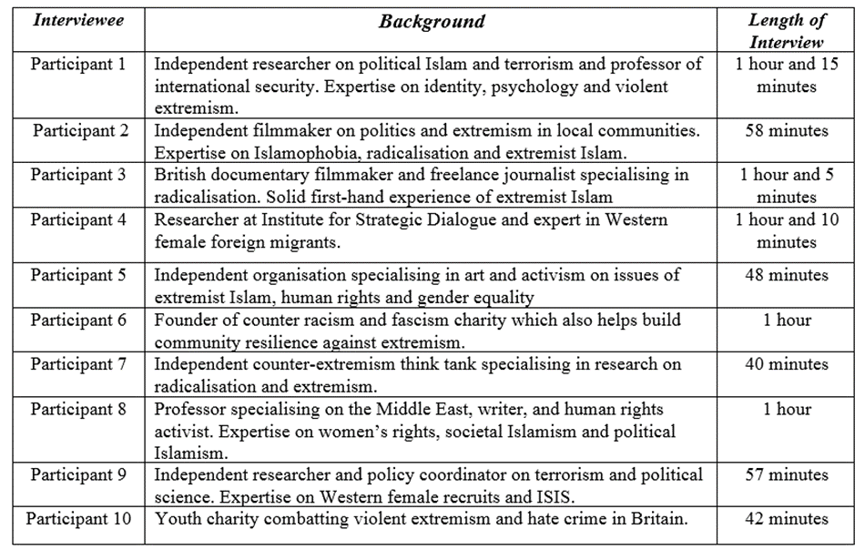

**Appendices**

**Appendix 1:** Root Cause Model of Radicalisation (Veldhuis & Staun, 2009)

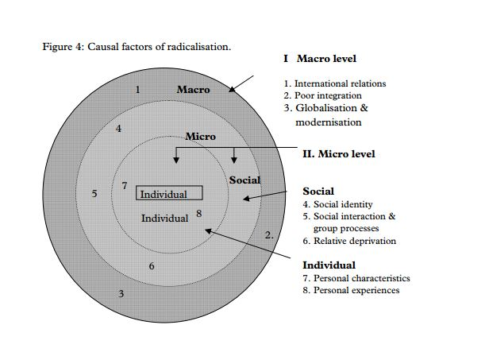

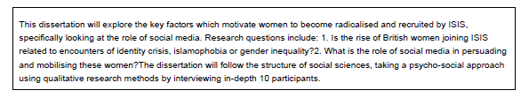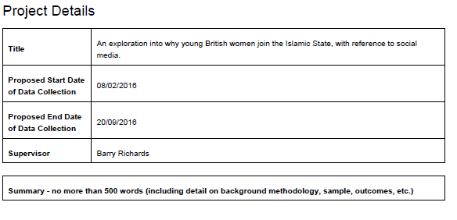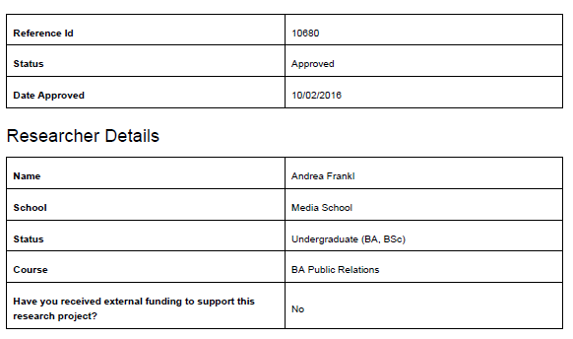

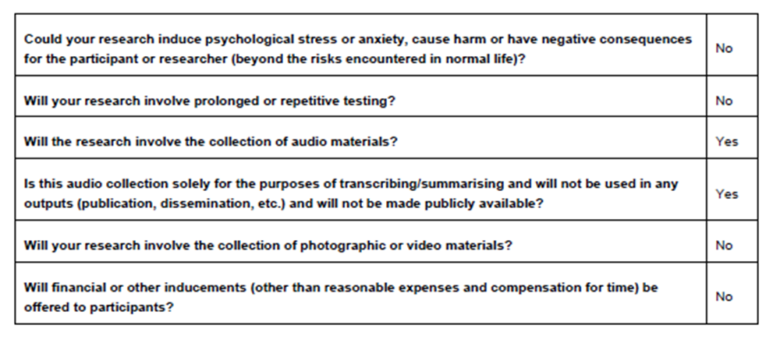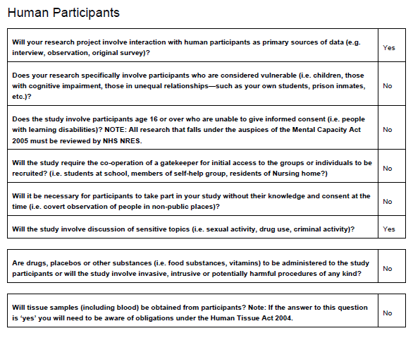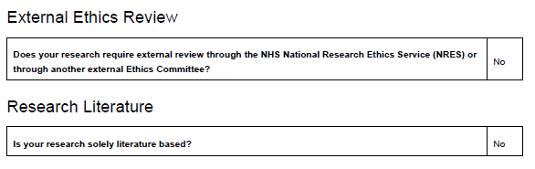

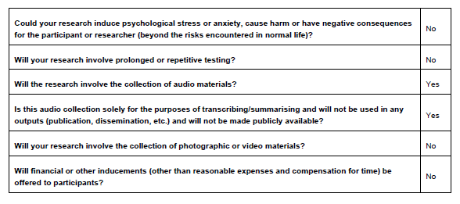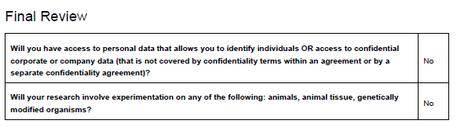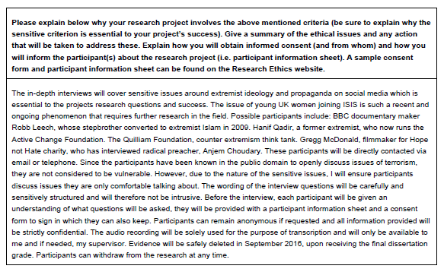

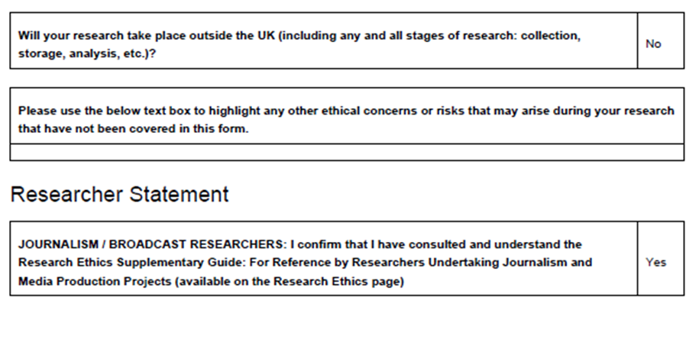

**Appendix 3: Participant Information Sheet**

Study Title: Why are British women drawn to ISIS?I would like to invite you to take part in a research study as part of a public relations dissertation at Bournemouth University. You have been carefully selected because of your expertise and experience in the issue of British women and Islamic extremism. Whilst there are no benefits for participating, the research gained from the study will be extremely beneficial and contribute towards the project.  
  
Before undertaking the interview, please take time to read the following information carefully and consider whether you wish to take part. Please do not hesitate to ask questions if anything is unclear or you would like more information.

Please note, the participation is entirely voluntary and you are free to withdraw from the study at any time, without given reason or loss of benefits. However, if you decide to continue, you will be asked to sign a consent form and be given this information sheet to keep.   
  
The purpose of the study is to understand why British female women are motivated to join the Islamic State and how they become radicalised. Furthermore, the study will also explore the three stages of radicalisation (pre-radicalisation stage, self-identification and radicalisation) and how an individual undergoes this process, with focus on social media.

The interview will take place April 2016 in London, United Kingdom and will approximately take 45 minutes of your time. The interview will cover aspects of radicalisation, with particular focus on British women and how social media is used to facilitate the grooming and recruitment process online. You are encouraged to answer all questions honestly and in as much depth as possible in order to provide a most accurate depiction of the interview.

All privacy and confidentiality will be strictly maintained throughout the course of research. Your personal data will not be identified in any reports or publications. The audio recordings of the interview will be conducted for research purposes to analyse data and will not be published or broadcasted.

For further information on the study please contact Andrea Frankl i7733406@bournemouth.ac.uk

For complaints, contact Professor Barry Richards at Bournemouth University [BRichards@bournemouth.ac.uk](mailto:BRichards@bournemouth.ac.uk)

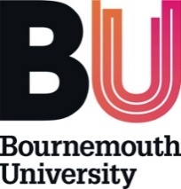 **Appendix 4: copy of consent form**

I volunteer to participate in an interview conducted by Andrea Frankl, a student from Bournemouth University studying public relations. I understand that the research is designed to gather information on Islamic extremism and British women and I feel comfortable talking about this subject.

1. I understand my participation in this project is voluntary. I understand that I will not be paid for my participation. I may withdraw or discontinue my participation at any time without penalty. If I decline to participate or withdraw from the study, no one will be told.

2. I understand that if I feel uncomfortable in any way during the interview session, I have a right to decline any questions or to end the interview.

3. Participation involves being interviewed by a student researcher from Bournemouth University. The interview will last approximately 45 minutes. Notes will be written during the interview. An audio tape of the interview will be made. If I don’t want to be recorded, I will not participate in the study.

4. I understand that the information I offer in this interview will be used by the researcher in subsequent reports, but I can opt out being identified by name. My confidentiality as a participant in this study will remain secure.

5. I have read and understood the explanation provided to me. I have had all my questions answered to my satisfaction, and I voluntarily agree to participate in this study.

6. I have been given a copy of this consent form.

My Signature My Printed Name Date

Signature of the researcher  
  
  
  
For further information, please contact Andrea Frankl [andreafranklsanz@gmail.com](mailto:andreafranklsanz@gmail.com)

**Appendix 5: Interview guide**

Ethics & Confidentiality  
All privacy and confidentiality will be strictly maintained throughout the course of research. Your personal data will not be identified in any reports or publications. The audio recordings of the interview will be conducted for research purposes to analyse data and will not be published or broadcasted in any way.

Introductions

* Introduce myself, my studies and background info on dissertation topic, why it is important.
* Introduction of participant, their background and research or interest in violent Islamic extremism.

**Part 1: Pre-radicalisation stage**

* How would you define identity crisis?
* To what extent do you think identity crisis is an important factor in the pre-radicalisation stage?
* What do you think are the (sociological or psychological) factors that enable a person to become radicalised? And what percentage would you place on each value?
* Many people have been through issues of identity, subjected to Islamophobia, but why is it that some act on revenge against the west and others don’t?
* There is a tendency in the UK (from some left-wing politicians) to claim that there is a strong connection between Islamophobia and the motivations for joining ISIS, would you subscribe to that opinion?
* Do you think women who visibly express their Muslim identity are more prone to Islamophobia than men by wearing garments such as the burqa?

**Part 2: Self-identification**

* Would you identify a common denominator or a way of thinking (ideology) which might trigger the path to radicalisation?
* What do you think are the motivating factors for fuelling hate against the West and joining an organisation such as ISIS? And at what percentage would you place them at?
* How strong is the attraction of ‘sisterhood’ in ISIS narrative?

**Part 3: Radicalisation**

* What is the impact of social media on the radicalisation process?
* Does it facilitate the process of radicalisation or is face-to-face contact the initiator?

**Part 4: Future**

* In your view, where do you see ISIS going?
* What is the solution to what is happening (radicalised youth)?

**Appendix 6: Participant 1 interview transcript**

**Part 1: Pre-radicalisation stage**

* **How would you define identity?**  
  It’s hard to define identity as it depends on the way you want to look at it and the purpose of your research. But, I tend to look at it from a social psychological perspective as the literature within this field has done the best job at defining identity. Simply put, identity is the way a person sees and understands themselves and their meaning of life and who they are in relation to the social categories which they belong to or not. There are 2 different levels of identity: individual identity (your roles, positions in society and personal life) which is the way an individual perceives themselves and understands their position in society. Then you have the greater, civil identity which is more relevant to radicalisation as terrorism is more of a social phenomenon than an individual one… so that is to do with their family ties, their networks and other social aspects.
* **How would you define identity crisis?**   
  The concept of identity crisis is basically where the individual in question feels like they don’t belong to the prototype of identities they are supposed to belong to. This is what makes them search for themselves, their identity and the identity created by terrorist organisations.
* **(Specific question to participant) Do you think issues of Muslim identity in Europe by the European non-Muslims in general are often linked to extremism? Is it due to ignorance or lack of respect?**  
  European governments in general have been quite inept in dealing with Muslim minority groups and it is important to note that you can’t pinpoint it to one thing. A European perspective on the matter is respect for other cultures, we believe in freedom of speech and governments don’t interfere in affairs of minority groups, they can do what they want to do. We respect their views and religious affairs. Understanding of multiculturalism has in some countries harmed more than helped because it has reached the point where governments understand regressive practices to be part of a certain minorities culture or religion. What that has done is placed a double standard on non-muslim populations and there has been more tolerance of practices which are associated with radical or extremist organisations who use the excuse of religion. There are cases where even parents who stop their daughters from attending certain classes like PE in the name of religion. It’s very relevant to females in Europe who have been excluded from western cultural and societal practices because of their religion. If they can’t take part in certain things, then they won’t feel part of society and if the government don’t place an importance on integration within these minority groups because they don’t want to interfere, then we have a problem. It’s also important for the nation or state to understand their own identity: who they are, what they stand for, and a robust set of values which can be incorporated in their narrative. Look at Belgium for example, they have a weak infrastructure, they are too liberal and they don’t have a clear set of national values. There are parents of children who don’t speak the language of the host culture, generations down the line, 1st and 2nd generations, they haven’t been educated, they don’t speak the host language and their children are doomed to various restrains and there are pressures to adapt and balance. They are told this society is an infidel society, sinful. It is also the responsibility of the Muslim community to understand theology and know the differences between Salafi-Islam and Islam.
* **What do you think are the factors that enable a person to be radicalised? And what percentage would you place on each value?**   
  It’s a hard question but simply put, it can be broken down into three stages and in many cases, some of these stages will be emphasised more than others but all these predisposing factors are a common denominator amongst individuals radicalised. The first one is ideology, the second is social contact (belonging, being part of something and having contact with someone that delivers the ideology) and the third is opportunity, having the opportunity to travel to Syria and Iraq for example, or carrying out an attack and having the means to do something and act upon that ideology. These are the three things I would say and I think they should be given an equal percentage each. However, it also depends on the context. For example, if you are talking about radicalisation in particular, the first and second stage would be important. Individuals who are radicalised are placed under a certain identity of that particular salfi-jihad organisation and are consequently known as ‘the other’. There are many predisposing factors which may influence a person to joining ISIS, for example a sense of adventure, romance, religion. But ideology is crucial as it is what mobilises that person and understanding how ideology sells and manipulates identity in order to serve goals is what is really important. The way that ideology is framed is highly emotional and it appeals to the hearts and minds of these young people. Without the ideology being delivered, those three stages I’ve mentioned cannot exist. There are such a wide range of other predisposing factors that can also be considered and a lot of them can be related to people like you and me.
* **There is a tendency in the UK (from some left-wing politicians) to claim that there is a strong connection between Islamophobia and the motivations for joining ISIS, would you subscribe to that opinion?**   
  My immediate answer is no, just because I think it is one of those predisposing factors. I don’t think there is a cause or connection between both, but I think it can be considered as a grievance which would happen all the way at the pre-radicalisation stage. One of the problems with this contention is, first of all what is Islamophobia? It depends on how you measure it and the assumption is that all Muslims in the diaspora are affected by it. And certain governments use this claim a lot but I haven’t seen any empirical studies to prove the extent to whether it is true. But I think countries in Europe like the UK or Belgium really stand in solidarity with minority groups, whether they are Muslim or not. Islamist organisations are also using the excuse of Islamophobia to push for further reforms or space for extremists. In terms of your question, Islamophobia is just one element; it is not something which is viewed as higher level but it would be one of the reasons which may perhaps trigger an identity crisis. The use of the term Islamophobia helps individuals legitimise the narrative of extremist organisations and can help to turn Muslims against the West and there’s a reason why they target Muslims specifically, because it appeals to their religious identity. Islamophobia can therefore be viewed as contributing factor, specifically because they are Muslim and for the people recruiting, the added grievance makes it easier to target them, they are vulnerable. I think the problem really lies with far-right parties like the Netherlands who are saying that they don’t want Muslims in their country or Hungary, Czech Republic who are responding to the refugee crisis by saying they won’t take any Muslims in their borders. When its starts translating into governments and countries, that’s when you start seeing the real problem because they are openly anti-Muslim and they are acting in ways that will prompt Islamophobic attacks. It is so damaging and it doesn’t help, it’s going to make Muslims become further radicalised.
* **Do** **you think women who visibly express their Muslim identity are more prone to Islamophobia than men by wearing garments veils or burkas?**   
  Short answer, yes. It doesn’t help when you look at the ISIS promotional videos and you see women in a niqab, and then you walk down the street and see another woman wearing a niqab. It shouldn’t be the case, but unfortunately that is the way it’s perceived to be by many people. But there is nothing in Islam that states the woman has to cover herself from head to toe, there are certain things in the Quran about modesty but even covering the hair is heavily disputed. It’s not an obligation, although now in the Muslim world most clerics would contest that because it’s become taken for granted that it is. It also depends on how you interpret it as it stems from a certain word which can be interpreted in a number of ways, but it should stay in its historical context as it is meant to be about head covering. Covering your hair as a Muslim is a myth but the general view is that if you cover your hair, you are better for it…which I think is an extremely harmful view.

* **Why is it some women are radicalised by ISIS and others aren’t?**  
  Firstly, an important factor to consider is whether the individual is getting the same opportunities as everyone else in society. As a child growing up in the Middle East, from a conservative Muslim family, I wasn’t getting some of the same opportunities as some of the other kids but I found a way to deal with that, by making friends with likeminded people who were also from a similar background to me and we used to go and do our own thing within our limits. I think it takes a lot of willpower to deal with the difficulties in a positive way, like I did. And in a perverse sense, joining an extremist Islamist movement is about emancipation and finding belonging in the world. It’s also about choice, when you come from a strict traditional Muslim family and you can’t make certain choices, the idea of having the freedom to make a choice (to go to Syria) is appealing… and it’s even better when it’s done in the name of religion. ISIS and their jihadist predecessors like Al Qaeda are very effective in framing their ideology to appeal to these particular people. Most of us go through many of the predisposing factors (in the pre-radicalisation stage) and feelings of mobilisation that terrorists go through. It usually appeals to the identity crisis, confusion and grievances which a lot of us go through, which makes you think that any one of us can become a terrorist. But there are things in ISIS narrative and ideology which especially relate and appeal to Muslims in particular, primarily because of the narratives of the ideology and the goal which is focused on Muslims having that specific radical religious identity. With Islamism in general and violent extremism, there is a reason why the majority of the audience are Muslim, because in the stages of mobilisation, they are the target audience - in terms of hearts and minds. It plays out on many levels, so you could say that many Muslims need to understand their identity in a certain way, and on the other hand, it falls under the broader strategy of terrorism, with what terrorists want to achieve – with their various ideologies. It also depends on the parents, their upbringing and the ways in which they manage the traditional Muslim values with the western values of democracy.. they are told it is sinful to wear makeup etc. there are so many pressures to adhere to.

**Part 2: Self-identification**

* **Would you identify a common denominator or a way of thinking which might trigger the path to radicalisation?**I would say Islamist ideology in general, is a conveyer belt on the way to radicalisation. I think that way of thinking creates a problem because of their worldview of power and supremacism for example, implementing sharia law because it is gods will to mankind. And it is exactly what the Muslim Brotherhood have accepted in a number of countries but many of the other Islamist parties go for the same thing. How it is implemented really differs, when you look at the more extremist groups like Al Qaeda or Al Shabaab, you find that they are all going or trying for the same things but just using different tactics. They might disagree on certain things like who to kill and how to kill, but these are really the ideological nuances. If you look at the end goal, to me at least, I find the problem lies in the much larger widely accepted legitimised Islamist ideology. It’s really harmful because it cultivates that mind set to have goals that aren’t realistic, with the domination of one religion, and they are doing it by killing. The ideology for me is the common denominator. There are many other ideological nuances, for example you have different sects like Shia and Sunni and the arguments within Salafism, but it’s about the mind-set.
* **Apart from politics and religion being strong drivers as you mentioned in your email, what are the other motivating factors that you have identified in your research?**As I mentioned earlier, opportunity and being able to make a choice is important for women especially. In the case studies I have researched, it’s often found to be a common and strong driver. One of the girls quoted that she could ride in a car with lots of jihad fighters and it’s something which she wouldn’t have done before. It’s really that form of rebellion essentially in an emancipatory way. For those young girls, it’s about being on the same level as the lads. So, this is one thing. I think another factor is the emotional aspect of the propaganda played by ISIS, for example the slaughtering of Muslims in Syria or women being raped, is something which appeals to hearts and minds of young women. The way it is framed is highly emotional. Another strong driver in ISIS propaganda is the religious element and how women play a huge role in being a mother of the future, its positioned as an alluring aspect. I’ve gone through a number of Dabiq ISIS magazines and I must say, that what’s really emphasised is the fact that they are doing something, fighting for a cause.
* **How strong is the attraction of ‘sisterhood’ in ISIS narrative?**I wouldn’t really know but it seems to play a role in their propaganda. In a lot of their tweets, they do talk about sisterhood and it’s something which is emphasised a lot. To go and join ISIS because of the sisterhood? I don’t know exactly because it’s very difficult to tell. But it is certainly something that they seem to be doing, the fact that there is a dedicated page in their magazine to women and the sisterhood, obviously proves important. That’s why ISIS are incorporating it in their propaganda more and more, because it’s obviously now becoming an incentive. Personal relationships are also really important, not just the sisterhood. It’s about the girls’ joining with their friends.

**Part 3: Radicalisation**

**What is the impact of social media on the radicalisation process?**  
I think there is too much hype made out of social media to be honest, but I know it definitely speeds up the process of radicalisation. Social media is helpful because it’s an outlet which operates 24 hours, it’s very accessible where a lot of material can be shared. It can help to facilitate the face-to-face contact as it substitutes that need to get out the house and meet people to establish a network, which takes longer. So in terms of that, it speeds up the process to meet and talk with likeminded people. But does it substitute for actual face-to-face contact? It depends. Some people say it depends how far you can go online. It’s a lot faster to connect with people online than through direct contact and it works 24 hours non-stop. For groups like ISIS, it’s so much easier for them to share that propaganda and disseminate visual content. It’s so much more difficult to track them down as well, they are using encrypted applications and their technology is getting much more sophisticated. And most intelligence agencies cannot actually break into them and see what people are saying on these apps. It makes it incredibly more difficult to disrupt the grooming and radicalisation of young girls in particular. There are cases where social media substituted the need for face-to-face contact, for example there was an 18-year-old girl last year in the United States who was groomed online by ISIS. A lot of resources were used and they spent a lot of time on this and gave her a sense of belonging. And this is one of the cases where you can see how social media bypassed a lot of security and substituted meeting face-to-face with the recruiters. The girl didn’t end up going as her grandma who she lived with found out. Face-to-face contact is still largely important though, and the case study I mentioned shows how much time and resources were used to groom this particular girl. It took about a month and she didn’t end up going to Syria in the end and that’s because it lacked that face-to-face interaction, in a physical setting surround by likeminded people. The question is, are relationships fostered online or is there still the need to some form of physical human contact?

**Part four: Future**

**What do you think is the future of ISIS?**Well ISIS are on the battle ground now but they are losing ground.. they will eventually lose and will be defeated. I think I’m more worried about the opposition in Syria than ISIS because many Salafi groups which have a significant amount of experience are making gains. And the next conflict could be there. It’s going to be a never-ending circle of destruction because some of the people that joined ISIS were previously with other organisation like Al Qaeda or malicious groups like the opposition. It won’t stop and I don’t see a solution right now, it’s such a mess with Syria, the opposition, the Kurds, the Turks. ISIS are just one small fraction of the bigger picture, in my opinion they are losing ground and are becoming weak.

**Appendix 7: Participant 4 interview transcript**

**Part 1: Pre-radicalisation stage**

* **Do you think being subjected to Islamophobia whether direct/indirect, can be considered as a predisposing factor in the path of radicalisation? If so, why?**  
  Yes I do. I think if you’re exposed to anti-Muslim hatred of any kind, whether it’s an attack or abuse that is targeted at you or whether it’s more broadly noticing that society is more anti-Muslim, which is what you are… then you are bound to become more vulnerable to messaging. ISIS themselves use that as a platform to say that everybody in the West hates you. We have seen it happen in a couple of cases where people have been victims of Islamophobic attacks, who have then thought ‘fine I’m going to go somewhere where I’m understood and we are all the same’. Being a victim of Islamophobia creates that identity confusion.
* **To what extent do you think identity crisis is an important factor in the pre-radicalisation stage?**  
  I think it’s the most important factor and the one which a lot of British women are most vulnerable to. With a lot of processes and movements, for example gangs or even social movements, there is always that process in the beginning where someone is trying to define who you are and who you are not. I think for young people in particular it’s something that makes it even more difficult as there are all these layers of identity and with women, it’s even more complicated. For example, what it’s like to be a British Muslim women in society today, how to express yourself and what femininity means… all those things can create a lot of confusion, especially for someone growing up with an Islamic background, they know they are very different from secular society and living in a country where their religion is not practiced by everybody makes them realise that their social identity is different. And sometimes it can be hard for these women to cope with all the changes and understand their place in the world. That’s how identity crisis develops. Through that processing, these women become more and more vulnerable and the idea of living in a place where everybody is the same [Syria] becomes more alluring. I think identity or identity crisis if you like, if definitely the most important factor.
* **You mentioned the Islamic background, tell me about the role of family in a British Muslim female’s life.**   
  I think the mother is the most important role within the family, as Islam teaches you that the mother is the most important person in their life. Pretty much everything that she says is the truth. The emphasis that is placed on that relationship means that the mother is in a such a position of responsibility in some ways, I mean that covers a whole load of responsibilities but one of which is making your kids aware of that cultural identity and how that fits within that community they live in. It also depends, if somebody grows up in a community where everybody is a Sunni Muslim for example, they have quite a strong cultural identity but it only reapplies to their immediate surroundings so sometimes when people move around the country or abroad, they start to realise that not everybody is the same. Exposure to people that are different from you is really important and it’s something which really your parents can give you from a young age. It’s about integration and exposure. If you keep kids in a very conservative environment with a Salafi way of living, it’s very strict and they don’t really have any exposure to anything else which means the avenues of how people can challenge them are immediately shut down. If you don’t come across a Jewish person, you are more than likely to hold negative perceptions of them. Your experiences of the outside world are largely through your parents and what they say about certain things and how much opportunity they give you to integrate in society. A lot of these women and men too have grown up with a binary view of the world so they are then pushed away further and further from reality. A lot of the time in case studies we have examined, some women have brought up the issue of Syria at the dinner table with their parents because they want to discuss the different people that are fighting and what that means…and most of those people have said that the parents didn’t want to talk about it or engage with anything political because they don’t think it’s compatible with their religion but if you don’t explain why and shut down the conversation then they will explore other avenues like the mosque or social media for answers. Parents are probably the first barrier to that.
* **Do you think women who visibly express their Muslim identity by wearing the niqab or burka are more prone to issues of identity than men?**   
  Yes definitely, I do think though that growing up as a young Muslim woman in Britain is really difficult. But there is also the other side to the issue, where a woman is taking that step to express her religious identity so openly. They might actually be more comfortable by doing that. It can work both ways. It can be a strong identity marker for some women and I think that is often misinterpreted. People can be intimidated when there are individuals wearing the niqab because of the uncertainty. And that’s how Islamophobia starts.
* **In your report, you identify a range of push & pull factors for why these female migrants are radicalised (including isolation, belonging, sisterhood and religious duty for example), what percentage would you place on each value?**   
  I think identity is the most important, maybe 60% and the religious duty aspect is really important too, perhaps 20%. The whole idea of utopia building is also equally important in a way, these female migrants think they are living on the best place in earth and the idea of the territory functioning as a state is alluring. All the propaganda that we see is about this fantasy world in Syria. Each individual case however, has unique trigger points and multi-layered drivers, you’ll find that these women like the sense of adventure, romance etc.
* **Many people have been through issues of identity or subjected to Islamophobia, but why is it that only a minority decide to take action against the west and others don’t?**  
  It’s a difficult question to answer but I think it’s the same with any of the grievances. The majority of people deal with it in their own way. It’s a combination of things and vulnerability as you’ve identified is really important. If you are not vulnerable, you will just brush it off but I think it takes a particular type of person to do that though. You have to have strong willpower and confidence. Those factors of having a stable upbringing are also really important, for example having someone to talk to about the questions you may have on political issues like foreign policy. Having someone to talk to is an important way for young people to get those feelings out and understand the questions they have.
* **In your report, you state that there are misperceptions of these women (jihadi bride), how can we better understand them?**   
  The issue of why women go to Syria in the media has not been dealt with very well, primarily because everything we read is very heavily gendered and passive, in terms of them being brainwashed, innocent women, young school girls… but that’s not true at all because in these case studies that we’ve seen, they are very violent and aggressive. For everyone in the media to pity them is ridiculous. I studied male foreign fighters before examining women and there are clear differences. When you look at the coverage on male fighters, a lot of the associations are around violence, aggression and there is the assumption that men are more violent than women which is statistically false. There is a responsibility to acknowledge these women as threats, if you don’t see them as angry, bloodthirsty and violent then you won’t see them as that when they come back, which is a huge problem. To some extent, some of the men are equally innocent and naïve but the media generally plays on those gender stereotype. The headlines around the Bethnal green girls were all around them being school girls, innocent and no one anticipated their move to Syria. Through our data, the stereotype of the jihadi bride was inaccurate and false. It’s such a simplification of what is happening, it’s dangerous because if we can’t understand the reasons then we can’t implement policy that is going to prevent women from going. It’s really harmful. At the same time, the concept of the jihadi bride is not completely false of US cases. We’ve seen a lot of cases in America where they have been contacted out of the blue and asked if they want to marry a jihad fighter. It’s a bit strange but there’s a social status associated with having an American wife, because you’ve taken the enemy and kind of converted it, married it and controlled it. It’s a strange psychological thing to think about. In the UK however, it’s not so common. There are more diverse triggers and multi-layered drivers.
* **What did you find from your research on these case studies?**   
  Generally, the case studies gave a really good steer for when we wrote the report on what makes people leave the UK to join Syria but also what attracts them, so the push and pull factors for example. The only way we can look at the push and pull factors is through those case studies. Also useful to identify the profiles of these women, there’s such a massive diversity. It’s interesting to see the case studies and see what they have in common, a lot of them don’t for example, if you look at the case of Sally Jones vs. the Bethnal green girls or Aqsa Mahmood from Glasgow. 14-20 age range is the category we looked at as the vast majority fall under this box. The majority of these girls that flee to Syria are teenagers because those processes of identity crisis, who you are, happens around that age. ISIS have become an alluring sub-culture and movement and they have packaged themselves as a brand.

**Part 2: Self-identification**

* **Would you identify a common denominator or a way of thinking which might trigger the path to radicalisation?**

Generally, when we look at these case studies of women, their view of the world and ideology is shaped by their hate for the west. A lot of these women will have some form of enemy or hate, so for example anti-Israel or anti-government. As soon as they become radicalised, that enemy becomes broader into everybody else. Assad is an enemy for these girls, and that then becomes twisted into a hate against the West because Assad is supposedly funded by Britain. There are a lot of conspiracy theories and you get drawn into a very black and white situation. Religion or ideology is really important, without that ISIS cannot exist. It’s deemed as controversial but it shouldn’t be, it’s like a big elephant in the room. Islam is where it stems from, people just don’t want to admit it because they are too scared to offend. The government are too scared to openly and publicly acknowledge the cause is Islam because they don’t want to be deemed as Islamophobic. It’s not, because when you think about the end goal, you’re only saying it so that you can create a better policy. It’s one of those unspoken things and a lot of academics and researchers are analysing the social factors instead, but that can only go so far. The women that have experienced grievances or issues with their family, don’t become jihadists without the religion and ideology. Without the religion and ideology, they just become like any other disgruntled teenager. It’s very rare in cases to find someone that has gone to Syria for other reasons except from religion.

* **What do you think are the motivating factors for joining an organisation such as ISIS?**   
  The sense of belonging is extremely important, being in a community where you are understood, especially as a teenager. The sisterhood aspect particularly for women is big too, it’s really powerful and the idea of friendship for a young person is comforting if they are feeling isolated in the UK or struggling to make friends at school for example. If you are teenager and struggling with knowing who you are, sisterhood is huge. Other motivating factors include the romance aspect, finding a jihad fighter husband is empowering to them and the duty of creating the next generation of fighters is enormous. That’s what helps the caliphate to flourish and as women, they are responsible for that.
* **How strong is the attraction of ‘sisterhood’ in ISIS narrative?**Really strong. The sisterhood is around that community spirit and also co-wives, where your husband is shared with your best friend. It’s interesting because it’s the only way you live with another woman and there’s an element of protection there where you have friendship and safety. When a woman first arrives, they are generally kept in a place called the maqab which is like an all sisters only hostel where you live with 7 or 8 women before you get married.

**Part 3: Radicalisation**

* **Does social media facilitate the recruitment or is face-to-face contact still very much important?**   
  Face-to-face contact is very important for the beginning to spark the radicalisation process… Everyone will tell you something different, this is just my opinion and I haven’t seen any studies that tell me otherwise. I think the majority of times, the introduction to ISIS or the ideology will happen offline in the immediate community, through friends or a family member who have exposed them to radical Islam. Or even from watching the news. The process is then facilitated on social media from that point onwards when individuals go online to satisfy their curiosity. The majority of times we see cases where people go online to ask questions like what does the Quran say about jihad for example. What they are being answered with if they are looking on sites like Twitter are ISIS recruiters who have an answer for everything. There’s not really any positive messaging that turns people away from that. It’s very much about persuasive messages to join the caliphate territory. For somebody that has read the Quran, the caliphate is something which comes up over and over again, it’s like the ultimate utopia. I think that is something that is particularly strong. Social media is something that can play different roles to different people, if you think about the girls that have extensive Tumblr blogs, they are using it as a form of propaganda by showing how great it is living in ISIS-controlled territory. Social media creates a distorted persona or representation of the world. People live their life by social comparison and if a female your age is seemingly living a better life elsewhere in Syria, then that becomes alluring. Social media is used to help facilitate the journey but it will generally happen in other encrypted platforms or apps like Telegram, VK, Wicker.

**Part Four: Future  
  
Where do you see ISIS going? What’s the future to all this?**

I think Syria is going to die out in importance in the next year. I think we will see Iraq as the strong hold in terms of ideology. You can tell ISIS are losing ground in Syria significantly and losing a lot of people which isn’t talked about enough. We are seeing geographical hotspots of ISIS spring up already like in Libya as there hasn’t been a government for about three and a half years now. There are so many men out there that don’t see where they fit and joining ISIS gives them that sense of empowerment and purpose that they didn’t have before. The same goes for Indonesia and Malaysia, it’s a big problem there. We’ve done so well at preventing people from travelling to Syria or warzones by taking their passports away but that’s not the solution because you will just make them angry and they will find another way. I think that is becoming a big issue. Cells like Brussels and Paris are very easy to mobilise, they have access to weapons… we are very lucky we live on an island.

**Appendix 8: Case study biographies**

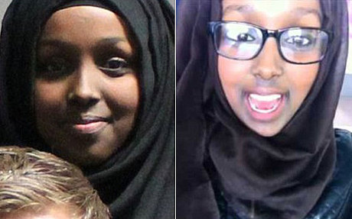

Salma and Zahra Halane are twins from Somali origin who grew up in Greater Manchester and were reported missing from their family home in June 2014 at the age of 16. The twins, now aged 18, left Manchester to travel to ISIS-controlled territory in Syria to marry jihad fighters. The two sisters have been active on Twitter in disseminating propaganda narratives and sharing images of their experiences in Syria, from cooking food with the sisters to training with Kalishnikovs.

The Halane twins are believed to have been introduced to extremist ideology prior to joining ISIS through their brother and father. Their 21-year old brother Ahmed Ibrahim Mohammed Halane, is thought to have been a primary influencer in introducing the girls to extremist ideology. Ahmed left the UK in 2013 to join the Islamic State.

Asqa Mahmood, aged 20 from Glasgow, left her family home in November 2013 to marry an ISIS fighter in Syria. Aqsa was privately educated and grew up in the affluent Glasgow suburb of Pollokshields with her brother and two sisters. Before travelling to Syria, she began a course in diagnostic radiography at Glasgow Caledonian University. Her parents have openly stated in the media that there is no fundamentalist preacher or family members that can be blamed for her radicalisation. To this day, there is little evidence to explain Aqsa’s migration to Syria.

Aqsa uses the name Umm Layth to communicate online and encourage other females to join the Islamic State. Her Tumblr account is regularly active and content is uploading specifically to attract and recruit likeminded sisters. See below for more info.

Salma Halane Zahra Halane

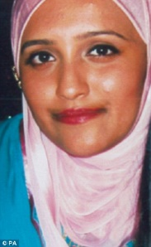

Aqsa Mahmood

**Appendix 9: Examples of social media postings**

Zahra Halane Tweets: religious ideology

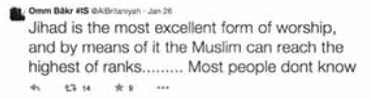

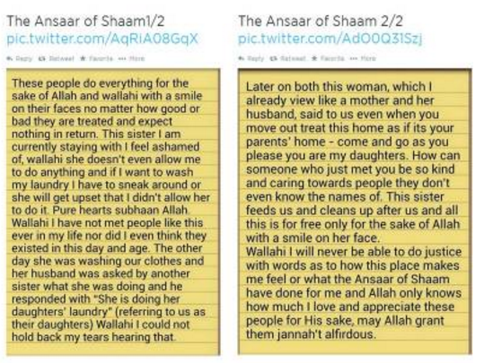Aqsa Mahmood, Umm Layth: Sisterhood

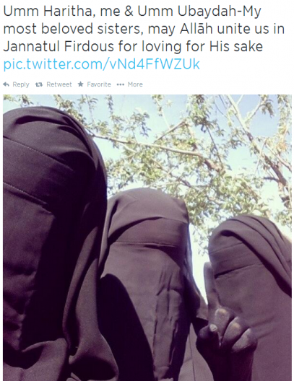

Umm Layth’s profile picture on Twitter:

