**LOCAL GOVERNMENT UNIT 4: BARANGAY FOOD MARKET SAFETY AND INSPECTION MANAGEMENT SYSTEM(DASHBOARD AND INSIGHTS, MARKET RATING REVIEWS, MARKET COMPLIANCE MONITORING, INSPECTION RESULTS AND OVERVIEW, RELEASING OF CERTIFICATES AND PERMITS) WITH MARKET CATEGORY LOCATOR AND GENERATIVE SUMMARY AND SUGGESTIONS USING GOOGLE CLOUD PLATFORM**

A Thesis

Presented to the Faculty of

The College of Computer Studies

Bestlink College of the Philippines

In Partial Fulfilment

Of the Requirements for the Degree of

Bachelor of Science in Information Technology

**ABINA, RALPH CHRISTIAN G.**

**CABILDO, JONARD V.**

**JUNIO, JOEMEL T.**

**MAGSADIA, JOHN CEDRIC R.**

**RAMOS, NICOLE DAVE**

November 2024

**APPROVAL SHEET**

This capstone entitled **LOCAL GOVERNMENT UNIT 4: BARANGAY FOOD MARKET SAFETY AND INSPECTION MANAGEMENT SYSTEM (DASHBOARD AND INSIGHTS, MARKET RATING REVIEWS, MARKET COMPLIANCE MONITORING, INSPECTION RESULTS AND OVERVIEW, RELEASING OF CERTIFICATES AND PERMITS) WITH MARKET CATEGORY LOCATOR AND GENERATIVE SUMMARY AND SUGGESTIONS USING GOOGLE CLOUD PLATFORM** prepared and submitted by **Ralph Christian G. Abina, Jonard V. Cabildo, Joemel T. Junio, John Cedric R. Magsadia, Nicole Dave Ramos,** in partial fulfilment of the requirements for the degree of Bachelor of Science in Information Technology, has been examined and is recommended for acceptance and approval Pre-Oral Defense.

**CHRISTIAN A. REMPILLO**

Adviser

**CAPSTONE REVIEW PANEL**

Approved by the Committee on Pre-Oral Examination with a grade of **PASSED**.

**ENGR. RENANTE B. PONAY** **VINCENT CARLO T. GARADOS**

Member Member

**ROMMEL J. CONSTANTINO, MSIT**

Chairperson

Accepted and approved in partial fulfillment of the requirements for the degree of Bachelor of Science in Information Technology.

**ROSICAR E. ESCOBER, Ph. D**

Dean, College of Computer Studies

Date of Pre-oral Defense: November 24, 2024

**ACKNOWLEDGMENT**

The researchers would like to express their heartfelt thanks and gratitude to the following persons who, in one way or another, has contributed much, and extended willingness and support needed to make this research possible:

**Dr. Maria M. Vicente,** President/CEO, Bestlink College of the Philippines, for her generosity and kind heart in establishing this institution and giving opportunities to those less fortunate students to continue their studies and pursue their dreams;

**Ms. Edith M. Vicente**, Executive Vice President, for providing the needed information to complete this research;

**Dr. Charlie I. Cariño**, Vice President for Academic Affairs, for his support and encouragement to make this thesis writing possible;

**Engr. Diosdado T. Lleno,** Vice President for Administration and

Finance, for his words of encouragement and motivation;

**Dr. Joy Evelyn A. Ignacio,** Director,Center for Research and Development, for her good heart to extend her help needed by the researchers.

**Dr. Rosicar E. Escober**, Dean, College of Computer Studies of Bestlink College of the Philippines, for providing a guideline documentation in capstone project.

**Mr. Rommel J. Constantino**, Program Head, Bachelor of Science in Information Technology, for the constant supervision as well as providing necessary information regarding the project and also for his support in completing this project

**Mr. Ronald G. Roldan Jr.,** Research Coordinator, for helping us in improving our research and guiding us in completing this project.

**Mr. Christian Rempillo** Capstone Adviser, for giving us suggestions and ideas to improve our research and guiding us in completing this project.

Panelists, **Engr. Reynante B. Ponay,** **Mr. Vincent Carlo T. Garados,** and **Mr. Rommel J. Constantino**, who extended their effort and time to be able to constructively criticize this thesis and share their knowledge with them to deepen and widen their needed information.

**Families and Friends**, for all the financial and moral support that have enabled the researchers to triumph all the challenges, especially during the lowest time that served as their inspiration to complete this study; and

Above all, to the **Almighty God**, for the strength and knowledge that were used for the accomplishment of this research journey.

**THE RESEARCHERS**

**DEDICATION**

This business research study is wholeheartedly dedicated first and foremost to the researchers, for executing dedication, time, effort, motivation, sacrifice, and courage to make this conducting study a fruitful and successful piece of work.

To our beloved parents who have been our inspiration and gave us strength when we thought of giving up, which continually provide their moral, spiritual, emotional and financial support.

To each sibling and circle of friends who shared their words of advice and encouragement to finish this study.

To the research advisers and professors, for extending help by giving guidance, supervision, time and wisdom to the researchers in conducting this business research study.

And lastly, above all, to our Almighty God, for giving guidance, strength, power of mind, protection, skills and for giving us a healthy life. All of these we offer to you.

**THE RESEARCHERS**

**ABSTRACT**

Title: **LOCAL GOVERNMENT UNIT 4: BARANGAY FOOD MARKET SAFETY AND INSPECTION MANAGEMENT SYSTEM(DASHBOARD AND INSIGHTS, MARKET RATING REVIEWS, MARKET COMPLIANCE MONITORING, INSPECTION RESULTS AND OVERVIEW, RELEASING OF CERTIFICATES AND PERMITS) WITH MARKET CATEGORY LOCATOR AND GENERATIVE SUMMARY AND SUGGESTIONS USING GOOGLE CLOUD PLATFORM**

Authors: **RALPH CHRISTIAN G. ABINA**

**JONARD V. CABILDO**

**JOEMEL T. JUNIO**

**JOHN CEDRIC R. MAGSADIA**

**NICOLE DAVE RAMOS**

Degree: **Bachelor of Science of Information Technology**

Major: **Information Management, Information Security, Network**

**Administrative**

Date of Completion:

This project aims to ensure food safety; therefore, we are developing a system that will revolutionize the process of permit tracking, inspection scheduling, and transparency of markets. Through ratings and reviews, it will make it easier for officials, inspectors, vendors, and even the consumers that are expecting to have clean and trusted food that they would eat. We also took advantage of our current technology, incorporating microservices and Agile Scrum methodology. We also added a market locator to make our consumers search and locate nearby markets. Therefore, it will make their venture to find trusted food easier.

**TABLE OF CONTENTS**

**Page**

**TITLE PAGE i**

**APPROVAL SHEET ii**

**ACKNOWLEDGMENT iii**

**DEDICATION v**

**ABSTRACT vi**

**TABLE OF CONTENTS viii**

**LIST OF TABLES x**

**LIST OF FIGURES x**

**CHAPTER I**

1. **Introduction**

1.1 Background of the Capstone Project 1

1.2 Context and Scope 3

1.3 Problem Statement 4

1.4 Objectives and Goals 6

1.5 Significance and Relevance 8

1.6 Structure of the Document 9

**2 Literature Review**

2.1 Agile Scrum Methodology Overview 11

2.2 Enterprise Architecture Concepts 18

2.3 Microservices Architecture 23

2.4 DevOps and CI/CD 24

2.5 Relevant Studies and Research 28

2.6. Related Literature 39

2.7 Integration of Information Systems in Enterprise Environments 46

**3 Methodology**

3.1 Agile Scrum Methodology in the Project 49

3.2 Roles and Responsibilities 51

3.3 Sprint Cycles 54

3.4 Scrum Artifacts 56

3.6 Devops Implementation 90

3.7 Integration Approach for Information Systems 94

3.8 Introduction to TOGAF and the Four Architectural Domains 99

3.9 Additional Considerations 101

**LIST OF TABLES**

**Table Page Page Page Page**

1 Objectives and Goals 6

2 Glossary of Scrum Terms 13

3 Roles and Responsibilities 51

4 Sprint Cycles 54

5 Product Backlog 56

6 Sprint Backlog 70

**LIST OF FIGURES**

**Table Page**

1 Sprint cycles 54

2 Microservices diagram 84

3 Communication pattern 85

4 Data flow diagram level 0 86

5 Data flow diagram level 1 87

6 Data flow diagram level 2 88

7 Data flow diagram level 3 89

8 CI/CD pipeline 90

9 Infrastructure as a code 91

10 Monitoring and alerting 92

11 Network topology 93

12 BPA top level 1 95

13 BPA top level 2 96

14 Data flow diagram level 3 (Integration) 97

15 API gateway 98

16 TOGAF Diagram 99

17 Use case diagram 101

18.1 Sequence diagram page 1 102

18.2 Sequence diagram page 2 103

18.3 Sequence diagram page 3 104

18.4 Sequence diagram page 4 105

**CHAPTER 1**

INTRODUCTION

1.1 Background of the Capstone Project

Local government units, especially at the barangay level, are responsible for ensuring food market safety and regulation. Many barangays still rely on manual processes for market inspections, compliance monitoring, and the issuance of permits and certifications. These outdated methods can lead to inefficiencies, delays, and gaps in ensuring food market safety. The need for a more efficient system has become evident as the population grows and food safety standards become more stringent. Previous studies and initiatives have highlighted the need for a more systematic and transparent approach to managing market safety, yet many barangays continue to struggle with the implementation of streamlined processes.

Traditional food markets play an important economic, cultural and social role and are sources of livelihood for millions of people in urban and rural areas. In the Asia Pacific region, traditional food markets play a very strategic role for food security. When not managed properly, traditional food markets can be unsafe environments that pose health risks related with food safety and zoonoses threats. Under these conditions, Traditional food markets can thus pose significant threats to the health of food handlers, vendors, consumers, and the community. (WHO, 2023)

This study builds on the previous work in public safety management and introduces a barangay food market safety and inspection management system using the Google Cloud Platform (GCP). By utilizing cloud technology, the system will centralize data on market inspections, provide real-time insights, monitor compliance, and issue permits and certificates more efficiently. Previous research has shown that automation and cloud-based solutions can significantly enhance the ability of local government units to manage their tasks more effectively, which has led to the initiation of this project. Additionally, by integrating AI-powered features, such as generative summaries and suggestions, the system will improve decision-making and provide barangay officials with actionable insights, further enhancing the effectiveness of market safety management.

The system will also introduce market rating reviews and a market category locator to improve transparency and usability for both officials and consumers. These tools will allow vendors to track their performance, encourage compliance, and give consumers access to important information about market safety. By addressing the inefficiencies of manual processes and incorporating modern technology, this project aims to provide a comprehensive solution that will enhance food safety management at the barangay level and contribute to improved public health standards.

1.2 Context and Scope

This system for the Barangay Food Market Safety and Inspection Management addresses its scope with regard to the local government units, specifically at the barangay level, where resources as well as technological infrastructure may be lacking. One of the major challenges in this environment is that monitoring compliance with market, inspection, and permit issuance tends to be manual in nature, often resulting in inefficiencies and delays. Apart from all these, limited funding and lack of appropriate technology expertise are also constraining factors for the successful implementation of more sophisticated solutions. Some features of the project has been developed using Google Cloud Platform (GCP), which are the market category locator and the generative insights and suggestions. It did not cover other barangay governance items not directly related to market safety and assumed that each barangay at least had basic internet services required for the proper operation of the system. The scope of the project will help manage expectations and bring people to focus on improving market safety and compliance using modern technology as well as focusing on all food vendors in the barangay for consistent adherence to health and safety regulations. Help inspectors, local governments, and the general public monitor and act on it. Include a feature that protects sensitive information on vendor compliance and market inspection through data security and user authentication. The needs of different stakeholders - be it the consumers, food vendors, or local government agencies - have been taken into account.

1.3 Problem Statement

The barangay food market system faces challenges that impact food safety and operational efficiency. These challenges include:

* Manual processes: Current market inspections, compliance monitoring, and permit issuance rely on manual methods that are prone to delays and errors.
* Lack of Centralized Information: The absence of a unified system makes it difficult to track market safety, compliance, and inspection data in real-time.
* Limited Transparency and Usability: Consumers and vendors have restricted access to crucial information such as market ratings, safety reviews, and compliance status, hindering informed decision-making.
* Inefficient inspections tracking and reporting processes:

This tracking market inspections and creating reports are time-consuming and make cause of error, and also manual processing like paper-based records are difficult to track inspections.

* Challenges in certificates and permit issuance:

The process for issuing certificates and permits to markets are time-consuming and inefficient; it may be caused by delays and inconsistencies that may harm the market operations and growth.

* Difficult in accessing market ratings and reviews:

The consumers and vendors lack centralized platforms that may be access to market ratings and reviews. It's important to know what markets or identifying areas are needed for improvement.

Our project aims to develop a barangay food market safety and inspection management system using the Google Cloud Platform (GCP). This web-based solution will integrate real-time dashboards, compliance monitoring, and AI-driven insights to enhance market safety management. By centralizing data, improving transparency, and streamlining processes, the system will address these challenges, leading to greater efficiency and improved public health outcomes.

1.4 Objectives and Goals

|  |  |
| --- | --- |
| Objectives and Goals | Description |
| Create a Centralized Dashboard | Real-time management of market inspections, compliance, and permit issuance that streamlines processes and minimizes errors.real-time management of market inspections, compliance, and permit issuance that streamlines processes and minimizes errors. |

|  |  |
| --- | --- |
| Implement AI | Automatically track compliance while creating actionable insights for better decision-making. |
| Market rating features and category locator | Improve accessibility towards safety information thereby mending the gap in trust between consumers and vendors. |
| Certificates and Permits | Develop an automated system of releasing needful health and safety certificates and permits that are issued to compliant vendors. This will increase public confidence and consumer confidence in food safety practices and patronage of local markets or vendors. |
| Design the means of monitoring compliance with compliance tools | Tracking on health and safety regulation compliance by food vendors for better food safety. |

1.5 Significance and Relevance

The significance of our barangay food market safety and inspection management system is that it provides an advanced solution for managing food market operations and ensuring safety at the local level. By integrating a centralized dashboard and AI-driven insights, the system effectively addresses the inefficiencies and inaccuracies of manual processes. This enhances the accuracy, efficiency, and real-time monitoring of market inspections and compliance. Barangay officials will benefit from streamlined operations and improved decision-making tools; vendors will receive clear performance metrics and compliance guidance; and consumers will have better access to safety information. Ultimately, the project aims to improve public health, build trust in local food markets, and create a more organized and responsive market environment, supporting broader goals of modernizing local governance and enhancing community and also promoting public health and safety in local communities. In an era of rising foodborne illness and safety concerns, this system offers a structured approach to ensuring compliance with health regulations and standards. By systematically monitoring food market operations, the system enables local governments to conduct thorough inspections and effectively enforce safety protocols. This not only protects consumers from potential health risks, but it also builds trust between the community and local vendors, promoting more responsible food market practices. Furthermore, the inclusion of features such as market rating reviews and compliance monitoring helps to improve the overall quality of food services available to the general public. By maintaining high standards and providing transparent feedback mechanisms, the system builds consumer trust and encourages local businesses to prioritize food safety. Furthermore, the ability to generate insights and suggestions for improvement aids in the continuous improvement of market practices, paving the way for a healthier and more dynamic community. Finally, the importance of this management system extends beyond mere compliance, as it contributes to the larger goals of improving public health, ensuring food security, and promoting economic development within the barangay.

1.6 Structure of the Document

**Chapter 1: Introduction**

This part introduces the project by providing the background, defining the context and scope, and identifying the problem statement. It outlines the objectives and goals of the system, showing its significance in improving food market safety. The part concludes with an overview of the document’s structure.

**Chapter 2: Related Studies and Literature Review**

This part reviews relevant literature, starting with an overview of the Agile Scrum methodology and its application in software development. It explores enterprise architecture concepts and dives into microservices architecture, discussing its benefits and challenges. It also covers DevOps practices and reviews studies on food safety systems, along with how information systems are integrated within enterprise environments.

**Chapter 3: Methodology**

This part details the methodology used in the project, focusing on the Agile Scrum approach, including the roles of team members and the sprint cycles. It discusses the scrum artifacts used to manage development. The part also explains the design of the system using microservices architecture and describes the implementation of DevOps for continuous integration and delivery. Finally, it highlights the integration of AI to enhance decision-making in food safety management.

**CHAPTER 2**

**Literature Review**

2.1 Agile Scrum Methodology Overview

Because of the effort to increase the quality of citizens' lives and, simultaneously, the transparency and accountability of a public administration, digital transformation in the public sector makes an effort to offer digital services to citizens. Agile methodologies appear best suited for the development of software in that area in case the adaptation of its needs is central for its success. However, as well documented by an attempt to use Scrum for an important Public Administration in Italy, vast modifications to standard Agile were required, and a new proposal called improved Agile was brought into being. The method Scrum@IMI is also highly notable, developed by the City of Barcelona specifically for the deployment of its digital services. However, given the strategic importance of digital transformation for the public sector and the lack of efforts documented in scholarly literature in order effectively to bring Agile within it, a strategically important contribution that Computer Science can make is a general paradigm describing how to tailor Agile methodologies and, more specifically, Scrum for such a particular context. Our proposal, called Scrum@PA, responds to the strategic challenge described. Based on it, a public administration has a technically sound avenue to follow to adopt Scrum rather than a generic set of guidelines as in the current state of the art. We show the validity of our proposal by describing how the quite successful Scrum@IMI approach can be derived from Scrum@PA. While iAgile is also applicable as a derivation from our paradigm, we have chosen Scrum@IMI as a pilot example to be publically available on GitHub.

Based on the overview of them, the concerted benefits of Agile Scrum methodology include the following:

* Iterative Development
* Strategy
* Collaboration
* Adaptability
* Quality Improvement
* Flexibility

Due to its dynamicity and the requirement of flexibility, a DT strategy requires the rapid adoption of novel technologies. the implementation of an inclusive coaching strategy that promptly makes available new digital competences to citizens, administrators, and policy makers; the adoption of adaptive and flexible organizational models for the design, implementation, and deployment of digital services. Therefore, a conventional plan-driven approach to the design and implementation of digital services is not perceived as appropriate in this context. Instead, a transition to Agile methodologies finds more and more support, although such a transition is not so simple and it is proceeding very slowly. (Ciancarini, P. 2024)

A Basic Glossary of Scrum Terms The following glossary, reported in Table provides some basic Scrum terms. It is based on the glossary provided.

|  |  |
| --- | --- |
| Team | Description |
| Scrum Master | It is a role, within a Scrum team, responsible for guiding, coaching, teaching and assisting a Scrum team and its environments toward a proper understanding and use of Scrum. |
| Product Owner | It is responsible for maximizing product value by managing and expressing business and functional expectations to developers. |
| Developer Team | Any member of a Scrum team committed to creating a usable increment in a sprint, regardless of specialization. |

The paper collects together and describes the main and most known Agile methodologies. Those methodologies are then compared in order to assess their fit in the context of highly innovative non-software companies. In particular, the focus is on a full system supplier for food processing and packaging equipment, packaging material and services. The fit between the Agile methodologies and the company is performed considering the innovation and development processes in place into the Research and Development department of the company itself. By doing so the paper aims at contributing to the theme of Agile application in non-software industries. Moreover, it will support the choice of which method or framework suits better, having clear the needs and characteristics of that specific context. Finally, the paper also provides a suggestion about how to approach this kind of choice. (Di Scienze E Metodi Dell’Ingegneria and Dell’informazione 2017)

Nanotechnologies are characterized by a growing legacy of already marketed and novel manufactured nanomaterials (MNMs) and nano-enabled products with a lack of a coherent risk governance system to address their safety effectively. In response to this situation, a proactive system is needed to minimize the gap between the pace of innovation and the pace of developing nano-specific risk governance. With the Safe Innovation Approach (SIA), we seek to enhance the ability of all stakeholders to address the safety assessment of innovations in a robust yet agile manner. The SIA is an approach that combines a) the Safe-by-Design (SbD) concept, which recommends industry to integrate safety considerations as early as possible into the innovation process, and b) the Regulatory Preparedness (RP) concept which aims to improve anticipation of regulators in order that they can facilitate the development of adaptable (safety) regulation that can keep up with the pace of knowledge generation and innovation of MNMs and M&M-enabled products. SIA promotes a safe and responsible approach for industry when developing innovative products and materials, and stimulates a proactive attitude amongst policymakers and regulators to minimize the time gap between appearance and approval of innovation and appropriate legislation. Here we introduce a SIA framework consisting of creating SIA awareness, developing a SIA methodology (SbD scenarios, SbD methodology including information needs, functionality, and grouping, SIA Toolbox and a nano-specific database), bringing the Trusted Environment and RP concept into an operational level, and the development of novel business for industry and novel governance models for regulators. The SIA framework once implemented will result in a system for MNMs and nano-enabled products that is agile and robust. Current international efforts such as in the OECD are now trying to bring this concept to practice. (Soeteman-Hernandez et al. 2019)

The master's thesis explores and systematizes the methodological and theoretical aspects of project management in the fast-food industry. The first chapter conducts an analysis of the theoretical and methodological foundations of project management in the fast-food sector, including an overview of key concepts, methodological approaches, and project types. The second chapter examines the implementation of the fast-food network establishment project “Culinary Crossroads”, including the formulation of project objectives, strategy, rationale for the choice of fast-food network concept, and project risk analysis. The third chapter discusses the planning and management of the “Culinary Crossroads” project, including the development of project scope, work schedule, team management, budgeting, and financial planning. The analysis and synthesis of the obtained results allow drawing conclusions regarding the peculiarities of managing the fast-food network establishment project and developing recommendations for its further development and improvement. The significance of such projects lies in their impact on the economic and social development of regions. They contribute to job creation, stimulate the local economy by engaging suppliers and producers, and increase the availability of diverse food options for the population. Additionally, the development of a fast food network can enhance service levels and introduce innovative technologies in the public catering sector, positively affecting customer satisfaction and the overall growth of the industry. (Korneliuk, O. 2024).

Anchored by thousands of immigrant-owned businesses, the commercial corridors of Main Street and Roosevelt Avenue in Flushing, Queens represents a culinary crossroads of restaurants, grocery stores, fruit and vegetable stands, supermarkets, bakeries, and street vendors, leading one journalist to deem Flushing the better (and sexier) Chinatown. While Flushing’s ethnic economy represents one of New York City’s dynamic immigrant entrepreneurial hubs, its small businesses tend to be commercial tenants and are at risk of gentrification and displacement due to the influx of transnational real estate capital. This chapter focuses on Flushing Commons as an exemplar former Mayor Bloomberg legacy commercial real estate project that marked a tipping point in Flushing’s evolution from an immigrant enclave economy into an epicenter of luxury developments and transnational finance with a high concentration of Asian banks and ancillary professional services in real estate, law, and finance. Based on archival research, data analysis, and interviews, my chapter argues that Flushing’s commercial properties have been transformed into financial assets bought and sold in a global market catalyzing the hyper-gentrification of an immigrant economy. (Hum, T. 2021)

2.2 Enterprise Architecture Concepts

EA is useful for effectively structuring digital platforms with digital transformation in information societies. Digital platforms in the healthcare industry help accelerate and increase efficiency in the drug discovery and development processes. However, there is a lack of knowledge concerning relationships between EA and digital platforms, despite the needs of it. In this paper, we investigated and analyzed the process of drug design and development within the healthcare industry, along with work on an enterprise architecture framework for the digital age that supported designing digital platforms therein named Adaptive Integrated Digital Architecture Framework (AIDAF). Based on such an analysis, we evaluate a method and offer a new reference architecture in the healthcare industry to facilitate digital platforms with future-specific features made efficient by Artificial Intelligence. Practical and conceptual contributions include: The streams of processes involving organizations streamlined by means of digital platforms. The informal knowledge supply and sharing among organizational members through digital platforms. Efficiency and effectiveness in planning production and business for drug development. The findings indicate that EA with digital platforms using the AIDAF contribute to digital transformation with effectiveness for new drugs in the healthcare industry. (Masuda et al, 2021).

This study of the integration of modern technologies in different fields- such as enterprise strategy, digital transformation, manufacturing, chemical industry, and ERP systems-is intended to identify its main objective: achieving sustainability, efficiency, and innovation. It checks the techniques, applications, problems, and effects of the applied technologies on sustainability, decision-making processes, digital transformation, and performance of the company as a whole. Combining earlier results on applied technologies, this paper explains the broad applications of such technologies in improving sustainability, operational efficiency, and digital transformation in a number of industries. These themes address the crucial role of AI in automating and enhancing decision-making, the capability of IoT and Edge AI to contribute toward emission carbon reductions, and the crucial significance of digital technologies in corporate management and supply chain operations that create sustainable growth. It also addresses the issues involving AI and IoT integration in relation to ethical dilemmas, data confidentiality concerns, and the growing need for a skilled workforce. In that respect, the research contributes greatly to knowledge concerning the complex influence of digital technologies on contemporary company practices and sustainability initiatives. It emphasizes organizational responsiveness to these technological breakthroughs if it will move forward in an increasingly evolving digital environment. It also comes with guidelines on how technology can feature in sustainability goals. (A Framework for Investigating the Adoption of Key Technologies: Presentation of the Methodology and Explorative Analysis of Emerging Practices,2024)

In this article, we present a framework for performing a systematic literature review on the implementation of emerging business practices and the adoption of these key technologies: three-dimensional printing, artificial intelligence, blockchain, computing, digital applications, geospatial technologies, immersive environments, Internet of things, open and crowd-based platforms, proximity technologies, and robotics. Through the content analysis of the full text of scientific papers, emerging practices are captured and then classified within a group of standardized labels. This allows us to summarize an emerging practice as the use of a key technology within a business context—represented by industry, business function, and business process adopting the technology—with the aim of achieving improvements in terms of business performance. The adoption of this methodology allows the recognition of the opportunities for companies to enhance performance through key technologies. With this study, the framework is tested by classifying more than 22 000 scientific articles and extracting 15 708 emerging practices. The explicative power of data collected is demonstrated by performing an explorative analysis aiming at illustrating the state-of-the-art of emerging practices. Moreover, by employing association rules algorithms, 262 practices are found as the most frequent and relevant and are the candidate for becoming future best practices.( Liao, M., & Wang, C. 2021)

The proliferation of urban agriculture on an array of urban spaces is one of the more visible responses to perceived failures of contemporary food systems. This paper seeks to identify fundamental strategies connected to food system change efforts, linking these with diverse attempts at designing and planning the productive city. It first situates the contemporary concept of the productive city within a broader historical dialogue of foundational figures in urban and regional planning, architecture, and landscape architecture for whom food production was a central component of future cities. Recently, a growing number of practitioners have theorized the need for integrating urban agriculture in urban design and planning. Across this spectrum of emerging theory and practice, we identify three approaches to designing productive cities. First, spatial design strategies identify new territories for food production. These offer the potential for systems design thinking that links the individual spaces of production to other sectors of food systems that extend across networks of spaces and multiple scales. Finally, both spatial and systems design involve strategies of designing productive infrastructures of soils, water, nutrients, and other essential flows. The engagement with spaces of production, food systems, and productive infrastructure opens up a range of challenges as well as opportunities for emerging forms of practice and design thinking for the productive city. (Nasr, J.; Potteiger, M.2023)

Although there are several healthcare and Information Technology (IT) practices in Implementing and Managing integrated care for Multimorbid patients (IMM), a synchronized perspective of the existing and emerging practices is still lacking. Our earlier research initiated the adoption of Soft Systems Methodology (SSM) to derive a model that specifies strategic drivers for guiding alignment of healthcare and IT practices in IMM. However, the model does not directly reveal details of how a programme can implement and continuously assess specific healthcare and IT practices in a coherent/integrated way, so as to realize goals and outcomes of IMM. This implies the need to extend the model by providing a mechanism that synchronizes specific elements of healthcare and IT practices, with the strategic goals of delivering integrated care for multimorbid patients. Such a synthesis of best practices in IMM, can serve as Scorecard for Continuous Assessment and improvement of programmes on Integrated Care for multimorbid patients (SAICO). To design SAICO, SSM’s multi-level thinking technique was mutually adopted with Co-Creation, Enterprise Architecture, and Balanced Scorecard approaches. SAICO’s design was enhanced using a Co-Creation by validation approach that involved 18 co-creators or subject matter experts from Spain and Uganda. Findings from SAICO evaluation affirmed its usefulness and provided insights that improved its design, understandability, and usability. SAICO can be perceived as an evolving reference map of elements/capabilities that shape a programme’s capacity for IMM, because it can be used to conduct continuous self assessment and identify actions for improvement. (Nakakawa et al. 2023)

2.3 Microservices Architecture

Nowadays, food market systems are becoming more complex due to stricter regulations and market growth. Traditional software, such as monolithic applications, can’t keep up in our modern digital era. To address this, our food market safety system uses a microservice architecture. This architecture breaks the system into smaller, individual, and manageable services, making it more efficient and easier to manage.

One of the advantages of using microservices is that each team can work on specific parts without needing to shut down the entire operation. This also allows us to easily identify problems, as they are isolated, enabling us to address issues without harming other components of the system. As a result, the system remains operational while we update, add, or replace parts.

While microservices offer many benefits, they also come with drawbacks. As the number of services increases, managing and integrating all of them can become complex. Despite these challenges, microservices remain the ideal choice because of their scalability, fault isolation, and flexibility, making them an efficient and modern food market safety system that adapts to evolving public health standards.

2.4 DevOps and CI/CD

DevOps are practices that unify the development and operations of software systems. Its goal is to streamline software development and improve the quality and speed of software delivery. This lessens the isolation of teams and differences in culture and norms as it encourages collaboration and communication between teams. This encourages teams to work together as it promotes shared responsibility where both development and operation teams are responsible for the software life-cycle. This empowers teams to make decisions and take ownership of their work as it also promotes teams' freedom to make decisions, ask for feedback and improvements, and work together.

The DevOps has the CI (Continuous integration) and CD (Continuous delivery). Continuous integration is where developers continuously integrate the code changes into the shared repository and automated builds and tests are run. Continuous delivery where it packages the software and prepares for deployment, improving the speed of releasing updates. This improves software development and operations with early detection of issues, automation, and streamlined processes.

DevOps has core principles that include collaboration where the development and operation teams are encouraged to communicate and work together reducing organization silos and improving team unity. Automation is where some processes are automated reducing human errors and easing some work. Continuous improvement is where teams find ways to improve their process and the system. And monitoring and feedback where teams identify and communicate issues.

With the advantages of DevOps CI/CD, organizations have some challenges adopting it. Outdated technologies cannot support and integrate new technologies. Adopting CI/CD to complex systems can be challenging. It can also have security concerns and issues with automation. Additional tools and technologies to existing ones can be challenging to manage. Other teams are not interested and resist adopting the new technologies.

Organizations can keep away from these challenges by modernizing systems incrementally, using middleware, standardized processes across teams for complex systems, implementing DevSecOps, using version control to track changes, using a standardized set of tools, and providing training to educate teams about the benefits of CI/CD.

The system development leverages DevOps principles and CI/CD practices to ensure continuous improvement, automation, and collaboration:

* GitHub: Serves as a central repository for source code, facilitating version control, collaboration between developers, and seamless integration with CI/CD pipelines. GitHub integrates with CI/CD, everytime a developer submits new code to GitHub, automated processes can be triggered to build, test, and deploy the system in different environments (e.g. testing and production). This automation ensures that the system is always up to date and reliable. GitHub facilitates collaboration between developers, allowing them to collaborate and share knowledge efficiently.
* XAMPP: Provides a local development environment for testing system functionality before deployment. It includes an Apache web server, a MySQL database and a PHP interpreter. XAMPP provides a local environment that mimics the production environment and allows developers to test the functionality of the system without impacting live data or users.
* VS Code: Acts as the primary code editor and provides advanced features for writing, debugging, and managing code. It integrates well with GitHub and other development tools. VS Code seamlessly integrates with GitHub and XAMPP, making it easier to manage code, version control, and local testing in a single environment.

2.5 Relevant Studies and Research

**FOREIGN**

Opportunities, challenges, and motivation offer flexibility in developing the enhancement program. This be taken into consideration to address any gaps in the knowledge of the many aspects of food technology studies. Using a phenomenological method, the researcher explored the experiences and beliefs of the participants which consisted of eight (8) undergraduates students studying food technology. Purposive sampling was used to choose the participants. Codes and themes were used in the study where Focus Group Discussion (FGD) were utilized to acquire responses and gather information. Based on the results of the study, three themes emerged concerning the challenges and opportunities: sustainability issues, technology advances and innovation and product development. Meanwhile, in the motivation of the students, the results emphasized the innovation and product development which implies that creativity and innovation must adapt to the ever-changing learning. With an emphasis on the impact on student motivation and the need for adaptable instructional strategies, the study seems to highlight the connections among sustainability, technology, innovation, and the development of products. Thus, implementing comprehensive training intended to reaffirm the institution's commitment to improve the knowledge and skills of food technology students. The enhancement program offers the advancement and capability program in the Food Technology institutions that strive to offer excellent instruction ought to give the food technology sector significant thought and support into real-life situations. This suggests that institutions should concentrate on developing and improving their knowledge, abilities, and skills in the area of food technology. (Rana, H. P. 2024).

The Internet of Things (IoT) is growing exponentially and can become an enormous source of information. IoT has provided new opportunities in different domains but also challenges are apparent that must be addressed. Little attention has been paid to the potential use of IoT in the food safety domain and therefore the aim of this study was to fill this gap.

This paper reviews the use of IoT technology in food safety. A literature review was conducted using academic documents written in English language and published in peer-reviewed scientific journals. The relevant articles were analyzed using the bibliometric networks to investigate the relationships between authors, countries, and content.

IoT in food safety is a relatively new approach; the first article appeared in 2011 and has increased since then. Majority of these studies were performed by Chinese universities and the main IoT applications reported were on food supply chains to trace food products, followed by monitoring of food safety and quality. The vast majority of publications were related to food, meat, cold chain products and agricultural products. These studies used sensors to monitor mainly temperature, humidity, and location. The most frequently used communication technologies were Internet, radio frequency identifications (RFID) and wireless sensor networks (WSN). This article identifies knowledge gaps to inform the community, industry, government authorities about research directions for IoT in food safety. (Bouzembrak, Y., Klüche, M., Gavai, A., & Marvin, H. J. 2019).

Food safety is an important issue in today’s world. The traditional agri-food production system does not offer easy traceability of the produce at any point of the supply chain, and hence, during a food-borne outbreak, it is very difficult to sift through food production data to track produce and the origin of the outbreak. In recent years, the blockchain based food production system has resolved this challenge; however, none of the proposed methodologies makes the food production data easily accessible, traceable and verifiable by consumers or producers using mobile/edge devices. In this paper, we propose FoodSQRBlock (Food Safety Quick Response Block), a blockchain technology based framework that digitizes the food production information and makes it easily accessible, traceable and verifiable by the consumers and producers by using QR codes. We also propose a large-scale integration of FoodSQRBlock in the cloud to show the feasibility and scalability of the framework, as well as give an experimental evaluation to prove this (Dey et al., 2021)

The lack of transparency and traceability in food supply chains (FSCs) is raising concerns among consumers and stakeholders about food information credibility, food quality, and safety. Insufficient records, a lack of digitalization and standardization of processes, and information exchange are some of the most critical challenges, which can be tackled with disruptive technologies, such as the Internet of Things (IoT), blockchain, and distributed ledger technologies (DLTs). Studies provide evidence that novel technological and sustainable practices in FSCs are necessary. This paper aims to describe current practical applications of DLTs and IoT in FSCs, investigating the challenges of implementation, and potentials for future research directions, thus contributing to achievement of the United Nations’ Sustainable Development Goals (SDGs). Within a systematic literature review, the content of 69 academic publications was analyzed, describing aspects of implementation and measures to address the challenges of scalability, security, and privacy of DLT, and IoT solutions. The challenges of high costs, standardization, regulation, interoperability, and energy consumption of DLT solutions were also classified as highly relevant, but were not widely addressed in literature. The application of DLTs in FSCs can potentially contribute to 6 strategic SDGs, providing synergies and possibilities for more sustainable, traceable, and transparent FSCs. (Nurgazina et al. 2021)

Efficacious control in the food chain has led to food quality and safety problems with key implications for human health, social stability, and economic progress and optical sensor arrays (OSAs) can effectively address these challenges. This review summarizes recent applications of nanomaterials-based OSA for food quality and safety visual monitoring, including CSA and FSA. The first part is about the basic properties of various advanced nanomaterials, which, primarily, are metal nanoparticles (MNPs) and nanoclusters (MNCs), quantum dots (QDs), upconversion nanoparticles (UCNPs), etc. Another part presents various ML and DL methods for high-dimensional data acquired from responses between different sensing elements and analytes. Furthermore, recent and representative applications of nanomaterials-based OSAs in pesticide residues, heavy metal ions, bacterial contamination, antioxidants, flavor matters, and food freshness detection were all summarized. Challenges and perspectives for nanomaterials-based OSAs are finally discussed. With the rapid development of AI techniques and integrated technology, it is believed that nanomaterials-based OSAs will be intelligent, effective, and efficient means for food quality assessment and safety control. (Lin et al., 2024)

**LOCAL**

A survey on food safety knowledge and practices of street food vendors from a representative urban university campus in Quezon City, Philippines was done. A face-to-face interview was conducted using a standardized survey tool containing 70 questions, which included queries on demographics and food safety knowledge and practices of street food vendors. Topics on food safety assessment in both practices and knowledge included: health and personal hygiene, good manufacturing procedures, food contamination, waste management, and food legislation. The study found that among the 54 street food vendors surveyed, knowledge on food safety concepts was established particularly on topics that dealt with health and personal hygiene, food contamination and good manufacturing procedures. However, vendors were shown to be not too knowledgeable in terms of food legislation and waste management. A significant gap between knowledge and practice on these topics was established and it was primarily attributed to the tendencies of street food vendors to compromise food safety for financial issues. Confusion in food legislation was established in this test microcosm because the purveyor of food safety regulations was not the local government health unit but the business concession office of the campus administration. The provision of continuous food safety education, some financial assistance through social services affiliations, and basic water and waste management utilities were recommended to diminish the gap between knowledge and practices of safe street food vending in school campuses. (Gatc, M. P. V. a. C. F. 2000).

Cognizant of the centrality of food systems in a rapidly urbanizing world amidst environmental and health risks, the Resilient Cities Initiative will strengthen capacities for research and innovation in the management of urban food systems in Africa, Asia, and Latin America. As part of this initiative, the CIPimplemented Philippine project aims to improve urban food systems by strengthening enterprise capacities of informal vendors, thereby helping to improve food supply and diets of the urban populace and securing economic opportunities, especially for the urban poor. This initial study reports findings from an assessment of the participation of informal food vendors in the agrifood systems of two Metro Manila pilot cities in order to contribute to the design of capacity development interventions in the next phase. Findings show that informal food vendors play a significant role in food provisioning, livelihood and income generation across the food chain. They are found to be key links between multiple food production locations and consumers in primary, secondary, and satellite markets, especially benefiting the urban poor. Recognizing these, city governments started policy initiatives to improve the functioning of informal vendors in market spaces, coming up with options that address issues on relocation, regularization, and marketing. At this point, though, it is still largely a work in progress. Evidence suggests a greater likelihood of informal food vendors contributing to resilient cities by strengthening their enterprise skills and giving them access to information, innovation, and support services to improve selling practices, sanitation and hygiene, and make nutrient-sensitive food chain improvements. Based on these, it is proposed that designs for developing the capacity of this sector involve the adaptation of the CIP-developed Farmer Business School into the Vendor Business School, integrating the capacity and learning needs of informal vendors in partnership with city governments and stakeholders. (Roa, J. 2023).

Implementation of the Meat Inspection Code and Compliance with Food Safety are two important factors required to meet the quality of fresh and safe meat produce and satisfy the consumers' desire to serve this fresh meat at their dining table. This has been a long-time struggle for the City Veterinary-Slaughterhouse Management Division since no system has been implemented. The authority whose function is to safeguard the cleanliness and safeness of these produce and maintain the quality of food animals that consumers expect every day for their families. This discussed the problems and concerns that could potentially obstruct achieving the goal of client satisfaction and retention, as well as the relationships between the level of implementation of the meat inspection code and the degree of seriousness of the challenges faced by the butchers and meat inspectors. A researcher-made questionnaire was utilized in this study. This was used to randomly gather surveys from 64 respondents of butchers and meat inspectors. The Mean, Pearson Product-Moment Correlation, and Four-Point Likert Scale were used to analyze and assess the model. Based on the findings, there was a slight but statistically significant positive correlation between the degree of implementation and the severity of the difficulties faced. Additionally, the study suggested a course of action to create and enhance new methods to support the current program and modernize the system, which will help enhance the quality and condition of meat produced at a slaughterhouse that has received accreditation. (Reyes, N. M. B. D. 2024).

The fruit and vegetable sector produces waste significantly, causing social, environmental, and economic loss. Thus, a study was conducted at Pasig Mega Market, Pasig City to describe the fruit and vegetable vendors' waste management practices. Vendors and government employees participated in focus group discussions and key informant interviews. Results showed an average of 100-200 kilograms of waste were collected in the market daily, with leafy vegetables, watermelon, melon, and saba as common types. Focus group discussions revealed that discounted prices for suboptimal items, quality assurance methods, adherence to First-In-First-Out principles, and marketing strategies were the vendors' efforts to reduce waste. The identified approaches in handling wastes were, giving them as animal feed, creating alternative products, and returning damaged products to suppliers. Key informant interviews disclosed that the local government and market administration practices in waste management were composting and donation as animal feed for the local zoo. Moreover, it revealed improvement in the management of implementing the ordinances. Problems encountered were focused on supplier issues, weather, market competition, and consumer preferences. Overall, their waste management reduces food waste disposed of in landfills. Recommended strategies for vendors and administration are valorizing food waste, organizing awareness and livelihood programs, and conducting regular evaluations. (Buhion et al. 2024).

This best practice was implemented post the damages brought by Super Typhoon Yolanda which first landed in Eastern Samar where the municipality of Guiuan was totally devastated causing voluminous typhoon debris scattered all over. While clearing major streets and public places, many responders offered help in all aspects; government organizations and international non-government organizations like UNDP and Oxfam focused on the improvement of Solid Waste Management where they offered all the necessary things needed for programs like materials, equipment, and even financial aid for cash for work assistance and a lot more.

Daily, a tremendous volume of wastes is generated at the public market, so it was always an aspiration to improve the waste management at the marketplace, searching for solutions and management strategy until an innovation was conceptualized by utilizing biodegradable market waste where the fish waste will be converted into Fish Amino Acid (FAA), vegetable waste will be converted into Fermented Vegetable Juice while fruit waste will be converted to Fermented Fruit Juice. This was initiated by an employee who happened to have a little knowledge of the fermentation process. Starting with an experimentation trial and error until such time that the production process was perfected. (Utilization/Conversion of Market Waste Into New Products – DAP, n.d.2019).

2.6. Related Literature

**Agile methodology**

**Foreign**

Ciancarini, P. (2024). Scrum@PA: Tailoring an agile methodology to the digital transformation in the public sector. *Information*.

<https://doi.org/10.3390/info15020110>

Di Scienze E Metodi Dell’Ingegneria, D., & Dell’informazione, A. (2017). *COMPARISON OF DIFFERENT AGILE METHODOLOGIES AND FIT ASSESSMENT IN AN INDUSTRIAL CONTEXT*.

<https://iris.unimore.it/handle/11380/1143690>

Soeteman-Hernandez, (2019). Safe innovation approach: Towards an agile system for dealing with innovations. *Materials Today Communications*, *20*, 100548.

<https://doi.org/10.1016/j.mtcomm.2019.100548>

Korneliuk, O. (2024). Project management of a fast food network creating (on the example of the “Culinary Crossroads” project).

<https://evnuir.vnu.edu.ua/handle/123456789/24517>

### 

Hum, T. (2021). “Flushing—The Bigger, Better and Downright Sexier Chinatown of New York”: Transnational Growth Coalitions and Immigrant Economies. In: Liu, C.Y. (eds) Immigrant Entrepreneurship in Cities. The Urban Book Series. Springer, Cham.

<https://doi.org/10.1007/978-3-030-50363-5_10>

**Enterprise architecture**

**Foreign**

Masuda, Y., Zimmermann, A., Viswanathan, M., Bass, M., Nakamura, O., & Yamamoto, S. (2021b). Adaptive Enterprise Architecture for the digital Healthcare industry: a digital platform for drug development. *Information*, *12*(2), 67.

<https://doi.org/10.3390/info12020067>

Cammarano, A., Varriale, V., Michelino, F., & Caputo, M. (2024) A framework for investigating the adoption of key technologies: presentation of the methodology and explorative analysis of emerging practices. IEEE Journals & Magazine | IEEE Xplore.

<https://ieeexplore.ieee.org/abstract/document/10051158>

Liao, M., & Wang, C. (2021). Using enterprise architecture to integrate lean manufacturing, digitalization, and sustainability: A Lean Enterprise case study in the chemical industry. Sustainability, 13(9), 4851.<https://doi.org/10.3390/su13094851>

Nasr, J.; Potteiger, M. Spaces, Systems and Infrastructures: From Founding Visions to Emerging Approaches for the Productive Urban Landscape. Land 2023, 12, 410.

<https://doi.org/10.3390/land12020410>

Nakakawa, A., de Manuel Keenoy, E., Zabala, A.F. et al. Mutual Adoption of Soft Systems Methodology, Co-Creation, Enterprise Architecture, and Balanced Scorecard for Continuous Assessment and Improvement of Programmes on Integrated Care for Multimorbid Patients. Syst Pract Action Res 37, 351–386 (2024).

<https://doi.org/10.1007/s11213-023-09648-w>

**Relevant Studies and Research**

**Foreign**

Rana, H. P. (2024). Challenges, Opportunities, and Motivations of Students in Studying Food Technology Towards the Enhancement Program. International Journal of Multidisciplinary Sciences, 2(2), 110–121.

<https://doi.org/10.37329/ijms.v2i2.3038>

Bouzembrak, Y., Klüche, M., Gavai, A., & Marvin, H. J. (2019). Internet of Things in food safety: Literature review and a bibliometric analysis. Trends in Food Science & Technology, 94, 54–64.

<https://doi.org/10.1016/j.tifs.2019.11.002>

Dey, S., Saha, S., Singh, A. K., & McDonald-Maier, K. (2021). FoodSQRBlock: Digitizing

Food Production and the Supply Chain with Blockchain and QR Code in the Cloud.

*Sustainability*, *13*(6), 3486.

<https://doi.org/10.3390/su13063486>

Nurgazina, J., Pakdeetrakulwong, U., Moser, T., & Reiner, G. (2021). Distributed Ledger Technology Applications in Food Supply Chains: A Review of Challenges

and Future research Directions. Sustainability, 13(8), 4206.

<https://doi.org/10.3390/su13084206>

Lin, Y., Cheng, J., Ma, J., Zhou, C., & Sun, D. (2024). Elevating nanomaterial optical sensor arrays through the integration of advanced machine learning techniques for enhancing visual inspection of food quality and safety. Critical Reviews in Food Science and Nutrition, 1–22.

<https://doi.org/10.1080/10408398.2024.2376113>

**Local**

Gatc, M. P. V. a. C. F. (2000). Food safety knowledge and practices of street food vendors in the Philippines university campus. International Journal of Food Sciences and Nutrition, 51(4), 235–246.

<https://doi.org/10.1080/09637480050077121>

Roa, J. (2023). Informal food markets in Quezon City and Pasay City, Philippines: A rapid assessment. Resilient Cities Initiative Research Report.

<https://doi.org/10.4160/9789290606642>

Reyes, N. M. B. D. (2024). Implementation of Meat Inspection Code (Republic Act No. 10536) and Challenges Encountered by Butchers and Meat Inspectors in Calamba City. Implementation of Meat Inspection Code (Republic Act No. 10536) and Challenges Encountered by Butchers and Meat Inspectors in Calamba City, 1(1), 23–34. <https://doi.org/10.32996/jpar.2024.1.1.3>

Buhion, R. P., Barrion, A. S., & Lanorio, M. C. (2024). Fruit and vegetable waste characteristics and management practices at Pasig Mega Market in Pasig City, Philippines. International Journal on Food Agriculture and Natural Resources, 5(1), 8–14.

<https://doi.org/10.46676/ij-fanres.v5i1.233>

Utilization/Conversion of Market Waste into New Products – DAP. (n.d.). <https://coe-psp.dap.edu.ph/compendium-innovation/utilization-conversion-of-market-waste-into-new-products-recycling-of-market-biodegradable-waste-basura-na-napakinabanagan-pa/>

2.7 Integration of Information Systems in Enterprise Environments

In the current digital age, it is more and more necessary for businesses to incorporate information systems (IS) into their company settings to boost effectiveness, simplify processes, and remain competitive. This collaboration is especially important for LGUs, which focus on efficient and open service provision.

In the Philippines, numerous research projects have investigated the effects of IS integration in different areas, such as local governance. In her study from 2018, Dr. Maria R. Santos analyzed how an online permit application system in a city in the Philippines could decrease processing time, increase transparency, and boost citizen satisfaction. Prof. Jose P. Reyes (2015) studied how a Geographic Information System (GIS) was used in a provincial government, showing its success in handling land records, disaster preparedness, and resource allocation. The research shows how integrating IS can improve service delivery and support good governance in LGUs. Nevertheless, there are still obstacles to overcome in terms of building infrastructure, increasing digital literacy among the population, and creating effective policy frameworks to facilitate the use of information systems.

Although there is limited research specifically on IS in food safety management in the Philippines, current studies emphasize the potential of technology in enhancing food safety practices. In her study in 2021, Dr. Elena B. Cruz investigated the implementation of mobile technology for educating and raising awareness about food safety among food handlers in a city in the Philippines. This research showed that mobile apps are effective in spreading information and encouraging the use of best practices for food safety. Another significant research project, while not specifically centered on food safety management, examined the utilization of a mobile app to track instances of food safety breaches in a city in the Philippines. Dr. Miguel A. Diaz (2020) emphasized the possibility of utilizing mobile technology to promptly report and monitor food safety breaches, leading to better enforcement and enhanced food safety measures.

The incorporation of information systems into food market safety and inspection management could greatly improve consumer protection, public health, and market efficiency. Through the use of technology, local government units can create a stronger and more transparent system for overseeing market compliance, guaranteeing the safety and quality of food items, and ultimately enhancing the welfare of the community. As an illustration, mobile applications might be utilized for conducting immediate food safety checks, online portals for receiving customer evaluations and grievances, and data analysis for pinpointing patterns and factors posing risks to food safety.

**References:**

* Cruz, E. B. (2021). Exploring the Use of Mobile Technology for Food Safety Training and Awareness Campaigns Among Food Handlers in a Philippine City.
* Diaz, M. A. (2020). The Potential of Mobile Technology for Monitoring Food Safety Violations in a Philippine City.
* Reyes, J. P. (2015). Implementation of a Geographic Information System (GIS) in a Provincial Government: A Case Study.
* Santos, M. R. (2018). The Use of an Online Permit Application System in a Philippine City: A Study on its Impact on Efficiency, Transparency, and Citizen Satisfaction.

**CHAPTER 3**

Methodology

3.1 Agile Scrum Methodology in the Project

The Agile Scrum methodology, which stresses an incremental and iterative approach, is being used to develop the project. During the course of the project, this approach fosters continuous improvement by offering flexibility and adaptability. Scrum ensures that the system is in line with the evolving needs of stakeholders by promoting cooperation, openness, and speedy feedback loops. In terms of flexibility, the development team modifies priorities in order to meet the needs of the stakeholders based on feedback from them following each sprint review.

Key components: The key components are intended to create a comprehensive system for improving food safety management in barangay markets. The system, which focuses on real-time insights, user engagement through reviews, automated compliance monitoring, and effective communication tools, will be an invaluable resource for vendors, inspectors, and community members alike. Each component works collaboratively to promote transparency, accountability, and higher food safety standards in local markets.

Scrum Master: The Scrum Master is responsible for guiding the development team through the Agile process for the Barangay Food Market Safety and Inspection Management System project. The Scrum Master can contribute to the creation of a productive environment that fosters innovation and efficiently delivers high-quality results by encouraging collaboration, removing impediments, facilitating Scrum ceremonies, and ensuring compliance with Agile principles. This leadership will ultimately help to achieve project goals while also raising food safety standards in local markets.

Product Owner: As a product owner my role is to guide the development and ensure that our product meets the needs of its user while adhering to business objectives. It will be pivotal in delivering a robust system that enhances the food safety in barangay markets.

Development Team: The development team is in charge of carrying out tasks to complete the project and converting user stories into concrete results. They guarantee quality and dedication to project objectives as they design, develop, test, and improve solutions. To deliver a successful product, they must collaborate well, be flexible, and be committed to continuous improvement.

3.2 Roles and Responsibilities

|  |  |  |
| --- | --- | --- |
| Name | Roles | Responsibilities |
| Christian A. Rempillo | Product Owner | The product owner will guide the team by providing requirements and product features. He will also ensure that the product meets it. |
| Ma. Cristina Baylon | Scrum Master | The scrum master is a lead for the whole project and assigned to monitor all stages to ensure continuous improvement and managing risk to ensure the project’s success. |
| Ralph Christian G. Abina | Lead Programmer | The lead programmer is a lead for the program and maintains the website for food market and safety. This role is responsible for maintaining the system and successful execution. |

|  |  |  |
| --- | --- | --- |
| John Cedric R. Magsadia | Assistant Programmer | The Assistant Programmer will support the Lead Programmer in developing the Barangay Food Market Safety and Inspection Management System. This role involves assisting with coding tasks, debugging, testing, and implementing features as assigned. The Assistant Programmer will collaborate closely with the lead programmer, follow the project’s technical guidelines, and contribute to ensuring code quality and project deadlines are met. Additionally, they will work under the supervision of the Lead Programmer to solve any technical challenges and help maintain the system’s overall functionality. |

|  |  |  |
| --- | --- | --- |
| Joemel T. Junio | Document Specialist | The document specialist will be in charge of keeping project-related data records organized and managed. They guarantee the correct recording and upkeep of all project documentation. |
| Nicole Dave Ramos | Document Specialist | The document specialist will be in charge of keeping project-related data records organized and managed. They guarantee the correct recording and upkeep of all project documentation. |
| Jonard V. Cabildo | Network Administrator | The network administrator is responsible for designing, implementing, maintaining, and securing the network infrastructure. This role is crucial to ensuring the network runs efficiently and effectively. |

3.3 Sprint Cycles

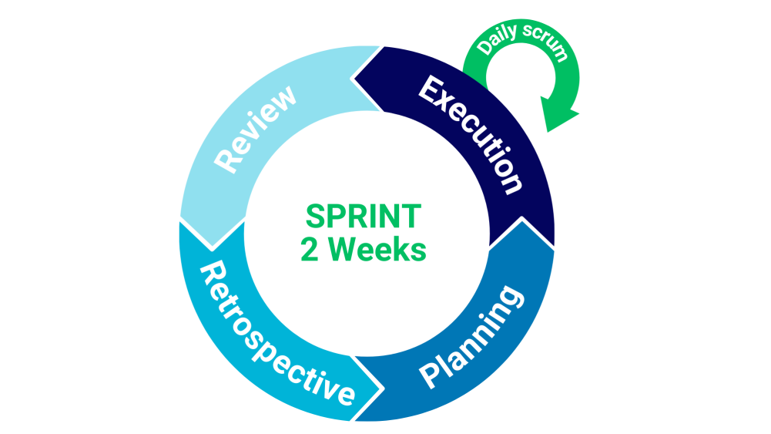

Figure 1: Sprint cycles

Agile project management under the Scrum framework relies on four critical events, which are sprint planning, sprint execution, sprint review, and sprint retrospective. All of them play a crucial role for teams to stay aligned, adaptive, and focused on producing value.

|  |  |
| --- | --- |
| Sprint Planning  Day 1 (4 hrs.) | After interviewing them, the team would share with each of its member what has to do, then the team would be setting a sprint goal with what task should undertake for every member covered to start working. |
| Sprint Execution  Day 2-13 (36-166 hrs.) | Team members are committed to achieving sprint goals and participating in a daily stand-up where they describe the progress and problems made. At the end of the sprint, to compensate for the management or running of the system. |
| Sprint Review  Day 14 (2 hrs.) | This enables the team to present their work completed to stakeholders, collecting feedback that informs future development to further improve the work and to present clearly to each member. |
| Sprint Retrospective  Day 14 (1.5 hrs.) | It allows the group to reflect upon what has been working well, on what hasn't been too good, and on their future scope for improvements through getting it to action towards its improvement so that there can be a better workflow ensured for the team in the following sprints. |

3.4 Scrum Artifacts

**3.4.1 Product Backlog**

|  |  |  |  |  |
| --- | --- | --- | --- | --- |
| PRODUCT BACKLOG ID | FEATURE/ TASK | DESCRIPTION/ USER STORIES | PRIORITY | STATUS |
| 1 | Planning | Choosing tools, designing the ui, and talk with team members. | High | Done |
| 2 | User authentication | As an Admin, I want to secure login for officials so that I can control the access to the system. | High | Done |

|  |  |  |  |  |  |  |
| --- | --- | --- | --- | --- | --- | --- |
| 3 | | Role-based access | As an Admin, I want to have secure access to different functions so that I can limit the access to functions and data. | High | Done | |
| 4 | | User Management | As an Admin, I want to have a function to view and update the user information so that I can manage the user of the system. | High | Done | |
| 5 | | Inspection scheduling | As an Admin, I want to schedule market inspections so that I can ensure compliance. | High | Done | |
| 6 | | Vendor registration | As a Vendor, I want to register for account so that I can register markets and use system functions. | High | Done | |
| 7 | | Market registration | As a Vendor, I want to apply for market permits online so that I can operate legally. | High | Done | |
| 8 | Permit cancellation | | As an Admin, I want to cancel permits of market violators so that I can lessen the violators. | Medium | | Ongoing |

|  |  |  |  |  |
| --- | --- | --- | --- | --- |
| 9 | Market filtering | As an Admin, I want to filter markets based on their compliance status so that I can prioritize high-risk vendors. | Medium | Ongoing |
| 10 | Inspection history | As a Vendor, I want to track the history of my inspections so that I can monitor my compliance. | Medium | Ongoing |

|  |  |  |  |  |
| --- | --- | --- | --- | --- |
| 11 | Update market details | As a Vendor, I want to update my market details (e.g., location, operating hours) so that I can ensure information stays accurate for consumers. | Medium | Ongoing |
| 12 | Inspection photo upload | As an Inspector, I want to submit inspection reports with photos so that I can provide detailed feedback on market conditions. | High | Done |

|  |  |  |  |  |
| --- | --- | --- | --- | --- |
| 13 | Pending schedule list | As an Inspector I want to have a list of pending Inspections so that I can make sure inspections are efficiently conducted. | High | Done |
| 14 | Inspection violation recording | As an Inspector, I want to log violations during inspections in real time so that I can ensure accuracy in my reports. | High | Done |

|  |  |  |  |  |
| --- | --- | --- | --- | --- |
| 15 | Inspector feedback | As an inspector, I want to add ratings and feedback to markets inspected so that markets can be informed about market safety. | High | Done |
| 16 | Inspector feedback view | As a vendor, I want to view market ratings and feedback so that I can improve my market and ensure approval. | High | Ongoing |

|  |  |  |  |  |
| --- | --- | --- | --- | --- |
| 17 | Criteria management | As an admin, I want to create and update inspection criteria so that I can comply with inspection laws and improve market compliance. | High | Done |
| 18 | Permit approval | As an admin, I want to review and approve permit applications so that I can regulate market activities. | Medium | Ongoing |
| 19 | Pending permit approval | As an admin, I want to review pending permit approvals so that I can approve or deny them efficiently. | High | Ongoing |
| 20 | Permit printing | As a vendor, I want to download my market safety certification so that I can display it publicly. | Medium | Ongoing |
| 21 | Permit tracker | As a vendor, I want to check my permit application status online so that I can follow the progress without visiting the office. | Medium | Ongoing |
| 22 | Permit expiration notification | As an admin, I want to be notified of upcoming permit expiration so that I can renew them on time. | Medium | Ongoing |
| 23 | Permit printing notification | As a vendor, I want to be notified if permits can be printed so that I can post it immediately. | Medium | Ongoing |
| 24 | Upcoming inspection notification | As a vendor, I want to receive notifications for upcoming inspections so that I can be notified about the permit process. | Medium | Ongoing |
| 25 | Custom notification | As a vendor, I want to receive notifications from the admin so that I can be notified and informed. | Medium | Ongoing |
| 26 | Market search | As a consumer, I want to search for markets by location and category so that I can easily find markets. | Low | Ongoing |
| 27 | Nearby markets | As a consumer, I want to see a map of nearby markets that have passed inspections so that I can shop at the safest markets. | Low | Ongoing |

|  |  |  |  |  |
| --- | --- | --- | --- | --- |
| 28 | Common market violation | As a admin, I want to receive AI-generated insights on common market violations so that I can make better decisions in regulating markets. | Low | Ongoing |
| 29 | Market safety compliance report | As an admin, I want to generate monthly reports on market safety compliance so that I can present data in meetings. | Low | Ongoing |

|  |  |  |  |  |
| --- | --- | --- | --- | --- |
| 30 | Market safety trends | As an admin, I want to view statistics on market safety trends in my barangay so that I can evaluate the effectiveness of our policies. | Low | Ongoing |
| 31 | Summary of inspection result | As an admin, I want to have summaries of inspection results so that I can have insights on the inspection results. | Low | Ongoing |
| 32 | Suggestion for improvements | As a vendor, I want to have suggestions for improvements based on results so that I can improve my compliance. | Low | Ongoing |
| 33 | Inspection statistics | As an admin, I want to view inspection statistics so that I can monitor market compliance. | Medium | Ongoing |
| 34 | Security check | Checking the security of the system. | Low | Ongoing |
| 35 | System test | Test the function of the system. | Low | Ongoing |
| 36 | Integration | Integration with other systems. | Low | Ongoing |
| 37 | Final Testing | Testing the system integrated with other systems. | Low | Ongoing |
| 38 | Deploying The system | Upload the system on the web. | Low | Ongoing |

**3.4.2 Sprint Backlog**

**Sprint #1:**

|  |  |  |  |  |
| --- | --- | --- | --- | --- |
| ID | FEATURE/ TASK | SPRINT TASKS | ASSIGNED TO | ESTIMATE |
| 1 | Planning | Choose the tools to use for system development. | Abina, Cabildo, Junio, Magsadia, Ramos | Day 1-2  (1-5 hrs.) |
| Create a design template for the system. |
| Talk with other team members. |
| 4 | User Management | Develop the user management interface. | Abina, Magsadia | Day 3-4  (24 hrs.) |
| Create functionality like create, update, view, and delete user data. |
| Test the user management functionality. |
| 2 | User authentication | Design the login interface. | Abina, Magsadia | Day 5-6  (24 hrs.) |
| Develop the login form functionality. |
| Set up multi-factor authentication. |
| Test login functionality (unit tests). |

|  |  |  |  |  |
| --- | --- | --- | --- | --- |
| 3 | Role-based access | Manage user management module. | Abina, Magsadia | Day 7-8  (24 hrs.) |
| Implement role-based access control (admin, inspectors, vendors, consumers). |
| Test access control functionality (unit tests). |
| 6 | Vendor registration | Develop registration interface. | Abina, Magsadia | Day 9-10  (24 hrs.) |
| Develop vendor registration form. |
| Implement registration backend logic. |
| Validate vendor inputs and store user data in the database. |
| Test vendor registration functionality (unit tests). |
| 7 | Market Registration | Develop permit application form. | Abina, Magsadia | Day 11-12  (24 hrs.) |
| Implement permit application logic (backend). |
| Test permit application functionality (unit tests). |
| Total estimate: | | | | 12 days  (125 hrs.) |

**Sprint #2:**

|  |  |  |  |  |  |
| --- | --- | --- | --- | --- | --- |
| ID | FEATURE/ TASK | SPRINT TASKS | ASSIGNED TO | ESTIMATE | |
| 5 | Inspection scheduling | Create an inspection scheduling form. | Abina, Magsadia | Day 1-2 (24 hrs.) | |
| Develop functionality for scheduling inspections (backend logic). |
| Test inspection scheduling functionality (unit tests). |
| 17 | Criteria management | Create criteria management interface. | Abina, Magsadia | Day 3-4 (24 hrs.) | |
| Develop criteria input form. |
| Develop functionanilties like insert, update, view, and delete inspection criteria. |
| Test criteria management functionality. |
| 13 | Pending schedule list | Create an inspection schedule list interface. | Abina, Magsadia | Day 5-6  (24 hrs.) | |
| Develop functionality for fetching inspection schedule list (backend logic). |
| Test inspection schedule list functionality (unit tests). |
| 12 | Inspection photo upload | Create file input in inspection form. | Abina, Magsadia | Day 7-8  (24 hrs.) | |
| Create logic that will store text input and uploaded photos in the database. |
| Test photo upload and preview functionality. |
| 14 | Inspection violation recording | Create violations input in the inspection form. | Abina, Magsadia | Day 9-10  (24 hrs.) | |
| Implement backend logic for storing violations. |
| Test violations submission. |
| 15 | Inspector feedback | Develop a rating and feedback interface for inspectors. | Abina, Magsadia | | Day 11-12  (24 hrs.) |
| Implement backend logic for storing inspector feedback. |
| Test feedback submission and retrieval functionality. |
| Total estimate: | | | | | 12 days  (144 hrs.) |

**Sprint #3:**

|  |  |  |  |  |
| --- | --- | --- | --- | --- |
| ID | FEATURE/ TASK | SPRINT TASKS | ASSIGNED TO | ESTIMATE |
| 16 | Inspector feedback view | Develop an interface for vendors to view market ratings and feedback. | Abina, Magsadia | Day 1-2  (24 hrs.) |
| Fetch market ratings and feedback data from the database. |
| Test the market ratings and feedback view feature (unit and integration tests). |
| 19 | Pending permit approval | Create a pending permit approval list interface. | Abina, Magsadia | Day 3-4  (24 hrs.) |
| Implement logic for fetching pending permit approval. |
| Test pending permit list functionality (unit tests). |
| 18 | Permit approval | Create an inspection approval interface. | Abina, Magsadia | Day 5-6  (24 hrs.) |
| Implement logic for inspection result review and approval process. |
| Test permit approval functionality (unit tests). |

|  |  |  |  |  |
| --- | --- | --- | --- | --- |
| 21 | Permit tracker | Create a permit status interface. | Abina, Magsadia | Day 7-8  (24 hrs.) |
| Develop functionality for filtering market based on their status (backend logic). |
| Test permit status functionality (unit tests). |
| 8 | Permit cancellation | Create a permit cancellation interface. | Abina, Magsadia | Day 9-10  (24 hrs.) |
| Implement backend logic for the interface. |
| Test permit cancellation functionality (unit tests). |
| 20 | Permit printing | Create a permit printing interface. | Abina, Magsadia | Day 11-12  (24 hrs.) |
| Implement logic for the permit printing process. |
| Test permit printing functionality (unit tests). |
| Total estimate: | | | | 12 days  (144 hrs.) |

**Sprint #4:**

|  |  |  |  |  |
| --- | --- | --- | --- | --- |
| ID | FEATURE/ TASK | SPRINT TASKS | ASSIGNED TO | ESTIMATE |
| 33 | Inspection statistics | Create a function that shows inspection statistics on the dashboard. | Abina, Magsadia | Day 1-2  (24 hrs.) |
| Create queries that will fetch the data in the database. |
| Test inspection statistics function. |
| 9 | Market filtering | Create a market list interface. | Abina, Magsadia | Day 3-4  (24 hrs.) |
| Create search input and drop-down for market status. |
| Develop functionality for filtering markets based on their status (back-end logic). |
| Test inspection scheduling functionality (unit tests). |

|  |  |  |  |  |
| --- | --- | --- | --- | --- |
| 11 | Update market details | Create a update button on market list. | Abina, Magsadia | Day 5-6  (24 hrs.) |
| Develop market data update form. |
| Implement backend logic for updating market data. |
| Test market data update form functionality (unit test). |
| 10 | Inspection history | Create a inspection history button on market list. | Abina, Magsadia | Day 7-8  (24 hrs.) |
| Develop an interface for vendors to view inspection history. |  |  |
| Fetch inspection history data from the database. |  |  |
| Test the inspection history feature (unit and integration tests). |
| 24 | Upcoming inspection notification | Set up notification triggers for upcoming inspections. | Abina, Magsadia | Day 9-10  (24 hrs.) |
| Create notification templates for inspection reminders. |
| Test inspection reminder notification system. |

|  |  |  |  |  |
| --- | --- | --- | --- | --- |
| 23 | Permit printing notification | Implement notification triggers for permit printing. | Abina, Magsadia | Day 11-12  (24 hrs.) |
| Create email/SMS templates for permit notifications. |
| Test notification system for permit expiration. |
| Total estimate: | | | | 12 days  (144 hrs.) |

**Sprint #5:**

|  |  |  |  |  |
| --- | --- | --- | --- | --- |
| ID | FEATURE/ TASK | SPRINT TASKS | ASSIGNED TO | ESTIMATE |
| 25 | Custom notification | Create an interface for submitting custom notification. | Abina, Magsadia | Day 1  (15 hrs.) |
| Set up notification triggers for custom notifications. |
| Create notification templates for custom notifications. |
| Test custom notification functionality. |
| 22 | Permit expiration notification | Implement notification triggers for permit expiration. | Abina, Magsadia | Day 2  (15 hrs.) |
| Create email/SMS templates for permit notifications. |
| Test notification function for permit expiration. |
| 26 | Market search | Create filtering functionality based on market category. | Abina, Magsadia | Day 3-4  (32 hrs.) |
| Update database queries to handle category-based filtering. |
| Test filtering functionality for market searches. |

|  |  |  |  |  |
| --- | --- | --- | --- | --- |
| 27 | Nearby markets | Develop market map interface. | Abina, Masadia | Day 5-6  (32 hrs.) |
| Implement back-end logic for locating markets on map. |
| Integrate with Google Maps API for location services. |
| Test market search functionality (unit tests). |
| 28 | Common market violation | Create a function that detect common market violations. | Abina, Magsadia | Day 7-9  (36 hrs.) |
| Integrate AI-generated insights into the dashboard. |
| Test AI insights functionality (integration tests). |
| 31 | Summary of inspection result | Create AI function for creating summaries. | Abina, Magsadia | Day 10-12  (36 hrs.) |
| Integrate AI-generated insights into the inspection report. |
| Test AI insights functionality (integration tests). |
| Total estimate: | | | | 12 days  (166 hrs.) |

**Sprint #6:**

|  |  |  |  |  |
| --- | --- | --- | --- | --- |
| ID | FEATURE/ TASK | SPRINT TASKS | ASSIGNED TO | ESTIMATE |
| 32 | Suggestion for improvements | Create AI function for generative suggestions. | Abina, Magsadia | Day 1-3  (36 hrs.) |
| Integrate AI-generated insights into the ratings and feedback. |
| Test AI insights functionality (integration tests). |
| 30 | Market safety trends | Generate performance dashboards based on inspection data and compliance history. | Abina, Magsadia | Day 4-6  (36 hrs.) |
| Create data visualizations for compliance trends. |  |  |
| Test dashboard functionalities and visualization accuracy. |

|  |  |  |  |  |
| --- | --- | --- | --- | --- |
| 29 | Market safety compliance report | Create report generation function for monthly/quarterly reviews. | Abina, Magsadia | Day 7-8  (32 hrs.) |
| Develop functionality to download reports in PDF/Excel formats. |
| Test report generation for accuracy and format. |
| 34 | Security check | Check the security features of every module. | Abina, Magsadia | Day 9  (12 hrs.) |
| 35 | System test | Test the function of the system. | Abina, Magsadia | Day 10  (12 hrs.) |
| 36 | Integration | Integrate with business registration and renewal system. |  | Day 11-12  (32 hrs.) |
| Integrate with public monitoring system. |
| Test the integration. |
| Total estimate: | | | | 12 days (160 hrs.) |

**Sprint #7:**

|  |  |  |  |  |
| --- | --- | --- | --- | --- |
| ID | FEATURE/ TASK | SPRINT TASKS | ASSIGNED TO | ESTIMATE |
| 37 | Final testing | Test every module functionality including the integration. | Abina, Magsadia | Day 1-2  (24 hrs.) |
| Check the system performance. |
| 38 | Deploying the system | Pull the website from github. | Abina, Magsadia | Day 3-4  (12 hrs.) |
| Test the website on the web. |
| Total estimate: | | | | 4 days  (36 hrs.) |

**3.5 Microservices Architecture**

**3.5.1 Microservices Diagram**

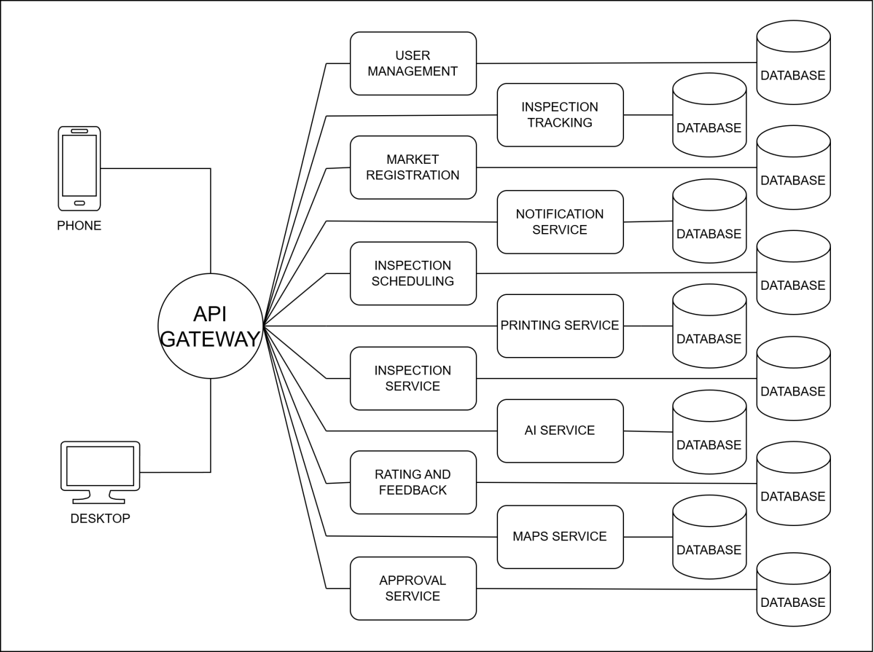

Figure 2: Microservices diagram

The diagram illustrates a microservices architecture, where users can access various services through web or API interfaces. These services, including login, permit tracking, and inspection scheduling, operate independently, promoting scalability and flexibility within the system.

**3.5.2 Communication Pattern**

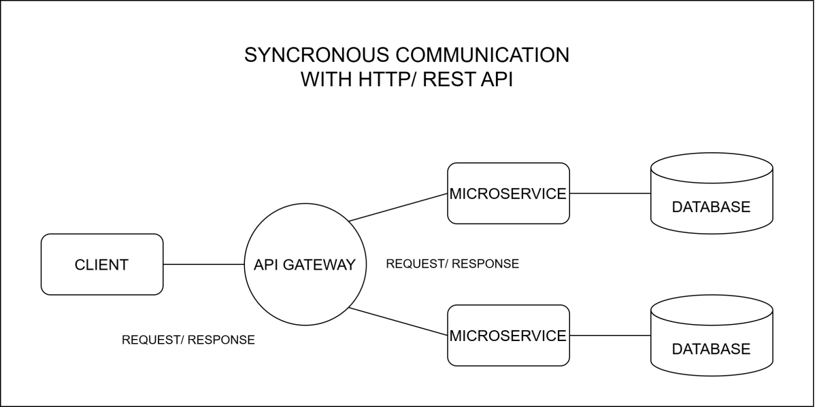

Figure 3: Communication pattern

The communication pattern shows how the microservices interact and exchange messages between each other. In the system, the communication pattern used is synchronous communication. In this pattern, the services request to fellow services and wait for a response before continuing to another process.

**3.5.2 Data Flow Diagram**

A data flow diagram shows how data moves into the system and how data transforms through a process. The following diagrams consist of several levels, which are level 0, level 1, level 2, and level 3, that will show the levels of data flow in the system.

**Level 0**

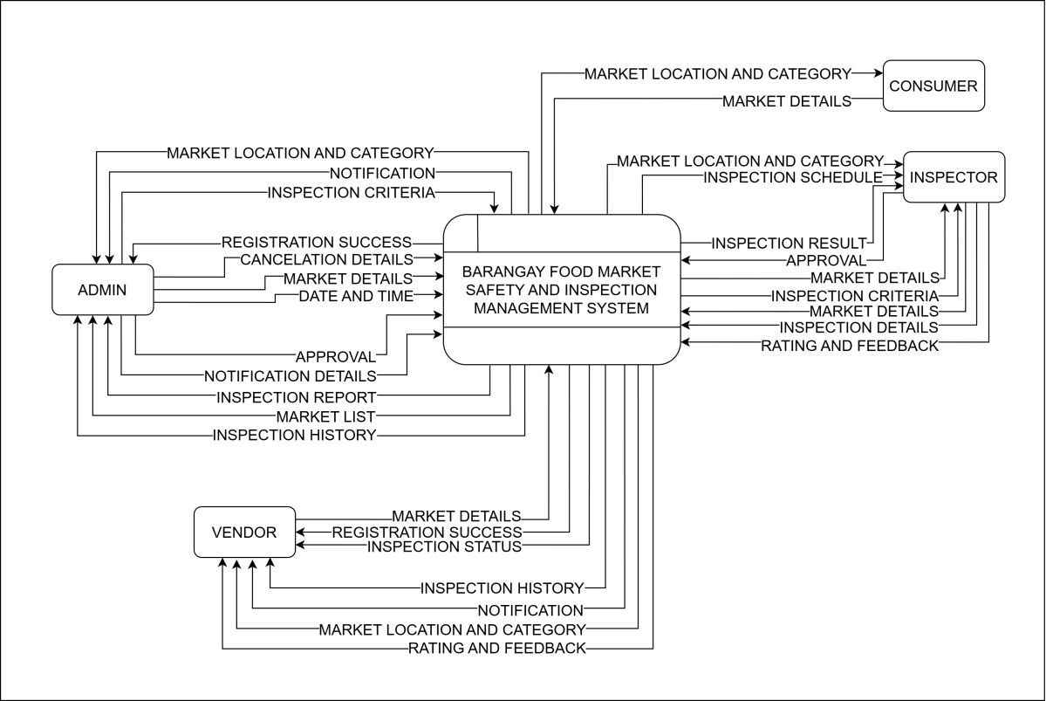

Figure 4: Data flow diagram level 0

**Level 1**

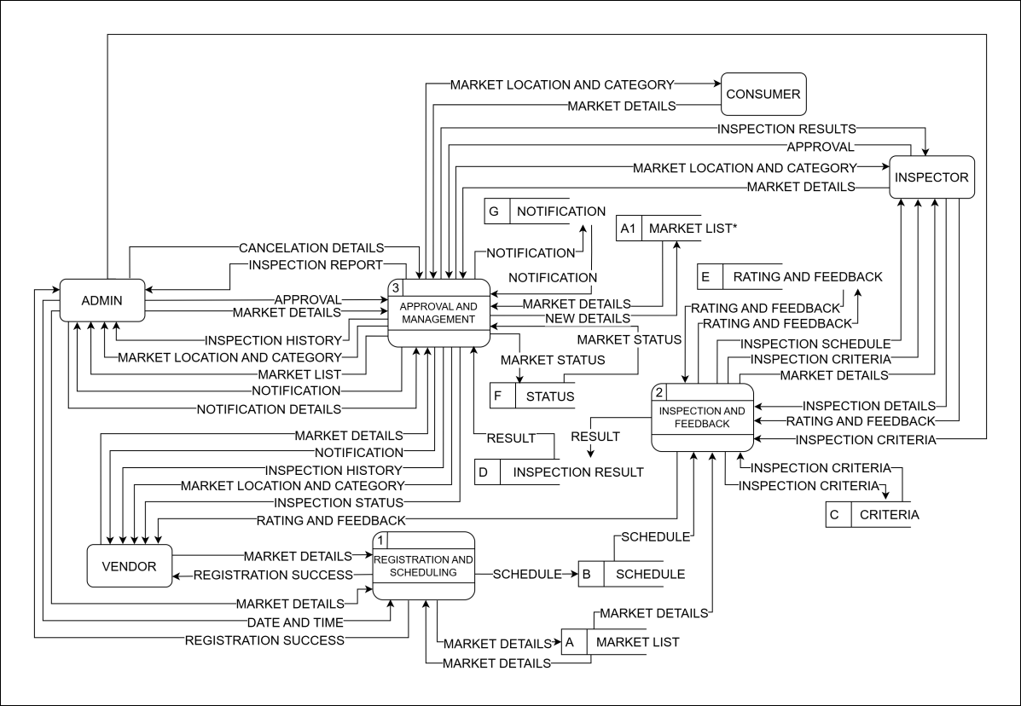

Figure 5: Data flow diagram level 1

**Level 2**

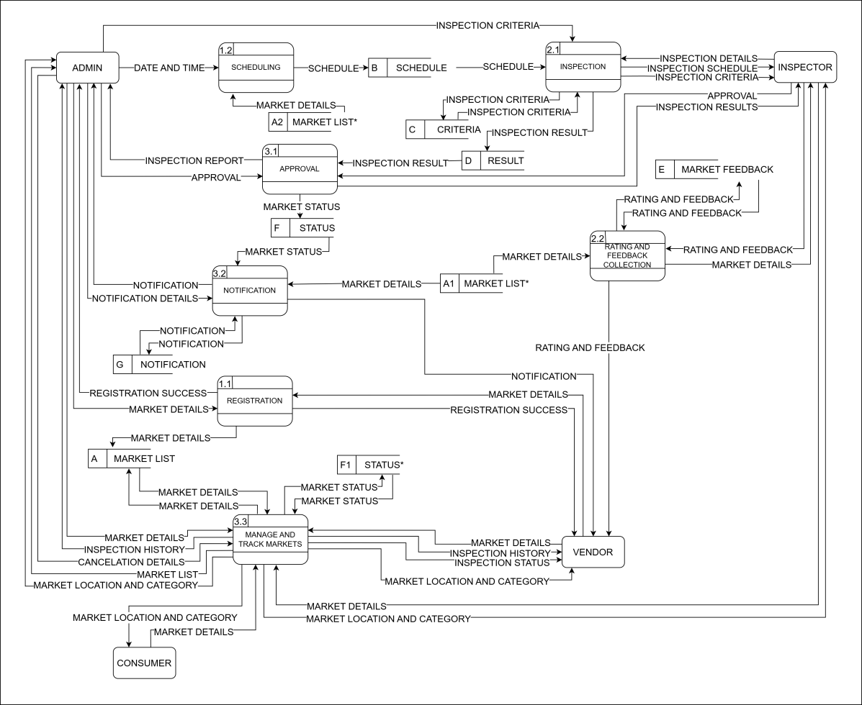

Figure 6: Data flow diagram level 2

**Level 3**

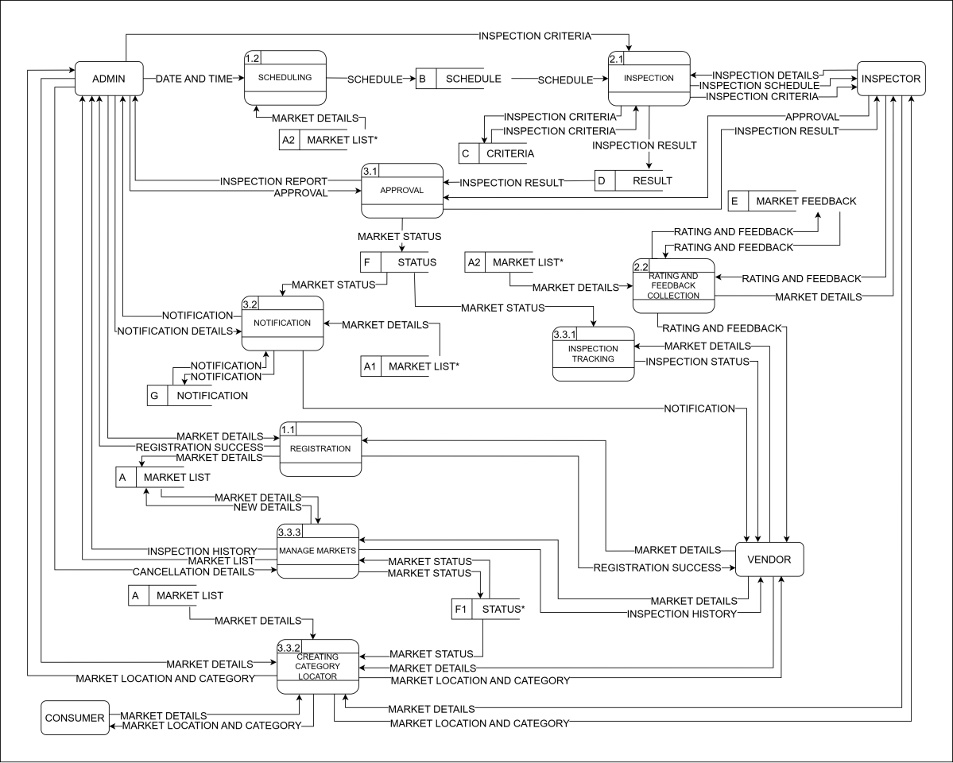

Figure 7: Data flow diagram level 3

3.6 Devops Implementation

Building a Food Market Inspection System requires the development process for each system function. In every development, each function has updates and modifications after it goes into testing and reviews. Managing those changes in the system requires tools for the developers to ease their work and have arranged and detailed information of every update. The system developers use a Dev Ops tool Github to ease their development process. This tool will be used as a version control tool to track changes and updates to the system. For collaboration, the developers will use this to discuss the changes and review the system codes. Also, with its continuous integration and continuous deployment, applying the changes to the system would be automated. That makes the system have its new features and bug fixes quickly.

**3.6.1 CI/CD Pipeline Diagram**

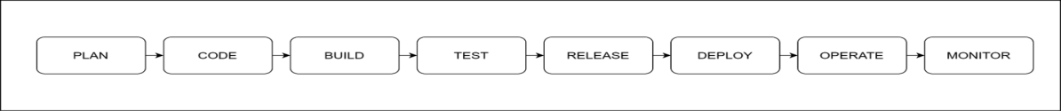

Figure 8: CI/CD pipeline

The diagram illustrates a CI/CD pipeline automating software development. It involves planning, coding, building, testing, and deploying, using tools like Visual Studio Code, XAMPP, and GitHub for efficient workflow. This streamlined process ensures faster and more reliable software delivery.

**3.6.2 Infrastructure as a Code**

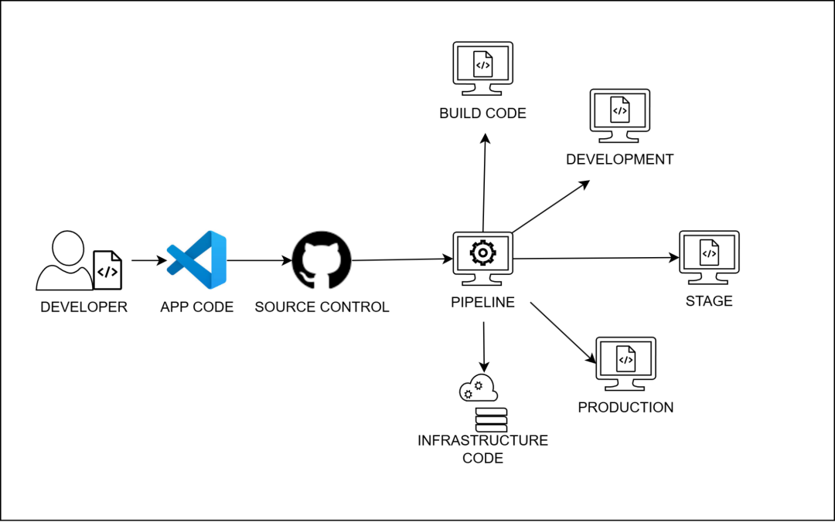

Figure 9: Infrastructure as a code

This image illustrates a software development pipeline with infrastructure as a code, which makes it easier to develop. Therefore, the process will be more efficient and streamlined, which will reduce the occurrence of errors.

**3.6.3 Monitoring and Alerting**

This diagram shows how notifications and reports are managed through monitoring and alerts embedded in the system. This depicts the processes in which the task is scheduled to expire in a specific timeframe; a notification/alert was about to be sent to users that handle the system.

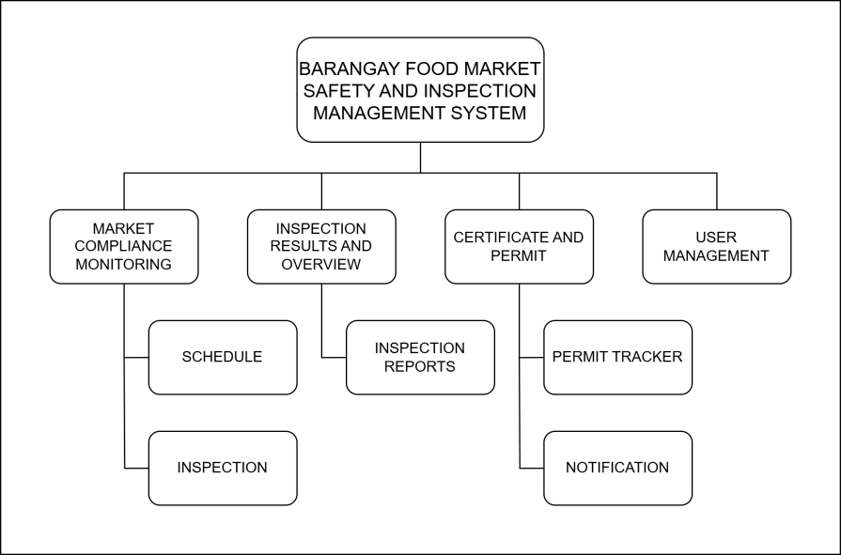

Figure 10: Monitoring and alerting

This diagram shows how notifications and reports are managed through monitoring and alerts embedded in the system. This depicts the processes in which the task is scheduled to expire in a specific timeframe; a notification/alert was about to be sent to users that handle the system.

**3.6.4 Network Topology**

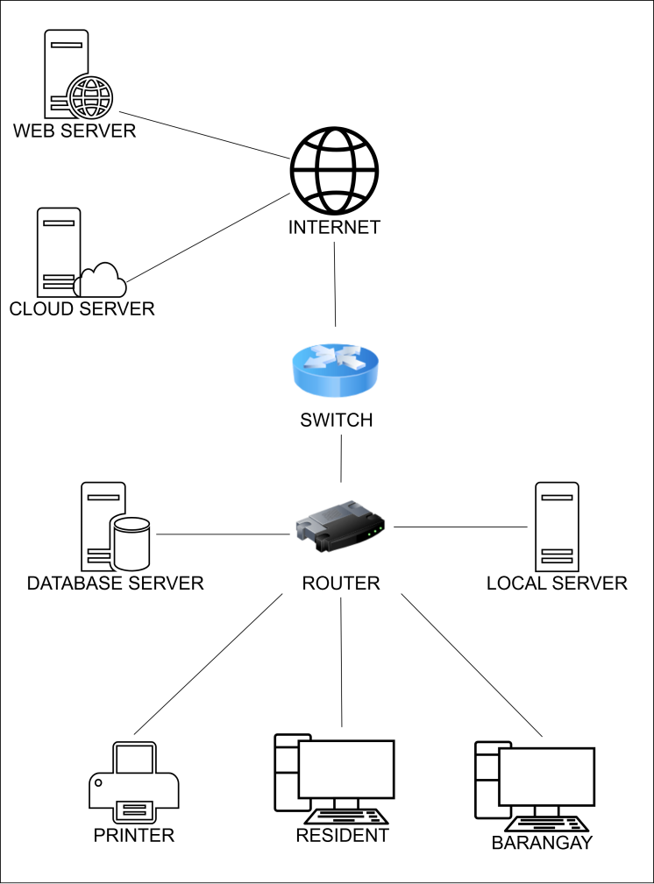

Figure 11: Network topology

The diagram illustrates a star network topology. Web servers host websites and applications, while database servers store and manage data. Users can access these resources through the internet. Local servers and databases handle data generated within the local network. To access data from the broader internet, users rely on the router to connect to the network and the switch to facilitate communication within the local network.

3.7 Integration Approach for Information Systems

**3.7.1 Integration Diagram**

The diagram illustrates how the Business and Market Management Integration sub-modules integrate. Which depicts that the **Public Market Monitoring System**, **Business Registration and Renewal System**, and **Barangay Food Market Safety and Inspection Management System** are all integrated and connected to each other.

**Integration:**

**Vendor and Business Portal Integration:** Combine vendor data from the Public Market System with the Business Registration System, allowing for streamlined registration, renewal, and monitoring of vendors.

**Inspection Reporting:** Integrate food market inspection results with the Business Registration System, ensuring that market vendors comply with health and safety regulations.

**Feedback and Monitoring:** Use the feedback mechanisms from the Market Monitoring System to gather insights on both businesses and market vendors, feeding the data into the Inspection Management System for compliance tracking.

**BPA Top Level 1**

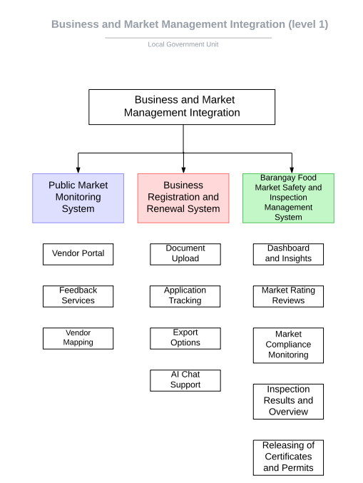

Figure 12: BPA top level 1

**BPA TOP LEVEL 2**

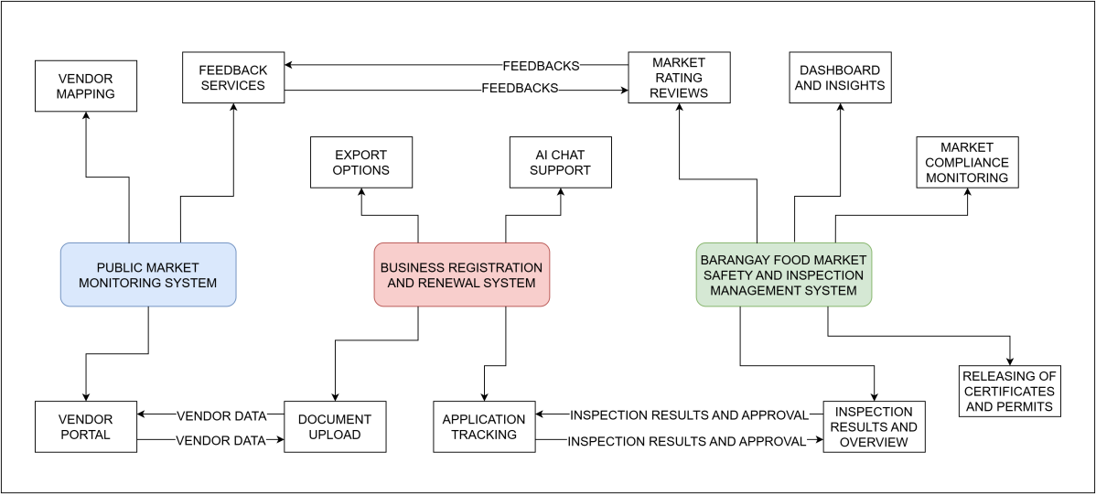

Figure 13: BPA top level 2

**3.7.2 Data Flow Diagram Level 3**

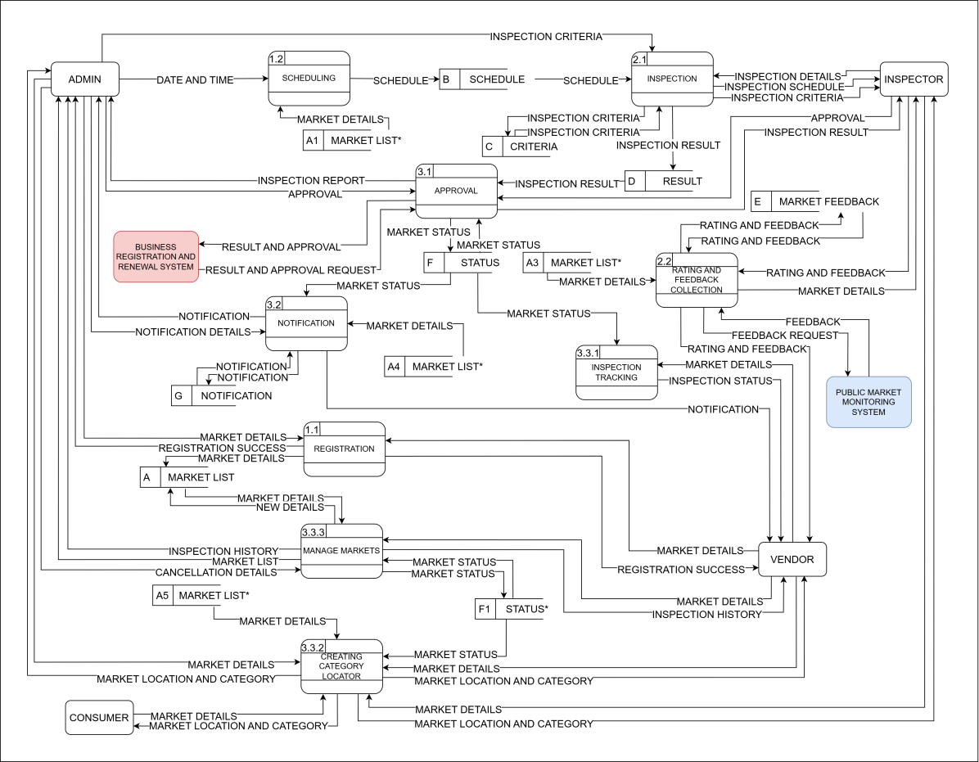

Figure 14: Data flow diagram level 3 (Integration)

**3.7.3 API Gateway**

API gateway acts as an intermediary between the client and the microservices. It routes users requests to the appropriate service.

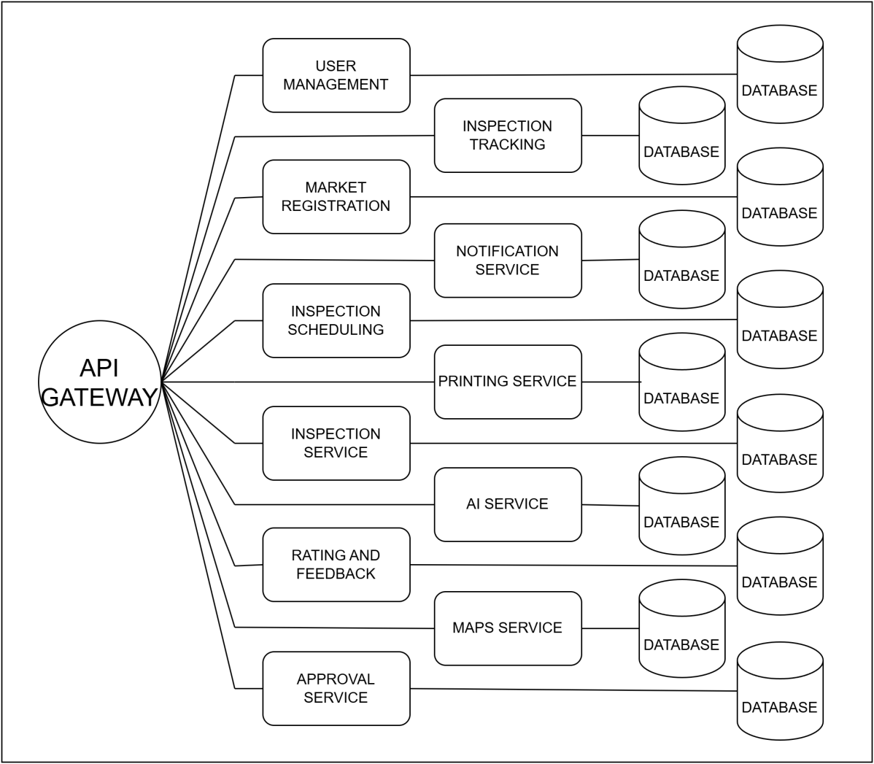

Figure 15: API gateway

3.8 Introduction to TOGAF and the Four Architectural Domains

TOGAF (The Open Group Architecture Framework)

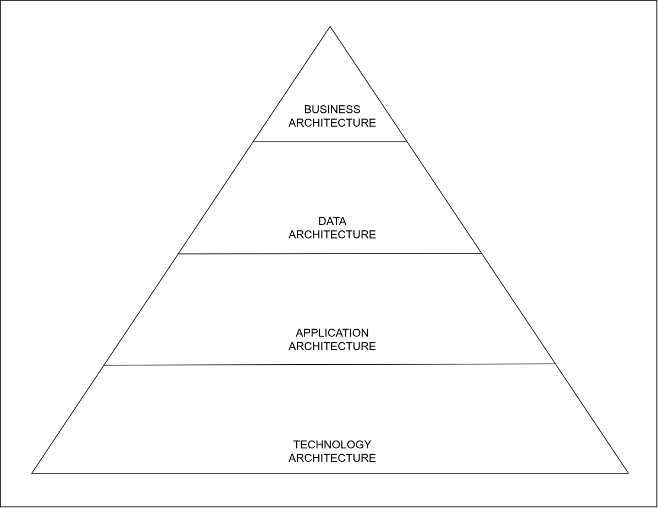

Figure 16: TOGAF Diagram

**Four architecture domains:**

**Business Architecture**

Defines main processes such as vendor registration, permit issuance, inspection scheduling, and feedback collection. It also identifies the stakeholders, including barangay officials, inspectors, vendors, and consumers/residents, to make sure that the objectives are properly aligned to make the operation efficient.

**Data Architecture**

Organizes and manages information such as vendor profiles, inspection schedules, and user feedback. It secures storage and uninteruptable dataflow, making information accurate for decision-making. It also provides backups so that the data entered is immutable.

**Application Architecture**

Structures the system into microservices that handle specific functions independently. This approach showcases flexibility, scalability, and seamless integration and connection between components to support key business processes effectively.

**Technology Architecture**

Provides the infrastructure to support the system; the main objectives are to introduce scalability, reliability, and security of the system. It also ensures efficient communication between components, real-time interactions, and long-term data storage for system stability and growth.

This framework will help the LGU establish and maintain their IT infrastructure. It will also help in aligning the business objectives with software products, making the LGU provide high-quality services.

3.9 Additional Considerations

**3.9.1 Use Case Diagram**

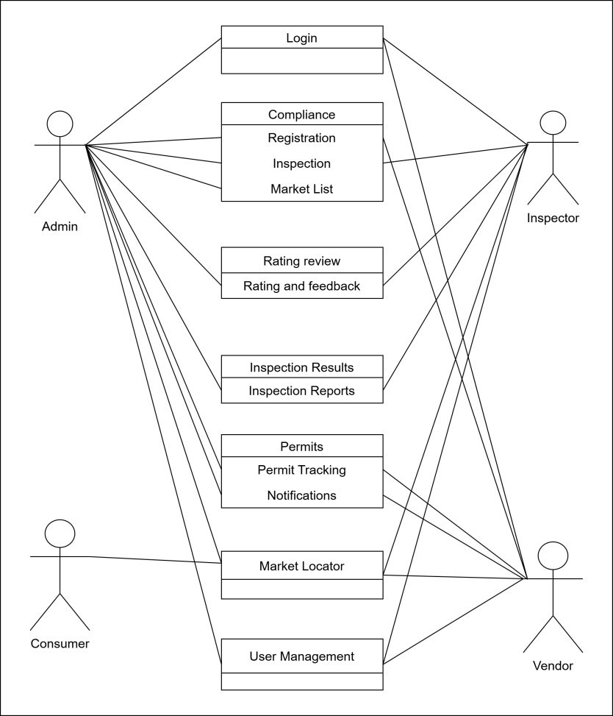

Figure 17: Use case diagram

This use case diagram illustrates the various interactions between different user roles (Admin, Inspector, Vendor, and Consumer/Community) and the Barangay Food Market Safety and Inspection Management System. These interactions include login, scheduling inspections, viewing market lists, inspecting markets, adding feedback, and managing user data.

**3.9.2 Sequence Diagram**

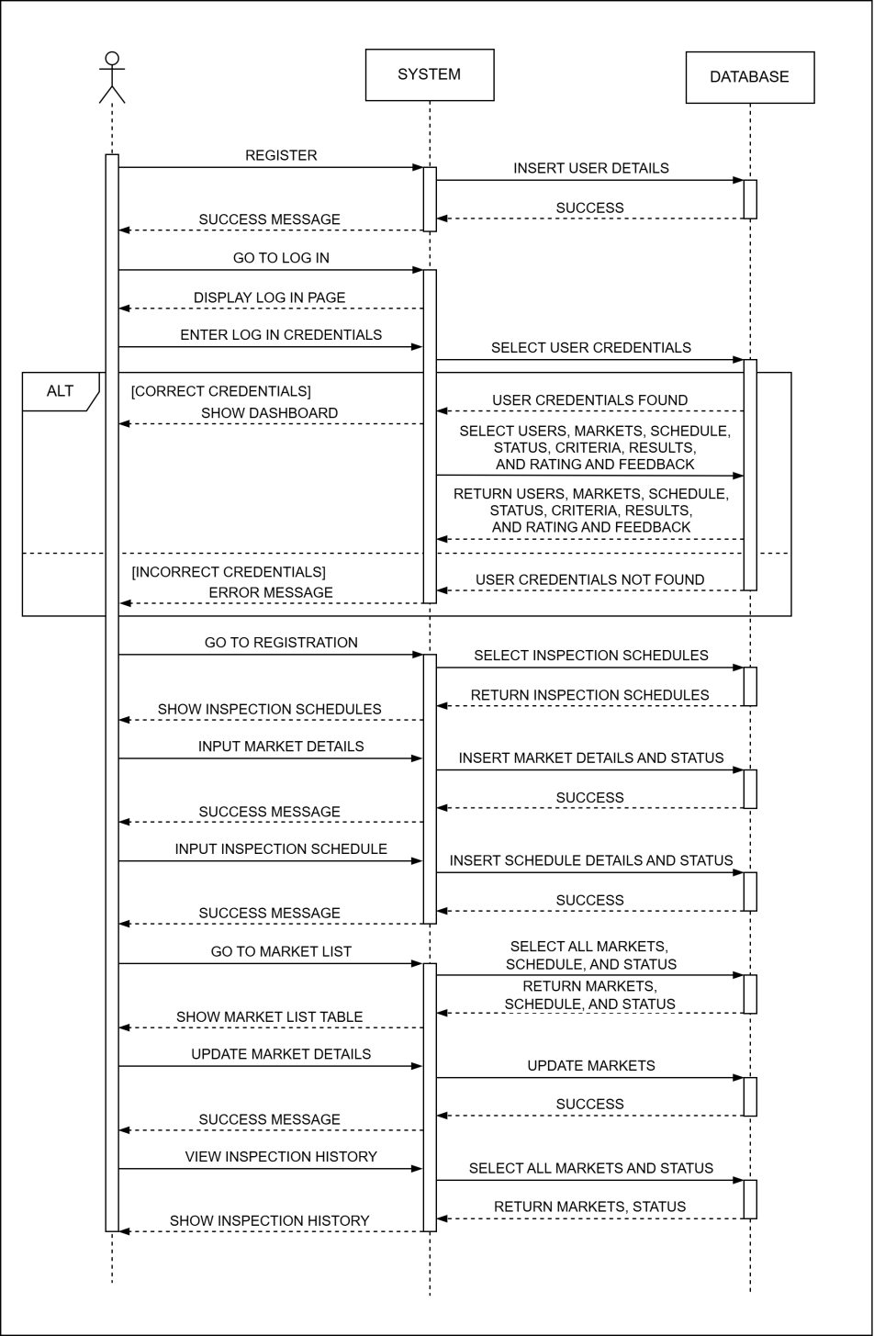

Figure 18.1: Sequence diagram page 1

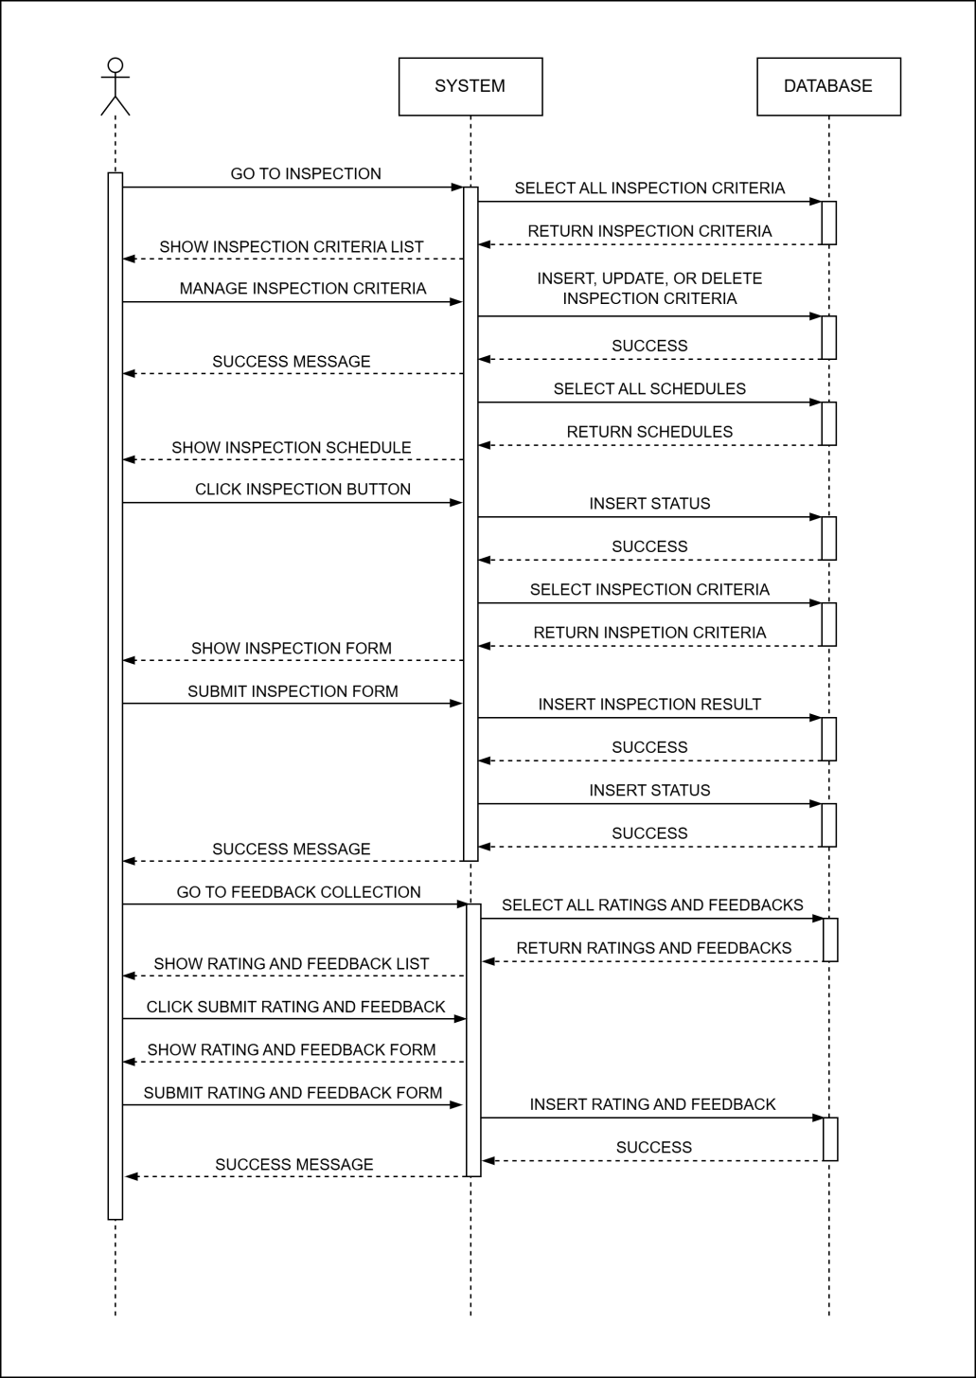

Figure 18.2: Sequence diagram page 2

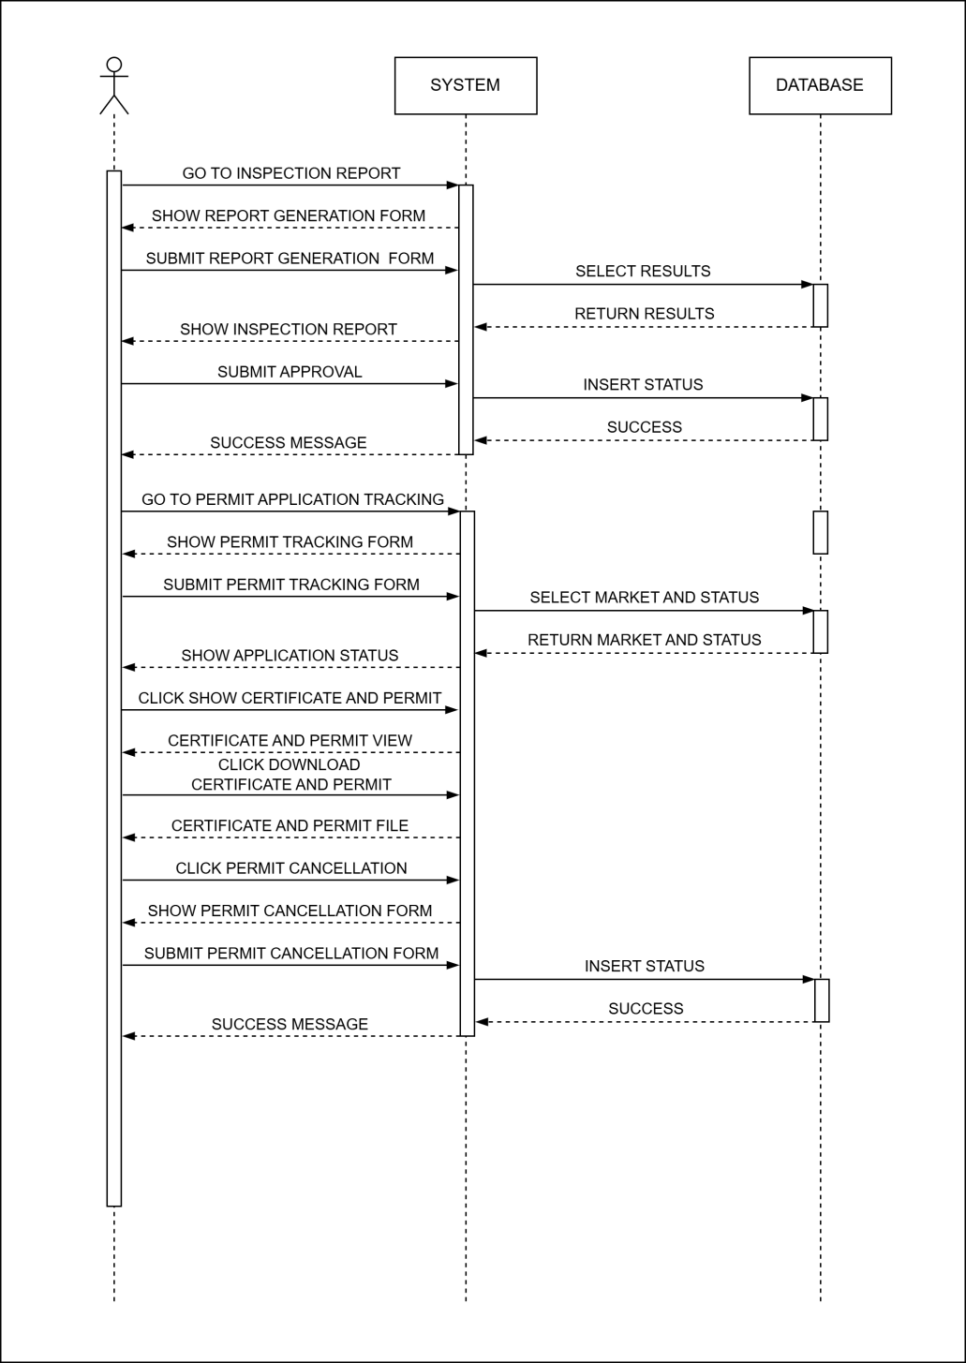

Figure 18.3 : Sequence diagram page 3

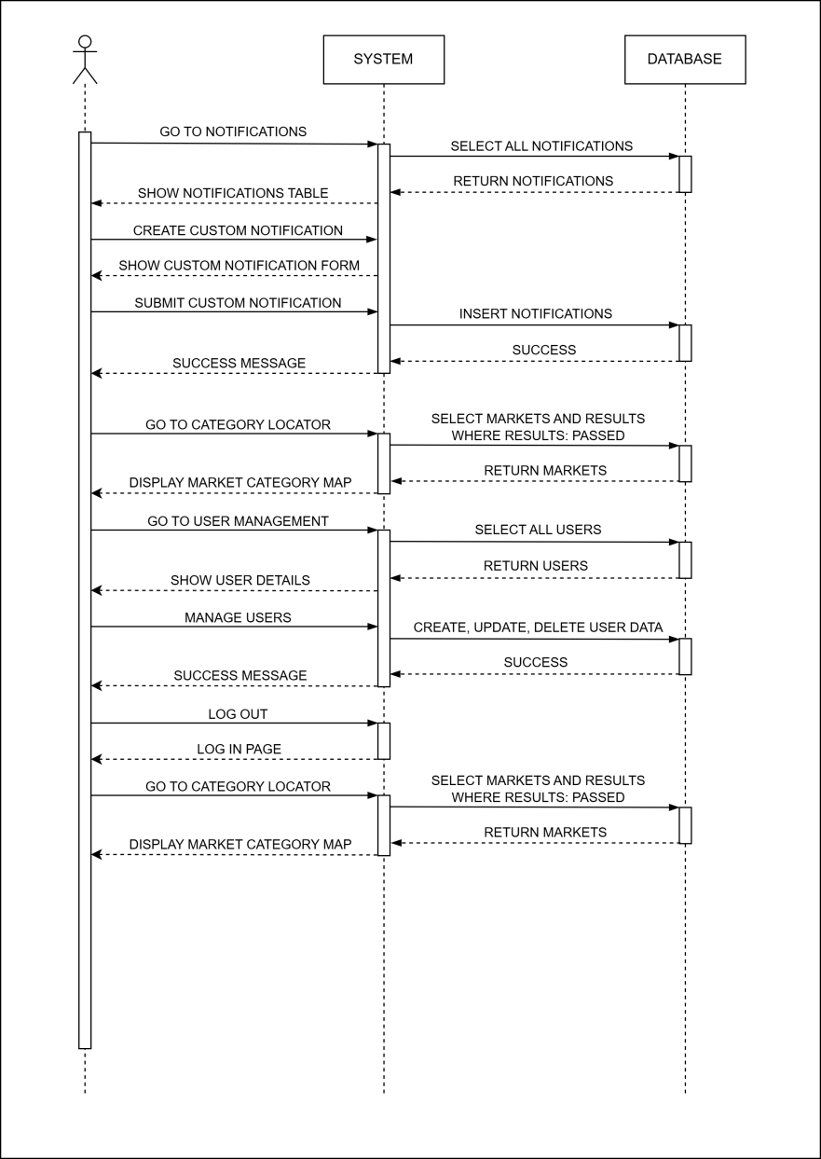

Figure 18.4: Sequence diagram page 4

The sequence diagram illustrates the interactions between different system components. They show the order of events and the messages exchanged. The diagram shows various user actions, system processing, data retrieval, and feedback mechanisms.