1. ***Tips*** 
   1. Readinformation before inputs.
   2. Can use the button to control the ruler.

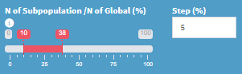

* 1. Non-inferiority in Binary: Non-inferiority Test for the difference between two proportions. If the margin is based on NI tests for the ratio of two proportions, user need to transfer the margin and adapt to margin of NI tests for the difference of two proportions.
  2. If running the programs are no work/ response, please clear the logs of website. Process can refer to **.**
  3. Seed for the simulation is not well workable for a series scenarios.
  4. Raw code can be found in Github Bayer website ([bayer-int/regionsizer (github.com)](https://github.com/bayer-int/regionsizer))
  5. If you cannot log in the RegionSizeR website, please contact us to update the tool in server.

1. ***Notations:***
   1. Even after clicking the Stop button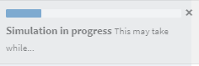, the system continues to run in the background; you would need to wait for a moment until finishing the running process and then refresh the page.
   2. If the sample size/event numbers in subpopulation is relatively small (especially in MCP-Mod and TTE design), the results of the consistency probability may not be very stable. Therefore, it is suggested to increase the number of simulations for better consistency.