Project

Problem Statement:
Creating a website connected to the company’s database from where any naive user can access the database in report format by typing out the prompt in English language and getting the output result.

Workflow:
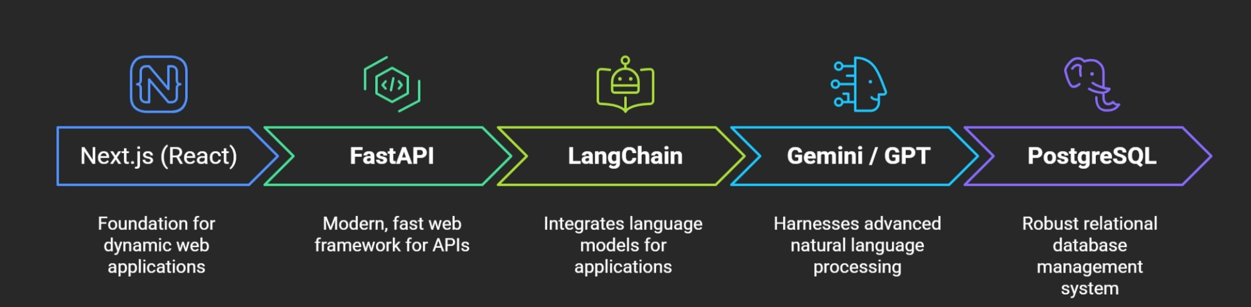

- Frontend:
- React:
React is the library used to build the user interface.
Think of it as:
User sees:
Ask Query
Results

React controls:
- Input box
- Submit button
- Loading animation
- Tables
- Graphs
- Dashboard
Example:-
User types:
Show all employees in sales department
React captures this text.

- Next.js:
- Next.js is built on top of React.
- It provides:
- Routing:
/dashboard
/login
/admin
- API Routes: Can create backend endpoints.
- Better Performance:
Server-side rendering
Faster loading
- Easier Deployment: Can deploy directly to platforms like Vercel
For this project:
React = UI Components ; Next.js = Complete Frontend Framework

Tech Stack:- Figma to make frontend using React, Next.js, Tailwind CSS.
- Backend:
- Fast API:
- FastAPI is the Python server.
- It acts as the middleman.

Example:-
- User submits: Show all employees
- Frontend sends: { "question":"Show all employees”} to FastAPI.
- FastAPI receives it and forwards it to the LLM.
Advantages:
- Extremely fast
- Built for APIs
- Easy integration with AI libraries
- Automatic API documentation
Tech Stack:- Python,

- LLM Layer:
- This is the brain.
- The LLM is responsible for:
    - Understanding Language:-

Converts:

people

workers

staff

employees

into the correct table.

    - Understanding Intent:-
- User: Which department spends the most on salaries?

LLM generates aggregation SQL.

    - Understanding Context
- User: Now show only top 5.

LLM understands previous conversation.

Tech Stack:- OpenAI API/Nvidia API

RAG:- Database contains:

tbl_emp

emp_nm

emp_sal

User asks: Show employee salaries

The LLM may not understand.

RAG stores documentation:

tbl_emp = Employee Table

emp_sal = Salary

emp_nm = Employee Name

Workflow:

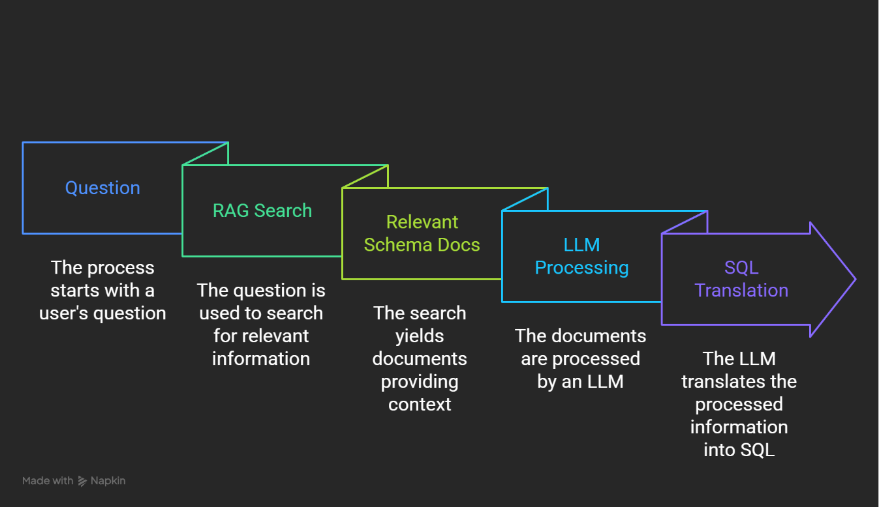

Langchain:-

LangChain manages the workflow.

Responsibilities:

Schema Retrieval

Prompt Contruction
Query Execution

Memory
- Database Layer:

SQL: Stores actual data.

When SQL arrives:

SELECT * FROM employee_master;

SQL executes it.

Returns: [ { "id":1, "name":"John" } ]
- Security Layer: Very important.

Permissions:
GRANT SELECT Only.
Not: (No DML/DDL commands)
    - DELETE
    - UPDATE
    - DROP
    - ALTER
Website UI: Prototype
