Random Forest Model 1:
Predictors: All the nutrients 65 variables
Outcome: The food category (171 unique classes)
Hyperparameters:
- Default:
  - number of trees = 500
  - variables sampled at each split = 8
Misclassification Rate = 0.197

Plot is evaluating the misclassification rate for the 10 most seen classes in the test set
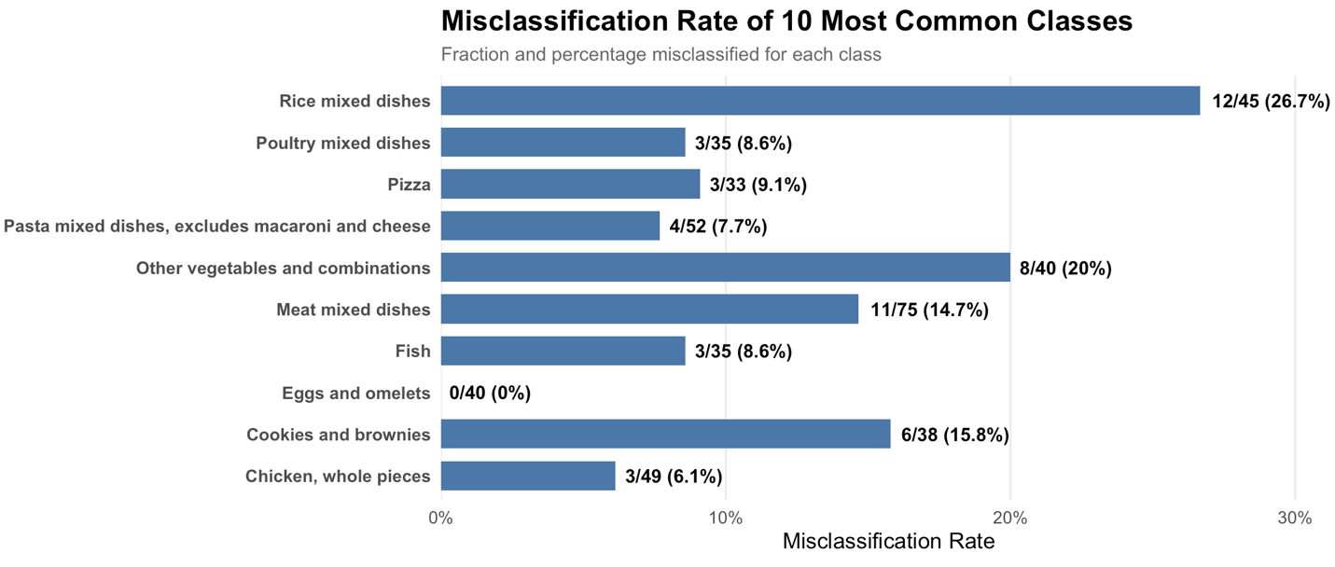

Variable Importance from Original Random Forest Model:
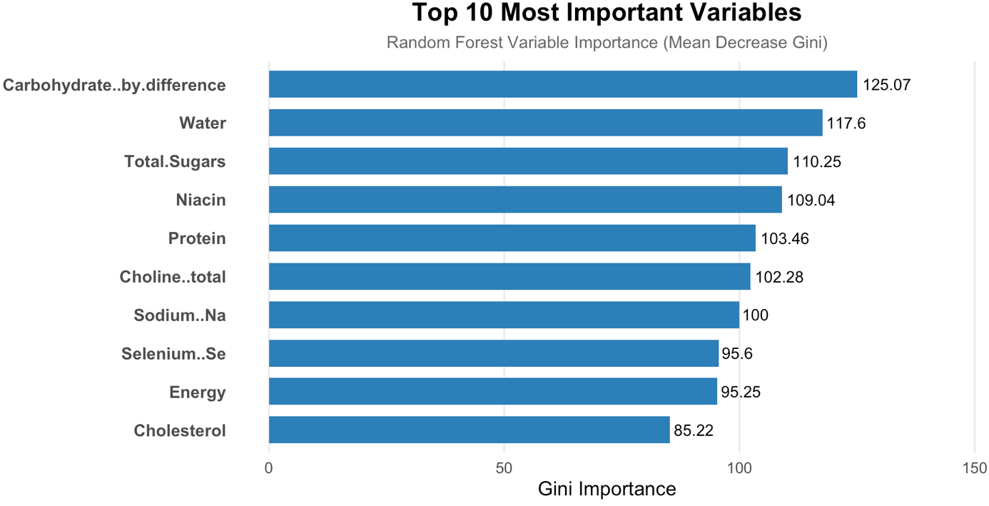

Random Forest Model 2:
Predictors: 10 most important variables
Hyperparameters:
- Default:
  - number of trees = 500
  - variables sampled at each split = 3
Misclassification Rate: 0.251
Plot is evaluating the misclassification rate for the 10 most seen classes in the test set
