Original codes are used.
Data in "testdata/Systematics/LAB2 Time Tests" (the one mentioned in systematics error analysis). Reference data is the median of all the data.
The following spectrum calculation using the “LAB2_20min_001” as original spectrum.
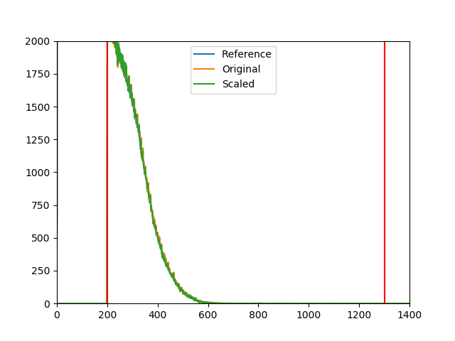
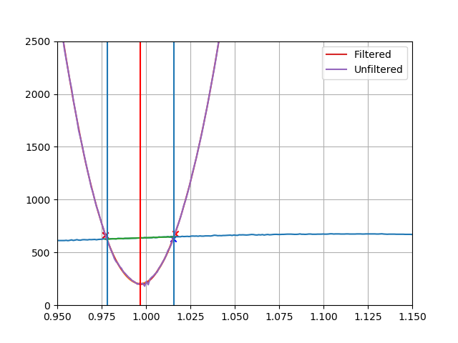
Statistical uncertainty obtained is 2.2% (it is also reported as 2.2% in Owen report)
Systematic uncertainty obtained is 1.14% while it is reported as 1.09% in Owen report.

